

LOCATION: Swansea | LLEOLIAD: abertawe
LEVEL 5 | LEFEL 5
EXAMINATION PERIOD | CYFNOD ARHOLIADAU
January 2023 | IONAWR 2023

MODULE CODE: ACDA5006
Transducers and Signal Conditioning
TIME: 2 HOURS
answer all questions

Equipment or materials required – Calculator, Graph paper
Adnoddau neu ddefnyddiau sydd eu hangen – Cyfrifiannell, Papur Graff

ANSWER ALL QUESTIONS

- Define the following terms:
  - Repeatability
[3 Marks]
  - Reproducibility
[3 Marks]
  - Accuracy
[3 Marks]
  - Precision
[3 Marks]
  - Sensitivity
[3 Marks]

- For the circuit shown in Fig Q2,
  - Explain the purpose of the networks R8, R9 & D1 – D4
[3 Marks]
  - Explain the purpose of U1 – U3
[1 Marks]
  - Explain the purpose of R7 and how this is achieved
[4 Marks]
  - State if the filter is a high pass or low pass filter along with its order.
[3 Marks]
  - Calculate the cut off frequency of the filter
[4 Marks]
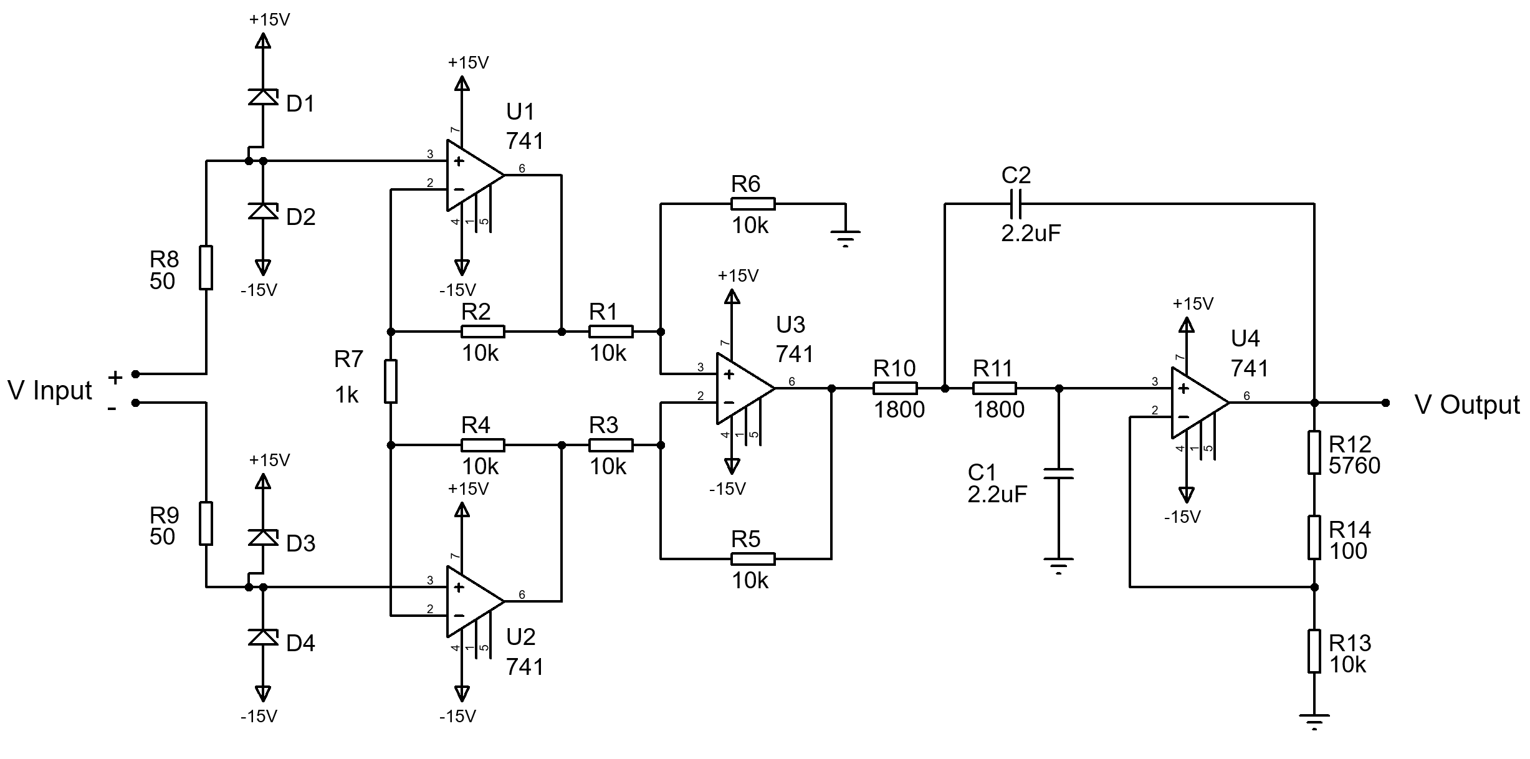
Fig Q2

- A digital voltmeter has a resistance of 500kΩ and is connected in parallel with the 2MΩ resistor in figure Q3.
  - What would the true voltage across the 1MΩ resistor be if the voltmeter was not connected?
[4 Marks]

  - Assuming the voltmeter is calibrated correctly, what is the reading shown by the voltmeter?
[5 Marks]

  - State one method of making the voltmeter more accurate.
[5 Marks]
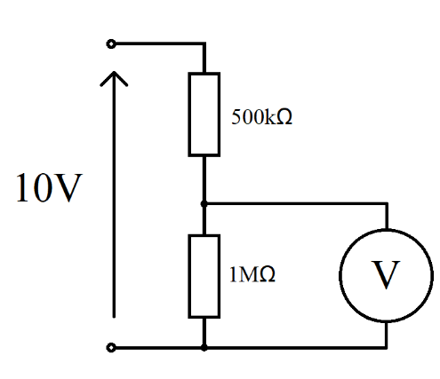
2MΩ
Figure Q3

- A load cell is calibrated in an environment at a temperature of 21 °C and has the following deflection / load characteristics:

Load (kg) | 0 | 25 | 50 | 75 | 100
Deflection (mm) | 0.0 | 1.0 | 2.0 | 3.0 | 4.0

When used in an environment at 35 °C, its characteristic changes to the following:

Load (kg) | 0 | 25 | 50 | 75 | 100
Deflection (mm) | 0.2 | 1.3 | 2.4 | 3.5 | 4.6

- Plot the load cell characteristics for both temperatures
[6 Marks]

- Determine the sensitivity at 21 °C and 35 °C.
[5 Marks]

- Calculate the total zero drift and sensitivity drift at 35 °C in units of (µm/°C) and (µm/kg)/°C
[5 Marks]

- Explain what methods could be used to reduce noise when transmitting transducer signals using wires in a noisy environment. Give an example circuit and explain how it works.
[10 Marks]

- Explain the need for and the process of calibration.
[10 Marks]

- Compare and contrast the requirements and specifications for a temperature sensor for the following applications:
  - Air temperature measurement for a weather station
  - Coolant temperature of a car engine.
[10 Marks]

Diwedd/End

Student Number ___________________________

Question Number __________________________



