
A critical analysis of the factors impacting the engagement of bank staff in Swansea Bay University Health Board (SBUHB) with the view to improving overall engagement levels. How can these be improved to help create a service fit for purpose and positively impact retention rates?
Strategic People Management (MA)
Author: Rhiannon Akers
Supervisor: Julie Thomas
Submitted: 03/05/24
Word count: 14,308 words

DECLARATION
This work has not previously been accepted in substance for any degree and is not being concurrently submitted in candidature for any degree.
Signed  (candidate)
Date 3rd May 2024

STATEMENT 1
This work is the result of my own investigations, except where otherwise stated.
Other sources are acknowledged by footnotes giving explicit references. A bibliography is appended.

Signed (candidate)
Date 3rd May 2024

STATEMENT 2
I hereby give consent for my work, if accepted, to be available for photocopying and for inter-library loan, and for the title and summary to be made available to outside organisations.

Signed (candidate)

Date 3rd May 2024

Contents
- Introduction 8
  - Context and background 8
  - Aims and objectives 9
  - Rationale 10
  - Hypothesis and key concepts 12
  - Research structure 12
  - Conclusion 13
2.0 Literature review 14
2.1 Introduction 14
2.2 Employee Engagement 15
2.2.1 Leadership and management impact 16
2.2.2 Employee engagement and patient satisfaction 18
2.2.3 Measuring employee engagement 18
2.3 Employee commitment and motivation 19
2.4 Employee voice 21
2.4.1 Employee voice in SBUHB 22
2.5 Reasons for joining the NHS bank 22
2.6 Employee retention 24 2.6.1 Retaining temporary employees 25
2.6.2 Impact of wellbeing on retention 25
2.7 Importance of bank staff 27
2.8 Conclusion 28
3.0 Methodology 29
3.1 Introduction 29
3.2 Research objectives 30
3.3 Research design 30
3.3.1 Research approach 31
3.3.1.1 Inductive reasoning 32
3.3.2 Data collection 32
3.3.2.1 Secondary data 33
3.3.2.2 Primary data 33
3.3.2.3 Research participants 35
3.4 Data analysis 37
3.4.1 Thematic analysis 37
3.4.1.1 Semantic approach 38
3.5 Validity and reliability of research 38
3.6 Ethical considerations and limitations 39
3.6.1 Ethical approval 39
3.6.2 Limitations 41
3.7 Conclusion 41
4.0 Data Analysis and Discussion 42
4.1 Introduction 42
4.2 Primary data 42
4.2.1 Participant information 43
4.2.2 Management support 44
4.2.3 Flexibility 45
4.2.4 Control 45
4.2.5 Belonging 46
4.2.6 Recruitment 47
4.2.7 Retirement 48
4.2.8 Wellbeing 49
4.2.9 Employee voice 50
4.2.10 Wagestream 50
4.2.11 Reward 51
4.2.12 Retention 52
4.3 Secondary data 54
4.3.1 Staff survey results 55
4.3.1.1 Morale 56
4.3.1.2 Staff engagement 57
4.3.1.3 We are able to speak up 57
4.3.1.4 We are compassionate and inclusive 58
4.3.1.5 We champion flexible working 59
4.3.2 Management training programmes 61
4.3.3 Leaver data 63
4.3.3.1 Reasons for leaving the bank 63
4.4 Conclusion 64
5.0 Conclusion and recommendations 65
5.1 Conclusion 65
5.2 Recommendations 69
5.2.1 NHS Wales Staff Survey 69
5.2.2 Stay interviews 69
5.2.3 Exit interviews 70
5.2.3.1 Quality 70
5.2.3.2 Quantity 71
5.2.4 Recruitment process 71
5.2.5 Wagestream promotion 72
5.2.6 Communication with agency staff 72
6.0 Bibiliography 73
7.0 Appendices 99
7.1 Appendix A – Wagestream initiative communication 99
7.2 Appendix B – Wagestream update 105
7.3 Appendix C – Ethics form 107
7.4 Appendix D – Participant consent form 127
7.5 Appendix E – Email to participants 128
7.6 Appendix F – Interview questions 129
7.7 Appendix G – Transcript sample 130

- Introduction

This chapter will clarify both the background and rationale for this research. The aims and objectives will be confirmed, key literature will be summarised and the research methodology explained to provide an overview of the research completed as a whole.

  - Context and Background

SBUHB is one of seven local health boards in Wales, serving a population of approximately 390,000 and currently employing 9,000 staff across various health care roles. 10% of their workforce is made up of temporary staff referred to as the National Health Service (hereafter NHS) staff bank.

According to Bank Partners (2016) an NHS staff bank is “an entity managed by a trust or through a third-party organisation who contract healthcare professionals to take on temporary shifts at trust hospitals”. Bank staff are relied upon in terms of workforce planning and ensuring staffing levels are met to provide patients with the best possible care in accordance with the Nurse Staffing Levels (Wales) Act 2016.

Recent years have seen a spike in attrition across the board but there has also been an increase in the number of substantive staff leaving their permanent roles in the NHS and joining the NHS staff bank. Bank Partners (2016) confirm the benefits for bank staff include weekly pay, personal development, priority placement over agency workers, be a part of the NHS family and valued member of the workforce. In turn, bank staff benefit the NHS as they are unable to work for other trusts unlike agency staff. This means bank staff are more likely to be available to fill the shift gaps. NHS Professionals confirm the value bank staff add by stating that “NHS Trusts do not have to rely on expensive agencies to fill staffing gaps”. The Welsh Government (2023) referenced plans to create an ‘All-Wales Collaborative Bank’ to help address staffing issues but this is yet to be implemented.

SBUHB are aiming to engage and retain their bank staff to improve overall service delivery and reduce agency costs. Agency costs for NHS Wales between January to March 2023 had risen to £1,941,843.00 (Public Health Wales, 2023). Spend on agency staff across the UK has more than tripled from 2015-16 to 2022-23 (Dowd, 2024). This research will focus on engaging bank staff with the aim of retaining them to the bank. Previous research has found that higher levels of employee engagement positively impact retention (Smith and Macko, 2014) which supports the main aim.

1.2 Aims and objectives

NHS leaders have identified the need for the bank service to be modernised to ensure it can be sustained and is fit for purpose. There is a concern regarding engagement levels of bank staff and the potential risk of staff leaving to join agencies or leaving the profession altogether. As referenced above, this can incur increased costs and the use of agency workers can negatively impact availability of temporary workers.

The aim of this research is to critically analyse the factors impacting the engagement of bank staff in SBUHB with the view to improving both engagement and retention.

The research objectives have been defined as follows:

- To research and analyse existing literature regarding employee engagement with particular focus on temporary workers in healthcare settings.
- To examine how engagement impacts retention and review the effectiveness of current NHS Wales initiatives.
- To review existing secondary data from within SBUHB, including staff survey results, retention rates and leaver feedback.
- To conduct qualitative research through interviews with SBUHB staff to establish views on how to improve and sustain levels of engagement and critically evaluate research findings.
- To make recommendations for improvement to engagement levels among bank staff to aid retention.

1.3 Rationale

In the past 12 months there has been an increased focus on engagement levels in the NHS but there has not been a specific focus on temporary workers, specifically bank staff. According to HEIW (2023a), the “gap between supply and demand has never been wider”. Bank staff play a significant part in ensuring staffing levels are met due to their flexibility therefore ensuring they are engaged and contributing positively is crucial. According to the NHS Wales Nurse Retention Plan (2023) agency and locum spend for registered nurses and midwives in Wales more than doubled from 2018/2019 to 2021/2022.

The aim of the primary research is to identify key factors impacting engagement levels of staff within the NHS staff bank with the view of improving engagement overall. In turn, this is likely to positively impact staff retention and patient care due to the benefits of employee engagement including higher commitment levels and quality of service (Kumar and Pansari, 2015).

Bajorek and Guest (2019) conducted research into temporary and permanent hospital employees. They found that permanent employees at times have increased responsibilities if having to support temporary employees who are unfamiliar with the environment and bank staff would be preferred over agency for this reason (HRM International Journal, 2021). Nursing Management (2013) also observed that bank staff provide better continuous care than agency staff. This adds further to the rationale to retain employees in the bank.
In November 2023 a progressive initiative called the Wagestream was introduced in a bid to improve the engagement of bank staff (Appendix A). Bank staff now have the option to receive pay at an increased frequent. For a small fee, payment can be received straight after a shift has been worked rather than having to wait for monthly pay day. This has helped to bridge the gap between working for the bank and working for an agency. As of February 2024, 295 individuals had joined the bank and 1097 staff had registered with Wagestream (Appendix B).

1.4 Hypothesis and key concepts

There is an assumed link between employee engagement and retention. This has been tested through an exploration of key concepts by theorists including Kahn (1990) and Macleod (2009). There are several drivers identified that are key to creating engaged employees. These include:

- Management support
- Feeling valued or sense of belonging
- Employee voice
- Autonomy
A review of previous studies into NHS and temporary workers has been completed to provide benchmarking for this research and SBUHB in general. Reasons for leaving the NHS staff bank have been considered in detail as some leavers will be caused by bank staff moving into substantive roles. Secondary research has been completed examining data from within SBUHB. Primary research has been completed through the use of semi-structured interviews with staff currently working for the SBUHB bank.

1.5 Research structure

Research has been structured using a subjective, interpretivist approach through semi structured interviews with current members of the SBUHB bank. Qualitative research has been completed to allow exploration of individual experiences and personal interpretation (Cresswell, 2014).

Primary research was conducted following the completion of secondary research. The interview questions were developed from the key drivers of employee engagement, secondary data from within SBUHB and previous studies into temporary staff and the NHS.

The questions attempted to gauge bank staff perception of the following:

- Management support
- Feeling valued as part of the NHS team
- Employee voice
- Motivation to work
- Benefits of working for the bank (over agency)
- Suggestions for improvement

The findings will be explored in detail in Chapter 4.

1.6 Conclusion

The rationale for this research has been established and supported with increased costs of agency staff in recent years. Bank staff are a vital part of the NHS team. By ensuring they are engaged and their needs are met, SBUHB are more likely to retain them and potentially attract others. Recommendations from this research will aim to feasibly improve, or indeed sustain, engagement levels of bank staff to ensure SBUHB can provide the required level of patient care and reduce costs.
2.0 Literature review

2.1 Introduction
The key research aim is to critically analyse the factors impacting the engagement of bank staff in SBUHB with the view to improving overall engagement levels, and in turn, positively impacting retention rates. The initial objectives to assist in achieving this are as follows:
- To research and analyse existing literature regarding employee engagement with particular focus on temporary workers in healthcare settings.
- To examine how engagement impacts retention and review the effectiveness of current NHS Wales initiatives.
This chapter will present the findings of a comprehensive review of relevant existing literature. Research has been conducted in the following areas:
- Employee engagement
- Employee commitment and motivation
- Employee voice
- Reasons for working for the NHS bank
- Employee retention
There is a wide range of literature relating to many of these areas, however research into temporary employees specifically is limited. This chapter will explore definitions of employee engagement and key factors of influence, along with any existing research into temporary employees.

2.2 Employee Engagement
There are various models and understandings of employee engagement. CIPD (2023b) articulate engagement as “a psychological state experienced by employees” differing from other elements such as “job quality, employee behaviour or management action”. Despite these being referenced as separate entities it is also important not to distance employee engagement from these factors completely. Factors such as job quality and management action can have major influence on employee engagement levels. This is supported by the recent findings in the CIPD Good Work Index (2023). Many academics refer to work engagement as opposed to employee engagement (Bridger, 2018) which encompasses the relationship between an employee and their work. Employee engagement has been deemed most appropriate for this research due to the prevailing concept that bank staff are choosing to work for the bank due to commitment to the NHS as an organisation, as well as the work carried out. This in contrast to temporary workers in other sectors who are often less committed to an organisation (Felfe and Franke, 2010).

Kahn (1990) identified the three dimensions of engagement as cognitive, physical and emotional (Dundon & Rollinson, 2011). Abbass et al (2014) explored this further in relation to both personal engagement and personal disengagement. They found that freedom of choice and personal responsibility compliment Kahn’s three dimensions to provide a “unique perspective within strategic human resource management”.
The MacLeod Review (2009) summarised four key enablers of employee engagement. These centre around strong leadership, motivational line managers, employee contribution to decision making and sustained organisational values. The review was criticised at the time of publication for not providing practical guidance on how to achieve this (Sweetman, 2009), however, researchers such as Gallup have since developed key drivers with more specific guidance.
Gallup (no date) defined employee engagement as “the involvement and enthusiasm of employees in their work and workplace”, confirming 5 key drivers of employee engagement.
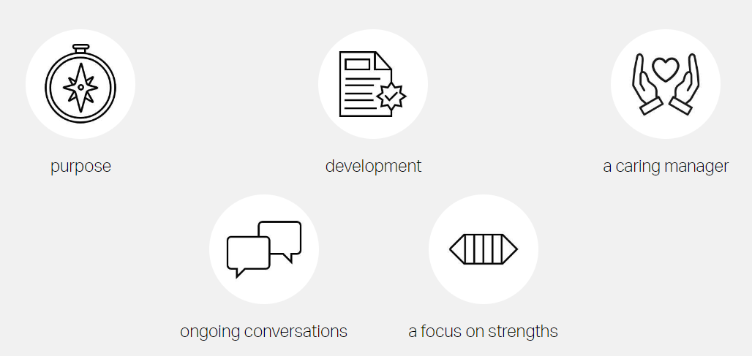
Fig. 1. Gallup (no date)
Meere (2005) identified three states of engagement; engaged; not engaged; and disengaged (Antony, 2018). The key difference between employees who are not engaged compared to engaged is the potential for the disengaged to negatively impact the work of their engaged colleagues. Meere went on to establish that engagement levels could be improved through effective human resources policies and practices, enabling performance and providing opportunities for development. It will be useful to compare these drivers to the needs of bank staff when reviewing previous research and conducting primary research.
2.2.1 Leadership and management impact
Most researchers agree that one of the main factors influencing levels of employee engagement is leadership. It is suggested by Smith et al (2016) that organisations will fail to achieve high levels of employee engagement if managers are unable to “facilitate and understand the nature of each employee’s psychological contract” (Sharafizad et al, 2019). Separate to a legal contract, CIPD (2023d) describe the psychological contract as how employers and workers “understand their relationship, their own views of commitment and what they can expect to receive in return”. Specific to the health care profession, Hayre-Kwan et al (2021) found that visibility of leaders on the frontline is important to boost confidence and trust in management, which in turn can positively impact employee engagement levels. Barker and Ford (2018) support this by stating “strategies for staff engagement are meaningless unless they are grounded in real practices on the ground”, therefore, transparency from leadership and management is key to achieving an engaged workforce.
NHS Wales has recently introduced a management guide to ‘Engaging your staff’ (HEIW, no date). The resource is intended as a ‘click and go’ to enable managers to access relevant information efficiently. It is unclear how often this is utilised and whether it has been effective in terms of engagement levels. It is essential to measure the impact of learning resources following implementation to justify the cost/benefit ratio. Measurement or evaluation can establish whether knowledge and skills have been improved (CIPD, 2023e). Mermon et al (2021) found training satisfaction to have a significant positive effect on engagement levels. There is no specific reference to permanent and temporary employees within the guide which could be detrimental due the potential of their differing needs. This will be explored in more detail throughout the discussion of motivational factors identified through both primary and secondary research.
2.2.2 Employee Engagement and Patient Satisfaction
A research study completed by Aston University focusing on engagement levels in the NHS found a positive correlation between levels of employee engagement and patient satisfaction (Bridger, 2018). West (2018) supports this by concluding factors including leadership, teamworking, working relationships, workload, change management and trust can all impact engagement levels. In turn, high levels of engagement will positively impact patient care. Clear links have also been identified between supportive line management and patient care (Bridger, 2018). Linking this to temporary staff, research has found that within the public sector, use of temporary staff can negatively impact the quality and effectiveness of services provided (Jung et al, 2018). This is less likely to be the case with bank staff than with agency staff as bank staff have to keep up to date with NHS training standards. Quality of work can be closely linked to job satisfaction which, as previously mentioned, is often considered an important factor in terms of employee engagement. Yalabik et al (2017) found job satisfaction to be an important factor in all aspects of engagement. It is, however, possible for an employee to be satisfied with their job without being fully engaged with the organisation. This is unlikely to be the case for NHS bank staff following research conducted into reasons for working for the bank. Culture and being aligned to the employer brand were identified as key drivers (NHS Professionals, 2023a).
2.2.3 Measuring employee engagement
When exploring employee engagement, it is essential to consider how engagement can be measured. Measuring employee engagement can help drive positive outcomes for an organisation (Craig, 2018). One of the key methods recommended for measuring engagement is the use of staff surveys. NHS Wales utilise annual surveys to assess and compare engagement levels across the different health boards. Gallup supports the value staff surveys can add and developed the Q12 employee survey. This focusses on four categories: basic needs, management support, teamwork, and growth (Bridger, 2018). The results are stored in a database making it a useful benchmarking tool for organisations. Although surveys can be an insightful tool, Gallup’s methods have been criticised by researcher, Peter Hutton, for being too basic due to using a Likert scale measurement (Crush, 2009). Other potential problems have been identified by Cappelli and Lendor (2019) who highlighted that 30% of employees do not see the benefit of surveys and 70% of employees do not respond.
Interviews or focus groups with employees give a greater perception of being heard and allow an organisation to delve deeper into thought processes and perceptions (Cleave, 2023). The use of surveys in giving employee’s a voice will be explored further when reviewing secondary data from the NHS Wales Staff Survey results.
  - Employee commitment and motivation
It is possible for employees to be engaged in their work but not committed to their organisation. According to Meyer et al (1991), commitment can be broken down into a three-component framework: affective, continuance and normative. Affective commitment is linked to an employee’s emotional attachment to an organisation. Employees who are affectively committed will continue with their employment because they want to. Continuance commitment is linked to an employee’s perceived risk of costs should they leave an organisation; therefore, they need to continue with their employment. Normative commitment is in reference to those employees who feel a sense of duty to continue with their employment.
It is likely commitment levels will differ between temporary and permanent employees. Kildron (2018) explored this in relation to affective commitment. Social exchange theory (Blau, 1964) was used to analyse the difference in relationships formed. Two social exchange relationships were identified: an employee’s relationship with their supervisor and an employee’s relationship with the organisation. Findings confirmed relationships between empowerment and commitment were similar for both temporary and permanent employees, but differing treatment negatively impacts how an organisation is perceived. They concluded motivating temporary employees to work towards organisational purpose is crucial. This conclusion was also supported by Cicellin et al (2022) who found that temporary workers are likely to engage in in their job and develop organisational commitment when considered a fundamental part of a social exchange. This is certainly the case for bank staff who are heavily relied upon in terms of staffing in SBUHB.
Determining how best to motivate employees can prove difficult as it is not a one size fits all approach (Wlodarczyk, 2011). Maslow’s hierarchy of needs focusses on the theory that human motivation centres around five basic needs: self-actualisation, self-esteem, love and belonging, safety and security and physiological needs (Maslow, 2013). According to Jerome (2013), these needs can be aligned with HR strategies such as performance evaluations, benefits, job design and cultural development (Simply Psychology, 2024). When considering the basic needs, love and belonging, safety and security, these may be lacking amongst temporary employees. Jung et al (2018) examined this in relation to relative deprivation theory and found that differences in working conditions between temporary and permanent employees are likely to be exacerbated over time due to the job security held by permanent employees. However, permanent job vacancies within the NHS are readily available and in recent years a record number of permanent nurses have resigned (BBC, 2022). If temporary NHS employees were motivated by permanent employment, they have an array of opportunities available to them.
People Management (2023) found that the lack of financial security provided by temporary employment can be disconcerting for many. This is not necessarily the case for members of the NHS bank due to the range of shifts available and the flexibility the bank offers. One key difference is the lack of long-term benefits such as sick pay. Members of the NHS bank accrue annual leave (NHS Professionals, no date - b) and are part of the NHS pension scheme. These are substantial benefits of working to the bank compared to an agency, providing stability as well as flexibility.
  - Employee Voice
The CIPD Good Work Index (2023a) highlights employee voice as one of the key elements of ‘good work’. This is also supported by MacLeod (2009) as employee voice was considered a key enabler of employee engagement. CIPD (2023c) include consulting employees as an important factor for both employee engagement and retention.
CIPD (2019) found one to one meetings with a manager to be the most common voice channel, followed by team meetings and employee surveys. This further supports the notion that leaders and line managers have a vital role to play in employee voice, which in turn will improve employee engagement by motivating staff (Vanderheyden, 2021). Active listening by management is essential for employees to have a true voice. It can create a sense of psychological safety, by allowing staff to express their true selves they can feel respected and valued (Zhu et al, 2022).
    - Employee Voice in SBUHB
SBUHB (2023) have recently introduced a new benefits strategy aiming to improve motivation of their bank staff specifically. This was implemented in response to employee feedback. The Wagestream app enables employees to withdraw wages immediately after a shift has been completed allowing for increased flexibility and a financial boost. This can be seen as an example of applying social exchange theory as bank staff are more likely to feel valued and supported for their efforts.
SBUHB conduct regular staff surveys but there is no obvious distinction between bank and substantive staff in the results. It is possible that temporary employees are less likely to engage in survey completion due to an assumption that their opinions are not considered as a separate entity. Lack of employee voice can negatively impact levels of engagement amongst employees in terms of wellbeing, commitment and innovation (CIPD, no date). This has been explored as part of the primary research completed to establish whether members of SBUHB bank feel like they have a voice.
2.5 Reasons for joining the NHS bank
NHS research into reasons for working for the bank found that a majority were “settling into their chosen career”, closely followed by “preparing for retirement” (NHS Professionals, 2023a).
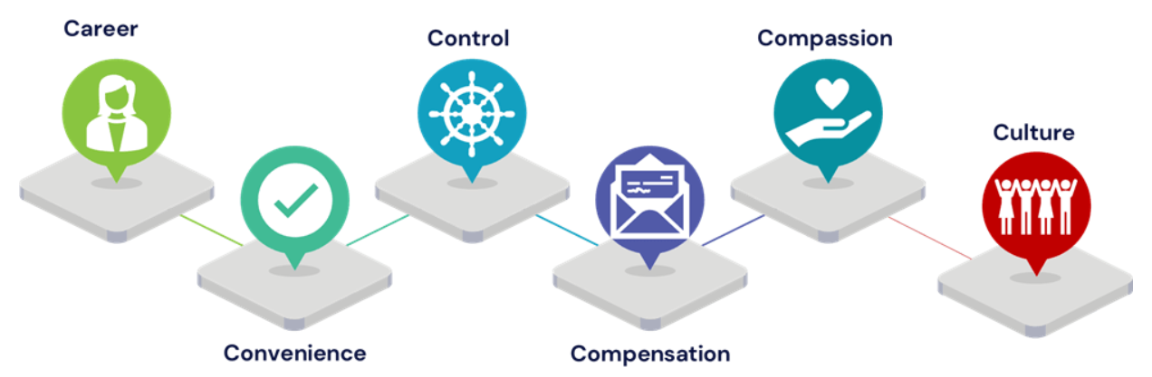
Fig. 2. 6 key drivers of NHS bank staff (NHS Professionals, 2023a)
There are likely to be varying motivations across these groups, but reasons often run deeper than pay and flexibility alone. NHS Professionals (2023a) confirmed the added benefits include “providing value without any sense of obligation”, “focusing on what attracted them to healthcare’” and “choosing where they enjoy working”. These benefits are likely to impact both wellbeing and performance positively.
When considering the key drivers of NHS bank staff alongside some of the key drivers of employee engagement there are clear similarities. Aon Hewitt (2013) identified six drivers of engagement; quality of life, work, people, opportunities, total rewards and company practices (Antony, 2018). Their definition of work included autonomy, empowerment and work tasks which can be obtained by working for the bank by having control over when and where you work. The results of a Bank Only Survey in 2022 confirmed the majority of nurses and midwives regularly worked in the same department (NHS Professionals, 2023a) which could suggest they choose work environments they are more comfortable and familiar with. Interestingly, previous research by De Cuyper and De Witte (2006) found that temporary staff could feel they have less autonomy compared to substantive staff due to a perceived lack of entitlement. This does not appear to be the case based on more recent research into the perceptions of bank staff but is an important theme to explore as part of the primary research completed.
2.6 Employee retention
Employee retention relates to the number of staff organisations retain and rates can vary considerably between occupations and industries (CIPD, 2023c). According to Kundu and Kusum (2017) employees can be retained through reward, recognition and respect. This differs somewhat to the engagement theories discussed so far, however, some of the key drivers of engagement identified could be included under the umbrella of these ‘3 R’s’. For example, respect could incorporate communication and employee voice.

NHS survey results indicate that lower than average engagement rates, lead to lower than average retention (Weeks, 2023). Retention of experienced staff in particular is imperative to maintaining the required levels of patient care (NHS Employers, 2024b). The CIPD Good Work Index (2023a) found that 18% of respondents surveyed stated they were likely to quit their job over the next 12 months. One of the important reasons given for this was “discontent with the leadership of senior management” (21%). According to the MacLeod Report (2009) one of the four key enablers of engagement is motivational leadership. CIPD (2023c) highlight poor line management relationships as a key factor when employees consider whether to leave an organisation. These findings confirm the connection between employee engagement and retention. Effective line management can help to retain staff by enabling them to feel valued and supported. Research completed into the link between employee engagement and employee turnover by Smith and Macko (2014) also identified a correlation between low employee engagement and high turnover. The main factor found to be causing low engagement levels was lack of communication or compassion from management.

2.6.1 Retaining temporary employees

A main driver in retaining temporary employees is competitive pay (Indeed Flex, 2022). Through Indeed’s study of temporary employees in 2022, pay was found to be the top priority. This is one of the main challenges for SBUHB. In recent years the priority has been to incentivise bank shifts but this has not always been apparent or achievable. In March 2023 bank nurses in Wales were initially excluded from receiving an isolated payment following NHW employee pay negotiations (RCNI, 2023). This may have had a negative impact on bank staff feeling valued due to the clear difference in treatment.

2.6.2 Impact of wellbeing on retention
Employee wellbeing is also an important factor in relation to retaining employees (CIPD, 2023c). The Boorman review (2009) found that the NHS needs to improve efforts to support employee wellbeing to ensure they can provide relevant care to their patients. An important link between wellbeing and service delivery was identified along with the need to engage all levels of employee, adequate resourcing, keeping health and wellbeing at the forefront and measuring success of these programs effectively (Tinline & Crowe, 2010). Daniels et al (2022) found that poor wellbeing costs the NHS £12.1 billion a year and 47% of staff have reported experiencing ill health due to work related stress. There is no distinction between bank staff and substantive staff in these figures so it could be an important consideration for future research. Bank staff could be less likely to experience this stress due to the control they have over their work. Working for the bank can satisfy people’s wellbeing needs in relation to the autonomy they have to create their own positive work experiences (NHS Professionals, 2023a).
Further research has been completed in the area of wellbeing following the Covid-19 pandemic due to the damaging impact this had on the wellbeing of healthcare workers (Powell et al, 2024). Clarissa, Quin & Stenhouse (2021) found that barriers to accessing wellbeing services included high workload and low staffing levels. In turn these barriers are likely to exacerbate wellbeing problems. One NHS trust who completed a successful initiative to reduce agency spend incorporated wellbeing into their strategy, with flexibility and safe staffing levels at the forefront of their approach.
Flexibility within the workplace can influence both the decision to join an organisation and the decision to stay (Richman et al, 2008) and is therefore an important factor to be considered when aiming to attract or retain employees. Flexibility can mean different things to different people. CIPD (2018) defined it as “working arrangements which allow employees to vary the amount, timing, or location of their work, usually to the mutual benefit of the individual and the organisation”. More recently, following the COVID-19 pandemic, research has found that flexible working has had a mixed impact on wellbeing due to more stress being experienced working remotely (Brecheisen, 2023). This is unlikely to be the case for SBUHB bank staff, as a majority of the roles are still in person, however, following the increase of online appointments and services across the NHS, this is a concern to be mindful of (Nuffield Trust, 2020).
Caring for nurses in particular following the pandemic has required the NHS to review how their needs can be met in relation to basic needs, specifically in relation to wellbeing (Hayre-Kwan, 2021). Phung et al (2022) conducted a study around perceptions of wellbeing among frontline NHS staff and found that the reality of support provided did not always meet the needs. The support required involved empathy, understanding and practical help. It was concluded that improved training for managers and readily available wellbeing services for staff would help towards providing the support required. This links to discussions earlier in this chapter, putting management at the forefront of driving initiatives such as these.
2.7 Importance of bank staff
As outlined in the chapter one, Nursing Management (2013) observed that bank staff provide better continuous care than agency staff. Bank staff are relied upon in terms of workforce planning and ensuring staffing levels are met to provide patients with the best possible care in accordance with the Nurse Staffing Levels (Wales) Act 2016. This was the case as far back as 2001 with Scott confirming the importance of valuing bank and agency staff due to the value of their contribution; specifically in relation to covering staffing shortfalls caused by sickness, holidays and changes in workload.
NHS annual UK spend on agency and bank staff has risen to 10.4 billion (O’Dowd, 2024). Despite this, over the past 12 months, successful strategies have been implemented by individual trusts, namely, the Southern Health NHS Foundation Trust. The Trust increased bank hours and reduced agency costs by migrating agency workers to bank (NHS Professionals, 2023c). They achieved this by increasing communication with key stakeholders, increasing controls on agency suppliers and prioritising bank staff to fill shifts over agency. The Trust also met with agency workers to encourage them to migrate to the bank, providing continued support during the transition, and delivered bespoke training to employees supporting them. The success of this approach has supported the notion that communication and wellbeing support are key motivators for individuals working as part of the bank.
Previous research exploring the value and effectiveness of temporary staffing in the NHS highlighted the benefits of bank staff over agency as improved quality of services and a reduction in spend by the trust (Esain and Massey, 2006). Waters (2022) found one trust had paid £2548.69 for a single agency nurse for one shift which is unsustainable. Waters also identified a variation across trusts from 1%-11% of staff budget being spent on agency staff. Esain and Massey (2006) made recommendations for neighbouring trusts to create a joint bank to increase the likelihood for adequate shift cover.
2.8 Conclusion
There are multiple definitions of employee engagement and a range of factors that can influence. Literature also supports the link between engagement levels, commitment and retention.
One of the consistent factors throughout of theories of engagement is management input. The concept that management having a substantial influence on engagement is supported by Macleod (2009), Gallup also highlighted caring managers as being a key factor. Managers have also been said to need to be able to facilitate and understand the needs of employees whilst having clear visibility (Hayre-Kwan, 2021).
Other key factors identified include feeling valued or sense of belonging, employee voice and autonomy. Autonomy has been determined as a driver of engagement in general but also specifically for bank staff.
Some recent case studies provide useful insight into the potential for agency staff to be motivated to work for the bank as an alternative (NHS Professionals, 2023c). Despite these insightful findings, research into the perceptions of bank staff within the NHS is limited. Numerous research studies have been completed into the NHS in general but other than a recent study by NHS Professionals (2023a), most other research does not distinguish between temporary and permanent employees.

3.0 Methodology
3.1 Introduction

There are many definitions of research. Although the specific reasons for conducting research will vary, most researchers will follow a process of inquiry and investigation, which is both systematic and methodical, with the aim of increasing knowledge of the chosen topic or area (Collis and Hussey, 2014: 2).

Both primary and secondary research has been completed to establish drivers of engagement among NHS bank staff. Taking a specific, scientific approach to research will help to overcome difficulties associated with understanding the complexities of human behaviour (Weathington, Cunningham and Pittenger, 2012).

McNeill & Chapman (2005) identified three important concepts: reliability; validity; and representativeness. These will be discussed in further detail throughout this chapter.

3.2 Research objectives
The overall purpose of this research study is to identify factors impacting the engagement of bank staff. Both secondary and primary research have been incorporated to ensure the following objectives are met:
- To review existing secondary data from within SBUHB, including staff survey results, retention rates and leaver feedback.
- To conduct qualitative research through interviews with SBUHB staff to establish views on how to improve and sustain levels of engagement and critically evaluate research findings.
3.3 Research design

Bell, Bryman and Harley (2019) define research as providing a framework for the collection and analysis of data. In the initial stages of research design, Saunders’ research onion can be used “to depict the issues underlying the choice of data collection techniques and analysis procedures” (Saunders et al. 2016: 122).
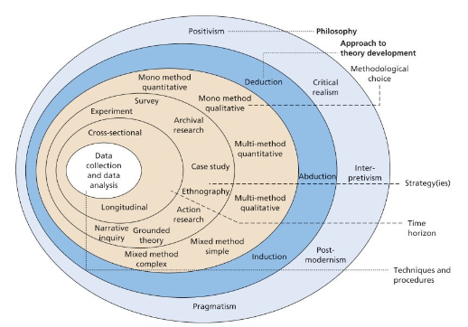

Fig. 3. ‘The research onion’ (Saunders et al, 2016: 124)

Each layer is equally important but prior to completing any research it is essential to identify the relevant philosophy as it reflects core values that could impact elements of the research process. A research paradigm has been defined by Collis and Hussey (2014: 10) as “a framework that guides how research should be conducted; it is based on people’s philosophies and assumptions about the world and the nature of knowledge”.

3.3.1 Research approach

The pragmatism paradigm has been selected for this research as there is a business problem and the aims of the research will contribute to practical solutions that inform future practice (Saunders et al., 2016: 143).

Saunders’ Research Onion should be considered with ontology, epistemology and axiology in mind. Ontology refers to what we know about the world or “theorizing about the nature of reality” according to Bell, Bryman & Harely (2015: 26). Epistemology asks how we know what we know, exploring the theory of knowledge. Axiology relates to the values and ethics of the researcher and how these may impact the findings. A subjective, interpretivist approach has been taken in this instance to explore individual experiences and personal interpretation.

3.3.1.1 Inductive reasoning

It has been imperative to determine whether an approach to research will be inductive or deductive. An inductive approach involves the data collected leading the themes identified whilst a deductive approach involves expected theme prior to reviewing the data collected (Caulfield, 2022). An inductive approach is likely to involve deduction and vice versa (Bell, Bryman & Harley, 2019). The strategy for this research is primarily inductive as the aim of qualitative research is to generate theories for recommendations for SBUHB. However, theory has also been used as the background to the research in formulating a research design.

Research has been exploratory as it has sought to better understand the initial research problem. Results will not be conclusive but will provide guidance and recommendations.

3.3.2 Data Collection

Both secondary and primary data has been collected and analysed. Collis and Hussey (2014: 59) confirmed the following definitions:

- “Secondary data - collected from an existing source, such as publications, databases and internal records.
- Primary data - generated from an original source, such as your own experiments, surveys, interviews or focus groups.”

3.3.2.1 Secondary data

Secondary data has been accessed from within SBUHB to establish any trends and themes that could be explored further through the completion of primary research. Advantages of utilising secondary data can include time efficiencies, good quality of data and the potential for longitudinal analysis (Clark, T. et al, 2021: 295). Data obtained for the purposes of this research includes staff survey results, management training initiatives, attrition rates and leave reasons. Detailed analysis of this data has assisted in identifying any gaps in employee engagement among bank staff. The specifics of the primary research were designed following this.

3.3.2.2 Primary data

When collecting primary data, researchers have the choice of either qualitative or quantitative data. The difference between them can be noted as qualitative use words as opposed to quantitative data using numbers (Creswell, 2014). Researchers also have the option of a mixed methods approach which is a combination of both. According to Clark et al (2021) qualitative and quantitative within the same research can compliment each other to add value to a study. Arguments against using mixed methods approach relate to qualitative and quantitative research being separate paradigms, blurring the lines of the research philosophy (Bell, Bryman and Harley, 2019).

In this case, primary data has been collected through qualitative research to gain insight and understanding of specific views regarding the bank service. Qualitative research can be useful when attempting to understand individual’s feelings towards a problem (Creswell, 2014).

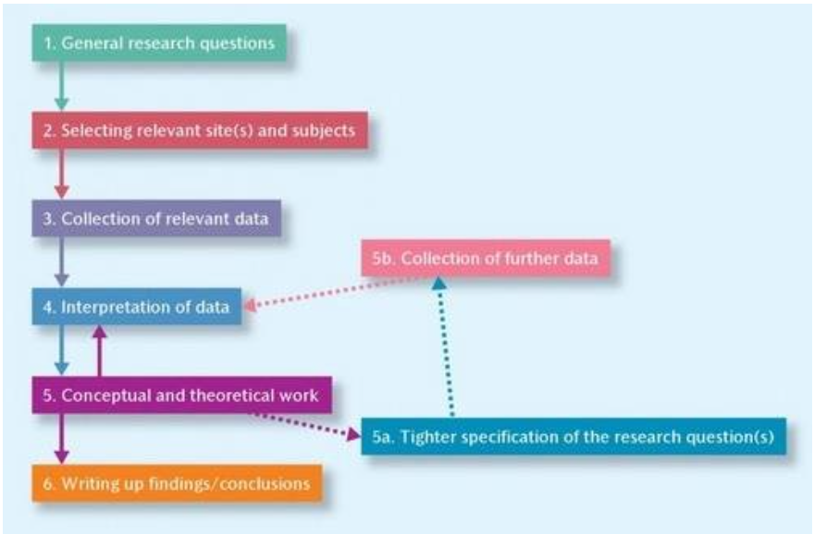

Fig. 4. Bryman and Bell (2015) – The main steps of qualitative research (Sewpersadh, 2016)

Walliman (2006) supports that qualitative research is commonly used whenever people are involved. It allows for in depth data to be obtained and for the researcher to probe. Within this study it has helped to establish a full understanding of the true feelings of employees within the NHS bank. Interviews were conducted with current members of the SBUHB NHS bank to establish their opinions and experiences.

There are three different types of research interview: structured, semi-structured and unstructured (Gill et al, 2008). Semi-structured interviews involve specific question but the interviewer has the ability to probe where necessary. They can be beneficial as they provide a guided format whilst allowing flexibility (Hammond & Wellington, 2012: 110). This is supported by Bell et al (2019: 11) who confirm researchers can keep an open mind allowing concepts and theories to develop from the data collected. They enable the interviewer to explore the thoughts and feelings regarding the research question, gaining insight into what the participant perceives as important (Clark et al., 2021: 425).

3.3.2.3 Research participants

Semi structured interviews were completed with 6 members of staff from the SBUHB bank. 6 to 8 interviews allow for a sufficient homogeneous sample (Guest, Bunce and Johnson, 2006) and ensure a rounded view until reaching saturation.

The roles of the participants were as follows:

Participant A - Workforce planning – 30 years plus service
Participant B - Heath Care Support Worker– 3 years service
Participant C - Health Care Support Worker – 5 months service
Participant D - Health Care Support Worker – 4 months service
Participant E - Health Care Support Worker – 2 years service
Participant F - Mental Health Nurse – 20 years plus

It was imperative to interview members of bank staff with a variety of experience to collate a wide range of perspectives. This has allowed for well-informed research.

Interview questions were piloted with the first participant and adjusted slightly to ensure all relevant topics were discussed. Interviews are more than just a conversation and require the interviewer to have considerable knowledge and skill to be effective (Frances, Coughlan & Cronin, 2009).

Key drivers of engagement identified through the literature review formed the basis of the semi structured interviews. They were categorised as follows:
- Management support
- Feeling valued and sense of belonging
- Employee voice
- Autonomy

Participants were given the option of completing the interview remotely via Microsoft Teams video call or in person. All participants chose to meet remotely. Salom (2023) highlighted that remote research can indeed be quicker than in person, however, in person research can help a researcher identify more context and there is less risk of digital skills negatively impacting the situation. 1 of the 6 participants experienced technical difficulties meaning the interview was conducted over the phone with no video.

3.4 Data analysis

The analytical stage of primary research is crucial in identifying key findings. Following completion of the semi-structured interviews, thematic analysis has been completed to gain a broad understanding of data in response to the research questions (Lester et al, 2020).

3.4.1 Thematic analysis

Thematic analysis is a qualitative research method defined by Brown and Clarke (2006) as “a method for identifying, analysing, organising, describing and reporting themes found within a data set” (Nowell et al, 2017). This approach allows for flexibility, is not attached to a specific research philosophy and is beneficial when reviewing human emotions (Saunders, Lewis & Thornhill, 2016). A theme can be referred to as a topic relevant to the piece of research, identified by the researcher (Clarke et al., 2021). Within this research, themes have been established from codes identified from the interview transcripts.

Bazeley (2013) criticised researchers who have used thematic analysis for being vague about how they established their themes (Clarke et al., 2021: 539). It is imperative for researchers to ensure themes have been identified on a deeper level.

3.4.1.1 Semantic approach

Researchers have the option of a semantic or latent approach to analysis. For the purpose of this primary research a semantic approach has been taken. A semantic approach involves evaluating the specific data content and research participants stated opinions (Caulfield, 2022). This differs from a latent approach which involves examining what statements made by participants reveal about their underlying assumptions.

3.5 Validity and reliability of research
Consideration must be given to the validity and reliability of chosen research methods. Lincoln and Guba (1985) proposed researchers should consider trustworthiness as a measure of the quality of a study with the following criteria in mind:

Credibility – How believable are the findings?
Transferability – Do the findings apply to other contexts?
Dependability – Are the findings likely to apply at other times?
Confirmability – Has the investigator allowed their values to intrude to a high degree?

(Clark et al, 2021: 42)

Klenke (2016: 37) stated “identical repetition of an interview is rather a sign of a constructed version than of the reliability” but also noted that arguments have been made that “the scope of qualitative methodologies is too broad to be represented by a single set of criteria”. The very nature of qualitative research is subjective when you are dealing with specific thoughts and opinions of individuals. Qualitative methods can be criticised for creating biased results (Mackieson, Shlonsky & Connolly, 2018). Bias within research alludes to any influence that could lead to a misrepresentation of results (Galdas, 2017).

For research to be valid, it needs to be reliable. When the chosen method involves a lone researcher, there is always a risk of reliability being called into question (McNeill & Chapman, 2005: 9). To overcome this risk, interviews were recorded and transcribed.
3.6 Ethical considerations and limitations
Everitt and Fursett (2013: 10) confirm “the research process must demonstrate respect for individual liberty and autonomy” and consent must be gained from the people involved prior to starting data collection.

3.6.1 Ethical approval

The relevant ethics form has been completed within the university with the agreement of SBUHB (Appendix C).

Considerations have been made in relation to the following:

- Confidentiality and anonymity – Participants details have been redacted, and interview notes have been saved anonymously.
- Consent – Participants have been informed that attendance at the interviews is voluntary and clear consent has been gained (Appendix D).
- Time - SBUHB have been consulted to ensure time allocated to interviews was reasonable and will not impact patient care.

Potential risks were considered, and this research has been deemed low risk. The interviews were conducted sensitively to ensure participants are not put under pressure to answer. A professional approach has been taken as a representative of the university to uphold their reputation. All transcripts have been kept confidential but there was a risk of SBUHB being able to identify the participants if they were involved in arranging the interviews. If anonymity is promised to participants, relevant measures should be in place to ensure this is the case (Clark et al, 2021). To ensure anonymity, it was agreed that an email would be sent from a manager within SBUHB to all bank staff explaining the purpose of the research (Appendix E). The researcher’s direct contact details were included to avoid participants having to go through SBUHB to arrange interview attendance.

External factors impacting engagement levels have been taken into consideration at the time of completing the interviews. For example, Cardiff and Vale University Health Board has recently declared the highest-level alert due to winter pressures and Swansea Bay Health Board has confirmed their largest hospital is under extreme pressure with high volumes of patients (BBC News, 2023). These seasonal pressures may negatively impact engagement levels due to high workload. CIPD (2021) confirm to be engaged “employees must not feel overwhelmed by the demands of their job”. However, with the right support engagement levels could thrive through times of increased workload. It is essential to determine factors that can improve engagement at these peak times to ensure patient care remains at required standards.

3.6.2 Limitations

Limitations have been encountered in terms of access to SBUHB data when analysing secondary data. Some internal data is not currently separated between permanent and temporary staff which has made it difficult to analyse in terms of this research topic. This has resulted in a recommendation relating to internal data collection within SBUHB in the future.

When collecting primary data some limitations were encountered in terms of bank staff availability. This was an anticipated limitation due to the flexible nature of working for the bank and required flexibility from the researcher.

3.7 Conclusion

This chapter has discussed the specific research methods considered and utilised. The decision to conduct qualitative research in the form of semi-structured interviews was derived from thorough analysis of methods and consideration of relevant research philosophy. Inductive research has developed from a subjective, interpretivist approach and provided the researcher with a suitable range of qualitative data. Thematic analysis has been completed, the findings of which will be discussed within the next chapter.

4.0 Data Analysis and Discussion
4.1 Introduction
This chapter summarises the primary and secondary data gathered through both description and analysis. The data is intended to answer the overarching research question:
How can engagement levels of bank staff within SBUHB be improved to help create a service fit for purpose and positively impact retention rates?

The following sub questions will be considered:
- What are the views of bank staff within SBUHB with specific reference factors impacting levels of engagement?
- How does existing secondary data from within SBUHB inform the researcher regarding engagement levels and attrition of bank staff.
Primary research will be explored initially due to the importance of the data collected.
4.2 Primary Data
Chapter two identified the key drivers of employee engagement as management support, feeling valued or sense of belonging, employee voice and autonomy. The primary research focussed on these areas (Appendix F).

4.2.1 Participant information
Thematic analysis was completed following the completion of semi-structured interviews with 6 members of SBUHB bank staff. Each of the key themes have been identified by looking for repetition, similarities and theory related material (Bell, Bryman and Harley, 2019). Open questions were utilised to avoid participants being led to a specific answer, allowing them to answer in their own terms (Clark et al, 2021).

One participant had worked for SBUHB for 30 years plus prior to joining the bank. Two participants work for the bank whilst employed in a substantive post with SBUHB.

4.2.2 Management support
Due to the pivotal role managers play in engagement levels of staff (Waite et al, 2021: 136) participants were asked: How would you describe support from management? There was an overwhelmingly positive response to this question. All participants confirmed they feel supported by management with some specific examples provided as follows:
Participant A: The managers are absolutely fantastic.
Participant B: The managers are good. So far, I don't have any issues. I'll go and do my job, I learn if I don't know, I'll ask them. They love to teach me back.
Participant D: My manager really motivates me. She gives me the platform, says “I believe in you, I know you can do it, but if you need an anything from me, just call on me.”
Participant D’s statement highlights the empowerment given by their manager and a sense of autonomy felt by the participant. Autonomy encourages self-determination which can lead to engagement at work (Reisinger and Fetterer, 2021). Phelps (2019) supports this and found that freedom and control will improve both employee engagement and productivity. In some circumstances clear direction is imperative for decision making (Brearley, 2020) but the bank staff interviewed feel they have a good balance of both. Participant B’s statement demonstrates that they receive guidance from management as and when required.
4.2.3 Flexibility
Participants were asked to explain their decision for joining the bank. Flexibility was identified as one of the main drivers and benefits of working for the bank with 6 out of 6 respondents confirming this as the main reason. Some of the specific comments are as follows:
Participant A: It just gave me that peace of mind that if I had to and circumstances changed with my family or myself or anything I had that flexibility to say I'm sorry everybody, I'm going to have to withdraw.
Participant F: Can work whenever I want to, flexible, easy to use the app or book directly though the app.
As outlined in Chapter 2, flexibility is a key driver of employee engagement. It has been linked to positive outcomes for both employees and an organisation (Richman et al, 2008). Both SBUHB and their bank staff mutually benefit from the flexibility that they offer each other.
4.2.4 Control
Participants were asked what they see as the key benefits of working for bank. As well as flexibility, control was also mentioned on several occasions, specifically in comparison to working for agency. 3 of the 6 participants have previously worked for agency and felt that the higher pay did not make up for the lack of control they had. Specific comments are as follows:
Participant E: More control over where I go in bank, but in agencies just different places, they can be far or near.
Participant D: You can pick the shift at your own convenience. It is preferable to work with the trust than with the agency, just that the money for the agency is more.
Participant F: Joined the bank as can work whenever you want to, choose where to go.
The feeling of control is also linked to staff development, wanting to provide the best patient care possible by getting to know patients and developing knowledge. This was highlighted by a member of substantive staff who joined the bank to improve their relationships with their patients and increase exposure. Control over working environment can also satisfy wellbeing needs of bank staff (NHS Professionals, 2023a).
4.2.5 Belonging
Participants were asked specifically if they feel part of the NHS team, and why. All answered yes with specific reasons as follows:
Participant B: Yeah (feel part of NHS team) they support me.
Participant E: We work as a team. We just work together.
Participant D: The management is being, oh, I call it what we what we also say like.
Oh, respect people's view and and give accordingly. Or treat each every member of the staff equally well. We got equality.
For one participant, being supported as part of the NHS team was considered a driver for working as part of the bank over agency:
Participant D: I’m loyal to the nurse bank as they are very supportive of me.
Feeling part of the NHS team provides a sense of belonging which is the third level within Maslow’s Hierarchy of Need (Pichere and Cadiat, 2015). Prior to being able to achieve a sense of belonging, Maslow identified that both physiological and security needs should be met. Working as part of the bank can provide more security than agency due to pension contributions and accruing annual leave. Once these first three needs are met, healthcare staff have more chance of meeting the top of the pyramid; self-actualisation (My Locum, 2024). Self-actualisation can include seeking personal growth and realising full potential, which have been identified as reasons for working for the bank. This inclusive approach has been supported by Firth (2017) who found that applying consistency to both permanent and temporary employees will lead to strong levels of employee engagement.
4.2.6 Recruitment
Participants were not asked specifically regarding the recruitment process, but recruitment was raised by some participants as part of the discussion. Concerns were raised regarding the delays, especially if applying externally, causing barriers to people applying. Specific comments were as follows:
Participant D: It's not that easy to join the bank.
Participant F: Process of joining the bank is difficult, used to be easier just filling out the form. References, experience, training, delays in the process.
As you would expect in the public sector, there are specific processes for SBUHB to follow to ensure relevant training is provided and staff members accepted into the bank meet the required standards.
This was also raised as part of a separate point concerning ex NHS staff returning to work agency shifts. Managers need to be aware so they can manage accordingly. One participant raised that they were more comfortable working with bank staff when had a substantive contract due to knowing the internal training standards had been met.
Participant A: You would see staff that you knew from the NHS who left the NHS under difficult circumstances. I think as a manager you need to know those things and be aware of those when you're having bank staff on shift.
This links back to research conducted by Banjorek and Guest (2019) who found that substantive staff at times have increased responsibilities if having to support temporary employees. This is more likely to be the case for agency staff over bank staff due to the difference in recruitment processes and the ability to work for agencies even after leaving the NHS on potential bad terms.
4.2.7 Retirement
Participant A confirmed they would have stayed in a substantive post rather than retiring and working with the bank, had the options been discussed. They highlighted the fact that 12 members of substantive staff reached retirement age following the COVID19 pandemic, they all retired and now work as part of the bank whilst receiving their pension. This participant felt their experience could have been utilised prior to retirement to assist in training less experienced staff.
Specific comments were as follows:
Participant A: They're paying us a pension and then paying everybody wages. We all returned, and we're all working in corporate in different roles because the experiences they have to bring to it and you just feel like, something has been missed.
Flexible retirement options should be in place to ensure employees feel valued and rewarded when approaching retirement (NHS Employers, 2024b). Failure to discuss these options can result in disengagement and in this instance, has led to staff leaving their substantive roles unnecessarily. The current retirement policy for SBUHB highlights flexible retirement options but it is unclear whether this is promoted or utilised effectively.
4.2.8 Wellbeing
Participants were not asked directly about their wellbeing but responses regarding being supported by management, flexibility and control indicate that wellbeing levels are good (Brower, 2023).
One participant acknowledged the need for self-management when working for the bank to ensure you have sufficient rest periods. The Work Force Planning Team ensure the requirements of the Working Time Directive are met but it is easy for staff working purely for the bank not to take time off longer term. The following was highlighted:
Participant A: You have to be able to manage yourself, time management is important, even if you are going into a job, you need to take time and you need to say I am taking holidays because it's very easy to work each week because you're doing less hours potentially.
This adds further to the element of control temporary staff have but highlights the need for self-management to avoid burnout. Research completed by the Kings Fund found that NHS staff are 50% more likely to experience chronic stress, leading to burnout (NHS Employers, 2024). Burnout can impact both staff wellbeing and patient care meaning it is an important consideration for management in relation to all staff.
4.2.9 Employee Voice
Participants were asked if they feel they have a voice within SBUHB and to explain their answer. 6 out of 6 participants confirmed they feel they have a voice and feel able to raise concerns by speaking to a manager. This is in stark contrast to the results of the NHS Wales Survey where employee voice among SBUHB in general was found to be lacking.
Specific comments relating to employee voice are as follows:
Participant B: We can raise our voice if have any problems.
Participant F: Yes, very vocal and feel I can say something if need to, able to give opinion and help people understand the root cause of a problem.
It is reassuring that bank staff feel able to speak up if needed. Linking back to earlier discussion regarding wellbeing, employee voice can help to avoid stress and burnout, especially within the healthcare profession (Shipton et al, 2024).
4.2.10 Wagestream
As referenced in chapter 2, the Wagestream app was launched as a result of SBUHB listening to what staff want. Participants were asked about the app, 2 out of 6 participants were unaware of it or did not think it applied to them.
Those who were aware of the initiative felt mainly positively about it and felt it helps to bring the benefits of working for the bank inline with the benefits of working for an agency.
Specific comments were as follows:
Participant D: It’s good, I’ve used it once. My colleague told me about it. They advised it boosts him financially in the sense that he is able to sort some things he needs to sort out because he couldn't wait till the end of the month. To sort it out, and he does not want to take a loan or borrow money from anybody, but with the help of the Wagestream, could collect the money he needs.
Participant F: Aware of it, I went onto the app, ended up owing them money somehow, keep it on my phone to keep an eye on shifts, don’t use it to draw money.
These responses indicate that more could be done to promote awareness and understanding of the app. The launch of the app has brought the benefits of working for the bank closer to the benefits of working for an agency. Increased communication could be key to encouraging staff to stay with the bank or even lure agency staff to join the bank.
4.2.11 Reward
Participants acknowledged the fact that could earn more by working for an agency instead of bank but felt the benefits of working for the bank outweigh this. Two participants mentioned the pay they receive for their bank shifts in relation to bandings with conflicting experiences:
Participant F: Only improvement is just the banding pay, at the weekend working with someone at band 8 who has a substantive post, they will be doing the same as me and I receive a lower rate.
Participant A: When I was put on the bank because of my experience I was put on the bank in the first instance as a band 6, which I was really happy with because I just thought everybody was automatically a band 5.
I personally strongly feel, you shouldn't be paid band 6 then because you're working as a 5 because there is a substantive 6 on duty.
Perceived fairness of reward can have a significant impact on both performance and engagement (Hussain et al, 2019). To continue to engage bank staff appropriately it could be necessary to review the consistency of rates of pay. If the current application of pay grading for bank staff is deemed appropriate it will be imperative for SBUHB to ensure clear communication. The more staff understand a decision through relevant communication, the more likely they will be receptive to it and be connected to the organisation (CIPD, 2023h).
4.2.12 Retention
Participants were asked: “Why work for the bank over agency?” Responses highlighted the following:
- Lack of control when working for an agency.
- Feelings of loyalty towards the NHS.
- Quality of training and standards set for bank staff.
- The security of a pension.
Specific comments include:
Participant A: There is a control measure with nurses in the bank of levels and standards, and again I think lots of people don't realise that where with agency you ain't got that. They are our own inbred trained standards that you don't have to worry about. And then you regularly get to see them and they feel comfortable coming in. So I think it's a win win more than the agency.
Agencies just ridiculous amount of money and it's amazing what you see, what people get paid. I didn't want to be travelling here there and everywhere again. You're not guaranteed on the agency. You might have to start travelling further to get that shift.
Participant B: Yes, because it's NHS. That's the thing. Mean, that's what I don't like agency mean different companies, but this part of the NHS only the difference between like I won't get like a holidays like there get.
Participant C: When I was a support worker, I did sign up with the agency to go to different schemes and to be truthful, they just sent me to where I was already working anyway. Main benefit of bank compared to agency is getting my pension paid.
Participant D: You know once if the bank wants to encourage people to come in (from agency), yes, because number one, they see even though you work as a bank for the trust, you still get the privilege. I mean, secure job.
Yeah, you can pick the shift at your own convenience. You can decide you want to work on so, so day, and you don't want to work on so, which is always, let me say sincerely speaking is more preferable to work with the trust with that than the agency, just that the money for the agency is more, but the shifts will not be coming constantly. But once you are on the bank, you'll be able to pick.
Participant E: The agency was always posting me to different locations outside Swansea. I live in Swansea, and they post me to different locations but with bank shifts it’s just like I'm just going to work as normal. So, I think I prefer bank to agency.
Participant F: Used to work for an agency but too much travelling, even though would have been better money, loyal to nurse bank as very supportive of me.
Friends who work for agency wouldn’t be convinced to move over, they receive £50 an hour.
In summary, all participants are driven by factors other than just finances. Although finances play a part, the key motivation for working for the bank over agency appear to be linked to feeling part of the NHS team, supportive management and pension contributions. To explore this further, and to provide the best environment for bank staff, it could be imperative to establish what motivates agency staff to see what would encourage them to move to the bank (Moore, 2022).
4.3 Secondary Data
Secondary data has been acquired through the Workforce Planning Team within SBUHB. It is essential to review existing data to assist in identifying trends. Organisation data is one of the four recommended sources of evidence when making evidence-based decisions (CIPD, 2023). Data deemed to be beneficial for the purposes of answering the sub questions above include staff survey results; existing management training programmes; leave reasons and exit interview completion.

4.3.1 Staff survey results
The NHS Wales Staff Survey is run annually across all Health Boards in Wales. The purpose of the survey is “to understand their experiences, perspectives, and insights related to their work environment, job satisfaction and overall well-being” (HEIW, 2023b). The survey was open for completion for a 6-week period between 16th October 2023 and 27th November 2023. Overall response rate for Wales was 20.7%, response rate for SBUHB specifically was 18.8%. This is less than the 30% average response rate to staff surveys identified by Cappelli and Lendor (2019).
Survey results are grouped under the following headings:
  - Morale
  - Patient safety
  - Staff engagement
  - We are compassionate and inclusive
  - We recognise everyone’s contribution
  - We are all able to speak up
  - We are stronger together
  - We nurture healthy working environments
  - We champion flexible working
  - We are continuously learning and improving
For the purposes of this research, SBUHB results for the following areas will be explored in more detail: morale; staff engagement; we are able to speak up; we are compassionate and inclusive; and we champion flexible working.

4.3.1.1 Morale
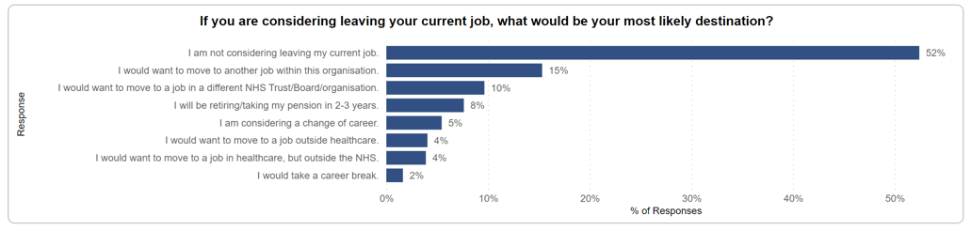
It is encouraging to see that the majority of respondents are not considering leaving their current job. A quarter of staff would want to move to a job either within the organisation or elsewhere within the NHS. Opportunities for a change of role leading to career growth can be an integral motivator and positively impact on engagement levels and affective commitment (Jia-Jun & Hua-Ming, 2022). The variation working for the bank provides, allows staff to explore alternative departments to determine where they are best suited.
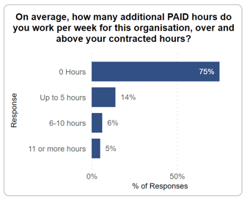
Responses to this question could lead to the assumption that a quarter of respondents work for the bank when completing their additional paid hours.

4.3.1.2 Staff engagement
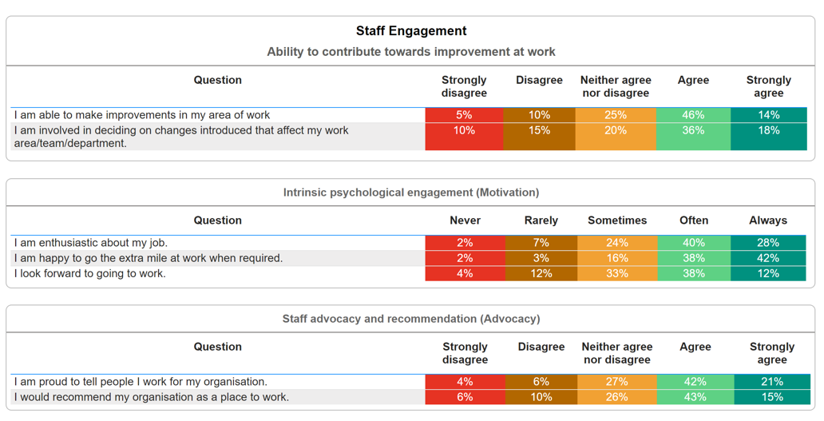
Over half of respondents felt involved in decision making processes that affect their work. A quarter of respondents do not feel involved which leads to concerns regarding their lack of employee voice.
95% of respondents were happy to go the extra mile at least sometimes which is a positive in terms of patient care. Support staff that go the extra mile can encourage a positive attitude among patients which in turn promotes recovery (Read, 2017).
4.3.1.3 We are able to speak up
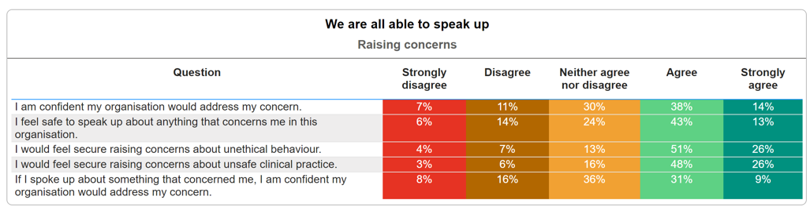
These results show employee voice in a slightly more positive light than the previous question regarding input in decision making, however, there are some concerns highlighted. Almost a quarter of respondents disagree that action would be taken to address concerns raised and a third neither agreed or disagreed. A best practice approach should involve a standalone ‘speak up’ policy supported by leaders and line managers (CIPD, 2024b). This should be promoted among staff to encourage suggestions for improvement and to raise concerns.
4.3.1.4 We are compassionate and inclusive
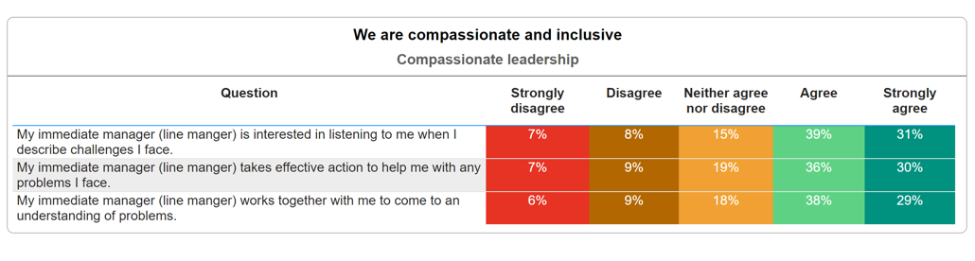
Bailey and West (2022) state that compassionate leadership can help staff to become more engaged and motivated, leading to better patient care. They describe compassionate leadership as focussing on relationships through listening, understanding, displaying empathy, being supportive, enabling staff to feel valued, respected and cared for. These results do raise some concerns regarding how effective managers are at displaying these qualities to assist their staff day to day as only two thirds of respondents agreed that their immediate manage is interested in listening to them when described challenges they face. This differs considerably to the findings from the primary research completed with bank staff.

4.3.1.5 We champion flexible working
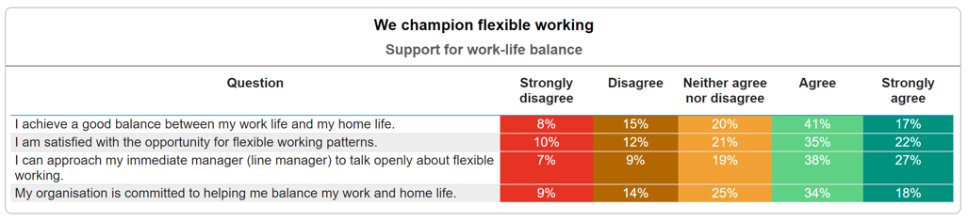
Over half of respondents feel positively about flexible working with roughly a fifth of respondents not feeling strongly either way. Almost a quarter of respondents do not feel they have a good work life balance and similar numbers do not feel the organisation is committed to helping to balance their work and home life. Workforce planning within the NHS in general can be extremely challenging due to patient care requirements in accordance with the Nurse Staffing Levels (Wales) Act 2016.
Lacobucci (2023) acknowledged that an intolerance to flexible working within the NHS is having a damaging effect on overall retention. Often, insufficient information is provided in terms of what they can request or may be entitled to which could have led to 16% of respondents not feeling like they can approach their immediate manage to talk openly about flexible working.

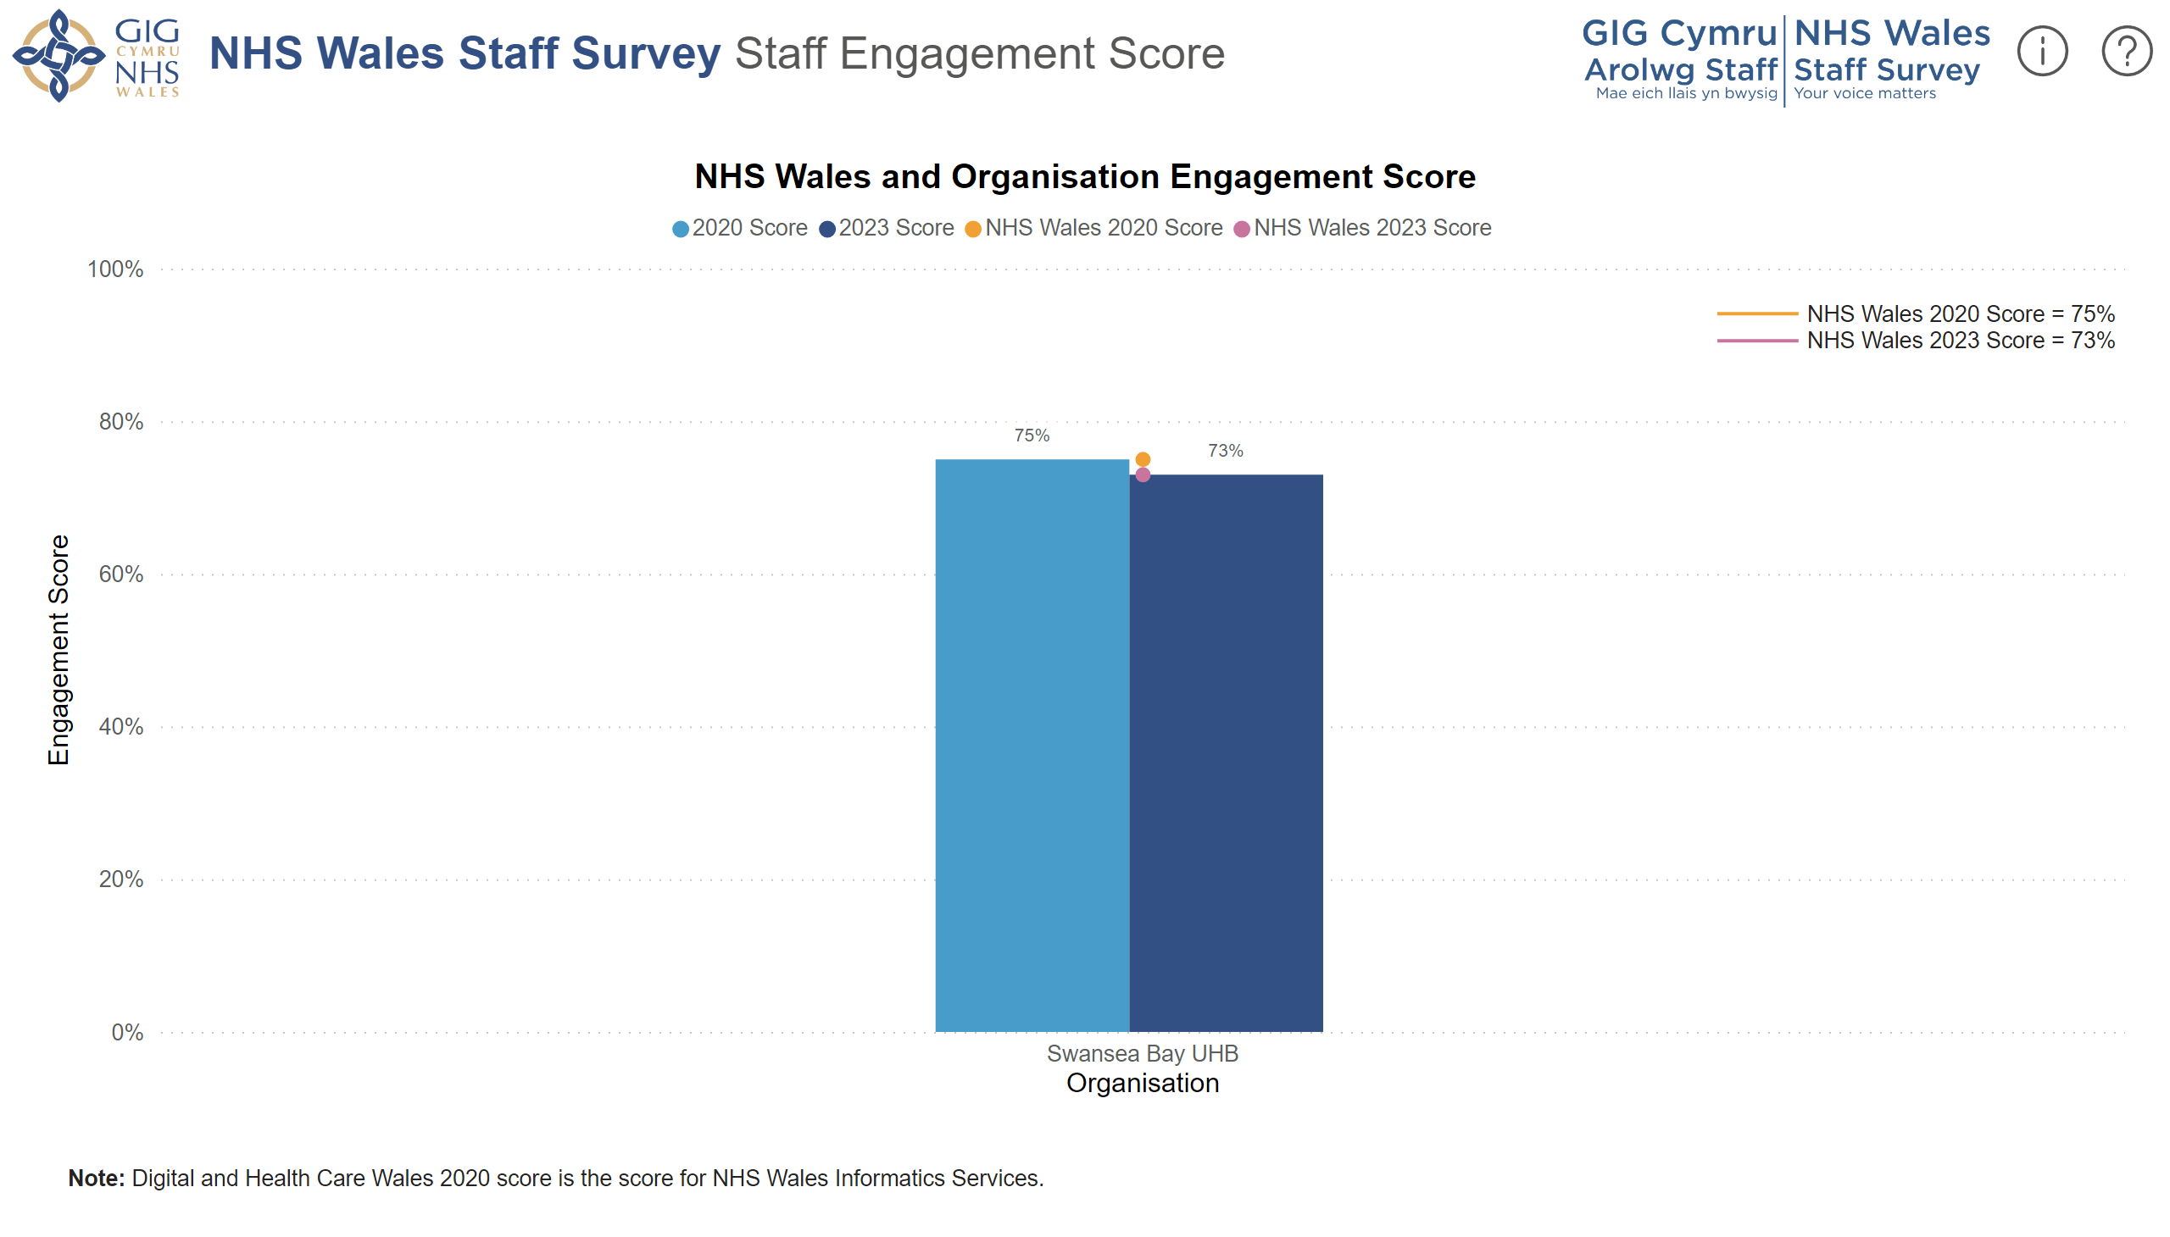

SBUHB’s overall engagement score has reduced by 3% since 2020. This is likely to have been impacted by the aftermath of the COVID-19 pandemic. Blake et al (2020) studied the impact of Supported Wellbeing Centres for hospital employees and referenced several measures that were implemented to support health care workers. These included highlighting the importance of self-care, rest breaks, mental health signposting and communication from leadership. Those who utilised the centres presented as more engaged leading to the conclusion that these could have been a useful addition for health boards across the UK.
There is no distinction between whether respondents of the NHS Wales Survey are substantive members of staff or members of the bank, possibly due to there being a crossover of staff in substantive roles who also work for the bank. This lack of separation could be viewed from two perspectives. Firstly, you could view it as bank staff are considered as equally as important as substantive staff so there is no need for distinction. Alternatively, it could be perceived as no consideration has been taken for the difference between engagement factors of permanent and temporary staff. This is problematic when reviewing engagement levels of bank staff specifically.
4.3.2 Management training programmes
As discussed within Chapter 2, the majority of research into employee engagement supports the fact that management have a direct impact on the engagement levels of their employees. Macleod (2009) identified strong leadership and motivational line managers as two of the key enablers of engagement. Smith et al (2016) support this by stating organisations will fail to achieve high levels of employee engagement if managers are unable to “facilitate and understand the nature of each employee’s psychological contract” (Sharafizad et al, 2019).
Human Resource Management practices such as training can enhance levels of engagement (Memon et al, 2021). SBUHB have numerous training programmes in place for managers to support them to support their teams.
These are outlined here:
Footprints programme – This is aimed at staff with permanent line management / supervisory responsibility, or who aspire to have a formal management role and have completed the IMPACT programme. The course is delivered over 3 days. The content is mixed and described as a mix of action learning sets designed to inspire and positively challenge managers.
Bridges programme – This is aimed to help senior leaders across Swansea Bay develop the skills, knowledge and confidence to lead themselves and their teams compassionately, whilst providing quality care and experience for patients. Learning includes a mix of content and action learning sets designed to inspire and positively challenge leaders.
Manager’s Pathway – This is a 1 year programme, consisting of a comprehensive range of modules aiming to provide managers with the skills, knowledge and information to enable them to undertake their roles efficiently and effectively. The programme consists of 15 core modules including the previous two programmes, as well as covering a range of other skills. Topics covered include occupational health referrals, wellbeing support, finance basics, difficult conversations, recruitment, report writing, digital and data literacy, risk management, workforce data systems and strategy. In addition, attendees are asked to select from two additional modules, which also include supporting staff dealing with trauma. This programme is very popular and sees high subscription levels.
Leadership Touch Point Events –These events provide an opportunity for all leaders throughout SBUHB to come together and share best practice. A forum is hosted via Sharepoint, where discussion takes place and events are shared for sign-up.
These formal training schemes are aimed at facilitating managers in SBUHB to manage as effectively as possible but there is no reference to managing bank staff within these schemes. This could be a relevant addition for future schemes to ensure that managers can consider the possible difference in motivation between temporary and permanent staff.

4.3.3 Leaver data
It is imperative to establish the reasons for people leaving an organisation but recording the relevant, accurate data can prove to be complicated (CIPD, 2023c). This can be due to employees not feeling able to disclose their true reason for leaving or indeed the lack of robust practices in place to enable an organisation to capture the relevant information.
4.3.3.1 Reasons for leaving the bank
2,017 members of staff left SBUHB bank between January 2021 and December 2023. 1,984 of these were voluntary leavers. Just 10 of these leavers completed an exit interview, the equivalent of 0.5%. Exit interviews can be a valuable tool to retain valued employees (Macafee, 2007). Low completion rates among bank staff indicates that exit interviews are not perceived as significant and SBUHB are missing important feedback opportunities.

Reasons for leaving are ambiguous. 95.5% of voluntary resignations have been recorded as Other/Not Known. CIPD (2024) acknowledge that establishing accurate reasons for staff leaving can be complicated but highlight the importance of understanding why people leave. Finding out why people are leaving is among the first steps in developing a retention strategy (CIPD, 2024). The leaver reason data collected by SBUHB for bank staff does not provide any useful insights due to the lack of detail.
The current exit interview process within SBUHB involves the member of staff leaving being sent a questionnaire to complete. The results are then held on the HR system for reporting purposes. It is unclear whether this information is then utilised to identify any trends or opportunities to retain the staff member. It is not uncommon for organisations not to take full advantage of the opportunity to gain feedback from their leavers but leaders should make exit management a priority (Broadbent and McGuire, 2023).
4.4 Conclusion
This chapter has presented the key findings of both the primary and secondary data collected as part of this research.
Primary data obtained through interviews with bank staff has revealed that bank staff are primarily engaged when compared to the key drivers of engagement. Specific motivations to work within the bank include flexibility, autonomy and patient care, and all feel well supported by management.
Secondary data has highlighted the quality of management programmes in place, the engagement levels of SBUHB as a whole and potential improvements required in the recording of data such as reasons for leaving and NHS Staff Survey results.

5.0 Conclusion and recommendations
This chapter will summarise the key findings from both the secondary and primary research completed. It is firstly important to revisit the main aim of the research; to critically analyse the factors impacting the engagement of bank staff in SBUHB, with the view to improving overall engagement levels. Specific recommendations will then be made for SBUHB with the aim of improving the engagement levels of bank staff.
  - Conclusion
Factors impacting employee engagement have been explored in relation to employees in general, temporary staff from a variety of sectors and temporary staff within the NHS, specifically, the SBUHB staff bank. The key factors driving engagement consistently link to management support, feeling valued or a sense of belonging, employee voice and autonomy.
When examining the difference in engagement drivers between permanent and temporary employees, the main finding is that temporary employees are more likely to be driven by financial reward and flexibility. However, they are still motivated by other fundamentals of employee engagement including being part of a team, supportive management and stability.
From the primary research conducted, it is reasonable to conclude that bank staff within SBUHB are engaged. There were many positives identified, these will now be discussed alongside the secondary research.
Firstly, relationships with management will be considered. The prevalence of the impact of management on engagement is noted within all relevant literature reviewed (MacLeod, 2009; Smith et al, 2016; Gallup, no date). To enable this, it is crucial that managers have the ability to support employees as required (Bailey and West, 2022). Previous research haa also found clear links between supportive line management and patient care (Bridger, 2018) which is an essential consideration for SBUHB.
Primary research established that NHS bank staff feel well supported by management and feel comfortable communicating. However, results from the NHS Wales Staff survey when asked about compassionate leadership contradict this. These results are potentially more representative of substantive staff rather than bank staff but as previously mentioned, there is no distinction between the two. Hutchinson and Purcell (2010) highlighted that the role of managers within the NHS is ever changing and responsibilities are regularly increasing. This is an important consideration in relation to expectations and adequate management training being provided. A variety of management training is conducted within SBUHB but further analysis could be completed in relation to the effectiveness of each programme.
Secondly, feeling valued and belonging will be explored. All participants felt part of the NHS team and the majority felt motivated by the additional benefits such as being included in the pension scheme. Several comments were also made regarding the additional support provided when experiencing personal difficulties which adds to the fulfilment of overall sense of belonging (Pichere and Cadiat, 2015). Comments relating to substantive staff retiring and joining the bank imply that staff could have felt more valued by utilising skills elsewhere in NHS prior to retirement. Utilising flexible retirement options could help staff feel both valued and rewarded as well as be of a financial benefit to SBUHB (NHS Employers, 2024b). Feeling valued also incorporates the perception of fair reward which was highlighted within the results of primary research in relation to payment received by bank staff compared to substantive staff. Clearer communication and transparency could improve the perception of this.
Moving on to employee voice, primary research confirmed bank staff feel they have a voice and able to raise concerns if needed. There are limited avenues for bank staff to give their voice, specifically based on the staff survey structure. Multiple initiatives could improve this including survey results being compartmentalised into substantive staff and bank staff as well as the introduction of formal conversation to focus on bank staff staying with the SBUHB.
According to HR inform (2021) stay interviews are becoming increasingly common within organisations. Stay interviews are a pre-emptive one to one conversation between a manager and staff member to discuss motivation, frustrations, support, development and values (Ronan, 2021). They have also been recommended as part of the NHS Long-Term Workforce Plan but have not been incorporated into every trust (Weeks, 2023). This could encourage more regular communication between bank staff and management, which would in turn allow employee voice to be acknowledged in a more structured way and help to avoid stress and burnout (Shipton et al, 2024). This could be a useful tool to retain staff to the bank rather than them leaving to work for an agency.
Lastly, autonomy has been highlighted as a key driver for employee engagement (Reisinger and Fetterer, 2021) and specifically a main benefit of working for the bank (Antony, 2018). Primary research has found that perceptions and experiences of working for an agency are that staff have a lack of control, specifically in relation to the location of work. Increased communication of this significant difference could not only retain staff to the bank but attract staff to join the bank from an agency. Research into successful initiatives within other health boards found that increased communication with agency staff along with continued support and bespoke training led to an increase in staff joining the bank who had previously worked for an agency (NHS Professionals, 2023c).
All of the key drivers discussed have close links with wellbeing, it is imperative that bank staff are encouraged to avoid stress or burnout and provided with support and encouragement to take regular breaks and leave. This was a factor raised through primary research that can be managed by making wellbeing services readily available to all staff (Phung et al, 2022).
It is essential at this stage to refer to the initial rationale for the research, which in part referred to the value that bank staff add to SBUHB in terms of patient care and flexibility. Primary research identified continuity of patient care as motivation to work for the bank in addition to completing a substantive role and research supports that patient care is influenced by both engagement levels of staff and supportive line management (Bridger, 2018). This further supports the notion that bank staff are a valuable addition to the NHS workforce.
Taking the above into consideration, specific recommendations will be made for SBUHB to consider.
  - Recommendations
The following recommendations focus on improving overall engagement levels of bank staff with the view of positively impacting retention rates. Consideration has been taken to ensure recommendations are viable and cost effective due to the aim of the research linking to reduced costs.
5.2.1 NHS Wales Staff Survey
There is currently no distinction between substantive staff and bank staff within the survey results. Clear distinction could help SBUHB to create engagement initiatives specifically aimed at bank staff. It would also ensure all bank staff are aware they have a voice which is becoming increasingly important for engagement (CIPD, 2024b).
For future surveys the following tick box option should be included at the beginning:
- Substantive staff
- Bank staff
- Both
Costs to this would be limited to administration of the survey provider.
5.2.2 Stay interviews
Stay interviews could be incorporated as part of regular one to one meetings with line managers at least once a quarter. They could also be completed with those showing signs of disengagement to tackle the ‘quiet quitters’. For example, if a staff member has failed to attend an agreed bank shift or appears to be doing the bare minimum during their bank shift. Effective conversations can be held to reduce disengagement and managers are best placed to lead these (Harter, 2023). They could also be held with staff members approaching retirement age to help promote flexible retirement options.
The one-to-one conversations could be called ‘good work conversations’ to help promote positively with staff.
Costs to implement a 3-month trial of 20 managers would include initial training for the managers and time to complete the interviews. Effective face to face training would be completed in 2 hours by the Learning and Development team and preparation time for the session would take up to 15 hours. The estimated cost would be £348.50 as well as management salary for attending the training which would be roughly £746.80.
5.2.3 Exit interviews
Exit interviews are one of the key tools to get to the root cause of why people are leaving. This allows trends to be identified and acted upon to ensure doing everything possible to engage bank staff. Secondary research has shown that the current process in SBUHB is not providing enough relevant information. This recommendation is broken down into two parts; to improve both the quality of information acquired and the quantity of exit interviews completed.
5.2.3.1 Quality
Completing exit interviews face to face rather than relying on a survey could help people to feel valued and provide more meaningful responses. Surveys would still be sent to the member of staff to complete but a follow up conversation would be arranged with a member of the HR team to probe. Improvements are also required with the accuracy of the leaver reasons recorded. This can be achieved through this more rigorous approach and following detailed leave reasons. This will allow for more accurate data and thorough analysis to be completed (CIPD, 2024d) to identify relevant engagement strategies for bank staff specifically
This task could be completed by HR administrators and would take an estimated half an hour each to complete and record. Based on an average of 661 voluntary leavers from bank every year and the salary of £12.30 an hour estimated annual costs would be £4,059.00.
5.2.3.2 Quantity
The introduction of exit interview completion rates with bank staff as a monthly metric for the HR team could help to improve completion rates. Key performance indicators (KPIs) can be a motivating tool when setting clear objectives (CIPD, 2024b).
Costs would be limited to the administration of adding to the existing monthly score card.
5.2.4 Recruitment process
Secondary research has confirmed that there is no specific policy for the recruitment of bank staff specifically. Findings from primary research alluded to delays in the process and ambiguity regarding the specific requirements. The development of a recruitment policy, specific to bank staff, would assist in creating transparency and managing expectations to attract and retain (CIPD, 2023i).
The cost estimated at £270 to include the salary of an HR Manager collating and writing the policy which is likely to take an estimated 15 hours.
5.2.5 Wagestream promotion
The launch of the Wagestream app has been progressive in terms of bringing the financial benefits of working for the bank closer to those received by working for an agency. Primary research has highlighted the gap in awareness of some current bank staff. Successful communication of a new initiative or change can be supported by a repeat, listen and refresh approach (Lancefield, 2022). Further promotion of the app to all SBUHB staff by attending onsite facilities as well as running online promotions could increase overall awareness.
Costs to promote online would be limited as the content is also developed. Costs associated with onsite drop-in sessions for staff would include salary of the HR advisor attending. Sessions would initially be held for 1 hour, once a week at each of the 4 main hospital sites on alternate days for 4 weeks to reach as many staff as possible. The estimated cost of this is £230.
5.2.6 Communication with agency staff
Secondary research highlighted the financial success achieved through communication with agency staff (NHS Professionals, 2023c). It will be beneficial to promote the benefits of joining the bank including choice of location worked, the Wagestream app, being part of the NHS team and the pension scheme. These have all been found to drive engagement for bank staff and link to reward, stability and autonomy. Further research into perceptions of agency staff would be an insightful addition to the primary research completed into bank staff.
Estimated costs are difficult to determine due this being part of a wider project but return on investment would be positive based on findings from previous investment.
6.0 Bibliography
Abbas, R. Z., Murad, H. S., Yazdani, N., & Asghar, A. (2014) ‘Extending “Kahn’s model of personal engagement and disengagement at work” with reference to existential attributes: A case study of HR managers in Pakistan’. International Journal of Social Economics, 41 (1), 2–31. Available at: https://doi.org/10.1108/IJSE-10-2012-0143
Antony, M.R. (2018) “PARADIGM SHIFT IN EMPLOYEE ENGAGEMENT – A CRITICAL ANALYSIS ON THE DRIVERS OF EMPLOYEE ENGAGEMENT,” International journal of information, business and management, 10(2), pp. 32–46.
Bailey, S. & West, M. (2022) What is compassionate leadership? Available at: https://www.kingsfund.org.uk/insight-and-analysis/long-reads/what-is-compassionate-leadership (Accessed: 7 April 2024)
Bajorek, Z. and Guest, D. (2019) ‘The impact of temporary staff on permanent staff in accident and emergency departments’. Journal of organizational effectiveness : people and performance, 6(1), pp. 2–18. Available at: https://doi.org/10.1108/JOEPP-09-2018-0074.
Bank Partners (2016) What is an NHS Staff Bank? Available at: https://www.bankpartners.co.uk/news/2016/02/what-is-an-nhs-staff-bank/#:~:text=An%20NHS%20staff%20bank%20is,temporary%20shifts%20at%20trust%20hospitals (Accessed: 5 Nov 2023)

Barker, R. and Ford, K. (2018) The case for employee engagement in the NHS. Available at: chrome-extension://efaidnbmnnnibpcajpcglclefindmkaj/https://kar.kent.ac.uk/69494/1/Point_of_Care_Report_2018.pdf (Accessed: 2 May 2024)

BBC News (2022) Record number of nurses quitting the NHS. Available at: https://www.bbc.co.uk/news/health-63080462 (Accessed: 30 Jan 2024)

BBC News (2023) Cardiff: Health board on high alert over winter pressures. Available at: https://www.bbc.co.uk/news/uk-wales-67355179 (Accessed: 13 Nov 2023)

Bell, E., Bryman, A. & Harley, B. (2019) Business Research Methods: Fifth Edition, Oxford University Press: Oxford

Blake, H., Yikdirim, M., Wood, B., Knowles, S., Mancini, H., Coyne, E. and Cooper, J. (2020) “COVID-Well: Evaluation of the Implementation of Supported Wellbeing Centres for Hospital Employees during the COVID-19 Pandemic,” International journal of environmental research and public health, 17(24), pp. 9401-. Available at: https://doi.org/10.3390/ijerph17249401.

Bodapati, S., Singh, R. and Gambhir, S. (2022) “Tackling the post pandemic NHS waiting lists – Mission impossible?” British Journal of Surgery, 109 (5), Available at: https://doi.org/10.1093/bjs/znac247.121

Brearley, B. (2020) The Power of Setting a Direction for your Team. Available at: https://www.thoughtfulleader.com/setting-direction/ (Accessed: 28 April 2024)

Brecheison, J. (2023) Research: Flexible Work is Having a Mixed Impact on Employee Well-Being and Productivity. Available at: https://hbr.org/2023/10/research-flexible-work-is-having-a-mixed-impact-on-employee-well-being-and-productivity (Accessed: 28 April 2024)
Bridger, E. (2018) Employee Engagement: A practical introduction: 2nd Edition, Kogan Page: London

Broadbent, L. and McGuire, M. (2023) Learning from leavers: making every exit a positive for your organisation. Available at: https://www.peoplemanagement.co.uk/article/1846299/learning-leavers-making-every-exit-positive-organisation (Accessed: 28 April 2024)

Brower, T. (2023) Managers Have Major Impact On Mental Health: How to Lead For Wellbeing. Available at: https://www.forbes.com/sites/tracybrower/2023/01/29/managers-have-major-impact-on-mental-health-how-to-lead-for-wellbeing/?sh=631d19ee2ec1 (Accessed: 8 April 2024)

Bryman, A. (2004) “Qualitative research on leadership: A critical but appreciative view”, The Leadership Quarterly, 15 (6). DOI: 10.1016/j.leaqua.2004.09.007

Burton, D. and Price, K. (2012) “Initiative to reduce reliance on agency staff”. Nursing Management. 19 (10) DOI: 10.7748/nm2012.03.18.10.9.p7654
Cappelli, P. and Eldor, L. (2019) Where measuring engagement goes wrong. Available at: https://hbr.org/2019/05/where-measuring-engagement-goes-wrong#:~:text=A%20second%20major%20problem%20with,them%20think%20they%20are%20useless. (Accessed: 27 April 2024)
Carrillo, R. A. (2019) The relationship factor in safety leadership : achieving success through employee engagement. Abingdon, Oxon: Routledge.
Caulfield, J. (2023) How to Do Thematic Analysis | Step-by-Step Guide & Examples. Available at: https://www.scribbr.com/methodology/thematic-analysis/ (Accessed: 24 March 2024)
Cicellin, M., Tomo, A., Consiglio, S. Moschera, L. and Aria, M. (2022) “Temporary and permanent agency workers. A study of perceived organizational support and dual commitment,” Employee relations, 44(5), pp. 1157–1178. Available at: https://doi.org/10.1108/ER-06-2021-0243.
Chambel, M.J., Castanheira, F. and Sobral, F. (2016) “Temporary agency versus permanent workers: A multigroup analysis of human resource management, work engagement and organizational commitment,” Economic and industrial democracy, 37(4), pp. 665–689. Available at: https://doi.org/10.1177/0143831X14550695.
CIPD (2012) Managing for sustainable employee engagement: Guidance for employers and managers. Available at: https://www.cipd.org/globalassets/media/knowledge/knowledge-hub/reports/managing-for-sustainable-employee-engagement-guidance-for-employers-and-managers_2012_tcm18-10753.pdf (Accessed: 26 Jan 2024)
CIPD (2019) Talking about voice: Employees’ experience. Available at: https://www.cipd.org/uk/knowledge/reports/employee-experiences/ (Accessed: 27 Jan 2024)

CIPD (2021) Employee engagement: An evidence review. Available at: https://www.cipd.org/uk/knowledge/evidence-reviews/evidence-engagement/ (Accessed: 13 Nov 2023)

CIPD (2023a) CIPD Good Work Index 2023. Available at: https://www.cipd.org/globalassets/media/knowledge/knowledge-hub/reports/2023-pdfs/2023-good-work-index-report-8407.pdf (Accessed: 14 Nov 2023)

CIPD (2023b) Employee engagement and motivation. Available at: https://www.cipd.org/uk/knowledge/factsheets/engagement-factsheet/#what-is-employee-engagement (Accessed: 9 Nov 2023)

CIPD (2023c) Employee turnover and retention. Available at: https://www.cipd.org/uk/knowledge/factsheets/turnover-retention-factsheet/#Whydo (Accessed: 19 Nov 2023)

CIPD (2023d) The psychological contract. Available at: https://www.cipd.org/uk/knowledge/factsheets/psychological-factsheet/ (Accessed: 28 Jan 2024)

CIPD (2023e) Learning evaluation, impact and transfer. Available at: https://www.cipd.org/uk/knowledge/factsheets/evaluating-learning-factsheet/#implications-for-learning-evaluation- (Accessed: 30 Jan 2024)

CIPD (2023f) Evidence-based practice for effective decision making. Available at: https://www.cipd.org/uk/knowledge/factsheets/evidence-based-practice-factsheet/#what-is-evidencebased-practice (Accessed: 2 April 2024)

CIPD (2023g) Organisational and employee-focused voice: Why both matter. Available at: https://www.cipd.org/en/knowledge/bitesize-research/organisation-employee-voice/ (Accessed: 2 May 2024)

CIPD (2023h) Employee communication. Available at: https://www.cipd.org/uk/knowledge/factsheets/employee-communication/ (Accessed: 2 May 2024)

CIPD (2023i) HR policies. Available at: https://www.cipd.org/uk/knowledge/factsheets/hr-policies-factsheet/#:~:text=HR%20policies%20can%20support%20trust,benefits%20for%20employees%20and%20organisations. (Accessed: 3 May 2024)

CIPD (2024a) Employee turnover and retention. Available at: https://www.cipd.org/uk/knowledge/factsheets/turnover-retention-factsheet/ (Accessed: 30 March 2024)

CIPD (2024b) Employee Voice. Available at: https://www.cipd.org/uk/knowledge/factsheets/voice-factsheet/#Whistleblowing (Accessed: 7 April 2024)

CIPD (2024c) Performance management: an introduction. Available at: https://www.cipd.org/uk/knowledge/factsheets/performance-factsheet/ (Accessed: 28 April 2024)

CIPD (2024d) People Analytics. Available at: https://www.cipd.org/uk/knowledge/factsheets/analytics-factsheet/#four (Accessed: 3 May 2024)

CIPD (no date) Employee Voice. Available at: https://www.cipd.org/uk/views-and-insights/cipd-viewpoint/employee-voice/#:~:text=Having%20a%20voice%20at%20work,'voice'%20in%20their%20organisation (Accessed: 27 Jan 2024)

Clarissa, C., Quinn, S. and Stenhouse, R. (2021) ‘‘Fix the issues at the coalface and mental wellbeing will be improved’: a framework analysis of frontline NHS staff experiences and use of health and wellbeing resources in a Scottish health board area during the COVID-19 pandemic,’ BMC health services research, 21(1), pp. 1–1089. Available at: https://doi.org/10.1186/s12913-021-07103-x.

Clark, T. et al. (2021) Bryman’s social research methods. 6th edition. Oxford: Oxford University Press.

Cleave, P. (2023) Focus Groups vs Surveys. Available at: https://www.smartsurvey.co.uk/blog/focus-groups-vs-surveys (Accessed: 02 May 2024)

Collard, D. (2022) Breaking barriers: Building trust and inspiring change for NHS bank workers. Available at: https://nationalguardian.org.uk/2023/10/17/breaking-barriers-building-trust-and-inspiring-change-for-nhs-bank-workers/ (Accessed: 24 March 2024)

Collis, J. & Hussey, R. (2014) Business research: a practical guide for undergraduate & postgraduate students: Fourth edition, Palgrave Macmillan: Hampshire.

Craig, W. (2018) 8 Benefits of Measuring Employee Engagement. Available at: https://www.forbes.com/sites/williamcraig/2018/09/18/8-benefits-of-measuring-employee-engagement/ (Accessed: 27 April 2024)

Creswell (2014) Research Design: Qualitative, Quantitative, and Mixed Methods Approaches. Sage Publications: London

Crush (2009) Engagement surveys: Gallup and Best Companies face criticism. Available at: https://www.hrmagazine.co.uk/content/features/engagement-surveys-gallup-and-best-companies-face-criticism/ (Accessed: 29 Jan 2024)

Daniels, K., Connolly, S., Woodard, R., Stolk, C., Patey, J., Fong, K., France, R., Vigurs, C. and Herd, M. (2022) “NHS staff wellbeing: Why investing in organisational and management practices makes business sense”. The International Public Policy Observatory. Available at: chrome-extension://efaidnbmnnnibpcajpcglclefindmkaj/https://eppi.ioe.ac.uk/cms/Portals/0/IPPO%20NHS%20Staff%20Wellbeing%20report_LO160622-1849.pdf (Accessed: 1 May 2024)

De Cuyper, N. and De Witte, H. (2006) “Autonomy and Workload Among Temporary Workers: Their Effects on Job Satisfaction, Organizational Commitment, Life Satisfaction, and Self-Rated Performance,” International journal of stress management, 13(4), pp. 441–459. Available at: https://doi.org/10.1037/1072-5245.13.4.441.
Dundon, T. & Rollinson, D. (2011) Understanding Employment Relations: Second Edition, McGraw Hill: Berkshire

Esain, A. and Massey, L. (2006) ‘Value relationships and effectiveness - pilot study in health’, International journal of productivity and performance management, 55(2), pp. 143–154. Available at: https://doi.org/10.1108/17410400610641717.
Everett, E. & Furseth, I. (2013) Doing your master’s dissertation: from start to finish, SAGE Publications Ltd: London

Felfe, J. and Franke, F. (2010) “Invited reaction: Examining the role of perceived leader behavior on temporary employees’ organizational commitment and citizenship behavior,” Human resource development quarterly, 21(4), pp. 343–351. Available at: https://doi.org/10.1002/hrdq.20057.
Frances, R., Coughlan, M. & Cronin, P. (2009) “Interviewing in qualitative research”, International Journal of Therapy and Rehabilitation, 16(6). Available at: https://www.researchgate.net/publication/261471599_Interviewing_in_qualitative_research#:~:text=The%20individual%20interview%20is%20a,to%20in%2Ddepth%20data%20collection (Accessed: 4 April 2024)

Frith, B. (2017) Employers should treat agency staff like employees. Available at: https://www.hrmagazine.co.uk/content/news/employers-should-treat-agency-staff-like-employees/ (Accessed: 2 May 2024)

Galdas, P. (2017). “Revisiting Bias in Qualitative Research: Reflections on Its Relationship With Funding and Impact”. International Journal of Qualitative Methods, 16(1). https://doi.org/10.1177/1609406917748992

Gallup (2023) State of the Global Workplace 2023 Report: The voice of the world’s employees. Available at: https://www.gallup.com/workplace/506879/state-global-workplace-2023-report.aspx (Accessed: 12 Nov 2023)

Gallup (no date) What is Employee Engagement and how do you improve it? Available at: https://www.gallup.com/workplace/285674/improve-employee-engagement-workplace.aspx#:~:text=Gallup%20defines%20employee%20engagement%20as,in%20their%20work%20and%20workplace. (Accessed: 30 Jan 2024)

Gill, P., Stewart, K., Treasure, E. and Chadwick, B. (2008) “Methods of data collection in qualitative research: interviews and focus groups”. 204, 291–295. https://doi.org/10.1038/bdj.2008.192

Giordano, F. B., Stoffregen, S. A., Klos, L. S. & Lee, J (2021) ‘Risks that are “worthy” to take: temporary workers’ risk-benefit and willingness perceptions’. European journal of work and organizational psychology, 30. DOI: 10.1080/1359432X.2021.1886086

Gould-Williams, J. and Davies, F. (2005) ‘Using social exchange theory to predict the effects of hrm practice on employee outcomes: An analysis of public sector workers’, Public management review, 7(1), pp. 1–24. Available at: https://doi.org/10.1080/1471903042000339392.
Grantham, A. (2023) How leaders can use ‘stay conversations’ to re-engage employees. Available at: https://www.peoplemanagement.co.uk/article/1818703/leaders-use-stay-conversations-re-engage-employees (Accessed: 13 April 2024)
Guest, G., Bunce, A. and Johnson, L. (2006) “How Many Interviews Are Enough? An Experiment with Data Saturation and Variability”. Family Health International. 18(1), pp. 59-82. DOI: 10.1177/1525822X05279903
Ham, C. (2014) Improving NHS care by engaging staff and devolving decision making. Available at: https://www.kingsfund.org.uk/insight-and-analysis/reports/improving-nhs-care-engaging-staff-devolving-decision-making (Accessed: 13 April 2024)
Hammond, M. & Wellington, J. (2012) Research Methods: The Key Concepts, Routledge: London

Harter, J. (2023) Is Quiet Quitting Real? Available at: https://www.gallup.com/workplace/398306/quiet-quitting-real.aspx (Accessed: 14 April 2024)

Hayre-Kwan, S., Quinn, B., Chu, T., Or, P. and Snoke, J. (2021) “Nursing and Maslow's Hierarchy: A Health Care Pyramid Approach to Safety and Security During a Global Pandemic.” Nurse Lead. 19(6):590-595. doi: 10.1016/j.mnl.2021.08.013. Available at: https://www.ncbi.nlm.nih.gov/pmc/articles/PMC8590157/ (Accessed: 1 May 2024)

HEIW (2023) Retaining and valuing nurses within the NHS in Wales. Available at: https://heiw.nhs.wales/news/retaining-and-valuing-nurses-within-the-nhs-in-wales/ (Accessed: 5 Nov 2023)

HEIW (DATE UNKNOWN) Engaging your staff: the NHS Wales staff engagement resource. Available at: https://heiw.nhs.wales/files/weds-effective-staff-engagement/engaging-your-staff-the-nhs-wales-staff-engagement-resource/ (Accessed: 5 Nov 2023)

HEIW (DATE UNKNOWN) What is the Nurse Staffing Levels (Wales) Act 2016? Available at: https://heiw.nhs.wales/our-work/all-wales-nurse-staffing-programme/what-is-the-nurse-staffing-levels-wales-act-2016/ (Accessed: 5 Nov 2023)

HR Inform (2021) Stay interviews – a valuable retention tool. Available at: https://www.hr-inform.co.uk/news-article/stay-interviews-a-valuable-retention-tool (Accessed: 30 March 2024)

HR Magazine (2009) The MacLeod Report – making it happen. Available at: https://www.hrmagazine.co.uk/content/features/the-macleod-report-making-it-happen/ (Accessed: 11 Nov 2023)

Human Resource Management International Journal (2021) Research at two NHS A&E departments shows inexperienced temps can negatively impact work of permanent staff, 29 (3). DOI: 10.1108/HRMID-05-2020-0118

Hussain, S. D., Khaliq, A., Nisar, Q. A., Kmboh, A. Z. and Ali, S. (2019) “The Impact of Employees’ Recognition, Rewards and Job Stress on Job Performance,” SEISENSE journal of management, 2(2). Available at: https://doi.org/10.33215/sjom.v2i2.121.

Hutchinson, S. and Purcell, J. (2010) “Managing ward managers for roles in HRM in the NHS: overworked and under-resourced,” Human resource management journal, 20(4), pp. 357–374. Available at: https://doi.org/10.1111/j.1748-8583.2010.00141.x.

Indeed (2023) What is a temporary worker? (Rights, advantages and FAQs) Available at: https://uk.indeed.com/career-advice/finding-a-job/what-is-temporary-worker (Accessed: 13 Nov 2023)

Indeed Flex (2022) Five ways to increase temporary employee retention. Available at: https://indeedflex.co.uk/blog/five-ways-to-increase-temporary-employee-retention/ (Accessed: 27 Jan 2024)

Jeve, Y. B., Oppenhemier, C. & Konie, J. (2015) ‘Employee Engagement within the NHS: A Cross-Sectional Study’, International Journal of Health Policy and Management, 4. DOI: 10.15171/ijhpm.2015.12

Jia-Jun, Z. & Hua-Ming, S. (2022) ‘The Impact of Career Growth on Knowledge-Based Employee Engagement: The Mediating Role of Affective Commitment and the Moderating Role of Perceived Organizational Support’, Frontiers in Psychology, Vol 13. Available at: https://doi.org/10.3389/fpsyg.2022.805208

Joshua-Amadi, M. (2003) “Recruitment and retention in the NHS. A study in motivation,” Nursing management (Harrow, London, England), 9(9), pp. 14–19. Available at: https://doi.org/10.7748/nm2003.02.9.9.14.c2140.

Joubert, M. and Roodt, G. (2019) “Conceptualising and measuring employee engagement as a role-related, multi-level construct,” Acta commercii, 19(1), pp. 1–17. Available at: https://doi.org/10.4102/ac.v19i1.605.

Jung, H., Noh, S. and Kim, I. (2018) ‘Relative deprivation of temporary agency workers in the public sector: The role of public service motivation and the possibility of standard employment’, Human resource management journal, 28(3), pp. 410–426. Available at: https://doi.org/10.1111/1748-8583.12186
Kahn, W. A. (1990) “Psychological conditions of personal engagement and disengagement at work”, Academy of Management Journal, 33 (4). DOI: 10.5465/256287

Kidron, A. (2018) “Examining the Mediating Role of Commitment to the Supervisor in Employees’ Affective Commitment: Temporary Employees Versus Permanent Employees”, Journal of Leadership & Organizational Studies, 25 (4), 456–468. https://doi.org/10.1177/1548051818755635

Klenke, K. (2016) Qualitative Research in the Study of Leadership: Second Edition, Emerald Group Publishing Limited: Bingley

Kumar, S. (2019) “Bullying and undermining by line managers in the NHS,” BMJ (Online), 365, pp. l2240–l2240. Available at: https://doi.org/10.1136/bmj.l2240.

Kumar, V. and Pansari, A. (2015) “Measuring the Benefits of Employee Engagement,” MIT Sloan management review, 56(4), pp. 67
Kundu, S.C. and Lata, K. (2017) “Effects of supportive work environment on employee retention: Mediating role of organizational engagement,” International journal of organizational analysis (2005), 25(4), pp. 703–722. Available at: https://doi.org/10.1108/IJOA-12-2016-1100.
Lacobucci, G. (2023) “Improving flexible working in the NHS”, British Medical Journal (BMJ), 380(618). Available at: https://www.bmj.com/content/380/bmj.p618 (Accessed: 7 April 2024)

Lancefield, D. (2022) How to Communicate Your Company’s Strategy Effectively. Available at: https://hbr.org/2022/11/how-to-communicate-your-companys-strategy-effectively (Accessed: 3 May 2024)

Latham, G. P. (2012) Work Motivation. Second Edition. Sage Publications: London

Lester, J., Cho, Y. & Lochmiller, C (2020) Learning to do Qualitative Data Analysis: A Starting Point, Vol 19, Issue 1. DOI: 10.1177/1534484320903890

Lewis, P., Saunders, M. & Thornhill, A. (2016) Research methods for business students: Seventh Edition, Pearson Education Limited: Essex

Macafee, M. (2007) How to… conduct exit interviews. Available at: https://www.peoplemanagement.co.uk/article/1743217/conducting-exit-interviews (Accessed: 30 March 2024)

Mackieson, P., Shlonsky, A., & Connolly, M. (2019) “Increasing rigor and reducing bias in qualitative research: A document analysis of parliamentary debates using applied thematic analysis”. Qualitative Social Work, 18(6), 965-980. https://doi.org/10.1177/1473325018786996

Maslow, A. H. (2013) A Theory of Human Motivation. USA: Start Publishing
Mcclain, D. and Morgan, I. (2021) Overwhelmed by employee turnover? Have stay conversations. Available at: https://www.gallup.com/workplace/355238/overwhelmed-employee-turnover-stay-conversations.aspx (Accessed: 13 April 2024)
McNeill, P. and Chapman, S. (2005) Research methods. 3rd ed. London: Routledge
Memon, M.A. et al. (2021) ‘Satisfaction matters: the relationships between HRM practices, work engagement and turnover intention’, International journal of manpower, 42(1), pp. 21–50. Available at: https://doi.org/10.1108/IJM-04-2018-0127
Meyer, J.P. and Allen, N.J. (1991) ‘A three-component conceptualization of organizational commitment’. Human Resource Management Review. 1 (1). Pp 61–89. DOI:10.1016/1053-4822(91)90011-Z

Mezher, S. and Sajid, M. (2019) “How could NHS change management agents learn from corporate innovation strategy to deliver services more effectively?” BMJ Leader, 3 (2) p. 52-58. DOI:10.1136/leader-2018-000131

Moore, A. (2022) Is the NHS getting the most out of its staff banks? Available at: https://www.hsj.co.uk/workforce/is-the-nhs-getting-the-most-out-of-its-staff-banks/7032383.article. (Accessed: 28 April 2024)

My Locum (2024) Maslow’s Hierarchy of Needs: How its applies to nursing. Available at: https://www.mylocum.com/maslows-hierarchy-of-needs-how-it-applies-to-nursing/#:~:text=Physical%20survival%20needs%2C%20safety%2C%20and,control%20and%20support%20within%20themselves. (Accessed: 1 May 2024)

Negrin, K. A., Slaughter, S. E., Dahlke, S., & Olson, J. (2022) ‘Successful Recruitment to Qualitative Research: A Critical Reflection’. International Journal of Qualitative Methods, 21. https://doi.org/10.1177/16094069221119576

Nelson, S. F. (2015) Say, Stay or Strive: The Effects of Leadership Style and Psychological Safety on Employee Engagement. Available at: chrome-extension://efaidnbmnnnibpcajpcglclefindmkaj/https://esource.dbs.ie/server/api/core/bitstreams/6e58013b-ffea-4ef1-b57b-0e09f9c77fd8/content#:~:text=The%20UWES%20describes%203%20factors,undermines%20effort%20of%20co%2Dworkers (Accessed: 27 April 2024)

NHS Employers (2024a) Improving retention through staff engagement: a Do OD case study. Available at: https://www.nhsemployers.org/case-studies/improving-retention-through-staff-engagement (Accessed: 28 April 2024)

NHS Employers (2024b) Using Flexible Retirement to Support Retention. Available at: https://www.nhsemployers.org/publications/using-flexible-retirement-support-retention#:~:text=The%20NHS%20Pension%20Scheme%20offers,of%20Health%20and%20Social%20Care (Accessed: 1 May 2024)

NHS Employers (2024c) Beating burnout in the NHS. Available at: https://www.nhsemployers.org/articles/beating-burnout-nhs (Accessed: 1 May 2024)

NHS England (2018) Employee engagement, sickness absence and agency spend in NHS trusts. Available at: chrome-extension://efaidnbmnnnibpcajpcglclefindmkaj/https://www.england.nhs.uk/wp-content/uploads/2018/03/wres-engagement-absence-agency-spend.pdf (Accessed: 13 April 2024)
NHS Professionals (2023a) Here to stay: what drives and motivates the NHS flexible workforce. Available at: https://www.nhsprofessionals.nhs.uk/joining-nhsp/latest-news/detail?Id=here-to-stay-what-drives-and-motivates-the-nhs-flexible-workforce (Accessed: 27 Jan 2024)

NHS Professionals (2023b) Driving down agency spend at Somerset NHS Foundation Trust with the NHS Professionals National Bank. Available at: 3141---national-bank-case-study-somerset_digital.pdf (nhsprofessionals.nhs.uk) (Accessed: 4 Mar 2024)

NHS Professionals (2023c) Collaboration boosts Bank fill and drives down agency costs. Available at: chrome-extension://efaidnbmnnnibpcajpcglclefindmkaj/https://www.nhsprofessionals.nhs.uk/-/media/corporate/partners/publications/3292-southern-health-agency-migration-case-study_digital.pdf (Accessed: 2 April 2024)

NHS Professionals (no date - a) Our Bank – Nursing, Midwifery, and Healthcare Assistants. Available at: https://www.nhsprofessionals.nhs.uk/joining-nhsp/nursing-and-midwifery-bank (Accessed: 13 Nov 2023)

NHS Professionals (no date - b) Plan Ahead. Available at: chrome-extension://efaidnbmnnnibpcajpcglclefindmkaj/https://www.nhsprofessionals.nhs.uk/~/-/media/3a08be4272034a3a98c141c26cc9405d.ashx#:~:text=2.,time%20week%20of%2037.5%20hours. (Accessed: 27 April 2024)

NHS Wales (no date) Bank FAQ – Guide for Staff who are only employed as Bank. Available at: https://cavuhb.nhs.wales/jobs/temporary-staffing-department/bank-faq-guide-for-staff-who-are-only-employed-as-bank/ (Accessed: 13 Nov 2023)

Nuffield Trust (2020) The remote care revolution during Covid-19. Available at: https://www.nuffieldtrust.org.uk/sites/default/files/2020-12/QWAS/digital-and-remote-care-in-covid-19.html#14 (Accessed: 28 April 2024)

O’Dowd, A. (2024) “NHS temporary staffing bill “skyrockets” to £10.4bn”, BMJ (Online), 384, pp. q140-. Available at: https://doi.org/10.1136/bmj.q140.
Personnel Today (2017) Nurses and teachers choose agency work for better work-life balance, report finds. Available at: https://www.personneltoday.com/hr/nurses-teachers-choose-agency-work-better-work-life-balance-report-finds/ (Accessed: 17 Nov 2023)

Pichère, P. and Cadiat, A. C. (2015) Maslow’s hierarchy of needs. Translated by C. Probert. Namur: Lemaitre Publishing.

Plomp, J., Tims, M., Khapova, S., Jansen, P. & Bakker, A. (2019) “Psychological Safety, Job Crafting, and Employability: A Comparison between Permanent and Temporary Workers”, Frontiers in Psychology. Vol 10, article 974. DOI: 10.3389/fpsyg.2019.00974

Phung, V.-H. et al. (2022) “PP42 Perceptions and experiences of wellbeing provision for NHS ambulance staff: a qualitative interview study of wellbeing leads and frontline staff,” Emergency medicine journal: EMJ, 39(9), pp. e5-. Available at: https://doi.org/10.1136/emermed-2022-999.42.

Powell, R. A. et al. (2024) “A cross-sectional study of the psychosocial and occupational impact of COVID-19 among NHS staff: findings from a Northwest London cohort during the second wave,” F1000 research, 13, pp. 61. Available at: https://doi.org/10.12688/f1000research.139607.1.

Presbitero, A., Roxas, B. and Chadee, D. (2016) “Looking beyond HRM practices in enhancing employee retention in BPOs: focus on employee-organisation value fit,” International journal of human resource management, 27(6), pp. 635–652. Available at: https://doi.org/10.1080/09585192.2015.1035306.

Public Health Wales (2023) FOI 2023 75 – Agency Spend on Temp Staff. Available at: https://phw.nhs.wales/use-of-site/contact-us/freedom-of-information/disclosure-log/foi-2023-75-agency-spend-on-temp-staff/ (Accessed: 2 May 2024)

RCNI (2023) NHS pay rise: bank nurses to lose out on part of agreed deal. Available at: NHS pay rise: bank nurses to lose out on part of agreed deal (rcni.com) (Accessed: 8 Jan 2024)

Read, C. (2017) When support staff go the extra mile to assist patients. Available at: https://www.hsj.co.uk/workforce/when-support-staff-go-the-extra-mile-to-assist-patients/7021045.article (Accessed: 7 April 2024)

Read, C. (2022) How can the NHS make the most of temporary staff? Available at: https://www.hsj.co.uk/workforce/how-can-the-nhs-make-the-most-of-temporary-staff/7032180.article (Accessed: 24 March 2024)

Reisinger, H. & Fetterer, D. (2021) Forget Flexibility. Your Employees Want Autonomy. Available at: https://hbr.org/2021/10/forget-flexibility-your-employees-want-autonomy (Accessed: 8 April 2024)

Richman, A. L., Shannon, L. L., Hill, E. J., Brennan, R. T. and Civian, J. (2008) “The relationship of perceived flexibility, supportive work-life policies, and use of formal flexible arrangements and occasional flexibility to employee engagement and expected retention,” Community, work & family, 11(2), pp. 183–197. Available at: https://doi.org/10.1080/13668800802050350.

Ronan, S. (2021) Stay interviews: how to prevent internal talent from flying the coop. Available at: https://www.hrmagazine.co.uk/content/features/stay-interviews-how-to-prevent-internal-talent-from-flying-the-coop/ (Accessed: 13 April 2024)
Rugg, G. & Petre, M. (2007) A Gentle Guide to Research Methods, Open University Press: Berkshire

Salom, I. (2023) Should we return to face-to-face research? Available at: https://insidehmcts.blog.gov.uk/2023/09/08/should-we-return-to-face-to-face-research/ (Accessed: 28 March 2024)

Scott, H. (2001) ‘Agency nurses must not be made scapegoats’, British journal of nursing (Mark Allen Publishing), 10(16), pp. 1020–1020. Available at: https://doi.org/10.12968/bjon.2001.10.16.9366.
Sewepersadh, A. (2016) ‘The impact of company acquisition and rebranding on thr workforce in a Kwazulu-natal manufacturing plant, SA’, Master of Business Administration. DOI:10.13140/RG.2.2.25494.37444
Sharafizad, J., Redmond, J. and Morris, R. (2019) “Leadership/management factors impact on employee engagement and discretionary effort.” International Journal of Organization Theory & Behavior. 23(1), pp. 43-64. DOI: 10.1108/IJOTB-12-2018-0134
Sharif Nia, H., Arslan, G., Naghavi, N., Sivarajan Froelicher, E., Kaveh, O. and Pahlevan Sharif, S. (2021) “A model of nurses’ intention to care of patients with COVID-10: Mediating roles of job satisfaction and organisational commitment”. Journal of clinical nursing, 2021, 30 (11-12), p.1684-1693. DOI: 10.1111/jocn.15723

Shipton, H., Kougiannou, N., Do, H., Minbashian, A., Pautz, N. and King, D. (2024) “Organisational voice and employee‐focused voice: Two distinct voice forms and their effects on burnout and innovative behavior,” Human resource management journal, 34(1), pp. 177–196. Available at: https://doi.org/10.1111/1748-8583.12518.

Simply Psychology (2024) Maslow’s Hierarchy of Needs. Available at: https://www.simplypsychology.org/maslow.html (Accessed: 27 Jan 2024)
Smith, L. (1999) “An evaluation of programmes for staff motivation in NHS and hotel ancillary staff,” Facilities (Bradford, West Yorkshire, England), 17(7/8), pp. 264–271. Available at: https://doi.org/10.1108/02632779910270221.
Smith, J. & Macko, N. (2014) “Exploring the relationship between employee engagement and employee turnover”, Annamalai International Journal of Business Studies & Research, Vol 6, Issue 1, p56. Available at: https://web.p.ebscohost.com/ehost/detail/detail?vid=0&sid=a1967402-12b2-4a4f-ba60-38c335a3ec52%40redis&bdata=JnNpdGU9ZWhvc3QtbGl2ZQ%3d%3d#AN=109025157&db=bth (Accessed: 2 April 2024)
Sweetman, P. (2009) MacLeod Review of employee engagement only gives half the story. Available at: https://www.personneltoday.com/hr/macleod-review-of-employee-engagement-only-gives-half-the-story/ (Accessed: 2 May 2024)
Tinline, G. & Crowe, K. (2010) “Improving employee engagement and wellbeing in an NHS trust”, Strategic HR Review, 9. DOI: 10.1108/14754391011022226
Vanderheyden (2021) The key to being a good manager is being a good listener. Available at: https://www.peoplemanagement.co.uk/article/1746234/key-to-being-good-manager-being-good-listener (Accessed: 3 May 2024)
Walliman, N. (2006) Social research methods, Sage Publications: London

Waite et al (2021) People Practice: A Complete Guide, Kogan Page: London

Waters, A. (2022) “High spending on agency staff by NHS is a “completely false economy,” warns BMA”, BMJ (Online), 379, pp. o2749–o2749. Available at: https://doi.org/10.1136/bmj.o2749.
Weathington, B., Cunningham, C. and Pottenger, D. (2012) Understanding Business Research. John Wiley & Sons Inc: New Jersey
Weeks, S. (2023) Staff engagement and retention – squaring the circle. Available at: https://www.nhsemployers.org/articles/staff-engagement-and-retention-squaring-circle (Accessed: 13 April 2024)
Welsh Government (2023) Plan to address NHS workforce challenges. Available at: https://www.gov.wales/plan-address-nhs-workforce-challenges (Accessed: 10 Nov 2023)

West, M. (2018) It’s not about the money: staff engagement comes first. Available at: https://www.kingsfund.org.uk/insight-and-analysis/blogs/staff-engagement-comes-first (Accessed: 9 Mar 2024)

Wise, J. (2015) ‘NHS is over-reliant on temporary staff, King’s Fund warns’, BMJ: British Medical Journal (Online), 250. DOI: 10.1136/bmj.h2315

Wise, J. (2020) ‘Covid-19: Study to assess pandemic’s effects on wellbeing of NHS staff’, BMJ: British Medical Journal (Online), 371. DOI: 10.1136/bmj.m3942

Wlodarczyk, A. (2011) Work Motivation: A systemic framework for a multilevel strategy. Bloomington: Author House
Yalabik, Z.Y., Rayton, B.A. and Rapti, A. (2017) ‘Facets of job satisfaction and work engagement’, Evidence-based HRM, 5 (3), pp. 248-265. Available at:
https://doi.org/10.1108/EBHRM-08-2015-0036

Yeoman, R., Bailey, C., Madden, A. & Thompson, M. (2019) The Oxford Handbook of Meaningful Work, Oxford University Press: Oxford

Zhu, H., Khan, M. K., Nazeer, S., Li, L., Fu, Q., Badulescu, D. and Badulescu, A. (2022) Employee Voice: A Mechanism to Harness Employees’ Potential for Sustainable Success. Int J Environ Res Public Health. 19(2), P921. Available at: https://doi.org/10.3390/ijerph19020921

Appendix A
Initial bulletin

Title: Early pay access app to benefit bank shift workers

Body:
From Sunday 11th December 2023 active bank staff will have the chance to draw down up to 60% of their earnings as soon as a Swansea Bay UHB bank shift has been worked.
This can be requested via the Wagestream app and is subject to a £1.95 fee per transfer, paid by the recipient, and the shift being confirmed by a manager.
Net pay, minus any draw downs and fees, will then be paid automatically as normal on the scheduled pay day.
The fee pays for Wagestream, a charity-backed organisation, to provide the draw-down service. The app is free to download.
The drawn-down option will apply ONLY to active bank staff. However, all Swansea Bay staff will be able to download the app and take advantage of its in-built financial planning tools, including a savings pot.
The health board has taken the decision to partner with Wagestream - already used by other health boards including Hywel Dda, Cwm Taf Morgannwg, Cardiff and Vale and English NHS trusts – to help manage the challenges we are facing this winter, both financial and in terms of pressure on our services.
While prioritising providing the best possible care for our patients, we must also deliver against our financial plans and one aspect of that is reducing spending on expensive agency staff.
We also recognise that the quality and safety of the care we provide is far better when our own staff undertake bank shifts since they’re familiar with structures and process and are working with colleagues they know.
We want to encourage our own staff to take on these bank shifts, but we’re very aware of your feedback - and you have told us that you are put off by the delay between working extra hours and seeing money in your bank account.
It’s hoped that the flexibility offered by Wagestream will encourage better bank shift uptake - the app can result in a 20 per cent increase in bank shifts worked – while helping bank staff out at a very expensive time of the year.

Sign up for Wagestream
Signing up to Wagestream is optional.
The app is free and available to all Swansea Bay staff. BUT ONLY active bank staff can use the draw-down facility.
Wagestream is linked to HealthRoster and ESR.
Anyone who is registered with and active on the staff bank can use the draw-down facility for bank shifts worked, including medics, registered nurses, HCSWs.
(Insert any other eligibility requirements.)
You can download the app to an iPhone, Android smartphone or tablet from the Apple App Store or Google Play.
Search Wagestream and select install.
Desktop and other mobile operating systems are not supported at this time.
Open the app, select log in / sign up, enter your email address, then select Swansea Bay.
Enter your personal details. You will need your employee number, which can be found on your payslip.
Follow the set-up instructions. This should take no more than a few minutes. But once your part has been completed some work needs to take place behind the scenes. Confirmation of enrolment will follow between one to four days after.
PLEASE NOTE: By enrolling in Wagestream your bank details in ESR will be updated to a newly created and unique Wagestream payment account for each assignment currently held. This is done in order to facilitate transfers and salary payments to your bank account that’s held in ESR and is a completely normal part of the enrolment process.
Once this happens you’ll receive a notification via ESR to let you know your bank details have been updated.

FAQs
How do I access my earnings through Wagestream?
Wagestream is linked to ESR and Healthroster.
For those using the draw-down facility, the money accrued from the shift or shifts you have worked will only appear and be accessible once a manager has confirmed you worked those shifts.
Select the amount you wish to transfer. You will be able to draw down up to 60% of earnings.
Once you have accessed your wages, they are considered as received. This means you will not receive those wages again with your upcoming salary. This information will not be shown on your payslip.
At the end of the pay period, the earnings you have not accessed, minus any transfer fees, will be paid into your bank account as normal.
The special Wagestream payment account will automatically reconcile your net wage on pay day.
It takes an average of a second for the Wagestream account to reconcile earnings and pass the net amount on to your bank account as normal.
Why am I paying to access my own money?
There is a fee of £1.95 per transfer, payable by the recipient.
This pays for Wagestream to run the service.
If paid by the health board the fee would be counted by HMRC as a benefit in kind which may have tax implications for the employee.
Is Wagestream a loan and can it affect my credit score?
The draw-down service is not a loan and does not affect your credit score. Wagestream does not share data with any credit reference agencies.
Will I be charged a fee if I don’t draw down earnings?
No – if you don’t transfer you don’t pay.
Why haven’t my shifts updated?

The most common reason why shifts are not appearing in the app as expected is because shifts may not have been fully entered by your manager. If you feel you are missing shifts worked that should be appearing in the app, please speak to your manager to resolve.
How can I start saving with Wagestream?
Savings pots are a micro-savings project brought to you by Wagestream, which allows you to automatically set aside a small amount from your earnings in order to build up a rainy-day fund.
- Set a savings goal and easily save up to a total of £1,000.
- Save as little as 50p per pay period, up to a maximum of £100.
- Withdraw instantly from your savings pot for free at any time.
- Once 10% of Swansea Bay’s total workforce has signed up to Wagestream, Wagestream will start paying 5% interest on savings.
Go to the Wagestream website to find out more about savings pots.
How can I learn about financial well-being through Wagestream?
Wagestream have teamed up with The Money Charity and the Government’s Money
Advice Service to offer easy to follow help on making the most of your money.
- Bite-sized in-app tips and tricks to help improve your financial skills
- Articles on a range of topics, including budgeting, how to manage and avoid debt, and saving
- All content provided by impartial, expert sources
For access, tap Coach after logging into the Wagestream app.
Why is the information on my Wagestream account different than my payslip?
Your payslip and your Wagestream account show different information as they track
different aspects of your finances.
Look to your payslip to see the following:
- Your total wages including any variable pay such as sick pay
- Any deductions for taxes, NI contributions, etc.
- NOTE: Your Wagestream activity will not be reflected in your payslip.
Look to your Wagestream account monthly statement to see the following:
- Your net wages for worked shifts
- Any transfers you’ve made through Wagestream
- Any transaction fees
- Any savings contributions you’ve set aside in your savings pot

Look to the Track section of your Wagestream app to see the following:
- Your gross estimated wages for worked shifts
- Any transfers you’ve made through Wagestream
- Any fees incurred for transfers made
What does ‘paid in arrears’ mean when using Wagestream?
When using Wagestream, since you are able to access your wages as you earn them, there will always be a date range in which you will have access to wages from two pay periods: the previous pay period and the current pay period. This is referred to as the Arrears Zone.
This means that if you stream any of your earned wages during the Arrears Zone, that stream may come from your previous pay period, not the current pay period.
Go to the Arrears Zone on the Wagestream website to find out more.
I’m currently working my notice. Can I still use Wagestream?
No. If you have resigned and are working your notice period, you will no longer have access to Wagestream. On your last payday, you will be paid the remaining total of your wages not already accessed as normal in addition to any funds from your savings pot, minus any transfer fees.
NOTE: Wagestream does not have the ability to reactivate your account once your notice has been received and your account disabled.
Can I opt out of the Wagestream service?
Yes. This is not a problem, you will simply need to contact Wagestream and confirm your employee number and this will be actioned on your behalf.
If you choose to leave Wagestream your account will automatically be disabled and you will no longer have the ability to access the app. Your bank account details in ESR will automatically revert back from your unique Wagestream payment account to your personal bank account details.
You will receive your last statement from Wagestream on your next scheduled payday where you will receive the remaining total of your wages, minus any transfer fees.
If you want to re-join Wagestream at a later date, the process will take a minimum of 7 business days, but could be longer. To avoid delays, an alternative solution is to pause your account. This means you will not be able to transfer your wages; however, if faced with a financial emergency in the future, you can request to have your account unpaused for you which happens immediately.

Who should I contact if I have questions about Wagestream?
Go to the Wagestream help centre for the answers to the most common questions.
Contact the Wagestream customer support team via the in-app chat or via email support@wagestream.com
Go to the Wagestream website for further information and help.

Appendix B – Wagestream update


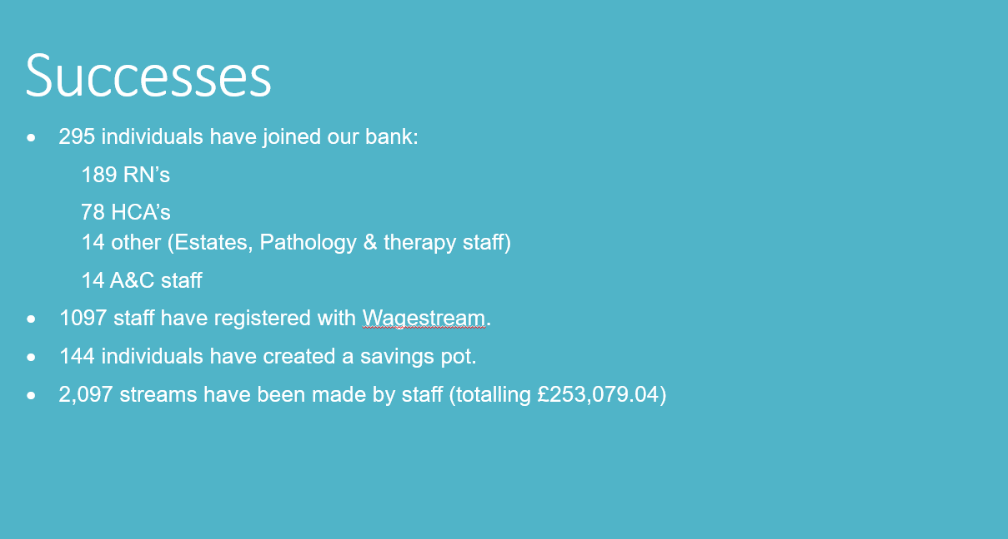
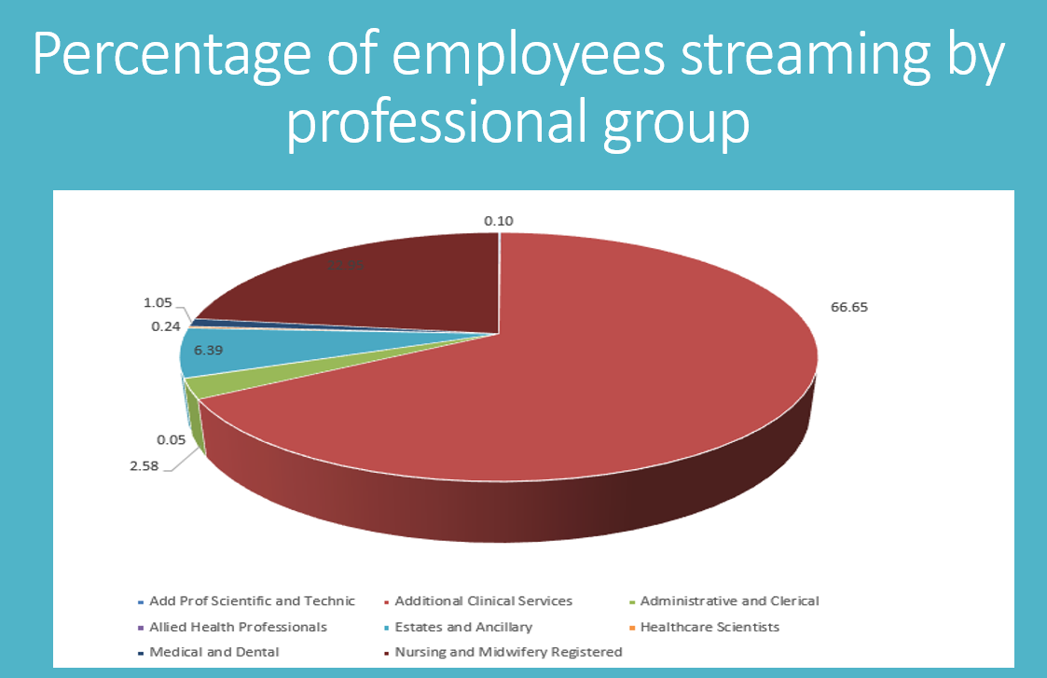
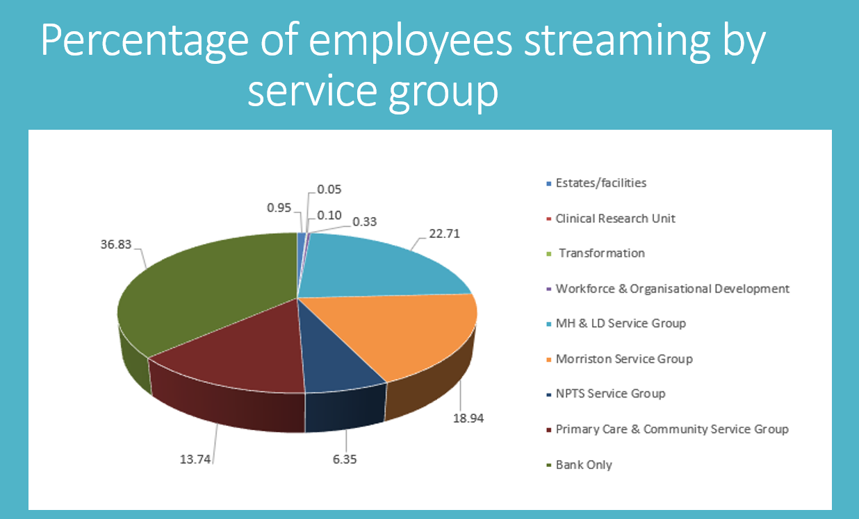

Appendix C – Ethics form
APPLICATION FOR ETHICAL APPROVAL

In order for research to result in benefit and minimise risk of harm, it must be conducted ethically. A researcher may not be covered by the University’s insurance if ethical approval has not been obtained prior to commencement.

The University follows the OECD Frascati manual definition of research activity: “creative work undertaken on a systematic basis in order to increase the stock of knowledge, including knowledge of man, culture and society, and the use of this stock of knowledge to devise new applications”. As such this covers activities undertaken by members of staff, postgraduate research students, and both taught postgraduate and undergraduate students working on dissertations/projects.

The individual undertaking the research activity is known as the “principal researcher”.

Ethical approval is not required for routine audits, performance reviews, quality assurance studies, testing within normal educational requirements, and literary or artistic criticism.

Please read the notes for guidance before completing ALL sections of the form.

This form must be completed and approved prior to undertaking any research activity. Please see Checklist for details of process for different categories of application.

SECTION A: About You (Principal Researcher)
1 | Full Name: |  | Rhiannon Akers
2 | Tick all boxes that apply: |  | Member of staff: | ☐ | Honorary research fellow: | ☐
 | Undergraduate Student | ☐ | Taught Postgraduate Student | ☐ | Postgraduate Research Student | ☒

3 | Institute/Academic Discipline/Centre: | Swansea Business School
4 | Campus: | Swansea
5 | E-mail address: | Rhiannon1985@hotmail.co.uk  0300943@student.uwtsd.ac.uk
6 | Contact Telephone Number: | 07540611814
 | For students:
7 | Student Number: | 0300943
8 | Programme of Study: | MA Strategic People Management
9 | Director of Studies/Supervisor: | Julie Thomas

SECTION B: Approval for Research Activity
1 | Has the research activity received approval in principle?  (please check the Guidance Notes as to the appropriate approval process for different levels of research by different categories of individual) |  | YES | ☒ | NO | ☐
 |  |  |  |  | Date
2 | If Yes, please indicate source of approval (and date where known): Approval in principle must be obtained from the relevant source prior to seeking ethical approval | Research Degrees Committee |  | ☐
2 |  | Institute Research Committee |  | ☐
2 |  | Other (write in) - Supervisor |  | ☒ | 10/11/23

SECTION C: Internal and External Ethical Guidance Materials
 | Please list the core ethical guidance documents that have been referred to during the completion of this form (including any discipline-specific codes of research ethics, location-specific codes of research ethics, and also any specific ethical guidance relating to the proposed methodology). Please tick to confirm that your research proposal adheres to these codes and guidelines. You may add rows to this table if needed.
1 | UWTSD Research Ethics & Integrity Code of Practice | ☒
2 | UWTSD Research Data Management Policy | ☒
3 |  | ☐

SECTION D: External Collaborative Research Activity
If there are external collaborators then you should gain consent from the contact persons to share their personal data with the university. If there are no external collaborators then leave this section blank and continue to section E.
1 | Institution | Swansea Bay University Health Board (SBUHB)
2 | Contact person name | Emma Owen
3 | Contact person e-mail address | Emma.owen@wales.nhs.uk
4 | Is your research externally funded? |  | YES | ☐ | NO |  | ☒
5 | Are you in receipt of a KESS scholarship? |  | YES | ☐ | NO |  | ☒
6 | Are you specifically employed to undertake this research in either a paid or voluntary capacity? | Voluntary | YES | ☐ | NO | ☒
7 |  | Employed | YES | ☐ | NO | ☒
8 | Is the research being undertaken within an existing UWTSD Athrofa Professional Learning Partnership (APLP)? | If YES then the permission question below does not need to be answered. | YES | ☐ | NO |  | ☒
9 | Has permission to undertake the research has been provided by the partner organisation? | (If YES attach copy)  If NO the application cannot continue | YES | ☒ | NO |  | ☐

Where research activity is carried out in collaboration with an external organisation
10 | Does this organisation have its own ethics approval system? | YES | ☒ | NO | ☐
 | If Yes, please attach a copy of any final approval (or interim approval) from the organisation (this may be a copy of an email if appropriate). TBC

SECTION E: Details of Research Activity
1 | Indicative title:
2 | Proposed start date: | November 2023 | Proposed end date: | May 2024
Introduction to the Research (maximum 300 words per section)
Ensure that you write for a Non-Specialist Audience when outlining your response to the points below:
- Purpose of Research Activity
- Proposed Research Question
- Aims of Research Activity
- Objectives of Research Activity
Demonstrate, briefly, how Existing Research has informed the proposed activity and explain
- What the research activity will add to the body of knowledge
- How it addresses an area of importance.
3 | Purpose of Research Activity  This research project will be completed with National Health Service, specifically Swansea Bay University Health Board. The purpose is to assist them in addressing one of the main areas of concern within their workforce in relation to engagement levels of bank staff.
4 | Research Question  A critical analysis of the factors impacting the engagement of bank staff in Swansea Bay University Health Board (SBUHB) with the view to improving overall engagement levels. How can these be improved to help create a service fit for purpose and positively impact retention rates?
5 | Aims of Research Activity  To make recommendations for improvements to engagement levels of bank staff within Swansea Bay University Health Board.
6 | Objectives of Research Activity  - To research and analyse existing literature regarding employee engagement with particular focus on temporary workers in healthcare settings.  - To examine how engagement impacts retention and review the effectiveness of current NHS Wales initiatives.  - To review existing secondary data from within SBUHB, including staff survey results, retention rates and leaver feedback.  - To conduct qualitative research through interviews with SBUHB staff to establish views on how to improve and sustain levels of engagement and critically evaluate research findings.
Proposed methods (maximum 600 words)
Provide a brief summary of all the methods that may be used in the research activity, making it clear what specific techniques may be used. If methods other than those listed in this section are deemed appropriate later, additional ethical approval for those methods will be needed. You do not need to justify the methods here, but should instead describe how you intend to collect the data necessary for you to complete your project.
7 | Following a review of research literature and more specifically, Saunders’ research onion, it has been determined the pragmatism paradigm will be best suited to this research as there is a business problem and the aims of the research will contribute to practical solutions that inform future practice.  Research will be exploratory and inductive; both secondary and primary data will be collected and analysed.  Secondary data will be accessed from within SBUHB to establish trends in attrition rates and staff survey results. Detailed analysis of this data will assist in identifying any gaps in employee engagement. The specifics of the primary research will be designed following this.  Primary data will be collected through qualitative research to gain insight and understanding of specific views regarding the bank service. Interviews will be conducted with current members of the NHS bank to establish their opinions and experiences. These will allow for in depth data to be obtained and for the interviewer to probe which will help to establish a full understanding of the true experience within the NHS bank.  The aim is to interview at least 5 staff to ensure a rounded view until reaching saturation of the sample. A short questionnaire may be necessary to supplement findings but this will need to be reviewed following the completion of the interviews.  Interviews will be conducted confidentially with prior consent gained from participants. Participants will be made aware that involvement is voluntary. Records will be anonymised and notes will be safely stored.
Location of research activity
Identify all locations where research activity will take place.
8 | Microsoft Teams
Research activity outside of the UK
If research activity will take place overseas, you are responsible for ensuring that local ethical considerations are complied with and that the relevant permissions are sought. Specify any local guidelines (e.g. from local professional associations/learned societies/universities) that exist and whether these involve any ethical stipulations beyond those usual in the UK (provide details of any licenses or permissions required). Also specify whether there are any specific ethical issues raised by the local context in which the research activity is taking place, for example, particular cultural and/or legal sensitivities or vulnerabilities of participants. If you live in the country where you will do the research then please state this.
9 | NA

10 | Use of documentation not in the public domain: Are any documents NOT publicly available? | NO | ☐
10 |  | YES | ☒
11 | If Yes, please provide details here of how you will gain access to specific documentation that is not in the public domain and that this is in accordance with the current data protection law of the country in question and that of England and Wales.  Access will be gained through Emma Owen (SBUHB) who is completing the relevant internal processes.  (this box should expand as you type)

 | Does your research relate to one or more of the seven aims of the Well-being of Future Generations (Wales) Act 2015? | YES | NO
12 | A prosperous Wales | ☐ | ☐
13 | A resilient Wales | ☐ | ☐
14 | A healthier Wales | ☒ | ☐
15 | A more equal Wales | ☐ | ☐
16 | A Wales of cohesive communities | ☐ | ☐
17 | A Wales of vibrant culture and thriving Welsh language | ☐ | ☐
18 | A globally responsible Wales | ☐ | ☐
19 | If YES to any of the above, please give details:
 | The aim of the research relates to improving engagement levels of part of the NHS workforce which could in turn improve the care provided on the frontline.

SECTION F: Scope of Research Activity
 | Will the research activity include: | YES | NO
1 | Use of a questionnaire or similar research instrument? | ☐ | ☒
2 | Use of interviews? | ☒ | ☐
3 | Use of focus groups? | ☐ | ☒
4 | Use of participant diaries? | ☐ | ☒
5 | Use of video or audio recording? | ☐ | ☒
6 | Use of computer-generated log files? | ☐ | ☒
7 | Participant observation with their knowledge? | ☐ | ☒
8 | Participant observation without their knowledge? | ☐ | ☒
9 | Access to personal or confidential information without the participants’ specific consent? | ☐ | ☒
10 | Administration of any questions, test stimuli, presentation that may be experienced as physically, mentally or emotionally harmful / offensive? | ☐ | ☒
11 | Performance of any acts which may cause embarrassment or affect self-esteem? | ☐ | ☒
12 | Investigation of participants involved in illegal activities? | ☐ | ☒
13 | Use of procedures that involve deception? | ☐ | ☒
14 | Administration of any substance, agent or placebo? | ☐ | ☒
15 | Working with live vertebrate animals? | ☐ | ☒
16 | Procedures that may have a negative impact on the environment? | ☐ | ☒
17 | Other primary data collection methods. Please indicate the type of data collection method(s) below. | ☐ | ☒
Details of any other primary data collection method:

(this box should expand as you type)
If NO to every question, then the research activity is (ethically) low risk and may be exempt from some of the following sections (please refer to Guidance Notes).

If YES to any question, then no research activity should be undertaken until full ethical approval has been obtained.

SECTION G: Intended Participants
If there are no participants then do not complete this section, but go directly to section H.

 | Who are the intended participants: | YES | NO
1 | Students or staff at the University? | ☐ | ☒
2 | Adults (over the age of 18 and competent to give consent)? | ☒ | ☐
3 | Vulnerable adults? | ☐ | ☒
4 | Children and Young People under the age of 18? (Consent from Parent, Carer or Guardian will be required) | ☐ | ☒
5 | Prisoners? | ☐ | ☒
6 | Young offenders? | ☐ | ☒
7 | Those who could be considered to have a particularly dependent relationship with the investigator or a gatekeeper? | ☐ | ☒
8 | People engaged in illegal activities? | ☐ | ☒
9 | Others. Please indicate the participants below, and specifically any group who may be unable to give consent. | ☐ | ☐
Details of any other participant groups:

Members of SBUHB staff bank and their management team.
(this box should expand as you type)

Participant numbers and source
Provide an estimate of the expected number of participants. How will you identify participants and how will they be recruited?
10 | How many participants are expected? | At least 5 interviews will be completed to ensure relevant sample is achieved. Will be mindful of reaching saturation.  (this box should expand as you type)
11 | Who will the participants be? | SBUHB bank staff and their management team.  (this box should expand as you type)
12 | How will you identify the participants? | This will be organised through Emma Owen, SBUHB.  (this box should expand as you type)

 | Information for participants: | YES | NO | N/A
13 | Will you describe the main research procedures to participants in advance, so that they are informed about what to expect? | ☒ | ☐ | ☐
14 | Will you tell participants that their participation is voluntary? | ☒ | ☐ | ☐
15 | Will you obtain written consent for participation? | ☒ | ☐ | ☐
16 | Will you explain to participants that refusal to participate in the research will not affect their treatment or education (if relevant)? | ☒ | ☐ | ☐
17 | If the research is observational, will you ask participants for their consent to being observed? | ☐ | ☐ | ☒
18 | Will you tell participants that they may withdraw from the research at any time and for any reason? | ☒ | ☐ | ☐
19 | With questionnaires, will you give participants the option of omitting questions they do not want to answer? | ☒ | ☐ | ☐
20 | Will you tell participants that their data will be treated with full confidentiality and that, if published, it will not be identifiable as theirs? | ☒ | ☐ | ☐
21 | Will you debrief participants at the end of their participation, in a way appropriate to the type of research undertaken? | ☒ | ☐ | ☐
22 | If NO to any of above questions, please give an explanation
 | (this box should expand as you type)

 | Information for participants: | YES | NO | N/A
24 | Will participants be paid? | ☐ | ☒ | ☐
25 | Is specialist electrical or other equipment to be used with participants? | ☐ | ☒ | ☐
26 | Are there any financial or other interests to the investigator or University arising from this study? | ☐ | ☒ | ☐
27 | Will the research activity involve deliberately misleading participants in any way, or the partial or full concealment of the specific study aims? | ☐ | ☒ | ☐
28 | If YES to any question, please provide full details
 | (this box should expand as you type)

SECTION H: Anticipated Risks

Outline any anticipated risks that may adversely affect any of the participants, the researchers and/or the University, and the steps that will be taken to address them.

If you have completed a full risk assessment (for example as required by a laboratory, or external research collaborator) you may append that to this form.
1 | Full risk assessment completed and appended? |  | Yes | ☐
1 |  |  | No | ☒
2 | Risks to participants  For example: sector-specific health & safety, emotional distress, financial disclosure, physical harm, transfer of personal data, sensitive organisational information
 | Risk to participants:  - Confidentiality and anonymity not being protected.  - Time out of working day which could impact their ability to meet patient care demands.  - Possible feelings of pressure to participate.  - Sensitive organisational information.  (this box should expand as you type) | How you will mitigate the risk to participants:  - Interview notes will be redacted accordingly and the interviewer will organise the research to ensure the sample is anonymous.  - The interviewer will liaise with the workforce planning team to ensure interviews are conducted at the most suitable time for staff and will be flexible.  - Consent will be gained along with a full explanation of the process with clear guidance that participation is voluntary.  - Any secondary data reviewed will be anonymised prior to being provided.  (this box should expand as you type)
3 | If research activity may include sensitive, embarrassing or upsetting topics (e.g. sexual activity, drug use) or issues likely to disclose information requiring further action (e.g. criminal activity), give details of the procedures to deal with these issues, including any support/advice (e.g. helpline numbers) to be offered to participants. Note that where applicable, consent procedures should make it clear that if something potentially or actually illegal is discovered in the course of a project, it may need to be disclosed to the proper authorities
The research topic is subjective as it deals with individual’s feelings and perceptions. If throughout the interviews it is identified that welfare support is required adequate signposting will be provided. If there is something their employer should be aware of, individual consent will be gained and relevant feedback will be passed on accordingly. This will be outlined in the initial consent form.

(this box should expand as you type)
4 | Risks to the investigator  For example: personal health & safety, physical harm, emotional distress, risk of accusation of harm/impropriety, conflict of interest
 | Risk to the investigator:  None identified.  (this box should expand as you type) | How you will mitigate the risk to the investigator:  NA  (this box should expand as you type)
5 | University/institutional risks  For example: adverse publicity, financial loss, data protection
 | Risk to the University:  Possible reputational damage if data not handled appropriately.  (this box should expand as you type) | How you will mitigate the risk to the University:  Any data will be shared securely and recorded confidentially.  (this box should expand as you type)
6 | Environmental risks  For example: accidental spillage of pollutants, damage to local ecosystems
 | Risk to the environment:  Time taken to complete the interviews could negatively impact NHS staffing levels.  (this box should expand as you type) | How you will mitigate the risk to environment:  The workforce planning team from SBUHB will co-ordinate the interviews to ensure adequate staffing levels will be met.  (this box should expand as you type)

 | Disclosure and Barring Service
 | If the research activity involves children or vulnerable adults, a Disclosure and Barring Service (DBS) certificate must be obtained before any contact with such participants. | YES | NO | N/A
7 | Does your research require you to hold a current DBS Certificate? | ☐ | ☒ | ☐
8 | If YES, please give the certificate number. If the certificate number is not available please write “Pending”; in this case any ethical approval will be subject to providing the appropriate certificate number.

SECTION I: Feedback, Consent and Confidentiality

1 | Feedback  What de-briefing and feedback will be provided to participants, how will this be done and when?
Participant welfare will be checked immediately after the interview and consent will be reiterated.
Participants will be provided with a summary of the research findings upon completion of analysis.
(this box should expand as you type)
2 | Informed consent  Describe the arrangements to inform potential participants, before providing consent, of what is involved in participating. Describe the arrangements for participants to provide full consent before data collection begins. If gaining consent in this way is inappropriate, explain how consent will be obtained and recorded in accordance with prevailing data protection legislation.
A full explanation of the research aims and objectives will be emailed to all potential participants requesting for volunteers.
Once participants volunteer they will be emailed a consent form for completion documenting the intended use of their data. This will also be clarified verbally prior to commencing the interviews.
Signed consent will be stored confidentially.

(this box should expand as you type)
3 | Confidentiality / Anonymity  Set out how anonymity of participants and confidentiality will be ensured in any outputs. If anonymity is not being offered, explain why this is the case.
Names will be redacted from notes taken during the interviews.
(this box should expand as you type)

SECTION J: Data Protection and Storage

 | Does the research activity involve personal data (as defined by the General Data Protection Regulation 2016 “GDPR” and the Data Protection Act 2018 “DPA”)? | YES | NO
1 | “Personal data” means any information relating to an identified or identifiable natural person (‘data subject’). An identifiable natural person is one who can be identified, directly or indirectly, in particular by reference to an identifier such as a name, an identification number, location data, an online identifier or to one or more factors specific to the physical, physiological, genetic, mental, economic, cultural or social identity of that natural person. Any video or audio recordings of participants is considered to be personal data. | ☐ | X
 | If YES, provide a description of the data and explain why this data needs to be collected:
2 | (this box should expand as you type)
 | Does it involve special category data (as defined by the GDPR)? | YES | NO
3 | “Special category data” means sensitive personal data consisting of information as to the data subjects’ –  (a) racial or ethnic origin,  (b) political opinions,  (c ) religious beliefs or other beliefs of a similar nature,  (d) membership of a trade union (within the meaning of the Trade Union and Labour Relations (Consolidation) Act 1992),  (e) physical or mental health or condition,  (f) sexual life,  (g) genetics,  (h) biometric data (as used for ID purposes), | ☐ | X
 | If YES, provide a description of the special category data and explain why this data needs to be collected:
4 | (this box should expand as you type)

 | Will data from the research activity (collected data, drafts of the thesis, or materials for publication) be stored in any of the following ways? | YES | NO
5 | Manual files (i.e. in paper form)? | ☐ | ☒
6 | University computers? | ☐ | ☒
7 | Private company computers? | ☐ | ☒
8 | Home or other personal computers? | ☐ | ☒
9 | Laptop computers/ CDs/ Portable disk-drives/ memory sticks? | ☐ | ☒
10 | “Cloud” storage or websites? | ☒ | ☐
11 | Other – specify: | ☐ | ☐
12 | For all stored data, explain the measures in place to ensure the security of the data collected, data confidentiality, including details of backup procedures, password protection, encryption, anonymisation and pseudonymisation:
All data will be stored on a secure One Drive which is accessible only by the researcher.

(this box should expand as you type)

 | Data Protection
 | Will the research activity involve any of the following activities: | YES | NO
13 | Electronic transfer of data in any form? | ☒ | ☐
14 | Sharing of data with others at the University outside of the immediate research team? | ☐ | ☒
15 | Sharing of data with other organisations? | ☐ | ☒
16 | Export of data outside the UK or importing of data from outside the UK? | ☐ | ☒
17 | Use of personal addresses, postcodes, faxes, emails or telephone numbers? | ☐ | ☒
18 | Publication of data that might allow identification of individuals? | ☐ | ☒
19 | Use of data management system? | ☐ | ☒
20 | Data archiving? | ☐ | ☒
21 | If YES to any question, please provide full details, explaining how this will be conducted in accordance with the GDPR and Data Protection Act (2018) (and any international equivalents, where appropriate):
The following information has been requested from SBUHB:
- Staff survey results relating to engagement and management support (are these broken down between bank and substantive staff?)
- Management training aimed at how to support staff
- Attrition figures for bank staff from the last 3 years
- Reasons for bank staff leaving and exit interview feedback
- Confirmation of the exit interview process
- Summary of the new initiative to increase payment frequency to bank staff
This secondary data will be fully redacted and anonymised before being sent electronically to aid the research. SBUHB are following their own internal data protection processes prior to sharing the information.

(this box should expand as you type)
22 | List all who will have access to the data generated by the research activity:
Emma Owen (SBUHB)
Julie Thomas (UWTSD)

(this box should expand as you type)
23 | List who will have control of, and act as custodian(s) for, data generated by the research activity:
Rhiannon Akers (primary researcher)

(this box should expand as you type)
24 | Give details of data storage arrangements, including security measures in place to protect the data, where data will be stored, how long for, and in what form. Will data be archived – if so how and if not why not.
Data will be stored in a secure One Drive and will be archived following completion of the dissertation in May 2024.

(this box should expand as you type)
25 | Please indicate if your data will be stored in the UWTSD Research Data Repository (see https://researchdata.uwtsd.ac.uk/ ). If so please explain. (Most relevant to academic staff)
NA

(this box should expand as you type)
26 | Confirm that you have read the UWTSD guidance on data management (see https://www.uwtsd.ac.uk/library/research-data-management/) | YES | ☐
27 | Confirm that you are aware that you need to keep all data until after your research has completed or the end of your funding | YES | ☐

SECTION K: Declaration
The information which I have provided is correct and complete to the best of my knowledge. I have attempted to identify any risks and issues related to the research activity and acknowledge my obligations and the rights of the participants.

In submitting this application I hereby confirm that I undertake to ensure that the above named research activity will meet the University’s Research Ethics and Integrity Code of Practice which is published on the website: https://www.uwtsd.ac.uk/research/research-ethics/
1 | Signature of applicant: | R. Akers | Date: 23/11/23

For STUDENT Submissions:
2 | Director of Studies/Supervisor: |  | Date:
3 | Signature: |  | Date:

For STAFF Submissions:
4 | Academic Director/ Assistant Dean: |  | Date:
5 | Signature: |  | Date:

Checklist: Please complete the checklist below to ensure that you have completed the form according to the guidelines and attached any required documentation:
☒ | I have read the guidance notes supplied before completing the form.
☒ | I have completed ALL RELEVANT sections of the form in full.
☒ | I confirm that the research activity has received approval in principle
☐ | I have attached a copy of final/interim approval from external organisation (where appropriate)  AWAITING EMAIL CONSENT – SHOULD BE RECEIVED BY 01/12/23
☐ | I have attached a full risk assessment (where appropriate) ONLY TICK IF YOU HAVE ATTACHED A FULL RISK ASSESSMENT
☒ | I understand that it is my responsibility to ensure that the above named research activity will meet the University’s Research Ethics and Integrity Code of Practice.
☒ | I understand that before commencing data collection all documents aimed at respondents (including information sheets, consent forms, questionnaires, interview schedules etc.) must be confirmed by the DoS/Supervisor, module tutor or Academic Director.

RESEARCH STUDENTS AND STAFF ONLY
All communications relating to this application during its processing must be in writing and emailed to pgresearch@uwtsd.ac.uk , with the title ‘Ethical Approval’ followed by your name.
You will be informed of the outcome of your claim by email; therefore it is important that you check your University and personal email accounts regularly.
STUDENTS ON UNDERGRADUATE OR TAUGHT MASTERS PROGRAMMES should submit this form (and receive the outcome) via systems explained to you by the supervisor/module leader.

Appendix D – Participant consent form

Participant Name: __________________________________
Interviewer Name: Rhiannon Akers
Interviewer Programme of Study: MA in Strategic People Management
Research Learning Tutor: Julie Thomas
Participation Agreement to be interviewed:
I agree to participate in the research concerning factors impacting the engagement of bank staff. I understand that the purpose of this study is to understand what motivates staff to be part of the bank and how engagement can be improved. I understand that this will involve me in a short 20-30 minute interview.
I understand that this interview will be recorded and transcribed for use only in the interviewer’s programme at the University of Wales Trinity Saint David.
I understand that my name or any reference to my identity will be kept anonymous in this study and for any subsequent publications I will be asked again for my consent. I understand that storage of the recordings and transcriptions relating to this interview will be anonymous; not be used for any other purpose than this study and will be subsequently destroyed after the use intended here.
I understand that I may withdraw from the study at any point with all records of my contribution removed without having to provide a reason.

Interviewee Signature:
Interviewer Signature:
Date of Interview:
A copy of this agreement should be retained by both interviewer and interviewee.

Appendix E – Email to participants
Hi NAME
Thanks for getting in touch to confirm your interest in participating in the research project into factors impacting the engagement of bank staff. It is great to have you onboard.
Prior to meeting could you confirm your current role within the bank please?
Are you available to attend on DATE at TIME? If so, would you prefer to meet via Teams or face to face?
I have attached the participation agreement you will be required to sign when we meet (this can be done virtually if your preference is via Teams).
Please let me know if you have any questions.
I look forward to meeting you.
Thanks,
Rhi
Rhiannon Akers (PGDip in Human Resources, Chartered FCIPD)
Lecturer in Human Resources Management
Institute of Management and Health
University of Wales Trinity Saint David
Powell Street, Swansea SA1 1NE
Email: r.akers@uwtsd.ac.uk

Appendix F – Interview questions
Research interview focussing on engagement levels of members of the NHS bank
Date:
Time:
Job title:
Length of time working as part of the bank:
- Talk me through your decision to join NHS bank?
- What do you see as the key benefits of being part of the bank?
- How do you feel bank staff are perceived?
- Do you feel part of NHS team? If yes, why? If no, why?
- What motivates you in work? (Give options if needed – patient care, money, recognition)
- How could the bank service be improved?
- How would you describe support from management?
- Do bank staff have a voice within SBUHB? Please explain
- Wagestream initiative?
- Why not agency?
- Any further comments?

Appendix G – Transcript example
Transcript
14 March 2024, 11:38am

Rhiannon Akers started transcription

Rhiannon Akers 0:04
And there we go. OK, so it's transcribing now for us and yeah, so does that all sound OK? Do you have any questions or anything?
Participant 0:13
Oh, no, really, because I've gone through what you sent to me. I've read everything. And it's OK. Yeah.
Rhiannon Akers 0:17
Lovely. Great. Thank you. It's a pleasure to meet you. Like I said. And first of all, are you able to tell me a little bit about your role in the bank? So what you do and how long you've worked as a member of bank staff as well?
Participant 0:35
Yeah, I think my role in in the bank is, you know based on the position I'm into now in, in the Swansea area, which is band three, it’s a position where you don't need anybody to supervise you. You just like do your thing. So you're accountable for what you do.
Rhiannon Akers 0:45
Mm hmm.
Participant 1:02
I joined the trust last September and my manager really tried for me in getting me on the bank.
Rhiannon Akers 1:16
Ok.
Participant 1:23
I think a month or so after because it's not that easy to join the bank. So yeah, but she did try to help. Since then I've been able to pick shifts on the back.
Rhiannon Akers 1:38
Right. OK, great.
So why did you decide to join the bank then?
Participant 1:47
Let me see. Basically, people look for extra income.
Rhiannon Akers 1:54
Yeah.
Participant 1:55
Yeah, which is majorly why people look to take extra shifts from the bank. But if you look at the aspects of not the monetary aspects, you know that's different. But really if you want to know, I believe to me personally, I know if you want to know your patients more.
You have to create more time more. That means your availability must be constant with them you know on and off doesn't get you to know or the patient to really know you. The more so and to be able to establish yourself in the job you're doing, you have to. So that is the main reason why I joined the bank.
Rhiannon Akers 2:35
Oh, that makes sense. So you have a substantive post within the NHS, and then you do bank work on the side as well?
Participant 2:42
Yes, because if I should stay with my substantive shift with the NHS, I may not be able to know my patient very well and I may not be able to gain more.
Or to tap into the knowledge of those that have been in the system for long.
Rhiannon Akers 2:57
Yeah, that makes sense. So, you joined the NHS in September and then you joined the bank shortly after.
Yeah. So, right, October kind of time, was it a month after?
Participant 3:08
Yeah, yeah.
Rhiannon Akers 3:10
Lovely. OK, that's useful. Thank you.
So in terms of the benefits, you’ve referenced the extra income and getting to know your patients. What other benefits do you see as being a key part of bank work?
Participant 3:31
Oh yeah, I think the benefit of the bank is.
You know, let me put it in the in the sense that.
In knowing your patient, he is like giving you the avenue or the platform to work.
In an extra.
Mindset.
With your patient in the sense that fine if I were I don’t know, my substantial shift after finishing the day shift, no, I would like I would have like 3 days off which I can have for myself. But when you have the passion for what you are doing, that means you really have the interest of the job in art. The bank really gives you the avenue to showcase that interest to whom you are looking after or taking care of. So the bank has given me the avenue just to move around.
You know, if I'm employed, for instance, I'm employed here in Morriston.
But the bank also have given me the privilege to move to other wards to know what is going on in other wards, all that you understand what I'm saying. So the bank has really widened my mindset and my IQ concerning the job.
Rhiannon Akers 4:45
Yeah, brilliant. So, it's given you that extra opportunity, I suppose?
Participant 4:58
Yeah.
Rhiannon Akers 5:02
And in terms of perception, I know you're obviously a substantive member of staff and work as part of the bank. How do you feel bank staff are perceived by substantive staff.
Participant 5:16
I really believe it is the same work, if you know what you're doing, and you meet people who are substantial staff and bank staff. Everyone is working under the same umbrella. Our goal is the same thing.
Rhiannon Akers 5:34
Yeah.
Participant 5:39
Everybody, those I've met, we work in one accord.
Rhiannon Akers 5:43
Right. So, it's like a team.
Participant 5:44
Yes, there is no difference between the two because literally once you come in, I wear the same uniform with you. People paying us is also paying my wages, so our goal is looking for the patient also. It's still the same thing. Those I really work with, we are so cool. Perfect. Everything has been fine.
Rhiannon Akers 6:12
Thanks.
And in terms of your motivation, you've referenced the kind of opportunities you get and getting to know your patients as well. And I guess I suppose extra income, are there any other things that motivate you in work?
Participant 6:31
My manager really motivated me.
Rhiannon Akers 6:34
That’s great to hear.
Participant 6:41
Yeah, she really gave me the platform. Like NAME, you can work on your own. I believe in you. I know you can do it, but once you need anything for me, just call on me or call on the staff and really, the team I've been working with have been so excellent.
Rhiannon Akers 6:57
That's good.
Participant 6:58
Yeah, you know, when you're working in a place to me, I believe my workplace is my second home.
Rhiannon Akers 7:08
Amazing. We do spend so much in work don’t we.
Participant 7:08
I believe my workplace isn’t like I'm working, it’s home from home.
Rhiannon Akers 7:13
Yeah.
Mm hmm.
Participant 7:19
So all those I've met there, the team, everyone had given me a lot of, like encouragement that motivated me.
Rhiannon Akers 7:22
Yeah.
Brilliant, so that the support from management is kind of motivational encouraging?
Participant 7:34
Yeah.
Yes, because if I don't work in a place where people share the same mindset, you know, I'll be discouraged. So they’re really giving me the platform.
Rhiannon Akers 7:48
Thanks. What are your suggestions of how the bank service could be improved do you think?
Participant 8:02
Hmm.
Though the bank has been really good in the sense that people really depend on them, but if you don't get some training you can't work in some wards which is which is very very good but for one thing me I will really want is.
You know, I we we believe we see the same thing because we're basically we see it is at the second job.
Yeah, because you know, and some people, you know, some staff, some may be doing like, OK, night shift after night shift.
Some never come in for a day shift.
Which is not really good in the sense of knowing your patient more.
Rhiannon Akers 9:34
Mm hmm, that makes sense. OK.
Participant 9:35
You might have been working 30-40 years before. You might have acquired the knowledge, but we really know that this patient or this that we work with, some of them develop some new skills. And you coming in the night you might not know, though there might be probably there might be proper handover how this is what patiently could there be good communication from the this staff to the night staff. You still need to come in. Also not doing only the night shift alone. Coming during the day to know your patient.
Rhiannon Akers 10:09
How do you think you could overcome that? Do you think from your knowledge?
Participant 10:20
From my own angle, I might think OK, you know, when once I book, for instance, if I booked the night shift, now is me acknowledged by the bank. I understand. So when if we are taking more of the bank shift and there is no day shift there, the bank should be also be able to dictate from them self. So sorry, why are you not taking bank on day shift like a message or if the if you know when the message or when the reason is really OK.
For them to go on the bank on the night shift, fine, people might say because of my kid, people might say because of my family. Yeah, but once in a while also, just give some sort of encouragement.
Ask can you please also take one or two day shift?
Rhiannon Akers 11:06
Mm hmm.
Participant 11:06
Yeah, just to know your patient, the more you know in a polite way, people will acknowledge that also. And if you really help also to broaden the scope of work of that of the staff.
Rhiannon Akers 11:19
Yeah. Makes sense. OK, thank you.
And from your point of view, do bank staff have a voice within the health board? Are they able to get their kind of opinions across?
Participant 11:37
Yes, to me, I will say yes, but sometimes it depends on the management.
Rhiannon Akers 11:44
In what way?
Participant 11:45
You know, because the reason why I say depend on the management is you know your substantial shift members have the opportunity to relate more with the management because they see each other during the daytime. But in general, they respect people's view and give accordingly. Treat each and every member of the staff equally well. We have equality.
Rhiannon Akers 12:27
Mm hmm.
Participant 12:27
I feel my voice can be heard. This is what people say and we all attend meetings together. Not excluding the bank staff, so it is all ok.
Rhiannon Akers 12:47
That makes sense. It depends on the individual sometimes.
Participant 12:53
Yes.
Rhiannon Akers 12:54
Have you utilised the wage stream initiative that has been launched?
Participant 13:00
Yeah, it's been launched. Yes, even though it was one of my in my colleague that helped me out, he was like, oh, NAME have you got this? I said yes. I got the message. But really it is good because I used it once. Even though I only used it once it is really good.
Rhiannon Akers 13:23
Do you think it's been beneficial for quite a few people or do you know many people use?
Participant 13:24
Yes, right. I have a discussion with a colleague. He was like, oh, it’s good. Even he was one. That prompted me to test run it myself because he was like, oh, it's really helped me, it boosts him financially in the sense that he is able to sort some things he needs to sort out because he couldn't wait till the end of the month.
To sort it out, and he does not want to take a loan or borrow money from anybody, but with the help of the wage stream, he could collect the money he needs. So the app makes life easy for some of the stuff.
Rhiannon Akers 14:20
Yeah, definitely. Good. And I suppose it depends on your circumstances when you use it.
Participant 14:24
Yes.
Rhiannon Akers 14:27
What do you think the benefits of working for the bank as opposed to an agency are?
Participant 14:48
I was working with an agency before I joined the trust and you know the agency pays more than the bank. Yeah. And if you now look at it, it could be fine to pay the same rate they pay the agency to the bank staff.
Rhiannon Akers 15:51
Yeah.

Participant 15:51
Yeah. And maybe give the people opportunity also to come into the bank.
Rhiannon Akers 15:59
Yeah. So, the agency pays more. And do you think there could be closer links between?
Participant 16:00
Yes. You know if the bank wants to encourage people to come in, yes, because number one, they see even though you work on the bank for the trust, you still get the privilege. I mean, secure job.
Rhiannon Akers 16:25
Mm hmm.
Participant 16:26
Yeah, you can pick the shift at your own convenience. You can decide you want to work on so, so day, and you don't want to work on so, which is always, let me say sincerely speaking is more preferable to work with the trust with that than the agency, just that the money for the agency is more, but the shift will not be coming constantly. But once you are on the bank, you'll be able to pick.
Rhiannon Akers 16:52
Yeah, that makes sense. Lovely. Thank you.
Participant 16:56
You're welcome.
Rhiannon Akers 16:57
That's really useful is. Is there anything else you wanted to mention? Any general feedback that you think you'd like to mention?
Participant 16:58
My general feedback would be good. Yes, it will. It will be excellent because the training we get as substantive staff is the same. Both bank staff and substantive staff were on the same training course, those that were there are also from the bank, which means everything is working in place.
Rhiannon Akers 17:24
Mm hmm yeah.
Yeah.
Participant 17:38
I love the reminder given to people also.
I mean, if I'm working tomorrow now, there will be a reminder that is sent to me through my mail.
Rhiannon Akers 17:51
That's good. OK, that's really useful to know. So they're covering all bases trying to make sure shifts are covered and people turn up as well.
Participant 18:05
Yes.
Rhiannon Akers 18:08
Lovely. Oh, that's been really helpful. Thank you so much for your insights.
Participant 18:12
Yeah. You're welcome.
Rhiannon Akers 18:14
If there is anything any questions you have or anything else that comes to mind that you want to add then let me know.

