Alternatives To Traditional Procurement

By Dylan J Pugh (2011595)

Contents
1. Introduction 2
2. What is Procurement in Construction 2
3. Types of Modern and Traditional Procurement 2
4. Welsh Assembly Building - Senedd and the approach taken 3
5. Scottish Parliament Building – Holyrood and the approach taken 4
6. Conclusion 4
7. References 5
8. Appendices 6

Introduction
In the following report, I’ll be looking at the procurement and tendering process within the construction industry regarding its reputation for quality and service. I’ll be looking at 2 projects in particular the Senedd and Holyrood both which had issues and used different procurement routes as examples. With looking at what problems and issues arose and whether or not there was a better approach that could’ve been taken instead for each of the projects.

What is Procurement in Construction
Procurement is the “Act of obtaining or purchasing goods or services” (Young, 2022) this is procurement in general as its to gain a means to do a task or activity. Within construction terms its described as the “lifecycle of a construction project” (CIOB, 2023) by the CIOB. It’s the way a project is carried out as there are a variety of methods or strategies. However each route contains it’s on risks and its benefits as well which will affect the client or contractor in different ways.
The main factors that help determine the method used is understanding the clients requirements and then down to the 3 risks which are Cost, Time and Quality as you can only have 2 out the 3 as one has to be sacrificed for the other 2 to happen. The reasons for these risks to occur can be down to delays in schedules, re-designs, increased prices of goods which you haven’t allowed in the tender or relationship with different parties. See Appendix 1 – Cost, Time and Quality Triangle.

Types of Modern and Traditional Procurement
There is all different types of procurement routes but they fall into 3 main groups which are the main procurement routes and most effective. Being Traditional, Design & Build and Management. The differences between these routes is down to who the risk falls upon either being the Client or Contractor.
Traditional Procurement is the oldest and popular procurement routes as there is 2 routes within it you can take being Single Stage Tendering or Two Stage Tendering. This procurement separates design from construction as the design team is selected by the client then the contractor is appointed after the tender process. Single stage is based on competitive tendering as the design and bill of quantities must be complete before issued out for contractors to tender. However, two stage tries to involve the contractor and designer together soon as possible in the design. The advantages of this method is that it “Transfer risk to the Contractor”, “Time to invest into design” and better level of cost comparison between different contractors. (TSK, 2021). This route relays on the relationship between the client and contractor as the contractor will carry out the work and the client or a Clerk of Works will supervise and monitor the project and making sure the requirements are being met.
Design and Build is the second most popular procurement route as it focus is to transfer the risk to the contractor as they’ll be “appointed to both design and then construct” (Wiki, 2022). As the name of this method suggests the contractor will appoint a design team to design the project to the clients requirements then for them to build it themselves. This method does reduce the quality as the contractor will have the costs and time on them as they’ll be the responsible party.
Lastly, Management is the most recent procurement method to be used where a company will do the whole project themselves. This route then would issue works out for other contractor or subcontractors to do for them as this could be specialist works such as concrete finishing, brick-laying or laying tracks. The main advantage of this route is cost as there’s no need for a main contractor. Although, the disadvantage of this method is all risk is on the client and it’s much more complex procurement route. (Architecture, 2020).

Welsh Assembly Building - Senedd and the approach taken
The Welsh Assembly Building, also known as the Senedd. This is the Welsh Parliament building in Cardiff down in the Cardiff Bay. The Senedd is also the auditing committee with in Wales. The building took occupation in February 2006. The design and start of the procurement for the Senedd started back in 1998. The approach taken for the construction of the Senedd was Design and Build. The first design was done by Sir Richard Rogers but was then revised in 2001 and approved for groundworks to begin. See Appendices 2 and 3 for images of the original designs for the Senedd.
In 2002 a review of the project was held. Which had an invite for “tender issued for the revised design and build contract.” (Senedd, 2021). This was due to the project being put on hold in 2001 as the architects, “Richard Roger Partnership, after forecast costs shot up” (Finance, 2008). Then starting back in 2002. In 2003 the Taylor Woodrow consortium won the contract for design and build of the Senedd.
In the report issued back in 5th November 2008 by the Audit Committee to the National Welsh Assembly, the committee stated that the project was handled well and had a “successful delivery” (Committee, 2008). They said this was due to “the establishment of an appropriate project management structure and a team which worked together effectively.” (THE NATIONAL ASSEMBLY FOR, 2008). The media had scrutinized the project for being over on time. However, the delays they suffered on the project were due to issues with the re-tendering of the project back in 2002/2003 and IT systems. When the project was put on hold back in 2001 due to the sacking of the original architect, they’re issued it out for tender with Taylor Woodrow Consortium wining the tender but it was only them and David McLean that submitted a formal tender. To make matters worse the tender that was submitted by McLean wasn’t up to the requirements issued by the Assembly Government. Welsh Assembly and McLean did reach an agreement that David McLean would become the Fall Back option after they re submitted their tender. Furthermore, what caused the project to be on delay and behind was the procurement on the IT systems. See Appendix 4 for Cover and Contents Pages of the Senedd 2008 Audit Report.

Scottish Parliament Building – Holyrood and the approach taken
Holyrood also known as the Scottish Parliament Building. Located in the capital city, Edinburgh. The discussions of the project started in 1997 and was completed in 2004. Construction started in June 1999. The architect for the project was Enric Miralles from Catalan. The procurement route that was adopted was the Construction Management route, this was because it was found to be “one of the most significant, if not the most significant” (Building the Scottish Parliament, The Holyrood , 2005). They believed this would work the best due to the advantage of speed with the disadvantage of the price uncertainty.
The decision to use this route was aided but the design team and professional consideration. However, the downfall to their procurement route and the project was in the documentation as the procurement route wasn’t fully complete and they didn’t prepare a comprehensive document which heavily effected the project. The project could’ve avoided this if they carried a reasoned analysis and more consideration to the procurement route. The project suffered from these repercussions as it become overdue and over budget.
The tenders for the Construction Manager were opened for bidding in November 1998. Bovis won the tender and was appointed as the projects Construction Manager. Although they were the most expensive option coming at a total of £6,272,162. With the next tender being £135,406 less than them. See Appendix 5 for table showing a summary of the Tenderer’s.
Holyrood projects timetable and budget well exceed the planned amount due to various factors and set backs to the project. In 2000, they carried out an audit on the project and it estimated to “risen from £90 million (January 1998) to £195 million (latest).” (General, 2000). The rising cost didn’t stop there as the cost continued to increase through out the project and the forecast at the time estimated the project to go on for 18 months longer than forecasted. These delays caused the media and public to scrutinized the project and government for their poor management. One of the rising costs was due to a re-design to increase the space inside the building which added extra costs as more material, new units to made and delays on schedules. See Appendix 6 – Table showing the impact of additional space and increased units.
For further evidence showing the increasing costs to the project see Appendix 7 – Increase forecast costs of the Holyrood Project.

Conclusion
With researching and looking further into the both projects and different sources regarding them I can see how the both projects performed and how the two different procurement routes worked. In conclusion, I believe The Senedd project was the better of the two as the route it used was more effective and managed better than Holyrood in terms of cost and time.
The Senedd used the design and build procurement route. Design and build gives the contractor all responsibility with the project and how its run. This method worked for the project as it had its set backs at the start with the sacking of the original architect then re-issued back out in 2002 and then the delay with the procurement on the IT systems. However, this didn’t effect the project heavily on the cost element and was delayed by 6 months but that wasn’t anything to due on the construction side. I think the best approach for this was Design and Build as it worked well for the project and weren’t any major issues due the construction phase.
With Holyrood, the method they used was Management. This route is effective and efficient as the client has full control and cost of the project but what caused the downfall to this project was the management of it. The client, Scottish Government managed the project awfully and poorly. As they failed to complete and didn’t do a comprehensive procurement for the project which later caused a knock on effect to the project. The project resulted in being heavily over budget and way over on the scheduled completion date. This project should’ve taken the Design and Build approach as the responsibility of the project and risk would’ve shifted to the contractor and all the pressure be on them to complete within time and in budget. Also, the design they would come up with wouldn’t change and the client won’t have any involvement in the process as it seemed the Scottish Government didn’t have the facilities to carry it out to the best standard and kept altering the design and adding cost and time. However, the Management route could’ve worked well if they gave more time and effort into the tendering and design stages as this would of improved the quality of the project and procurement route and reducing the costs.

References
Architecture, V. (2020, April 19). 3 Main procurement routes explained. Retrieved from Vita Architecture: https://vitaarchitecture.com/journal/the-3-main-procurement-routes-explained/
CIOB. (2023, January 6). Procurement. Retrieved from CIOB: https://www.ciob.org/industry/policy-research/policy-positions/procurement
Committee, A. (2008). THE NATIONAL ASSEMBLY FOR. Cardiff: National Assembly for Wales.
Finance, P. (2008, March 14). Auditor praises Senedds final stage. Retrieved from Public Finance: https://www.publicfinance.co.uk/news/2008/03/auditor-praises-senedds-final-stage
General, A. (2000). The new Scottish Parliament building. Edinburgh: Auditor General .
Hawkes, D. (2010, December 14). Procurement in the Construction Industry. Retrieved from CIOB: https://www.ciob.org/industry/research/Procurement-Construction-Industry
Hogan, P. (2019, May 24). 5 Challenges in Procurement That Plague Construction Companies. Retrieved from PASA: https://procurementandsupply.com/2019/05/5-challenges-in-procurement-that-plague-construction-companies/#:~:text=5%20Challenges%20in%20Procurement%20That%20Plague%20Construction%20Companies,procurement%20cycle%20...%205%205.%20Inaccurate%20data%20
Hudson, J. (2020, August 17). What is tendering in construction? Retrieved from Construction Tenders : https://www.construction-tenders.co.uk/what-is-tendering-in-construction/
Isbol White, I. S. (2005). Building the Scottish Parliament, The Holyrood . Edinburgh: Parliament and Constitution Centre.
IvyPanda. (2021, December 2). Scottish Parliament Building: Project Failure Essay. Retrieved from IvyPanda: https://ivypanda.com/essays/scottish-parliament-building-project-failure/
PlanRadar. (2021, February 22). 7 major risks in construction projects and how to avoid them. Retrieved from PlanRadar: https://www.planradar.com/gb/builders-risk/#:~:text=1%20Failure%20to%20comply%20with%20contractual%20quality%20requirements,Scheduling%20errors%2C%20contractor%20delays%203%20Project%20team%20conflicts
Senedd. (2021, March 9). Senedd at 15. Retrieved from Senedd Wales: https://senedd.wales/visit/our-estate/senedd-at-15/
Stephen Clancy, C. (2016, August 31). In an SOW triangle: Cost, speed and quality are a delicate balance. Retrieved from SIA: http://cwstrategies.staffingindustry.com/sow-management-cost-speed-and-quality-a-delicate-balance/
TSK. (2021, October 25). Design and Build vs Traditional Procurement. Retrieved from TSK: https://tskgroup.co.uk/design-build-vs-traditional-procurement/#:~:text=Pros%20of%20Traditional%20Procurement%3A%201%20Greater%20level%20of,Affords%20clients%20time%20to%20invest%20in%20the%20design
Wiki, T. C. (2022, October 12). Design and build procurement route. Retrieved from Designing Buildings, The Construction Wiki: https://www.designingbuildings.co.uk/Design_and_build_procurement_route
Young, J. (2022, July 6). What is Procurement? . Retrieved from Investopedia: https://www.investopedia.com/terms/p/procurement.asp

Appendices
Appendix 1 – Cost, Time and Quality Triangle (Stephen Clancy, 2016)
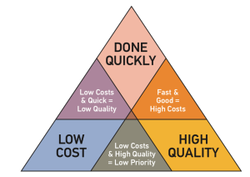
Appendix 2 – Design concept of the Senedd from 2001 (Senedd, 2021)
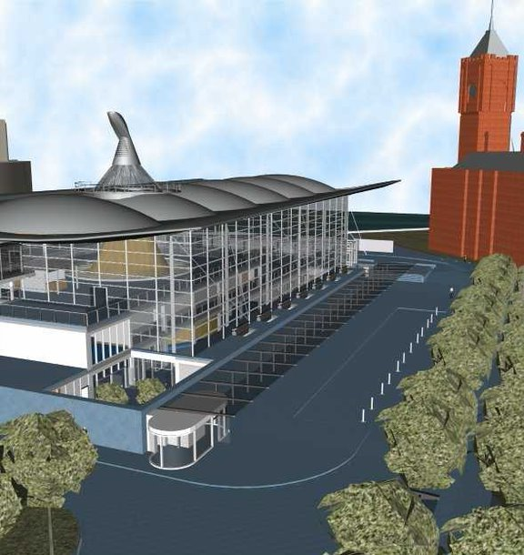
Appendix 3 – Design concept of the Senedd from 2002 (Senedd, 2021)
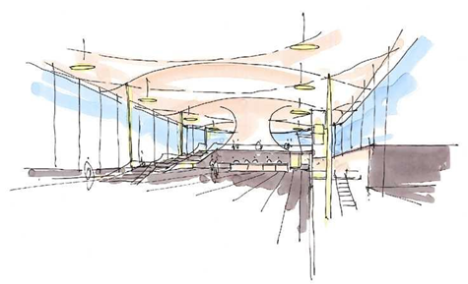
Appendix 4 for Cover and Contents Pages of the Senedd 2008 Audit Report. (Committee, 2008)
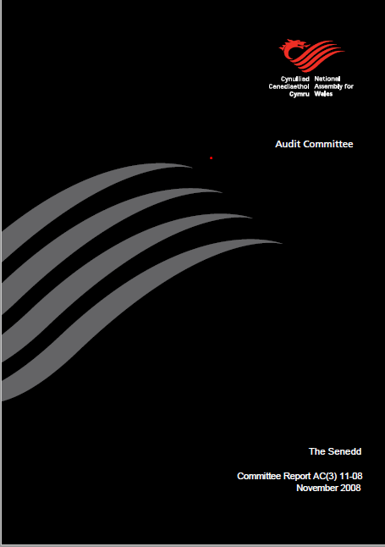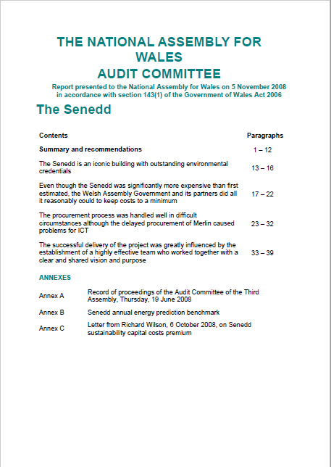
Appendix 5 for table showing a summary of the Tenderer’s. (Building the Scottish Parliament, The Holyrood , 2005)
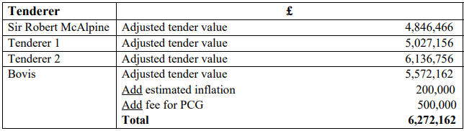
Appendix 6 – Table showing the impact of additional space and increased units. (General, 2000)
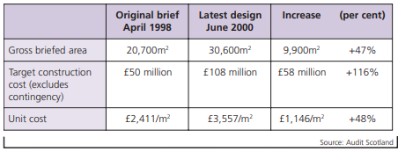
Appendix 7 – Increase forecast costs of the Holyrood Project. (General, 2000)


