University of Wales Trinity Saint David
School of Engineering



Technical Report

Van Watkins
2104732
Automotive Engineering
24th March 2022
Vehicle Technology, ACHA4004

Table of contents
2.Introduction.........................................................................................................................................2
3.Equipmennt and Methodology……………………………………………………………………………………….………………3
3.Associated questions………………………………………………………………………………………………………………………4
4.Conclusion……………………………………………………………………………………………….…………………………….……….9
5. References………………………………………………………………………………………….……………………………………….10

Introduction
In this report, we will discuss data retrieved from an engine dynamometer and related questions regarding the data and calculations. An engine dynamometer is used to test the performance of an internal combustion engine to record data before reinstalling the engine in to where it needs to be. The benefits of using an Engine dynamometer is to troubleshoot the engine after being modified or rebuilt to look for faults and poor performance in a controlled environment to tweak certain things (Editorial by industrial quick search, Engine Dynos: Types, Applications, Benefits, and Maintenance (iqsdirectory.com)). By knowing what issues there are with the engine, less money is spent trying to repair issues and having to recall cars to fix them and knowing what issues an engine may have such as overheating or poor brakes, it increases safety. I will also discuss the equipment used and method of collecting the data. Lastly, I will discuss the related questions regarding the data collected, using calculated figures and graphs from MATLAB to support my answers.

Equipment and Methodology
The equipment used in the dynamometer room include sensor recorder modules which feed the computer, an exhaust extraction system for the exhaust fumes, and a fuel supply board.
Fuel board: The fuel is pumped by a lift pump from the main tank in the fuel safe, through a filter and pumped up by a fuel flow meter to the secondary swirl pot, which feeds the main fuel pump, which is then fed to the engine by a regulator.
The engine itself is a d16 model Honda 1.6 litre VTEC engine, from 2000-2001. The sensors on the engine include coolant temperature, flow meter and lambda sensor. The throttle is controlled by a computer and is actuated from the throttle actuator box which gave us readings on throttle position throughout the system.
The engine is connected to the dynamometer through the driveshaft, folded straight to the crankshaft.
The dynamometer is an eddy current, ‘Schenck w230’ dyno. The inner casing spins freely, while the outer casing is fed by current which produces electromagnetic field, which puts a load on the engine trying to slow itself down
(UWTSD Dynamometer video, assignment brief)

Associated questions
Questions 1: Why does Specific Fuel Consumption (SFC) vary as it does with engine speed and load?
Specific Fuel Consumption is the measure of how efficient the engine is at converting chemical energy into mechanical energy. To calculate SFC we divide the mass of fuel used per hour by power (in kW). To obtain SFC we also must measure Torque (Nm) from the dynamometer.
Figure 1: SFC Heatmap

This graph shows us that the specific fuel capacity at a range of RPM, it also shows us that the SFC is greatest at 40% load and 2250 RPM and worst at 2% load and 6500 RPM.

The reason it could be at its worst at 6500RPM is because the engine is working so fast and so must use more fuel per power output. Its also at its worst with a low load value, the reason for this is because the less load there is, the less power output is needed for the engine and so fuel is being wasted, resulting in a decreased SFC.

However, the opposite true for SFC at its greatest, where a low RPM is maintained, less fuel is being used for each unit of power output, so less fuel is going to waste and being used, and its also reached a much higher load in the midrange values, the reason this helps is because not too much power is needed to move the vehicle, however, it has an acceptable fuel consumption for the desired power. Therefore, both values being midrange result in a more optimum Specific fuel capacity.

Questions 2: Why does torque and power vary as they do with engine speed?

Figure 2: Torque and Power against RPM at Full Load

This graph shows us that as the RPM increases, the Torque drastically increases to roughly 199Nm where it levels off from 2000 RPM to 3000 RPM and then slowly begins to decrease as a somewhat steady rate to 6000 RPM.

Torque:
The reason torque initially increases as RPM increase is because a higher RPM means the piston are getting pushed down more frequently, causing the crankshaft to have more turning force (torque) and so having a higher RPM, so increased torque is to be expected, however, it begins to level off and decrease. There are a few reasons for this, friction, Ignition delay, too little time for combustion, air flow complications and mechanical/material limitations. The main reason for torque decreasing is because after torque reaches its peak, the engine’s RPM is so fast that it can’t breathe and suck in enough air as the valves and air supply can’t reach the demand.
Power:
The power is directly dependant on the torque, and more torque means more frequent piston movement, meaning more power, however, the effect of the torque and RPM reaching so high still influences the power due to momentum, therefore it takes longer for the power to begin to decrease. (Shibashis Ghosh, Understanding Torque Curve, September 7th 2011, Diesel Engine Performance Torque Curve (mechguru.com))

Question 3: Why does thermal efficiency and BMEP (Brake Mean Effective Pressure) vary as they do with engine speed.

Figure 3: Thermal Efficiency and BMEP against RPM at Full Load

Differences and importance of values found in the different engine operating strokes
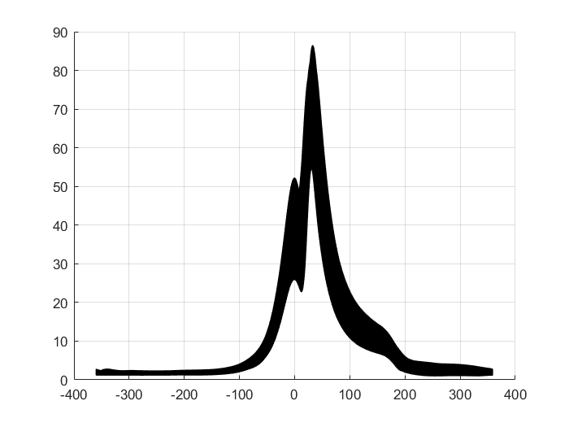
Figure 4: Cylinder Pressures across all RPM’s and crank angles
This graph shows the position of the piston (crank angle, x axis) during a stroke and the pressure (y axis) inside a cylinder
Between -360(Top Dead Centre) and roughly 100, there is hardly any pressure in the cylinder, this is because it is performing the intake stroke, resulting in a negative pressure to pull in air until it reaches bottom dead centre. Then between the initial increase in pressure and the peak of the graph, is the compression stroke, the initial fall and continued rise of the line could be due to fuel injection causing in more pressure, however, the overall increase in pressure is due to the piston rising and compressing the mixture, as the same mass is compressed into decreased volume. The drop in pressure is the power stroke, which is also the mixture being ignited, which results in the piston being shot down the cylinder, producing torque and so power to the crankshaft. The final section, just after 200, is the exhaust stroke, the exhaust valve opening and so as the piston moves upwards again, although due to the valve allowing the exhaust gas to escape, there is no build up in pressure. (Bosch handbook) (Piston stroke, Applied Drilling Circulation Systems, 2011, Piston Stroke - an overview | ScienceDirect Topics)
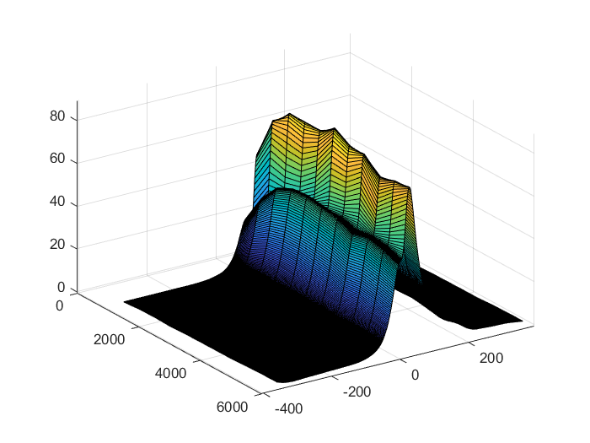
Figure 5: Cylinder Pressures across all RPM’s and crank angles
The side value of the graph shows that as RPM (z angle, 0-6000 range) increases, we can visibly see the two peaks, being the compression stroke, have an increase in pressure as the RPM increases to roughly 2000 RPM, where there is more fuel added to the mixture and the volume of the cylinder always staying the same, results in higher pressure, however, the pressure from 2000 to 6000 RPM begins to oscillate, this could be due to the mechanical parts of the engine not being able to keep up and so different quantities of fuel is injected.

Conclusion
To conclude, the Dynamometer is a very useful machine which benefits by reducing costs, increasing safety, and more precise results without having to take apart or test a car at the risk of breaking the vehicle and easier way of discovering faults. We have also discussed that torque and power have a mutual relation as the increase/decrease of torque results in the same for effect on power, and we have seen how torques increases as RPM increases until torque reaches a peak when the air demand is too great to Keep increasing torque, and so it begins to drop after a high enough RPM is reached, which also causes power to drop after the affect of torque begin to take no affect.
We have also seen how midrange load and RPM result in the greatest SFC and lower load and higher RPM results in low SFC. Due to Low load causing less power needed and high RPM needing more fuel to work.
We’ve also discussed the pressure being greater at higher RPM in the compression stroke.

References
1. Piston stroke, Applied Drilling Circulation Systems, 2011, Piston Stroke - an overview | ScienceDirect Topics)
2. Shibashis Ghosh, Understanding Torque Curve, September 7th 2011, Diesel Engine Performance Torque Curve (mechguru.com))
3. Editorial by industrial quick search, Engine Dynos: Types, Applications, Benefits, and Maintenance (iqsdirectory.com)

