Mock EXAM

MODULE CODE: ACDA5001

Module Name: Electrical Engineering

TIME: 2 HOURS
Maximum Mark: 100

answer All the questions

ANSWER ALL THE QUESTIONS

Question 1 [25 marks]
- Describe the construction and working of a single phase transformer, with the aid of necessary diagram. [8 marks]
- A supply voltage of $V_{1}=20V$ is given to the circuit shown in fig:1. Determine the following
- The load current, [6 marks]
- Value of load resistor, when maximum power is transferred across the load,
[2 marks]
- Simplified circuit diagram for the circuit shown in fig.1 [3 marks]
- The maximum power transferred across the load ($P_{L})$. [2 marks]
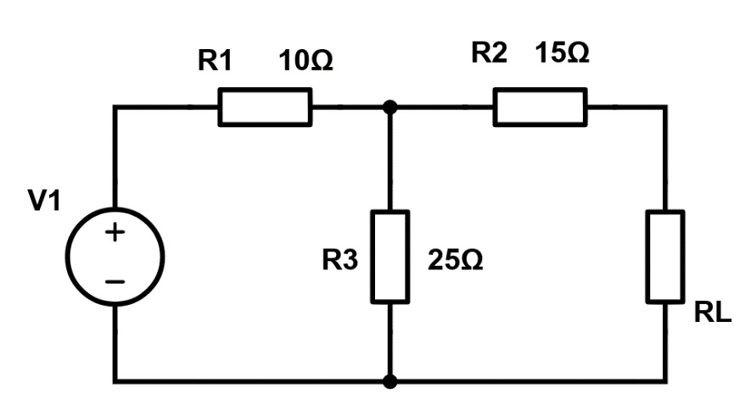
Fig:1
- Describe the functions of the following components used in DC machines
- Field System [2 marks]
- Armature [2 marks]
Question 2 [25 marks]
- A circuit consisting a resistor of 20 $Ω$ and inductance of 0.1H is connected in series across a single phase 200V, 50Hz supply. Calculate the current drawn, power consumed and draw the phasor diagram. [5 mark]
- The voltage and current of a RC circuit is given by $V=120sin(314t)$ and $I=10sin(314t+π/6)$. Determine the following.
- Value of Resistance and Capacitance [6 marks]
- Power consumed by the circuit [2 marks]
- Phasor diagram [2 marks]
- A coil having an inductance of 1.4H and a resistance of 1$Ω$ is connected to a12V source through a switch. What will be the value of current after 400msec of switching on the supply? How much will it take for the steady state current to drop to half its value after the switch is turned ON. [10 marks]
Question 3 [25 marks]
- A $400V$, three phase star connected alternator supplies a delta – connected load as shown in fig: 2, each phase of which a resistance of $20Ω$ and inductive reactance 50$Ω$. Calculate the following, neglecting the losses in line between the alternator and the load.
- the current supplied by the alternator, [4 marks]
- the output power of the alternator, [4 marks]
- the kVA of the alternator. [2 marks]
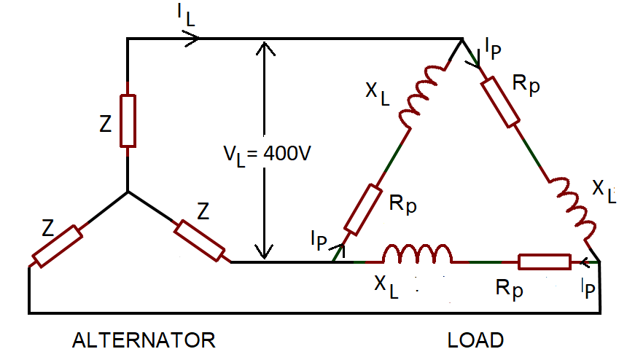
Fig: 2
- A shunt generator supplies a 20kW load at 200V through cable of resistance, R=100mΩ. If the field winding resistance, $R_{f}=50Ω$ and the armature resistance 40m $Ω$ as shown in fig3. Determine,
- the terminal voltage [5 marks]
- the emf generated in the armature [5 marks]
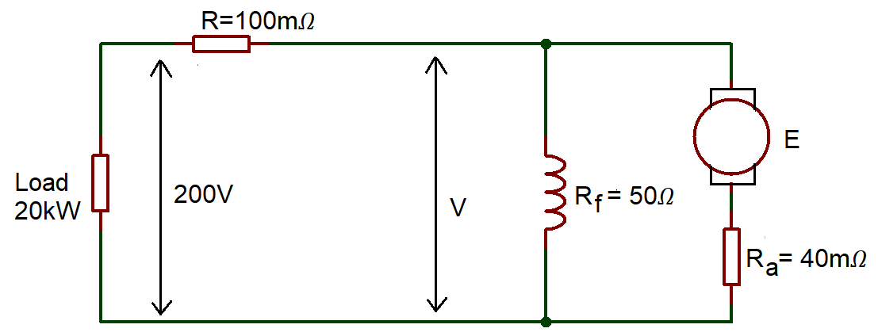
Fig:3
- An Alternating voltage is given by $V=75sin(200πt-0.25)$ volts. Find the following.
- Amplitude [1 mark]
- peak to peak voltage [1 mark]
- RMS value [2 marks]
- the periodic Time [1 mark]
Question 4 [ 25 marks]
- A series combination of a $12Ω$ resistance and $600μF$ capacitance is connected to a 220V, 50Hz supply. Using Complex functions analyse and determine the following.
- Impedance in the circuit [6 Marks]
- Current across the circuit [3 Marks]
- Voltage across resistor and Capacitor [4 Marks]
- Power factor [2 Marks]
- Apparent power [2 Marks]
- Active Power [2 Marks]
- Reactive power [2 Marks]
- Construct a Phasor diagram to represent the circuit [4 Marks]

Diwedd/End

