To what extent can projects like 'City Witness: Place and Perspective in Medieval Swansea' deepen our understanding of a historical period?

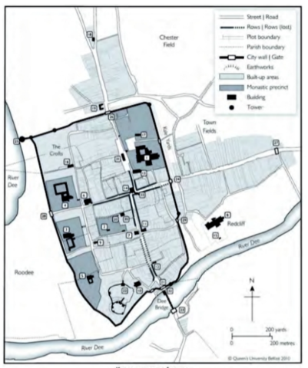
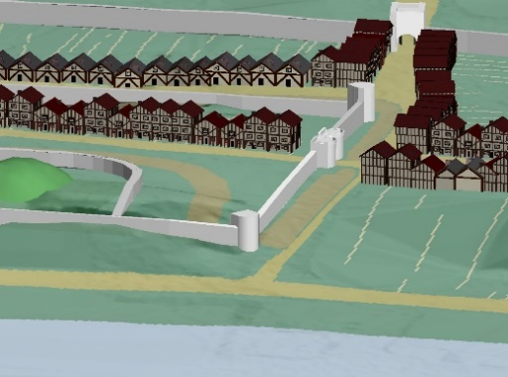
The ‘City Witness’ project, and others like it, are part of an ongoing attempt to bring History to life and further our understanding of the medieval way of life. The project itself, aims to “forge connections between the modern city and its medieval antecedent, and through digital mapping and textual analysis reveal how medieval individuals from different cultural and ethnic communities understood and represented their town” This project in particular, can be a crucial tool for helping us to deepen our understanding of the medieval period, as it compares directly the old and new towns, giving us a visual aid. For example, in their recreations of the old town - based on evidence from their witness accounts, along with estimations drawn from other towns in which medieval buildings remain - we can grasp a better understanding of the planning and layout of a medieval town, which if compared with other such towns, begins to form a pattern that we can see is used throughout the medieval era - such as the tendency for a ‘main street’ to be central to the planning, or for there to be a direct line from the city gates to the river/sea.
This digital mapping is only possible as a result of the 9 witness testimonies, which provide invaluable information on locality, landscape and architecture, that enabled the City Witness Project to be as successful as it is. An example of how these accounts were utilised can be seen in the testimony of Thomas Marshall, who provides details such as “a certain mound near the aforesaid town, and the said gallows can be seen from the castle and from the town, and is about two crossbow shots away from the castle”, which can be used to plot the geography of medieval Swansea – not just within the town but also it’s immediate surroundings and terrain.
Figure 2- Chester 1500
Keith D. Lilley, Mapping the Medieval City: Space, Place and Identity in Chester, c. 1200-1600 (2011)
Figure 1- Swansea Recreation
Another use for such detailed mapping, is developing an understanding of the importance of buildings in the era. The fact that the castle is centralised suggests it was seen as the heart of the town, while both of the churches being placed at the outskirts of the town makes them more readily available for travellers and in more secluded, peaceful areas. This geographical placement of the church is further supported by one witness statement used in the ‘City Witness Project’, by a Mary de Briouze who said the “chapel is near the town of Swansea, and the said chapel is about half an English league distant from the gallows on which the said William was hanged”, helping to gauge a placement of the building. This is one of 9 witness testimonies which makes up the Vatican MS Lat. 4015 manuscript, detailing the events of a ‘twice hanged man’. Part of the ‘City Witness Project’ is using these testimonies “to extend our understanding of the medieval town” which can be an invaluable source of information about the era, as it is the personal accounts of ‘regular’ people. These kinds of materials can help to deepen our understanding of an era, by providing a relatively agenda-free account of the workaday individual’s experiences: though no source can be said to be unbiased, the testimony of a random witness is unlikely to have a true political motivation that would muddy it’s reliability.
The project director, Prof Catherine Clarke, defines her aims for ‘City Witness’ as: “to further our understanding of medieval Swansea and its cultural contexts, as well as to engage with wider-reaching questions about medieval urban culture, place, identity and memory”. This is achievable through the use of these personal testimonies, which as Prof Clarke implies, can be used to deepen our understanding of ‘identity and memory’ in the medieval era, as they give an insight into the lives of the average person. In the case of the twice-hanged man, William Cragh, the testimonies reveal a certain attitude toward his hanging, or to hanging in general, and even more so it reveals a sense of community built around this event – or miracle as they believed. In this way, this project is a vital part of unravelling mundane medieval culture, and deepening our understanding or it.
In conclusion, and put simply, any historical investigation using primary sources is, to a huge extent, vital for understanding that era, and is likely to provide an individual and detailed perspective that is key to deepening our understanding of any point in time. The City Witness project in particular, provides both that personal side to history which allows us to see the medieval era through the eyes of those who lived through it, but also brings history to life in a visual way, mapping out a town that no-longer exists, so that we might grasp an understanding of how it functioned, and what role it played in people’s lives.

https://www.medievalswansea.ac.uk/en/information/the-project/index.html
https://www.medievalswansea.ac.uk/en/statement/2.html
https://www.medievalswansea.ac.uk/en/information/the-project/index.html
Witnessing history: perspectives on medieval Swansea and its cultural contexts, Clarke, Catherine A.M, Journal of medieval history, 2015, Vol.41 (3), p.249-255

