DS 1 Template

My Screenshots/Photos
- Please add 4–6 screenshots or photos of your digital life.
- You can use your phone or laptop.
- For each screenshot, write one or two sentences explaining what it shows.

Screenshot/Photo 1
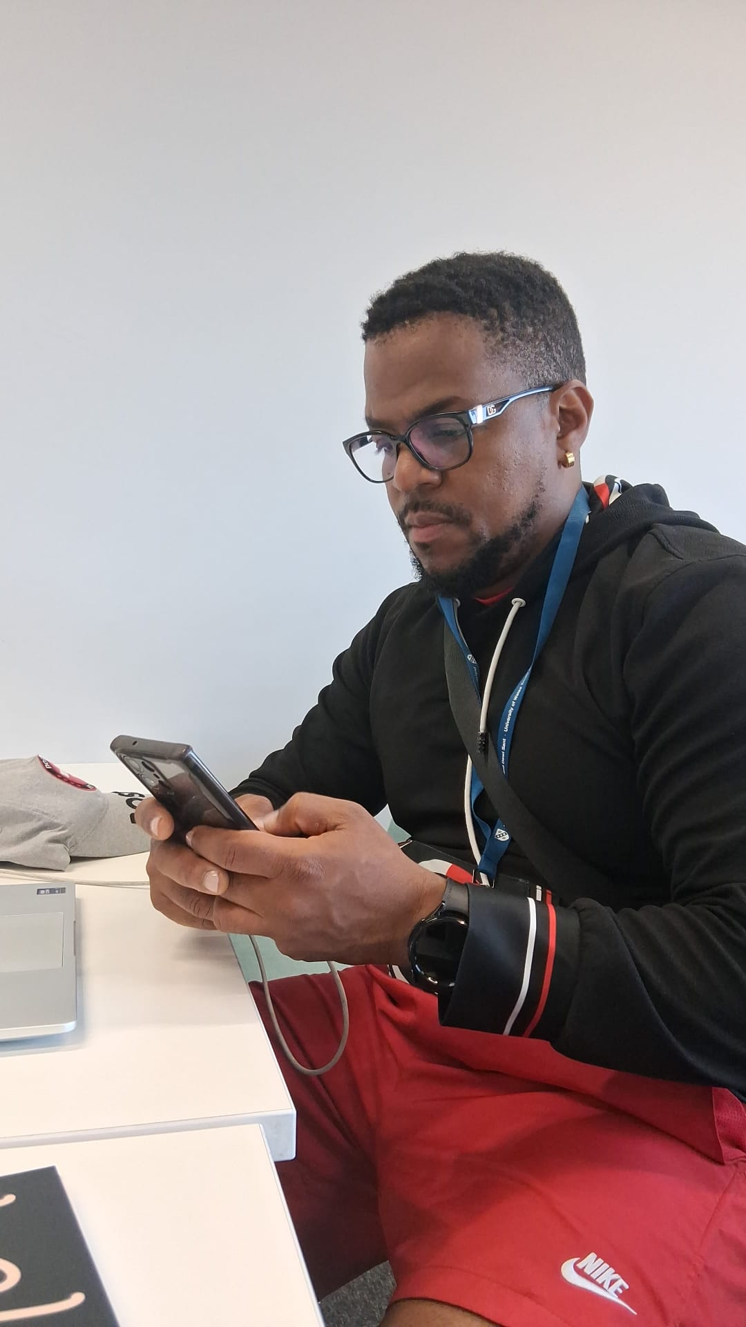
preparing a video to record a restaurant in chancery lane for promotion.

Screenshot/Photo 2
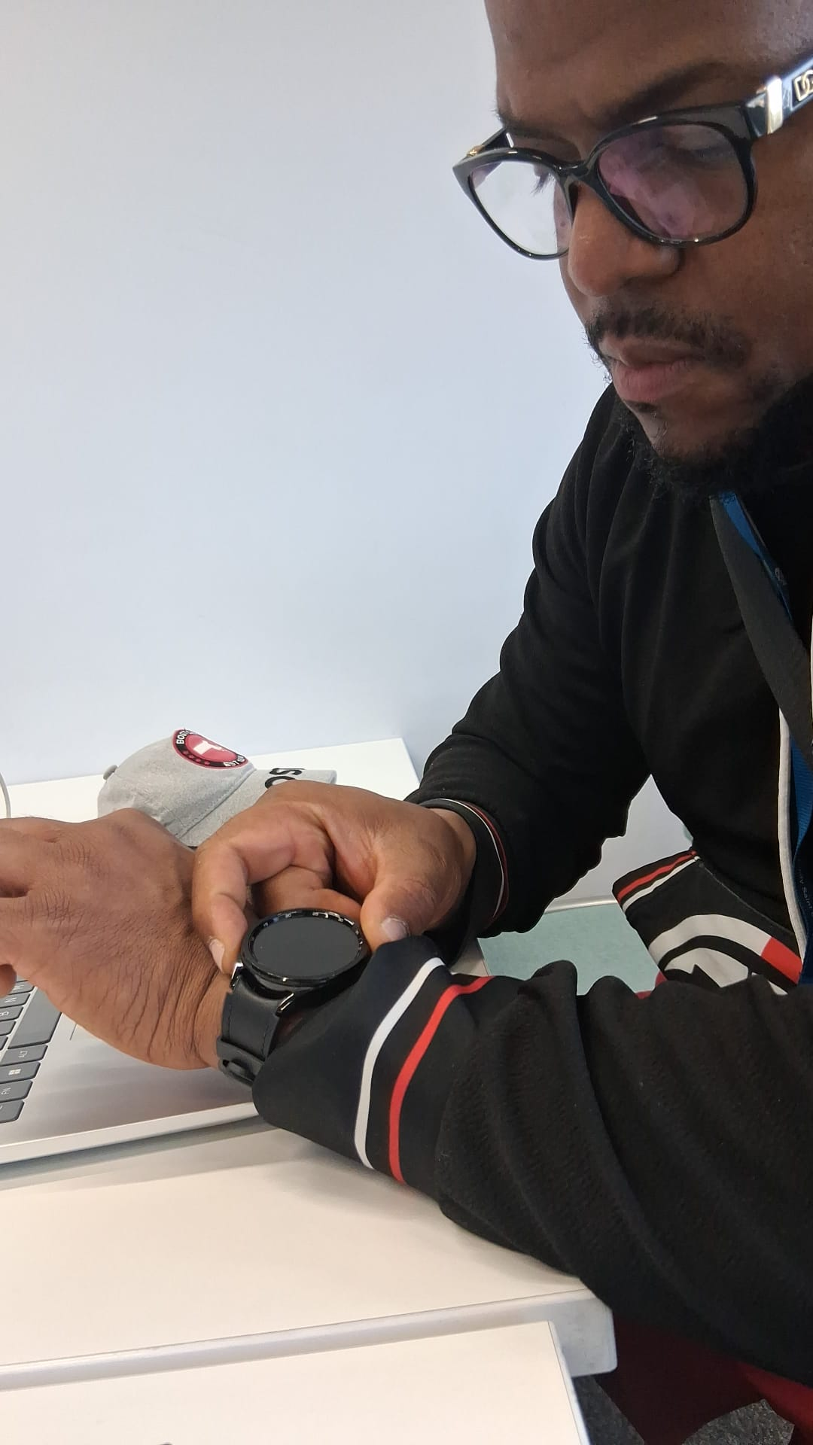
Looking at my heart rate all day Monday to see how my heart is doing on my whole digita;l watch that monitors my whole body.

Screenshot/Photo 3
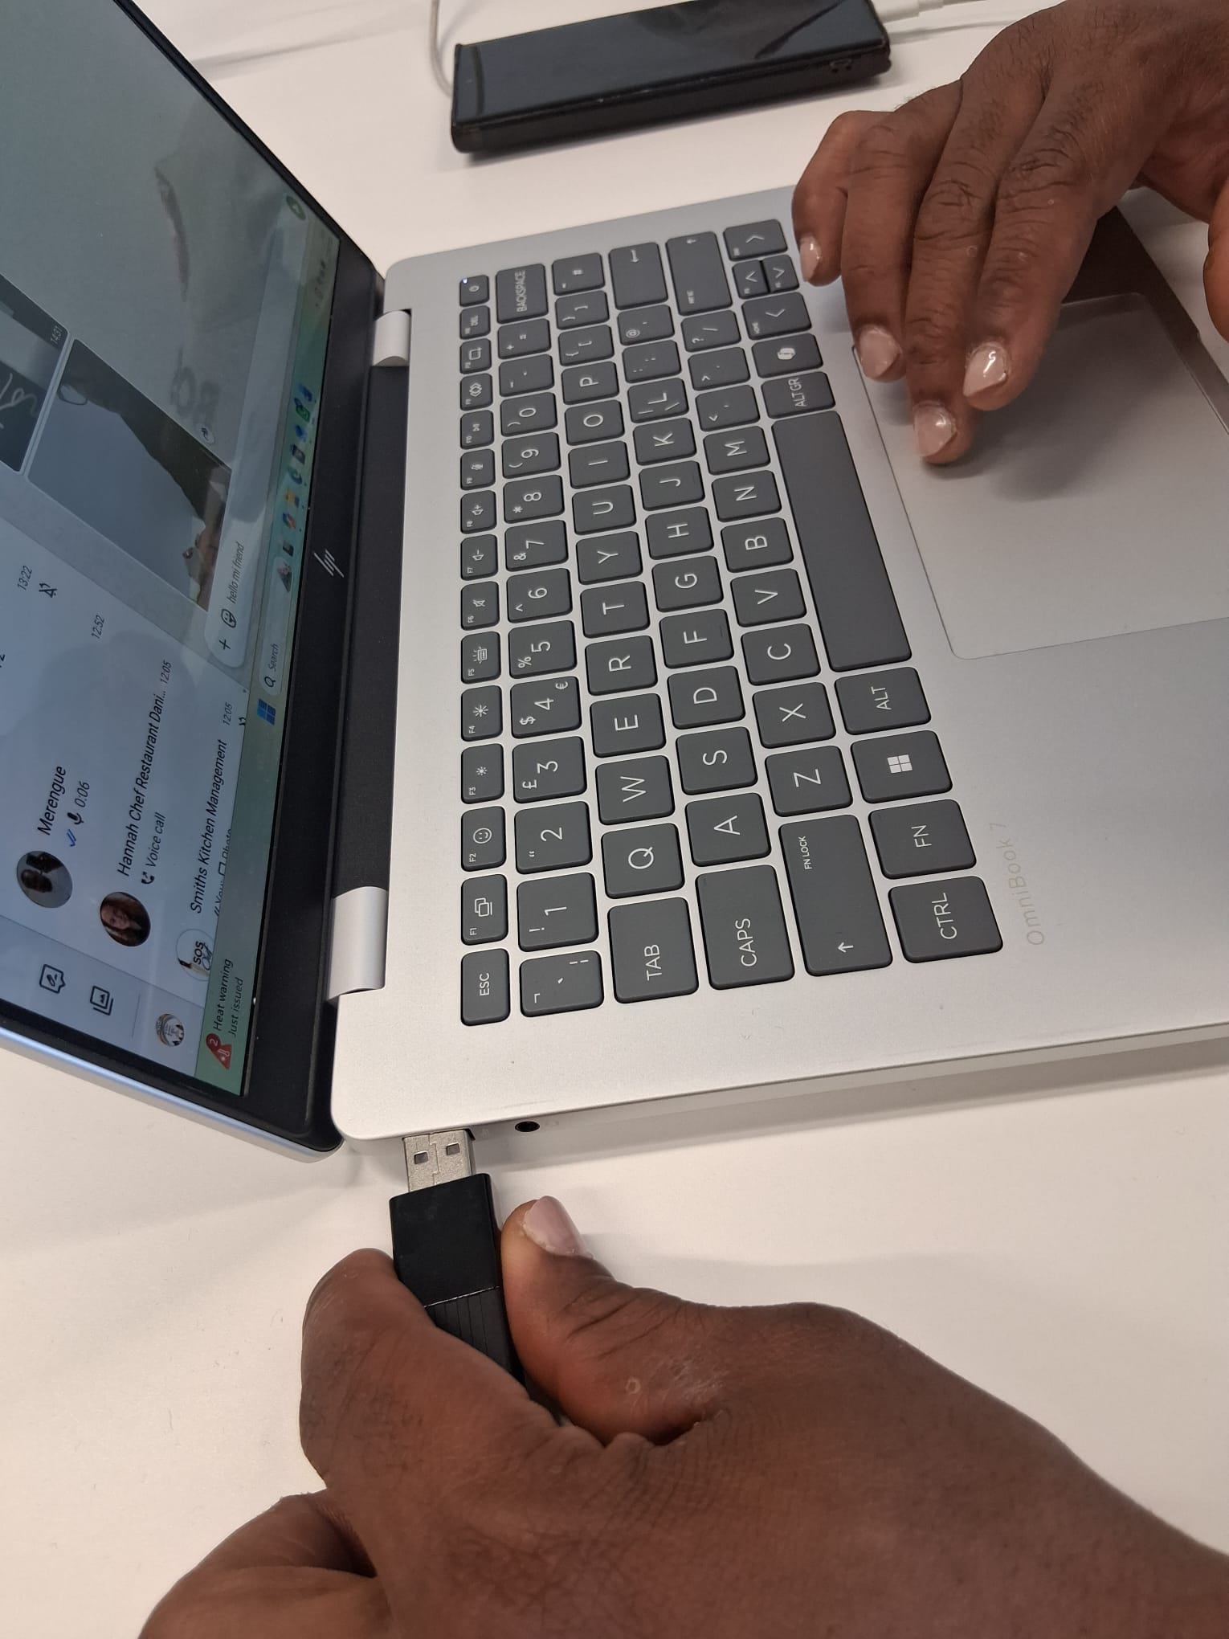
Using my USB drive to try to edit photos and make digital adjustments and retouching.

Screenshot/Photo 4

Screenshot/Photo 5
[Insert Photo/Screenshot below]
Working on my computer doing digital work for my university and linkelink.

Screenshot/Photo 6
[Insert Photo/Screenshot below]

[Write what this shows of your digital life]

My Short Reflection
- Write 5–8 simple sentences about your digital life.
- You can use the sentence starters below if helpful.
My digital life is very interesting I really like digital life because it”s what”S happening now and will be in the future it”s very interesting for anyone who wants to learn how to technology today they have to learn about digital technology today they have to learn how to use it and work with it well I like big cities for taking photos and visiting old museum so I can enjoy then later .

Sentence starters
- I use digital tools to …
- I feel confident when I …
- I want to improve …
- I often use these tools: …
- I sometimes feel nervous about …
- I hope this module will help me …
- Digital skills are important for me because …
You can write more if you want.

Submission Checklist
Before you submit, please check:
​​​ ☒ I added 4–6 screenshots
☐ I wrote short sentences for each screenshot
☐ I wrote my short reflection
☐ My work is my own
☐ My file opens correctly
​​☐ My file opens correctly

