University of Wales Trinity saint David
Elyse Cathryn Hopkins (1550604)

Is the Criminal Justice System Failing Victims of County Lines?
Analysing the multi-agency approach of identifying victims to determine whether these strategies are effective

Contents

Introduction ……………….2
Literature Review …………3
Research Method …………6
Practicalities ……………….9
References………………...11

County Lines Drug Trafficking is considered to be the most prevalent and complex form of organised crime within the UK; it is the practice of dispersing a quantity of drugs into rural areas exploiting vulnerable individuals including children to sell the drugs (NCA, 2015). This topic chosen for the dissertation aims to investigate and address the county lines issue faced in the United Kingdom, most specifically the way in which multi agencies and the criminal justice system identifies victims and whether these services prove to aid those affected by county lines - or if the methods and strategies to tackle the issue is counterproductive. From research gathered, it will be collected and analysed to explore the possibility to whether there could be more done for victims and to ensure safeguarding is carried out more effectively to enhance safety. The aims and objectives from this research would be to:
- Researching into the agencies that work specifically with county lines cases; how they go about strategies to tackle county lines and challenges that come with it.
- Research into the perspectives of the victims, what causes them to be involved in the first place, analysing the economical and sociological aspects of being involved in county lines.
- Observe how the criminal justice system handles county lines cases, to see if they are effective or counterproductive from researching the experience and perspectives of those who are or were involved in county lines.

The term ‘county’ refers to the geographical area of crossing counties to disperse the drugs whilst ‘line’ referring to communication through phone lines in which it would be orchestrated through the use of technology such as burner phones (Blakeburn, Smith, 2021, p.240). Once the gang is in the areas they will overthrow the local dealer through violence, which in turn poses a great threat to an unsuspecting local area, reducing the safety of the community and risks the wellbeing of the residents. The gangs provoke individuals such as vulnerable adults or drug users to use their properties to hold the quantity of drugs, also known as “cuckooing” (Moyle, 2019, p740). The individuals in question are vulnerable in the sense that they may be dependent on this form of business to earn a living, they may be brought up into an organisation, are not able to live independently or they are drug dependant and suffer from mental health complications, thus potentially causing an unbreakable cycle of abuse from the crime groups. Due to the age of these “runners”, they risk being subjected to abuse and sexual exploitation, cases where they are manipulated into thinking they owe or are in debt to the crime groups, thereby being enslaved to work for them for nothing (Home Office, 2020). This tactic carries great risk low reward system to the runners, whilst those orchestrating are in a high reward low risk position. The theme of vulnerability seems to emphasise how organised crime groups utilise the individuals for their entrepreneurial gain, whilst the long-term effects of this abuse could see higher rates of prisoners placing a strain on these services and victims growing up to living a criminal lifestyle (Brown, 2019, p.636-637).
The gangs would recruit children as runners to transport the drugs to far distanced areas away from the production, as this would draw attention away from those higher up in the group, particularly in densely populated areas such as a city it works in favour for the gangs to remain undetected. Blakeburn and Smith expresses the popular method of transport would be through train couriering more favourably than adults accompanying them by road travel (Blakeburn,Smith, 2021,p245). Thus, making British Transport Police being one of the initial active response to detect county Lines, the problem that is faced is the complexity of sharing information and communicating between other agencies to effectively tackle County Lines (Blakeburn, Smith, 2021, p.240. Children who are subject to go missing or location of their whereabouts are not being reported by their carers or services, the disconnect between schools or families picking up on who their child associates with can cause serious risks towards children going undetected and falling into the county lines trafficking regime (Blakeburn, Smith, 2021,p.240).
This potential miscommunication between agencies and the secrecy of the organised crime groups makes the operations to crackdown on county Lines challenging. Further, problems may lie in the way the criminal justice system handles cases of county lines - the way in which victims can end up being perpetrators over time; adult members of the organised crime are likely to have been children themselves starting off in these groups and were exploited in the gangs - once caught are prosecuted, even with the case of a young adolescent potentially facing prosecution (Stone, 2018, p288-289) it appears that there isn’t a vast amount of rehabilitation offered. The strategy to prosecute and fine, if they were to report to authorities they may risk danger to not only themselves but to associates such as family members (Williams, Finlay, 2019) a catch 22 situation that does not show a safe means of a way out. Currently in England and Wales the rate of county lines drug trafficking has circulated greater attention of awareness of this form of organised crime; NCA stated in 2017 that there was an “88% increase of reports of police forces responding to county lines cases in their local force area” (Moyle, 2019, p.740). Thus bringing to the spotlight, in 2018 the UK Government launched a violence strategy to incorporate intervention and prevention schemes “supporting communities and partnerships, and implementing effective law enforcement and criminal justice response” (Moyle, 2019, p.739) as a way of tackling the county lines issue.

However, this proposal to safeguard is complex; with reports of child sexual exploitation has “risen to the highest level” (Brown, 2019, p.623) failing to protect young individuals could be perhaps down to the vagueness of categorising the vulnerable, as of yet there is no confirmed “definitive categorization of groups that should be considered as vulnerable” (Moyle, 2019, p742) meaning that there could be challenges in correctly distinguishing between the “exploiter vs the exploited” – as although “zero tolerance” approach to protect vulnerable individuals, arrests would still be made towards labourers or “runners” due to complexities of how to appropriately handle those involved (Moyle, 2019, p742).
County lines itself doesn’t appear to be a new form of crime, but rather an “evolving and fluid” form of organised crime; tactics and methods have advanced such as the use of technology and the way recruitment is used to attract children into the crime groups, and without coherent information exchange between agencies it can make the “fight to control county lines” more difficult (Blakeburn, Smith, 2021, p.254).

The importance of conducting the research will be appropriate for the study, “a collection of methods are important because of how the information is collected and used and what explanation can be generated” (Paradis et al, 2016, p.263). Therefore, credible sources and data will be from qualitative and quantitative, qualitive most favourably to stress the importance of better understanding the subject (Klopper, 2008, p.62). Quantitative research methods would be best used for survey data, “to quantify opinions, attitudes and behaviours suited to testing theories and hypothesis” (Sukamolson, 2007, p.9). Primarily, data will be obtained from credible sources discussed with tutors, with the proposal of arranging interviews from agencies or associates of institutions mentioned; along with anonymous surveys to ensure integrity and no breach of personal information (Saunders, Kitzinger, Kitzinger, 2015, p.627). The reason for this is to compare experienced information analysed with secondary sources such produced from books and articles to perhaps discover whether or not proposed predictions of findings would be correct, organisational information compared with experienced information could perhaps give an “authentic real world” point into my research in place of assumption that institutions are handling county line cases without any problems (Grove, Fisk, 1992, p.218). Potential risk with conducting anonymous surveys is perhaps that public input may have bias towards certain agencies such as the police or social services (Bowen, 2005, p.218). Secondly, it is intended to gather a certain amount of anonymous surveys to estimate a percentage of agree or disagreements which can result unpredictable results ceasing any form of correlation that could back predictions. Thus, Further research using the “triangulation” method of data collecting would be conducted from findings to get more concise data findings (Grove, Fisk, 1992, p.223).

The method in which data will be collected through primary sources through interviews and surveys would be conducted online; due to the current situation of COVID 19 regulations and safety of persons in this research it would not be feasible to conduct interviews in person. The target audience will be adults, favourably those who have had experience in any way, such as having worked for these agencies, in order to understand the working of their organisation. The anonymous surveys may draw attention to those who have had experience with certain agencies such as the police and would want to give their input; there would be no way in telling those who will partake in these surveys therefore it is intended to have a mix of conflicting views. Overall, it is intended to collect data from approximately >100 individuals; at least 3 in depth interviews and up to 100 anonymous participants to be statistically valid (Klopper, 2008, p.71).

Invites would be sent via email with a consent form to fill. communication with participant to ensure they consent to the conditions of the interview before proceeding, as well as providing help links for if they feel personally affected by the interviews (Klopper, 2008, p.71). The questions in the interview will not be intended to harm the reputation of the participants or the institutions they work for, but to get a better understanding of how these institutions work to tackle county lines (Klopper, 2008, p.71). As the integral part of the research is focused on victims of county lines, it is therefore to protect identities of all who are involved any victims mentioned will remain anonymous to an extent, research will be stored appropriately, once research has completed remaining information will be destroyed to uphold integrity. This way of collecting research would be the most ethical way without addressing to victims of county lines, interviewing victims would be the most challenging, specifically if it’s distressing for them, wish to remain anonymous or are unable to conduct an interview due to circumstances (Harrell, Bradley, 2009,p.8). Therefore, in order to obtain victim experience would have to be through secondary sources that have been published. Understanding the seriousness of the subject, participants who are affected by the interview or surveys will be able to opt out if they feel that the questions asked are not appropriate or potentially be emotionally distressing. Contact links or helplines would again be offered to the participants prior to and after conducting the surveys in order to aid those who have been personally affected by the research.

Budgeting for data collection would comprise of the cost of the technology used for collecting information such as recording devices for the interviews, possible payment of survey creating websites, along with the cost of travelling to the university to obtain sources such as books. Furthermore it is to be mindful that what is needed for the research that it is within the affordable budget (Klopper, 2008, p.71). For the questions in the interviews and surveys, the amount given, although subject to change, will be aimed towards 10-20 questions, to ensure there is enough information to analyse. The questions asked will be tailored appropriately to the participants in the interview and likewise the survey questions will be suited to the target audience of anonymous adult participants.

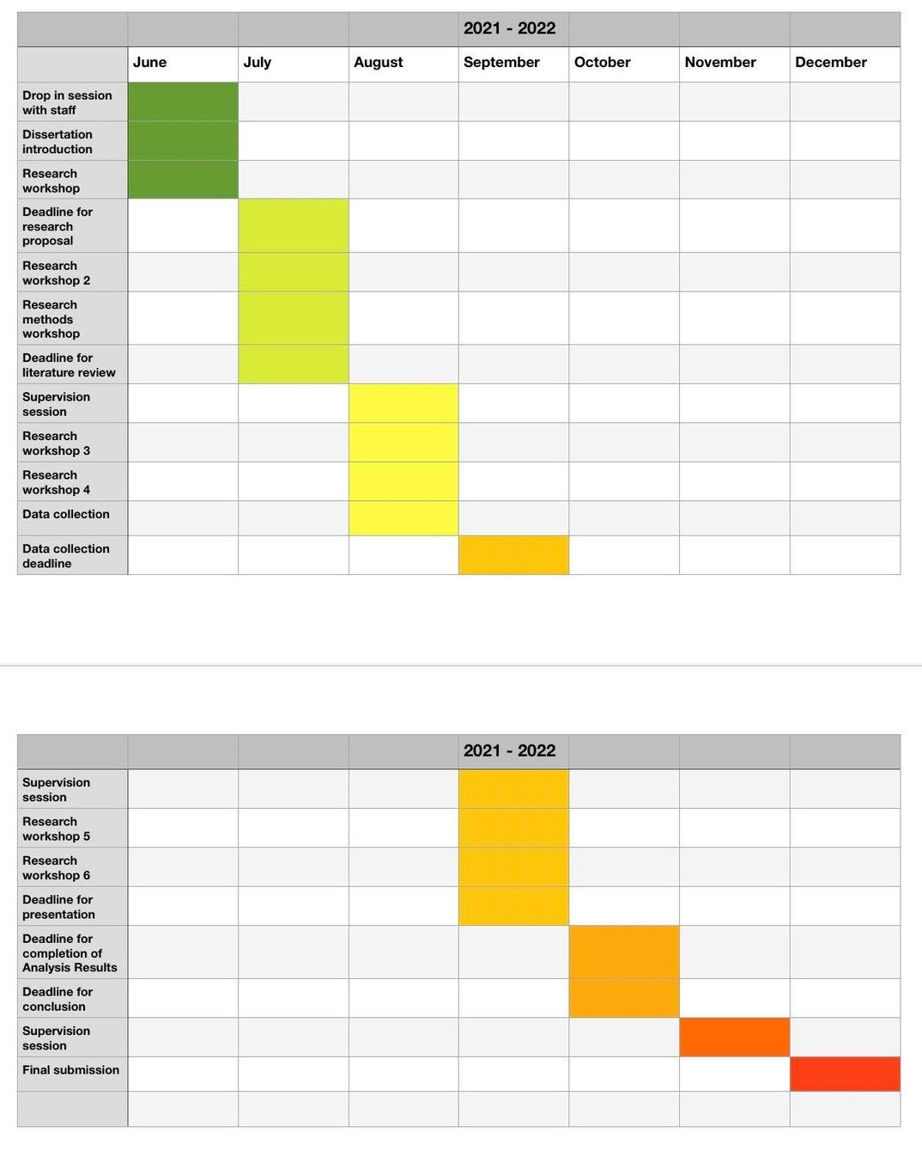
Figure 1
The practicalities of this research will concern most importantly the way in which the research will be conducted; firstly, ensuring time frames would be put in place to give enough time for research leaving room for more research if possible. A timetable will set up (figure 1) to organise time management most effectively. Due to the size of the dissertation and time frame given it would be most efficient to set tasks in a time frame of months, whilst communicating with tutors before proceeding to the next phase of the project. It will be kept in mind to be realistic of the set time frames and being mindful of the potential challenges; the list of possible challenges could include:
- unable to receive feedback or communicate well to tutor, although can be avoided if discussions and communications are kept consistent and managing timing in advance to avoid delays
- Unable to receive feedback or any form of communication from proposed interviewees, to tackle this will discuss options with tutor and look toward relying on data from surveys
- Unforeseen Circumstances that may slow progress or prevent conducting research, possible COVID 19 interferences.
As mentioned with current COVID-19 situation, there is a great risk of limited access to facilities or resources may hinder the outcome of the research. Furthermore it is to be mindful of these possible challenges and to ensure assessment and feasibility of current situation and planning in advance would be most beneficial to the success of the research.

References

Bavington, S., 2021. Exploring the Impact of Anti-Social Behaviour, Drug-Related Crime and County Lines on Local Communities: A Qualitative Inquiry. Journal of Applied Business and Economics, 23(1), pp.131-141.
Blakeburn, M. and Smith, R., 2020. Exploring the role of the British Transport Police in responding to ‘County Lines’ drug markets: Enforcement and safeguarding perspectives. The Police Journal: Theory, Practice and Principles, 94(2), pp.239-254.
Bowen, G., 2015. Preparing a Qualitative Research-Based Dissertation: Lessons Learned. The Qualitative Report, pp.208-219.
Britton, B. and Tesser, A., 1991. Effects of time-management practices on college grades. Journal of Educational Psychology, 83(3), pp.405-410.
Broad, R., 2015. ‘A Vile and Violent Thing’: Female Traffickers and the Criminal Justice Response. British Journal of Criminology, 55(6), pp.1058-1075.
Brown, K., 2019. Vulnerability and child sexual exploitation: Towards an approach grounded in life experiences. Critical Social Policy, 39(4), p.623.
Childrenssociety.org.uk. 2021. Child Protection & Safeguarding | The Children's Society. [online] Available at: <https://www.childrenssociety.org.uk/child-protection-and-safeguarding> [Accessed 1 July 2021].
Childrenssociety.org.uk. 2021. Counting Lives Report | The Children's Societyu. [online] Available at: <https://www.childrenssociety.org.uk/information/professionals/resources/counting-lives> [Accessed 1 July 2021].
Glover Williams, A. and Finlay, F., 2018. County lines: how gang crime is affecting our young people. Archives of Disease in Childhood, 104(8), pp.730-732.
Grove, S. and Fisk, R., 1992. Observational data collection methods for services marketing: An overview. Journal of the Academy of Marketing Science, 20(3), pp.217-224.
Harden, T., Kenemore, T., Mann, K., Edwards, M., List, C. and Martinson, K., 2014. The Truth N’ Trauma Project: Addressing Community Violence Through a Youth-Led, Trauma-Informed and Restorative Framework. Child and Adolescent Social Work Journal, 32(1), pp.65-79.
Harrell, M. and Bradley, M., 2009. Data collection methods. Santa Monica, CA: RAND, pp.02-11,13,17,24-25,26-40,41-61,75-102.
Harrison, M. and Whalley, W., 2008. Undertaking a Dissertation from Start to Finish: The Process and Product. Journal of Geography in Higher Education, 32(3), pp.401-418.
Hesketh, R. and Robinson, G., 2019. Grafting: “the boyz” just doing business? Deviant entrepreneurship in street gangs. Safer Communities, 18(2), pp.54-63.
Holligan, C., McLean, R. and McHugh, R., 2020. Exploring County Lines: Criminal Drug Distribution Practices in Scotland. Youth Justice, 20(1-2), pp.50-63.
Home Office, 2020. Criminal exploitation of children and vulnerable adults: county lines. London: Home Office.
Irwin-Rogers, K., 2019. Illicit Drug Markets, Consumer Capitalism and the Rise of Social Media: A Toxic Trap for Young People. Critical Criminology, 27(4), pp.591-610.
Klopper, H., 2008. The qualitative research proposal. Curationis, 31(4), pp.62-71.
Lay, C. and schouwenburg, H., 2007. trait Procrastination, Time Management, and Academic Behavior. journal of social behavior and personality, 8(4), pp.647-662.
Moyle, L., 2019. Situating Vulnerability and Exploitation in Street-Level Drug Markets: Cuckooing, Commuting, and the “County Lines” Drug Supply Model. Journal of Drug Issues, 49(4), pp.740-751.
O’Hagan, A. and Long, A., 2019. The socioeconomic effects of organised crimes county lines on the United Kingdom community. Forensic Research & Criminology International Journal, 7(5), pp.274-280.
Paradis, E., O'Brien, B., Nimmon, L., Bandiera, G. and Martimianakis, M., 2016. Design: Selection of Data Collection Methods. Journal of Graduate Medical Education, 8(2), pp.263-264.
References
Saunders, B., Kitzinger, J. and Kitzinger, C., 2014. Anonymising interview data: challenges and compromise in practice. Qualitative Research, 15(5), pp.616-632.
Saunders, B., Kitzinger, J. and Kitzinger, C., 2015. Participant Anonymity in the Internet Age: From Theory to Practice. Qualitative Research in Psychology, 12(2), pp.125-137.
Spicer, J., 2018. ‘That’s their brand, their business’: how police officers are interpreting County Lines. Policing and Society, 29(8), pp.873-886.
Spicer, J., 2021. Between gang talk and prohibition: The transfer of blame for County Lines. International Journal of Drug Policy, 87, p.102667.
Spicer, J., Moyle, L. and Coomber, R., 2019. The variable and evolving nature of ‘cuckooing’ as a form of criminal exploitation in street level drug markets. Trends in Organized Crime, 23(4), pp.301-323.
Stone, N., 2018. Child Criminal Exploitation: ‘County Lines’, Trafficking and Cuckooing. Youth Justice, 18(3), pp.286-291.
Sukamolson, S., 2007. Fundamentals of Quantatitive Research. [online] Available at: <http://www.culi.chula.ac.th/Research/e-Journal/bod/Suphat%20Sukamolson.pdf> [Accessed 18 June 2021].
Windle, J., Moyle, L. and Coomber, R., 2020. ‘Vulnerable’ Kids Going Country: Children and Young People’s Involvement in County Lines Drug Dealing. Youth Justice, 20(1-2), pp.64-78.
wroe, L., 2019. Contextual Safeguarding and ‘County Lines’. insititute of Applied social research, [online] pp.3-22. Available at: <https://uobrep.openrepository.com/bitstream/handle/10547/624865/Contextual-Safeguarding-and-County-Lines-Briefing_-Wroe-Oct-2019-FINAL.pdf?sequence=2&isAllowed=y> [Accessed 26 June 2021].
The National Crime Agency, 2015. NCA Intelligence Assessment County Lines, Gangs, and Safeguarding. National Crime Agency, pp.1-8.

