Ceramics for High Temperature Applications
  - Advanced materials and process’
Josef Ahmed | P152238

Abstract
In this report Ultra-high Temperature Ceramics have been analysed to achieve a better understanding of what they do and what they are used for. It was found that they have a complex and sensitive manufacturing process that is affected by pressure and temperature. Whilst there is a wide variety of ceramic materials that can withstand high temperatures. There is still a real difficulty with finding the correct material for the applications required within the aerospace industry. Although, it is heading in the right direction.
Contents
1 Abstract 1
3 Glossary of Acronyms 3
4 Introduction 4
5 Ceramics for High Temperature Applications 5
5.1 Material Properties 6
5.2 Manufacturing 7
5.2.1 Boron Carbide Reduction of Metal Oxide 7
5.2.2 Hot Pressing 8
5.2.3 Chemical Vapor Deposition 10
5.3 Environmental impact 10
5.4 Health and Safety Implications 11
6 UHTCs for Sharp Leading Edges within the Aerospace Industry 12
7 Conclusion 13
8 References 14

Glossary of Acronyms
Ultra-High Temperature Ceramic – UHTC
Zirconium diboride – ZrB2
Hafnium diboride - HFB2
Ultra-High Temperature Ceramic – UHTC
Chemical vapor deposition – CVD
Silicon Carbide - SiC
Refractory ceramic fibre – RCF
The European Ceramic Fibres Industry Association – ECFIA
Ultra-High-Temperature Ceramic Matrix Composites - UHTCMC

Introduction
This report will analyse ceramics that are used for high temperature applications. It will discuss material properties, manufacturing methods, environmental impacts and any health and safety considerations. The report will comment on ceramics used in the aerospace industry and what is currently being done with regards to ceramics used in extreme environments. A conclusion will then be drawn on the findings made throughout the report.

Ceramics for High Temperature Applications
Ceramics used for high temperature applications, also known as ultra-high temperature ceramics (UHTC) are materials that are manufactured for environments that present excess in temperature, chemical reactivity, erosive attack (AZoM, 2010). UHTC’s were researched extensively, firstly during the 1960’s – 1970’s, secondly during the late 1990’s and early 2000’s. The research during these years, was carried out by the US and Soviet Union for applications within the aerospace industry, as well as the space industry. This research focused on boride and carbide ceramics. (Fahrenholtz, 2014). When choosing a UHTC for a high temperature application, melting point is a critical property that needs to be considered. There are over 300 materials with a melting point over 2000°C, whereas there are only 15 with a melting point over 3000°C (Riedel, 2019). As well as temperature, thermal and mechanical stress also need to be considered for longevity as well as avoiding any serious failures (Emanuel Ionescu, 2019). An example of some commonly used materials can be seen in Table 1 .
Table 1
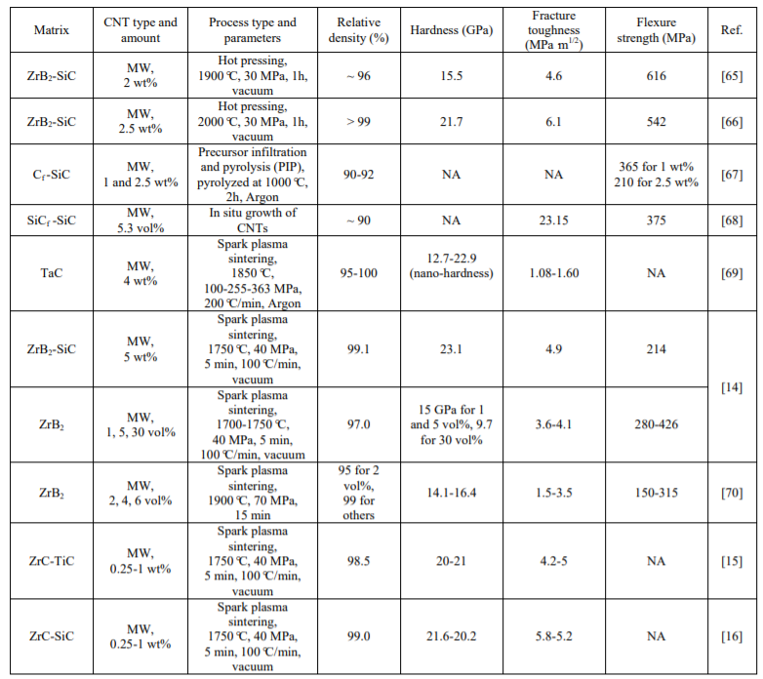
(Ipek Akin, 2015)

Material Properties
The two materials that will be discussed are Zirconium diboride (ZRB2) and Hafnium diboride (HFB2), due to their popularity within the UHTC world. Both materials are improved with the use of additives, such as carbon. (Sylvia M. Johnson, 2009) The properties of UHTCs include the following: (Ipek Akin, 2015)
- Extremely high melting point (>3000°C)
- High Hardness (≥GPA)
- High Thermal Conductivity
- Good thermal shock resistance
- Good chemical inertness
It has been found that sintering (a manufacturing process) can be difficult to carry out for borides boride. Using sinter additives can help improve the densification process (discussed under the Manufacturing section of the report). In doing so this can affect the high temperature properties in a negative manor. (A K Suri, 2013). Material properties of UHTC’s vary based on the manufacturing process used as well as the matrix composition used. This involves the addition of sinter additives as previously discussed, as well as a reinforcing, oxidization resistance phase. (Luca Zoli, 2018)

Manufacturing
The manufacturing of UHTC’s is known to be a difficult process, mainly due to the material’s high melting point. Powder synthesis is the first process to be carried out during the manufacturing of UHTC’s. It is used to acquire the desired properties and microstructure in the final product. (I. M. Low, 2013) The next process would be densification of the material. A traditional method for this is hot pressing (J.F. Justin, 2015). The final process is then coating, which can be done by chemical vapor deposition (CVD) , this process is known to give good oxidization resistance. (Open Learn, 2018). Although, the methods discussed are not the only process’ that can be used for the manufacture of UHTC. Table 1 shows other processing types and parameters that can be used, and gives a clear comparison of how varying the processing types and parameters can affect the materials final properties (Ipek Akin, 2015).

Boron Carbide Reduction of Metal Oxide
This is the most preferred process for synthesis for UHTC’s such as ZrB2 and HfB2. This method uses a cheaper charge material. The reaction used for this process can be seen in Figure 1. The reaction is carried out at a temperature of approximately 1800°C (I. M. Low, 2013). The temperature used for synthesis will determine the particle size of the powder, this can later affect the densification process. Other synthesis methods are available and can be seen in Table 2. The advantage and disadvantage of each method can be seen. Some techniques such as solution-based techniques and synthesis from polymer precursors are only suitable for lab use only.
Figure 1
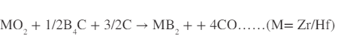
Table 2
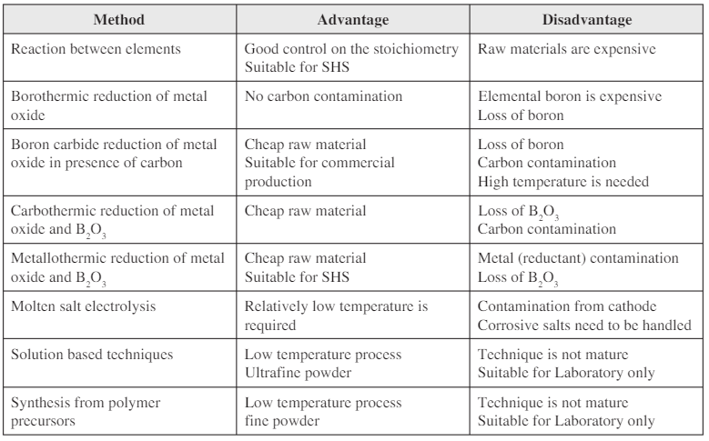
(I. M. Low, 2013)

Hot Pressing
Hot pressing is a traditional method used for densification. It involves using pressures between 60-100Mpa and temperatures between 1900-2100°C. The process uses heat furnaces and graphite dies to densify the diboride. This process has been around for approximately 60 years and has been developed to improve final material properties in various ways. One being the use of additives such as Silicon Carbide (SiC) to improve densification, along with fracture toughness and oxidization resistance. (Sylvia M. Johnson, 2009). It was found, that to achieve complete densification, the process can become costly due to the high temperatures and pressures required. (J.F. Justin, 2015). Table 3 shows a comparison between other densification methods. Although Hot pressing is not the only method, due to the age of this process there is more knowledge of it, whereas the like of spark plasma sintering has been around for approximately the same amount of time but was only researched from the mid 90’s (Anselmi-Tamburin, 2019).
Table 3
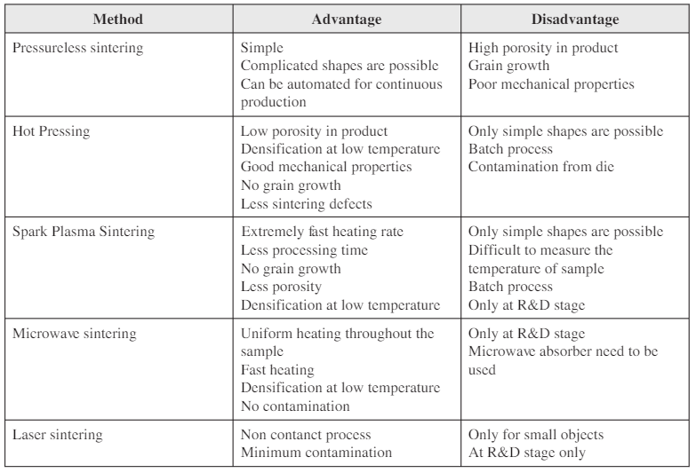
(I. M. Low, 2013)

Chemical Vapor Deposition
CVD is a process used throughout the engineering industry and has some fundamental steps. These are as follows:
- Vacuum chamber with material to be coated inside
- Material is heated
- Material is either heated or pressure reduced until material vaporized
- The suspended material (UHTC) can then be added and will begin to set on the substrate material.
- Thickness of coating can be varied by adjusting duration and temperature of process.
These are the fundamental steps of the CVD process. (Chandler, 2015). The process will vary slightly depending on the materials used for coating, or material being coated. It is usually carried out at temperatures between 500-1200°C (I. M. Low, 2013).

Environmental impact
The main waste product of manufacturing UHTC’s are gaseous products such as silica fume. The benefit of silica fume is it is used as an additive to increase the hardness of cement. It is a by-product of the production of products containing silicon in an electric arc furnace. (Panesar, 2019). Research was carried out do find other uses for silica fume. This can be seen in Table 4 where silica fume is recycled and used in various process’ (By Sehliselo Ndlovu, 2017).
Table 4
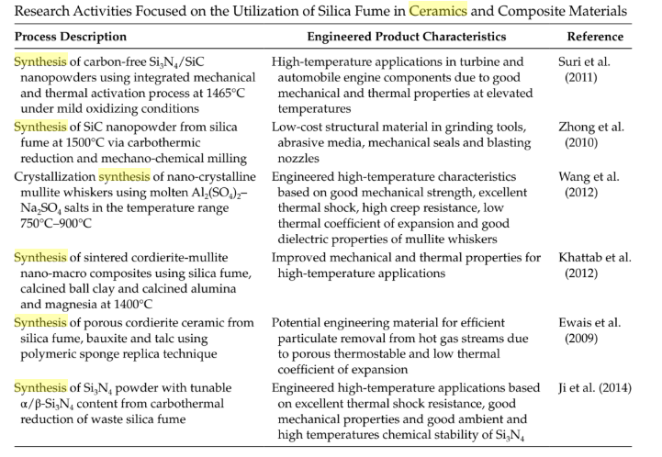

Health and Safety Implications
There are some health and safety implications when dealing with the use and manufacture of UHTCs. It was found that refractory ceramic fibre (RCF) is used for high temperature applications such as a lining for kilns and furnaces. The fibres can cause skin irritation to skin, eyes and upper respiratory tract. There were also concerns of the fibres being carcinogenic, studies were carried out by The European Ceramic Fibres Industry Association (ECFIA) and there was no evidence found to show cause of disease in humans. It is advised that respiratory protective equipment is used when jobs involving the cause of high dust levels are used. (HSE, 2020) This is also backed up by (Shipley, 2019) who also states that ZrB2 can be flammable in its powder form.

UHTCs for Sharp Leading Edges within the Aerospace Industry
In recent years, research has been carried out on the use of UHTCs on sharp leading edges on parts for re-entry vehicles, propulsion applications and hypersonic flights. This could mean shorter flight times on long haul civil flights, or even just an increase in the life span of the parts. (A. Jankowiak, 2014).
UHTCs for use with rockets is said to be beneficial due to the ablation, widening it causes to the throat. This causes the rocket to decrease in power. To overcome this, more fuel is used. This is not cost effective and in addition, payload must be reduced to account for the extra fuel. By using UHTCs as a lining it can prevent ablation which in turn will reduce the amount of fuel required. (Binner, 2020). Research for near zero-erosion rocket nozzles and near zero-ablation thermal protection is being carried out by the Aerospace Propulsion Laboratory using Ultra-High-Temperature Ceramic Matrix Composites (UHTCMC), specifically C3HARME. (Raffaele Savino, 2018) C3HARME is a consortium involving 12 parties, for the design development, manufacturing and testing of a new group of UTHCMCs that is reinforced with carbon fibres. (Binner, 2020).

Conclusion
UHTCs appear to be used massively within the aerospace industry. It is clear they have their pros, but with them, come their cons. Due to the harsh environments specific parts in the aerospace industry have to cope with, it causes a lot of problems when trying to develop a UHTC that will cope at each extreme. Thermal shock and oxidisation have stood out as the main causes to making it difficult in creating the ideal ceramic.
The manufacturing process of the UHTC is a complex process which can make it difficult to achieve the correct properties. There appears to be a lot of experimenting that achieve results which only differ very slightly. The hot-pressing process appears to be the most popular process used for densification. Although, there are process’ such as spark plasma sintering which appear to be becoming more and more common and share similar advantages with hot pressing. This has the potential to be the next development in the UTHC world, providing the R&D returns with positive results.
Ceramics are proving to be a beneficial material for high temperature applications. With the development of C3HARME, it shows that the industry is heading in the right direction for taking the next step in aerospace travel. It has the potential to make drastic changes if it can withstand extremely high temperatures for prolonged periods of time.

References
A K Suri, J. K. (2013). Synthesis and consolidation of zirconium diboride.
A. Jankowiak, J. J. (2014). Ultra High Temperature Ceramics for aerospace. HAL Archives.
Anselmi-Tamburin, U. (2019). Spark Plasma Sintering. Retrieved from www.sciencedirect.com: https://www.sciencedirect.com/topics/materials-science/spark-plasma-sintering
AZoM. (2010, February 21). An Introduction to Ultra-High Temperature Ceramics. Retrieved from www.azom.com: https://www.azom.com/article.aspx?ArticleID=5127
Binner, J. (2020). HIGH-TEMPERATURE COMPOSITES FOR AEROSPACE. Materials World Magazine.
By Sehliselo Ndlovu, G. S. (2017). Waste Production and Utilization in the Metal Extraction Industry. CRC Press.
Chandler, D. L. (2015). Explained: chemical vapor deposition. Massachusetts Institute of Technology.
E. Wuchina, E. O. (2007). UHTCs: Ultra-High Temperature Ceramic Materials for. Electrochem.
Emanuel Ionescu, S. B. (2019). Polymer‐Derived Ultra‐High Temperature Ceramics (UHTCs) and Related Materials. Advanced Engineering Materials Hall of Fame.
Fahrenholtz, W. G. (2014). A Historical Perspective on Research Related to Ultra‐High Temperature Ceramics. In W. G. Fahrenholtz, E. J. Wuchina, W. E. Lee, & Y. Zhou.
HSE. (2020). Hazards from the use of Refractory Ceramic Fibre. Retrieved from ww.Hse.gov.uk: https://www.hse.gov.uk/foi/internalops/ocs/200-299/267_3v2.htm
I. M. Low, Y. S. (2013). MAX Phases and Ultra-High Temperature Ceramics for Extreme Environments. Hershey PA: Engineering Science Reference.
Ipek Akin, G. G. (2015). Spark Plasma Sintering of Zirconia-Toughened Alumina Composites and Ultra-High Temperature Ceramics Reinforced with Carbon Nanotubes. In G. G. Ipek Akin. Istanbul: Department of Metallurgical and Materials Engineering, Istanbul Technical University.
J.F. Justin, A. J. (2015). Ultra High Temperature Ceramics : Densification,. hal.archives-ouverte.
Luca Zoli, A. V. (2018). On the thermal shock resistance and mechanical properties of novel unidirectional UHTCMCs for extreme environments. US National Library of Medicine.
Open Learn. (2018, March). Chemical vapour deposition (CVD). Retrieved from www.open.edu: https://www.open.edu/openlearn/science-maths-technology/engineering-technology/manupedia/chemical-vapour-deposition-cvd
Panesar, D. K. (2019). Developments in the Formulation and Reinforcement of Concrete (Second Edition).
Raffaele Savino, L. C. (2018). Aero-thermo-chemical characterization of ultra-high-temperature ceramics for aerospace applications. Journal of the European Ceramic Society.
Riedel, E. I. (2019). Polymer‐Derived Ultra‐High Temperature Ceramics (UHTCs) and Related Materials. WILEY-VCH Verlag GmbH.
Shipley, N. (2019). Ultra-high Temperature Ceramics.
Sylvia M. Johnson. (2009). Recent Developments in Ultra High Temperature Ceramics. Nasa.

