Engineering Management Assignment

ACHA5012

By Jacob Gough



Contents
1. Introduction 3
2. Roles & Responsibilities 5
2.1. Skills & Traits within my roles: 8
3. Overall group tasks and associated timing 10
4. Personal Tasks 13
4.1 Personal Gantt Chart 14
4.2 Preliminary Bill of Materials (estimated) 15
4.3 Specialist Equipment 16
4.4 Personal Milestones Previous, Current and future. 17
4.5 Personal Gateway and Analysis 18
5. Evaluating Risk 19
6. Group Gantt and personal milestones/ gateways. 21
6.1 Personal Milestone/Gateways 22
7. Reference List 26

Introduction

The primary objective of this project is to develop a functional and aesthetically compatible aerodynamic spoiler/wing, for the Morgan plus vehicle located in the workshop. The design must accommodate the vehicles soft-top design, ensuring compatibility for the use of the roof up or down.

To achieve this, our team has allocated individual roles and responsibilities to each group member, while still focusing on the main goal of the project. Each role consists of different areas of development, all contributing to the desired outcome. The wing must meet the criteria needed, making use of research and development along the way. I will be focused on the design and structure side of the project, making sure to adapt and change designs based upon dimensions of the vehicle and structural integrity.

The spoiler/wing will be designed and structurally evaluated using SolidWorks design software, using the same software to create model stages of the design process. Once an initial prototype of the design is developed, we can use CFD to process data for aero analysis, being able to adapt any necessary changes for the final design. We intend to increase rear downforce percentages, decrease frontal lift and increase cornering stability with this design.

To measure success within this project, we will use a shared and personal Gannt chart to tack and journal our milestones throughout the project. Changes can be made to increase the success rate of our outcome.

Roles & Responsibilities

Team Roles

Team Member | Section | Role
Alex Griffiths | Aero | Pm
 | Aero | Wind Tunnel, CFD
  Mohamad Mahmood
James Evans | ECS | Mechatronics
Jacob Ling | ECS | Software Design
Angel Stanley | Simulation | Track Data Analysis
Emily Dawes | Simulation | Track Data Analysis
Jacob Gough | Structure | Design/ Structure
Nevin Jyothis | Structure | Design/ Structure
Preston Thomas | ECS | Software Design

Team Responsibilities

Aero Team

Alex Griffiths - Project Manager (PM)

Oversee the Aero team's progress and ensure alignment with project goals.
Manage timelines, budgets, and resources for the Aero section.
Facilitate communication between the Aero team and other sections.
Manages the schedule goals for each team, ensuring timescale is met.

Mohamad Mahmood - Wind Tunnel Specialist

Lead the setup and execution of wind tunnel experiments.
Analyse aerodynamic data collected from tests and provide recommendations.
Collaborate with Alex to optimize aerodynamic performance based on test results.
Incorporation of the design teams models to facilitate CFD data, for future modifications.

ECS (Environmental Control Systems) Team

James Evans – Mechatronics Specialist

Design and develop mechatronic systems for ECS.
Integrate sensors, actuators, and control systems to ensure optimal performance.
Collaborate with software and design teams for seamless system functionality

Jacob Ling + Preston Thomas – Software Design Engineer

Develop software for controlling and monitoring ECS systems.
Ensure software is dependable, user-friendly, and meets performance criteria.
Coordinate with the Mechatronics Specialist for system integration.

Simulation Team

Angel Stanley – Simulation Engineer

Develop and run simulations to predict system performance.
Analyse simulation track data and provide insights for design optimization.
Collaborate with all sections to validate simulation models.

Emily Dawes – Simulation Engineer

Support the development of simulation models.
Focus on ensuring the accuracy and reliability of simulation track data.
Assist in analysing simulation outcomes and validating design choices.

Design/Structure Team

Jacob Gough – Lead Structural Design Engineer

Responsible for the conceptual and detailed design of primary structural components within the project.
Conduct advanced structural analysis, including finite element analysis (FEA), to ensure all designs meet safety and durability requirements under applied loads.
Ensure compliance with relevant industry standards and align structural designs with project-specific objectives.
Supply past and future models to the Aero team for CFD analysis.
Review and approve technical drawings and CAD models to verify accuracy and feasibility before submission.

Nevin Jyothis – Structural Design Support Engineer

Assist in the design of secondary structural elements, ensuring attention to detail and adherence to project specifications.
Perform material optimization studies to enhance efficiency, cost-effectiveness, and environmental sustainability of the design.
Document design decisions and analysis outcomes, providing technical calculations to support project deliverables.
Collaborate with Jacob to refine construction techniques and validate proposed solutions for structural challenges.

Skills & Traits within my roles:

My Personal roles

- CAD development of designs structure and dimensions of the wing.
- FEA analysis to conclude structural integrity.
- Transport of designs to the Aero team for CFD data transposition.
- Implement necessary change to the designs, past and future modelling.

Required Skills and personality traits for my given roles

Skills | Personality traits
In depth understanding of SolidWorks Software | Detail Oriented, Spatial intelligence, Creativity, Patience, and Focus.
In depth understanding of Stress analysis, including the ability to calculate load/ stress points of the design. | Analytical thinking, Problem solving, technical understanding, Curiosity.
Being able to use teams and email. | Communication skills, Openminded, Team -orientated
Strong organizational skills and the ability to plan methodically. | Accountability, Forward thinking, Resilience, Adaptability.

Belbin’s Model
My personal score.

My two highest scores for the Belbin’s model, were categorised under Implementer and Specialist. These scores correspond directly with my roles. Implementor being well organised and specialist having expert knowledge. This being my understanding of SolidWorks software from past employment, during my Mechanical engineering Apprenticeship.

However, I lacked score on Finisher. Indicating I lack ability to fully complete assigned tasks, this can be improved by subtle yet efficient time management and further team communication.

Overall group tasks and associated timing
Section | Group | What will you do for it? | What do you need from other groups | Deadline
Pulled From brief, what’s expected of us in viva 1 | Your Group Add a row in to split into your subgroups if you want | What you plan to contribute to that section | what you need with teams it will come from in brackets | When you will be finished with it (doesn't have to be in chronological order from top to bottom but must be before its needed by other groups)
Initial Project Considerations | Whole Team | GRP Rules read and understood | Group Work | 07-Oct
Initial Project Considerations | Whole Team | Groups and roles established | Group Work | 07-Oct
Research Complete | Aero | Learn CFD, research aerodynamics | Independent | 30-Oct
Research Complete | Structural | research different wing types. | Independent | 30-Oct
Research Complete | ECS | common mechatronic elements and how they work, potential Parts, Signal types and conversion methods learned | Independent | 02-Dec
Research Complete | Sim | Learn sim | Independent | 21-Oct

Experimental Work | Aero | Investigate wing profiles and dimensions, Target max CL and minimum CD then run at different angles | I dependant | 10-Nov
Experimental Work | Structural | Simulate and evaluate various conditions (static, dynamic, and aerodynamic) to validate design assumptions | Data from CFD | 23-Nov
Experimental Work | ECS | Testing Different Arduino configurations, Testing different Simulink methods. | Independent | 25-Nov
Experimental Work | Sim | Simulate track data with suggested wing profile | Suggested wing profile from aero | 20-Nov
Analytical Work | Aero | Investigate the maximum force exerted on the structure of the wing and mounting due to the lift and drag | Inform structural of loads, receive mechatronic design for wing adjustment to implement into cad model. | 15-Nov
Analytical Work | Structural | Perform structural simulations to assess stress, strain, and deformation under various load conditions | More Data from CFD, Stress and strain analysis. | 23-Nov
Analytical Work | ECS | What are requirements for various parts in real world/prototype | Resistive forces due to weight and air (Structural, Aero), Rate of response (Simulation) | 23-Nov
Analytical Work | Sim | Use track sim to find time needed for wing deployment and acceleration on axes | Independent | 23-Nov

Modelling Work | Aero | define shape and dimensions of wing components |  | 01-Nov
Modelling Work | Structural | Develop various models, while applying the aero and ECS needs to generate a practical wing design. | independent | 13-Nov
Modelling Work | ECS | Initial Plan for Layout no specific parts, initial Simulink structure | Dimensions of Wing and brackets (Structural and Aero) | 17-Nov
Modelling Work | Sim | Continuation of simulations and data analysis | Independent | 23-Nov
Results | Aero
Results | Structural | Final design/ model of mounting system along with the wing, tested and manufactured. | Data from CFD, Optimal positioning of pneumatics/ hydraulic/ electrical operation, accessibility from ECS. | 30-Nov
Results | ECS | layout with list of potential prototype parts and requirements for real parts, Simulink structure and methods established | Independent | 30-Nov
Results | Sim | Final testing done ensuring best result possible is achieved | Model of wing (Structural) | 30-Nov
Viva Prep Done | Whole Team | All PowerPoint slides filled in |  | 02-Dec
Viva Prep Done | Whole Team | Viva Rehearsed |  | 09-Dec

- Personal Tasks
Activity | Description | Plan start | Plan duration | Completion
Initial Dimensions of vehicle. | Using the apparatus supplied by the university, in the workshop. I took dimensions of the vehicle, to understand datums and boundary points to initiate design stage. | October 1st, 2024, | 2 weeks.  (20-40) hrs | 100%
Implementation of dimensions for design. | I then used the measurements to start the design process, initialising a base point to work from, first create a structure to work with. | October 16th, 2024, | 2 weeks.  (20-40) hrs | 100 %
Initial mounting bracket for wing developed. | In this stage, we had a base design for the structure secured to the base of the chassis, which would be the mounting bracket for the wing. | November 1^{st, 2024,} | 2 weeks.  (20-40) hrs | 100%
Completion of mounting system model. | Once I was happy with the design, and conducted viable testing for integrity using FEA, the design would be applicable for the first prototype. | November 16^{th, 2024,} | 3 weeks.  (30-40) hrs | 100%
Material selection of mounting system. | With Nevins' expertise, we finalized agreements and considered high-grade aluminium tubing, sheet, and titanium rivets for the mounting structure. | December 7th, 2024, | 3 weeks.  (30-40) hrs | 100%
Design one finalised. | Once we had conducted all tasks to finalise the first design protype, we could then experiment for better success. Ways to increase strength, while reducing weight. | December 28th, 2024, | 2 weeks.  (30-40) hrs | 85%

Time for reporting and presentation preparation: 2-4 weeks (50-60) hrs.

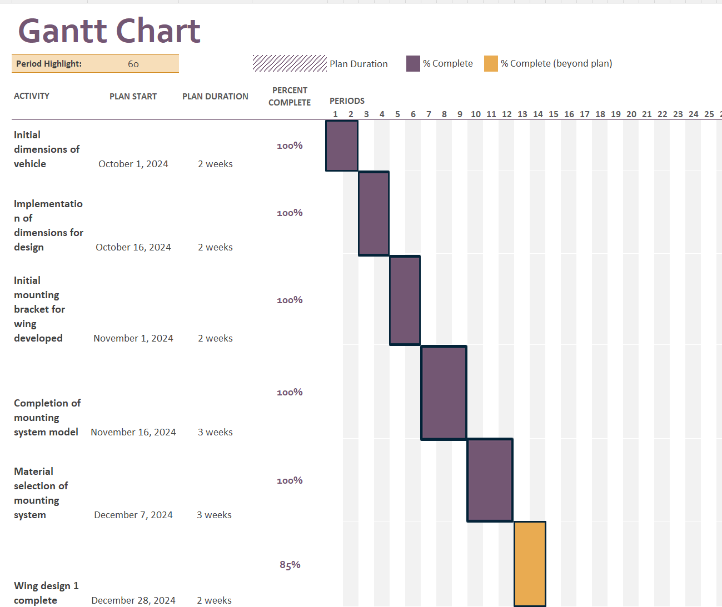
4.1 Personal Gantt Chart

Item | Material | Estimated Cost (£) | Manufacture/shipment lead Time.
Carbon Fibre Sheeting/ panelling | Carbon fibre | (500mm x 1m)  £15  (Carbon 2024) | (5-7) days
Aluminium tubing | Aluminium 7075 | (5/8” OD x 10swg)  (£4.19 p/m)  (Metals4u.co.uk 2025) | (5-6) days
Aluminium rivets | Aluminium 2024 | (100 rivets at £4)  (The Insulation Shop 2025) | (2-3) days
Adhesives | Epoxy resin | (per 25kg at £144.50)  (Rawlins Paints 2025) | (5-7) days
Fasteners | Titanium bolts | (M6 x 35mm at £10 each)  (Accu. 2022) | (5-10) days
Mounting Brackets | Stainless Steel | (Per bracket 41mm x 21mm at £3.28)  (Architectural Stainless Fittings 2025) | (5-7) days
Paint/ coating | Weatherproof coating/ chemical resistant. | (Galvanizing Paint 2kg at £42.82)  (Promain.co.uk 2025) | (5-6) days

4.2 Preliminary Bill of Materials (estimated)

Specialist Equipment

Equipment | Description | Machinery sourcing | Lead time
CNC Machining | For solid component or cylindrical machining | Available at our university | N/A
Laser Cutting Machine | Used to cut and shape, prototype components for out mounting system. | Available at our university | N/A
3D Printer | Used to print protype components, for a small-scale build and test. | Available at our university | N/A
Structural Analysis (FEA)  CAD Software | This software will be used to produce the designs, then test using the FEA | Available at our university | N/A
Carbon Fibre Impregnation Vacuum | This will be used to embed the resin, in a specific designed Mold, vacuumed to cure the resin and bond with the carbon fibre sheets. | Available at our university | N/A

Personal Milestones Previous, Current and future.

Milestones & Gateways Table
Stage | Milestone/Gateway | Completion Date (Target) | Criteria for Completion
Vehicle Dimensions Defined | Milestone - Initial dimensions of vehicle finalized | October 15, 2024 | Dimensions align with design specifications
Design Initiation | Gateway - Approval of vehicle dimensions for CAD implementation | October 16, 2024 | Design team agrees on feasibility
Wing Mounting Structure Defined | Milestone - Initial mounting bracket for wing developed | November 15, 2024 | Concept validated for strength and compatibility
Material Selection & Structural Completion | Gateway - Approval of mounting system material choice | December 27, 2024 | Meets weight, cost, and structural integrity requirements
Aerodynamic & Structural Progress | Milestone - Completion of Wing Design 1 | January 10, 2025 | Initial aerodynamic and structural criteria satisfied
Optimization & Refinements | Gateway - Approval for modifications on Design 1 | January 24, 2025 | Design review confirms need for refinements
First Structural Validation | Milestone - FEA conducted on Design 1 | February 7, 2025 | Simulation confirms structural feasibility
Iteration & Second Validation | Milestone - Design 2 completed & FEA conducted | March 6, 2025 | Further improvements validated
Final Optimization Cycle | Milestone - Design 3 completed & FEA conducted | March 27, 2025 | Last set of refinements tested for robustness
Final Design Confirmation | Gateway - Selection of final design for implementation | March 30, 2025 | Meets all aerodynamic, structural, and regulatory requirements
Final Engineering Analysis | Milestone - Final FEA & force calculations conducted | April 1, 2025 | Forces acting on structure fully analysed
Project Conclusion | Gateway - Final design justified & approved | April 1, 2025 | Ready for report submission and implementation

Personal Gateway and Analysis

Gateway Objective Chosen.

For my gateway I have chosen the structural analysis review, this will consider our designs structural integrity using methods such as FEA, to indicate stresses on the design, while using hand calculation values. To indicate percentages, (min-max) yield values and maximum strain values.

Using chosen SMART objectives, I can analysis successful outcomes for my chosen gateway.

Measurable

Using SolidWorks FEA, we can apply the hand calculations forces to obtain stress valves. These values will help us to gain and understand insight to out designs capability. The FEA stress values must be within a tolerance of (+or- 5%) for a successful structure, the yield Margin for this design must withstand a maximum stress of 80% of material yield strength, the safety margin for this being 20%. The maximum strain this structure can withstand, depending on material choice should be around 0.25%, any more can risk failure. I would like to see a 10% weight reduction in the revised design phase, while maintaining strength, even chances of an increase in strength. I will conduct as above, to achieve the desired outcome, while providing a safe and structurally sound design.

Cost Performance Criteria

For cost of manufacture, all components will be manufactured in house, therefore cost will be reduced. By sourcing different/ unwanted materials, we could potentially reduce cost margins by 5% to produce the final design. Any scrap material could potentially be used in the production process for further reinforcement of the product, therefore no waste necessary.

Evaluating Risk

- Structural Integrity

The rear-mounted wing is subjected to significant forces. This will increase at high speeds, this can lead to issues like deformation, fatigue and even failure completely. This is due to the exertion of high loads and force; vibration is also a problem in this area. To validate my concern for these issues, I can include ways to mitigate these concerns.

Material selection

Using lightweight, high-strength materials such as carbon fibre, titanium, or advanced composites will ensure the wing is both strong and lightweight. These materials offer excellent strength-to-weight ratios and fatigue resistance.
(www.compositesworld.com, n.d.)

Finite Element Analysis FEA:

Using FEA software during the design phase to model the stresses and strains on the wing under various loading conditions. This helps identify weak points or areas where reinforcement may be necessary.

Reinforced Mounting Points:

Ensure that the mounting points between the wing and the vehicle are designed with enough strength. Reinforcing these areas can prevent failure due to mounting stresses.

Fatigue Testing:

Performing extensive real-world testing such as vibration testing and fatigue cycles will help to simulate long-term use and identify any potential weaknesses that could cause failure under repeated stress.
(Racecar Engineering, n.d.)

Boundary Layer Control:

Designing the wing with features that manage the boundary layer, such as vortex generators or tailored wing tips. These features will help reduce drag and maintain smooth airflow over the wing surface, improving aerodynamic efficiency.

By addressing these two primary concerns, the structural integrity and aerodynamic performance. Through appropriate design and testing methods, the risks associated with manufacturing and using a rear-mounted wing can be minimized, ensuring both safety and optimal performance.

- Material weather proofing/ corrosion resistance.

The risk involved, is the deterioration or oxidation of components on the structure. Not correctly treating the final design for weatherproofing or corrosion resistant properties, can lead to these issues. I can address these issues/ prevent them.

Material selection

Material selection is vital when producing a final product, as this product use is indented for outdoor use, it must be weatherproof and corrosion resistant. Using non-ferrous materials such as grades of aluminium can help to prevent this problem, as aluminium does not oxidise. Other material choices such as carbon fibre can help to improve the longevity of the project and decrease deterioration.

Applicants

Using applicants such as galvanising methods for ferrous metals can be very efficient with this issue if the budget for the product is low cost. This strategy can be quite effective, without breaking the bank. There are a variety of coatings/ paints that can help/ stop oxidisation and deterioration of metals all together. Some including spray paints, resin-based coating, or even ceramic coatings.

Group Gantt and personal milestones/ gateways.
Plan Duration
Complete according to plan
Complete outside plan
Milestones
Deadlines

Personal Milestone/Gateways

Project Overview

Goal:

Design a high-performance rear-mounted wing that balances aerodynamic efficiency and structural integrity under high-speed loads.

Timeline:

Estimated duration: 6-12 months depending on scope and resources.

Key Stages and Milestones

The design process is divided into clear stages with key milestones and gateways where progress depends on the approval of prior work.

Stage 1: Conceptualization (2-3 weeks)

Objectives:
- Define project scope and requirements.
- Research vehicle specifications and materials.
- Review relevant regulations.

Tasks:
- Study existing rear-wing designs.
- Define aerodynamic goals alongside the aero team.
- Choose materials.
- Outline potential adjustments.

Deliverables:
- Design brief and material selection.
- Preliminary structural targets.
- Compliance with regulations.
- Hand calculations for stress and strain.

Gateway:
Approval of the project brief and material choice.

Stage 2: Preliminary Design (3-4 weeks)

Objectives:
- Develop initial 3D CAD models.
- Define basic structural designs and develop alongside the aero team for an appropriate wing shape and design.
- Consider mounting and integration with the vehicle.

Tasks:
- Create initial CAD models of the wing.
- Define mounting points and load-bearing areas.

Deliverables:
- 3D CAD models of the mounting structure and wing .
- Structural analysis (for weak points).

Gateway:
Approval to proceed with detailed aerodynamic optimization.

Stage 3: Structural Analysis (3-4 weeks)

Objectives:
- Ensure the wing can withstand high-speed aerodynamic loads and mechanical stresses.

Tasks:
- Perform FEA to assess wing strength and fatigue resistance.
- Reinforce high-stress areas/ mounting points.
- Simulate the wing under various loading conditions.

Deliverables:
- FEA results showing stress distribution.
- Recommendations for material changes or reinforcements.

Gateway:
Approval of structural integrity results to proceed to prototype fabrication.

Stage 4: Final Design and Production (3-4 weeks)

Objectives:
- Finalize the design for production and integration into the vehicle.

Tasks:
- Make final adjustments based on test feedback.
- Finalize CAD models and production specifications.
- Prepare production-ready materials and moulds.

Deliverables:
- Final production-ready design.
- Technical documentation and assembly instructions.

Summary of Key Milestones:

Milestones with dates

Conceptualization: Define scope and material choices
Start date: October 1, 2024
End date: October 15, 2024
Activities:

- Establish project scope, objectives, and requirements.
- Select preliminary materials based on strength, cost, structural and aerodynamic considerations.
Preliminary Design: Develop CAD models and define aerodynamic features
Start Date: October 16, 2024
End Date: November 15, 2024
Activities:
- Create initial CAD models to define structural and aerodynamic features.
- Validate initial design choices through basic hand calculations and software analysis.

Structural Analysis: Conduct FEA to ensure strength and durability
Start Date: November 16, 2024
End Date: December 31, 2024
Activities:
- Perform FEA on mounting systems and wing structure.
- Adjust material choices and design features based on FEA results.
- Ensure the design meets strength and durability requirements under operational loads.
Final Design and Production: Finalize design and prepare for production
Start Date: January 1, 2025
End Date: March 30, 2025
Activities:
- Refine CAD models and validate final design iterations (Designs 2 and 3).
- Conduct advanced FEA and aerodynamic testing on the chosen design.
- Prepare documentation and calculations for production readiness.

Reference List
Accu. (2022). Buy M6 x 35mm Socket Cap Head Screws (DIN 912 / ISO 4762) - Grade 5 Titanium - Accu. [online] Available at: https://www.accu.co.uk/metric-cap-head-screws/652707-SSC-M6-35-TI5?uk_google_shopping=1&c=3&msclkid=f9375d8fc0bd1d2154dd34acd5cbe0a3&utm_source=bing&utm_medium=cpc&utm_campaign=Shopping%20-
%20Zombie%20SKUs%20MM%20UK&utm_term=4581733694692273&utm_content=PL%20-%20Zombie%20SKUs [Accessed 23 Nov. 2025].

Architectural Stainless Fittings. (2025). Stainless Steel Corner Connecting Bracket, Rust-Proof & Suitable For Exterior Use. [online] Available at: https://asfittings.co.uk/collections/brackets-mountings/products/stainless-
steel-corner-connecting-bracket-rust-proof-suitable-for-exterior-use [Accessed 23 Nov. 2025].

Carbon (2024). Carbon Fibre 2x2 Twill 1m Wide (200g/m?). [online] MB Fibreglass. Available at: https://www.mbfg.co.uk/1m-wide-carbon-fibre-twill.html[Accessed 23 Nov. 2025].
| CompositesWorld. [online] Available at: https://www.compositesworld.com.

Metals4u.co.uk. (2025). 5/8" od x 10swg wall Aluminium Tube | metals4U. [online] Available at: https://www.metals4u.co.uk/materials/aluminium/aluminium-tube/3038-p [Accessed 23 Nov. 2025].
Promain.co.uk. (2025). Promain (UK). [online] Available at: https://www.promain.co.uk/zinga-zingaceram s.html [Accessed 23 Nov. 2025]
Rawlins Paints. (2025). Watco Concrex Carbon Fibre Mortar. [online] Available at: https://www.rawlinspaints.com/products/9167-watco-concrex-carbon-fibre-epoxy-repair-
mortar.html?msclkid=e85d380c64461e4f4690512f77bd0480&utm_source=bing&utm_medium=cpc&utm_campaign=Performance%20Max%20Stocked&utm_term=www.rawlinspaints.com&utm_content=Best%20Sellers [Accessed 23 Nov. 2025].
Racecar Engineering. (n.d.). Racecar Engineering» Motorsport | Racing |

The Insulation Shop. (2025). Contact us. [online] Available at: https://theinsulationshop.co.uk/pages/contact-us [Accessed 23 Nov. 2025]
Technology. [online] Available at: https://www.racecar-engineering.com.
www.compositesworld.com.
(n.d.). Delivering the Global Composites Market

