Professional Skills and Health & Safety in Construction

KERRI FARMER 2100037 ACBA4003

Investigating Health and Safety Records of UWTSD CONSTRUCTION LTD

CONTENTS

1. Introduction Pg. 3

2. Review of Incidents
Incident 1: Working on contaminated ground Pg. 3
Identifying the root causes, legislations violated and
consequences of each incident.
Incident 2: Working on demolition site Pg. 5
Identifying the root causes, legislations violated and
consequences of each incident.
Incident 3: Scaffolding collapse Pg. 7
Identifying the root causes, legislations violated and
consequences of each incident.
Incident 4: Workers hit by falling objects Pg. 9
Identifying the root causes, legislations violated and
consequences of each incident.

3. Review of the Company Health and Safety Management Pg. 10

4. Conclusion and Recommendations Pg. 10
5. Statistics Pg. 12

6. References Pg. 14

INTRODUCTION

This report is on the health and safety investigation of UWTSD Construction Limited (UCL) sets out to pinpoint the weak points, reasons and legislations violated in the company’s health and safety management and policy, to ensure there is clear guidance to help improve the safety of the company and their employees for the future.

“Health and safety is relevant to all businesses. So, if you are an employer – or are self-employed – you are responsible for the health, safety and welfare of employees and any others who may be affected by what you do. This includes employees, casual or part time workers, trainees, customers, neighbours, salespeople, and members of the public.” (HSE , n.a)

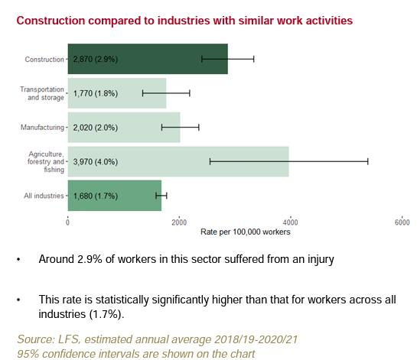
(HSE, 2021)

review of incidents

Incident 1: working on contaminated ground (improvement notice – may 2021)

Causes
The main cause for working on contaminated land that was previously used for a landfill site, was due to no desktop study, ground investigation report completed as well as an Environment Impact Assessment none of these were submitted by the client and or the main contractors.
Adequate personal protective equipment not supplied to the employees, thus leading to the illness of two employees. If the correct personal protective equipment were supplied the risk would have been minimised as well as prevented.
Risk Assessments not completed, if they had been the risks would have been identified prior to employees falling ill and preventative, or remedial measures could have been implemented.

legislation violation
Environmental Protection Act 1990 Part 2A Contaminated Land Statutory Guidance, DEFRA 2012. (Legislation Government United Kingdom, 1990)
The CDM Regulations 2015 No. 51 Part 4 regulation 17 2. A construction site must be, so far as is reasonably practicable, made and kept safe for, and without risks to, the health of a person at work there. (Legislation Government United Kingdom, 2015)
The Building Act (1984) BA 1984 supported by the Buildings Regulation 2000 and their Approved Documents, particularly Document C1, Site Preparation and Resistance to contaminants. (Legislation Government United Kingdom, 1984)
The Personal Protective Equipment at Work Regulations 1992 (PPER 1992), UK Statutory Instruments 1992 No. 2966 Regulation 6, Assessment of personal protective equipment (Legislation Government United Kingdom, 1992)

Health and Safety at Work Regulations 1999, identify what could cause injury or illness in your business (hazards), decide how likely it is that someone could be harmed and how seriously (the risk), take action to eliminate the hazard, or if this is not possible, control the risk. (Legislation Government United Kingdom, 1990)

Consequences
The major consequences of the above improvement notice 2021 issued on UCL, would be the loss of time and the cost to the company.

The cost to the company for the loss of the injured employee and the subsequent employment of new personal to complete the work. There is a major cost implication on the investigations that are needed to take place and the falling behind the program of work, deadlines will not be met.

This includes a loss of income for the injured employees who are off work due to the injuries, long term health issues can arise for instance COPD due to the exposure to harsh gases from the exposure to the construction site that was previously a landfill site.

incident 2: working on demolition site (improvement notice – july 2020

Causes
The main cause on this UCL demolition stie was not all the employees on the demolition site were wearing the correct personal protective equipment, the workers exposed to air and noise pollution.
It was discovered that there was a huge breakdown in communication from management down the chain to employees. There was also no risk assessment done with regards to the noise assessment and disturbances and possible risks to employees on the site.

The method statement was not adequate, and neither was the method statement communicated to the employees correctly to ensure the methods are understood and the sequence of works, prior to the commencement of work.

There were no inductions completed on the UCL demolition site, further investigation revealed the complete lack of supervision on the UCL demolition site and an overall lack of management.

Compounding the issues stated, it was discovered there was no license in place for the disposal of waste on the UCL demolition site.

legislation violation
The Control of Noise at Work Regulations 2005, UK Statutory Instruments 2005 no. 1643 Regulation 5. (1) Assessment of the risk to health and safety created by exposure to noise at the workplace. (Legislation Government United Kingdom, 2005)

Control of Pollution Act 1974, UK Public General Acts 1974 c. 40 F7 5 Licences to dispose of waste. (1) An application for a disposal licence in respect of any land in the area of a disposal authority must be made in writing to the authority.

Environmental Protection Act 1990 (Legislation Government United Kingdom, 1974)

The Management of Health and Safety at Work Regulations 1999, UK Statutory Instruments 199 No. 3242 Regulation 4 Principles of prevention to be applied Where an employer implements any preventive and protective measures, he shall do so on the basis of the principles specified in Schedule 1 to these Regulations. Regulation 10 Information for employees (1) Every employer shall provide his employees with comprehensible and relevant information. (Legislation Government United Kingdom, 1999)

The Personal Protective Equipment at Work Regulations 1992 (PPER 1992) 4 (1) Every employer shall ensure that all employees are supplied with suitable personal protective equipment. (Legislation Government United Kingdom, 1992)

CDM Regulations 2015 require that site inductions be done for all sites, (including those listed in Schedule 3 of the CDM 2015 Regulations) site inductions need to be proportionate to the reason for the site visit, either working full-time, part-time contractors, occasional visits such as HSE inspectors. (HSE, n.a)

Consequences
The consequences due to the improvement notice issued to the UCL demolition site on July 2020 are quite severe, the safety records with HSE are updated and this impacts the reputation of the company.
Dust inhalation is a serious matter and can lead to endless and dire health issues in the future for the affected employees and any public that may have be exposed near the site. Due to the exposure of the noise pollution on the site to employees they were at significant risk of experiencing tinnitus.
The environmental nuisance the demolition site has caused to the nearby neighbouring businesses could have a drastic affect on the business during the time of construction works, leading to loss of income for surround businesses.
Should the improvement notice be not adhered to and followed, a following prohibition notice could be issued, this would lead to a huge loss of income and time on the programme of works for the demolition, in turn this would have an affect on other contractors to begin the construction works after demolition has taken place.
Extra costs incurred due to investigations needed to be conducted on the site.

incident 3: scaffolding collapse on site (prohibition notice – january 2020)

Causes
There was a failure to do an investigation on the ground before erecting the scaffolding, the need for base plates was of utmost importance, and due to lack of supervision by a competent person the correction of the scaffolding was missed. Had there been a competent person on site, doing regular inspections this accident may be prevented.
There was negligence on the scaffolder who climbed through the bracing of the scaffolding, this is due to lack of training, communication barrier due to differing cultural background and lack of supervision on site, which could have prevented the employee from climbing the scaffolding.
These incidents were not recorded or reported as discovered when the HSE inspector visited site.

legislation violation
The reporting of Injuries Diseases and Dangerous Occurrences Regulations 2013 UK Statutory Instruments 2013 No. 1471 Regulation 7 Dangerous occurrences. (Legislation Government United Kingdom, 2013)

Health and Safety at Work Etc Act 1974 UK Public General Acts 1974 c 37 Part I General Duties Section 6 (3). (Legislation Government United Kingdom, 1974)

The Construction (Design and Management) Regulations 2015 UK Statutory Instruments 2015 No. 51 Part 4 Regulation 19 Stability of structures. (Legislation Government United Kingdom, 2015)

The Work at Height Regulations 2005 UK Statutory Instruments 2005 No. 735 Regulation 5 Competence. (Legislation Government United Kingdom, 2005)

Consequences
This is a serious offence and can cause significant injury or death, the reputation on UCL due to an incident like this is irreparable, loss of working time as well as employing new workers to complete the job once all regulations were adhered to. There is a huge knock-on effect on the program of works with the trades to follow and deadlines will be missed this in the end incurs a huge monetary loss.
The monetary loss due to investigations, penalties and fines that would need to be paid.

incident 4: workers being hit by falling objects (prohibition notice – March 2019)

Causes
The main cause for the acro-pole falling from height was a prop screw that was not tightened and put into the lock position by an employee who has no relevant training on the erection of acro-poles this was aggravated by the lack of supervision at the point of erecting the acro-poles.

The premature collapse of the door was due to the method statement not completed correctly with the sequence of works to be followed clearly defined.

In both incidents there were no designated exclusion or mark off zones as well as no control of site access and security.

legislation violation
The Work at Height Regulations 2005 UK Statutory Instruments 2005 No. 735 Regulation 4 Organisation and planning. (Legislation Government United Kingdom, 2005)

The Work at Height Regulations 2005 UK Statutory Instruments 2005 No. 735 Regulation 5 Competence. (Legislation Government United Kingdom, 2005)

The Work at Height Regulations 2005 UK Statutory Instruments 2005 No. 735 Regulation 10 Falling objects. (Legislation Government United Kingdom, 2005)

The Work at Height Regulations 2005 UK Statutory Instruments 2005 No. 735 Regulation 11 Danger area. (Legislation Government United Kingdom, 2005)

The construction (Design and Management) Regulations 2015 UK Statutory Instruments 2015 No. 51 Part 4 Regulation 17 Safe Places of work. (Legislation Government United Kingdom, 2015)

Consequences
Reputation of the company and its health and safety record will have a major mark against the UCL on the HSE website. Severe injury and death due to the incorrect methods of work being followed. Cost to the company while site is shut down and investigations take place as well as fines and penalties paid.
No security and control to site access could lead to severe injury or fatalities to public, or kids entering the site.

3. Review of the company health and safety management practise
UCL has a lack of safety records, no traceability within the current records, and there are missing method statements and risk assessments, off all works in progress or already completed. The health and safety management system is non-existent, and no training matrix record for any employees. The company policy on health and safety is present but needs to be reviewed, updated, and followed.
The culture within the company is not one focused on health and safety, this has consequence on the approach to health and safety within UCL these influences begin with management. UCL has no checks in place for equipment and inspection of equipment very minimal records kept on toolbox talks.

4. Conclusion and recommendations
In conclusion the following recommendations put forward.
- Complete restructure of company hierarchy with clarification on job descriptions.
- Rewrite the policies and procedures in the health and safety file.
- Training matrix set up with proper training provided for all employees.
- Incentive scheme implemented.
- HR to implement a safe place for employees to come to with concerns being emotional, personal, and or physical to improve the mental wellbeing of all employees
- Regular internal and external auditing of all policies, procedures, and documentation throughout the company.

FIGURE 1 KEY ELEMENTS OF A MANAGEMENT SUBSYSTEM

POLICY

ORGANISATION

RISK ASSESSMENT

PLANNING

IMPLEMENTATION

AUDITING

(Griffith & Howarth, 2001)

The end goal is to improve the management of the health and safety policy and prevent any future injuries and time loss within the company. In return the improvement of all health and safety policies will lead to less or no employees being injured or killed at or during work, this will lead to a better reputation for the company, minimise penalties, fines, and prosecution and greater success for the company.

5. Statistics

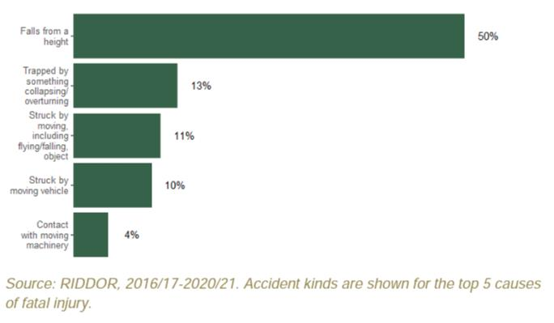
Fatal injuries There were 39 fatal injuries to workers in 2020/21p. This is in comparison with the annual average number of 36 fatalities for 2016/17-2020/21p (HSE, 2021)

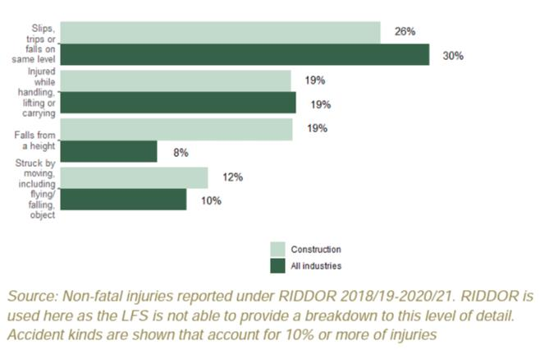

61,000 non-fatal injuries to workers each year averaged over the three-year period 2018/19-2020/21. Prior to the coronavirus pandemic, the rate of self-reported nonfatal injury to workers showed a downward trend. The rate for the latest period, which includes years affected by the coronavirus pandemic, is not statistically significantly different from the previous period. (HSE, 2021)

References
Griffith, A. & Howarth, . a. T., 2001. Construction Health and Safety Management. In: Construction Health and Safety Management. s.l.:Routledge, p. 122.
HSE , n.a. HSE Government Site. [Online]
Available at: https://www.hse.gov.uk/construction/new-health-safety.htm
[Accessed 15 April 2022].
HSE, 2021. Construction statistics in Great Britain, 2021, United Kingdom: HSE.
HSE, 2021. Construction statistics in Great Britain, 2021, s.l.: s.n.
HSE, n.a. HSE. [Online]
Available at: https://www.hse.gov.uk/construction/safetytopics/site-rules-induction.htm#:~:text=The%20inductions%20should%20be%20proportionate,to%20and%20the%20control%20measures.
[Accessed 22 April 2022].
Legislation Government United Kingdom, 1974. Control of Pollution Act 1974. [Online]
Available at: https://www.legislation.gov.uk/ukpga/1974/40
[Accessed 21 April 2022].
Legislation Government United Kingdom, 1974. Health and Safety at Work etc. Act 1974. [Online]
Available at: https://www.legislation.gov.uk/ukpga/1974/37/section/6
[Accessed 22 April 2022].
Legislation Government United Kingdom, 1984. Building Act 1984. [Online]
Available at: https://www.legislation.gov.uk/ukpga/1984/55
[Accessed 22 April 2022].
Legislation Government United Kingdom, 1990. Environmental Protection Act 1990. [Online]
Available at: https://www.legislation.gov.uk/ukpga/1990/43/part/IIA
[Accessed 15 April 2022].
Legislation Government United Kingdom, 1992. The Personal Protective Equipment at Work Regulations 1992. [Online]
Available at: https://www.legislation.gov.uk/uksi/1992/2966/regulation/4/made
[Accessed 21 April 2022].
Legislation Government United Kingdom, 1999. The Management of Health and Safety at Work Regulations 1999. [Online]
Available at: https://www.legislation.gov.uk/uksi/1999/3242/regulation/10
[Accessed 21 April 2022].
Legislation Government United Kingdom, 2005. The Control of Noise at Work Regulations 2005. [Online]
Available at: https://www.legislation.gov.uk/uksi/2005/1643/regulation/5/made
[Accessed 21 April 2022].
Legislation Government United Kingdom, 2005. The Work at Height Regulations 2005. [Online]
Available at: https://www.legislation.gov.uk/uksi/2005/735/contents/made
[Accessed 22 April 2022].
Legislation Government United Kingdom, 2005. The Work at Height Regulations 2005. [Online]
Available at: https://www.legislation.gov.uk/uksi/2005/735/regulation/4/made
[Accessed 22 April 2022].
Legislation Government United Kingdom, 2005. The Work at Height Regulations 2005. [Online]
Available at: https://www.legislation.gov.uk/uksi/2005/735/regulation/10/made
[Accessed 22 April 2022].
Legislation Government United Kingdom, 2005. The Work at Height Regulations 2005. [Online]
Available at: https://www.legislation.gov.uk/uksi/2005/735/regulation/11/made
[Accessed 22 April 2022].
Legislation Government United Kingdom, 2013. The Reporting of Injuries, Diseases and Dangerous Occurrences Regulations 2013. [Online]
Available at: https://www.legislation.gov.uk/uksi/2013/1471/contents/made
[Accessed 2022 April 2022].
Legislation Government United Kingdom, 2015. The Construction (Design and Management) Regulations 2015. [Online]
Available at: https://www.legislation.gov.uk/uksi/2015/51/regulation/17/made
[Accessed 22 April 2022].
Legislation Government United Kingdom, 2015. The Construction (Design and Management) Regulations 2015. [Online]
Available at: https://www.legislation.gov.uk/uksi/2015/51/regulation/19/made
[Accessed 22 April 2022].
Legislation Government United Kingdom, 2015. The Construction (Design and Management) Regulations 2015. [Online]
Available at: https://www.legislation.gov.uk/uksi/2015/51/regulation/17/made
[Accessed 15 April 2022].

