Managing Enterprise in 21st Century
(A reflective writing on a Business plan)
Module N°: BMSK 4006_ Lon (Term 2)

Student: Shahida Hiren Badshah
Student ID: 1705709

Lecturer: Dr Mushfiqur Rahman

University of Wales Trinity Saint David
Contents
Introduction 3
Describing the awareness of the learning journey in business plan development 4
Reflection on business plan development 4
Reflective Cycle 5

Development of the personal skill set for self-employment 9
Conclusion 10
Reference 11

Table of Figures
Figure 1 - Gibb's model of reflective Cycle 5

Introduction

The reflection report mainly includes understanding of the module learning journey regarding the business plan interaction. However, this module also includes discussion on the development of personal skills which can help to establish me in self-employment situation. The discussion starts with reflection on the business plan that has been prepared by my group of 6 members where I engaged in different activities such as group discussion for field research, presentation session and so on. This report will reflect my work and the facts on my achievements as an individual and as a team member to do the research, gather information, critically analyze the situation and present the project paper, as well as to establish this reflective report. With the help of academic writing skills, one’s can increase the potential skills and learning in life (Almeida, Robalino, and Behrman, 2012). The purpose of this report is to present my personal record including my thoughts and experiences achieved during the development of my plan. The Gibbs model of reflective cycle has also been discussed in order to prioritize the business plan interaction during the class.

Describing the awareness of the learning journey in business plan development

Reflection on business plan development

A business plan reflects the organizations’ motives, its mission and vision in overall activities. In this course, we have learned how a business plan is being developed in order to incorporate the organisation's goals and objectives. There are some key elements in business plan that we have learned and these elements also reflect on the overall objectivity of the plan.
While working in my group for developing a business plan of a day care centre “Little Stars”, I had my parts on “Human Resource Management” and “Products and Services”. I have done my research to collect information from the Child Care centers in Tower Hamlets and in Barking personally. I have learnt that Child Care service is influenced by the skills of employees and the activities of the centre. They need to be directed by proper guidelines and framework, and motivated by employers and managers. In the day care / child care system, the employees who are being hired and those who are involved need to increase the skills like Interpersonal skills, Analytical skills, IT skills to improve the potentiality in work.
During the course, we have learnt about different key elements of business which helped in developing our business plan, such as: situation analysis, purpose of the report, situation of the marketplace and market environment; understanding the nature of products and services; financial analysis, market structure and marketing plan, and implementation plan for development of strategies.

Reflective Cycle
According to Husebo et al (2015), as learning arose from our own experience in the different field, developing a habit of constant learning can also help to increase our learning in the long run. The Gibbs model of reflective learning suggests that we have to incline to learn things continuously from different sources and surrounding to develop our inner. There are 6 steps of this model which also work as a cycle of learning and development. These are described in terms of the course learning as follows:
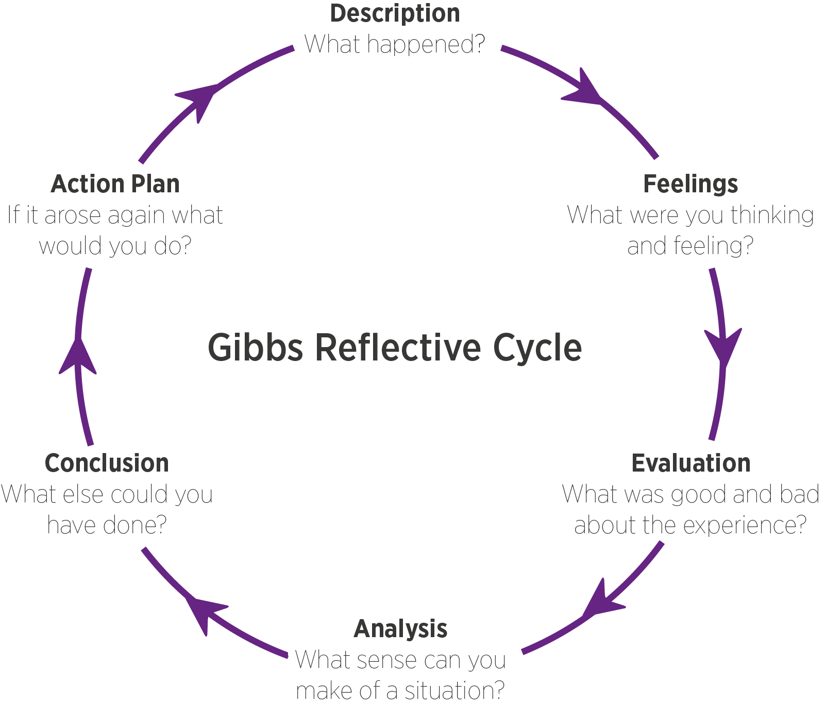
Figure 1 - Gibb's model of reflective Cycle
Source: internet

Description: The description should include the situation of the learning, the roles played by me and other members, what are the key elements that happened. Answering such questions can help me to find an understanding of the situation to learn. As I attended session class lecture, I found that business plan is important for analyzing the problem or implementing a strategy for a new market environment. During the development of our business plan, we have followed the suggestion of our tutor, we arranged discussion meeting which helped us generating new ideas and concepts about the project. The vision and mission of the business project were generated through these discussion and brainstorming sessions. I found these sessions excellent team-work towards establishing a business plan. We distributed the task of our project activities among the team members, in relation to the structure of our business plan. Following the distribution of the task activities, we agreed to prepare our group presentation and submit our group assignment project on a prescribed date.
Feelings: In this stage, I have to concentrate on the thoughts and feelings that I experienced during the class session on business development. Before I started the project, I did not know much about how to develop a business plan. I had an impression that anyone with business experience and capital required can buy a local and start a new business. I did not know there are certain rules and regulations, and certain limitations to obtain a license.
I got to know that to establish a successful business, it is required to have a specific goal which helps to get through the starting point where the business/ project can be launched. It is also needed to develop a business plan to assess the situation and get look into the possible scenario of the problem.
Whenever we have formed a group of 6, I had a confused feeling. I am hardworking and take everything seriously, while the efforts of other group members made me unhappy. All of our team members were not serious or motivated in completing the business plan. We met several times for brainstorming ideas with members and successfully managed to develop a business plan. I reflected upon my experience of work in GP practices for planning, gathering information, analyzing and presenting the facts. We have consulted how to minimize our barriers and maximize our strength to reduce our weakness, and I found the way to exploit the possible opportunities and remove threats. We stayed in touch with each other to put forward our assigned tasks. Having the team members from different cultures caused some problems such as little understanding of each other’s ideas, lack of knowledge, lack of knowledge in conducting research, business management and lack of ability to think and analyze critically conflicts in decision making process. But we were able to resolve our disagreements professionally and pleasantly to work together. From experience I learnt that a team becomes successful when works jointly. Being a team member is very crucial but I understood its significance where the combination of skills and knowledge of the team creates a positive effect on producing greater team success and results.

Evaluation: By asking questions such as what are the positive and negative aspects of the situation, why these are bad or why those aren’t etc. can help to find out which was correct decision (Parker, 2006). For instance, I learned that evaluation of my decisions and feeling can help me to realize the importance of the business plan development. My skills for research increased considerably. I learnt how to better argue, use facts on management issues. This business plan development process made me confident, cooperative, extroverted and effective as a team member. The process of collecting information, its analysis and writing it and presenting it in a prescribed format made me feel pride and gave me a sense of achievement, which will help me in any future research project.
Analysis: It is important for me to develop a sense of the situation, to assess the situation and the the information, and overall finding to reach a solution for the problems or issues, and increase my learning ability. I acknowledged my roles and responsibilities by working in a team which provided me confidence. Working together to achieve the common goal within a limited time, improved my communication and coordination skills. The energy of some group members’ participation, and constant contact and coordination with team members made me feel more participatory and assisted me to learn and grasp their ideas and experiences. I felt more interested and enthusiast in searching various data sources using various tools and methods. The knowledge from the lectures and my workplace experience helped me search various data source. I practically collected information about the Child Care from the Children’s Centers and from my colleagues in GP Care group Network in Tower Hamlets.
Conclusion: The conclusion is the justification of the findings in the previous stages. When I reach a conclusion, it means that I reached my final decision about something and I need to carry on my skills and knowledge and devote myself to that. I admit that the development of this business plan has helped me to understand the application of critical thinking and analyzing the information and I have learnt the lectures and modules as well as to use the theory into practice.
Action plan: Action plan is the last stage but it can also lead to reflection and understanding of something new. It includes what are the different activities that I might do in different situation so that my actions are being justified. It is also related to the future actions of different situations in the future (Parker, 2006). If I proceed on the project we have developed, I will try my best to overcome the mistakes we have made, some of my drawbacks and weaknesses. Prior to set-up childcare business I will attend the training courses require to obtain the license. I will need to do more research to gather knowledge about the child care business and to improve my research skills.

Development of the personal skill set for self-employment

Self-employment skills are different from other related career paths, it can help me establish differently among them. The following section consists of different skills for self-employment I require to manage my everyday professional situation incorporation my personal life.
Organising skills: According to Andrews and Higson (2008), the key skill for self-employment is the organising skills which help me to organise the resources for self-employability. In parallel to my study in University, I work in GP care group Netwok in Tower Hamlets as an Administrator, and as self-employed to do as Online Translator-Interpreter for the political asylum seekers in France. I write books to learn French for the Bengali speakers since years. I am a single parent of three children. I do a lot of charity works overseas and local. To balance and maintain my personal, social and professional life, I had to develop certain organising skills and I use an organiser to make them functional without any disruption.
Communication skills: Communication skills is very critical skill which requires in every situation. It helps to develop a better relationship with the people surrounding (Dwyer, 2005). As I am working independently for the vulnerable people, I have to make a connection with people from similar or different sector or organizations, professional bodies. Building communication skills helps me to develop a better prospect and to understand what others are saying, and to express myself and my opinions among others.
Problem-solving skills: Dwyer (2005) found that problem-solving skills are also important in workplace as different problems might arise from the work and employment. It could be complaint from customers, environmental issues, and it can also come from family. In order to develop problem-solving skills, I also need to increase my knowledge and find out solutions for possible problems that I might face from my work. It can also help me to build self-confidence and desire to perform even complex tasks.
Team-working: The purpose of the team working in my self-employment situation is that different opportunities might come positively for me and it might require working with others. For every work situation I have formed several teams locally and overseas level. Developing such skills helps me understand the nature of teamwork how to handle different situation in team work. It also helps to learn from other team members and apply them in my work so that I could increase my productivity.
Quick-decision making: According to Mumford (2007) decision-making skills are important in the development of key strategies in different work. Quick decision-making skills can help me to decide in critical and sensitive situations which are important for my self-employability and to overcome the challenges that appear suddenly. Sometimes taking quick decision might be wrong and can bring unexpectedly negative impact. Sometimes lack of quick decision can be devastating for certain domain I am working for.
Negotiation skills: Thomas (2008) emphasised that having and developing negotiation skills can help me to develop my own strategies and present them to others in conflicts and bargains. Having strong negotiation skills help me address the adverse situation, and develop a better position among the competitors. The skilful negotiation skill helps me to develop peaceful solutions for the different parties and to improve my reputation.

Conclusion
In conclusion, there are lots of skills important for a person to survive in as self-employment situation. Developing such skills can help a person to keep him self-employed for a significant time in the competitive market. This module has given various knowledge and insights about the self and work-related knowledge. Applying them in any situation might help me to establish a better self and position as a skilful person.

Reference
Almeida, R., Robalino, D. and Behrman, J. (2012). The right skills for the job?. Washington, D.C.: World Bank.
(https://openknowledge.worldbank.org/bitstream/handle/10986/13075/709080PUB0EPI0067869B09780821387146.pdf? sequence=1&isAllowed=y)
Andrews, J. and Higson, H., (2008). Graduate employability, ‘soft skills’ versus ‘hard’ business knowledge: A European study. Higher education in Europe, 33(4), pp.411-422.
Dwyer, J., (2005). Communication in business: Strategies and skills. Pearson Education.
Husebo, S.E., O'Regan, S. and Nestel, D., (2015). Reflective practice and its role in simulation. Clinical Simulation in Nursing, 11(8), pp.368-375.
Mumford, T.V., Campion, M.A. and Morgeson, F.P., (2007). The leadership skills strataplex: Leadership skill requirements across organizational levels. The Leadership Quarterly, 18(2), pp.154-166.
Parker, V., (2006). Business impact of executive coaching: demonstrating monetary value. Industrial and Commercial Training, 38(3), pp.122-127.
Thomas, D., (2008). Cultural Intelligence: People Skills for Global Business: Easy read Super Large 20pt Edition. ReadHowYouWant.com.

