Dafydd Edwards (2417062)
Changemakers: Creativity and Value Creation
Report

Contents
Introduction 2
Task 1 – Project Management 3
Task 2 – Enterprise and Innovation 6
Task 3 – Project Reflection 9
Conclusion 11
References 12
Appendices 13

Introduction
This report presents a structured plan for a proposed Wi-Fi access point replacement project, focused on upgrading legacy Wi-Fi 5 infrastructure to Wi-Fi 6. The aim is to improve network performance, increase device capacity, and ensure better coverage within a modern enterprise environment. The report is divided into three main tasks: project management and planning, enterprise and innovation, and project reflection.
In Task 1, I outline the full project scope, including technologies required, a proposed solution, design elements, and a detailed Gantt chart to support planning and time management. Task 2 explores the business potential of the project by analysing a relevant tech company and developing a business concept based on the proposed upgrade service. This includes a SWOT and PEST analysis, branding, and funding considerations. Finally, Task 3 offers a personal reflection on the skills I aim to develop through this project and considers the broader impact the project could have on society, alongside the challenges it may face.
The report is supported by visuals, diagrams, and cited sources to demonstrate a well-researched and realistic approach to planning and delivering a technical solution related to my area of study.

Task 1 – Project Management
This project focuses on upgrading the current wireless network by replacing all existing Wi-Fi 5 access points with Wi-Fi 6 models. The goal is to improve speed, coverage and the network's ability to support more connected devices. Speeds will increase by around 60%. [6] The process will begin with site surveys to assess the current setup, identify dead zones and review the existing infrastructure. Based on this assessment, we will plan the optimal placement of the new access points to ensure the best performance. The new devices will then be configured with the correct settings, including network names, passwords, VLANs, and security protocols and enrolled into the existing controller (SCCM). Following testing and once the appropriate equipment is selected, the old devices will be removed and the new access points installed, ensuring proper connectivity and power through the existing network. After installation, we will run tests to verify signal strength, coverage, and overall network performance. At the end of the project, updated documentation will be provided, including access point locations and configuration details. [1]
Below is a Gantt chart that I have completed for my project using Microsoft Excel.
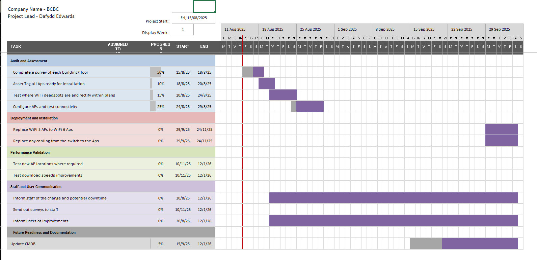
This Gantt chart shows the full timeline and structure of my Wi-Fi access point replacement project, broken down into clear phases and tasks. It helps me visualise how the work is planned from the project start date on the 15th of August 2025 through to early January 2026. Each task is colour-coded and scheduled with a specific start and end date, and the progress of each task is shown as a percentage, so I can keep track of what has already been completed and what still needs attention.
For this project, I decided to use a phased approach. By using a phased method for the Wi-Fi access point replacement project offers several important benefits. It provides a clear structure by breaking the project into distinct stages, which makes planning and managing tasks more straightforward and helps ensure that critical steps such as auditing existing equipment, designing the new setup, and testing are completed thoroughly and in the correct order, reducing the risk of errors or oversights. The phased approach also allows for better control over the project timeline and resources. By focusing on one stage at a time, I can allocate the necessary time, tools, and staff efficiently, which helps avoid rushing tasks and missing important details. This is valuable in projects involving physical installations where coordination and preparation are essential. Additionally, this method supports risk management and flexibility. Suppose issues arise during one phase, such as discovering incompatible equipment or unexpected site conditions. These can be addressed before moving forward, reducing the chance of costly mistakes or rework later in the project. Finally, a phased approach facilitates clear communication and progress tracking. It enables me to set SMART goals for each phase and review progress before starting the next step. This structured progression helps keep the project organised, reduces confusion, and allows team members to stay informed about the current status and upcoming work. Overall, the phased method is a practical, reliable and effective way to manage a technical upgrade like a Wi-Fi access point replacement, ensuring the project is completed successfully and with minimal disruption. [7]
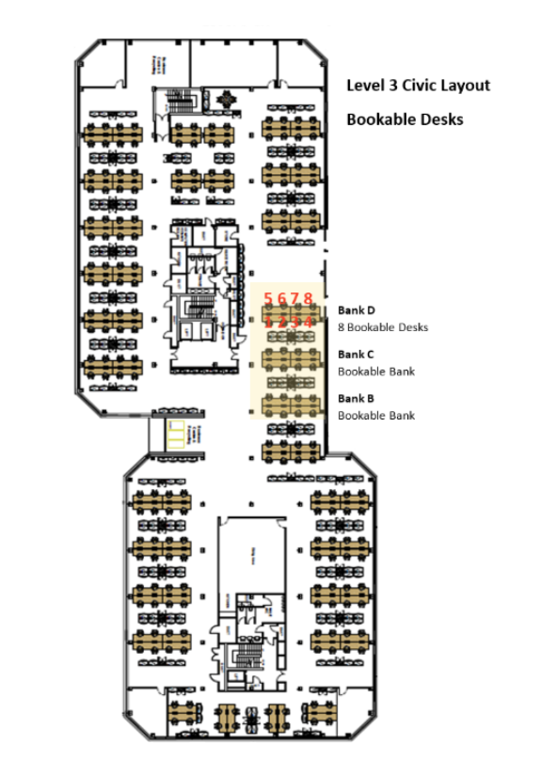
I will be using the floor plans to audit where current APs are and will aim to replace the current ones in the same places. Having a clear and accurate floor plan helps me visualise the layout and identify where the existing Wi-Fi 5 access points are currently installed. I would either mark the locations directly on a digital copy of the floor plan or print it out and note the positions manually during a site walk.
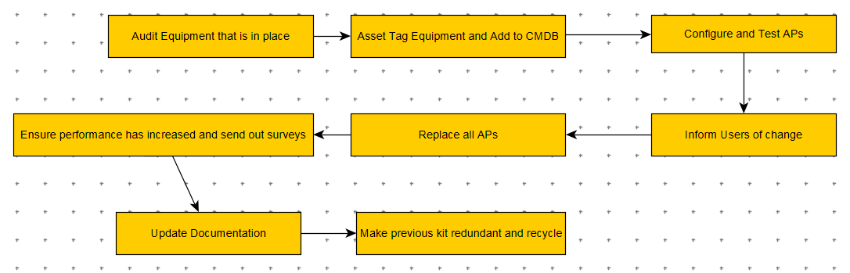
This flowchart represents the step-by-step process I will follow for my Wi-Fi access point replacement project. I start by auditing the equipment that is already in place so I can understand what hardware is currently being used and what needs upgrading. Once I have a full list, I will asset each item and add the details to the Configuration Management Database (CMDB), which helps keep everything organised and traceable.
After that, I move on to configuring and testing the new access points to make sure they are set up correctly and functioning as expected. I will also inform users about the upcoming changes so they are aware of any possible downtime or improvements. Once everything is ready, I will replace all the old access points with the new Wi-Fi 6 models.
Following the installation, I will ensure that performance has improved by running tests and sending out surveys to users for feedback. I will then update all documentation to reflect the changes made, including network maps and asset records. Finally, I will make the previous equipment redundant and arrange for it to be recycled properly. This process will help me stay organised, minimise disruption, and ensure the upgrade is completed effectively and responsibly.

Task 2 – Enterprise and Innovation
  - SWOT and Pest Analysis
For the SWOT and PEST analysis, I have decided to use a local company to me called Advanced Satellite Solutions. They aim to provide specialist communication solutions and network cabling to businesses of all sizes throughout the world. [5]
Strengths  Specialised Expertise – deep knowledge in the subject ranging from Site Surveys to AP Configuration | Weaknesses  Scalability Challenges – hard to find staff with broad knowledge of the situation if they wanted to upscale.
Opportunities  Increased Demand for WiFi 6  Reselling redundant equipment to those who have a lower budget.  Recurring Business Contracts | Threats  High competition – bringing competitive prices will lower profit margins.  In-house IT Teams

Political  Regulations and Compliance laws – must work under the current networking laws for security reasons.  Licensing and Certifications – may require certifications for certain equipment, e.g. Cisco, Aruba. | Economical  Stock Levels – a shortage in stock can cause increased prices and delays on projects.  Inflation – prices on products and wage demands have risen recently, so lower profit margins are further reduced if wanting to remain competitive.
Social  Increased remote working policies – companies heavily rely on stable, high-speed connections. | Technological  Advancements in technology – replacing WiFi 5 to WiFi 6 (Soon to be WiFi 7)  Cloud-based Management

  - Enterprise
I have decided that I will create a Tech Business that will be related to my project. I have decided to name my business WiFli. There are zero businesses currently set up under this name on the Gov.UK website. This play on words is a catch way for people to remember the name of the business. [4]
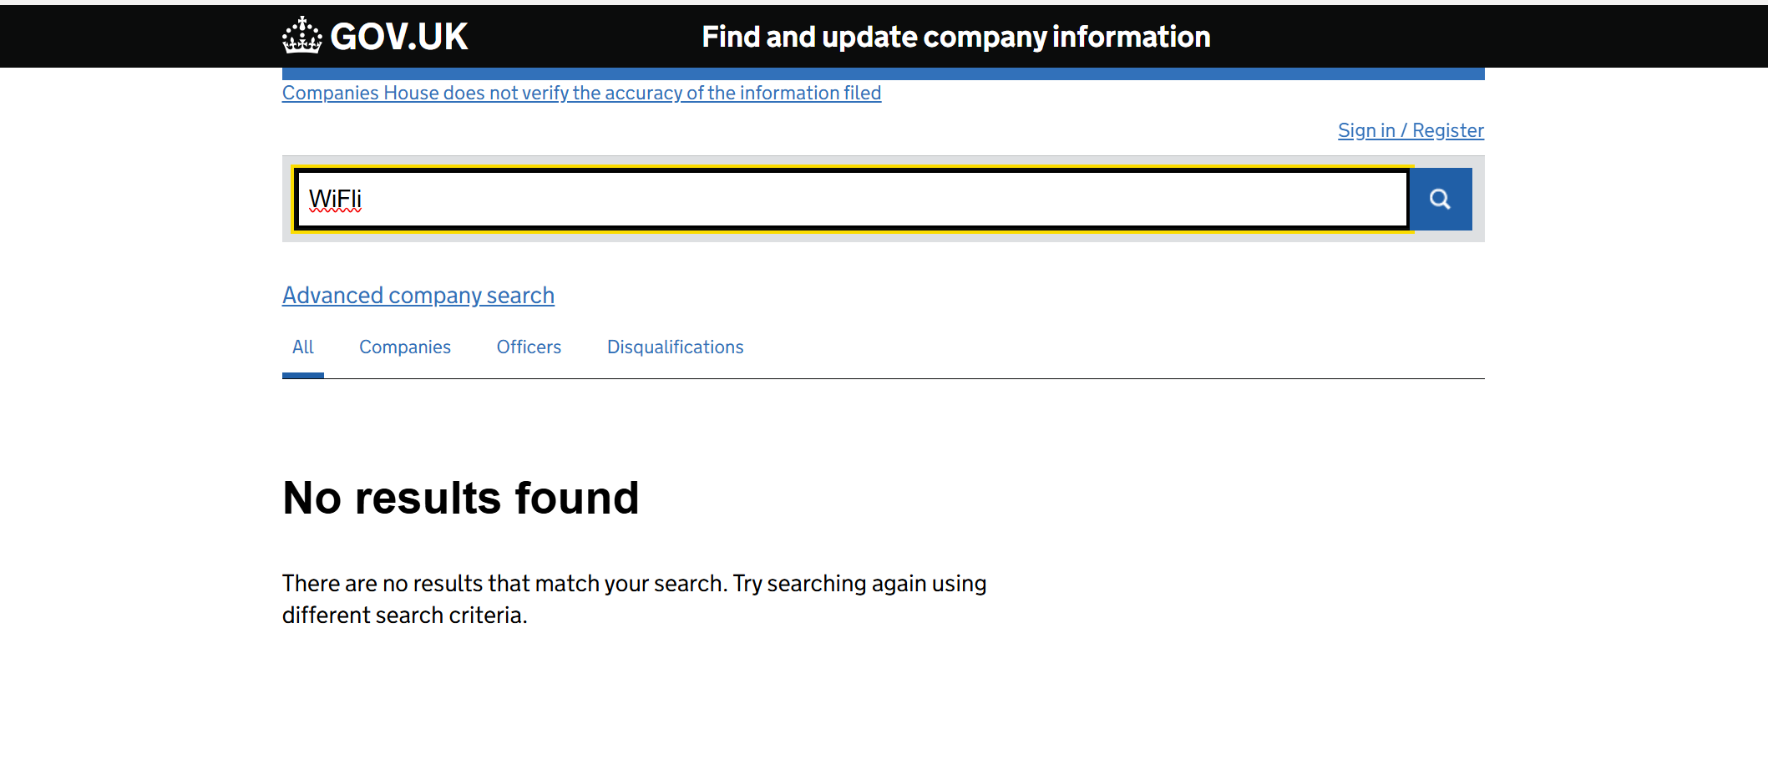
The logo I have designed is as shown below.
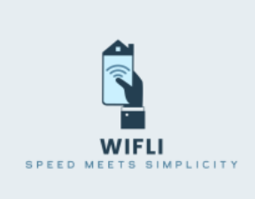

I would choose to structure my business as a limited liability company (Ltd) because it offers a good balance between simplicity and protection. Since my work would involve installing and replacing networking equipment like access points and switches, I want to make sure my personal assets are protected in case of any unexpected issues. A Ltd allows me to keep the business legally separate from my personal finances, which gives me peace of mind. It also helps present a more professional image to clients, which is important when working with businesses that expect reliability and credibility. [2] [3]
To establish my Wi-Fi access point replacement business, I chose to take a practical and cost-effective approach. I am initially self-funding the business using personal savings to cover essential startup costs, such as purchasing tools, acquiring a small stock of access points, and handling legal requirements including registration and insurance. In addition, I have explored local small business grants and startup support schemes that are designed to assist technology-focused companies. These initiatives often provide valuable resources such as business advice, training, and financial support, which can be especially helpful in the early stages.
To keep overheads low, I will carry out all work independently and focus on smaller, local projects to build a client base and gain industry experience. I can do this in many different ways such as TikTok and Facebook which are forever growing. Not only this, I could enlist onto Yellow Pages. I will also reach out to suppliers to negotiate competitive pricing on hardware and will actively complete vendor certifications such as those offered by Aruba and Cisco, to enhance my credibility and technical expertise. This approach allows me to grow the business steadily while managing risk and delivering a reliable and trustworthy service. [9]

Task 3 – Project Reflection
I intend to use the Wi-Fi replacement project as a hands-on opportunity to develop both technical and professional skills. From a technical perspective, I aim to deepen my understanding of wireless networking by learning how to carry out site surveys, plan access point placements and configure modern Wi-Fi Systems such as Wi-Fi 6 APs. This project will also allow me to gain practical experience with troubleshooting connectivity issues and working with different network environments. In doing so, I hope to build confidence in deploying infrastructure that meets current performance standards while remaining scalable for future needs.
Additionally, I want to become more familiar with the tools and software used in professional networking, such as network monitoring platforms such as Sentinel and configuration management systems such as SCCM. Becoming comfortable with these tools will support my goal of working in IT roles where attention to detail, accuracy, and problem-solving are essential.
On the professional side, I plan to improve my project management, time management, and communication skills. I want to become more confident in planning and organising tasks, especially when working to deadlines or adapting to unexpected challenges. This includes learning how to manage resources effectively, balance priorities, and keep progress well-documented. The project will also help me practise explaining technical information clearly, both in written form and during discussions with others. These communication skills are just as important as the technical ones, especially when working alongside team members or providing support to users.
Overall, I see this project as an opportunity to become a more well-rounded IT professional who is adaptable and capable of overcoming challenges. It also allows me to experience what it’s like to plan a real-world project where things don’t always go as expected and ensures I understand that preparation and flexibility are required.
My Wi-Fi replacement project and the skills I develop through it could also have a positive impact on society by helping improve access to faster, more reliable internet in everyday settings. Whether it's for work, study, communication, or accessing services, people depend heavily on stable connections. Upgrading outdated networks supports productivity and allows more people to benefit from digital tools and opportunities.
By learning how to carry out these upgrades professionally and efficiently, I can contribute to reducing the gap in connectivity, especially in places where internet performance is still an issue. Over time, this kind of work can help more people stay connected in a world that relies so much on hybrid working, etc.. There is also a practical benefit to reusing or recycling any removed equipment, which supports more responsible technology use and reduces unnecessary waste. [8]
Some risks and challenges my Wi-Fi replacement project could face include hardware delays, unexpected conditions at the installation site, and potential compatibility problems with existing equipment. For example, delivery delays for new access points could slow down progress. To reduce this risk, I would make sure to order equipment early and stay in regular contact with suppliers. Performing a full audit of the current setup in advance would also help avoid issues like outdated cabling that might not support the new technology. In addition, I would have backup plans in case configuration problems arise, so that time isn’t lost troubleshooting on the spot.
By preparing carefully and using this project as a learning experience, I believe it will give me a solid foundation for future work in IT and networking. It brings together technical knowledge, planning, and problem-solving skills that are essential in many areas of the industry.

Conclusion
This report has provided a detailed and structured plan for a Wi-Fi access point replacement project, with a focus on upgrading outdated infrastructure to meet modern networking demands. Through the project planning outlined in Task 1, I demonstrated how a technical upgrade like this can be managed effectively using industry-standard tools, clear timelines, and considered design decisions. Task 2 expanded on this by exploring how the project could be turned into a viable business opportunity, supported by market analysis and strategic planning. Finally, Task 3 allowed me to reflect on the personal and professional skills I would expect to develop through this project, as well as how it could impact connectivity.

References
[1] "Network Refresh: How to Plan and Execute a Successful Upgrade", Cablify, https://www.cablify.ca/network-refresh-how-to-plan-and-execute-a-successful-upgrade/ (accessed Aug 15, 2025).
[2] G. T. c. manager, "What does it mean to be a ‘limited’ company? – Companies House", https://companieshouse.blog.gov.uk/2018/05/15/what-does-it-mean-to-be-a-limited-company/ (accessed Aug 15, 2025).
[3] P. Williams. "What Does Ltd. (Limited) Mean After a Business Name?" https://www.investopedia.com/terms/l/ltd-limited.asp (accessed Aug 15).
[4] "Find and update company information - GOV.UK." https://find-and-update.company-information.service.gov.uk/ (accessed Aug 15).
[5] "Advanced Satellite Solutions", https://www.advancedsatellitesolutions.co.uk/ (accessed Aug 15, 2025).
[6] "WiFi 6 vs. WiFi 5", Yomura Fiber, https://yomurafiber.com/blog/wifi-6-vs-wifi-5-the-evolution-of-wireless-networking/ (accessed Aug 15, 2025).
[7] “Phased Implementation” https://dealhub.io/glossary/phased-implementation/ (accessed Aug 15)
[8] “Wi-Fi warning for Brits using BT, Sky or Virgin Media due to 'significant limitations’” https://www.manchestereveningnews.co.uk/news/uk-news/wi-fi-warning-brits-using-31656271 (accessed Aug 15)
[9] “Top 60 ways to promote your business” https://entrepreneurhandbook.co.uk/how-to-promote-your-business/ (accessed Aug 16)

Appendices
Excel Gantt Chart
Floor Plans
Flowchart

