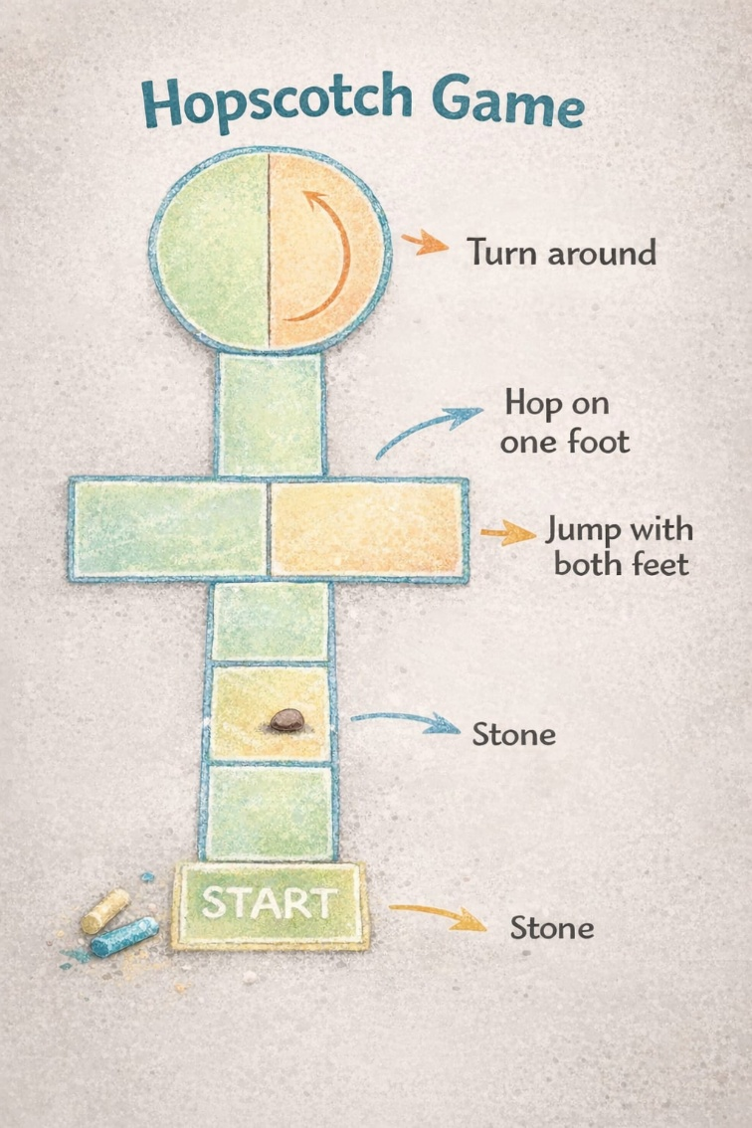

Reflective

Account of the

Hopscotch

Outdoor Play

Session

I acknowledge the use of an AI tool. I use the prompts
1. https://www.scribbr.com/ to generate references
2. https://app.grammarly.com/ Grammarly Proofreader; fix critical mistakes, improve accuracy and clarity
3. https://www.google.com/search?q=scholar+google to search for academic articles and sources.
4. https://www.google.com/search?q=translate&rlz= for translating
5. https://clipchamp.com/ I used to create and edit the video recording for this assignment.
I confirm that I have not presented any AI-generated text as my own work.

My play session in an outdoor setting was meant to facilitate a simple activity that would allow children to relax, manage their emotions, and enjoy themselves through movement and interaction with the natural environment. The session activity was the Hopscotch game, based on a conventional game I used to play with my siblings and friends as a child. My childhood memories were about laughing, having fun, and playing with people outside. Reflecting on these memories also allowed me to realise how relatively simple games could facilitate emotional attachment and social bonding. The activity was initially aimed at children aged 7 to 12 years; however, this time the assessment session was concluded with adults and lasted about 15 minutes. Thus, observations relate to adult participants, and reflections are predominantly theoretical, with assumptions based on existing information about children's development and well-being.

A central concept of this session was that therapeutic play need not be complex to be effective. Even basic outdoor activities can provide physical exercise, fun, and emotional release. Children today often face pressures, including school expectations or other societal demands. Even outdoor play may be a relief from these stressors and a source of relaxation for children. The experience was held in a nearby park, where natural surroundings can facilitate relaxation and emotional control. Parks offer open space, fresh air, and a natural environment in contrast to indoor environments. Such attributes may encourage individuals to pause and live in the moment. Scientists have found that children and young people are happier and experience reduced stress when they spend time in nature (Tillmann et al., 2018).

Attention Restoration Theory was one of the theoretical perspectives that guided my reasoning, indicating that natural settings help restore cognitive resources and the alleviation of mental exhaustion (Kaplan & Kaplan, 1989). Children may experience fatigue in their attention when they devote many hours to structured activities, like schoolwork. Natural surroundings can help regain this concentration by offering both restful and stimulating stimuli. However, nature in itself does not necessarily yield therapeutic results. It is also important in the organisation and facilitation of the activity. That is why I set very specific boundaries by drawing the hopscotch grid and explaining the rules during the activity.

The game of hopscotch was played as follows: the players jumped on one foot on single squares, on two on double squares, and turned to retrace the path. Starting with a small object like a stone or beanbag, which was tossed on every square sequentially, and participants were supposed to retrieve it with an upright posture. It was a structure that demanded concentration, coordination and body awareness. This activity would help children in various ways, particularly in therapy. First, it prompts physical activity that may assist with emotional regulation and stress alleviation. Body movement focus is needed in jumping and balancing, and potentially to redirect the mind from anxious thoughts.

Furthermore, the exercise promotes mindful movement. The game does not require the children to sit back quietly, and thus encourages them to concentrate on their body motions as they play. This form of active involvement can be especially useful with children who are difficult to relax through conventional methods. Moreover, the game can contribute to the development of confidence and resilience. The participants lose control and, at times, fail to reach a square, thus losing their turn. However, they have an opportunity to do it again. This creates an opportunity to experience minor failures in a harmless, fun-filled scenario. The other theory that helped me understand the outdoor environment was affordance theory, which posits that environments offer opportunities for action (Gibson, 2014). Some of the affordances provided by the park environment included open space for drawing the hopscotch pathway and adequate space to move.

My responsibility as the facilitator was to establish a supportive environment during the session. My goal was to encourage people to join the event and focus on fun rather than competition. Studies indicate that supportive play settings can help develop children's confidence, emotional stability, and self-regulation (Lester et al., 2010; Whitebread et al., 2017). I had some contingency plans in place before the session started. The activity may be conducted in the same manner as initially designed, which might be more difficult and require greater balance control, or changed to a group game if the competition is too intense.

Looking back at the session, a few areas went well. The task was simple to demonstrate, and the participants learned the rules quickly. It seemed that the repetitive movements helped participants concentrate on the game as it became increasingly complex. Although the sample population was adults, the activity fostered a light-hearted atmosphere, immediate interaction, and laughter. Meanwhile, the session illuminated some challenges. Others would start with the aim of covering the grid perfectly or moving faster than others. This demonstrated how easily competition can manifest in structured games. In response, I shifted the focus to enjoyment and participation.

Generally, this experience suggested that the Hopscotch game could theoretically serve as a therapeutic play activity for children ages 7 to 12. Although the assessment session was carried out with adult participants and was merely fifteen minutes, the concepts that the activity was based on could be modified in case of children experiencing stress and anxiety. Even though these activities will not address complex mental health problems, they may provide short-term relaxation, physical activity, and fun in nature settings.

References
Gibson, J. J. (2014). The ecological approach to visual perception: classic edition. Psychology press..
Kaplan, R., & Kaplan, S. (1989). The experience of nature: A psychological perspective. Cambridge university press.
Lester, S., & Russell, W. (2010). Children's Right to Play: An Examination of the Importance of Play in the Lives of Children Worldwide. Working Papers in Early Childhood Development, No. 57. Bernard van Leer Foundation. PO Box 82334, 2508 EH, The Hague, The Netherlands.
Tillmann, S., Tobin, D., Avison, W., & Gilliland, J. (2018). Mental health benefits of interactions with nature in children and teenagers: A systematic review. J Epidemiol Community Health, 72(10), 958-966.
Whitebread, D., Neale, D., Jensen, H., Liu, C., Solis, L., Hopkins, E., ... & Zosh, J. (2017). The role of play in children’s development: A review of the evidence.

