WORKSHEET 2 – QUESTION (TILES)

A homeowner is redecorating. The tiles they have chosen measure 20cm x 20cm each. The homeowner needs to buy enough tiles to cover their wall.

Allow the homeowner to enter the dimensions of the wall to be tiled (you can assume that the wall is either square or rectangular).

Calculate how many tiles the user needs to cover their wall.

Example walls:
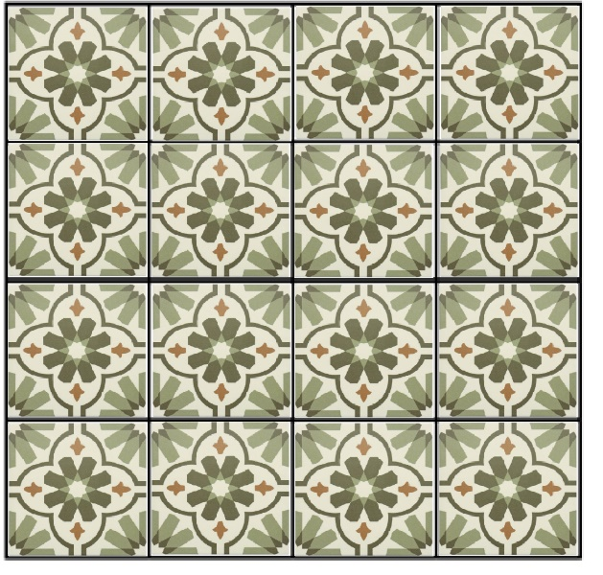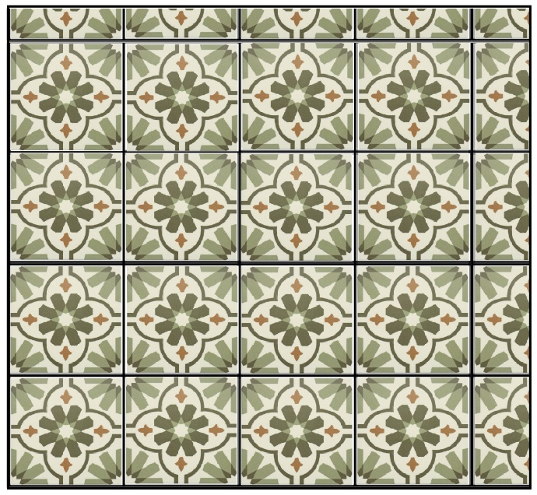
Wall = 80cm x 80cm = 16 tiles Wall = 85cm x 90cm = 25 tiles

Remember that all of the wall must be covered with tiles. You also must maintain the pattern across tiles as shown above, so that the finished wall looks nice.

Tiles are expensive, so you should calculate the minimum number of tiles required to achieve coverage.

Use validation in your code where appropriate to prevent the user from entering inappropriate values.

