

RESULT

ASSIGNMENT DETAILS AND FEEDBACK
SOUTH WEST WALES CENTRE FOR TEACHER EDUCATION
Sections marked with * should be completed by module lead
Student name: | Abbie Glading | Student P number: | 133809
Programme: * | PGCE Primary
Module: * | School Development and Pupil Progress | Module Level (6 or 7):* | 7
Module code: * | M7X02153 | Contribution to Overall  Module Assessment (%): * | 70%
Module Lead:* | Helen Lewis
Assignment Title:* | Written assessment 4,500 words | Assignment No (x of x):* | 1/2
Start date:* |  | Submission deadline:* | 30th May 2018
Return date of provisional marks & written feedback:* | 27th June 2018

Referencing: | In the main body of your submission you must give credit to authors on whose research your work is based. Append to your submission a reference list that indicates the books, articles, etc. that you have read or quoted in order to complete this assignment (e.g. for books: surname of author and initials, year of publication, title of book, edition, publisher: place of publication).
Submission: | All assignments must be submitted to Turnitin unless otherwise instructed by the Lecturer.  Note: the Turnitin version is the primary submission and acts as a receipt for the student. Late submission of the electronic version of the assignment will result in a late penalty. Penalties for late submission: Up to one week late, maximum grade D. Over one week late, Refer. Only the Extenuating Circumstances Panel may grant an extension. | Date: | 30th May 2018

Module lead to tick to indicate if a hard copy version of the assignment must be submitted.* | YES
 | NO

Learning Outcomes tested  (from module syllabus) | Assessment Criteria: To achieve each outcome a student must demonstrate the ability to:
• critically reflect upon teachers’ professional responsibilities in working closely with parents governors, local authorities and agencies which support schools and the wider community  • synthesise and analyse performance data accurately to inform decision-making, illustrating a comprehensive understanding of national requirements relating to progress within the statutory and non-statutory curricula  • identify, apply and evaluate appropriate formative and summative assessment strategies, and critically reflect on the effectiveness of selected strategies in their own classroom practice  • reflect critically upon their own learning, drawing upon relevant theories and personal experience | - Discuss the intended professional data collection justifying its suitability and purpose;  - Support the discussion by referring to a range of relevant literature;  - integrate theory and practice with regard to the pedagogic context;  - Discuss the ethical issues that should be considered during the assessments  - Write a well-structured piece of work in a coherent writing style

Student Self Evaluation Form

This section repeats in brief the common assessment criteria detailed on previous pages. The extent to which these are demonstrated by you determines your mark. Using these criteria, tick the box that best indicates the level of achievement you feel you have achieved with regard to each of them.
Common Assessment Criteria Applied
Common Assessment Criteria Applied | REFER |  | D |  | C |  | B | A
 | OUTRIGHT FAIL | UNSATISFACTORY | SATISFACTORY | GOOD |  | VERY GOOD |  | EXCELLENT
1. Subject Knowledge and Understanding (which includes using research-informed literature and knowledge and understanding of the subject)
2. Intellectual Skills (Analysis)
3. Pedagogic and Professional Applications (Practical Application and Deployment)
4. Key Transferable Skills

PLEASE COMMENT ON AREAS IN WHICH YOU FEEL THAT YOU HAVE PERFORMED WELL | PLEASE COMMENT ON AREAS you feel that you need TO DEVELOP
I have taken on board feedback from my previous assignment with regards to referencing and using the University referencing guidelines.  I feel that I have performed well with using Welsh Government documents to track the progress of the participant pupil appropriately, and made useful suggestions having used the data collected. | I feel that my academic writing could be improved for future research assignments.

Student’s Name | Abbie Glading | Date | 29/05/18
Student’s Signature | - Glading



Module Code: M7X02153-C

Module Title: School Development and Pupil Progress

Abbie Glading
P133809
Post Graduate Certificate of Education – Primary with Qualified Teacher Status
Word Count: 4465

Table of Contents

Introduction 7
Data Collection 8
Analysis of Learner 10
Next Steps 13
Conclusion 15
References 17
Appendices 19

Introduction
This assignment will follow the learning journey, experiences and pupil progress of one individual identified within my current placement at a school for PTE2. The research and evidence to support the pupil progress of this individual has been obtained from a well-established inner-city school situated in the south of Cardiff (Estyn, 2012). The school caters for around 450 pupils from ages 3 to 11 and has a Free School Meals percentage of 43.7% calculated on a 3-year average (My Local School, 2017). The participant pupil belongs to a Reception class of 29 children, all of whom vary widely in ability and attainment levels. The participant pupil is a boy of 4 years old and is of Polish heritage with his first spoken language being Polish, therefore he is considered as an English as Additional Language (EAL) pupil.
When looking at the participant pupil’s outcome levels across the Foundation Phase Profile he has been assessed at baseline 1c for Personal, Social and Emotional. This identifies the pupil as beginning to make early social interactions with pupils or familiar adults by gesturing or replying verbally, either spontaneously or when prompted. Through interactions and learning from primary carers the pupil was able to express similar behaviours and emotions towards others.
The participant pupil is in the middle ability groupings within his reception class for Mathematical Development and Language, Literacy and Communication. Looking at the pupil participant’s assessment for when he first began nursery his level for Language, Literacy and Communication was placed at Outcome Gold which recognises the pupil can join in with rhymes and songs, respond to one-step instructions, use simple sentences and respond verbally in simple terms. He could explore tactile and interactive books and experiment with mark making (WG, 2011).
The participant pupil was assessed at baseline 1a for Mathematical Development where the pupil can demonstrate the ability to recite numbers 1-3 independently or when prompted, can explore properties of 2D/3D shapes, recognise patterns and make marks to represent numbers, begin to recognise ‘more’ or ‘less’ and can copy movement with instructions and gestures.
Looking at the participant pupil’s assessment against Personal and Social Development, Well-being and Cultural Diversity outcomes he was assessed at outcome 1c at baseline. This means that he was just beginning to become dependent on familiar adults emotionally and starting to express in simple terms his own feelings. He had begun to show an understanding of acceptable and unacceptable behaviour and would need some assistance with everyday personal skills (WG, 2015).
Within the participant pupils’ school, the expected level for entering nursery is at 2b at the beginning of their learning experience which should have developed into the expected level of 3b when leaving Reception.

Data Collection
This section of the assignment will outline the methods of data collection and justify why the chosen research methods were appropriate for the style of this assignment. The research methods will be evaluated on their limitations and strengths which will be supported with current literature. This section will also highlight an awareness of ethical considerations and issues when conducting such research and data collection within a primary school environment.
The main method of data collection for this assignment has been an adaption of the Mosaic approach (Clark and Moss, 2001). The Mosaic approach is a multi-method approach that was designed to listen to young children’s perspectives on events and experiences that occur in their daily lives, and to include the ‘voice of the child’ (Clark and Moss, 2001:2011).
The approach uses a range of traditional research methods with participatory techniques that are combined to help young children explore their own individual learning experiences and to provide many opportunities for reflection, thinking and communication. The name of the approach being ‘Mosaic’ represents the bringing together of various aspects and perspectives in order to create a rounded image of a child’s world (Clark and Moss, 2001). It combines observation and interviewing alongside the use of the child’s own work, photographs and images to gain a deeper understanding of the child’s perspective on their early childhood settings. The approach can be broken down into three stages:

Stage 1: Children and adults gathering documentation
Stage 2: Piecing together information for dialogue, reflection and interpretation
Stage 3: Deciding on continuity and change.
(Clark and Moss, 2005:13)

The Mosaic approach holds important values that young children are ‘experts in their own lives’, they are skilful communicators, are rights holders and meaning-makers (Clark and Moss, 2005:11). The approach highlights the importance of following the listening framework which remains respectful to children’s views and rights to express as well as their right to remain silent. Listening to young children is considered essential in approaches to learning that view the child as an active participant in their own learning (Clark and Moss, 2005). The approach supports inclusivity for all young people and has the strength of being reflexive as it includes children, practitioners and parents in reflecting on meanings and interpretations (Clark et al., 2005).
Clark and Moss (2005:6) argue that too often children are seen as ‘incomplete individuals who need to be prepared for the next stage’. The Mosaic approach is something can be used throughout schooling and life where the children are ‘knowledge building’ (Clark, 2010) as they are able to identify what is important to them in their immediate environment through the provision of a tool which makes the task achievable.
A disadvantage to the approach identified by Clark and Moss (2005) is that the range of perspectives collected may lead to different interpretations, however it is strongly expressed that this is not viewed as a weakness but only as an opportunity to further communicate, reflect and take action. Cowie et al. (2014) supports adapting a multi-method approach to research stating that a strength of the Mosaic approach is that there are always a range of participatory tools from which the children can choose. Through piecing together data collected from such a diverse range of methods researchers are at an advantage to increase the quality of their interpretations, though Clark (2001, cited in Cowie et al., 2014) warns that researchers should not underestimate the time-consuming and complex process of data interpretation and using such a multi-method approach.
The observations conducted for this research will be participant observations that will observe the participant child in natural environments that will engage natural behaviour. This observation method allows the researcher to gain a deeper insight into the lives of those being observed as they join in and become part of the group. Sharp (2012:83) highlights the greatest strength of participant observation to be the provision of first-hand accounts of what people say and do and stresses the importance that ‘observation involves hearing as much as it does seeing’. Certain limitations of participant observation suggest that the researcher may become too involved which may result in bias. Other limitations to consider is being selective when recording information and a change in attitudes and behaviour of those being observed (Sharp, 2012), all of which may hinder the validity and reliability of the research. To overcome these limitations the observations will be documented in the style of a diary with the date, time and setting outlined and the researcher will be mindful of recognising noticeable changes in behaviour.
When conducting the interviews for this research the data will be collected in the form of note taking, again with the date and time stated accordingly. The interviews will be semi-structured meaning that it holds an advantage of having a focus or topic in mind for the purpose of the interview, however it offers a sense of freedom as to how that is explored and flexibility in the participants responses (Edwards and Holland, 2013 and Cohen et al., 2011).
It was explained to the participatory child that he was helping me to see and understand how well he learns within school and his learning experiences, which he seemed eager to be involved in. When conducting research in a school environment concerning young children it is vital to address the ethical considerations and issues that may arise.
With regards to the research and the data collected it was made clear to the participant child that his name would not be seen on anything used or recorded and that he would remain anonymous as the research will follow the BERA (2011) ethical guidelines. After careful reassurance of the participant’s confidentiality and anonymity verbal assent was obtained from the participant child to continue with the process of conducting the research. As well as obtaining verbal assent from the participant child, consent to conduct the research within the school of the participant was signed and agreed through a consent form (See Appendix 1) provided to the class teacher that outlined the nature and purpose of the research. It was carefully explained to the participant pupil that he may wish to withdraw from the research at any point and that this would not be an issue.

Analysis of Learner
Through the use of the Mosaic approach as a research method, alongside the ASK model (Nottingham, 2013), the data collected is to be analysed in order to discover the attitudes, skills and knowledge of the participant pupil (See Figure 1).
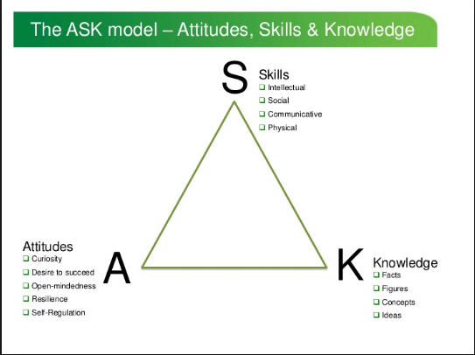

Figure 1 (https://www.slideshare.net/jabulani4/develop-ask)

The first aspect of the Mosaic approach adapted in the research involved the participant pupil embarking on a learning walk where he guided the researcher around his immediate learning environment. The pupil has free access to a large outdoor learning environment and shares an early year’s unit with a second reception class of 28 pupils and a nursery.
The learning walk was documented through the taking of photographs, which were taken by the pupil himself on an iPad provided by the school. It was previously explained to the pupil that he may want to consider taking photographs of his favourite areas in the learning environment or areas where he liked to learn best and enjoyed learning. The pupil was given the freedom to explore all areas of his learning environment and interacted with other pupils along the learning walk. The participant pupil is often seen interacting and playing with peer of his that he considers a ‘best friend’ and seemed a little reserved to embark on the learning walk without him, therefore I said that the close friend of the pupil could join him which helped generate greater responses to questions asked as they engaged in dialect with each other as well as with the researcher on the different areas of the learning walk.
The pupil was very enthusiastic during the learning walk and was sure to express that he preferred playing and learning outside in the outdoor learning environment rather than inside the classroom. He took photos of a particular hill outside where a lot of the children seem to congregate and explained that he likes to play here a lot (See Appendix 2). During the learning walk the pupil shared that his favourite thing to do outside is to play football with his friends where he continued to name 3 of his peers that he called his ‘best friends’. Whilst sharing this information the pupil was smiling and taking photographs of the area where him and his friends are often found kicking a ball around (See Appendix 3). Moyles (2009:2010) comments on how powerful the process of learning through play is and expresses the idea that learning will spontaneously occur as the child takes control over their own independent learning and focuses it upon their own needs.
When analysing the pupil’s attitudes, skills and knowledge within observations the pupil demonstrates curiosity and wonder as he explores his outdoor surroundings, showing that he is open to new experiences offered to him by his peers as they create and imagine new games and ideas to play. At such an early stage in the pupil’s journey through education a lot of his learning is very child centered and independent, drawing on the sociocultural theory of Vygotsky (1978), the pupil appears to continually develop his learning through his social interactions, culture and influences from teachers and additional adults.
Throughout the time observing the participant pupil it was noticed that he would often sit in the writing area and work independently. The pupil would demonstrate prolonged concentration on what he would be doing and appeared to enjoy his time spent in this area of the classroom. During one of these moments it was taken as an opportunity to observe and interview the participant pupil as he seemed relaxed and comfortable in the environment and it was a natural setting. The pupil was questioned on what he was drawing to which he responded by saying ‘School one.’, ‘Black one.’ and pointing to his image drawn (See Appendix 4). It was understood that the pupil was referring to the top of the person he had drawn and was comparing it to his red school jumper by saying it was a black one. As the pupil added 4 fingers to the hand of the person he was drawing he stated, ‘There needs to be one more’ and when finishing he laughed at his drawing and exclaimed ‘That’s a big one! That’s like a spider!’ looking at the hand that he had just drawn. The pupil’s current topic theme in school is ‘In Our Garden’ where the children have been learning about different minibeasts, in particular spiders, therefore it was nice to see that he was linking and identifying his previous learning to something current and spontaneous. The pupil confidently wrote his name across the top of his image and was eager and proud to show me stating ‘Look that’s my name’. He continued to write random letters, noticeably letters that can be found in his name, and would sound out each letter as he did trying to make sense of putting them together. When I asked him what he liked learning he answered, ‘Words like these I done. Tricky ones.’
The pupil shows a positive attitude and intrinsic motivation to learn independently within his learning environment making use of the resources and opportunities available to him. Valerio (2012) states motivation is a fundamental element of students learning and through engaging learning experiences and a supportive classroom environment, teachers can empower students to find joy and excitement in their individual learning.
During an observation taken within the classroom the participant pupil was involved in the playing of a game with two other children. The participant pupil appeared to understand how to play the game and was happy to explain the process of the game to his peer who appeared confused on what to do (See Appendix 5). The participant pupil engaged in playing with the other children and was aware that the game involved turn taking in a certain direction as he reminded the other children when it was their turn to roll the dice. When one of the other children appeared upset at the fact she had turned over a card with no ladybirds on it he explained, ‘it’s ok you get another go’. During this observation the participant pupil showed elements of Personal and Social Development, Well-being and Cultural Diversity skills at outcome level 3 as he cooperatively played with other children, demonstrating turn taking and showed sensitivity to his peer’s feelings as she appeared disappointed with the result of her card.
When interviewing the pupil’s teacher, she explained that at the beginning of the school year the participant pupil displayed very minimal elements of speech and language and was not able to compose a sentence (See Appendix 6). When looking at the comparison from the beginning of the school year to now the progression in his development is evident as he can be seen often effectively engaging in conversation with others using full sentences, expressing opinions and ideas and is able to draw on an increasing vocabulary within his talk.
When I asked the participant pupil what his favourite things are to do when he is at school he answered, ‘I like listening in there’ pointing towards the carpet area, followed by ‘I like helpwr heddiw’. In the day previous to when this question was asked the participant pupil had been chosen as helpwr heddiw of the day due to his good behaviour and learning, which meant that he was allowed to say ‘bore da’ to each child present when taking the register and could ask a variety of questions in Welsh to his peers. When observing the participant pupil during the taking of the register on this day, one of the other pupils was marked not present as he was off ill to which the participant pupil responded by saying ‘Mae hi’n sâl’ meaning to say ‘he is sick’ in Welsh. The teacher was pleasantly surprised and impressed by his knowledge of the Welsh language as he independently expressed this saying with confidence. During the learning walk it was noticed that the pupil had taken a photograph of the apron that the helpwr heddiw is allowed to wear for the duration of the day that they have been chosen.
Taking the data collected into consideration the pupil shows evidence of developing Language, Literacy and Communication skills across outcome level 3 which is a great progression from his baseline assessment at Gold. He shows a developing ability to confidently take part in group discussions and show listening and understanding by asking appropriate questions. He has demonstrated that he can identify initial sounds of letters with confidence and can pronounce most of his words correctly and clearly.
When looking at samples of the participant pupils work his progress throughout the school year is well displayed especially within his Mathematical Development. The pupil has advanced from simple mark making to represent numbers (See Appendix 7) to combining sets of numbers to achieve a total (See Appendix 8) and is beginning to address the concept of ‘one more’, ‘one less’ in practical activities. His number formation has significantly improved, and he regularly incorporates a form of self-assessment within his work that is encouraged by the school known as ‘What Went Well’ (WWW) and ‘Even Better If’ (EBI). This form of assessment allows the pupil to identify areas of their work that have gone well, normally by highlighting in yellow, and areas that could have gone even better if maybe some changes were made, which would be highlighted in green.
When observing the pupil during a practical maths activity where the pupil was adding and subtracting spider models onto cobweb designs, and then writing out the number sentence with support, he was able to identify errors with his number formation which he highlighted in yellow and then followed with writing the number again the correct way. Analysing this observation against the ASK model it is clear to see that the pupil has a developing understanding of the concept of self-assessment and is willing to try things to improve his own skill and knowledge.

Next Steps
Possible next steps to consider for the participant pupil’s future learning and development would suggest incorporating more opportunities for cooperative learning, this is where students of various levels of ability work together in small groups on activities or tasks to help improve their understanding on a certain topic or subject. The data collected on the participant pupil shows evidence of progression within his development of Personal and Social Development, Well-being and Cultural Diversity skills at best fit outcome 3, however the pupil appeared to be more reserved during conversations with him at times when his close friends were not around. Interviewing and observing pupils of such a young age does have limitations to a lack in data collected due to their limited level of speech, especially with the aim of getting answers to a series of questions. More experiences of cooperative learning would open up opportunities for the pupil to access and explore a wide range of vocabulary from peers and may help build confidence in his own ability as well as build more positive relationships with peers. Donaldson (2015:70) suggests that good learning encourages collaboration and supports the research of Hattie (2009) which concludes ‘cooperative learning is effective’. The participant pupil has shown growing independence within his own learning and is able to recognise the needs of others with sensitivity. By encouraging the pupil to engage in cooperative tasks or play the pupil will be experiencing and developing skills that would help ease the transition from Reception into Year 1.
Another way to support the learning of the participant pupil would be to try and extend certain interests the child has shown to further benefit his learning. It was highlighted throughout the observations and learning walk that the pupil enjoyed playing football and mostly being in the outdoor learning environment. This interest could be extended to access different areas of the curriculum such as transferring mathematical skills to play and classroom activities. The pupil can be encouraged to keep a score board of matches that he plays with his friends which could be displayed through a tally chart or other forms of record. If his interest in football it particularly strong he may like to have the opportunity to take part in extra-curricular activities or be willing to explore and experience different elements of sport. The Welsh Government (2014) believes that all children benefit from personalised learning and considers it one of the six key principles within its vision to improve education across Wales. By valuing diversity and inclusivity all children should benefit from learning that meets their needs and encourages them to widen their interests and ambitions.
The pupil displayed intrinsic motivation to practice his writing skills and expressed joy when drawing and colouring in the writing area. Another way to further support the participant pupil’s development would be to set personalised goals or tasks in the areas which the pupil has identified to enjoy learning. Providing a range of differentiated tasks might encourage the pupil’s self-motivation and consider challenging his own learning whilst maintaining a high level of engagement. Donaldson (2015) suggests children need to be ready to learn throughout their lives and should develop a confidence in engaging with intellectual challenge to further develop what they have learned.
If the participant pupil was to be assessed against the Language, Literacy and Communications skills framework his best fit level would be outcome 3 as he is beginning to demonstrate an increasing range of vocabulary to complete sentences and exchange ideas and opinions, as well as beginning to use spelling strategies and correct initial sounds when writing words. When observed in the writing area the participant pupil was engaged in writing random letters, those which could mostly be found within his name, and was trying to make sense of them together by saying out loud the initial sounds even though they did not form a word. The pupil has shown elements of a self-regulated learner, being aware of the strategies he uses to learn and developing them to further enhance and improve his development. His development is at the initial stages of outcome 3 therefore to continually support his progress opportunities to be made aware of his own strengths and weaknesses would be appropriate to move the pupil progressively towards greater independence within his learning.
Within observations taken of the participant pupil it was highlighted that he was developing his understanding of the school’s assessment policy, which encourages pupils to highlight areas within their work as WWW and EBI and use it to discuss future learning. If this form of assessment was to be continuous and reinforced across the curriculum, it would help the pupil to become aware of personal strengths and weaknesses in different Areas of Learning. This could then be used as a tool where the pupil and teacher can come together to work cooperatively on setting personal goals or tasks which could be applied to the pupil’s areas of interest within his learning environment as mentioned previously.
After analysing of the data that displays evidence of the participant pupils progress within his Mathematical Development it would be suggested he is just achieving at a best fit level of outcome 3. When looking at observational notes made during maths focus tasks the pupil is highlighted as being capable of reciting numbers up to 10, and with support to 20. He has demonstrated confidence in working out simple addition sums within his head and a willingness to try and write the sum as a number sentence. A next step for development would be to incorporate subtraction into the pupils learning to build on his previous knowledge. This could be done through practical activities, so the pupil can get comfortable with the concept first before developing it further.
As the participant pupil has expressed his enjoyment and preferred method of learning through the outdoor learning environment it is important to consider addressing these next steps for learning in strategies and approaches that could include elements of the outdoors. Pupils should be provided with opportunities to follow their interests through free play that is balanced with adult-led activities that supports skills development outdoors at every possible chance (WG, 2014). By using the pupil’s personal interests to enhance his development it will help promote a healthy relationship with learning and will cater to the needs of the pupil that will allow him to achieve at his full potential.

Conclusion
In conclusion to the analysis of the participant pupil he has been identified as demonstrating increasing progress within his learning, at times being self-regulated, which highlights the pupil’s active involvement and positive attitude towards his development. It is evident that his journey within education so far has allowed the pupil to explore and experience new skills, attitudes and knowledge. The participant pupil has made positive relationships with his peers and has discovered through exploration interests and ways in which he enjoys learning.
By taking these factors on board next steps for the pupil’s development suggest to further enhance his communication and social skills when interacting with others through a cooperative learning strategy. This would encourage the pupil to build more positive relationships and develop his confidence in his abilities as he works together with others to develop a deeper understanding on certain topics. Another approach to further support the participant pupil’s next steps for development would be to extend and enhance the pupil’s interests in all Areas of Learning. By doing so would help further encourage his already existing intrinsic motivation to better his learning whilst maintaining high levels of engagement.
The participant pupil has displayed a range of skills, knowledge and attitudes that will help the move from Reception into Year 1 be a comfortable and easy transition. He is confident enough to take control over his own learning and has shown that he is a capable learner who enjoys his school experience.

References
British Education Research Association (2011) Ethical Guidelines for Educational Research. London: BERA.

Clark, A. (2010) ‘Young Children as Protagonists and the Role of Participatory, Visual Methods in Engaging Multiple Perspectives’, American Journal of Community Psychology, 46, (1-2), pp.115-123, 8 June 2010.

Clark, A. and Moss, P. (2001) Listening to Young Children: The Mosaic Approach. London: NCB.

Clark, A. and Moss, P. (2008) Spaces to Play: More listening to young children using the Mosaic approach. London: NCB.

Clark, A. and Moss, P. (2011) Listening to Young Children: The Mosaic approach. 2nd edn. London: NCB.

Clark, A., Kjorholt, A. and Moss, P. (2005) Beyond Listening: Children’s perspectives on early childhood service. Bristol: University of Bristol.

Cohen, L., Manion, L. and Morrison, K. (2011) Research Methods in Education. London: Routledge.

Cowie, H., Huser, C. and Myers, C. (2014) ‘The Use of Participatory Methods in Researching the Experiences of Children and Young People’, Croatian Journal of Education, 16, (2), pp.51-66, March 2014. file:///C:/Users/kwilliams/Downloads/CJE_Vol_16_Sp_Ed_No_2_Cowie_Huser_and_Myers.pdf (Accessed: 21/05/18).

Donaldson, G. (2015) Successful Futures: Independent Review of Curriculum and Assessment Arrangements in Wales.
Edwards, R. and Holland, J. (2013) What is Qualitative Interviewing? London: Bloomsbury Publishing Plc.

Estyn (2012) https://www.estyn.gov.wales/sites/default/files/documents/Inspection%20report%20Moorland%20Primary%202012%20%28English%20only%29_0.pdf.pdf.pdf.pdf.pdf.pdf.pdf.pdf.pdf.pdf.pdf.pdf.pdf.pdf.pdf.pdf.pdf.pdf (Accessed:14/05/18).

Hattie, J. (2009) Visible Learning: A Synthesis of Over 800 Meta-analyses Relating to Achievement. London: Routledge.
Moyles, J. (2009) Play: the powerful means of learning. London: Routledge.

Moyles, J. (2010) The Excellence of Play. 3rd edn. Berkshire, England: McGraw-Hill International (UK) Ltd.

My Local School (2017) Moorland Primary http://mylocalschool.wales.gov.uk/School/6812037?lang=en (Accessed: 14/05/18).

Nottingham, J. (2013) Encouraging Learning: How you can help children learn. London: Routledge.
Sharp, J. (2012) Success with Your Education Research Project. London: SAGE.
The Welsh Government (2015) Qualified for Life: An education improvement plan for 3 to 19-year-olds in Wales. [Online] Available at: http://www.erw.wales/media/1769/141001-qualified-for-life-en.pdf (Accessed: 23/05/18).

Valerio, K. (2012) ‘Intrinsic motivation in the classroom’, Journal of Student Engagement: Education matters, 2 (1), pp.30-35.

Vygotsky, L. (1978) Mind in society: The development of higher psychological processes. Cambridge, MA: Harvard University Press.

Welsh Assembly Government (2011) Foundation Phase child development assessment profile. [Online] http://dera.ioe.ac.uk/3642/1/110517foundassessmenten.pdf (Accessed: 23/05/18).

Welsh Assembly Government (2014) Further Steps Outdoors. [Online] http://learning.gov.wales/docs/learningwales/publications/141013-further-steps-outdoors-en.pdf (Accessed: 24/05/18).

Welsh Assembly Government (2015) Foundation Phase Framework. [Online] http://learning.gov.wales/docs/learningwales/publications/150803-fp-framework-en.pdf (Accessed: 23/05/18).

Appendices
Appendix 1
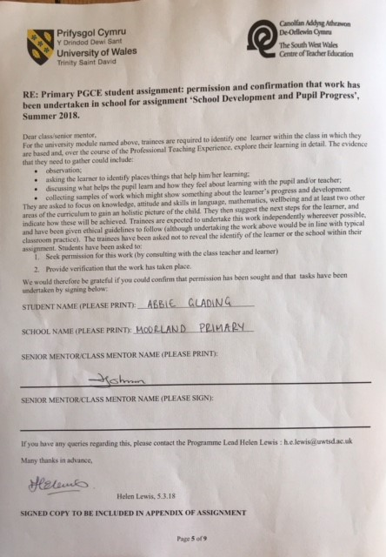

Appendix 2

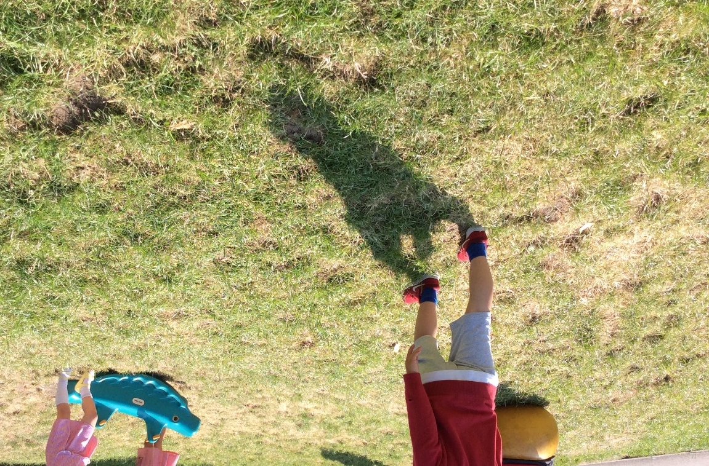

Appendix 3

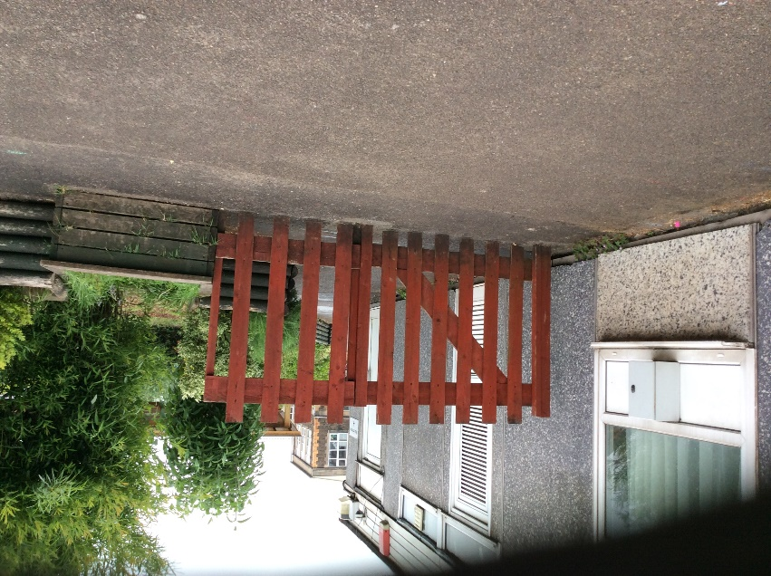

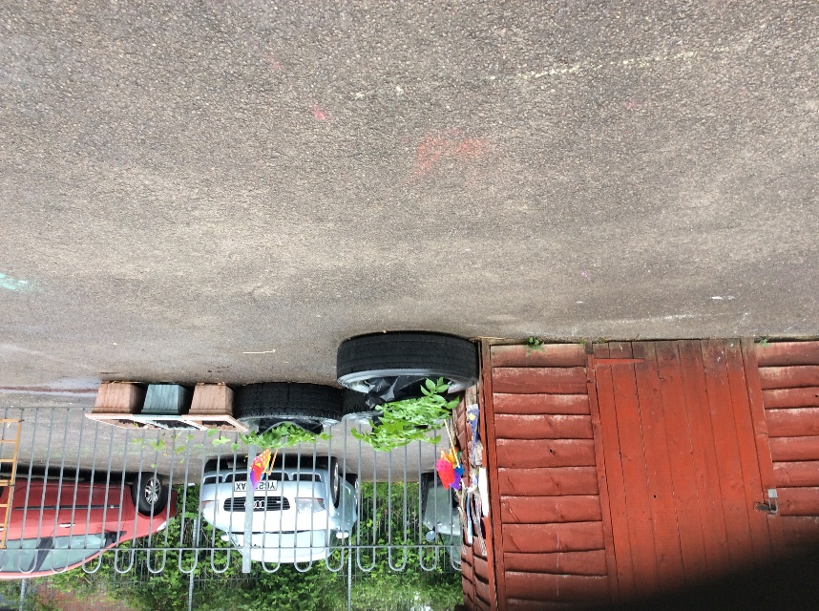

Appendix 4
The participant pupil’s name has been blanked out for data protection purposes.
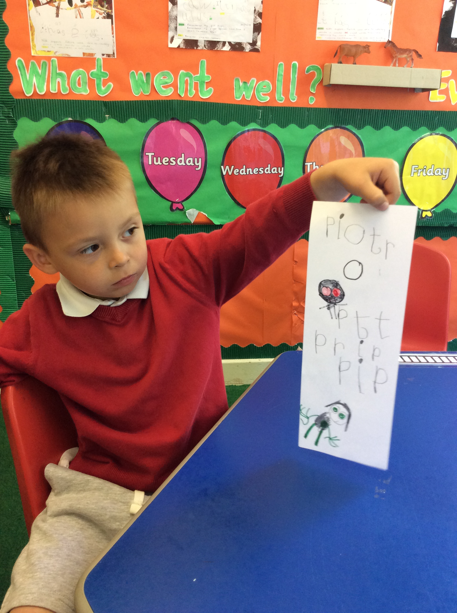

Appendix 5
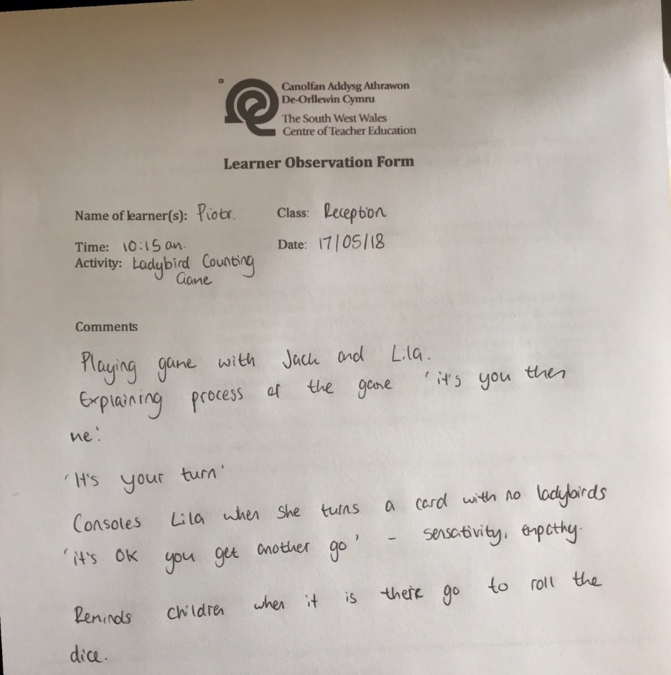
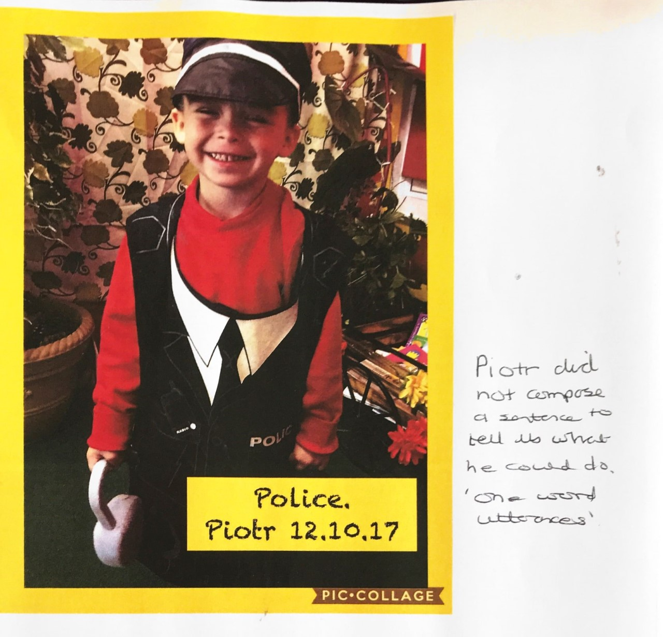
Appendix 6

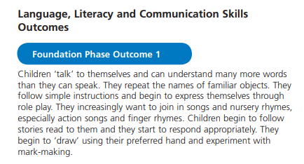

Appendix 7
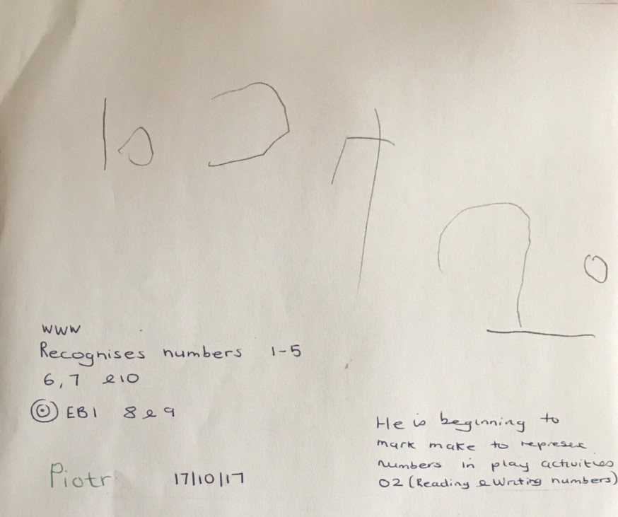
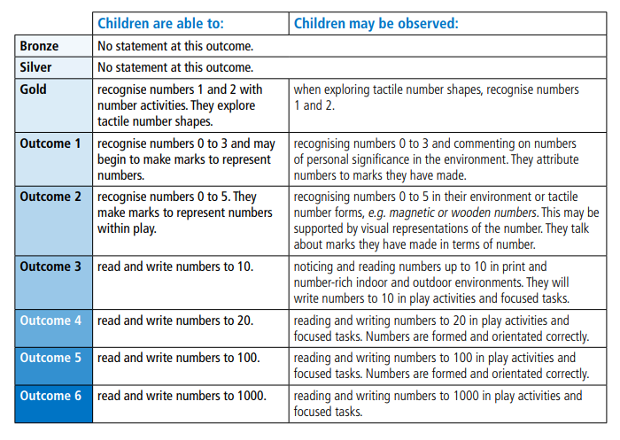
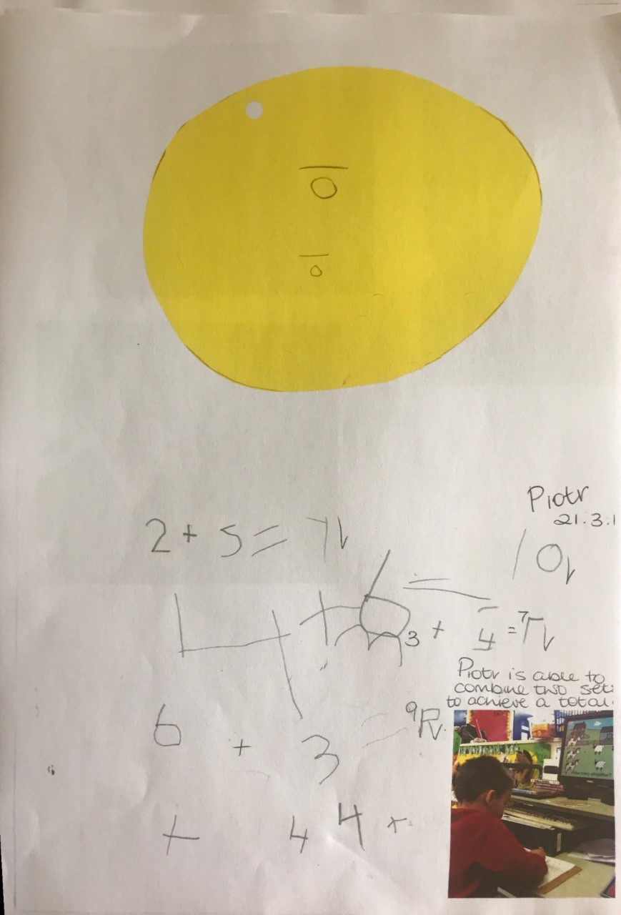
Appendix 8



