Module: Employability and Career Development
Module Code: LCLM4005
Assignment Title: Portfolio of Written task

Student Name:
Student Number:
Lecturers Name:

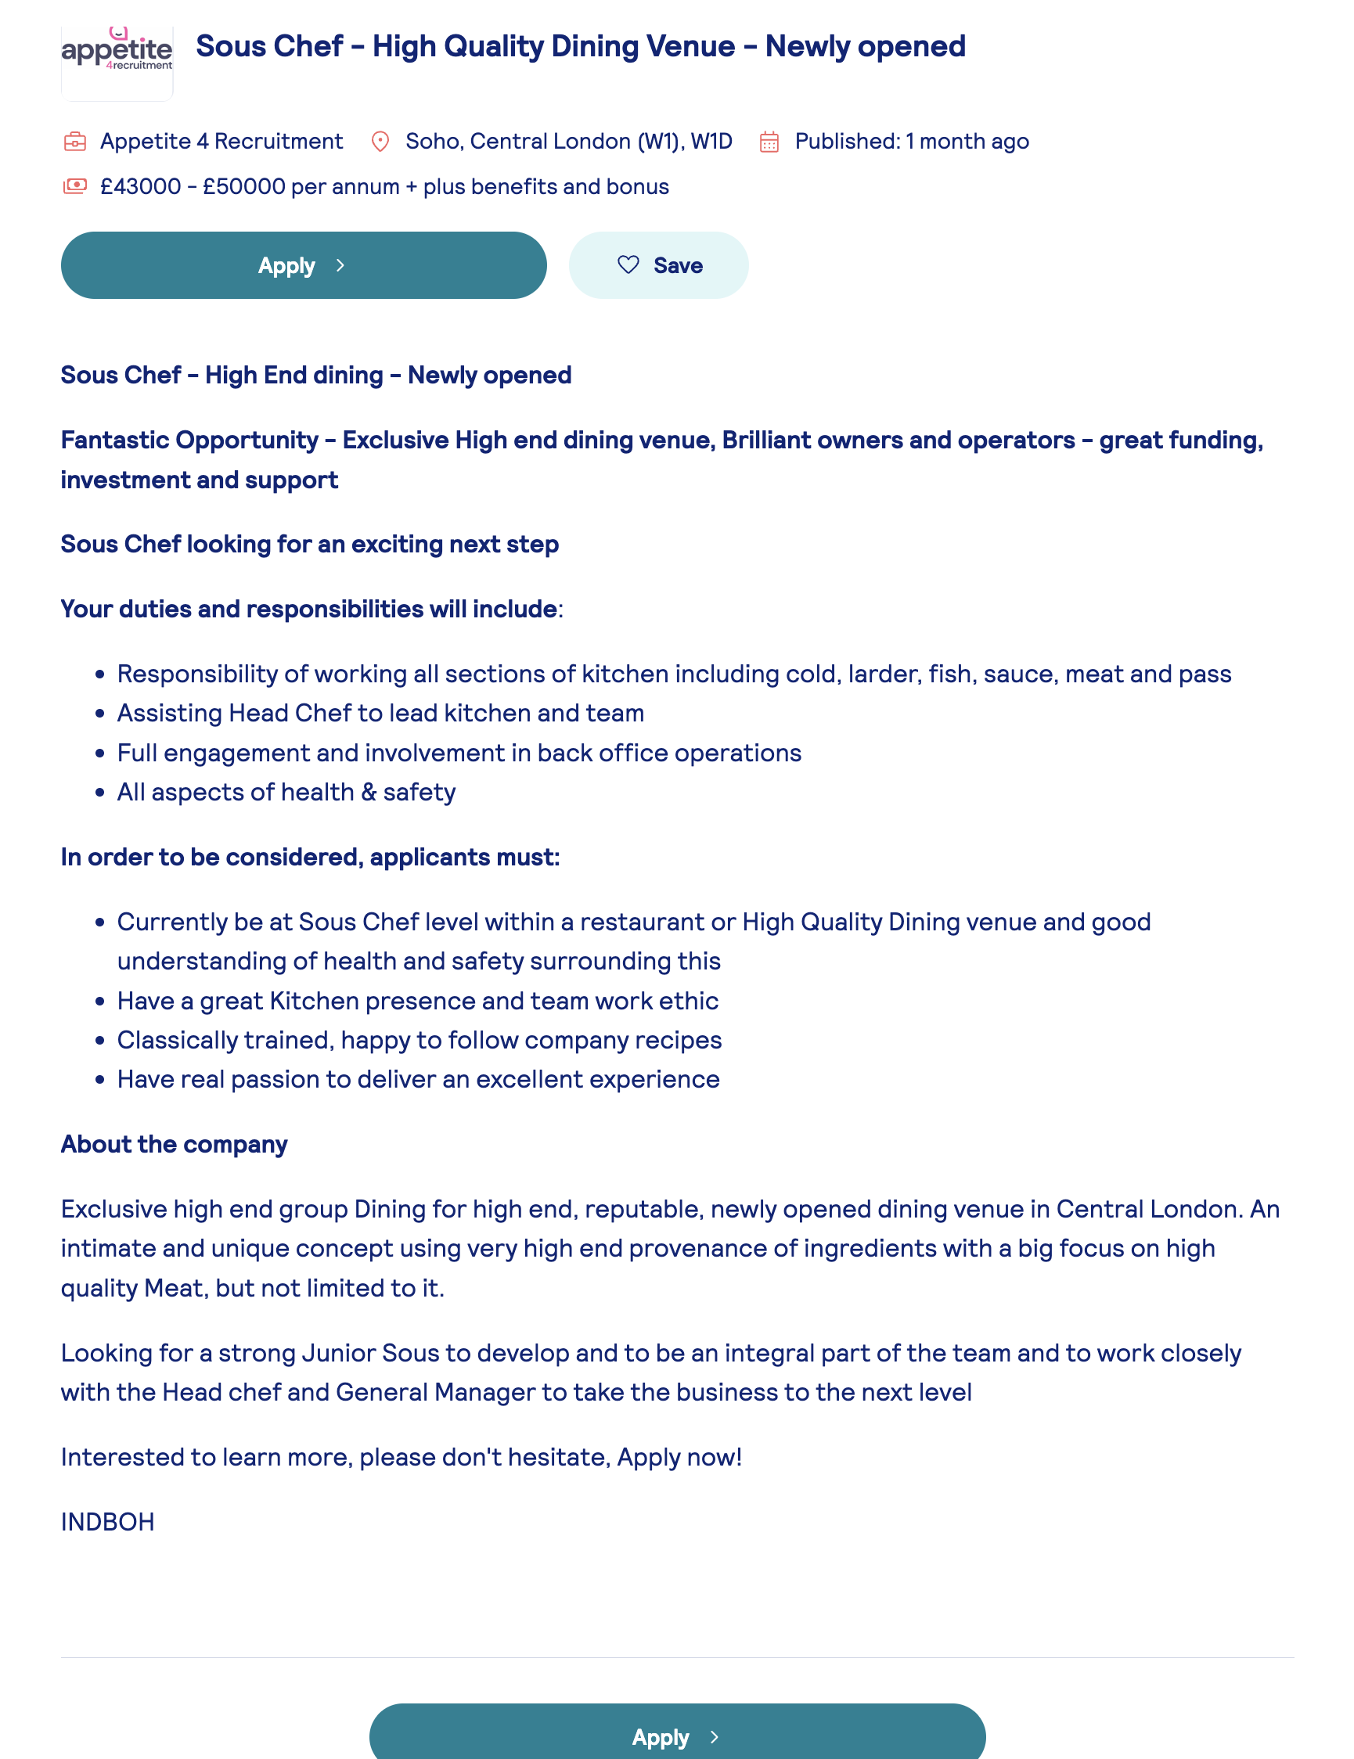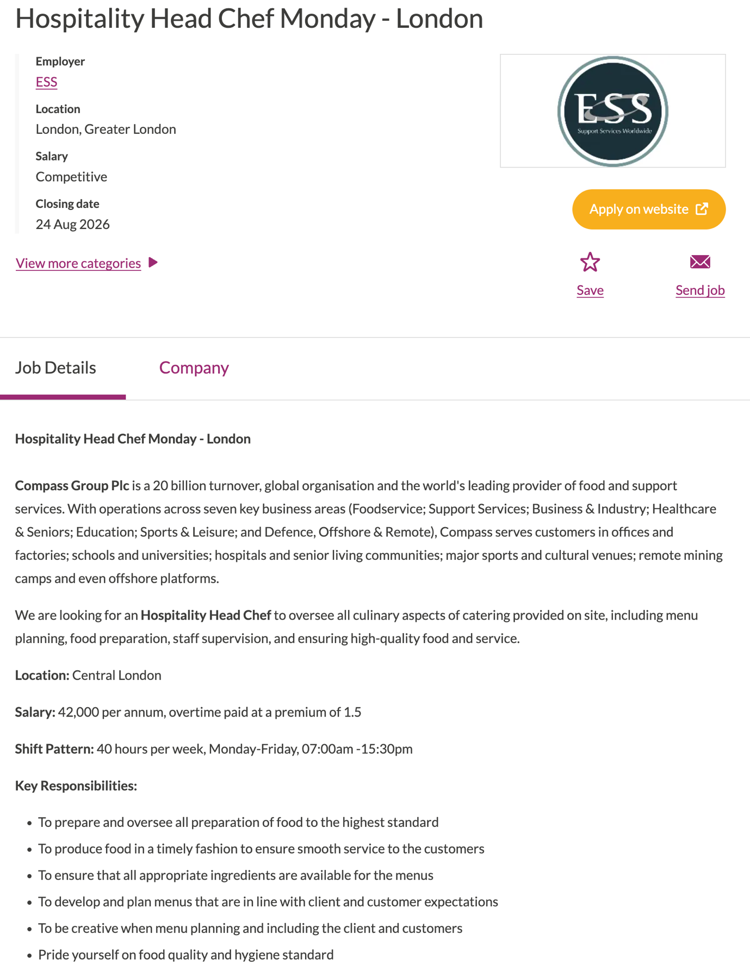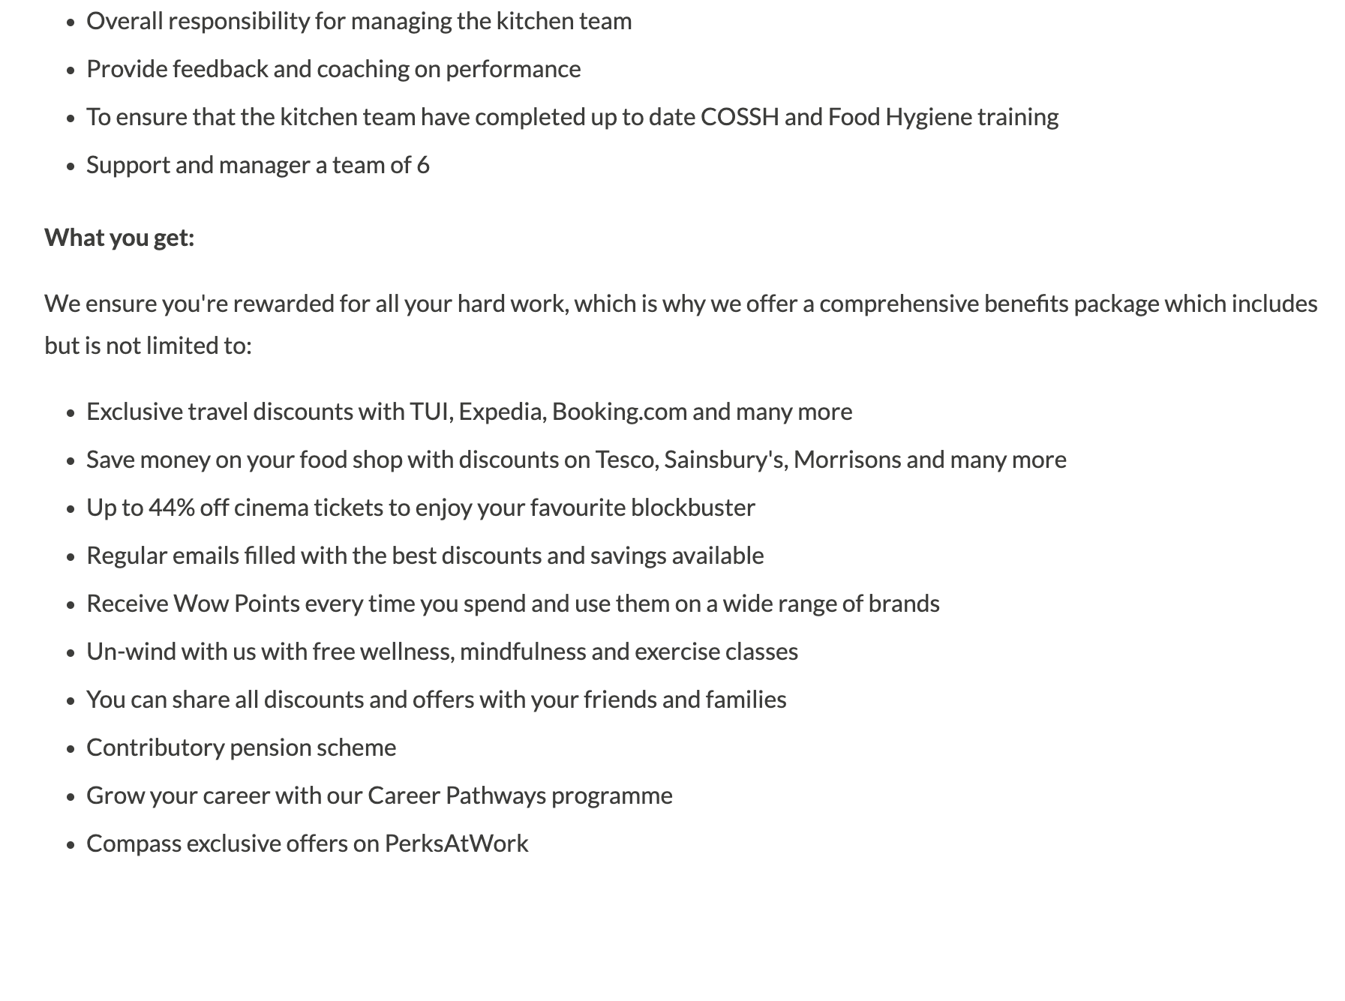
Task 1 Comparing Two Jobs: Chef Profession
The two job adverts I selected are the hospitality head chef at Compass Group and suit Sous Chef at appetite for Recruitment. Both jobs are in London and are part of the hospitality and food industry. I choose these adverts because they are related to my future career in the chef profession. The advert shows that chef need more practical cooking skills and people's skills. They need to prepare good food, follow food safety rules and work well with another member of the kitchen team. They also need good communication and teamwork skills to provide good service to customers. These skills are important for becoming a successful chef.
The first advert is Hospitality Head Chef at Compass Group. The main responsibilities include preparing and overseeing food, planning menus, making sure ingredients are available, managing the kitchen team and maintaining high food and hygiene standards. The head chef also needs to give feedback and support staff. They must make sure that the team completes food hygiene and COAHH training (Compass Group, 2026). This shows that leadership, communication, organisation, food preparation and food safety are important skills for head chef.
The second advert is a Sous Chef at Appetite 4 Recruitment. The soup chef is expected to write across different kitchen sessions and have the head chef manage the kitchen team. The role also includes some of his duties and following health and safety rules. The advert asks for good teamwork, kitchen management skills, food knowledge, and customer service skills (Appetite 4 Recruitment, 2026).
There are several common skills in both adverts. These include teamwork, leadership, food quality, health and safety, communication and kitchen management. Both jobs are also required the chef to work well with other members of the kitchen. This is important because the kitchen needs good teamwork to provide food on time and to a good standard. Skills England also identify team work together and provide good food and service. The institute of hospitality also identifies leadership and teamwork as important areas for people working in hospitality (Institute of Hospitality, 2026).
Task 2 Self-assessment and Evidence of Readiness for Employment
A self-assessment helps me understand my strength and the areas where I need to improve. I use a SWOT analysis to look at my strength, weaknesses, opportunities and Threats. SWOT can be used to identify strengths and skills as well as areas that need improvement (CIPD, 2024). This is useful for my future career in the hospitality and chef profession.
SWOT Analysis
Strengths  - Good teamwork skills  - Good communication  - Hard working and reliable  - Interested in cooking and food  - Able to work under pressure | Weaknesses  - Need to improve my leadership skills  - Need more experience managing a large kitchen  - Need to improve my menu planning  - Need more confidence when making decisions  - Need to improve my knowledge of kitchen cost
Opportunities  - More training and qualification  - Learning from experienced chef  - career progression to Sous chef or head chef  - Developing leadership skills  - Gaining mortgage and experience | Threats  - Competition for chef job  - High pressure in professional kitchen  - Long working hours can be difficult  - Changes in customer needs  - Food safety mistakes can affect the business

My Strengths
One of my main strengths is teamwork. Working in a kitchen requires people to work together because food needs to be prepared and served on time. I understand the importance of listening to other people, helping team members and communicating clearly. Skills England states that chef needs to work effectively with others and use good communication to support teamwork.
Another strain is that I am hard working and reliable. Working in a kitchen can be busy and stressful, so I understand that staff need to be responsible and complete their task on time. I am also willing to learn new skills and improve my knowledge.
I also believe that I can work under pressure. Kitchens can become very busy, especially during service. A chef needs to stay calm and continue working safely. Excuse England identifies remaining calm under pressure as an important behaviour for chef (Skills England, 2024).
My weaknesses
One area I need to improve is leadership. I can work well as part of a team but I need more experience in leading other people. A head chef or Sous chef may need to give instructions, support staff and solve problems in the kitchen. Senior chef needs to coach motivate and support other members of the team.
I also need to improve my menu planning and costing skills. A chef needs to understand ingredients, portion sizes and food waste. Controlling waste is important because it can reduce costs for the business.
Another area for development is my confidence in decision making. In the busy kitchen, problems can happen quickly. I need to become more confident when making decisions and dealing with unexpected situations.
Opportunities
There are many opportunities to meet to develop my career. One important opportunity is training. I can compete for their food safety, health and safety and leadership training. Training can help me improve my knowledge and prepare for higher positions.
I can also learn from experience chef. Working with experienced people can help me improve my cooking skills, communication and leadership. I must continue to develop my skills and knowledge through training and experience.
Threats
One threat is competition for chef jobs. There may be many people applying for the same position therefore I need to continue improving My cooking, communication and teamwork skills. Gaining more weight experience in training can also help you become a stronger candidate.
Another threat is the pleasure of working in a busy kitchen. Chef often have to work quickly while still making sure that food is prepared to a good standard. If I cannot manage pressure properly, it could affect my performance and the quality of my work. I need to learn how to stay calm and organise during busy period.
Food safety is another important area. Chef must follow food safety rules and keep the kitchen clean and safe they need to prepare food and serve food correctly to customers. Mistakes with food safety can cause serious problems for bad customers and the business therefore I need to improve my food safety knowledge and follow workplace rules carefully.
Evidence of my Readiness for Employment
I believe I am becoming ready for employment because I am developing both my academic and practical skills. My academic studies have helped me improve my communication, research, organisation and time management skills. These skills are useful in the workplace as well as in education.
My previous work experience has also help me developed important personal skills. These skills are useful in the workplace as well as in education.
My previous work experience has also helped me develop important personal skills. For example, working with other people has helped me understand the importance of communication, reliability and teamwork. These skills are important in hospitality because chef work closely with other kitchen staff, managers and customers.
My studies also show that I am willing to learn and improve myself. Completing assignments, meeting guidelines and receiving feedback have helped me become more organised and responsible. I understand that feedback is important because it can show me what I am doing well and what I need to improve.
I also understand that employability is not only about having technical skills employers also look for people who are reliable, professional, willing to learn and able to work with others.
Task 3 Employment Goals and Personal Development plan
Based on my SWOT analysis I identified leadership, menu planning, forecasting and decision making as areas I need to improve.
My short-term goal is to gain more experience in the professional kitchen and improve my leadership skills within the next 6 to 12 months I will take more responsibility, support other team members and learn from experience chef. I will also complete food hygiene and health and safety training. These skills are important because chef need to work well with others, organise their work and follow food safety rules. Setting short term goal can help me take a small step towards achieving my longer career goals (Cottrell, 2024).
My long-term goal is to progress in my career from a Chef to a Sous chef and eventually a Head chef. I want to become more confident in managing your kitchen team, planning menus, controlling cost and maintaining high food and hygiene standards. I also want to improve my communication and leadership skills because these are important when working with other members of our kitchen team. Setting clear goals can help me understand what I need to achieve and improve my skills (Armstrong and Taylor, 2023).

This goal is important to me because I want to build a successful career in the hospitality industry. Becoming a head chef would give me more responsibility and allow me to use my cooking management and leadership skills. I would also like to support other chef and help create a positive working environment.
To achieve my goal, I will continue to learn and gain more experience. I will take part in training courses and learn from experience chef. I will also ask for feedback about my work so I can understand my strengths in areas that need improvement. Continuous learning can help hospitality workers improve their skills and career opportunities.
I will review my progress every month and make changes to my development plan when needed. Overall, these goals will help me become my confident skilled and prepared for my future career as a Sous chef and eventually a Head Chef.
Development area | Action I will take | Timeline | Resources needed | How I will measure progress
Leadership | I will ask an experienced chef to give me more responsibility and allow me to support junior staff. | 6 months | Support from Head Chef/Sous Chef | Feedback from my manager and ability to lead small tasks
Menu planning | I will practise creating menus and learn how to choose suitable ingredients. | 3–6 months | Chef, recipes, online resources and training | Complete at least 3 sample menus and receive feedback
Food costing | I will learn how to calculate ingredient costs, portion sizes and food waste. | 6 months | Costing sheets, kitchen records and manager support | Complete costing exercises correctly.
Decision-making | I will practise making decisions during busy kitchen periods and learn from experienced chefs. | 6–12 months | Workplace experience and feedback | Review my decisions and discuss them with my manager
Food safety | I will complete or update my food hygiene training. | Within 6 months | Food safety course | Obtain a food hygiene certificate
Career progression | I will apply for suitable chef positions and work towards a Sous Chef role. | 1–3 years | CV, job websites, training and experience | Apply for suitable jobs and attend interviews

References
Armstrong, M. and Taylor, S. (2023) Armstrong's handbook of human resource management practice: A guide to the theory and practice of people management. 16th edn. London: Kogan Page.
Appetite 4 Recruitment (2026) Sous Chef – High Quality Dining Venue. Available at: Appetite 4 Recruitment Job Board (Accessed: 17 August 2026).
CIPD (2024) SWOT analysis template. Available at: CIPD SWOT Analysis Template (Accessed: 17 August 2026).
Compass Group (2026) Hospitality Head Chef Monday–Friday – London. Available at: Compass Group Careers (Accessed: 17 August 2026).
Cottrell, S. (2024) The Study Skills Handbook. 6th edn. London: Bloomsbury Academic.
Institute of Hospitality (2026) Mentoring. Available at: Institute of Hospitality (Accessed: 17 August 2026).
Skills England (2026) Senior culinary chef. Available at: Skills England – Senior Culinary Chef (Accessed: 17 August 2026).

