
Student Name: Joseph Bangura
Student Number: 1818368
Assignment Title: Community Care and Development A 2 (BMHP6022_LON)
Lecturer Name: Dr Laila Surani
A Report
on
Approaches and Initiatives for Addressing Health and Social Needs of a Community.
Table of Contents
Introduction 3
Blackpool community overview 3
Approaches for Addressing Health and Social Needs of The Blackpool Community 4
Community Health Workers as a Culturally Sensitive and Linguistically Appropriate Health Intervention 4
Communication Strategies for Promoting Culturally Sensitive Health Interventions in Blackpool 6
Prioritising Culturally Sensitive Health Treatments in Public Policy and Practice 6
Recommendations to adapt to suit an increasingly more digital world 7
Incorporating Telehealth and mHealth Technology 7
Practice and policies regarding the given recommendation 8
Conclusion 8
References 9

Introduction
The purpose of this paper is to present an overview of the community of Blackpool, which is situated on the northwest coast of England, as well as of the health and social difficulties that it confronts. Low life expectancy is one of the community's health risks. Other risks include high rates of obesity, smoking, and alcoholic liver disease, as well as a lack of accessibility to health accessories and services. The community's population is declining, and there is a high proportion of people in their later years (Lincoln, 2019). Inadequate income-earning potential, high unemployment rates, and a lack of education and skills further add to the health hazards faced by the population. In addition, the neighborhood is culturally diverse, but it also has difficulties with substance abuse, mental health issues, inadequate housing, criminal activity, and anti-social behaviors (Martin et al., 2021). This research suggests the adoption of health interventions that are culturally sensitive and linguistically compatible, such as the employment of community health workers (CHWs) and the establishment of culturally relevant health education programs, to solve the problems that have been identified. The research also explores communication tactics that may be used to increase awareness of these treatments, give them more priority in public policy and practice, and close the digital gap that exists within the community.

Blackpool community overview
Blackpool is a community located on the northwest coast of England and is the 5th largest in the region. According to the Office for National Statistics, in 2020, the estimated population of Blackpool was approximately 139,000, with a relatively high proportion of older adults (McMillan and Rayns, 2019). However, its population has been declining since 2001, and social ties are not in good shape. The community faces various health and social care needs, including a low life expectancy of 68.2 years for men, high rates of obesity, smoking, and alcoholic liver disease, and a lack of accessibility to health accessories and services. Poor income capacity, high unemployment, and poor education and skills also contribute to the community's health risks. The community has cultural diversity but also suffers from addiction, mental health problems, poor housing, crime, and anti-social activities (Lincoln, 2019). To address these issues, there is a need for an effective strategy that involves setting targets, assessing needs, developing strategies, taking action, and evaluating the process. Additionally, the use of digital platforms can help in spreading knowledge and making people aware of different social prejudices regarding health and education.
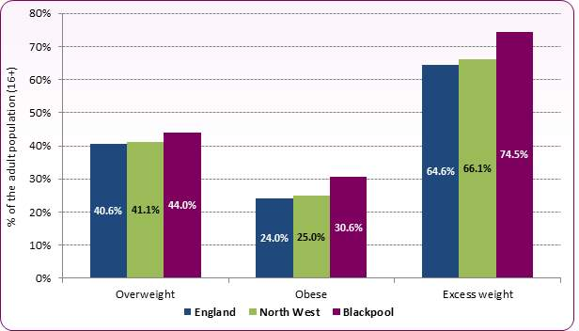
Figure 1: Public health evaluation of Blackpool (Clayden, 2019).

Approaches for Addressing Health and Social Needs of The Blackpool Community

Community Health Workers as a Culturally Sensitive and Linguistically Appropriate Health Intervention
The adoption of health interventions that are culturally sensitive and linguistically suitable is one separate strategy and endeavour that is important for making changes in terms of both health and social conditions within the community that was selected. This is because the community is varied and contains members who come from a variety of cultural and linguistic backgrounds, both of which may influence a person's ability to access and utilise healthcare services (Rosenthal, 2020). Utilising community health workers (CHWs) who have been educated to provide culturally sensitive health education, promote preventative health behaviours, and facilitate access to healthcare services for members of the community is an example of such an initiative. CHWs are trained to do all of these things. CHWs can give their customers language interpretation, cultural mediation, and advocacy services, which all serve to bridge the gap that exists between the community and the healthcare professionals (Swider, 2022). Those who may have trouble receiving healthcare services due to language or cultural issues might also get home visits from these professionals.
Many different approaches may be used to communicate this knowledge to the audience that will be the target of our attention. The usage of community health workers (CHWs) and the services they provide may be promoted via the use of social media. There is the potential for information on CHWs to be placed on social media platforms that are widely used within the community, and then community leaders and organisations might share this information with the networks that they are a part of. Also, community activities and gatherings provide opportunities that may be leveraged to promote the usage of community health workers as well as the advantages of culturally sensitive health treatments (Russell, 2021). Another strategy relating to this approach would be to devise health education programmes that are sensitive to the local culture and sensitive to the particular requirements of the community. For instance, if there is a high diabetes prevalence in the neighbourhood, one might organise a campaign to educate people about how crucial it is to take preventative measures and effectively manage diabetes. The campaign may make use of culturally appropriate messages and graphics that connect with people in the community (Anderson et al., 2013). Moreover, the campaign may be spread via numerous channels including social media, community events, and local media sources.
The use of health treatments that are culturally sensitive as well as linguistically suitable, such as community health workers and culturally relevant health campaigns, may contribute to the improvement of health outcomes within the community of interest. Promoting these interventions and raising awareness within the population of focus may be accomplished via the use of communication strategies such as social media, community events, and local media sources, amongst others (Walton et al., 2015). When developing health treatments that are culturally sensitive and linguistically adequate for a world that is becoming more digital, it is necessary to take into consideration the digital divide as well as the varied degrees of access to digital technology that exists within the community. Hence, it is vital to building interventions that are accessible and inclusive for all members of the community, regardless of their degree of digital literacy or access to digital technology. This should be done to ensure that all members of the community can participate.
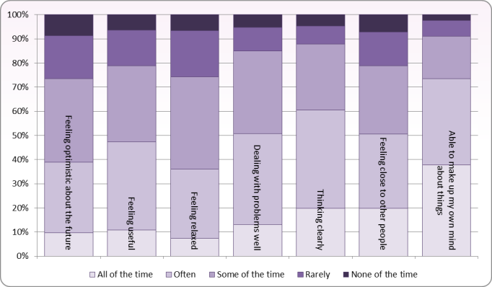
Figure 2: Mental health statistics of the population of the Blackpool community (Sayce et al., 2021).

Communication Strategies for Promoting Culturally Sensitive Health Interventions in Blackpool
The provision of digital tools and training to community health workers (CHWs) is one manner in which these interventions may be adapted. This will allow CHWs to reach out to and interact with the community online. This might involve providing CHWs with online training sessions on how to make the most of social media and other digital channels to engage with community members and advertise the services they provide (Rosenthal et al., 2020). Also, online materials that are accessible to people in the community, such as health information that takes into account cultural norms and instructive films, may be developed and made available to them. In addition, community members who may not have access to digital devices or internet connections may be provided with access to these resources via the establishment of partnerships with regional groups that work to promote digital inclusion (Swider, 2022). These collaborations may also give members of the community training in digital literacy to guarantee that they can access and use digital health services efficiently.

Prioritising Culturally Sensitive Health Treatments in Public Policy and Practice.
When it comes to public policy, it is essential for healthcare providers and decision-makers to place a high priority on the research, development, and deployment of health treatments that are culturally sensitive and linguistically suitable in the community (Nicholls, 2015). These projects should be supported with funding and resources, and those resources should be allocated such that the programmes can be maintained over the long term. In practice, healthcare institutions may collaborate with community leaders and groups to determine the particular health needs of the community and to create treatments that are culturally acceptable and which meet these requirements (Russell, 2021). Training may be provided to community health workers (CHWs) on how to utilise various digital tools and platforms to facilitate engagement with community members and access to digital health resources. In addition, the use of social media and other digital platforms may be incorporated into already established health initiatives to expand their scope of influence and increase the number of people they contact.
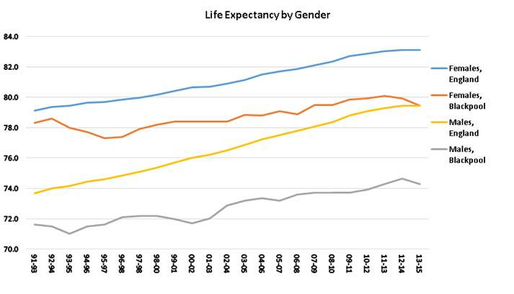
Figure 3: Life expectancy by gender; comparison of Blackpool with the nation (Mezes et al., 2022)

Recommendations to adapt to suit an increasingly more digital world

Incorporating Telehealth and mHealth Technology.
It is essential to modify health treatments so that they are compatible with the rising prevalence of digital technology around the globe. Using digital communication techniques such as telehealth and mobile health (mHealth) technology is one of the recommendations that is made to adapt health treatments that are culturally sensitive and linguistically suitable to a world that is becoming more digital (Kelchner, 2013). Those who may have trouble obtaining healthcare services owing to language or cultural obstacles, as well as mobility challenges, may benefit from remote health education, monitoring, and assistance that may be provided via the use of these technologies. With telehealth technology, for instance, community health workers (CHWs) may remotely assist their clients with language interpretation, cultural mediation, and advocacy services (Lupton, 2013). They are also able to make use of mHealth technology such as text messaging and mobile apps to simplify access to healthcare services and encourage individuals to engage in preventative health practices. In addition, health education initiatives that are culturally relevant and suitable may be broadcast via digital platforms such as social media, mobile apps, and email newsletters to expand their reach and have a greater effect.
Yet, it is essential to remember that digital technology access may not be equally available to all members of the community is considered. As a result, there is a need for concerted efforts to ensure that these technologies are available to and within the financial means of all members of the community (Dorsey and Topol, 2016). This might involve giving financial assistance in the form of subsidies or grants for the purchase of digital devices and access to the internet, as well as providing training and support for those who are unfamiliar with these technologies (Walton et al., 2015). To summarise, combining digital communication techniques into health treatments, such as telehealth and mHealth technologies, may assist in adapting health interventions to a more digital environment in a manner that is culturally sensitive and linguistically suitable. To advance health equality, efforts should be made to make certain that these technologies are available to all community members at prices that are within their financial means.

Practice and policies regarding the given recommendation.
In terms of policy, the government of the United Kingdom has made efforts to address the health needs of Blackpool through programmes such as the Healthy Towns programme, which aimed to create healthier environments and promote healthy behaviours. In addition, the government of the United Kingdom has made efforts to address the health needs of Blackpool. In addition, the government has made investments in the improvement of the town's infrastructure, such as the construction of a brand-new medical facility and a brand-new tramway system (Sayce et al., 2021). To interact with the community, the Blackpool Better Start programme has used a variety of communication strategies, including the use of social media, participation in local events, and collaborations with other community groups. Also, the programme has made use of community champions to disseminate information on the programme and interact with families.

Conclusion
In conclusion, the community of Blackpool is facing various health and social challenges, including low life expectancy, high rates of obesity, smoking, and alcoholic liver disease, and a lack of accessibility to health accessories and services. Additionally, inadequate income-earning potential, high unemployment rates, and a lack of education and skills are further contributing to the health hazards faced by the population. The adoption of culturally sensitive and linguistically compatible health interventions, such as community health workers (CHWs) and culturally relevant health education programmes, may contribute to solving these problems. The use of communication strategies, including social media, community events, and local media sources, can increase awareness of these interventions, give them more priority in public policy and practice, and bridge the digital divide within the community. The incorporation of digital tools and training for CHWs will also ensure that all members of the community can participate in health interventions, regardless of their degree of digital literacy or access to technology. Overall, it is essential to address the health and social challenges facing the community of Blackpool through targeted strategies and interventions to improve health outcomes and reduce health disparities.

References:
Anderson, L.M., Scrimshaw, S.C., Fullilove, M.T., Fielding, J.E., Normand, J. and Task Force on Community Preventive Services, 2003. Culturally competent healthcare systems: A systematic review. American journal of preventive medicine, 24(3), pp.68-79.
Clayden, A., 2019, November. Blackpool, Wyre and Fylde Community Health Services, NHS Trust, UK. In Monitoring, Evaluating, Planning Health Services-Proceedings Of The 24th Meeting Of The European Working Group On Operational Research Applied To Health Services (p. 203). World Scientific.
Dorsey, E.R. and Topol, E.J., 2016. State of telehealth. New England journal of medicine, 375(2), pp.154-161.
Kelchner, L., 2013. Telehealth and the treatment of voice disorders: A discussion regarding evidence. Perspectives on Voice and Voice Disorders, 23(3), pp.88-94.
Lincoln, H., 2019. Report into Children’s Services in Blackpool following inspection: report for the Secretary of State for Education by Helen Lincoln and Essex County Council, Commissioner for Children’s Services in Blackpool. July 2019.
Lupton, D., 2013. Quantifying the body: monitoring and measuring health in the age of mHealth technologies. Critical public health, 23(4), pp.393-403.
Martin, S., Longo, F., Lomas, J. and Claxton, K., 2021. The causal impact of social care, public health and healthcare expenditure on mortality in England: cross-sectional evidence for 2013/2014. BMJ open, 11(10), p.e046417.
McMillan, A.S. and Rayns, G., 2019. Evaluation of the Inner Strength Programme for Domestic Violence and Abuse, Blackpool.
Mezes, B., Kara, B., Owens, R., Morris, R., Butler, S., Hanson, L., Cameron, J. and Eryigit-Madzwamuse, S., 2022, March. Self-Harm Support: A targeted community-based resilience intervention for young people who self-harm and live in a socioeconomically disadvantaged area. In Society for Research on Adolescence (SRA) 2022 Biennial Meeting: Redefining Possibilities and Amplifying Marginalized Voices.
Nicholls, J., 2015. Public health and alcohol licensing in the UK: challenges, opportunities, and implications for policy and practice. Contemporary drug problems, 42(2), pp.87-105.
Rosenthal, E.L., Brownstein, J.N., Rush, C.H., Hirsch, G.R., Willaert, A.M., Scott, J.R., Holderby, L.R. and Fox, D.J., 2020. Community health workers: part of the solution. Health Affairs, 29(7), pp.1338-1342.
Russell, W., 2021. Politicians, patients, and practitioners. British Medical Journal (Clinical research ed.), 283(6299), p.1133.
Sayce, L., Craig, T.K.J. and Boardman, A.P., 2021. The development of community mental health centres in the UK. Social Psychiatry and Psychiatric Epidemiology, 26, pp.14-20.
Swider, S.M., 2022. Outcome effectiveness of community health workers: an integrative literature review. Public health nursing, 19(1), pp.11-20.
Walton, G., Childs, S. and Blenkinsopp, E., 2015. Using mobile technologies to give health students access to learning resources in the UK community setting. Health Information & Libraries Journal, 22, pp.51-65.

