Network Operating Systems and Services (NOSS) ACCA5023
Build, deploy, configure, and manage a Type 2 Hypervisor platform based Virtualized Network

Worksheet One

Network Operating Systems and Services – ACCA5023
Sarah Rule - 1810755

Worksheet One

Task One: VM Creation and Operating System Installations

Using Virtual Box to create Virtual Machines

1.1 Creating a Windows 2019 Server Virtual Machine

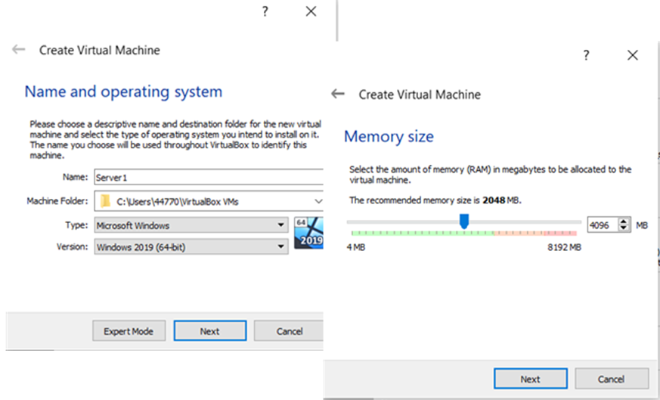
Figure 1

The requirement of this task is to install a total of 4 servers, two of these are to be Windows 2019 servers. Figure One shows the name of the server, the folder where it is stored and what Type and Version of the Server has been installed as well. For this server, 4096MB of memory (RAM – Random Access Memory) has been allocated to the Virtual Machine. A Windows 2019 (64-bit) version has been installed on this machine and named as Server1.

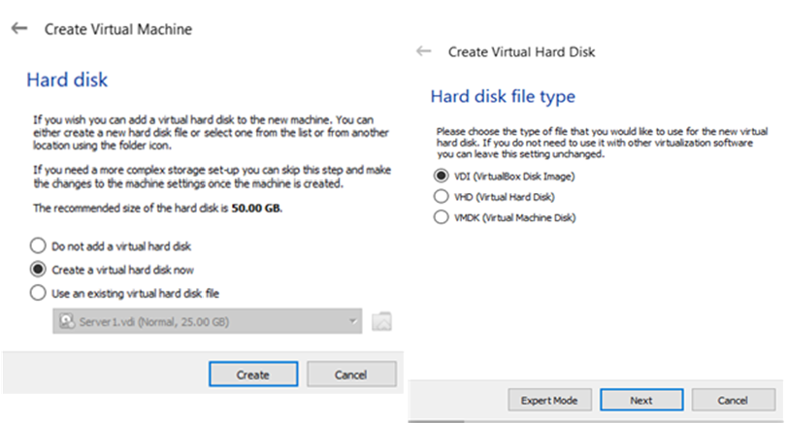
Figure 2

The Virtual Hard disk has been created with the file type being VDI (VirtualBox Disk Image) as shown above in Figure 2.

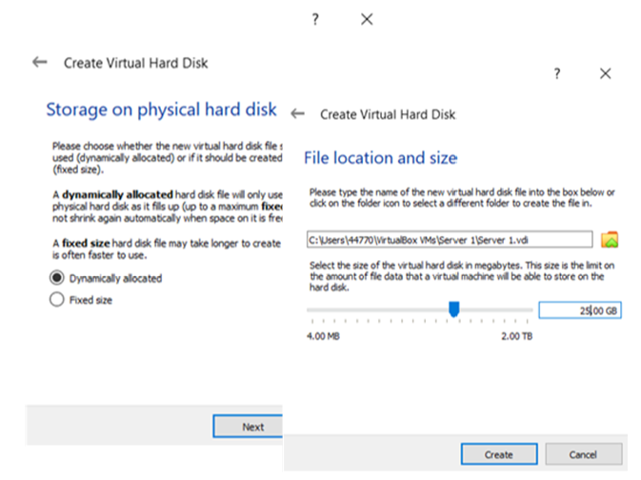
Figure 3
The storage on the physical hard disk has been ‘dynamically allocated’ with a size of 25.00GB given to it as well. As stated within the screenshot above, dynamically allocated hard disks will only use space on your physical hard drive as it fills up. As shown in Figure 3, the author has saved the Virtual Server in the C: drive where she will likely save further servers for easy access when she requires access to them again.

Creating a Windows 10 Client Virtual Machine

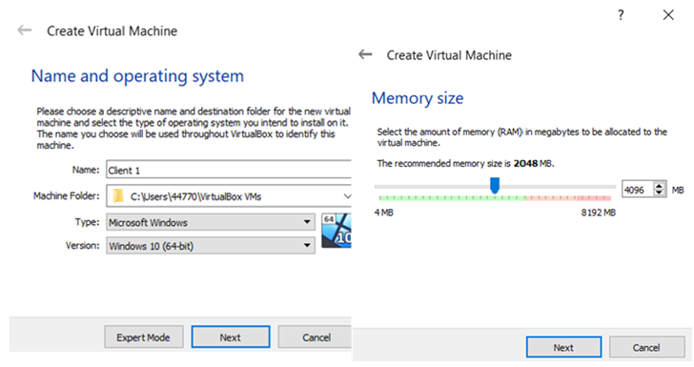
Figure 4
The requirement of this task is to install a total of 4 servers. Two 2019 servers have already been created and Figure 4 shows the creation of the Windows 10 (64-bit) machine for Client 1, the same will be created for Client 2. As before, there has been 4096MB of RAM allocated to this Virtual Machine.

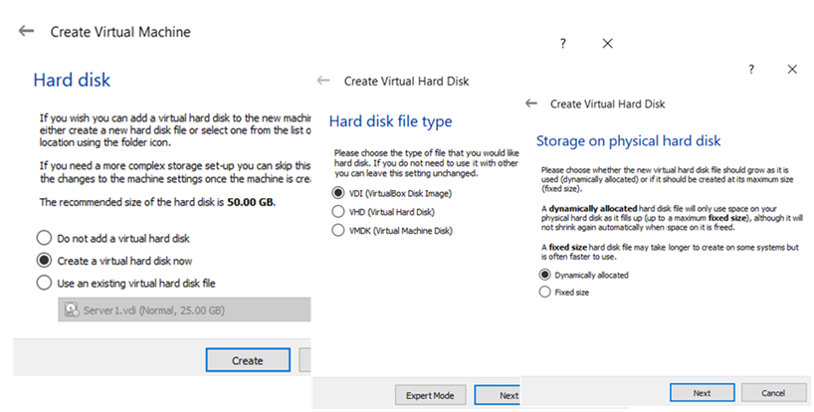
Figure 5
A virtual hard disk has been created, with the file type of VDI (VirtualBox Disk Image) and the storage on the physical hard disk has again been dynamically allocated.

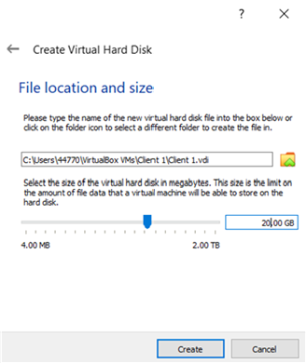
Figure 6
The file location is within the C: drive, labelled VirtualBox VMs. Storing the VMs in a well labelled folder, with a clear naming convention will prevent any VMs that are created from being lost altogether, but will also save time in locating them for future use.

Installing Windows 2019 on a Virtual Machine

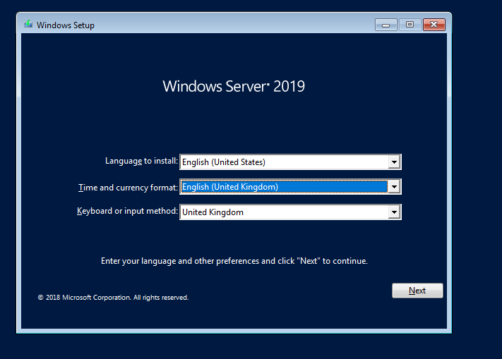
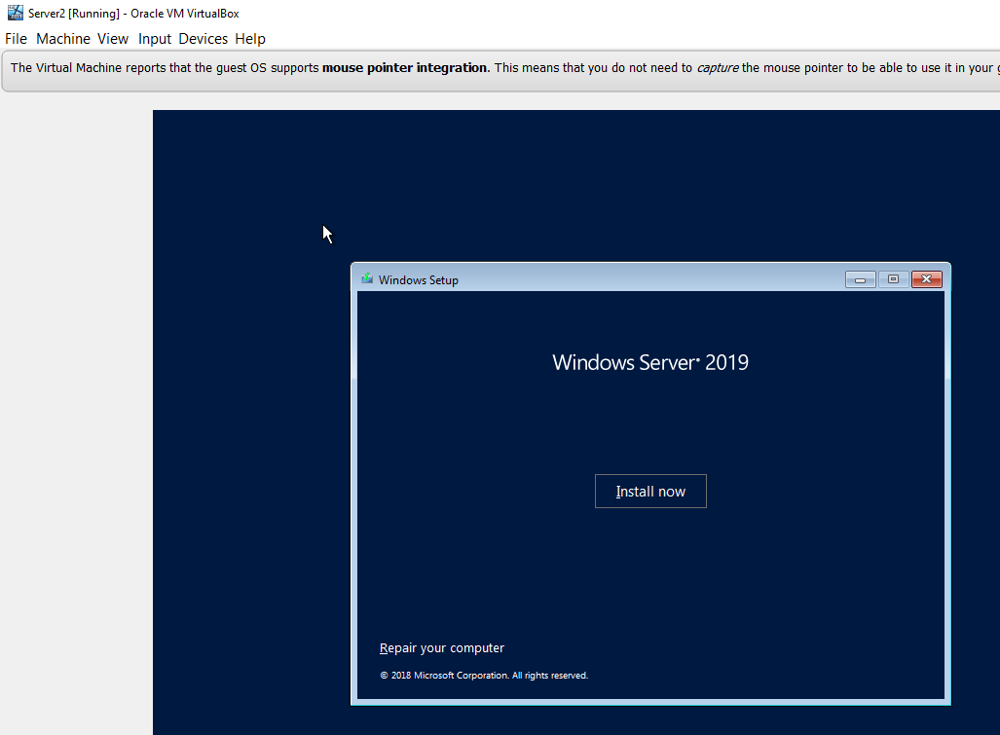
Figure 7

Figure 8

Figure 7 and 8 show a Windows 2019 Server being installed on the Virtual Machine.
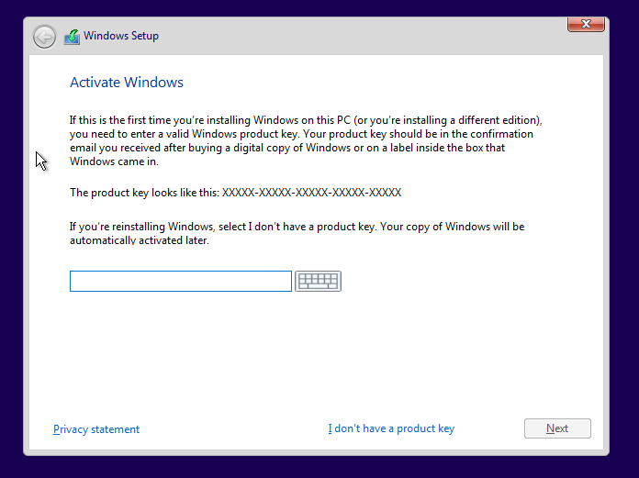
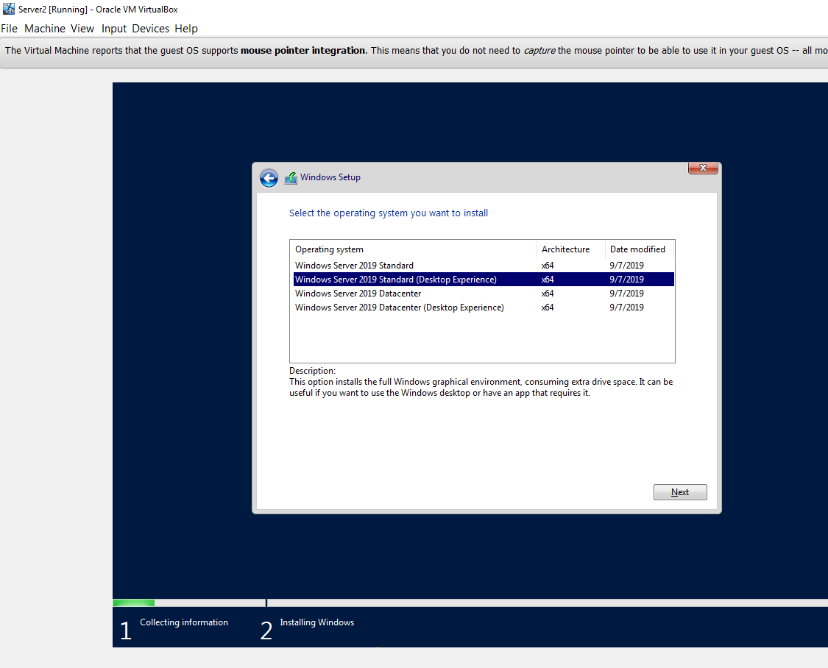
Figure 9

Figure 10

The installation process required selecting the Operating System with a choice of four options. Here, Figure 10 shows the chosen option was ‘Windows Server 2019 Standard (Desktop Experience)’, when the ‘Datacentre Experience’ option should have been chosen, and would have been a better choice for the required task.

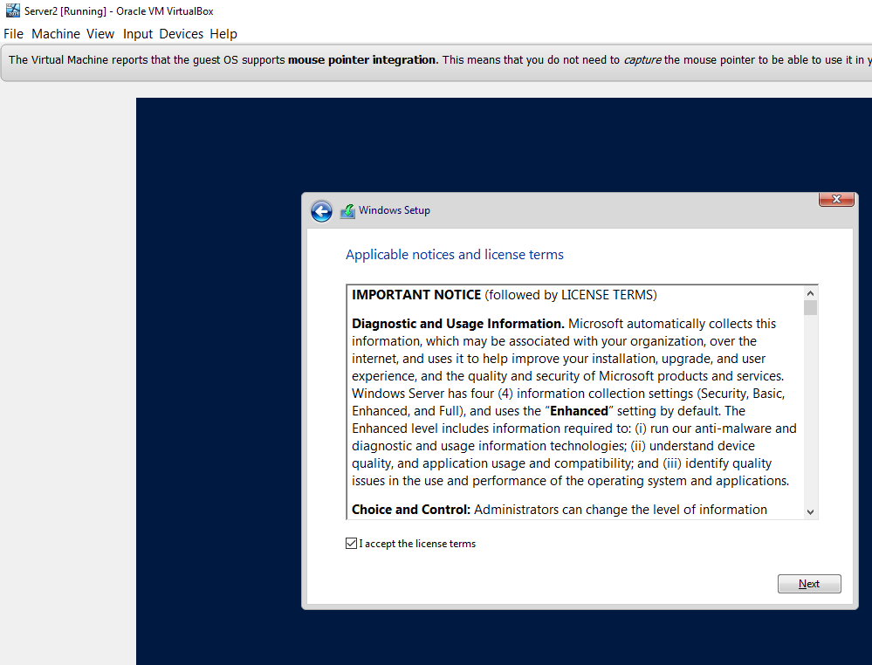
Figure 11
Figure 11 requires the acceptance of the ‘Applicable notices and licence terms’.

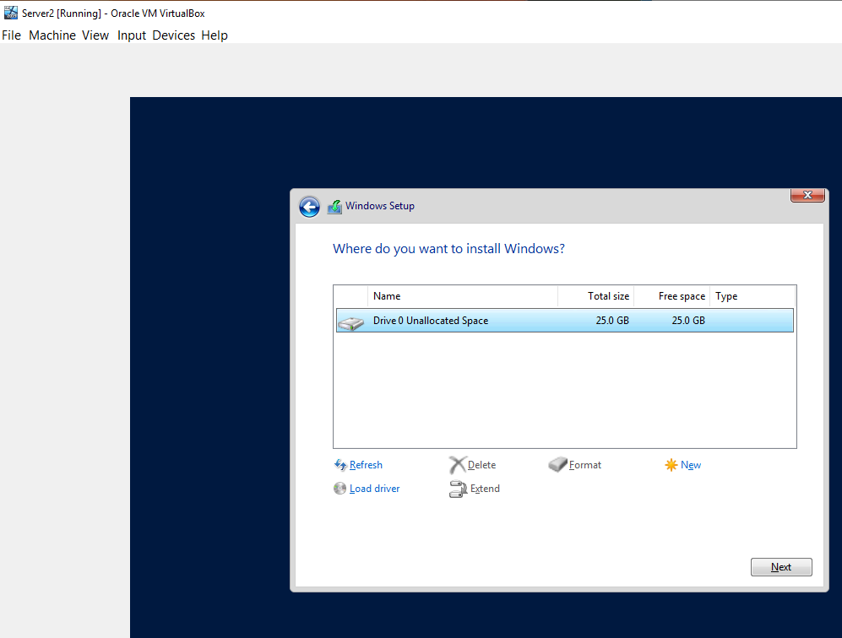
Figure 12
A total of 25GB drive space is available for the installation of Windows. As shown is the figure above, there is nothing yet allocated within this space.
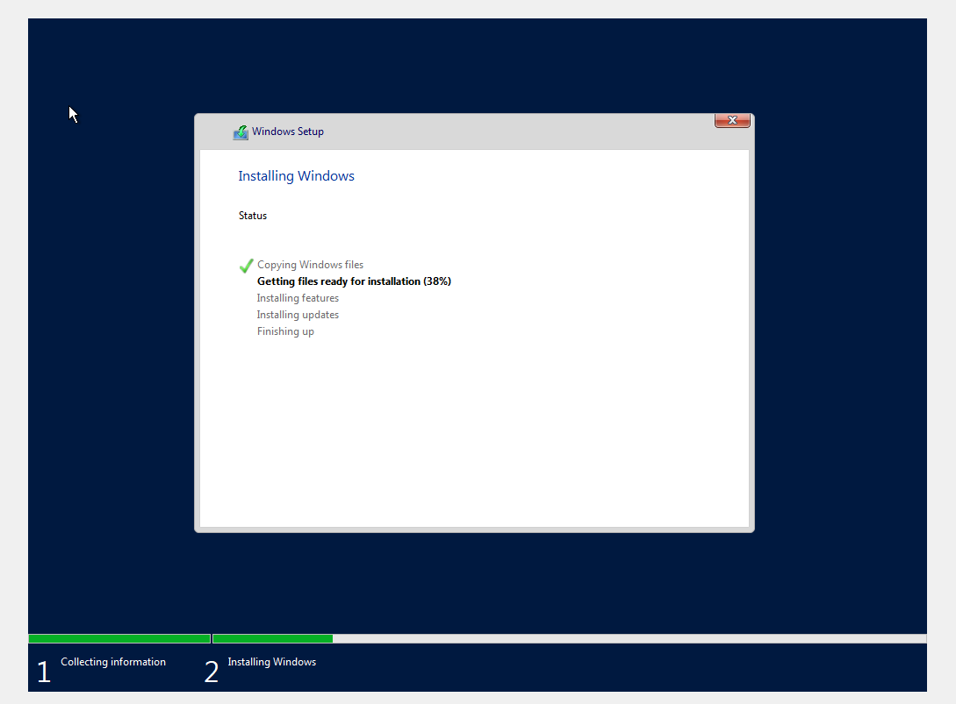
Figure 13
Figure 13 is showing the installation progress in steps across the bottom of the screen.

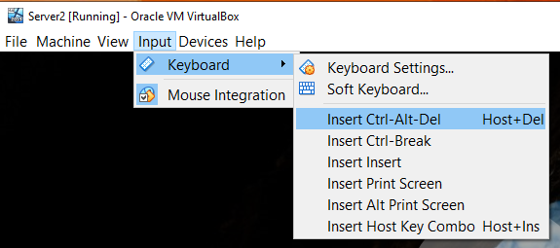

Figure 14
Figure 14 explains how to log into the server using the keyboard. This is done by clicking ‘Input’, then ‘Keyboard’ and selecting ‘Insert Ctrl-Alt-Del’, this unlocks the screen and allows credentials to be entered for access.

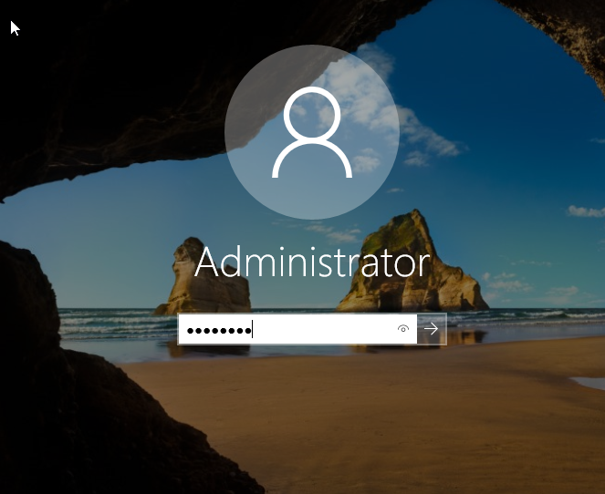
Figure 15
The username for this Server has been set to Administrator, and she has entered the associated password to gain access.

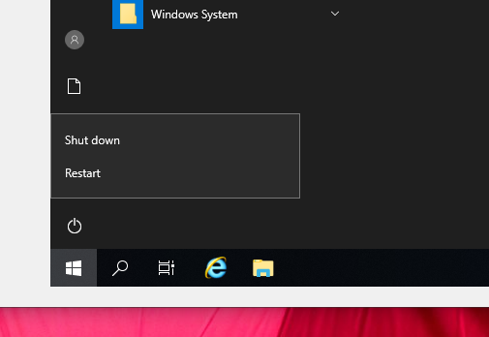
Figure 16
As Windows Server 2019 has successfully been installed, the user can shut down the Server as shown above.

Installing Windows 2010 on a Virtual Machine

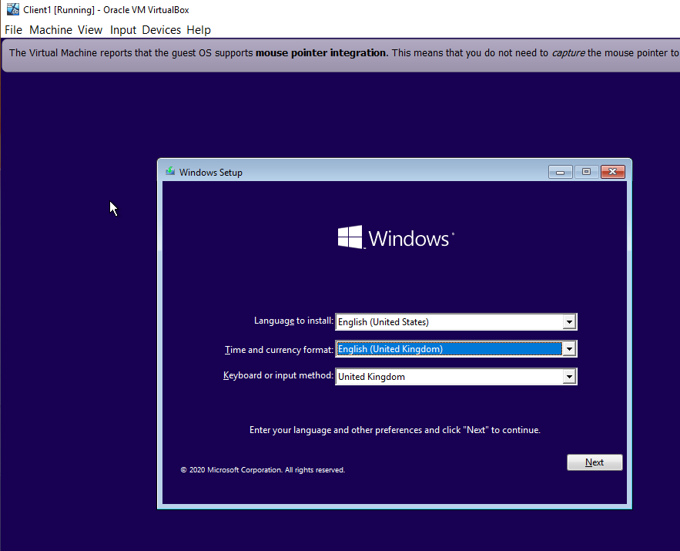
Figure 17

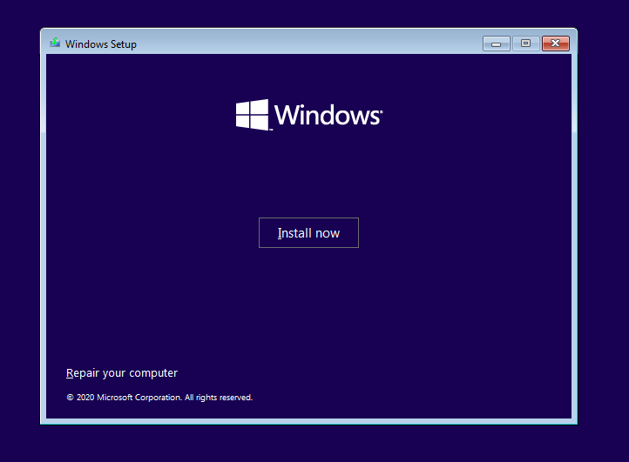
Figure 18
Windows 2010 is being installed on the Virtual Machine.
Figure 19
To activate Windows, she needs to enter a product key. As there isn’t one available, she will need to click ‘I don’t have a product key’ shown at the bottom of Figure 19.

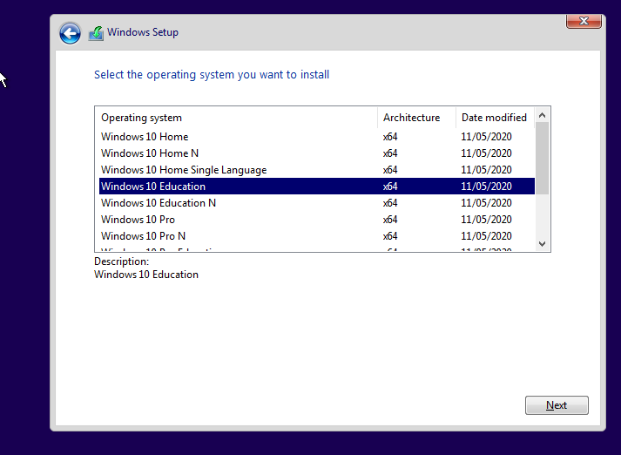
Figure 20

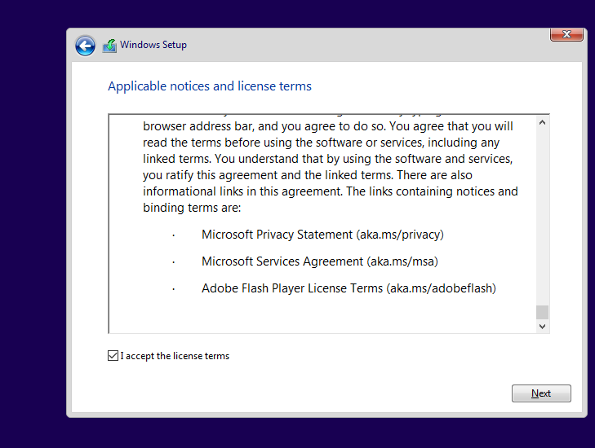
Figure 21
On setup, the ‘applicable notices and license terms’ have to be accepted before being able to proceed further into the setup.

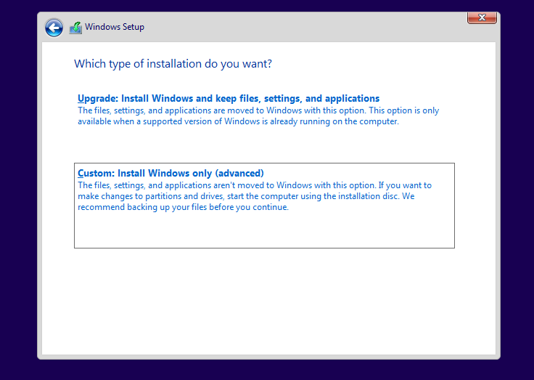
Figure 22
A custom installation was installed here. This installed Windows Only on the Virtual Machine.

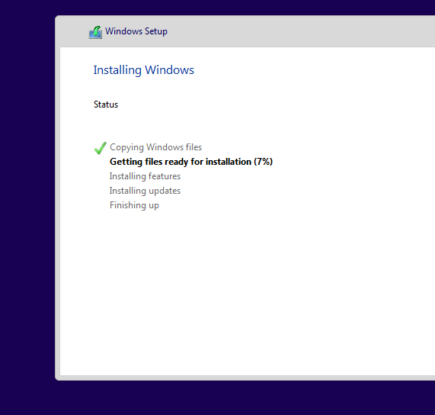
Figure 23
Figure 23 shows the progress of the Windows Installation. Each step shows a percentage of completion next to the step.

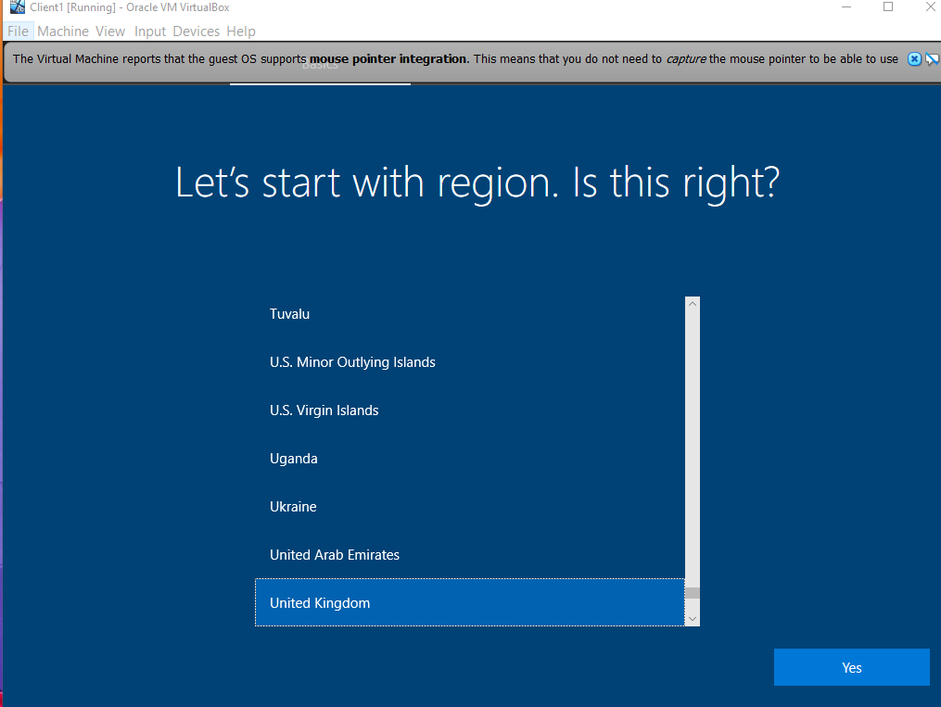
Figure 24
Here, the selected Region has been chosen as the United Kingdom.

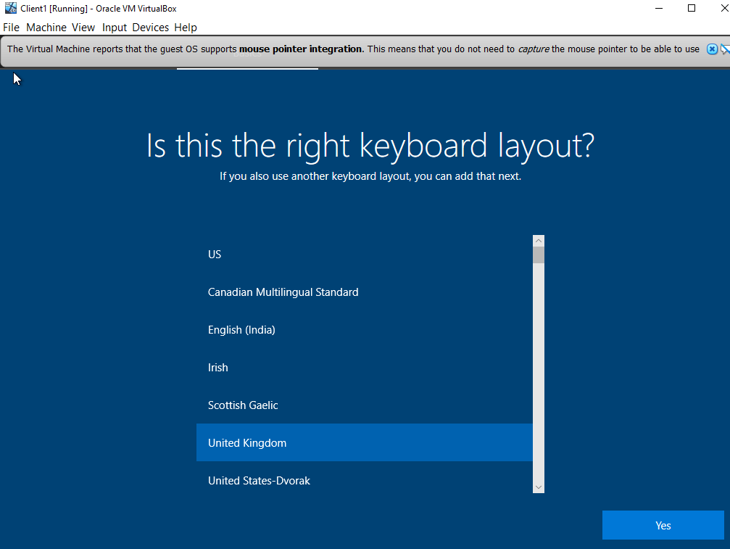
Figure 25
In Figure 25, the author has chosen the keyboard layout to also be the United Kingdom.

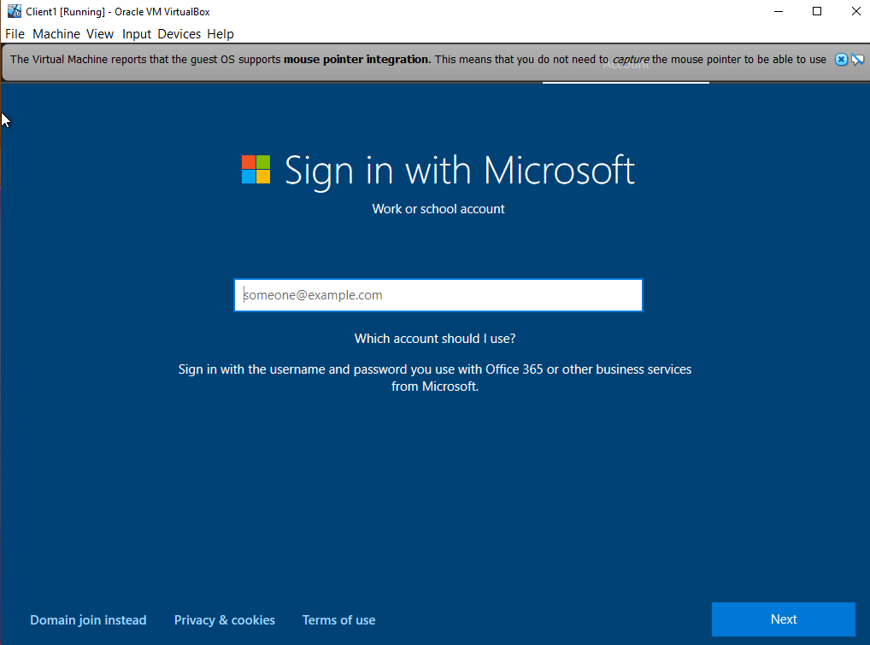
Figure 26

Task Two: Virtual Network Configurations

Configuring Virtual IPs

Creating a Virtual Switch and LAN for the Virtual Servers

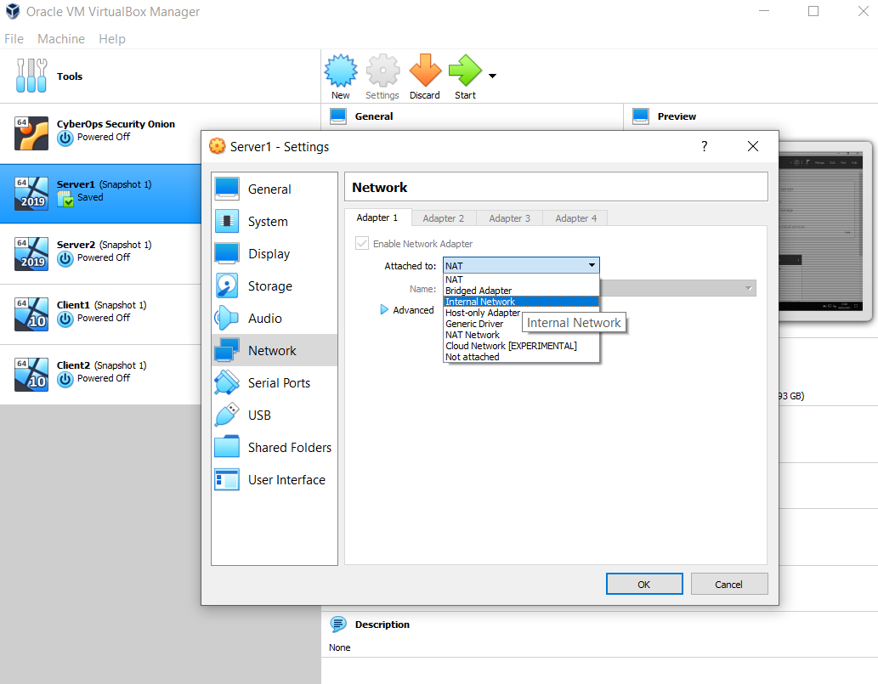
Figure 27
In Task Two the author is going to create a Virtual Switch and LAN for the Virtual Servers. First, she needs to right click into Server 1, find Network settings and change the Adapter 1 settings for ‘Attached to:’. This needs to be set to ‘Internal Network’ as shown in Figure 27.
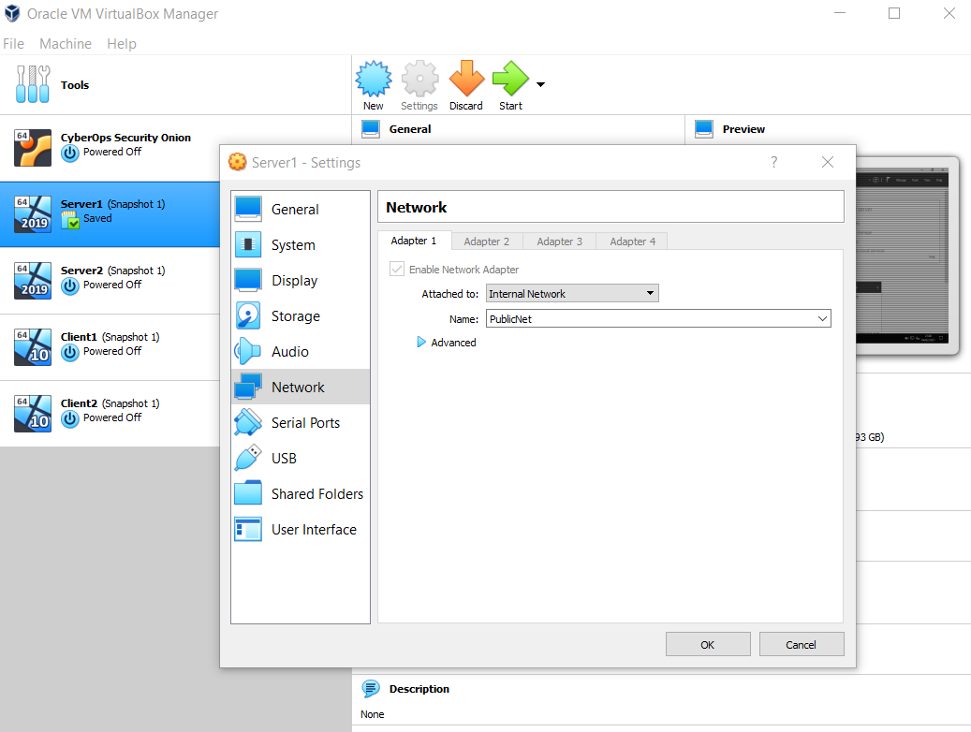
Figure 28
This Internal Network is going to be called ‘PublicNet’.

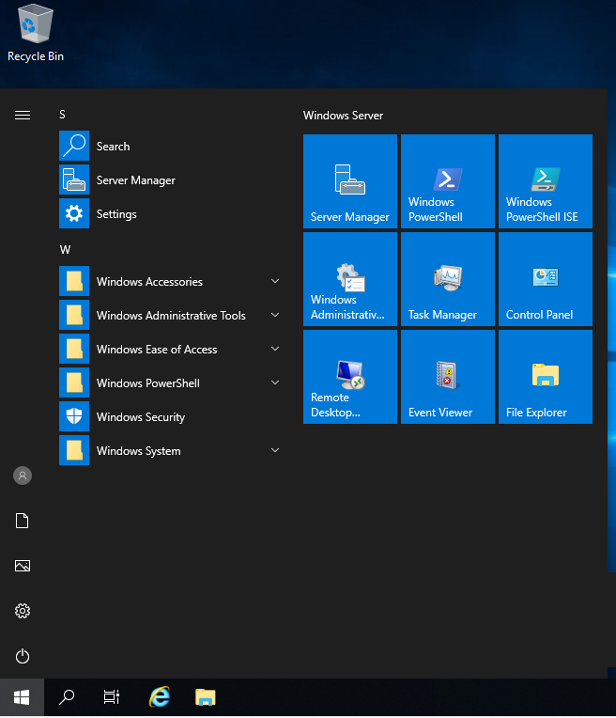
Figure 29

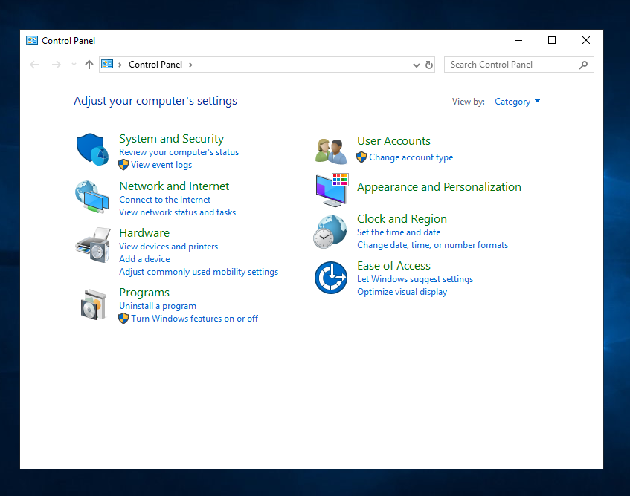
Figure 30
The Network and Sharing Centre needs to be accessed via the Control Panel.

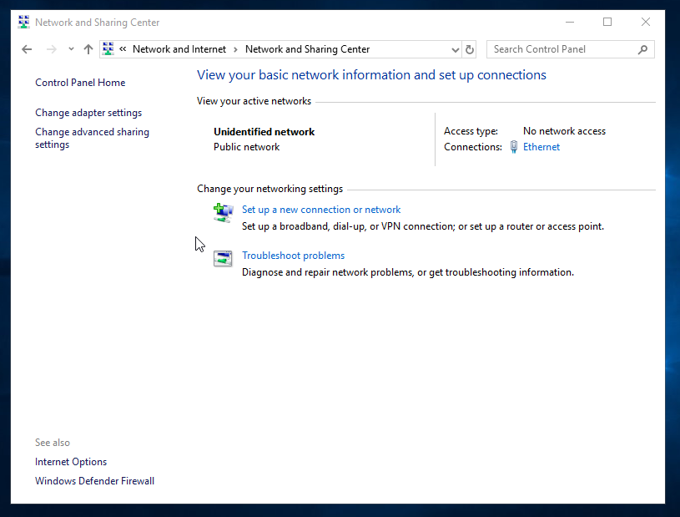
Figure 31

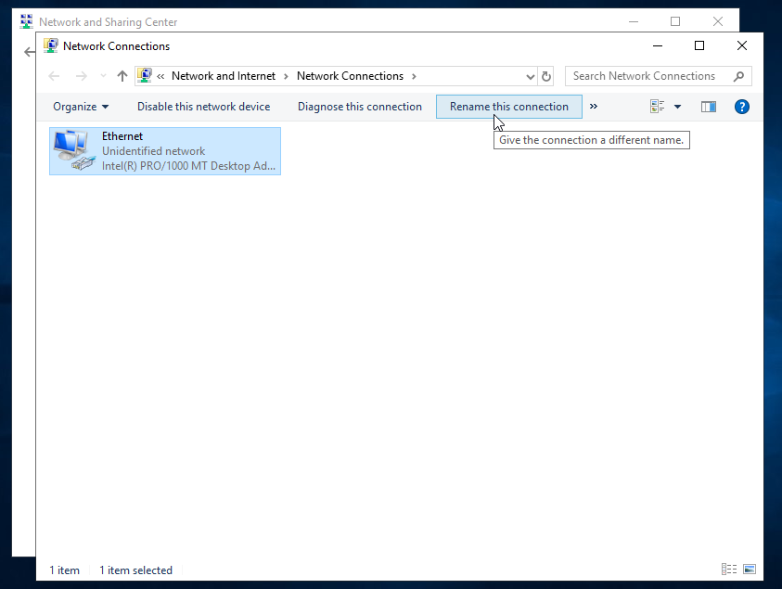
Figure 32
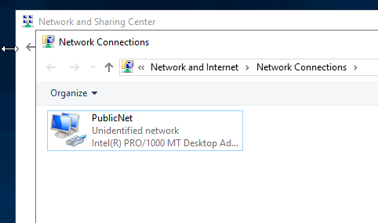
Figure 33
The Network connection is going to be renamed here, this will now be called PublicNet.

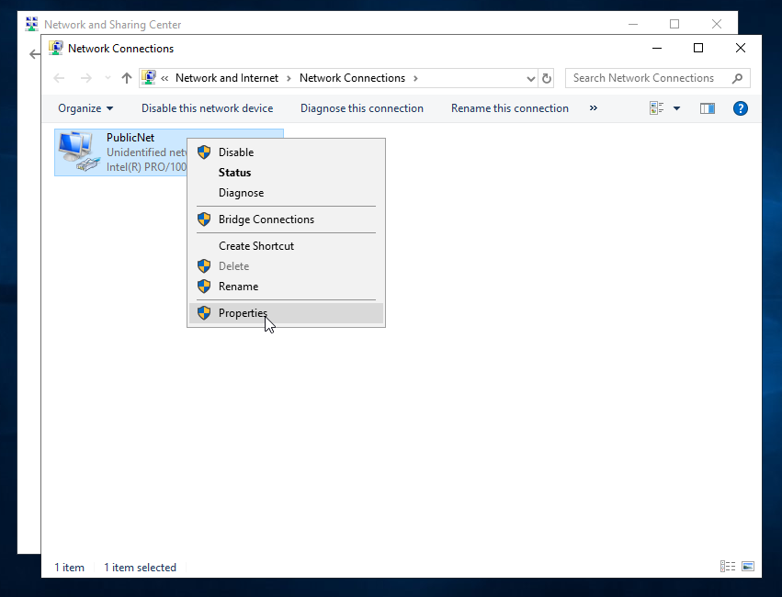
Figure 34

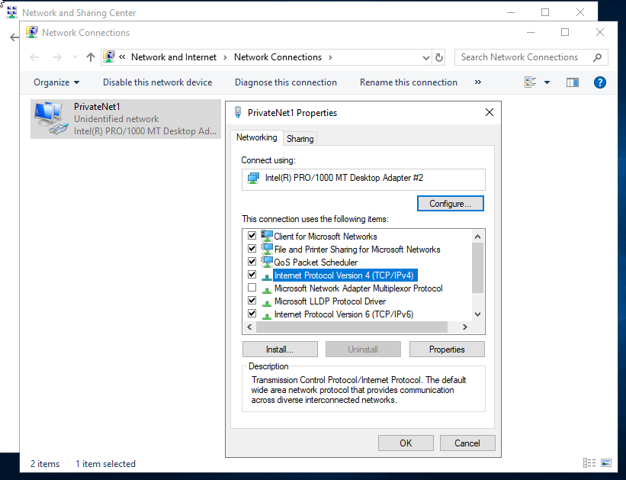

Figure 35
Internet Protocol Version 4 (TCP/IPv4) is to be enabled. Once ticked, the author needs to double click to enter the IPv4 IP Addresses.
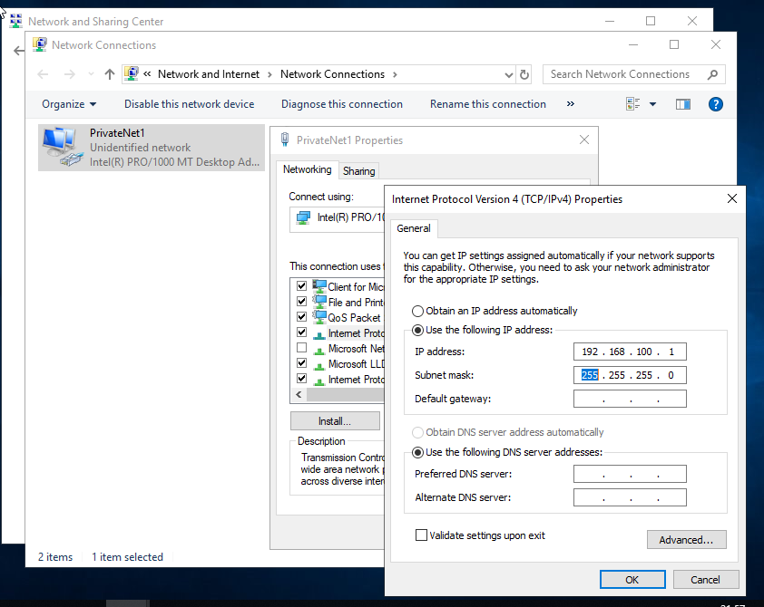

Figure 36
The IPv4 Address used is 192.168.100.1, with the subnet mask being 255.255.255.0. This subnet has a 256 address range.

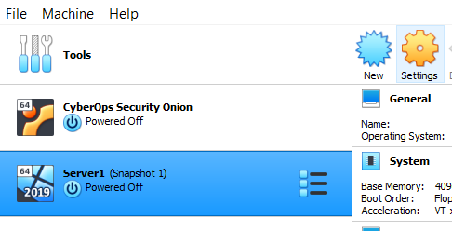
Figure 37

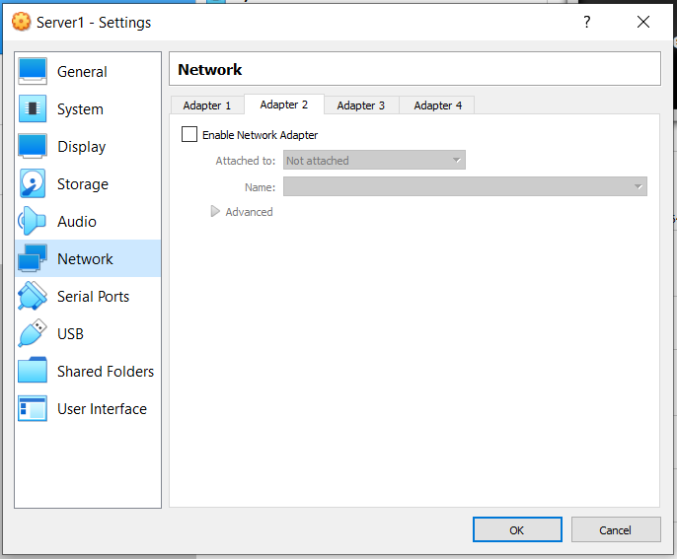
Figure 38
On Server 1, Figure 37, the Network Adapter needs to be enabled. This is done by ticking the box next to ‘Enable Network Adapter’.

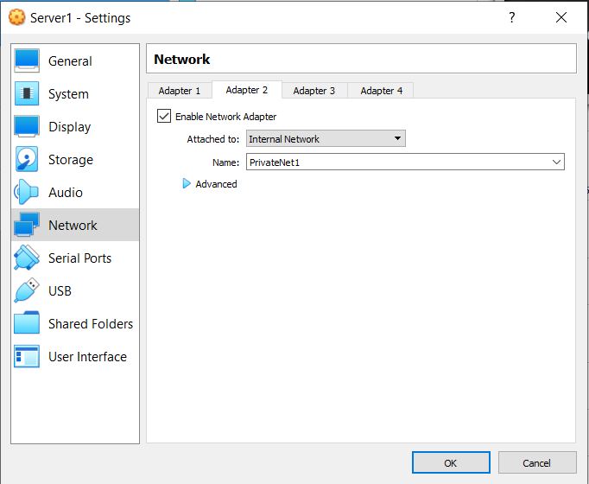
Figure 39
Adapter 2, as shown in Figure 39, has been attached to an Internal Network. This has been named PrivateNet1.

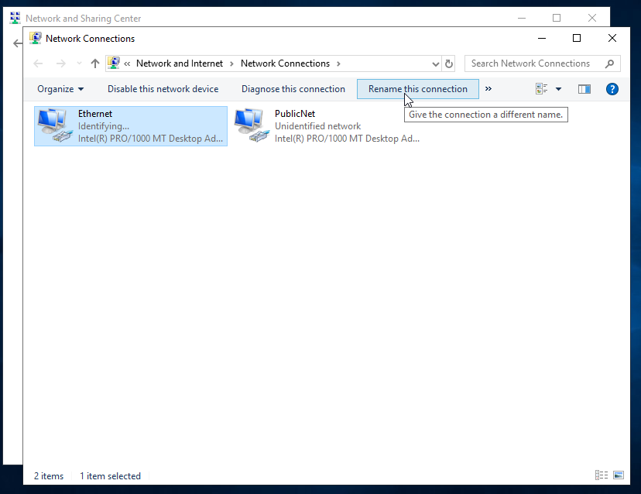
Figure 40
The author will, as before, rename this connection to PrivateNet1 to easily identify each Network with a simple naming convention.

Creating a Virtual Switch and LAN for the Client Machines
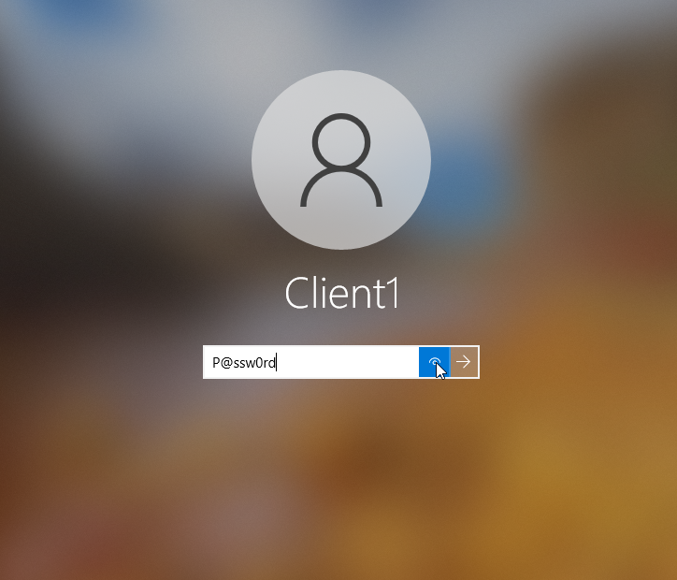
Figure 41

Logging into the Client 1 Virtual Machine that was created. Figure 41 shows that a secure password, containing special characters, numbers and capital letters is being used for the account.
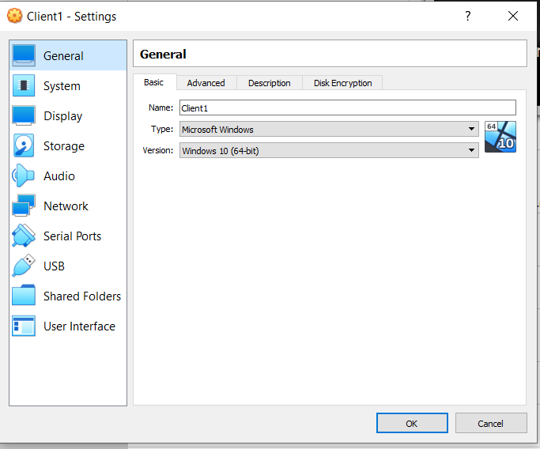
Figure 42
The Client 1 virtual machine is a Microsoft Windows 10 64-bit version.

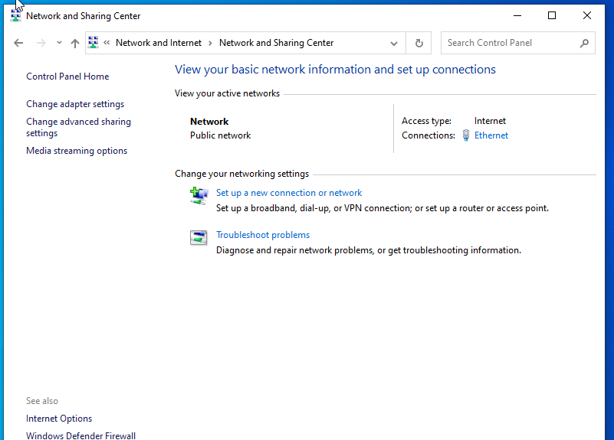
Figure 43
Within the Network and Sharing Centre of Client 1, she will rename the Network to PrivateNet1.

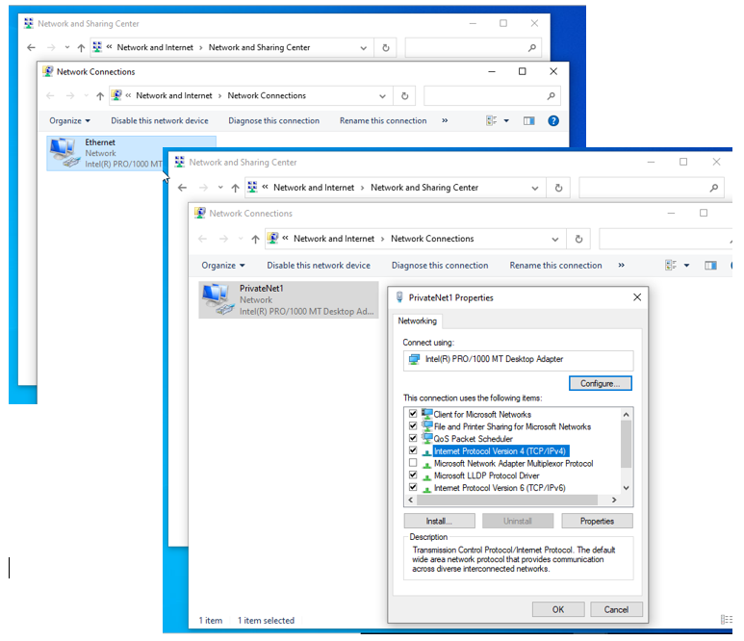
Figure 44
Figure 44 shows that the Network has ow been renamed to PrivateNet1 as mentioned above, the IPv4 address needs to be input. This is done by ticking, then double clicking the highlighted area, as the author previously did for Server 1.

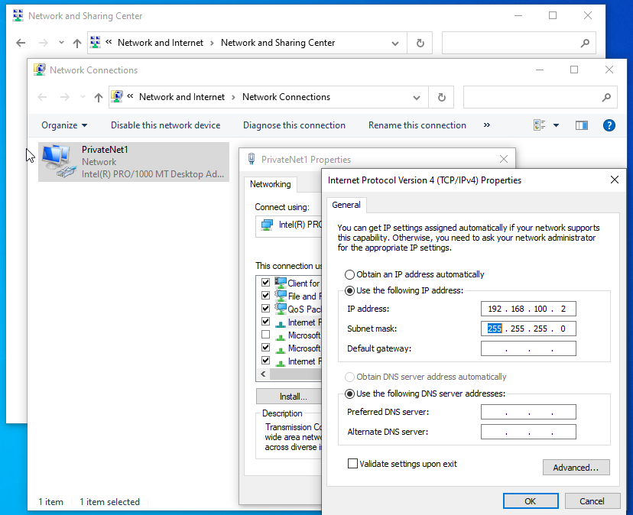
Figure 45
The IPv4 address for Client 1 will be 192.168.100.2, with the subnet mask being 255.255.255.0.

Linking a PrivateNet and PublicNet

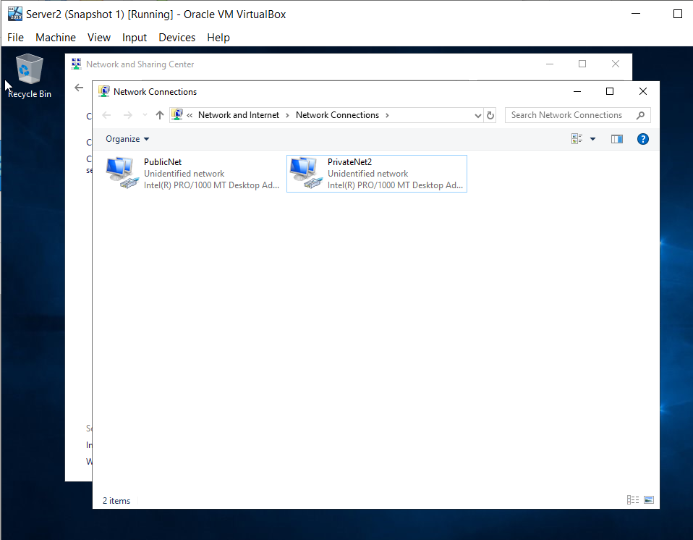
Figure 46
There is a Public Network, and a Private Network on Server 2. These need to be linked together.
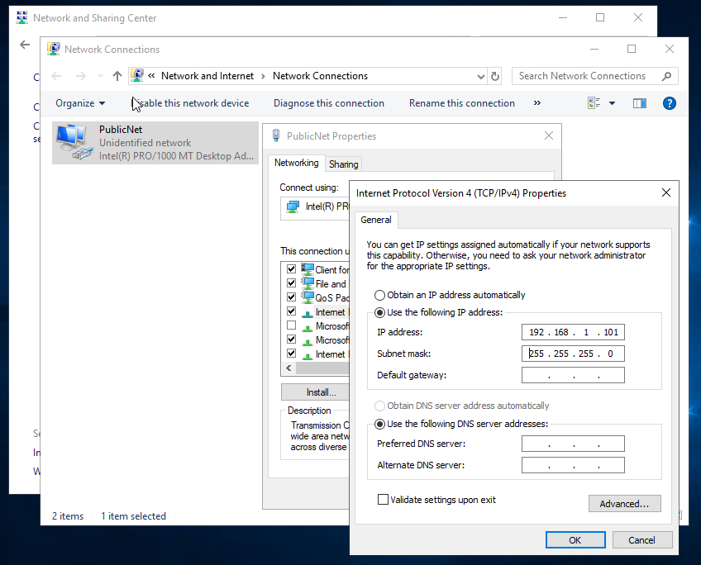
Figure 47
As before, in Server 1 and Client 1, she is going to enable IPv4 and input the IP addresses herself. The IP address used here for the PublicNet is 192.168.1.101, with the subnet mask being 255.255.255.0.

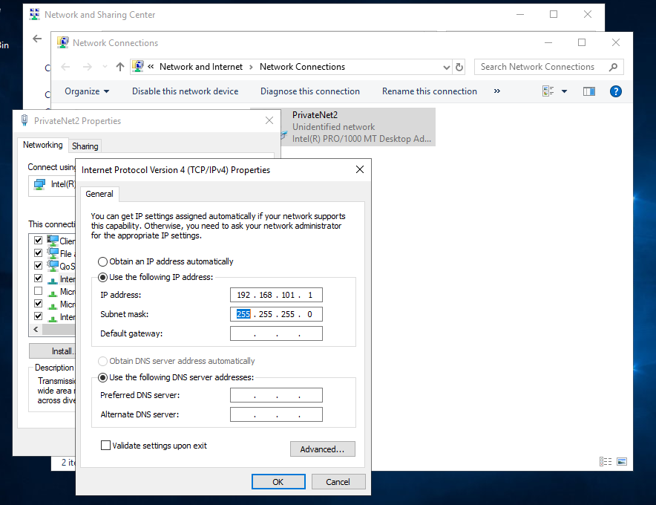
Figure 48
For PrivateNet2, the IPv4 address is 192.168.101.1, with the subnet mask being 255.255.255.0.
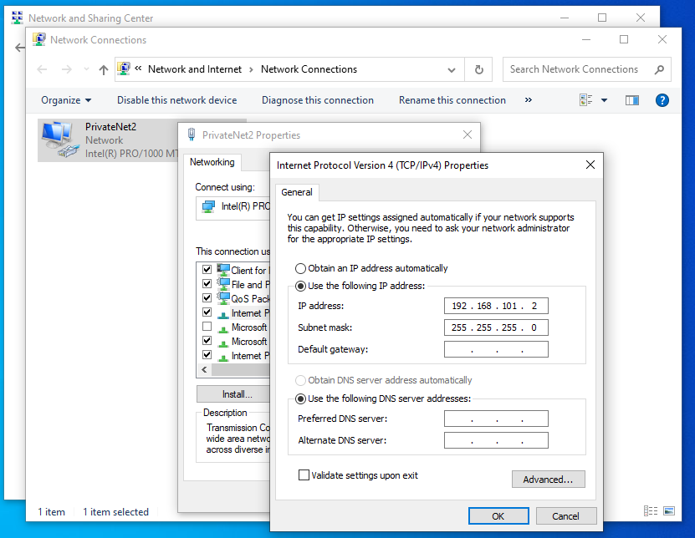
Figure 49
Figure 49, above, shows the IPv4 address for the Client 2 machine. The IPv4 address has been enabled and input as 192.168.101.2. The subnet mask is 255.255.255.0.

Turning off the Firewalls in the Server
The firewalls for each of the Server 1 and Server 2 need to be disabled for the ‘Ping’ command to be completed. This is to test the connectivity between the different Networks that have been created.
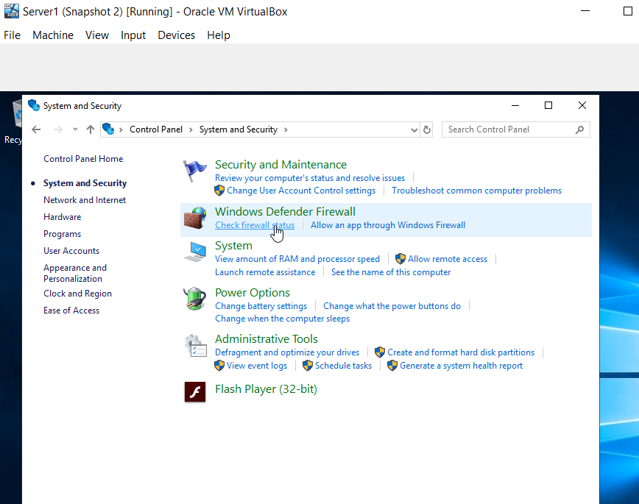
Figure 50
The Firewall can be disabled through the Control Panel - System and Security Centre as shown in Figure 50.

Turning off the Firewalls in the Client Machine

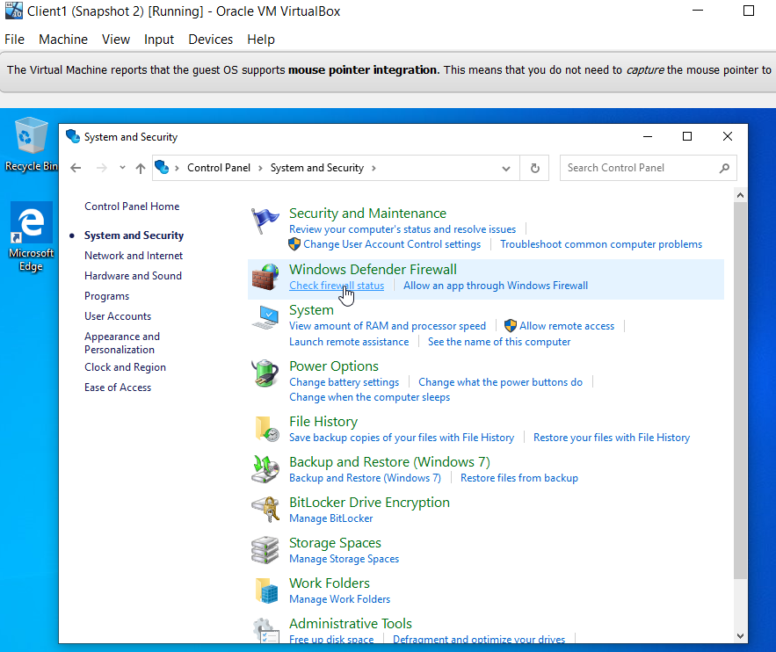
Figure 51
The firewalls for the Client Machines also need to be turned off in the same way as she has done above for the Server Machines.

Task Three: Observational Tasks

3a) Describe the main differences between Type 1 and Type 2 Hypervisors. Identify benefits and drawbacks of both and provide some example Vendors.

What are Hypervisors?
A Hypervisor is a software that creates and runs Virtual Machines (VMs). A Hypervisor is also known as a Virtual Machine Monitor or VMM.

Type 1 and Type 2 Hypervisor differences.

Example Vendors

3b) What is the significance of the subnet mask in IPv4 addressing?

3c) Cloud computing has revolutionised the way that enterprise networks are hosted. Describe the use of cloud computing including its benefits and drawbacks and identify example vendors within the industry.

3d) Give an in-detail description about the different terminologies and its purposes (like (not limited to) Ping, Server Management, Firewall, PAE/NX, OOBE etc) you came across during the Task 1 and Task 2. Compare your list of terminologies in the aspect of their operations/functionality with other Network Operating Systems. (For example: If you select Windows Firewall and describe the operations/functionality of Windows Server 2019 Firewall, you have to compare these features with the operations functionality of other Networks Operating Systems like Linux, Mac)

