

Student Name: Nishtha Savaliya
Student ID: 2530041

Programme: Master of Business Administration (MBA)

Module Name: Financial Management
Module Code: LCMB7002

Lecturer’s Name: Shengfeng Mei

Word Count: 5,350

Term 1

Assessment: Financial Performance and Management of MG Motor

Table of Contents
Introduction 4
1. Financial Health Check 4
1.1 Five-Year Financial Performance Overview 4
1.2 Profitability Ratio Analysis 4
1.3 Liquidity Ratio Analysis 5
1.4 Efficiency Ratio Analysis 6
1.5 Gearing Ratio Analysis 6
1.6 Investment and Cash Flow Ratio Analysis 7
1.7 Key Strengths and Threats 7
2. Working Capital Management Analysis 9
2.1 Assessment of Cash Operating Cycle 9
2.2 Strategies to Improve Liquidity Through Working Capital Reforms 10
2.3 Short-Term vs Long-Term Financing Options 10
2.4 Final Working Capital Recommendation 11
3. Strategic Financial Restructuring Plan 12
3.1 Need for Financial Restructuring 12
3.2 Recommended Financial Restructuring Options 12
3.2.1 Equity Injection from Parent Company 12
3.2.2 Strategic Divestiture of Non-Core Operations 12
3.2.3 Joint Venture for Battery Production 13
3.2.4 Selective Debt Restructuring 13
3.2.5 Green Financing and Sustainability Bonds 13
3.3 Impact on Shareholder Value and Capital Structure 13
3.4 International and Ethical Considerations 14
3.4.1 Taxation and Transfer Pricing 14
3.4.2 Currency Exchange Risk 14
3.4.3 Inflation and Global Supply Chain Costs 14
3.4.4 ESG and CSR Commitments 14
3.4.5 Ethical Financial Governance 15
3.5 Final CFO Strategic Recommendation 15
4. Investment Appraisal and Capital Budgeting 16
4.1 Introduction to Proposed Investment Projects 16
4.2 Investment Appraisal Calculations 16
4.3 Comparative Evaluation of Projects 17
4.4 Final Project Recommendation 18
4.5 Capital Rationing Decision (£100 Million Limit) 18
4.6 Final CFO Investment Decision 19
Conclusion 19
Reference List 20
Appendices 23
Appendix 1: Ratio Analysis 23
Appendix 2: Profitability ratio 26
Appendix 3: Liquidity ratio 26
Appendix 4: Gearing ratio 28
Appendix 5: Earning per share 29
Appendix 6: Efficiency Ratios 30
Appendix 7: Cash flow ratios 31
Appendix 8: Investment Appraisal and Capital Budgeting 31

Introduction
This report analyses the financial performance and financial management strategies of MG Motor as an electric vehicle manufacturer. It provides ratio analysis, working capital efficiency and financial restructuring options and investment appraisal decisions in five years on financial statements. The aim is to discover the financial issues and recommend long term viable policies that enhance profitability, liquidity and shareholders value in the long-term. MG Motor has been selected as a rapidly growing EV manufacturer with expanding global operations. Due to limited standalone public financial disclosures for MG Motor, this report uses financial information derived from the parent company, SAIC Motor, to evaluate financial performance and strategic financial management.

1. Financial Health Check

1.1 Five-Year Financial Performance Overview
MG Motor’s revenue increased from $36,242 million in 2021 to $42,010 million in 2025, showing 15.9% growth. The most dynamic growth was 2021-2023 and EV demand and global growth. The slight declines in 2024 and 2025 are indicative of the growing competition and inflation, as well as the cost in the supply chains. The gross profit has increased by $5,145 million in 2021 to $5,989 million in 2025 and it indicates that scale of operations has been increased. Gross profit margin also recovered to 14.26% in 2025 after falling to 12.29% in 2022 (MG Motor, 2026). This means that there is greater pricing discipline and cost of production and procurement. The operating profit was not very dynamic because it increased between $1,916 million in 2021 and $2,110 million in 2025 in comparison with the operating profit margin which increased between 4.16% in 2022 and 5.02% in 2025. This is an indication of a more efficient operation despite the pressure on cost in the industry [Refer to appendix 1].
Net profit dropped significantly to $1,514 million to $829 million in 2021 and 2025 respectively and net profit margin is decreasing to 1.97% compared to 4.18% in 2021 and 2025, respectively, so financing, taxation and expansion costs are decreasing shareholder returns. Although total assets have increased by $31,417 million as well as the operating cash flow by $3,598 million, the current liabilities remain high and thus short-term funding difficulties and profitability challenges are still high.

1.2 Profitability Ratio Analysis
The profitability ratios show that MG Motor is in good operation but with less retention of final profits. ROCE remained relatively stable, moving from 10.25% in 2021 to 10.33% in 2025, with a peak of 11.17% in 2024. This is a pointer that the capital in use is being used fairly well to generate operating returns. The ROCE of more than 10% would be considered as a decent performance of a capital-intensive EV manufacturer, whereas a high-growth international manufacturer should have higher returns.
Gross profit margin improved from 12.29% in 2022 to 14.26% in 2025. This is an indication that the company has increased its production efficiency and cost management, after the former inflationary pressure on raw materials, logistics and sourcing of batteries. The expansion also indicates a stronger supplier power and enhanced pricing strategy of high-end EVs [See appendix 2].
The operating profit margin has increased consistently in 2022 and 2025 by 4.16% and 5.02% respectively, however, they are lower than 2021, 5.29%. This indicates that the underlying business is stabilising and overhead and growth expenses keep posing a challenge to the profitability. Management efficiency is also improved, but at a lower rate than it is necessary to deal with the competition in the industry (Armono, 2024).
The lowest ratio is the net profit margin, which decreased significantly in 2025, the net profit margin of 1.97% as compared to 4.18% in 2021. Although its gross and operating margins are higher, the business is holding on to less final profit.

1.3 Liquidity Ratio Analysis
Liquidity ratios indicate that MG Motor is relatively stable in the short term financially and cash flexibility in the near future is low. The current ratio declined from 1.30 times in 2021 to 1.06 times in 2023 before recovering to 1.25 times in 2025. This implies that the company experienced a more liquidity squeeze at the expansion stage but over the last years the company has been able to experience better working capital management. Having a current ratio more than 1 means that the short-term liabilities can be financed using the short-term assets but a limited margin of safety [See appendix 3].
The quick ratio is a more conservative opinion. It declined from 0.92 times in 2021 to 0.71 times in 2023 before improving to 0.87 times in 2025. This does not take into account inventory thus this means that MG Motor is still heavily dependent on inventory conversion to roll over immediate liabilities. This is typical of the auto industry and low-quick ratio (less than 1) means that the business would be extremely vulnerable to a nonfunctional state in the event of a slowdown in the inventory flow. This improvement of 2025 is attributed to the better receivables management and better operating cash-generation. Cash discipline should therefore be prioritised by the CFO, instead of just looking at the accounting liquidity.

1.4 Efficiency Ratio Analysis
Operation ratios show-off ambivalent performance. The inventory turnover was lower than in 2021 (15.67 times) and 2025 (8.70 times). This means that the rate of inventory turnover is low compared to previous that suggests overstocking, ineffective demand forecasting or increased production cycle. The low EV inventory turnover increases holding costs and the risk of technology obsolescence, especially with battery models having a high turnover [See appendix 6].
Receivables turnover also fell sharply from 11.49 times in 2021 to 5.61 times in 2025. This implies that it is experiencing slower customer collections and high working capital is tied up in receivables. It can be indicative of the aggressive approach of dealer credit or low payment discipline in foreign markets (Hasidi, Baheri and Hajar, 2024).
The turnover of assets was not very high ranging between 1.25 times and 1.38 times in the five years, and 1.34 times in 2025. This means that the asset investment productivity is yet to be productive in regards to revenue. Inventory optimisation and receivable acceleration should be a major concern of the CFO as the decline of efficiency is directly cutting cash availability.

1.5 Gearing Ratio Analysis
Gearing analysis reveals that MG motor is moderately leveraged but sensitivity to financing is on the rise. Debt-to-equity increased from 0.29 times in 2021 to 0.38 times in 2023 before improving slightly to 0.36 times in 2025 [See appendix 4].
The gearing also went up to 22.93% in 2025, as compared to 18.93% in 2021, indicating an increased financial reliance on borrowing in the long-term. This is not excessive so that manufacturing businesses could not consider it but the general trend has been towards increasing the financial risk (Situmorang et al., 2024).
The interest cover is negative as the interest expenses are shown as negative figures in the statements. Still operationally, the business finances are met, but the decreasing power of net profitability indicates that the debt servicing is becoming more important. The debt is not excessive and in case the profitability drops even further, then the flexibility of the funding would decline at very high rate.

1.6 Investment and Cash Flow Ratio Analysis
The decline in EPS was to 2.96% in 2025, as compared to 5.08% in 2021, which shows the sharp decline in net profit. This undermines the trust of shareholders since the earnings per share have been declining significantly. The P/E ratios are low which portrays reserved expectations of investors and least market confidence with regard to future earnings growth [Refer to appendix 7].
Dividend yield stood high in 2025 at 8.13% as compared to 13.38% in 2021. Increasing dividends with declining earnings may help to maintain investor confidence in the short term, but will reduce retained earnings to make strategic investments in EV.
A better picture is portrayed by cash flow analysis. The cash flow ratio increased to 32.74% in 2025 compared to 19.05% in 2022, which indicates that the company has much cash generation capacity as compared to current liabilities.
The cash sustainability ratio increased to 53.79% in 2025, which shows that the company has a greater potential of meeting the debt obligations with the help of operating cash generated. The ratio of free cash flow increased to 63.51% in 2025 (compared to 19.76% in 2022) that shows that more amounts of cash can be used as a surplus after the capital expenditure. In other words, with the pressure on the accounting profitability, the cash generation is significantly higher (Aldo, 2022). It is a big plus to the CFO because the strategic restructuring process can be carried out in-house and not based on the absolute dependence on external funding.

1.7 Key Strengths and Threats
Continuing increase in revenue, growing capacity of gross and operating margin, the enhanced operating cash flow and the controllable gears are the most notable strengths of MG Motor. The rising need in EVs and opportunities in the global market are another increased need of the company. The key weaknesses are the decreasing net profit margin, decreasing EPS, low quick ratio, low inventory turnover and receivables turnover.
The key threats are: the cost of the batteries is increasing, the EV industry is highly competitive, currency risk, and inflation within the global supply chains. The profitability would only decrease without a stronger working capital control and restructuring in spite of the increase in sales. The most important issues that the CFO should be concerned with and not expansion are financial discipline, liquidity improvement and capital restructuring.

2. Working Capital Management Analysis

2.1 Assessment of Cash Operating Cycle
The cash operating cycle of MG Motor provides a good image on how the business utilizes its inventory purchases to make ultimate cash inflows to the business by the customers. The cash operating cycle can be typically calculated by the formula:
Cash Conversion Cycle (CCC) = Inventory Holding Period + Receivables Collection Period – Payables Deferral Period
This calculation can help the CFO decide how long the cash is not being utilized in the day-to-day operations and not being recovered. Short cycle implies that it enjoys a superior liquidity management and long cycle implies that there is increased pressure of working capital.
The inventory turnover is calculated and used to determine the inventory holding period as:
Inventory Holding Period = 365 / Inventory Turnover
In 2025, inventory turnover was 8.70 times compared to 15.67 times in 2021. This means the inventory holding period increased from approximately 23 days in 2021 (365 ÷ 15.67) to nearly 42 days in 2025 (365 ÷ 8.70). The effectiveness of the collection of receivables is:
Receivables Collection Period = 365 / Receivables Turnover
The turnover of the receivables dropped by 2021-2025 to 11.49 times to get 5.61 times and as a result the collection period, which was about 32 days, increased to 65 days. This means that the dealers and customers are paying extremely gradually. It lowers the ratio of the collection directly undermining the cash flows and the short-term debting to fund the operations.
This pressure gets counterbalanced by Payables deferral that delays the payment to suppliers. Excessive ambitions in the growth of the payables could kill the credibility of the suppliers and a reduction in the supply of the necessary battery materials and semiconductors (Seretidou, Billios and Stavropoulos, 2025). The current ratio has recovered to 1.25 times and operating cash flow ratio has recovered to 32.74%, but the longer inventory and receivable turnsover periods means that there is still a locked up inefficient operating cash in the business.

2.2 Strategies to Improve Liquidity Through Working Capital Reforms
The first priority should be the inventory optimisation. To minimize the overstocking, MG Motor needs to reinforce the prediction of the demand using data-based production planning. Lean inventory management can be applied to increase the stock turnover and reduce the holding costs by improving inventory management and enhancing coordination with the suppliers (Prathapachandran and Devadas, 2023).
Second, it ought to be enhanced on the collection of receivables. The credit policies must also be changed in such a way that they minimise the unnecessary dealer credit periods. The reduction in the number of collection cycles can be availed through the avenue of better credit evaluation of the customers and automatic tracking of the payment. Premature payments and increasing restrictions on overdue would make it easier to improve liquidity, without raising new funds.
Thirdly, there will be an improvement of supplier payment plan. By negotiating sustainable and more long-term credit terms with the key suppliers who are strategic, to boost short term liquidity. Yet, it should be backed by the goodwill of suppliers since EV production is intertwined with the routine provision of batteries and semiconductors. Fourth, it needs to adopt digital treasury, which would increase the visibility of cash on a daily basis (Habib, 2022).
Finally, it must have a lean policy in terms of working capital as compared to aggressive borrowing. The cash generation internally has now been more powerful as the free cash flow has improved to 63.51% in 2025. It will allow improving the liquidity by reforming its operations rather than relying too heavily on short-term debts (Zheng, Zhou and Iqbal, 2022).

2.3 Short-Term vs Long-Term Financing Options
Banks overdrafts, trade credit, revolving working capital loans and short-term supplier financing are some of the short-term financing options. They are short-term and liquidity facilities that are extremely short-lived particularly when it comes to seasonal production or temporary interruption in supplies. They come in handy in controlling the inventory purchases and receivable gaps. Dependency will destroy financial stability.
Under long-term financing are bonds, retained earnings, equity finance and parent company strategic investment. They provide more stability in high-EV growth projects such as battery factories, charging systems, and worldwide manufacturing enhancements. Long term finance decreases the pressure of refinancing and enhances strategic planning ability (Pamungkas, 2023). An optimal financing structure in the case of MG Motor is a balanced financing structure.

2.4 Final Working Capital Recommendation
The best advice that could be given to MG Motor is to enhance the liquidity through conversion of internal working capital rather than relying more on external borrowing. The huge fall in the inventory turnover of 15.67 times to 8.70 times and receivables turnover of 11.49 times to 5.61 times is an indication that a significant amount of cash is trapped in the operations. The short-term cash would be released by the reduction of the remaining stock by lean production planning and improved demand forecast that would reduce the price of the storage and obsolescence.
More cash will be available by accelerating the speed of collection of receivables by tightening the reins of credit and by bettering enhanced terms of payments made to dealers. Tactful supplier credit management would be applied to the extension of payment term with the suppliers without impairing the relationship of suppliers in the long run (Ramadan and Morshed, 2024). The project can only be financed with short-term sources of funds such as retained earnings and green financing but not the short-term funding of EV expansion projects.

3. Strategic Financial Restructuring Plan

3.1 Need for Financial Restructuring
Electric vehicle (EV) business is a highly capital-intensive, dynamic industry that MG Motor is in and financial restructuring is one of the keys to the long-term competitiveness. Even though the revenue will rise to $42,010 million in 2025 after, the increase in revenues has already been $36,242 million in 2021, profitability has already been undermined. The net profit has gone down to $829 million against $1,514 million previous and the net profit margin has gone down to 1.97% against 4.18%. This means that the growth in sales is not producing sustainable shareholder value. The ultimate profitability is being reduced by increasing the cost of financing, international expansion, sourcing batteries and inflationary pressure. The issue of liquidity is not a non-issue since despite the improvement of the current ratio to 1. The quick ratio was low 0.87% and it was quick ratio 25. There had been a decline in inventory and collection of receivables and these are cash in operations. This increased its dependence on external capital and decreased its flexibility that increased the gearing to 22.93% and the debt-equity ratio to 0.36%.

3.2 Recommended Financial Restructuring Options

3.2.1 Equity Injection from Parent Company
An equity injection by the parent company, SAIC Motor is one of the most powerful restructuring alternatives. As MG Motor is a part of a bigger car manufacturing business, the extra equity capital can be a strategic capital source without the impact of raising the debt load.
Equity injection would also play a great role in significant investments in EV like production of battery, charging infrastructure and international expansion. In contrast to debt financing, equity enhances stability in finances by cutting down on repayment (Sogomi, Patrick and Kamau, 2024).

3.2.2 Strategic Divestiture of Non-Core Operations
Selective divestiture of non-core assets or poor performing business units should also be considered by MG Motor. Even in the majority of manufacturing enterprises, the old processes that do not add value to the creation of EVs continue to eat up capital and management attention. The sale of non-strategic operations can be used to bring cash flow and contribute to the further concentration of efforts on the operations (Tarighi et al., 2024). Divestiture will also improve the effectiveness of capital allocation as the funds will be re-allocated to other expanding EV regions.

3.2.3 Joint Venture for Battery Production
One of the most significant cost drivers in the EV manufacturing is battery supply. The strategic joint venture of battery production would minimize the procurement risk, enhance supply chain security as well as assist in controlling costs. Inflation of batteries and shortage of semiconductors have been a major issue in profitability within the automotive industry. Joint venture minimizes the burden of fund-raising cost on capital cost since the cost of the investment is shared with the strategic partners (Eldomiaty et al., 2023).

3.2.4 Selective Debt Restructuring
The restructuring of debt should be geared towards substituting the high-cost short term financing with long term financing. Although debt to equity is rather moderate, the growing interest costs continue to put a strain on net profit. The expensive borrowings would be rolled over into the long-term structured debt to take off the pressure on the short-term repayment and enhance cash planning (Nicolas, 2022).

3.2.5 Green Financing and Sustainability Bonds
As an EV company, MG Motor has a high likelihood of utilizing the green financing instruments such as sustainability-linked bonds and green loans. These sources of finance are likely to be cheaper to borrow and enhance the environmental sustainability (ESG) credibility. Corporate sustainability has been strongly associated with green financing and there are more investors investing in socially responsible companies. This will enhance availability of capital, reputation of businesses, and will help meet CSR requirements (Bhattacheryay, 2023).

3.3 Impact on Shareholder Value and Capital Structure
The financial restructuring that will enable it to increase shareholder value should be the final result, as opposed to just alleviating the short-term financial strain. The injection/divestiture of equity would enhance the balance sheet and give a better market confidence since the financial instability would be minimized. More liquidity and dependence on debt minimises quality of the long-term earnings, which is directly correlated to maximisation of the shareholder wealth.
The 5.08% and 2.96% change in EPS in 21 and 25 respectively, illustrates a declining investor return. Reorganizing to increase profitability and cash is generated would reverse this. The resulting enhancement in the free cash flow that will be boosted to 63.51% in 2025 will be then used to invest in strategic areas instead of being used to finance pressure.
Refinancing and selective reduction of debt would also help to improve the debt structure. The decrease in the cost of financing would be a direct result of the net profit margins which is the least financial attribute of the business. A lower amount of short-term borrowing also lowers the risk of refinancing and protects the operations in times of economic turmoil (Potla, 2023). It would also make the operations of the business to be more flexible with the management being able to spend more on strategic EV development as opposed to spending the funds to cover liquidity in the short-term.

3.4 International and Ethical Considerations

3.4.1 Taxation and Transfer Pricing
Being an international producer, MG Motor should take into account international taxation. Profitability can be greatly impacted by the transfer pricing between subsidiaries, manufacturing hubs and export markets. The beneficial aspect of aggressive tax minimisation is that it improves the short-term performance, but the disadvantage is that it is unlawful and reputational.

3.4.2 Currency Exchange Risk
Mg Motor has a number of markets in various countries and this subjects the company to risks of fluctuation of foreign exchange. The prices of the imports, export earnings and debt repayment will be affected by the exchange rates. Having a weak domestic currency, the price of acquiring batteries could be very high (Celadon et al., 2024).

3.4.3 Inflation and Global Supply Chain Costs
The labour costs, logistics and the prices of the raw materials are under pressure due to international inflation. Semiconductor inflation, lithium and cobalt directly affect EV margins. Restructuring of finances should thus be in line with cost resilience as opposed to depending solely on revenue growth.

3.4.4 ESG and CSR Commitments
As an EV producer, MG Motor has to uphold good environmental, social, and governance (ESG) standards. Green financing will probably be linked to actual sustainability performance as compared to the symbolic reporting (Asna, Deb and Shareef, 2026).

3.4.5 Ethical Financial Governance
CFO has to ensure that decisions related to restructuring are more profit-oriented and not long-term responsibility. Any type of cost cutting that is arbitrary and at the cost of the welfare of the employees or relationship with suppliers may increase the performance in the short run but decrease the sustainability in the long run.

3.5 Final CFO Strategic Recommendation
A balanced approach that involves infusion of equity, selective divestiture, joint battery ventures and financing green without excessive growth in debt is the best restructuring strategy that MG Motor can use. The plan will boost the shareholder worth by increasing the liquidity, reducing the pressure to finance, and further developing EVs. Restructuring of finances must be focused on profitability enhancement, instead of expansion in itself (Hu, Chen and Cao, 2026). An increased capital and ethical financial management effectiveness will be capable of helping MG Motor improve on the competitiveness in the long run and create financially viable international growth.

4. Investment Appraisal and Capital Budgeting

4.1 Introduction to Proposed Investment Projects
One of the major CFO tasks is capital budgeting since long-term investments have direct impacts on profitability, liquidity, and shareholder value. In the case of MG motor, investment appraisal has to strike a balance between financial returns and strategic sustainability since EV production is a massive outlay of capital in battery technologies, intelligent production system, and internationalization to survive.
It has also offered three other projects, which will be initially invested in 50 million pounds, and will last five years. The varying inflows of cash of project A are medium and slow 10m, 12m, 14m, 10m and 8m. Project B has stable yearly revenues of £11m throughout the five years which implies that the activities are less uncertain. Project C has lower but high and larger returns i.e. 5m, 10m, 20m, 25m and 5m, a high-growth, but risky, structure of investments.
Straight-line depreciation to zero, and a discount of 10% have been used. Payback Period (PBP), Accounting rate of Return (ARR), Net Present value (NPV), Profitability Index (PI) and Internal rate of return (IRR) are used to evaluate the projects. The strategies enable taking into account the profitability and liquidity outlooks in order to make the final recommendation based on the monetary position and strategies of MG Motor.

4.2 Investment Appraisal Calculations
The Payback Period indicates that the project B takes the shortest 3.45 years to recover then Project A 3.5 years and then Project C 6 years. Liquidity wise, Project B has lesser financing risk compared to Project C which will expose them to delayed cash recovery and uncertainty [See appendix 8].
Accounting rate of Return (ARR) is founded on profitability which entails comparing yearly average profit and investment. The ARR of Project A is 21.60%, Project B is 22.00% and the highest ARR is 26.00% of Project C. This will mean that, Project C will have the highest accounting payback and profitability throughout the project life. In the case of MG motor, where the net profit margin had fallen to 1.97%, profitability needs to be enhanced and ARR is a big determinant in making decisions.
The most significant method of capital budgeting is Net Present Value (NPV) since it is a method of estimating the direct value in the shareholder wealth where time value of money is taken into account. The NPV of Project A is 91.32%, B is 91.70% and 98.02% is the highest NPV of project C. Project C would be an ideal project based on this criterion since NPV is directly related with maximising the shareholder value. The economic importance of the difference of Project B and C is the fact that the project C is more valuable in the long-term despite its lower payback.
This is also backed by use of Profitability Index (PI). Project A PI is 1.826, project B is 1.834 and project C has the best PI of 1.960. The projects are above 1, meaning that all the projects are acceptable, in terms of finances. Project C however, has the highest payoff to pound invested, and is therefore the most efficient use of capital subject to the limitations on investment.
Internal rate of Return (IRR) represents the rate of returns per project as compared to the amount that is required by the company. Project As IRR = 3 and B = 3 and Project C has much preferable IRR = 9. All the values are below the discount rate of 10, however, Project C is still significantly better. NPV is prioritised in this analysis as it is considered a more reliable capital budgeting technique for measuring shareholder value and long-term strategic benefits. It means that although the projects can be based on strategic, but not strictly on financial, justification, Project C represents the best long-term investment option (Hardana and Hasibuan, 2023). The outcomes of the investment appraisal show that there is a conflict between the liquidity and profitability. Project B has the best short-term recovery, whereas Project C is the best in value creation in terms of the long term.

4.3 Comparative Evaluation of Projects
A critical comparison of the three projects suggests that all the three projects advocate various strategic priorities. Project A is mediocre and equally risky but not too much on any of the main appraisal approaches. It has a fair PBP of 3.5 years and a high ARR of 21.60 but its NPV and PI are low, relative to options.
Project B is more liquidity safe. The payback period is lowest at 3.45 years and fixed cash flows every year reduce the risk associated with the operations and maximise predictability of planning. This project is particularly suitable when the business is further worried with the short-term liquidity insuring. Project B is also applicable in the aspects of finances since the quick ratio of MG Motor is low, that is, 0.87 times and the pressure of the working capital is also high.
Project C would be more economically better off regarding shareholders. It generates the highest ARR, NPV, PI and IRR which is a definitive sign of a higher long-term profitability. The biggest weakness is that it has a lengthy payback period of 6 years that exposes it to political risks, fluctuation in customer demand and technological turmoil (Paterson and Walters, 2023). Slow innovations are an added source of uncertainty in the EV market, as battery technology and consumer tastes change rapidly.
The strategic growth opportunity of Project C is best, and the financial safeguard of Project B is better.

4.4 Final Project Recommendation
Project C was suggested to be the sole project because it will produce the largest shareholder value in the long-run and it is the most realistic one in changing MG Motor into a stronger EV player. Its ARR, 26.00, NPV, 98.02, PI, 1.960 and IRR, 9% are all better than the Project A and Project B. Project C have the best financial justification as the main goal of financial management is to maximise wealth (Kalra and Afzal, 2023).
The fact that cash flow scenario of MG Motor had improved also helps in justifying this suggestion. Operating cash flow increased to its peak of 3 598 million and a ratio of the free cash flow also increased significantly, to 63.51, by 2025. This implies that it has increased the internal financing capacity and will not be as reliant on short-term returns (Kumar, 2022). The liquidity issues will persist and as the cash generation will increase, the management will be able to cover the increased payback period. The rate of exposure to non-financial risks such as delayed returns as a result of inflation, changes in the value of the currency, trade tariffs, battery supplies disruption and alterations in the preferences of the EV customers is higher in project C. It contributes to changes in strategy and international growth in the long run. However, the longer payback period of Project C increases exposure to technological change, market uncertainty, and future fluctuations in EV demand, which may affect long-term returns. Project B is not so risky in terms of money, but it provides less competition in the long-term.

4.5 Capital Rationing Decision (£100 Million Limit)
The maximum amount of capital investment has been fixed by the board as 100 million and that means that only two out of three projects can be selected. Capital rationing is the decision of the CFO to pick the combination that will optimise the total shareholder value and which will be economically feasible.
The possible combinations are:
- Project A + Project B
- Project A + Project C
- Project B + Project C
Each combination requires exactly £100 million.
Project B + Project C is the best option as Project C has better NPV and long-term strategy than Project B that has the lowest payback and the right liquidity protection.
Project A + Project B would enhance the liquidity, but will not be of equal value in terms of overall strategic value as Project C since neither of the projects would be as profitable as Project C.
Considering that MG Motor is already failing miserably in terms of quick ratio, low receivable and working capital turnover, a high level of financial risk is reduced by integrating Project C with Project B and strategic growth is guaranteed (Bui, Nguyen and Pham, 2023). Project B and Project C have the best combination of the projects under capital rationing.

4.6 Final CFO Investment Decision
The last CFO recommendation is Project C is the most appropriate single investment as it will lead to the highest NPV, ARR, PI and IRR as it will directly lead to maximization of the shareholders wealth and growth of strategic EV. Project B and Project C are the best combination of investments in less than 100 million pounds capital limit; as this is the most profitable and liquid combination of investments. Project B is making stable in the short-term cash and project C has concentrated on development of competitiveness in the long-term. The plan is consistent with the growing operating cash flow of MG Motor and it is susceptible to sustainable restructuring, and fortifies financial bases in a highly competitive global EV market.

Conclusion
The review has shown that MG Motor is enjoying high growth rate in revenues and improved cash flow but diminishing net profitability and inefficiency in its working capital. This requires a lot of restructuring, enhancement of liquidity and selective investment. Project C and Projects B and C have the best long-term value, which contributes to the long-term sustainable growth and financial stability. Overall, MG Motor requires stronger financial discipline, improved working capital efficiency, and balanced strategic investment to maintain long-term competitiveness in the rapidly evolving global EV industry.

Reference List
MG Motor, 2026. Magna International Inc. (TSX:MG) [Online]. Available at: https://stockanalysis.com/quote/tsx/MG/financials/ [Accessed on: 20th April, 2026]
Hasidi, M.H., Baheri, J. and Hajar, K.I., 2024. Financial performance evaluation using profitability and liquidity ratio analysis. Jurnal Ilmiah Manajemen Kesatuan, 12(4), pp.1347-1358.
Situmorang, D.R., Sagala, F., Silitonga, I.M., Panjaitan, R.Y. and Sagala, L., 2024. Analysis Of The Influence Of Loan To Deposit Ratio, Capital Adequacy Ratio, Non-Performing Loan, Operational Efficiency Ratio, And Total Asset Turnover On Return On Asset Of Commercial Bank Listed On The Indonesian Stock Exchange Period 2019-2023. Jurnal Ilmiah Accusi, 6(1), pp.66-76.
Aldo, M., 2022. The Effect of Gearing, Price Earning Ratio, Interest Rate, Risk on Abnormal Return. Indonesian Interdisciplinary Journal of Sharia Economics (IIJSE), 5(2), pp.751-767.
Seretidou, D., Billios, D. and Stavropoulos, A., 2025. Integrative analysis of traditional and cash flow financial ratios: Insights from a systematic comparative review. Risks, 13(4), p.62.
Prathapachandran, N. and Devadas, V., 2023. Sustainable and traditional agricultural practices to reinforce income dynamics among tribal communities in rural wayanad, Kerala, India. Agricultural & Rural Studies, 1(3), pp.15-15.
Habib, A.M., 2022. Does the efficiency of working capital management and environmental, social, and governance performance affect a firm’s value? Evidence from the United States. Financial Markets, Institutions and Risks, 6(3), pp.18-25.
Zheng, X., Zhou, Y. and Iqbal, S., 2022. Working capital management of SMEs in COVID-19: role of managerial personality traits and overconfidence behavior. Economic Analysis and Policy, 76, pp.439-451.
Pamungkas, M.S., 2023. Capital Management Strategy for Liquidity Refinancing: A study on SMEs' Restructuring Solutions. SUKUK: INTERNATIONAL JOURNAL OF BANKING, FINANCE, MANAGEMENT AND BUSINESS, 2(II), pp.17-30.
Ramadan, A. and Morshed, A., 2024. Optimizing retail prosperity: Strategic working capital management and its impact on the global economy. Journal of Infrastructure, Policy and Development, 8(5), p.3827.
Sogomi, F.C., Patrick, M.K. and Kamau, C.G., 2024. Exploring the relationship between working capital management, liquidity, and financial performance within the context of Kenyan SME’s. African Journal of Commercial Studies, 4(2), pp.113-120.
Tarighi, H., Zimon, G., Sheikh, M.J. and Sayrani, M., 2024. The impact of firm risk and the COVID-19 crisis on working capital management strategies: Evidence from a market affected by economic uncertainty. Risks, 12(4), p.72.
Eldomiaty, T., Eid, N., Taman, F. and Rashwan, M., 2023. An assessment of the benefits of optimizing working capital and profitability: Perspectives from DJIA30 and NASDAQ100. Journal of Risk and Financial Management, 16(5), p.274.
Nicolas, T., 2022. Short-term financial constraints and SMEs’ investment decision: evidence from the working capital channel. Small Business Economics, 58(4), pp.1885-1914.
Bhattacheryay, S., 2023. Distinguished competency and efficacy of working capital management ensuing firm survival, liquidity, solvency and profitability: a study on automotive industry. American Business Review, 26(1), p.3.
Potla, R.B., 2023. Supplier Collaboration Portals for Component Manufacturers: Procure-to-Pay Automation and Working-Capital Outcomes. ISCSITR-INTERNATIONAL JOURNAL OF ARTIFICIAL INTELLIGENCE (ISCSITR-IJAI), 4(1), pp.16-40.
Celadon, A., Sun, H., Sun, S. and Zhang, G., 2024. Batteries for electric vehicles: Technical advancements, environmental challenges, and market perspectives. SusMat, 4(5), p.e234.
Asna, M., Deb, S. and Shareef, H., 2026. Re-Envisioning Electric Vehicle Charging Infrastructure and Sustainable Energy Transitions in the Gulf Cooperation Council Countries. Energies, 19(5), p.1367.
Hu, C., Chen, Z. and Cao, T., 2026. Mission Drift or Strategic Expansion? Non-Core Lending, Risk, and Capital in US Credit Unions. Risks, 14(2), p.32.
Paterson, S. and Walters, A., 2023. Selective corporate restructuring strategy. The Modern Law Review, 86(2), pp.436-464.
Kumar, S., 2022. A quest for sustainium (sustainability Premium): review of sustainable bonds. Academy of Accounting and Financial Studies Journal, 26(2), pp.1-18.
Bui, T.N., Nguyen, X.H. and Pham, K.T., 2023. The effect of capital structure on firm value: A study of companies listed on the Vietnamese stock market. International Journal of Financial Studies, 11(3), p.100.
Kalra, A. and Afzal, M.N.I., 2023. Transfer pricing practices in multinational corporations and their effects on developing countries' tax revenue: a systematic literature review. International Trade, Politics and Development, 7(3), pp.172-190.
Hardana, A. and Hasibuan, A.N., 2023. The Impact of Probability, Transfer Pricing, and Capital Intensity on Tax Avoidance When Listed Companies in the Property and Real Estate Sub Sectors on the Indonesia Stock Exchange. International Journal of Islamic Economics, 5(01), pp.67-78.
Armono, D., 2024, January. Profitability ratio analysis as a basis for financial performance assessment. In Proceeding International Conference on Accounting and Finance (pp. 205-209).

Appendices

Appendix 1: Ratio Analysis
RATIO ANALYSIS: MG Motor
Profitability Ratios Inputs: | 2025 | 2024 | 2023 | 2022 | 2021
Revenue | $ 42,010 | $ 42,836 | $ 42,797 | $ 37,840 | $ 36,242
Gross Profit | $ 5,989 | $ 5,799 | $ 5,612 | $ 4,652 | $ 5,145
Operating Profit | $ 2,110 | $ 2,116 | $ 2,038 | $ 1,573 | $ 1,916
Net Profit | $ 829 | $ 1,009 | $ 1,213 | $ 592 | $ 1,514
Total Assets | $ 31,417 | $ 31,039 | $ 32,255 | $ 27,789 | $ 29,086
Current Liabilities | $ 10,989 | $ 12,097 | $ 13,234 | $ 10,998 | $ 10,401
PROFITABILITY RATIOS: | 2025 | 2024 | 2023 | 2022 | 2021
ROCE = Operating Profit / Capital Employed | 10.33% | 11.17% | 10.71% | 9.37% | 10.25%
Gross Profit Margin = (Gross Profit / Revenue) * 100 | 14.26% | 13.54% | 13.11% | 12.29% | 14.20%
Net Profit Margin = (Net Profit / Revenue) * 100 | 1.97% | 2.36% | 2.83% | 1.56% | 4.18%
Operating Profit Margin = (Operating Profit / Revenue) * 100 | 5.02% | 4.94% | 4.76% | 4.16% | 5.29%
Liquidity Ratios Inputs: | 2025 | 2024 | 2023 | 2022 | 2021
Current Assets | $ 13,738 | $ 13,118 | $ 14,037 | $ 12,525 | $ 13,502
Current Liabilities | $ 10,989 | $ 12,097 | $ 13,234 | $ 10,998 | $ 10,401
Inventories | $ 4,126 | $ 4,151 | $ 4,606 | $ 4,180 | $ 3,969
LIQUIDITY RATIOS: | 2025 | 2024 | 2023 | 2022 | 2021
Current Ratio = Current Assets / Current Liabilities | 1.25 | 1.08 | 1.06 | 1.14 | 1.30
Quick Ratio = (Current Assets - Inventories) / Current Liabilities | 0.87 | 0.74 | 0.71 | 0.76 | 0.92
Asset Efficiency Ratios Inputs: | 2025 | 2024 | 2023 | 2022 | 2021
Cost of Goods Sold | $ 36,021 | $ 37,037 | $ 37,185 | $ 33,188 | $ 31,097
Inventories | $ 4,126 | $ 4,151 | $ 4,606 | $ 4,180 | $ 3,969
Revenue | $ 42,010 | $ 42,836 | $ 42,797 | $ 37,840 | $ 36,242
Trade Receivables | $ 7,593 | $ 7,376 | $ 7,881 | $ 6,791 | $ 6,307
Total Assets | $ 31,417 | $ 31,039 | $ 32,255 | $ 27,789 | $ 29,086
ASSET EFFICIENCY RATIOS: | 2025 | 2024 | 2023 | 2022 | 2021
Inventory Turnover = Cost of Goods Sold / Average Inventory | 8.70 | 8.46 | 8.46 | 8.15 | 15.67
Receivables Turnover = Revenue / Average Trade Receivables | 5.61 | 5.62 | 5.83 | 5.78 | 11.49
Asset Turnover = Revenue / Total Assets | 1.34 | 1.38 | 1.33 | 1.36 | 1.25
Gearing Ratios Inputs: | 2025 | 2024 | 2023 | 2022 | 2021
Short-Term Debt | $ - | $ 271 | $ 511 | $ 8 | $ -
Shareholders' Equity | $ 12,839 | $ 11,940 | $ 12,277 | $ 11,335 | $ 12,225
Long-Term Debt | $ 4,685 | $ 4,134 | $ 4,175 | $ 2,847 | $ 3,538
Operating Profit | $ 2,110 | $ 2,116 | $ 2,038 | $ 1,573 | $ 1,916
Total Assets | $ 31,417 | $ 31,039 | $ 32,255 | $ 27,789 | $ 29,086
Interest Expenses | $ (209) | $ (211) | $ (156) | $ (81) | $ (78)
Current Liabilities | $ 10,989 | $ 12,097 | $ 13,234 | $ 10,998 | $ 10,401
GEARING RATIOS: | 2025 | 2024 | 2023 | 2022 | 2021
Debt-to-Equity = Total Debt / Shareholders' Equity | 0.36 | 0.37 | 0.38 | 0.25 | 0.29
Gearing = (Long-Term Debt / Capital Employed) * 100 | 22.93% | 21.82% | 21.95% | 16.96% | 18.93%
Interest Cover = Operating Profit / Interest Expenses | -10.10 | -10.03 | -13.06 | -19.42 | -24.56
Investment Ratios Inputs: | 2025 | 2024 | 2023 | 2022 | 2021
Net Profit | $ 829 | $ 1,009 | $ 1,213 | $ 592 | $ 1,514
No. of Shares Outstanding | $ 280 | $ 283 | $ 287 | $ 286 | $ 298
Market Price per Share | $ 24 | $ 18 | $ 26 | $ 15 | $ 13
Dividend per Share | $ 2 | $ 2 | $ 2 | $ 2 | $ 2
INVESTMENT RATIOS: | 2025 | 2024 | 2023 | 2022 | 2021
EPS = Net Profit / No. of Shares Outstanding | 2.96 | 3.57 | 4.23 | 2.07 | 5.08
P/E = Market Price per Share / EPS | 0.08 | 0.05 | 0.06 | 0.07 | 0.03
Dividend Yield = (Dividend per Share / Market Price per Share) * 100 | 8.13% | 10.61% | 7.13% | 12.07% | 13.38%
Cash Flow Ratio Inputs: | 2025 | 2024 | 2023 | 2022 | 2021
Net Cash from Operating Activities | $ 3,598.00 | $ 3,634.00 | $ 3,149.00 | $ 2,095.00 | $ 2,940.00
Current Liabilities | $ 10,989.00 | $ 12,097.00 | $ 13,234.00 | $ 10,998.00 | $ 10,401.00
Free Cash Flow | $ 2,285.00 | $ 1,456.00 | $ 649.00 | $ 414.00 | $ 1,568.00
Total debt | $ 6,689.00 | $ 7,068.00 | $ 7,223.00 | $ 5,073.00 | $ 5,673.00
Cash Flow Ratio | 2025 | 2024 | 2023 | 2022 | 2021
Cash Sustainability Ratio | 53.79% | 51.41% | 43.60% | 41.30% | 51.82%
Operating Cash Flow Ratio | 32.74% | 30.04% | 23.79% | 19.05% | 28.27%
Free Cash Flow Ratio | 63.51% | 40.07% | 20.61% | 19.76% | 53.33%

Appendix 2: Profitability ratio
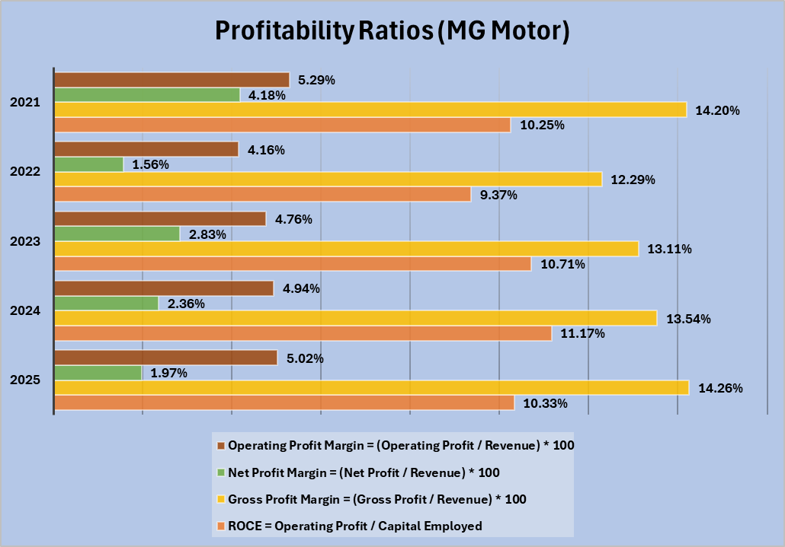
Figure 1: Profitability analysis
(Source: Excel)

Appendix 3: Liquidity ratio
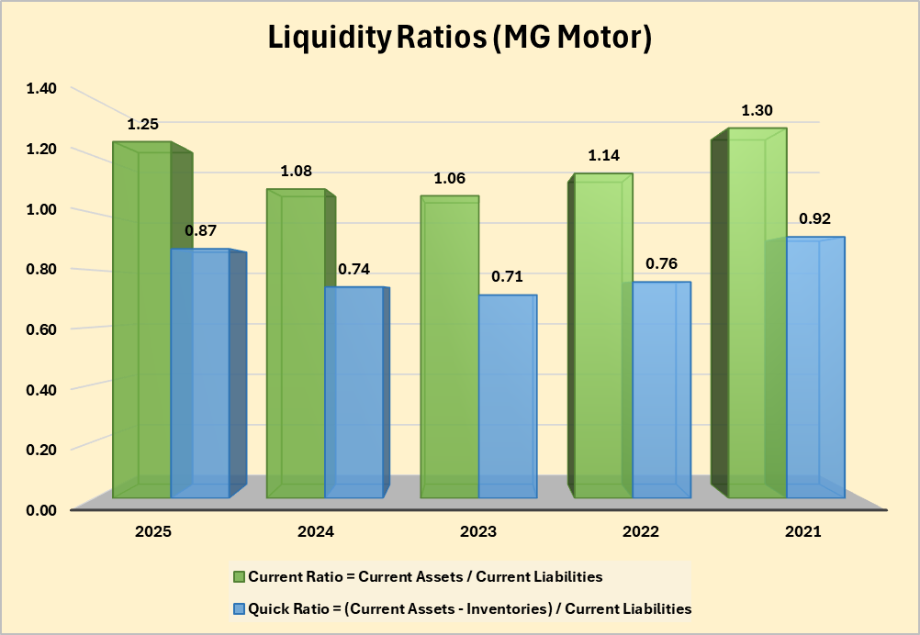
Figure 2: Liquidity analysis
(Source: Excel)

Appendix 4: Gearing ratio
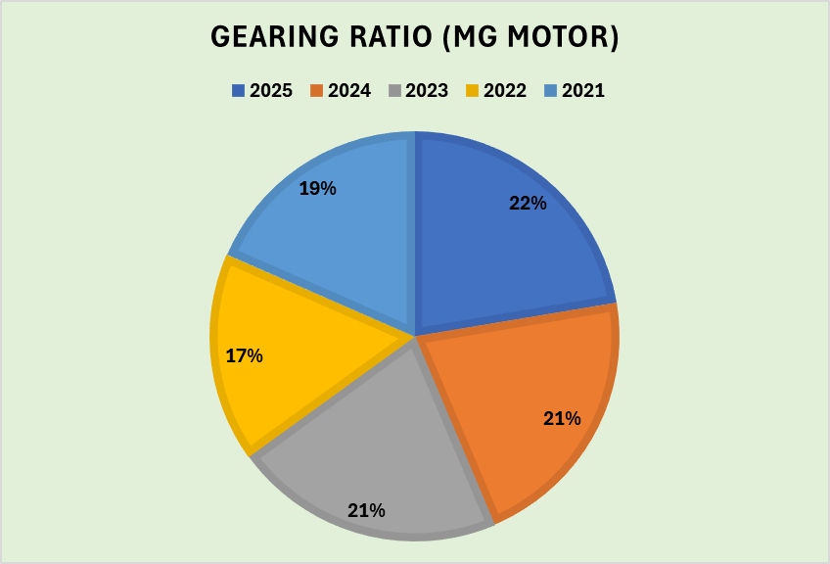
Figure 3: Gearing ratio
(Source: Excel)

Appendix 5: Earning per share
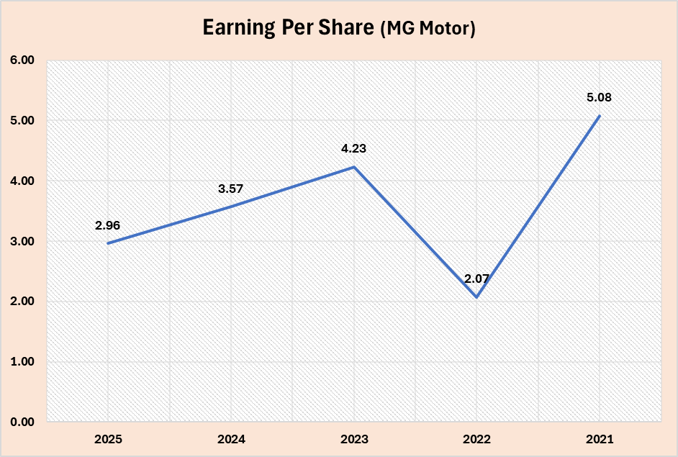
Figure 4: Earning per share
(Source: Excel)

Appendix 6: Efficiency Ratios
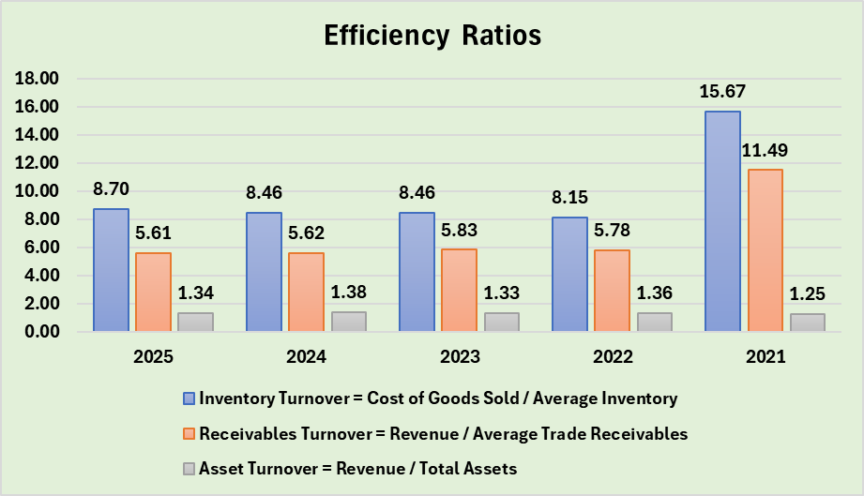
Figure 5: Efficiency ratio
(Source: Excel)

Appendix 7: Cash flow ratios
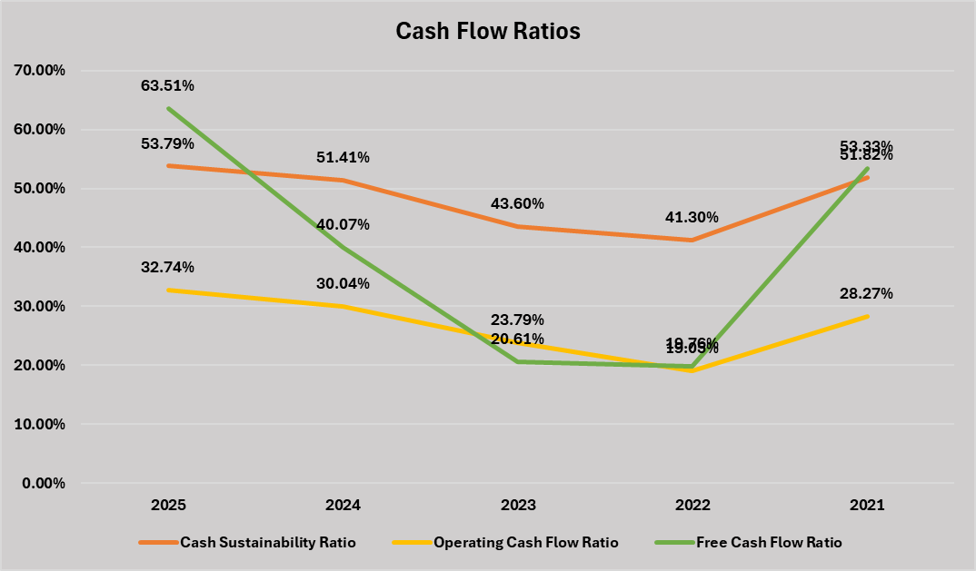
Figure 6: Cash Flow ratio
(Source: Excel)

Appendix 8: Investment Appraisal and Capital Budgeting
Project A
Year | Net cash flow | Discounting factor | DCF | Cumulative cash flow
0 | -50 | 1.000 | -50.00 | -50
1 | 10 | 0.909 | 9.09 | -40
2 | 12 | 0.826 | 9.92 | -28
3 | 14 | 0.751 | 10.52 | -14
4 | 10 | 0.683 | 6.83 | -4
5 | 8 | 0.621 | 4.97 | 4
Discounting Rate | 10%
PBP | 3.5
ARR | 21.60%
NPV | 91.32
PI | 1.826
IRR | 3%

Project B
Year | Net cash flow | Discounting factor | DCF | Cumulative cash flow
0 | -50 | 1.000 | -50.00 | -50
1 | 11 | 0.909 | 10.00 | -39
2 | 11 | 0.826 | 9.09 | -28
3 | 11 | 0.751 | 8.26 | -17
4 | 11 | 0.683 | 7.51 | -6
5 | 11 | 0.621 | 6.83 | 5
Discounting Rate | 10%
PBP | 3.45
ARR | 22.00%
NPV | 91.70
PI | 1.834
IRR | 3%

Project C
Year | Net cash flow | Discounting factor | DCF | Cumulative cash flow
0 | -50 | 1.000 | -50.00 | -50
1 | 5 | 0.909 | 4.55 | -45
2 | 10 | 0.826 | 8.26 | -35
3 | 20 | 0.751 | 15.03 | -15
4 | 25 | 0.683 | 17.08 | 10
5 | 5 | 0.621 | 3.10 | 15
Discounting Rate | 10%
PBP | 6
ARR | 26.00%
NPV | 98.02
PI | 1.960
IRR | 9%

