Rick Turner (2520197)
12/05/2026

Computer Architecture and Operating Systems – Operating Systems Assignment
ACCA4022

Contents
Introduction 3
1 – Key functions of general Operating Systems 3
2 – Use of Windows OS CLI commands 8
Process Management 8
File/Directory Management 9
Network testing 10
User management 11
3 – Use of Linux OS CLI Commands 12
Process management 12
File/Directory management 13
Network testing/monitoring 14
User management 14
4 – Use of Windows OS scripts 15
5 - Use of Linux OS Scripts 18
6 – Conclusion 21
7 - References 21
8 – Appendices 22
Tutorial Activity 22
CPD 23

Introduction
The following assignment has been created to display a variety of command functions in both the Windows and Linux Operating Systems (OS). The general functions of an OS will be outlined with further detail provided on use of Command Line Inputs and scripting in navigating and operating an OS.

1 – Key functions of general Operating Systems
An operating system (OS) is system software responsible for managing a computer’s hardware and coordinating the execution of applications by controlling resources such as memory, the CPU, input/output devices, and file storage. [1]
Examples of popular OS systems include MS Windows, Linux and Apple macOS.

Key functions of an operating system include the following:
- Process management
  - This is a core function for an OS. It allows for processes to be created, scheduled, handled and terminated to allow for efficient use of the Central Processing Unit (CPU).
  - In MS Windows OS this can be accessed through Task Manager as displayed below. CPU, Memory, Disk and Network data is also displayed via this feature.
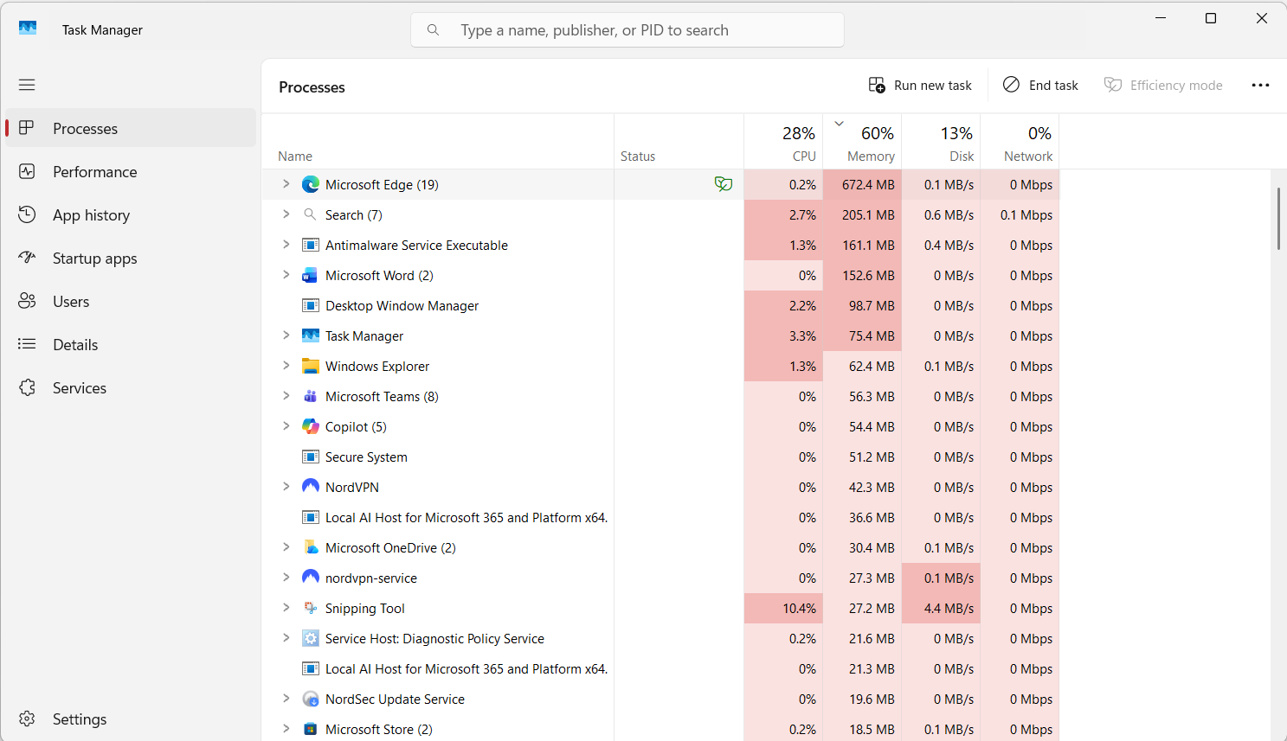
- Memory management
  - The OS manages memory to ensure that sufficient resources are allocated to programs to allow for them to run smoothly.
- File system management
  - This function allows users to create, organise, edit and delete files and folders. It is a key function to for strong system function and allows systems to run smoothly, keeping data secure an accessible. [2]
  - In Windows this can be accessed through File Explorer. See below screenshot. 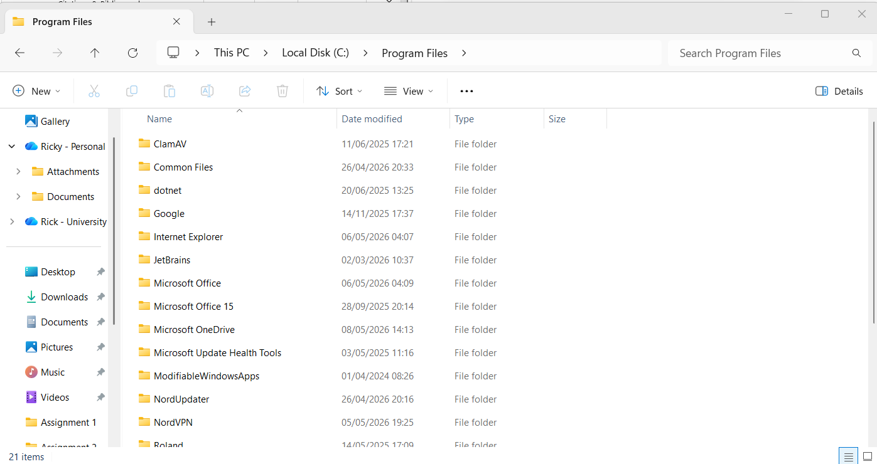
- Device management
  - Input/Output (I/O) devices, also known as peripherals such as keyboards, printers, monitors etc are hardware that can be managed through an OS. It provides an interface for hardware to interact with software (device drivers) allowing users to access I/O devices [3]
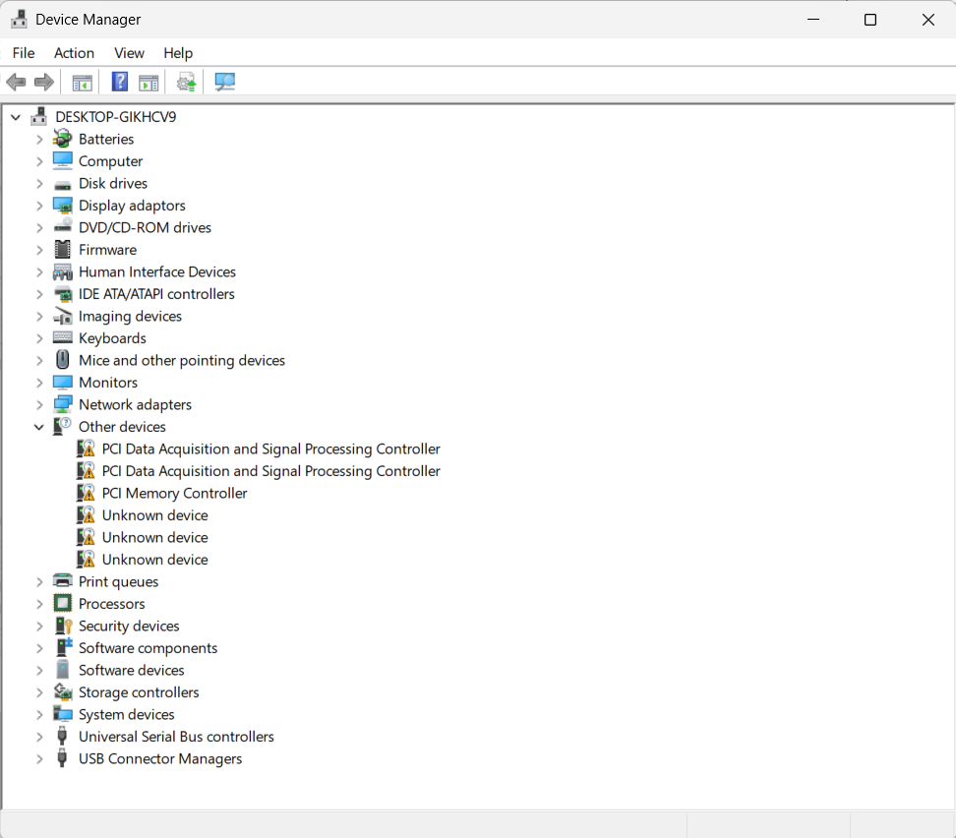
  - Windows allows users to manage devices through the Device Manager as seen below.
- Protection and Security
  - This function allows the management of user accounts, ensuring security protocols are in place to validate only authorised users with relevant permissions can access files, directories and other resources.
  - As an example, the below displays how users can be managed through Computer Management feature in MS Windows.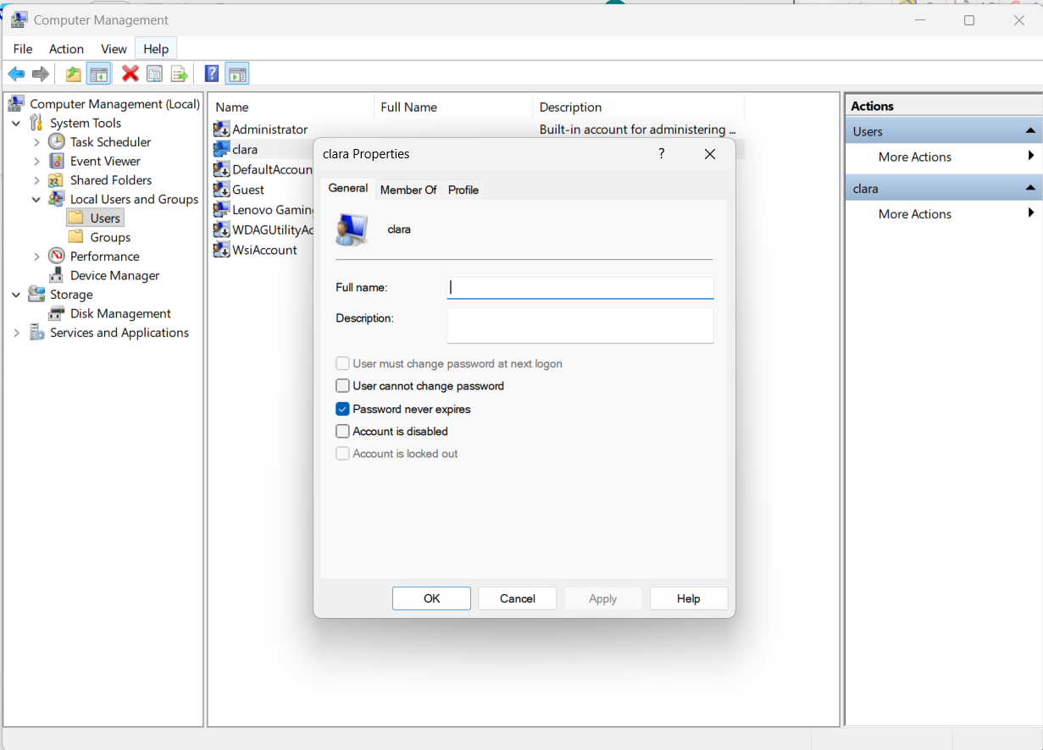
- Performance management
  - Similar to memory and process management, performance management allows users to monitor the overall performance of the computer, identifying areas that are resource intensive and potential bottlenecks that may impede performance. [4]
  - By selecting the Performance tab on task manager in Windows, enhanced detail around performance are available as displayed below.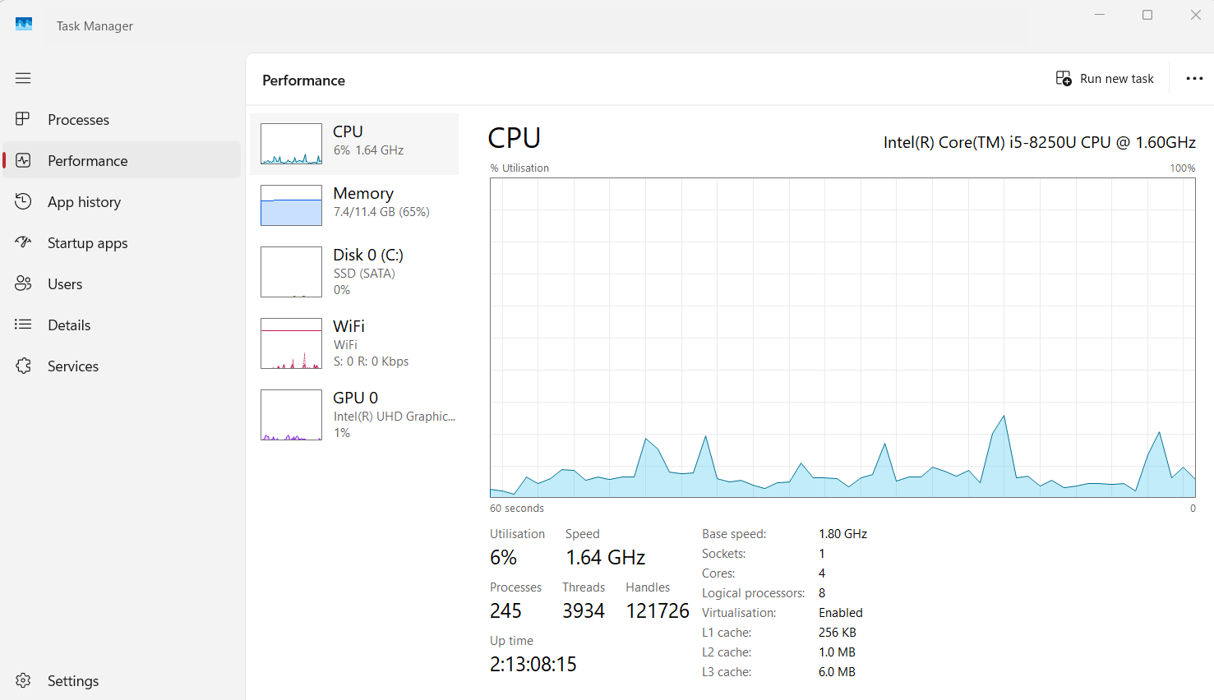

2 – Use of Windows OS CLI commands

Process Management
The below prompt displays a list of all current running processes. A switch and option has been used to define parameters of running tasks only.
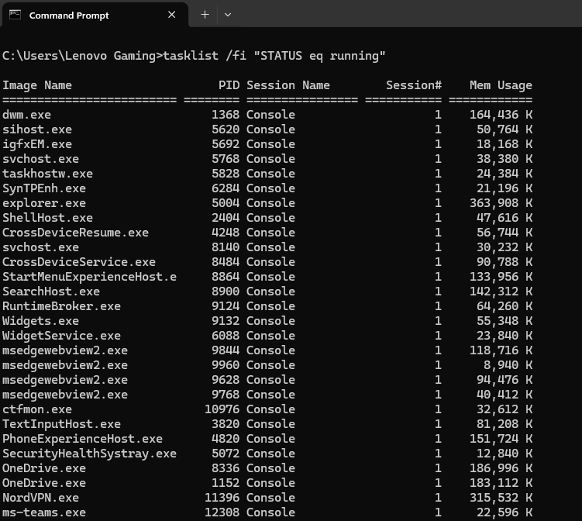

File/Directory Management
The mkdir command has been used to create a new directory, this is displayed below with the output also captured in the screengrab.
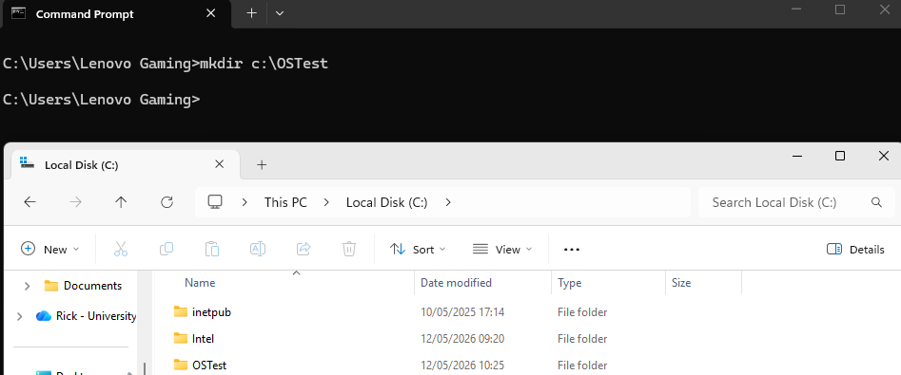
The use of /a switch in the below prompt displays all files in the directory.
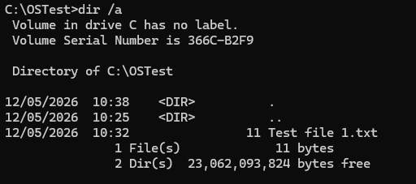

Network testing
The ping command allows users to test for latency and server availability.
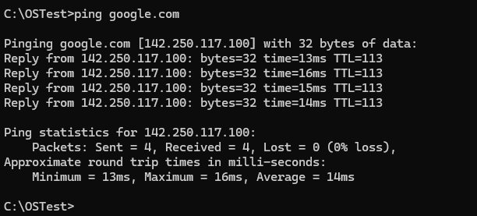
The ipconfig command displays IP information for the device. The use of a switch “/all” has been used to provide a detailed output in the CLI.
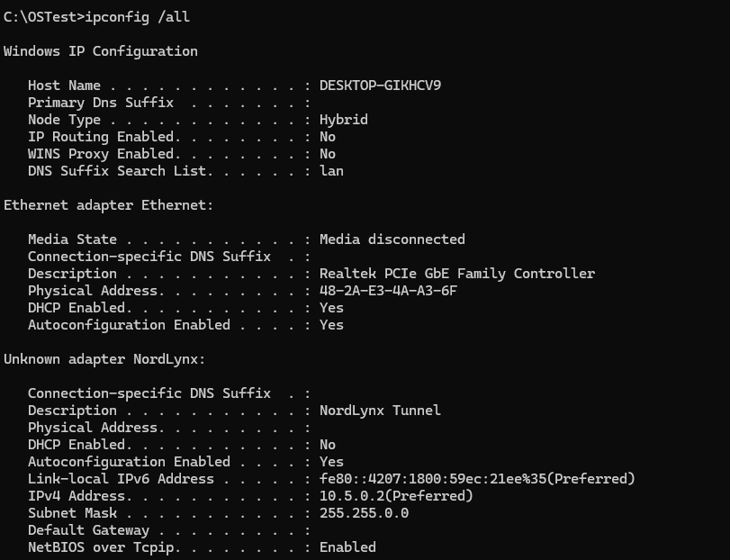

User management
The net user prompt displays the users in the computer along with their current
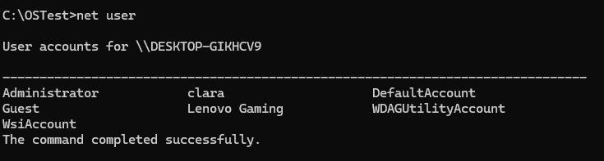
By adding the specific user account name into the net user prompt, we are able to display detailed information about the account as displayed below.
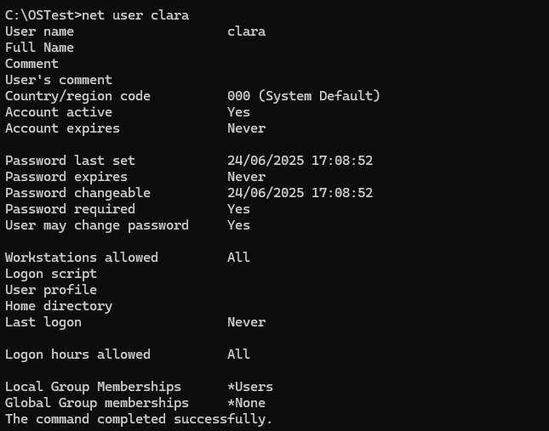

3 – Use of Linux OS CLI Commands

Process management
The “ps aux” command displays a verbose list of processes as displayed below.
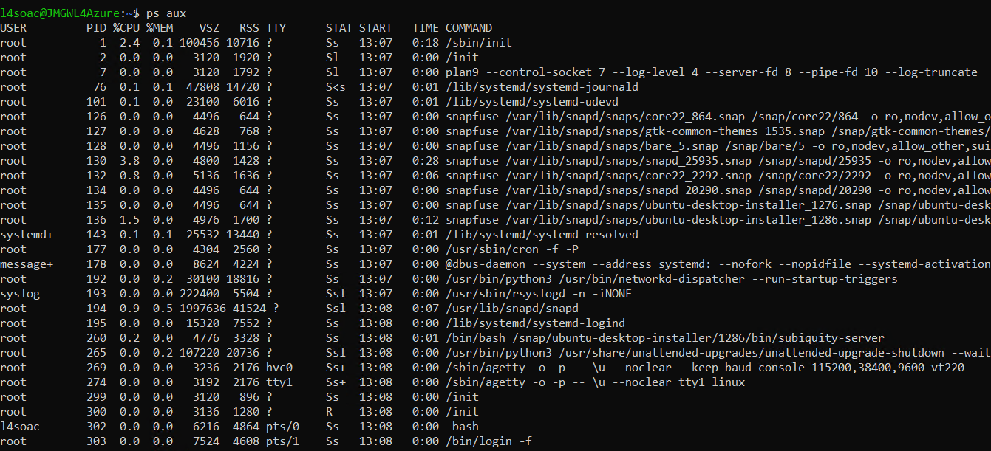
The “htop” command is a newer version of the “top” command and provides an interactive, real time process monitor.
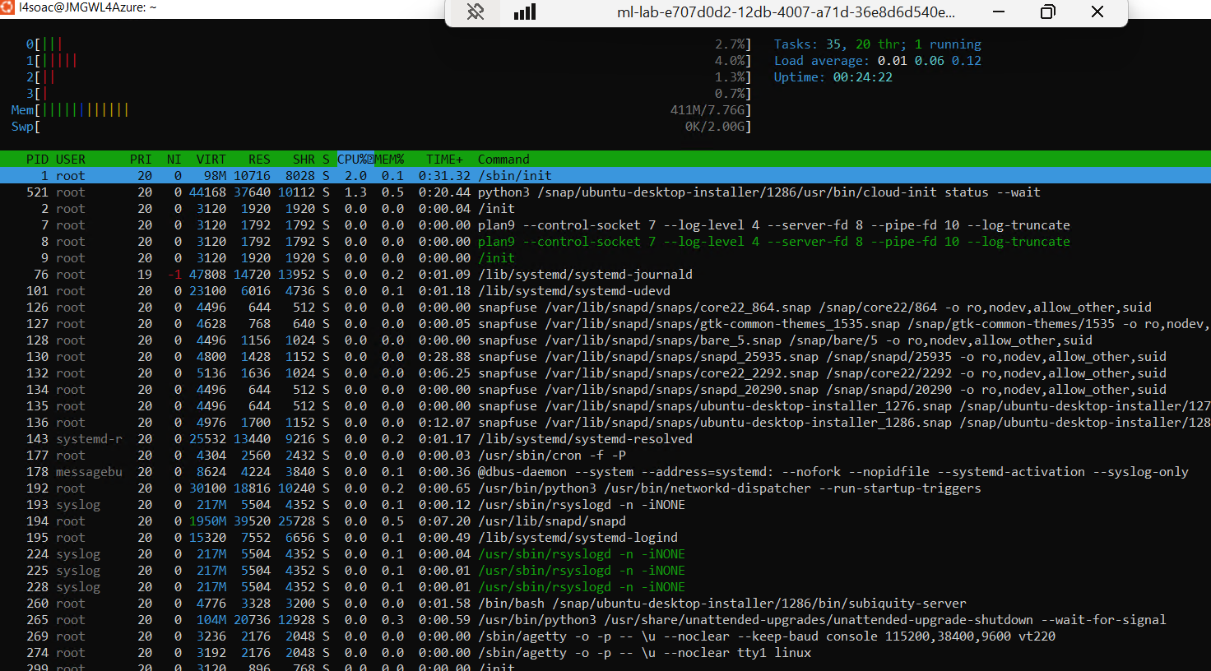

File/Directory management
The “ls” command displays all files in the directory.
By adding the “-l” switch it will display a longer list which includes permissions, the owner and the size of the files/directory.
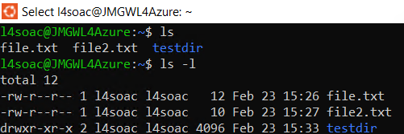
Files can be deleted using the “rm” command.
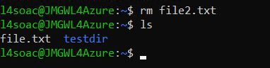

Network testing/monitoring
Using the “ping” command is useful in identifying if a domain is available. By adding the “-c” switch the number of packets sent can be controlled which stops the ping running continuously.
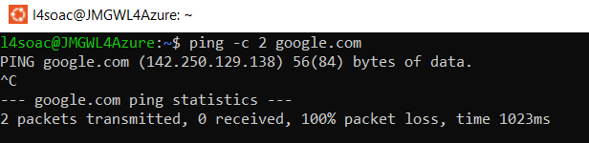

User management
Using the “adduser” command allows new users to be added to the system via the CLI.
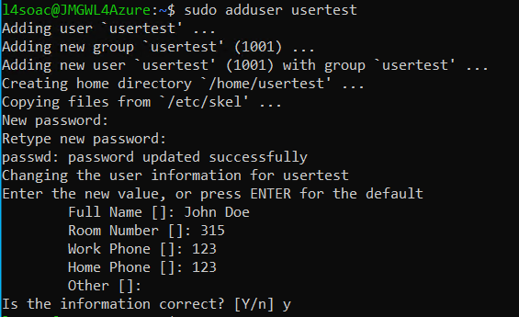
Once a new user is created it useful to be able to place users into specific groups which will assist with controlling permissions of users in specific groups.
Firstly, groups can be created using the “groupadd” command. Once this group has been completed users can be placed in groups using the “usermod” command. Below is an example of this with the addition of of the “-ag” switch which appends the user to the group.
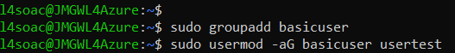

4 – Use of Windows OS scripts
One method of creating scripts for Windows OS is to use a Batch file. A Batch script has commands which are run sequentially when the file is run. They are useful for running repetitive tasks without the need for human intervention and can therefore be time efficient and less prone to human error. [5]
Powershell is considered as the next generation of CLI and can be used cross-platform on Linux and Mac OS.
The following is a simple script that requires the user to select an item from a menu and produces a relevant output using Windows CLI.
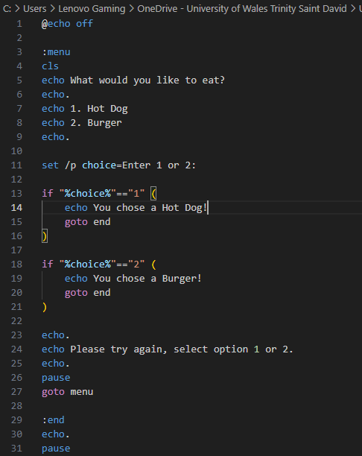
The following screengrabs display the output when the script is run through the command prompt.
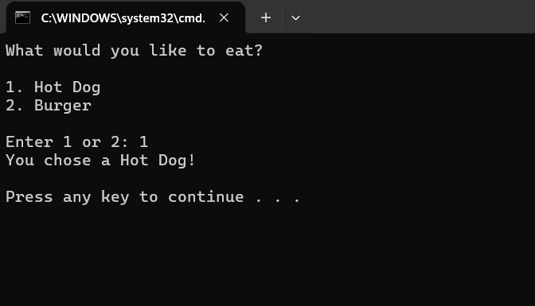

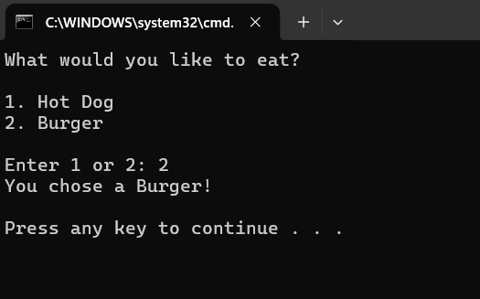
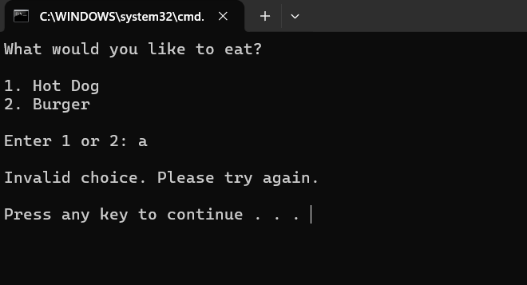

This code uses several syntax’s which are described below:
- @echo off – Stops the command prompt from displaying each command making the program look cleaner.
- “:” – This is label which is used to define a location in the script. In this code 2 are used which are :menu and :end
- Cls – This syntax clears the screen
- Echo – prints out text for the program
- Set /p choice – prompts the user for an input into a variable. The variable in this instance is called “choice”.
- If – The if statement checks if the variable choice, which is enclosed in %
- == - This checks if the variable is equal to the integer
- Goto – this command instructs the program to return to the label in the instruction
- Pause – this pauses the program and until the program presses a key

5 - Use of Linux OS Scripts
To create a script which is functional in the Linux OS bash scripts can be used.
Bash scripts contain arguments and commands and can return outputs for the user. They can include loops, conditions and arithmetic. [6]
The following is a simple BASH script that requires the user to select an item from a menu as per the previous example used for the Windows CLI. It has been adapted to function within Ubuntu.

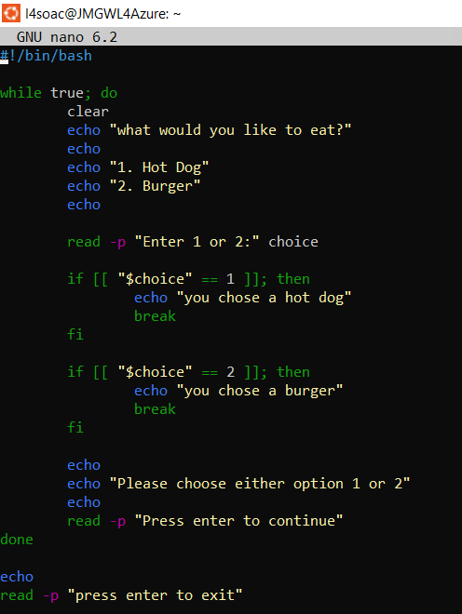
The following screengrabs display the output when the script is run through Ubuntu.
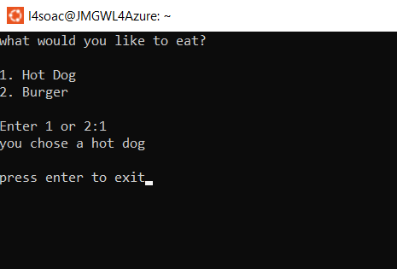
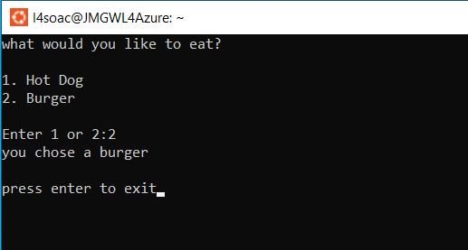
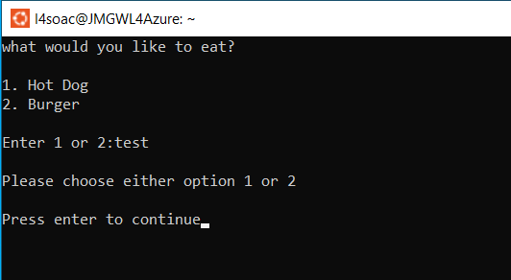
- #!/bin/bash – The first line of the script is known as the “shebang”. This line informs Linux to use the Bash shell.
- While true – this command instructs the program to continue to run a loop until a “break” is identified.
- Clear – this command clears the screen to provide a cleaner look.
- Echo – prints the text as required
- Read – this syntax requires a user input and the addition of “-p” prints a prompt for the user. This is then entered into the variable which is called “choice” in this example.
- If – this command checks the variable against the defined parameters. In this example “==” is used to denote equal to.
- Break – this command allows the program to exit the while loop
- Done – this command ends the while true loop.

6 – Conclusion
There advantages and disadvantages in using either the Linux or Windows OS. One of the greatest advantages Linux has over Windows is that it is free to use, i.e. does not require a licence and that is an open-source OS. For this reason it is more customisable and is the preferred OS for servers and cloud computing. [7]
Linux is not necessarily as user-friendly as the Windows OS. For the non-technical user, the Windows OS has an attractive User Interface and when coupled with the widely used MS Office suite of programs this is arguably why it has been largely adopted worldwide by organisations.
In this report both Bash and Batch scripting has been used for their respective platforms. While Powershell hasn’t been used to provide examples, this tool is effective and creating and running scripts as it’s cross-platform ability makes it attractive to users of various OS.

7 - References

[1] | “IBM - Operating Systems,” IBM, [Online]. Available: https://www.ibm.com/think/topics/operating-systems. [Accessed 08 05 2026].
[2] | J. Sheehan, “Operating systems key functions,” SynchroNet, 13 02 2025. [Online]. Available: https://synchronet.net/operating-system-key-function/. [Accessed 12 05 2026].
[3] | “bbc bitesize,” bbc, [Online]. Available: https://www.bbc.co.uk/bitesize/guides/zkkkw6f/revision/6. [Accessed 12 05 2026].
[4] | “geeksforgeeks,” 16 10 2025. [Online]. Available: https://www.geeksforgeeks.org/operating-systems/functions-of-operating-system/. [Accessed 08 05 2025].
[5] | Lenovo, [Online]. Available: https://www.lenovo.com/gb/en/glossary/batch-file/?orgRef=https%253A%252F%252Fwww.google.com%252F. [Accessed 12 05 2026].
[6] | University of Warwick, 03 02 2026. [Online]. Available: https://warwick.ac.uk/research/rtp/sc/rse/training/linuxdesktop/scripting/. [Accessed 12 05 2026].
[7] | “geeksforgeeks,” 24 02 2026. [Online]. Available: https://www.geeksforgeeks.org/linux-unix/difference-between-linux-and-windows/. [Accessed 12 05 2026].

8 – Appendices

Tutorial Activity
General Purpose OS
General purpose OS (GPOS) can carry out a wide variety of tasks and applications. Examples would include MS Windows, Linux, and Apple macOS
Mobile OS
This is specialised software specifically designed for devices such as smart phones, smart watches and tablets. Generally, they are optimised for touch input from users and provide a framework for apps to be run. Common examples include Android, iOS and HarmonyOS.
Network OS
A specialised software that connects multiple devices onto a network work to share resources, control communication, allow user management and security. Examples include Windows Servery, UNIX and Linux.
Real-time OS
A real-time OS provides the function of carrying out tasks and applications that require precise timing and speed. They focus on a priority-based schedule which is useful for some industries that require speed and predictability. Examples are FreeRTOS, Zephyr and SAFERTOS.
Embedded OS
An embedded OS is a small-scale computer with limited features, typically used to carry out a limited number of functions.

CPD


