I confirm that I have not used any AI tools in the research and creation of this assignment. I confirm that I have not presented any AI generated materials as my own work. I confirm I have copies of my drafts, notes and other resources I used, which I may be asked to provide in evidence.

This qualitative study explored undergraduate students’ beliefs and opinions regarding the cognitive, emotional and social effects of social exclusion on older adults with Autism Spectrum Disorder (ASD), and how such effects might be improved. Semi-structured interviews were conducted using a case study stimulus and thematic analysis was applied to two transcripts. Findings indicated that participants perceived older autistic adults as particularly vulnerable due to generational differences in awareness, late diagnosis, and societal misunderstanding. Social exclusion was conceptualised as both externally imposed and internally reinforced, contributing to emotional distress, withdrawal, and potential cognitive difficulties. Participants also described a cyclical relationship between exclusion and reduced social engagement. Suggested strategies for improvement centred on education, increased awareness, and societal acceptance. These findings are discussed in relation to existing literature, including the double empathy problem, highlighting the importance of shifting from deficit-based to relational understandings of autism in later life.
Introduction
Autism Spectrum Disorder (ASD) is a neurodevelopmental condition marked by limited or repetitive behavioural patterns, as well as enduring abnormalities in social communication and interaction (American Psychiatric Association, 2013). Importantly, contemporary perspectives increasingly conceptualise autism through a neurodiversity framework, recognising it as a natural variation rather than a disorder to be “fixed” (Pellicano & den Houting, 2022).
Social exclusion refers to the processes by which individuals are marginalised from full participation in social, economic, and cultural life (Cacioppo & Hawkley, 2009). It is closely related to social isolation, defined as an objective lack of social contact or isolation (Cornwell & Waite, 2009), though exclusion emphasises structural and societal influences rather than purely individual circumstances.
Individuals with ASD are particularly vulnerable to social exclusion due to differences in communication, social interaction, and sensory processing (Muller et al., 2008). These differences may lead to difficulties navigating social norms, increasing the likelihood of misunderstanding and marginalisation. Mazurek (2014) found that autistic individuals report significantly higher levels of loneliness compared to neurotypical individuals, highlighting the social challenges associated with the condition.
Milton (2012) introduced the “double empathy problem”, which challenges deficit-based interpretations by suggesting that social difficulties arise from a reciprocal lack of understanding between autistic and non-autistic individuals. This perspective reframes social exclusion as a rational issue rather than an individual deficit.
Older adults with ASD may be particularly vulnerable to exclusion due to historical and societal factors. Autism was not widely recognised in previous decades, meaning many individuals were undiagnosed or misdiagnosed (Brugha et al., 2011). As a result, older autistic adults may have experienced lifelong misunderstanding without access to appropriate support.
Social exclusion has significant cognitive, emotional and social consequences. Baumeister et al. (2002) demonstrated that exclusion impairs cognitive functioning, including memory and decision-making. For autistic individuals, these effects may interact with existing cognitive differences, potentially intensifying difficulties. Emotionally, exclusion is strongly associated with anxiety, depression and reduced well-being (Cacioppo & Hawkley, 2009). High rates of mental health difficulties among autistic adults, often linked to social experiences. Socially, exclusion can lead to withdrawal and reduced engagement, reinforcing a cycle of isolation. This cyclical pattern is particularly relevant for autistic individuals, who may avoid social interaction following negative experiences.
Research suggests that education and awareness can improve attitudes towards autism (Gillespie-Lynch et al., 2015). Support networks, both formal and informal are also critical in reducing isolation (Howlin & Moss, 2012). Importantly, adopting a neurodiversity perspective may promote acceptance and inclusion (Pellicano & den Houting, 2022).
Despite increasing research on ASD, older adults remain underrepresented, particularly in relation to social exclusion. Furthermore, limited research has explored how individuals perceive these issues. Understanding such perceptions is important, as societal beliefs influence behaviour and inclusion. Qualitative approaches allow for in-depth exploration of these beliefs, addressing limitations of quantitative research which may overlook subjective experiences (Braun & Clarke, 2006).
Method
Participants
Participants were undergraduate students recruited through opportunity sampling. Each group member interviewed one participant from another group, the present study analyses two transcripts. Participants were aged 50 years and only included female individuals.
Design
A qualitative design using semi-structured interviews was employed. A case study scenario (Alan, an older autistic adult experiencing social exclusion) was used as stimulus material to prompt discussion and ensure consistency across interviews. The data was analysed using thematic analysis (Braun & Clarke, 2006), enabling identification of patterns in participants’ beliefs.
Data Collection
Ethical approval was obtained from the Research Ethics Committee prior to data collection. Participants were recruited and provided with an information sheet outlining the study. Informed consent was obtained before participation. Interviews were conducted individually, face to face and lasted approximately 15 minutes. At the beginning of each interview, participants were presented with a recap of the case study of Alan, an older autistic adult experiencing social exclusion. This stimulus was used to initiate discussion, after which broader questions were asked about older autistic individuals more generally. Interviews were audio-recorded and transcribed. Transcripts were anonymised and uploaded to Microsoft Teams, where they were shared among group members. Each researcher analysed their own transcript and one additional transcript. See appendix for interview questions.
Data Analysis
Thematic analysis followed Braun and Clarke’s (2006) six-phase approach. Themes were actively interpreted by the researcher, reflecting an interpretivist approach.
Results
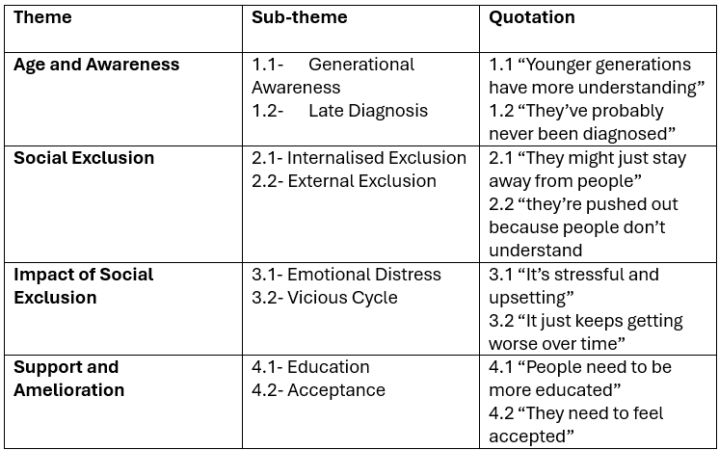
Theme 1: Age and Awareness
This theme reflects how participants understood the role of generational differences in shaping the experiences of older autistic adults. It incorporates sub-themes relating to awareness and diagnosis, both of which were interpreted as contributing to increased vulnerability to social exclusion in later life.
Sub-theme 1.1: Generational Awareness
Participants suggested that awareness of autism has improved significantly over time, resulting in younger generations having greater understanding. One participant stated that “younger generations have more understanding” indicating a perception that knowledge about autism is socially and historically situated.
Both participants expressed similar views, suggesting consistency across the dataset. However, this perception also implicitly positioned older adults as disadvantaged, as they were believed to have grown up in contexts where autism was less recognised or understood. This interpretation suggests that participants view social exclusion in older autistic adults as partly rooted in historical inequalities in awareness, rather than solely individual characteristics.
Sub-theme 1.2: Late Diagnosis
Participants highlighted the likelihood that older autistic adults may not have received a formal diagnosis. One participant commented that “they’ve probably never been diagnosed,” reflecting an understanding of past limitations in diagnostic practices.
While both participants acknowledged this issue, one emphasised it more strongly, suggesting variability in how central this factor was perceived to be. The absence of diagnosis was interpreted as contributing to misunderstanding, lack of support and difficulty in self-identification. This suggests that participants recognise diagnosis not only as a clinical label but as a mechanism for accessing support and validation.
Theme 2: Social Exclusion
This theme captures how participants conceptualised the processes through which older autistic adults may become socially excluded. It includes both internal and external dimensions, reflecting a more complex understanding of exclusion as a dynamic interaction.
Sub-theme 2.1: Internalised Exclusion
Participants described how individuals may withdraw from social interaction as a response to negative experiences. One participant stated that “they might just stay away from people,” suggesting that avoidance may function as a coping mechanism. Both participants referred to withdrawal, although one framed it more as a conscious choice, while other implied it was a reaction to repeated negative experiences. This indicates slightly different interpretations. The data suggest that participants view internalised exclusion as a protective strategy, but one that reinforces isolation.
Internalised exclusion was interpreted as a self-protective withdrawal from social interaction that may reinforce isolation.
Sub-theme 2.2: External Exclusion
Participants also emphasised the role of societal misunderstanding in excluding autistic individuals. One participant noted that “they’re pushed out because people don’t understand,” highlighting the role of others in creating exclusion. Both participants strongly aligned on this point, suggesting a shared belief that exclusion is not solely the responsibility of the individual. Instead, it is shaped by broader social attitudes and lack of awareness. This reflects an understanding of exclusion as socially constructed, aligning with relational perspectives.
External exclusion was attributed to societal misunderstanding and lack of awareness, positioning exclusion as socially driven.
Theme 3: Impact of Social Exclusion
This theme reflects participants’ beliefs about the consequences of social exclusion, particularly in relation to emotional wellbeing and the development of cyclical patterns of isolation.
Sub-theme 3.1: Emotional Distress
Participants consistently described social exclusion as emotionally harmful. One participant stated that it is “stressful and upsetting,” indicating recognition of its psychological impact. Both participants emphasised emotional consequences, with one also referring to anxiety and loneliness. This suggests a shared understanding that exclusion has significant effects on mental health. The data indicates that participants perceive emotional distress as a central outcome of social exclusion for older autistic adults.
Social exclusion was interpreted as having significant negative effects on emotional wellbeing, including stress and loneliness.
Sub-theme 3.2: Vicious Cycle
Participants described social exclusion as a cyclical process, where initial exclusion leads to further withdrawal and worsening outcomes. one participant stated that "it just keeps getting worse over time.” Both participants referred to this cyclical nature, although one described it more explicitly. This suggests that participants recognise the reinforcing nature of exclusion. This interpretation highlights how social exclusion may become self-perpetuating, particularly when combined with reduced social opportunities in older adulthood.
Social exclusion was perceived as a self-reinforcing cycle that exacerbates isolation and negative outcomes over time.
Theme 4: Support and Amelioration
This theme captured participants’ beliefs about how the negative effects of social exclusion might be reduced. It includes both societal and interpersonal strategies.
Sub-theme 4.1: Education and Awareness
Participants emphasised the importance of increasing public understanding of autism. One participant stated that “people need to be more educated,” suggesting that lack of knowledge is a key barrier to inclusion. Both participants strongly supported this view, indicating understanding that education is central to reducing exclusion. This reflects a belief that change must occur at a societal level rather than solely at the level of the individual.
Education and awareness were identified as key strategies for reducing social exclusion by addressing misunderstanding.
Sub-theme 4.2: Acceptance
Participants also highlighted the importance of social acceptance. One participant stated the “they need to feel accepted,” emphasising the emotional dimension of inclusion. While both participants mentioned acceptance, one focused more on practical support, indicating slight variation in emphasis. This suggests that participants recognise inclusion as both a structural and emotional process.
Acceptance was interpreted as essential for improving social inclusion and emotional wellbeing.
Overall, the analysis indicates that participants perceive older autistic adults as particularly vulnerable to social seclusion due to generational differences in awareness and diagnosis. Social exclusion was understood as both internally and externally driven, with significant emotional consequences and a tendency to form self-reinforcing cycles. Participants emphasised education and acceptance as key strategies for ameliorating these effects, highlighting the importance of societal change.
Discussion
The findings support existing literature highlighting the vulnerability of older adults with ASD to social exclusion. Participants emphasis on late diagnosis aligns with Brugha et al. (2011), reinforcing the idea that older individuals have been historically overlooked. The conceptualisation of exclusion as both internal and external supports Milton’s (2012) double empathy problem, suggesting that participants recognise the relational nature of social difficulties. This represents a shift away from purely deficit-based models of autism. The identification of emotional distress is consistent with Cacioppo and Hawkley (2009), while the notion of a cyclical process reflects broader theories of social withdrawal and isolation. However, participants’ reliance on generalisations indicates limited depth of understanding, supporting Gillespie-Lynch et al., 2015, who found that awareness does not necessarily equate to accurate knowledge.
In addition to these points, the present findings contribute to a growing body of research advocating for a broader, lifespan-oriented understanding of autism. Much of the existing literature has historically focused on children and adolescents, often neglecting the experiences of individuals in later adulthood. The participants’ emphasis on generational differences highlights this gap, suggesting that older autistic adults may not have benefitted equally from advances in research, diagnosis and support. This reflects wider literature identifying older autistic adults as underrepresented within autism research (Howlin & Moss, 2012).
Quantitative research has been valuable in identifying patterns of loneliness and exclusion but may overlook subjective experiences. In contrast, qualitative approaches allow for exploration of beliefs and meanings. However, qualitative research is interpretive and may be influenced by researcher bias, limiting objectivity and generalisability.
The notion of internalised exclusion identified in the present study also warrants further consideration. Participants described withdrawal as a coping mechanism in response to repeated negative social experiences. This aligns with research indicating that autistic individuals may disengage from social interaction following misunderstanding or social difficulty (Cacioppo & Hawkley, 2009; Mazurek, 2014). While such strategies may provide short-term emotional relief, they may contribute to longer-term isolation and reduced opportunities for meaningful engagement. In the context of older adulthood, this may be particularly significant given potential reductions in social networks.
Furthermore, the identification of a cyclical relationship between exclusion and withdrawal reflects a dynamic understanding of social processes. Rather than viewing exclusion as a singular event, participants recognised it as an ongoing pattern that may intensify over time. This is consistent with broader models of loneliness, which conceptualise social isolation as a self-reinforcing cycle (Cacioppo & Hawkley, 2009; Qualter et al., 2015). However, it is important to note that such interpretations may reflect generalised assumptions about autistic individuals, rather than fully capturing the diversity of lived experiences.
Participants’ emphasis on education and awareness as key strategies for improvement is consistent with existing literature, yet it also raises questions regarding the effectiveness of such approaches. While increasing awareness may reduce stigma, it does not necessarily lead to meaningful behavioural change or improved social interactions. Research suggests that awareness alone may not translate into deeper understanding of autistic perspectives (Gillespie-Lynch et al., 2015). This indicates that future initiatives should move beyond basic awareness towards more nuanced and experimental forms of education.
The importance of acceptance, as highlighted by participants, reflects a shift towards relational and neurodiversity-informed perspectives. Acceptance involves recognising and valuing neurological differences, rather than attempting to normalise them. This aligns with research emphasising the importance of societal adaption in promoting inclusion (Kapp et al., 2013; Pellicano & den Houting., 2022). For older autistic adults, this may be particularly important in validating experiences that have historically been misunderstood or overlooked.
A strength of this study is the use of semi-structured interviews, allowing for rich and detailed data. The use of a stimulus case enhanced ecological validity. Limitations include a small sample size and reliance on student participants, limiting generalisability. Additionally, participants’ lack of lived experience with ASD may have influenced their responses.
Future research should include older autistic individuals to capture lived experiences. Longitudinal studies could explore how social exclusion develops over time and evaluates interventions.
Conclusion
This study highlights the perceived impact of social exclusion on older adults with ASD, emphasising emotional distress and cyclical patterns of isolation. Participants identified education and acceptance as key strategies for amelioration. These findings underscore the importance of addressing societal attitudes to promote inclusion and improve outcomes for older autistic individuals.

References
Baumeister, R. F., Twenge, J. M., & Nuss, C. K. (2002). Effects of social exclusion on cognitive processes: Anticipated aloneness reduces intelligent thought. Journal of Personality and Social Psychology, 83(4), 817–827. https://doi.org/10.1037/0022-3514.83.4.817
Braun, V., & Clarke, V. (2006). Using Thematic Analysis in Psychology. Qualitative Research in Psychology, 3(2), 77–101. https://doi.org/10.1191/1478088706qp063oa
Brugha, T. S., McManus, S., Bankart, J., Scott, F., Purdon, S., Smith, J., Bebbington, P., Jenkins, R., & Meltzer, H. (2011). Epidemiology of autism spectrum disorders in adults in the community in England. Archives of General Psychiatry, 68(5), 459–465. https://doi.org/10.1001/archgenpsychiatry.2011.38
Cacioppo, J. T., & Hawkley, L. C. (2009). Perceived social isolation and cognition. Trends in Cognitive Sciences, 13(10), 447–454. https://doi.org/10.1016/j.tics.2009.06.005
Cornwell, E. Y., & Waite, L. J. (2009). Social Disconnectedness, Perceived Isolation, and Health among Older Adults. Journal of Health and Social Behavior, 50(1), 31–48. https://doi.org/10.1177/002214650905000103
Gillespie-Lynch, K., Brooks, P. J., Someki, F., Obeid, R., Shane-Simpson, C., Kapp, S. K., Daou, N., & Smith, D. S. (2015). Changing College Students’ Conceptions of Autism: An Online Training to Increase Knowledge and Decrease Stigma. Journal of Autism and Developmental Disorders, 45(8), 2553–2566. https://doi.org/10.1007/s10803-015-2422-9
Gillespie-Lynch, K., Kapp, S. K., Brooks, P. J., Pickens, J., & Schwartzman, B. (2017). Whose Expertise Is It? Evidence for Autistic Adults as Critical Autism Experts. Frontiers in Psychology, 8(438). https://doi.org/10.3389/fpsyg.2017.00438
Happé, F., & Charlton, R. A. (2012). Aging in Autism Spectrum Disorders: A Mini-Review. Gerontology, 58(1), 70–78. https://doi.org/10.1159/000329720
Howlin, P., & Moss, P. (2012). Adults with Autism Spectrum Disorders. The Canadian Journal of Psychiatry, 57(5), 275–283. https://doi.org/10.1177/070674371205700502
Hull, L., Petrides, K. V., Allison, C., Smith, P., Baron-Cohen, S., Lai, M.-C., & Mandy, W. (2017). “Putting on My Best Normal”: Social Camouflaging in Adults with Autism Spectrum Conditions. Journal of Autism and Developmental Disorders, 47(8), 2519–2534. https://doi.org/10.1007/s10803-017-3166-5
Kapp, S. K., Gillespie-Lynch, K., Sherman, L. E., & Hutman, T. (2013). Deficit, difference, or both? Autism and neurodiversity. Developmental Psychology, 49(1), 59–71. https://doi.org/10.1037/a0028353
Milton, D. (2012). On the ontological status of autism: the “double empathy problem.” Disability & Society, 27(6), 883–887. https://doi.org/10.1080/09687599.2012.710008
Mazurek, M. O. (2014). Loneliness, friendship, and well-being in adults with autism spectrum disorders. Autism, 18(3), 223–232. https://doi.org/10.1177/1362361312474121
Müller, E., Schuler, A., & Yates, G. B. (2008). Social challenges and supports from the perspective of individuals with Asperger syndrome and other autism spectrum disabilities. Autism, 12(2), 173–190. https://doi.org/10.1177/1362361307086664
Pellicano, E., & den Houting, J. (2022). Annual Research Review: Shifting from “normal science” to neurodiversity in autism science. Journal of Child Psychology and Psychiatry, 63(4), 381–396. https://doi.org/10.1111/jcpp.13534
Qualter, P., Vanhalst, J., Harris, R., Van Roekel, E., Lodder, G., Bangee, M., Maes, M., & Verhagen, M. (2015). Loneliness across the life span. Perspectives on Psychological Science, 10(2), 250–264. https://doi.org/10.1177/1745691615568999

Appendix
Alan Scenario
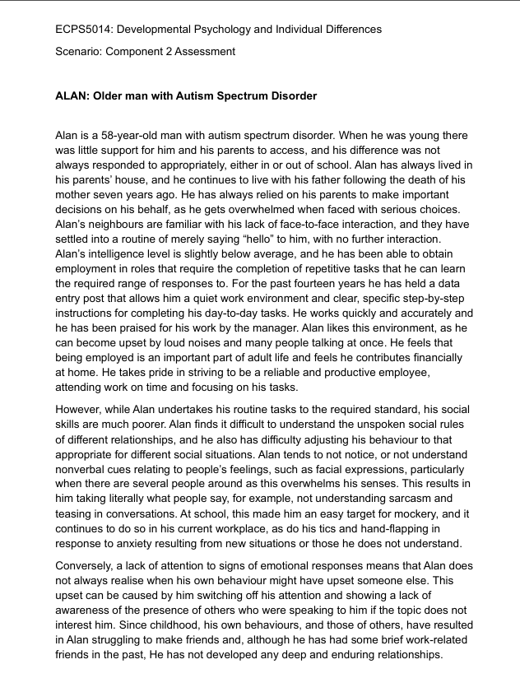
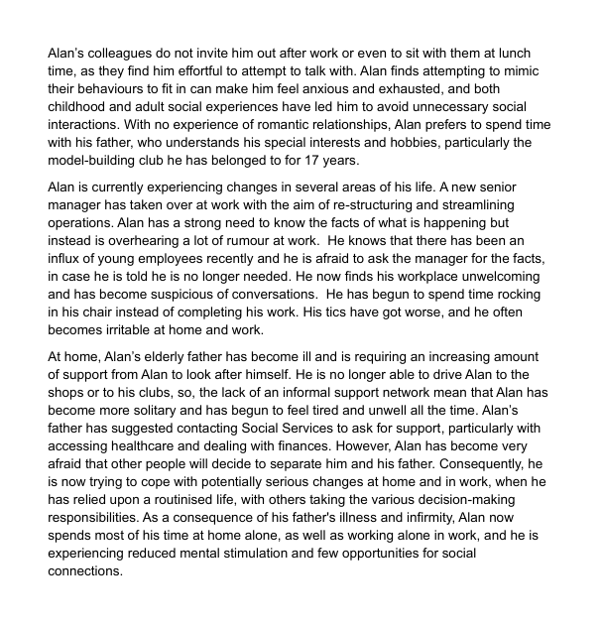

Information Sheet
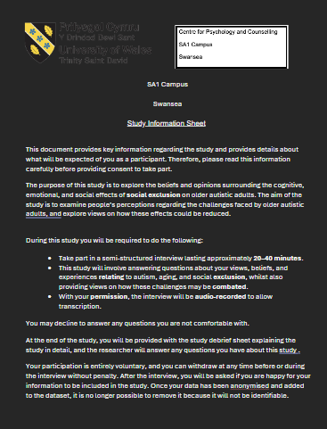
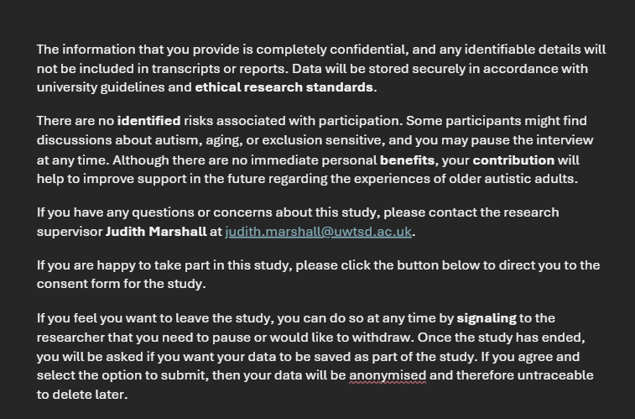

Consent Form
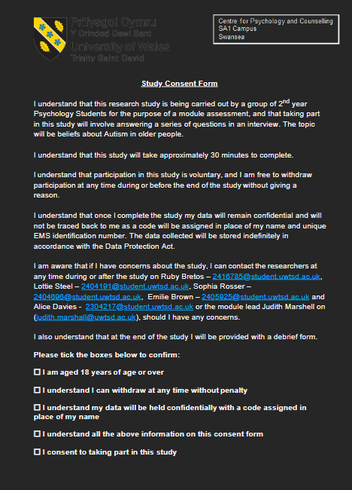
Interview Questions
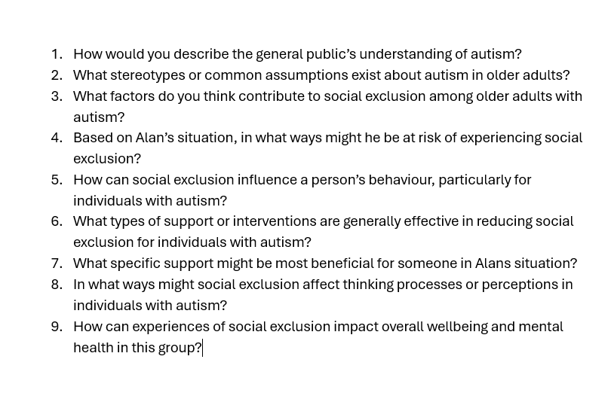

Debrief Sheet
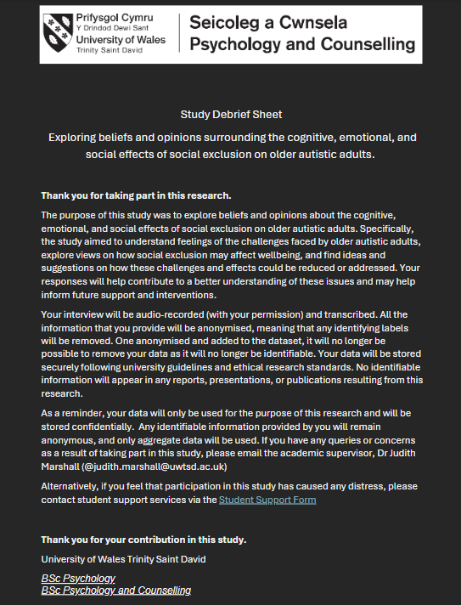

Thematic Analysis


