Data Handling and Business Intelligence
Module Code: LCBB5000
Lecturer: Khaza Ahmed
Student: Andrei Florin Stefan
Student ID: 2027355

Table of Contents
Part one 2
Introduction 2
Ice cream data 2
Correlation analysis 2
Analysis conclusion 4
Preprocessing, visualizing, and analyzing data and information about the business world 5
Conclusion 5
Part two 6
Introduction 6
Covid-19 cases data 6
Covid-19 cases Data analysis 6
Advantages and disadvantages of using Excel and SPSS 9
Conclusion…………………………………………………………………………………….13
Reference……………………………………………………………………………………13

Part one

Introduction
In academic period, students eat different ice cream and play different video game to become happy and satisfied. Each student has different demand and expectation about the tests of ice cream. There are various flavor of ice cream like-chocolate flavor, vanilla flavor and strawberry flavor (Galit Shmueli, 2018). This report describes 200 high school students and their test on ice cream flavor and different video game. It also focuses on ice cream data, correlation analysis, pre-processing, visualizing and analyzing data in the business world.

Ice cream data
The work sheet name is ice cream data that included student’s ID, numerical value of gender where described o as assigned as male and 1 assigned for female. According to the excel sheet, each student has own test of taking ice cream and plying game to fulfill demand and get pleasure. The excel sheet describes that 1 indicates vanilla, 2 indicates chocolate and 3 indicates strawberry. The described video game also has different numerical value. As each gender has different demand and expectation, about taking ice cream and performing game so the numerical data provide information about the correlations about various tests and privilege of those selected video games (Goleman, Mckee and Achor, 2018).

Correlation analysis
According excel sheet, the correlation between vanilla and gender is 0.008629.
The correlation between chocolate flavor and gender is 0.0222.
The correlation between gender and strawberry is 0.01936.
This excel sheet tried to show the correlations of those two genders and their demand and expectation about various echolocate flavor available to them. The excel sheet showed that the correlation between the choosing vanilla flavor and gender is 0.00862, the correlation between choosing the chocolate flavor and gender is 0.022 and the last correlation between the strawberry flavor and gender is 0.0192. After analyzing and evaluating the testing demand of different genders is versatile. There have a good correlation between the choose of chocolate flavor and gender for fulfilling demand and enjoying happiness. According to the excel sheet, maximum female students tended to take chocolate flavor ice cream for enjoying maximum pleasure. However, the demand of each gender take ice cream can be changed according to dynamic environment and availability in marketplace. But the consumer’s demand of chocolate flavor is high in any complex or changing environment in marketplace (Funmilola A, 2017). Specifically, female gender mostly like echolocate flavor to get high satisfaction after taking ice cream.
According to excel sheet, male students scored total video game as 4844.
Male students scored total puzzle game as 4713.
Female students total scored video game as 5526.
Female student scored puzzle game as 5768.
The pivot table tries to show the total scores and performances of male and female students to play video game and puzzle solving. The data report showed that female students ensured outstanding performance than male students to play video game and solve puzzle. The male student scored total video game as 4844 and total puzzle solving of male students is 4713, Female student scored total video game is 5526 and puzzle-solving score is 5768. After analyzing and justifying the above data and information, it can be said the gaming performance and puzzle solving quality of female students was better than male students. Besides, female students were more innovative, intellectual and productive who also ensured outstanding performance to other sector in workplace. The excel sheet also showed the correlation between video gaming performance and gender versatile that influenced to overall gamming and puzzle solving in academic period (Fink, 2010).
According to excel sheet, there were an effective correlation between video gaming performance and testing ice cream flavor of male and female gender. The correlations between taking vanilla ice cream flavor and performing video game is 0.132. The correlations between solving puzzle game and taking vanilla ice cream o.154. Besides, the correlations between video gaming performance and taking chocolate ice cream is 0.1444. It has a mild or supportive relationship between the chocolate ice cream and performing video game during study and learning period of students (Kambaraj, Shalinie and Bhuvaneshwaran, 2018). The excel also analyzed the relationship between taking strawberry flavor and performing video game as 0.173.
So it can be concluded that students had a strong trend to take chocolate flavor ice cream and performing video game and puzzle solve to fulfill demand and enjoy maximum happiness.
According to excel sheet, the video gaming performance and taking different ice cream flavor is 0.0314.
The trends to take ice cream flavor and playing video game of females students is 0.1323.
The puzzle performance and taking different ice cream flavor of male students is 0.2319.
The testing demand of ice cream flavor and solving puzzle of female student is 0.1689.
According to excel sheet pivot table, there had an effective relationship between performing video game, solving puzzle and taking different flavor ice cream of male and female students in study and learning period. After conducting above analysis, we can understand that there was a mild and friendly relationship of female students to take different flavor ice cream and perform various video game in academic period. The correlations of video gaming and taking ice cream of female students is 0.132. On the other hand, the video gaming performance and taking ice cream of male students were very poor in study and learning period (Olsen and Dupin-Bryant, 2012).
They did not like most to play video game and take different flavor of ice cream. The puzzle performance and taking various ice cream flavor of male students is 0.2319.

Analysis conclusion
After describing and justifying the above factors, it can be said that there have a strong relationship to take versatile ice cream flavor and perform different video game and solve puzzle game. Female students mostly liked echolocate flavor ice cream and male students liked vanilla and strawberry flavor ice cream to fulfill demand and expectation. Besides, female students also tried to play different video game and solved various puzzle than male students in academic period (Rachid Zahidi, 2015). Male students were more intellectual and rational thinker to operate any action procedures and take decisions to improve academic and non-academic performance in study and learning process.

Preprocessing, visualizing, and analyzing data and information about the business world
Excel is very popular word file that plays an effective role to show, analysis and describe data and information accurately. It provides accurate data and information within very short time. Maximum business organization and educational institution use this excel sheet to summarize and present various data and information. According to the case study, 200 high school students used to take various ice cream flavor and also performed various video game and puzzle solving problems. Excel file played a supportive role to show and summarize the correlations of taking ice cream and play various video game. In preprocessing stage, individuals try to gather accurate and relevant data and information. In this step, individuals tried to collect accurate information about taking ice cream and plying various video game. Besides, they also tried to the collect accurate information about male and female gender to take ice cream and perform various video game in study and learning period. In preprocessing steps, individuals mainly focused on detecting actual approaches, demand and performance of plying video game and taking different ice cream flavor like-chocolate flavor, vanilla flavor and strawberry flavor.
In visualizing stage, individuals tried to show the approaches and correlations of male and female gender about the demand of chocolate flavor, strawberry flavor and vanilla flavor to fulfill demand and expectations. Besides that time, individuals also visualized the gaming performance of both male and female gender during academic period. According to excel sheet, female gender used to take chocolate flavor than male gender in academic period. Besides, the gaming performance of female gender was more better than female gender in study and learning period. In analyzing stage of data, individuals tried to justify positive and negative performance of both male and female gender during plying video game and taking ice cream. The ice crème taking tendency of female gender was very high than male gender. Besides gaming approaches of female gender also very innovative and strategic than male gender of those 200 high school students.

Conclusion
In nutshell, we can say MS excel is very useful tool for any educational institution and business organization to show, describe and summarize data and information. It provides more accurate and authentic data and information. According to case study, those 200 high school used MS excel to describe the demand of ice cream flavor of students and their gaming performance in study and learning period.

Part two

Introduction
Global pandemic covid-19 has negative influence to overall action procedures of individuals in society. Excel file is very useful tool to describe different data and information about covid-19. Here excel file shows the death rate of covid-19 patient of various countries in world ‌ (Abbott, 2011). It also describes the highest death rate and lowest death rate of country.

Covid-19 cases data
In excel sheet, there are data, text data, numerical value and so on about the covid-19. It shows numerical data as a number of case and qualitative data as a country name. In excel sheet there also have different factors like-population data, country data, date, months, years and so on. All those factors play an effective role to provide accurate and authentic data and information about global pandemic covid-19.

Covid-19 cases Data analysis
Total number of covid-19 cases in every country (Asia, Europe and America)
According to excel file total number of covid-19 case in America is 30887593 and total number of death rate in America is 3%.
Total number of covid-19 cases in Asia is 16782046 and death rate is 2%.
Total number of covid-19 case in Europe is 21400012 and death rate is 2%.
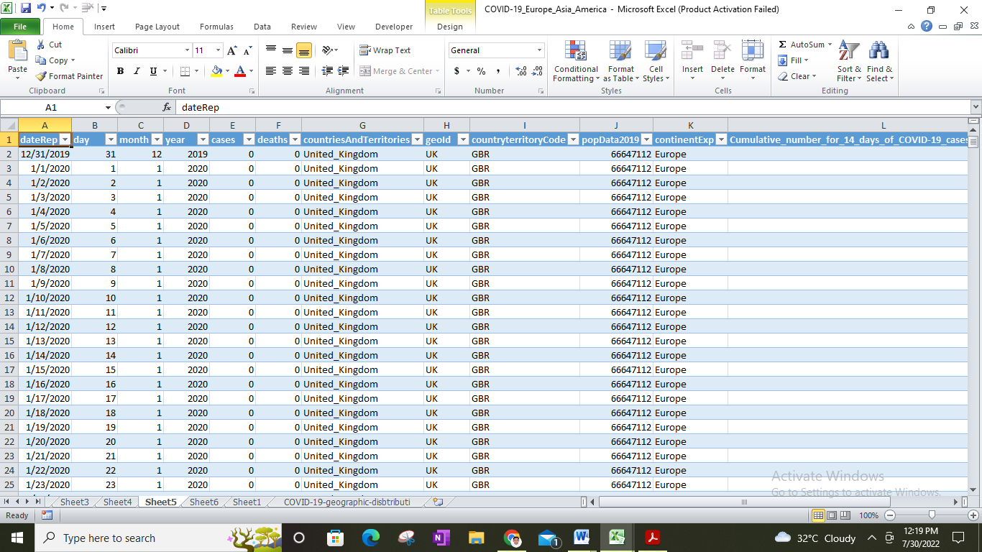
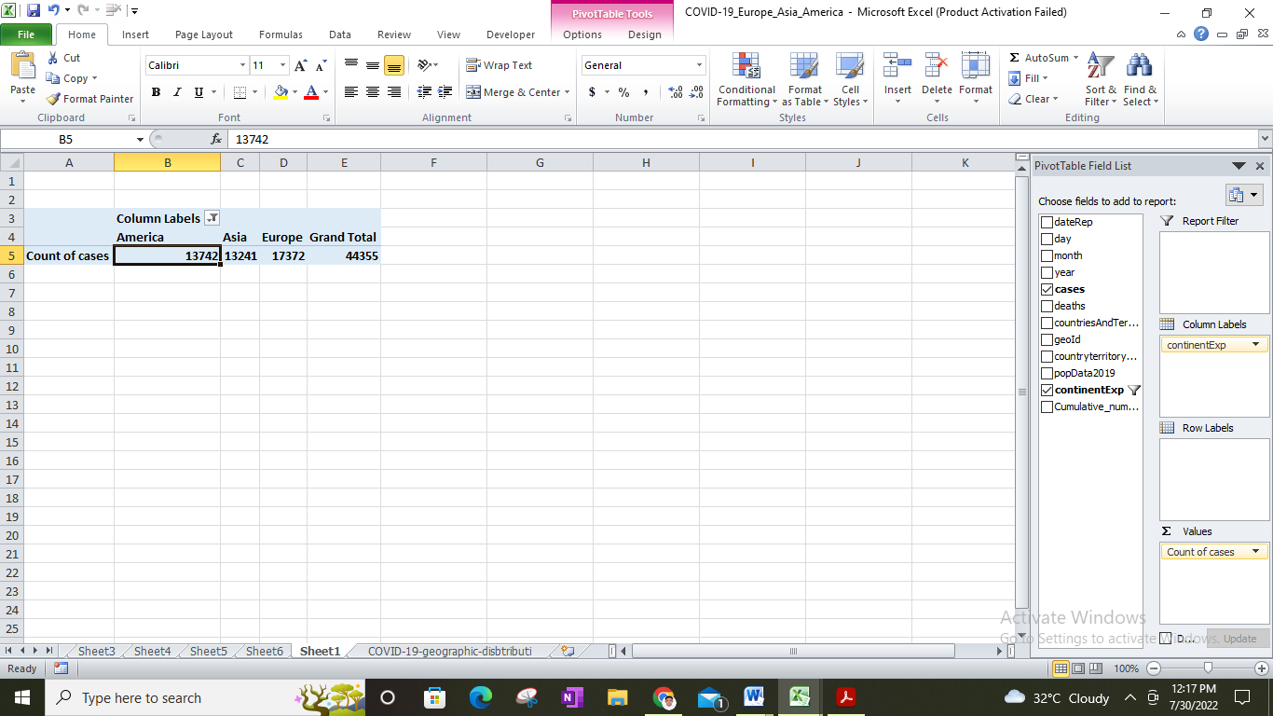
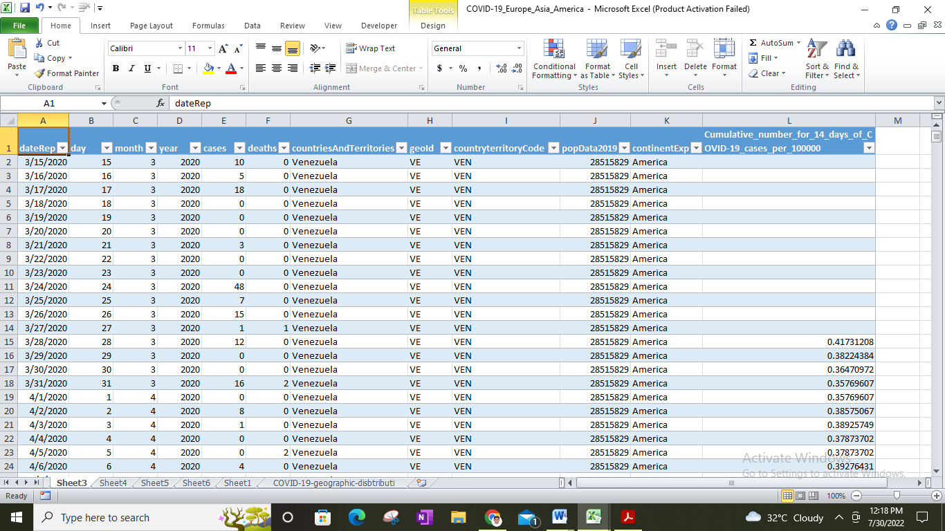
The continent, which had highest death rate
According to the case study, there were highest death rate in America than other continent like-Europe and Asia (Cleff, 2014). The covid-19 patient’s death rate in America was 0.0244 or 2%.
The country, which has lowest death rate
According to pivotal table of excel, the lowest death rate of covid-19 patient was in Asia than Europe continent. The death rate of Asia was 0.172, which was satisfied than another continent in the world.
The correlations between covid-19 cases and death in America
The excel file also showed the correlations between the covid-19 cases and death rate in America. According to excel file, the correlations of covid-19 death and case of America is 0.730.
Most common text mining method that maximum business organization use
Text minding refers to systematic policy and framework to collect data and information from various unstructured source. Text minding techniques play a supportive role to business organization for detecting meaning and purpose of various data and information related to business operations. Text pre-processing technique is must before applying text-minding techniques in workplace. Maximum business organization use various text minding approaches and policies for collecting information and performing outstanding operations in complex business place.
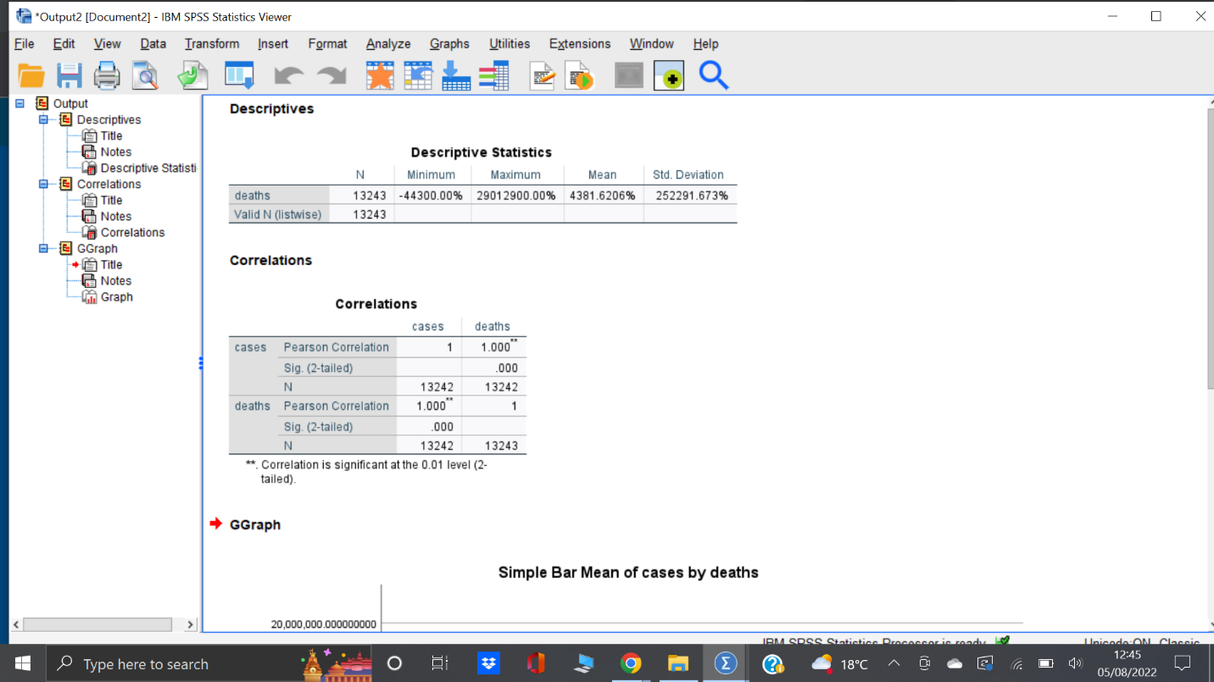
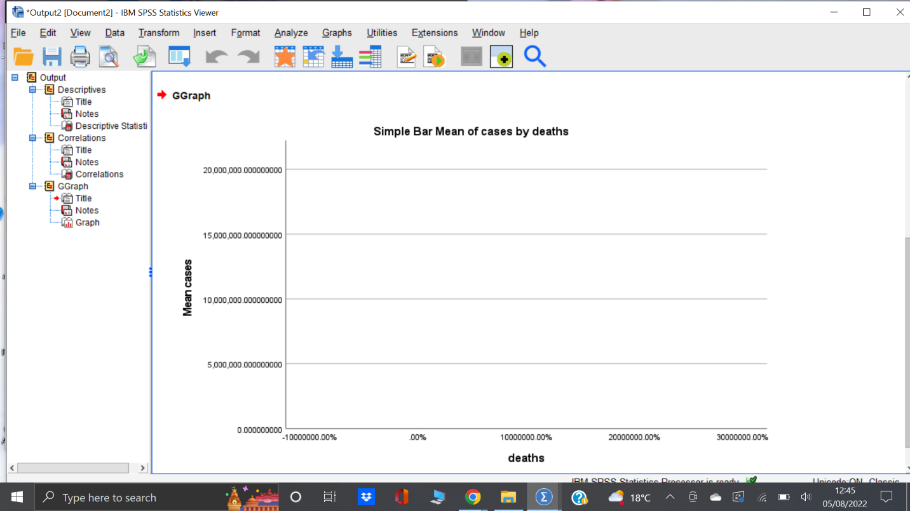

Information retrieval
Information retrieval is a systematic process of extracting pertinent information and texts or phases. Google crawler used this information retrieval method for improving performance and action procedures of business organization. Information retrieval played a significant role for collecting data and information of covid-19 patients.
Natural language process
Natural language process refers to a systematic policy and method to analysis customer’s approaches and expectation, and collect data and information from various unstructured source of information. Different educational institution and business organization use this natural language process for collecting and sharing data and information.
Clustering
Clustering refers to a prominent tool to classify text documents into various segment or group. In clustering process similar data and information are showed into different pattern and visual policy.
Categorization
Categorization is a method or policy to divide data and information into different categories and segment (Al-Hashami, 2014). There are different factors of text categorizing like- dimensionality reduction, indexing, pre-processing and so on. All these factors play a supportive role to categorize data and information to different visual approaches.

Advantages and disadvantages of using Excel and SPSS
Advantages of SPSS
SPSS refers to a comprehensive data analysis and management tool that use different data using instruments and functions. SPSS is very easy process of collecting and sharing data and information for any academic, non-academic and business operations. It has an attractive geographical instrument that play a significant role to shoe and visualize data and information. SPSS provides different types of graphic like-histograms, boxplots, scatterplots and so on that attract learner to collect data and information. It is very easy process and any learner can get desired idea and concept by using this SPSS data management tools. Business organization and educational institution use this instrument to provide accurate and effective data and information for improving learning and capability of individuals.
Disadvantage of SPSS
SPSS has also some disadvantages that play a negative influence to overall data analysis and management process. SPSS has limited functionality to describe complex data and information in any dynamic situation. It can not provide dynamic data and information about the current environment in society. Sometimes, different files of SPSS can be destroyed for having virus issue.
Advantages of Excel
Microsoft excel is very popular and useful tool to analysis, visualize and present different data and information. Different business organization and educational institution use this Excel tool to collect accurate data and shoe that data and information to the learners. Some advantages of Microsoft excel can be such as-authentic way to store and share information, effective calculation method, easy data visualize, clean and transform data and information, free template to use different purpose, easy printing policy of data and information. Business organization and educational institution can ensure outstanding performance and also can take competitive advantages and facilities in any critical situation in society. Some uses of Microsoft excel in business operations can be such as-people management, business analysis, managing operations, managing program, project management, strategic analysis, office administration, performance reporting and so on (Mcdaniel, 2014). All these activities and factors bring about competitive advantages and opportunities in any complex business situation.
Disadvantages of Microsoft excel
Microsoft excel has significant role to academic, non-academic and business operations of different institution in society. But Microsoft excel also has different disadvantages like-lack of security and control, excel is prone to human error, it does not collaborate to work, it is difficult to understand data and information, it is unsuitable for agile business project (Lee and Peters, 2016). Beside, different reporters can not use this excel tools to provide dynamic data and information.

Conclusion
In nutshell, we can say SPSS and excel is very popular and useful tools to store, analysis and share data and information. Those two instruments have both some advantages and disadvantages and maximum business organization and educational institution use excel and SPSS to ensure desired performance in workplace. According to the case study, case rate of covid-19 patient is lowest in Asia and highest death rate in America. SPSS and excel provided accurate data and information about covid-19 case and death rate of patients.

Reference
Abbott, M.L. (2011). Understanding educational statistics using Microsoft Excel® and SPSS®. Hoboken, N.J.: Wiley.
Al-Hashami, Z. (2014). Range of outputs precise of digits rounding in SPSS and MS Excel. Journal of Advanced Computer Science & Technology, 3(2), p.154. doi:10.14419/jacst.v3i2.3573.
Cleff, T. (2014). Exploratory Data Analysis in Business and Economics An Introduction Using SPSS, Stata, and Excel. Cham Springer International Publishing.
Fink, A. (2010). Advances in data analysis, data handling and business intelligence : proceedings of the 32nd Annual Conference of the Gesellschaft für Klassifikation e.V., Joint Conference with the British Classification Society (BCS) and the Dutch/Flemish Classification Society (VOC), Helmut-Schmidt-University, Hamburg, July 16-18, 2008. Berlin: Springer, C.
Funmilola A, O. (2017). Analysis and Comparison of Open Source Business Intelligence to Commercial Business Intelligence for SME in UK. Data Research, 1(1), p.44. doi:10.31058/j.data.2017.11005.
Galit Shmueli (2018). Data mining for business analytics : Concepts, techniques, and applications in R. Hoboken, New Jersey: John Wiley & Sons, Inc.
Goleman, D., Mckee, A. and Achor, S. (2018). Everyday emotional intelligence : big ideas and practical advice on how to be human at work. Boston, Massachusetts: Harvard Business Review Press.
Kambaraj, N., Shalinie, S.M. and Bhuvaneshwaran, A. (2018). BAIT: Behavior aided Intruder Testimony Technique for Attacker Intention Prediction in Business Data Handling. International Journal of Business Intelligence and Data Mining, 13(1), p.1. doi:10.1504/ijbidm.2018.10012004.
Lee, N. and Peters, M. (2016). Business statistics using Excel & SPSS. Los Angeles: Sage.
Mcdaniel, C.D. (2014). Marketing research essentials : with data analysis in Excel and SPSS. Toronto: John Wiley & Sons Canada, Ltd.
Olsen, D.H. and Dupin-Bryant, P.A. (2012). Combining Business Intelligence And Stock Market Data: A Primer For Data Analytics And Business Intelligence. Journal of Applied Business Research (JABR), 29(1), p.139. doi:10.19030/jabr.v29i1.7562.
Rachid Zahidi (2015). The business immunity system : the pitfalls & side effects of data handling, privacy issues, & background checks. Charleston, South Carolina: Advantage Media Group.

