



Structural & Fluid Analysis
Application of CAE Processes
(ACHA6010)
Name: Evan Craig
Student ID: 2012643
Date: November 2024 Word Count: 2778

Name: Evan Craig
Student ID: 2012643
Date: 10/2022

Table of Contents
1. Introduction 1
2. Methodology 2
2.1 Modelling and Assembly 2
2.2 Material Selection 2
2.3 Rigid Dynamics Simulation 2
2.4 Static Structural Analysis 2
2.5 Material Optimisation 3
2.6 Validation Testing 3
3. Results and Discussion 4
3.1 Baseline Piston Results and Analysis 4
3.2 Piston Material Optimisation 6
3.3 Piston Geometry Optimisation 7
3.3.1 Version 2 7
3.3.2 Version 3 8
3.4 Validation Testing 9
3.4.1 Validation Case 1 – 0078 – Bimetallic Strip 9
3.4.2 Validation Case 2 – 0042 – Bending Cantilever with Axial Force 10
3.4.3 Validation Case 3 – 0016 Elastic Bending, Continuous Load 11
4. Limitations of CAE Tools 12
5. Conclusion 13
6. References 14
7. Appendices 15

Introduction

This report aims to investigate the application of Computer Aided Engineering, or CAE, tools to optimise the performance of a piston found in an assembly with a crankshaft, connecting rod and gudgeon pin, only the performance of the piston will be studied. The tools used are critical in modern engineering as they enable accurate simulation and analysis of mechanical components under a wide variety of operating conditions. By reducing the reliance on physical component testing of prototypes CAE can significantly accelerate the design process while also helping to reduce costs.
In this analysis a software package called ANSYS will be used to model and simulate the structural and dynamic behaviour of the piston assembly under realistic operating conditions such as a rotational speed of 6,000 RPM and the loads and temperatures you would expect to see at these conditions will be applied too. Then any optimisation of piston geometry will be conducted on SolidWorks. This report will focus on enhancing the components' performance by evaluating material properties and refining geometry to reduce deformation and stress concentrations. Then validating the use of CAE tools three validation cases will be completed to ensure the accuracy of the software.
Reducing mass and improving fatigue life in engine components like pistons is of paramount importance in the automotive industry. These improvements not only contribute to better performance but also ensure the durability and reliability of pistons under high-stress conditions. The findings from this study provide valuable insights into how CAE tools can be used to address these challenges effectively.

Methodology

2.1 Modelling and Assembly

For the analysis, a group of components that were made using SolidWorks were provided. They were a piston, a gudgeon pin, a connecting rod and a crankshaft thus meaning the simulation is to replicate the motion of a piston moving up and down in a cylinder under operating conditions of 6,000 revolutions per minute.
Once the three components were assembled in ANSYS Workbench the first task was to use the joint tool. This allows for the replication of connections between the components, such as connecting the connecting rod to the piston and the crankshaft etcetera. The model was then simulated to ensure that all joints were correctly applied, the software allows for previews of how it will compute the movements which is vital for accuracy in the later segments.

2.2 Material Selection

ANSYS has multiple tools, with one of them being a materials database called GRANTA. This software contains multiple materials of which the simulation called for 6061-T6 Aluminium, the data for this material was downloaded from GRANTA and uploaded onto Workbench. Meaning the piston could be modelled in the correct material with all relevant material properties already being set up. (Reddy, 2014)

2.3 Rigid Dynamics Simulation

Rigid dynamics means that all components of the simulation are assumed to be completely rigid implying there is no flexibility. The simulation then requires more data to know what speed to simulate the assembly at, for this case 6,000 RPM was used. This is then simulated for 1 rotation, as that is all we need, with the data obtained from this being highly useful in further analysis and simulation.

2.4 Static Structural Analysis

Static structural analysis is different to rigid dynamics as it requires the crankshaft assembly to be converted from rigid to flexible components which allows for the deformations and stress distribution to be calculated correctly. This means the analysis can compute the realistic behaviour of the components at operating conditions. (Kerley et al., 2011)

Data from the rigid dynamics data simulation at 6000 RPM, specifically from the peak loading conditions, was used in the static structural analysis. To make sure that the applied forces closely resemble real-world conditions, the peak loads represent the highest mechanical stress during operation. The static analysis can now precisely calculate the stress distribution and deformation of the piston using the predicted loads from the simulation which will enable a more reliable assessment of piston performance.

2.5 Material Optimisation

The challenge of improving the results of the 6061-T6 Aluminium piston began with a range of other alloys of the same metal these can be seen below:
- 6061-T6
- 7020-T6
- 6082-T6
- 2618-T6
Each of these aluminium alloys has different benefits and negatives over each other. The main goal is reducing the pressure and temperature the piston is exposed to, increasing the durability or heat resistance to achieve better performance. The results of each alloy can be seen in a later segment of the report.

2.6 Validation Testing

As the testing and simulation are all done with predictions and computer-aided engineering, there needs to be a way to validate the data that’s being produced. To do this there are validation cases on components that have been validated in real-world conditions. The three cases that are used to validate the piston data can be seen in the validation results segment the focus will be on how accurate the analytical results compare to the real results and how mesh sizing can affect results.

Results and Discussion

3.1 Baseline Piston Results and Analysis

The baseline model was made from 6061-T6 aluminium. It was subjected to combined kinematic, structural and thermal analysis at a rotational speed of 6000 RPM. Stress concentrations and total deformations were observed around the whole model as can be seen in Figures 1 - 4. These were used to evaluate the pistons' mechanical performance under peak operating loads.
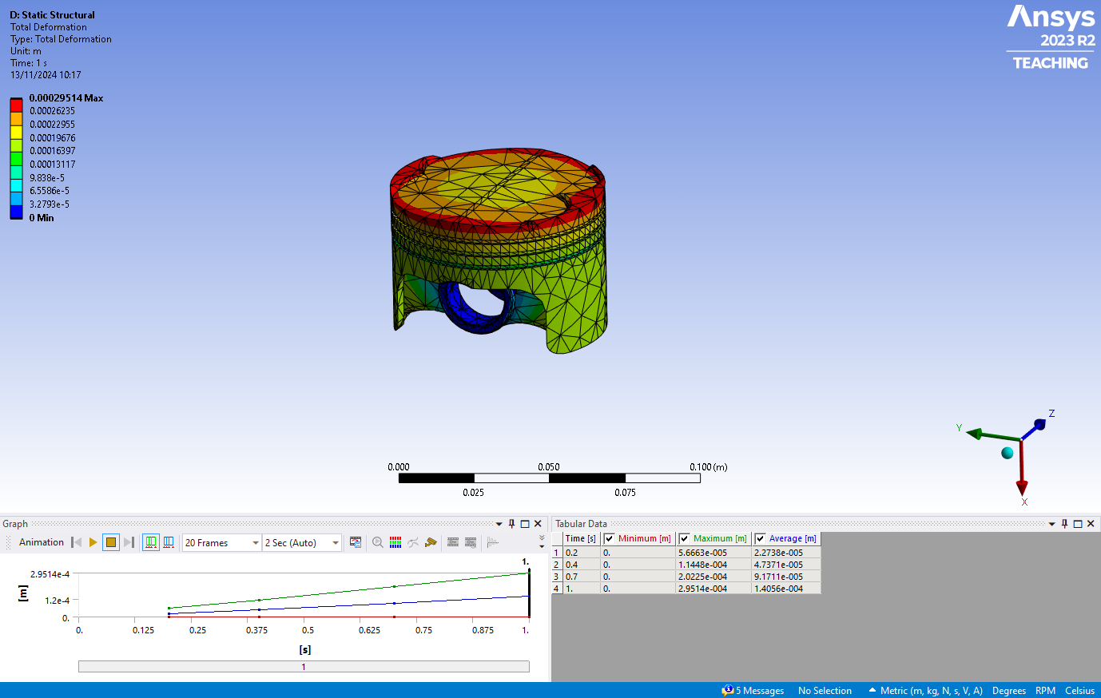
Deformation Analysis

Figure 1 - Total Deformation for the Baseline Piston Model Simulation
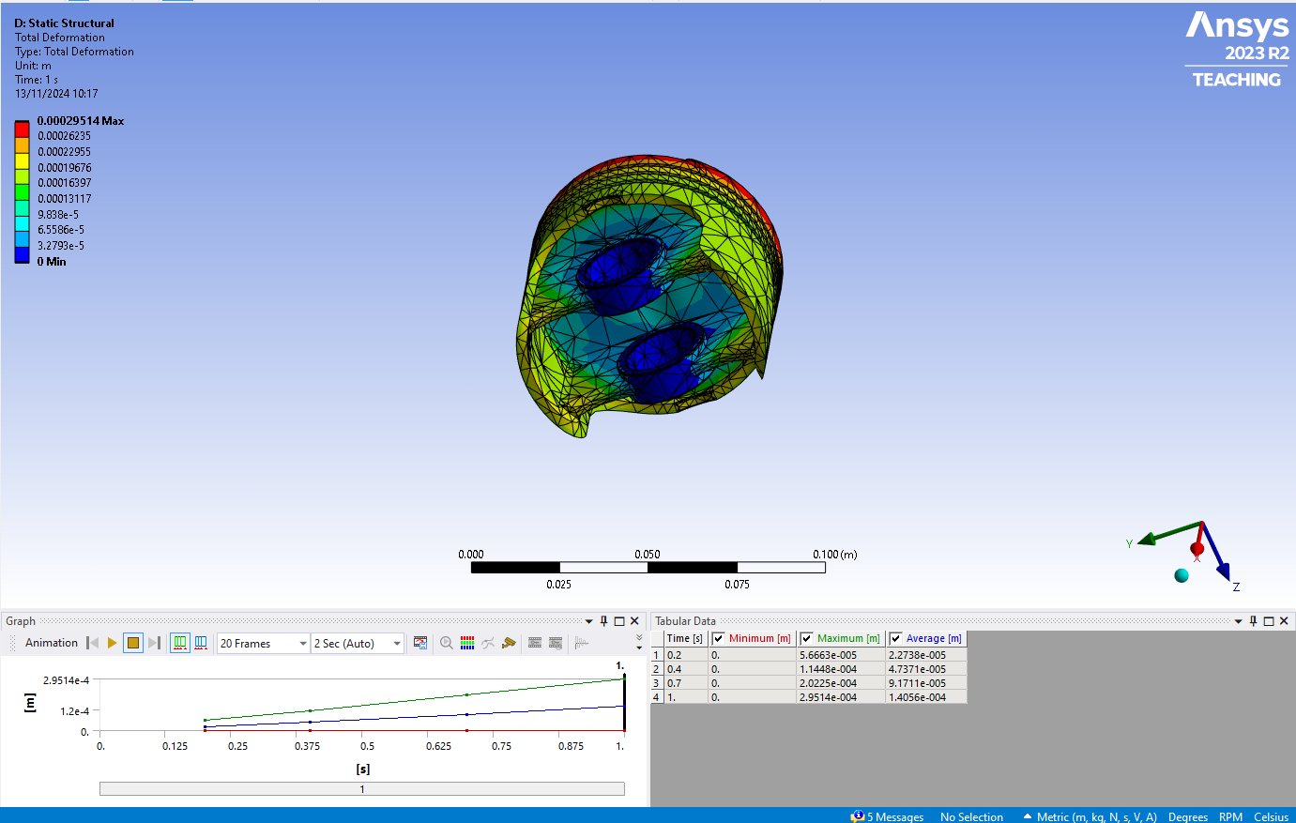
Figure 2 - Total Deformation for the Baseline Piston Model Simulation
The piston experienced a maximum deformation of 0.29514 mm, this is primarily concentrated around the edge of the top face of the piston as shown in Figure 1. This pattern may suggest the material and design of the piston are sufficient for operational loads but it also highlights the need for further optimisation to minimise the distortion and improve durability.

Stress Analysis
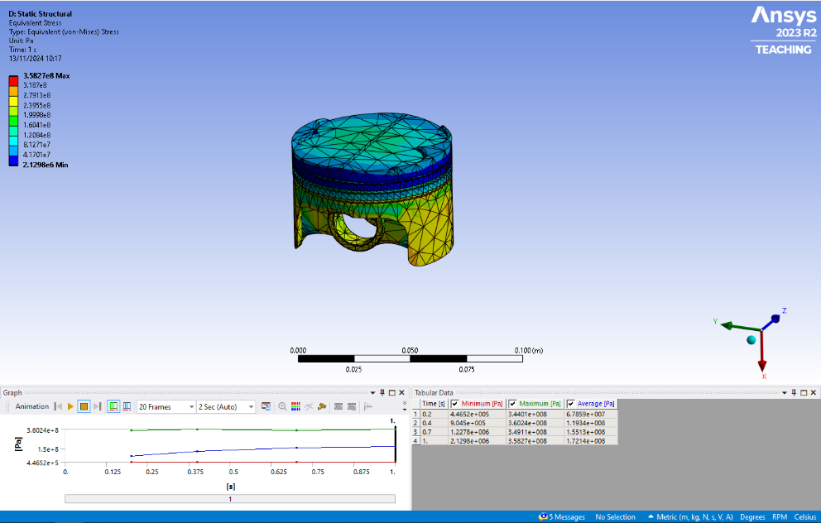

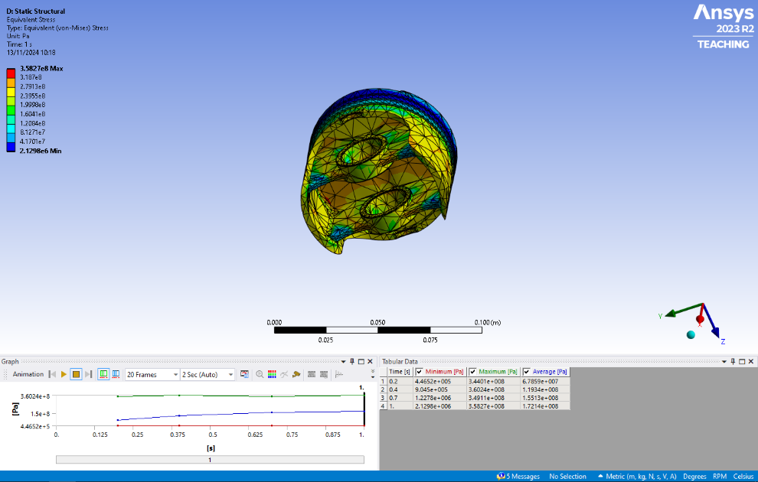
Figure 3 – Total Stresses for the Baseline Piston Model Simulation

Figure 4 - Total Stresses for the Baseline Piston Model Simulation

Now looking at Figures 3 and 4 you can see the total equivalent stress for the Piston. The highest stressed area is at the bottom of the piston, Figure 4, around the piston pin bosses with a maximum stress of 360.24 MPa. These are critical areas of the piston as they support the reciprocating motion and can be seen as potential failure points when they are under high loads, so there may need to be changes to the model in this area.

The analysis of the baseline model revealed critical areas of the piston which will require improvement. The concentration of stress at the piston pin bosses indicates a need for a redesign of this area to reduce the concentration of the stresses. The overall deformation around the top face edge of the piston also suggests the potential need for a refined material to enhance the stiffness and reduce distortion during operation, this material optimisation will be conducted next.

3.2 Piston Material Optimisation

To improve the performance of the piston several alternative aluminium alloys were evaluated: 6061-T62, 7020-T6, 6082-T6 and 2618-T6.
Each alloy was obtained from the ANSYS Granta material library and also tested under the same loading condition as the baseline material of 6061 – T6. The focus will still be on deformation and stress which both influence the overall durability. The goal was to identify a material that provided superior performance and the results can be seen in the table below:
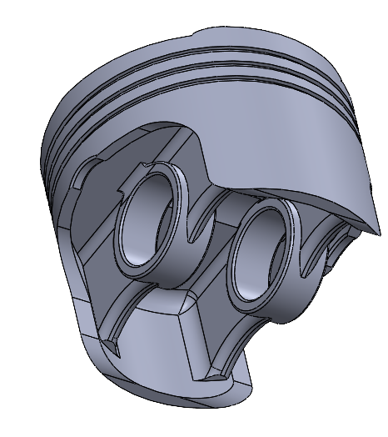
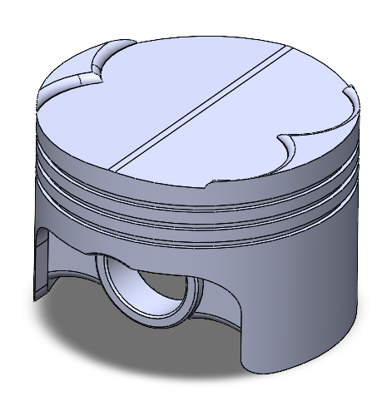

Figure 5 - A SolidWorks Model of Version 1 of the Piston
Figure 6 - A SolidWorks Model of Version 1 of the Piston
Table 1 A Table to Show the Deformation and Stress of Version 1
Material | Max Deformation (mm) | Deformation Improvement (%) | Max Stress (MPa) | Stress Improvement (%)
6061 – T6 | 0.29514 | 0% | 360.24 | 0%
7020-T6 | 0.27053 | 8.33% | 415.58 | -15.37%
6082-T6 | 0.26671 | 9.63% | 369.39 | -2.48%
2618-T6 | 0.28193 | 4.47% | 428.90 | -19.09%

On version one of the piston, the best-performing aluminium alloy would be 6082-T6, this would be down to the additional magnesium in 6082 which would contribute to better material strength and durability.

3.3 Piston Geometry Optimisation

3.3.1 Version 2

To further improve the performance of the piston, refinement of the geometry was conducted which produced two additional versions of the design. Version 2 used the data gathered from the FEA testing to improve the design. With the majority of deformation affecting the edge of the top face of the piston and the stress being concentrated underneath the piston and around the pin bosses, these areas were redesigned first.
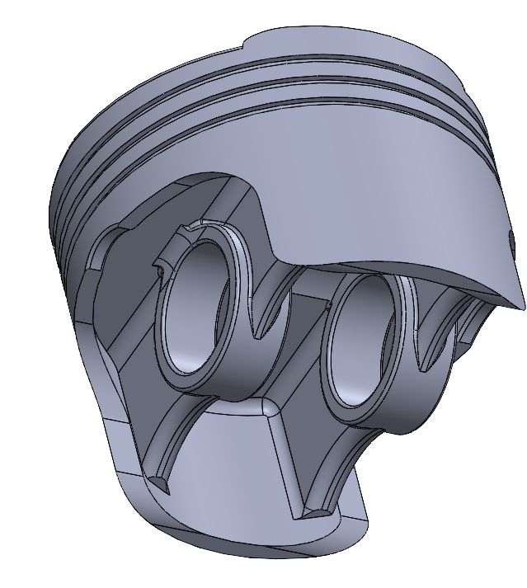
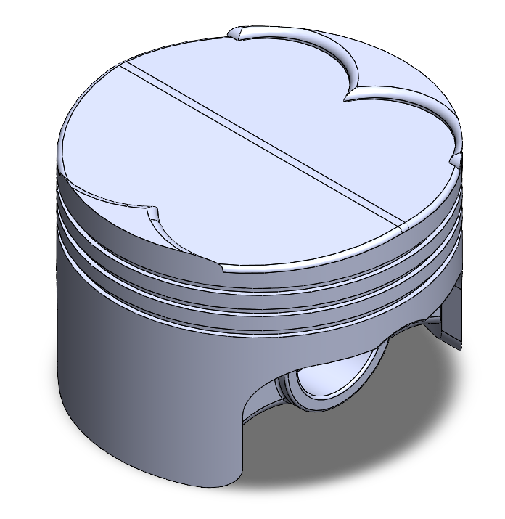
Figure 7 - A SolidWorks Model of Version 2 of the Piston

Figure 8 - A SolidWorks Model of Version 2 of the Piston
Figures 7 and 8 show the redesigned piston. The modifications were as follows:
- A 1 mm chamfer was added around the edge of the top face of the piston to reduce pressure concentrations, which in turn should reduce deformation.

- A 0.5 mm chamfer was added underneath the piston near the pin bosses to eliminate sharp edges in an attempt to reduce stress.

- An existing 2 mm chamfer was upped to 2.5 mm to help further reduce stress.

Table 2 - A Table to Show the Deformation and Stress of Version 2 Compared to Version 1
Material | Max Deformation (mm) | Deformation Improvement to Version 1 (%) | Max Stress (MPa) | Stress Improvement to Version 1 (%)
6061 – T6 | 0.29208 | 1.04% | 359.27 | 0.27%
7020-T6 | 0.26454 | 2.21% | 426.30 | -2.58%
6082-T6 | 0.26417 | 0.95% | 337.85 | 8.54%
2618-T6 | 0.27945 | 0.88% | 427.62 | 0.30%

With an increase across the board for deformation the changes seem to be a success. However, looking at the changes to the stress they seem to be a lot lower in terms of performance gained. This leads to the third design of a piston which will only compare the two best-performing materials to compare to the baseline material, these will be the 6082-T6 and 2618-T6 alloys.

3.3.2 Version 3
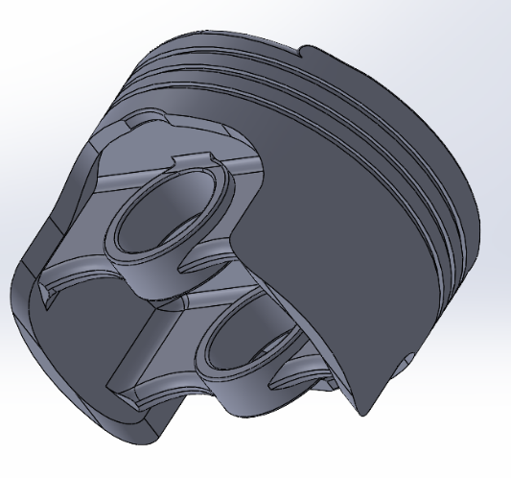
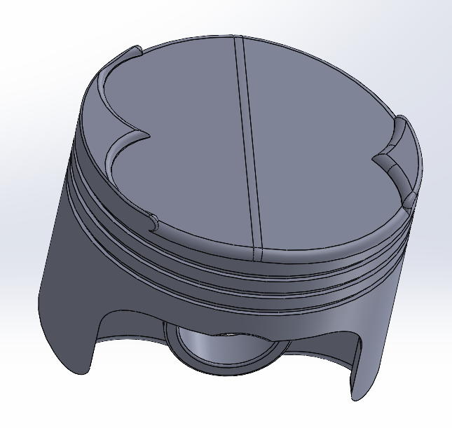

Figure 9 - A SolidWorks Model of Version 3 of the Piston
Figure 10 - A SolidWorks Model of Version 3 of the Piston
Onto the third and final version of the piston, shown in figures 9 and 10, this time the changes are aiming to do the same as version 2 with the edge of the face on top of the piston and the pin bosses. The changes for this version are:
- An additional 0.4 mm chamfer to one of the valve relief cutouts, was to reduce the concentration of deformation in this area.
- A 1 mm chamfer to the smaller valve relief cutout to reduce deformation similar to the previous change.
- Underneath the piston, a 2 mm chamfer was upped to 4 mm to reduce the concentration of stress in this critical area.
Table 3 - A Table to Show the Deformation and Stress of Version 3 Compared to Version 2
Material | Max Deformation (mm) | Deformation Improvement to Version 2 (%) | Max Stress (MPa) | Stress Improvement to Version 2 (%)
6061 – T6 | 0.28908 | 1.03% | 355.72 | 0.99%
6082 - T6 | 0.26125 | 1.11% | 308.21 | 8.77%
2618 - T6 | 0.27581 | 1.30% | 424.39 | 0.75%

The data gathered from the simulations and testing will be discussed further in the conclusion of the report, the next section will demonstrate how validation testing ensures that this data is correct.

3.4 Validation Testing

To validate the results of finite element analysis there were three validation cases completed. The cases provide valuable data that was gained from real-world testing of the components, the aim is to replicate the component and create a likewise model of it then you can add the loads that the component was put under. The data from the simulation can then be compared to the real-world data to validate the use of finite element analysis. (Park et al., 2011; Srinivas, 2020)

3.4.1 Validation Case 1 – 0078 – Bimetallic Strip
The first case in the validation testing was the Bimetallic strip, this component consisted of two materials bonded together, one being invar and the other copper. For this case having 2 martials meant they both would need material property files to be created, the data for this is provided on the validation sheets that can be seen in the appendix.
Figure 11 - Problem Sketch for 0078 - Bimetallic Strip
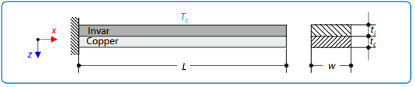
Figure 11 shows the component that needed to be created in ANSYS Discovery, once this was completed it was imported into Workbench, this case only had thermal loading of 100 °C applied to it meaning the measured deflection should be relatively low.
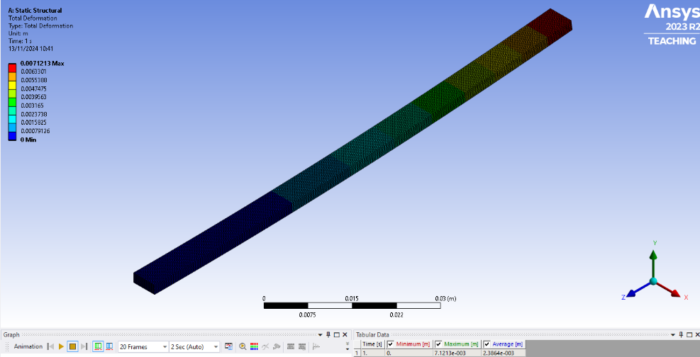

Figure 12 - A Picture of Component 0078 - Bimetallic Strip

Above in Figure 12 is the Workbench simulation of the deflection, the result can be seen under the green text with it being 7.1213 mm, if you compare this to the real-world data of 7.049 mm you can see that the difference between them is very marginal so the error is down to mesh generation, with fine tuning probably able to get an almost exact match.

3.4.2 Validation Case 2 – 0042 – Bending Cantilever with Axial Force

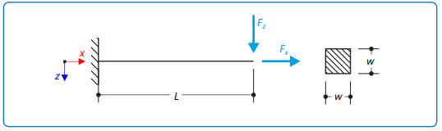
Case 2 is also a cantilever beam however; this time the load was applied axial along the x and z axis. The load distribution can be seen in the figure below.
Figure 13 - Problem Sketch for 0042 - Bending Cantilever with Axial Force

Similarly to the other case, this was replicated with ANSYS Discovery and the material details were uploaded to Workbench. A mesh can then be created with the default mesh size being 0.05m. From there to replicate the cantilever effect one end is fixed, from here you can apply loads of 7650 Newtons on the Z axis and 1600 Newtons on the X axis. You can see the component in ANSYS Workbench in the figure below:
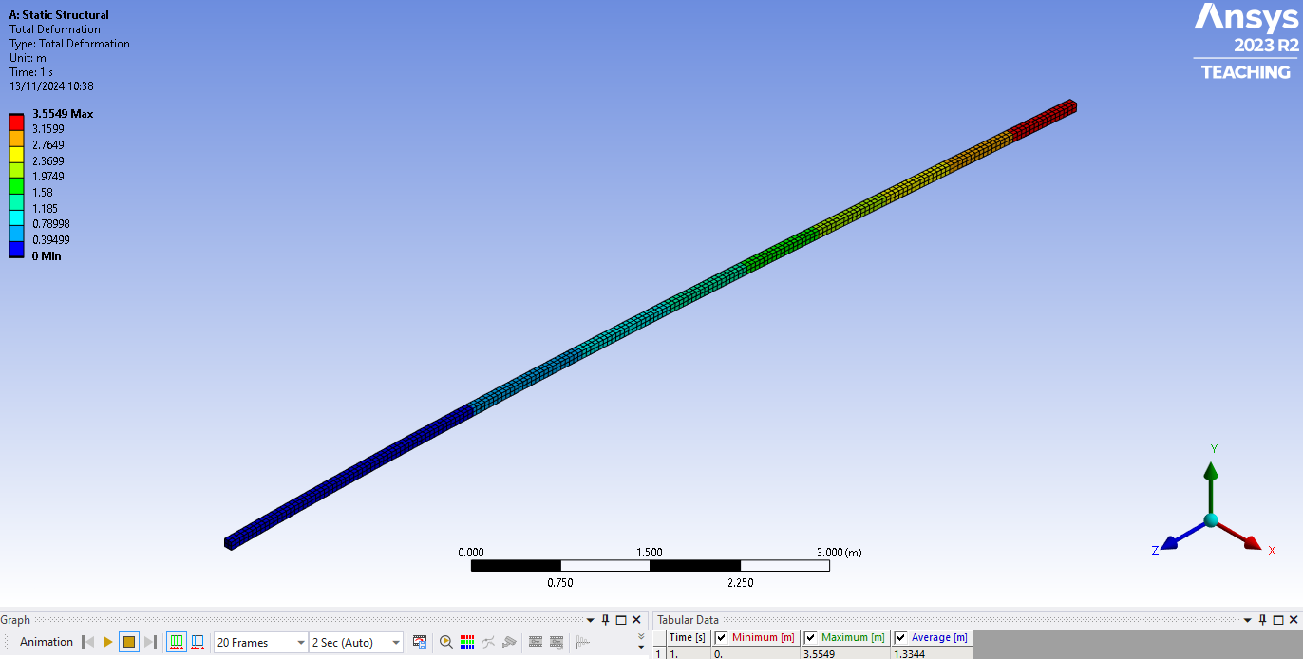

Figure 14 - A Picture of Component 0042 – Bending Cantilever with Axial Force in ANSYS Workbench
Once this was all set up correctly it was time to validate the results, the real-world data should be 3.27 Meters the results for the simulation can be seen below the green text in the figure that reads ‘Maximum [M]’. As you can see the result is 3.5549 metres, this is very close to the actual result meaning that the difference is down to the mesh setup and altering this may make the results come closer.

3.4.3 Validation Case 3 – 0016 Elastic Bending, Continuous Load
Case 3 depicted in Figure 15 is a cantilever beam with a uniformly distributed load acting upon the top surface with the provided material details inputted into ANSYS Workbench and an exact model of the component created in ANSYS Discovery it was possible to add the uniform load on the top.
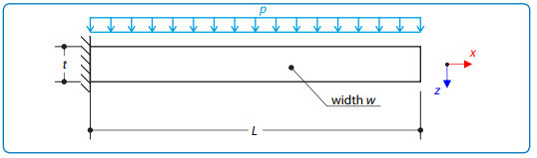

Figure 15 - Problem Sketch for 0016 - Elastic Bending - Continuous Load
Once the component was created and the mesh was generated it was time to view the deformation of the beam. The validation data is 157.143mm below you can see the component and result.
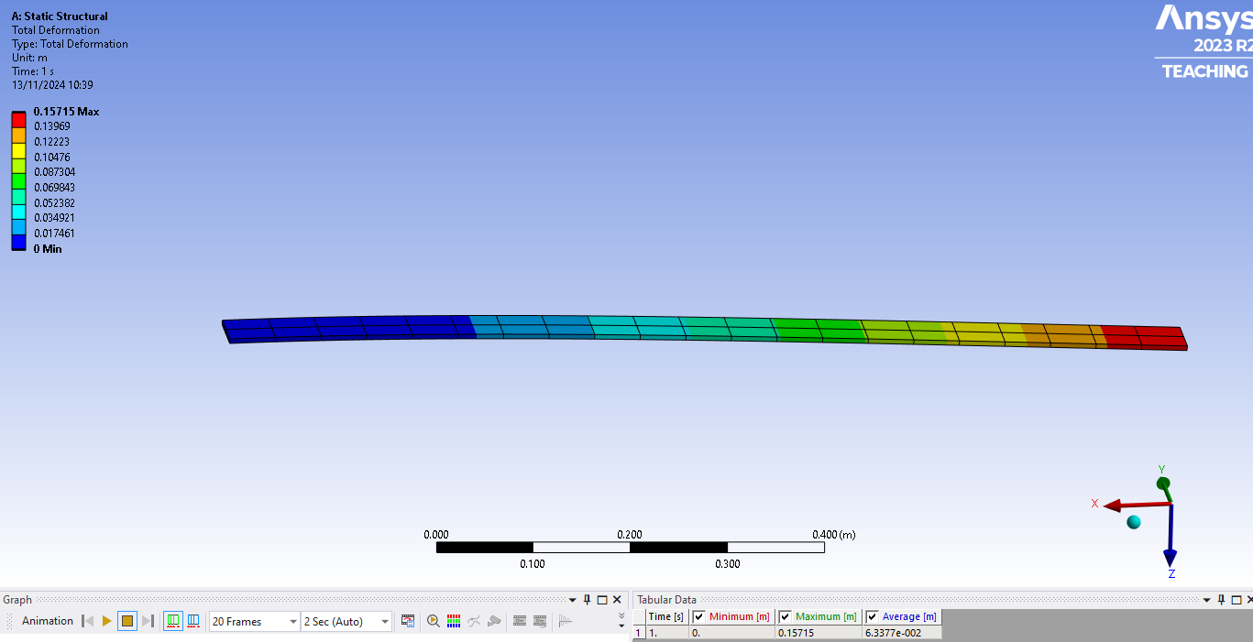
Figure 16 - A Picture of Component 0016 - Elastic Bending - Continuous Load

The result for this case is 157.15 mm, which is only 0.007 mm off the real-world data. This suggests that not only is finite element analysis simulation viable but it is also highly accurate and closely matching the expected real-world results. Therefore, the data generated from the piston simulation can be trusted and believed to be accurate.
Studies highlight that effective validation of CAE simulations bridges theoretical understanding with practical testing this can ensure credibility and accuracy in engineering analysis. (Kondo, Hayashi & Toyoshi, 2023).

4. Limitations of CAE Tools

Computer Aided Engineering tools like ANSYS are incredibly valuable for the engineering discipline however, they do not come without limitations. One significant challenge that was encountered during this study was the use of a titanium alloy in the simulations. When using titanium alloys, the simulation presented numerous hotspots which are regions of excessively high stress concentrations this meant the data could not realistically be validated against performance metrics of the material that would be considered realistic. These inaccuracies highlight the limitations in the meshing process and boundary conditions which can result in exaggerated stress distribution. (Svenninggaard, 2017)
There are more general limitations of CAE tools too, these can include:

Meshing Inaccuracies
The results of the simulation rely heavily upon the meshing process meaning that a poorly designed or sized mesh can lead to incorrect deformation and stress predictions. Decreasing the size of the mesh to make it finer will not necessarily improve performance or accuracy. This highlights the importance of adaptive mesh techniques which can dynamically adjust the mesh density according to the component. (Acikgoz, 2007)

Dynamic Effects
In a real-world scenario, the piston would also be exposed to more transient effects than the simulation can reproduce things like vibrations, unsteady forces and cyclic loading are effects that simulations can fail to reproduce. For instance, when incorporating vibrations which can induce resonance into the piston which can amplify stress and accelerate fatigue of the component. (Rice University, n.d.; Rice University, 2020 )

Simplifications and Assumptions
These tools will always assume ideal conditions which they can use to simplify the simulation, for example even when the material data is from a database such as ANSYS Granta they are still highly accurate however the boundary conditions and load applications are ideal for the material which will exclude the minor varieties and defects that would be present in the real world. These assumptions can cause discrepancies and may require a validation case to validate them. (Wen , 2007)

5. Conclusion
After looking at the results from the material and geometry testing and simulations there was a clear choice to be made in terms of material selection and the best geometry for the piston. The following table will compare 6082-T6 to the baseline material of 6061-T6 with the original model/version 1 geometry, to show how much of an improvement was made in each area for each version.
Table 4 - A Table to Show the Improvement of 6082-T6 compared to 6061-T6 When Piston Geometry Changes
Version | 6082-T6 Deformation | 6082-T6 Stress
1 | 9.63% | -2.48%
2 | 10.49% | 6.22%
3 | 11.48% | 14.44%
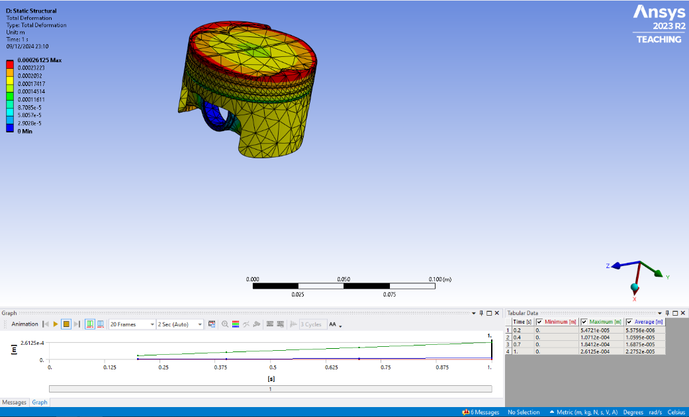
As you can see by changing the aluminium alloy to 6082-T6 there was already almost 10% less deformation when compared to 6061-T6 even with the negative effect on the stress value this was easily fixed with the changes to the piston. Version 2 carried on with the benefits being an improvement across the board when compared to version 1 and this trend follows with version 3 being a massive improvement when compared to version 1.
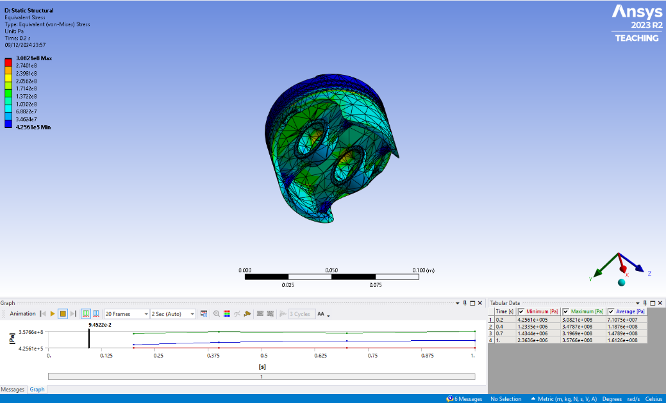
Figure 17 - ANSYS Deformation Results for Version 3 and 6082-T6 Piston Simulation
6082-T6 has slightly higher yield strength and ultimate tensile strength when compared to 6061-T6. This means that 6082-T6 can withstand greater stresses before deforming or failing, making it more resistant to deformation under load, with the higher silicon and magnesium content that’s found in 6082-T6 contributing to this. (Ye et al., 2023; Liu, 2005)

Figure 18 – ANSYS Stress Results for Version 3 and 6082-T6 Piston Simulation

By selecting 6082-T6 as the material and implementing geometric optimisation in selected areas of the piston design achieved significant reductions in deformation and improved stress distribution. This ensures that durability and performance are enhanced under operating conditions. This study shows how important the combination of material and geometric optimisations is to achieve superior performance through the use of finite element analysis. Such improvements align with findings from Gadala (2018), where iterative CAE analysis enhances both material performance and structural integrity.

6. References
Reddy, J.N., 2014. An introduction to nonlinear finite element analysis: with applications to heat transfer, fluid mechanics, and solid mechanics. 2nd ed. Chapter 3, The Finite Element Method: A Review, pp.97–174. DOI: 10.1093/acprof:oso/9780199641758.003.0003.
Kerley, W., Armstrong, G., Pepe, C., Moss, M. & Clarkson, P.J., 2011. Using simulation to support process integration and automation of the early stages of aerospace design. In: International Conference on Engineering Design (ICED11), 15-18 August 2011, Technical University of Denmark. University of Cambridge, UK; Rolls-Royce Civil Aerospace, Derby, UK.
Park, J.S., Lee, J.W., Cho, S.S., Kim, D.O., Lee, W.J., and Lee, Y.S., 2011. Validation of finite element analysis method for structural dynamic characteristics of SMART. Transactions of the 21st SMiRT Conference, 6-11 November, New Delhi, India. Div-I: Paper ID# 559. Div-V: Paper ID# 559. SMART Development Division, Korea Atomic Energy Research Institutes, Deajeon, Korea; Mechanical Design Engineering, Chung-Nam National University, Deajeon, Korea.
Srinivas, K., 2020. Verifications and validations in finite element analysis (FEA). Advanced Scientific and Engineering Services (AdvanSES), Ahmedabad, India. Available at: https://advanses.com/wp-content/uploads/2020/05/verifications-and-validations-in-finite-element-analysis-FEA.pdf [Accessed 6 Dec. 2024].
Kondo, A., Hayashi, H. & Toyoshi, T., 2023. Project-based learning of mechanical design utilizing CAE structural analyses. Educational Sciences, 13(7), p.687. DOI: 10.3390/educsci13070687.
Svenninggaard, J., 2017. How to deal with the annoying Hot Spots in FEA. Danish University Colleges. [online] Available at: https://www.danishuniversitycolleges.com [Accessed 6 Dec. 2024].
Acikgoz, N., 2007. Adaptive and dynamic meshing methods for numerical simulations. Ph.D. thesis. Georgia Institute of Technology, School of Aerospace Engineering.
Rice University (no date) FEA Vibration Analysis Summary. Available at: https://www.clear.rice.edu/mech403/HelpFiles/Frequency_simulation_summary.pdf (Accessed 8th December 2024).
Rice University (2020) Acceleration Body Force. Available at: https://www.clear.rice.edu/mech403/HelpFiles/Frequency_simulation_summary.pdf (Accessed 8th December 2024).
Wen, J.H., 2007. FEA modelling verification and validation: correlating model with test data by optimisation analysis. SAE Technical Paper 2007-01-1745. DOI: 10.4271/2007-01-1745.
Ye, T., Xia, E., Qiu, S., Wang, Y., Yue, H., Liu, J. & Wu, Y., 2023. High-temperature tensile mechanical properties and microstructure of rolled 6082-T6 aluminium alloy sheets. Materials, 16(21), p.7019. DOI: 10.3390/ma16217019. Available at: https://www.mdpi.com/1996-1944/16/21/7019 [Accessed 10th Dec. 2024].
Liu, A.F., 2005. Mechanics and mechanisms of fracture: an introduction. Appendix 7: Mechanical Properties Data for Selected Aluminium Alloys. ASM International. DOI: 10.1361/memf2005p397. Available at: https://materialsdata.nist.gov/bitstream/handle/11115/177/Mecnanical%20Properties%20Data.pdf [Accessed 11th Dec. 2024].
Gadala, M., 2018. Finite elements for engineers with ANSYS applications. Cambridge University Press.

7. Appendix
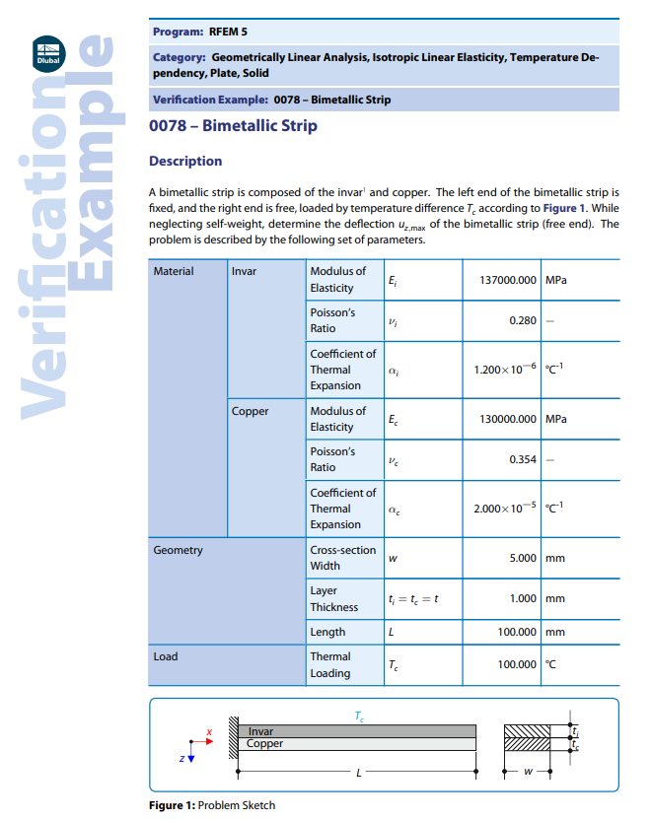
Figure 19 - 0078 – Bimetallic Strip Validation Data Sheet

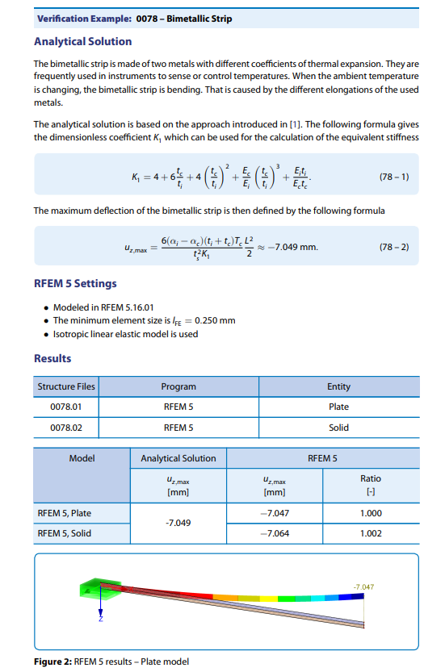
Figure 20 - 0078 – Bimetallic Strip Validation Data Sheet

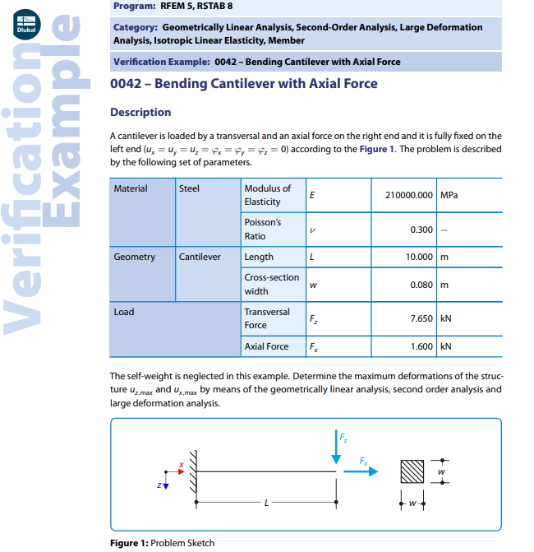
Figure 21 - 0042 – Bending Cantilever with Axial Force Validation Data Sheet
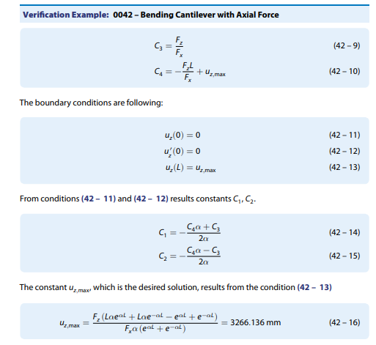
Figure 22 - 0042 – Bending Cantilever with Axial Force Validation Data Sheet

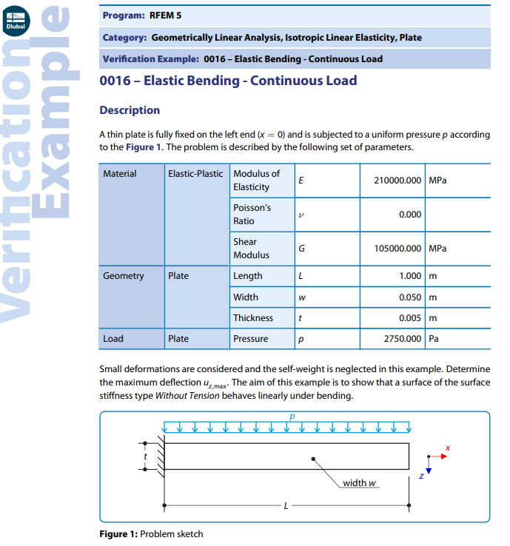
Figure 23 - 0016 – Elastic Bending - Continuous Load Validation Data Sheet
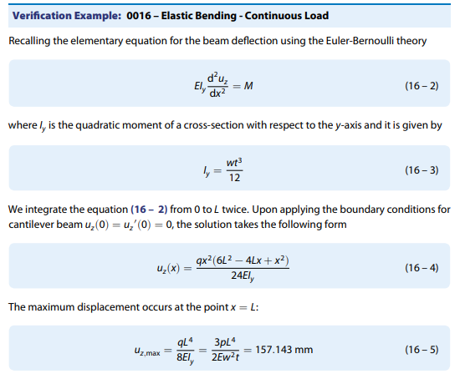
Figure 24 - 0016 – Elastic Bending - Continuous Load Validation Data Sheet

