Learning In the Digital Era
E-portfolio

Nicoleta Bichir
Student number: 2126694

Lecture: Christian Felices

Contents
Contents 2
Introduction 3
Report introductions have three key purposes: 3
Main finding 4
Academic writing 5
Conclusion Similarity: 7
Critical Analysis 8
PowerPoint Presentation 10
Conclusion 11
References: 12

Introduction
The introduction is one of the three most important sections of any academic essay or report. The introduction will introduce the topic to the reader by stating what the topic is and giving some general background information. In essence, this assists the reader in the ability to understand the explanation of the central idea or topics covered in the remainder of the text.

Report introductions have three key purposes:

- Clearly expressing the document’s aim
- Explaining the scope of the document
- Laying the foundation for the reader to understand the content of the text (Print, 2022).

Main finding

According to the Library Leeds the principal outcomes of a research project, what the project proposed, relieved, or indicated usually refers to the summary of the results rather than the conclusion recommendation derived from them.
Each point is presented, explored, and developed in the main finding. This point must be set out in a logical order, to make it easier for the reader to follow and understand (Leeds, 2022 ).

Academic writing

Academic writing is a way to share the knowledge you've gained in a certain field of study. We learn to look at what we've read and summarise what's important. Students must learn how to look at theories from different points of view and then write about what they've learned. In academic writing, a lot of attention is paid to technique and how it should be used to best communicate ideas.
According to The Star (17 September 2018), academic writing is one of the most important parts of the academic curriculum. At university, the lecturers are in the position to train students to write academically, and think critically and objectively, which is something that will benefit students later (Lumpur, 2018)
Academic writing is a formal writing style used in universities and academic journals. In order to confidently express and demonstrate our understanding of a subject, we must use academic writing. Since we started reading and searching for information, it requires time to reflect on the knowledge, compare it with other sources, and use it to complete your assignment. As you progress in your academic writing journey, you will add critical thinking and analysis to your work, ensuring that your views about the information in your subject area come through clearly and that you share your understanding in greater depth (Parson, 2011).

Academic writing
Academic writing is an advanced, procedure-focused style of writing. Although it has a formal tone and style, but no necessary the use of complicated terminology. Use formal language:
- Avoid using contraction, for example : use ,,did not” rather than ,,didn’t”
- Avoid emotional language, for example, instead of strong word such as, wonderful” or ,,terrible” use more moderate words such as, helpful or problematic”
The main aim of academic writing in English is to educate the reader. A few underlying characteristics of academic writing are: formality, clarity, accuracy, objectivity, and transparency (Smith, 2022).

Screenshot Similarity check
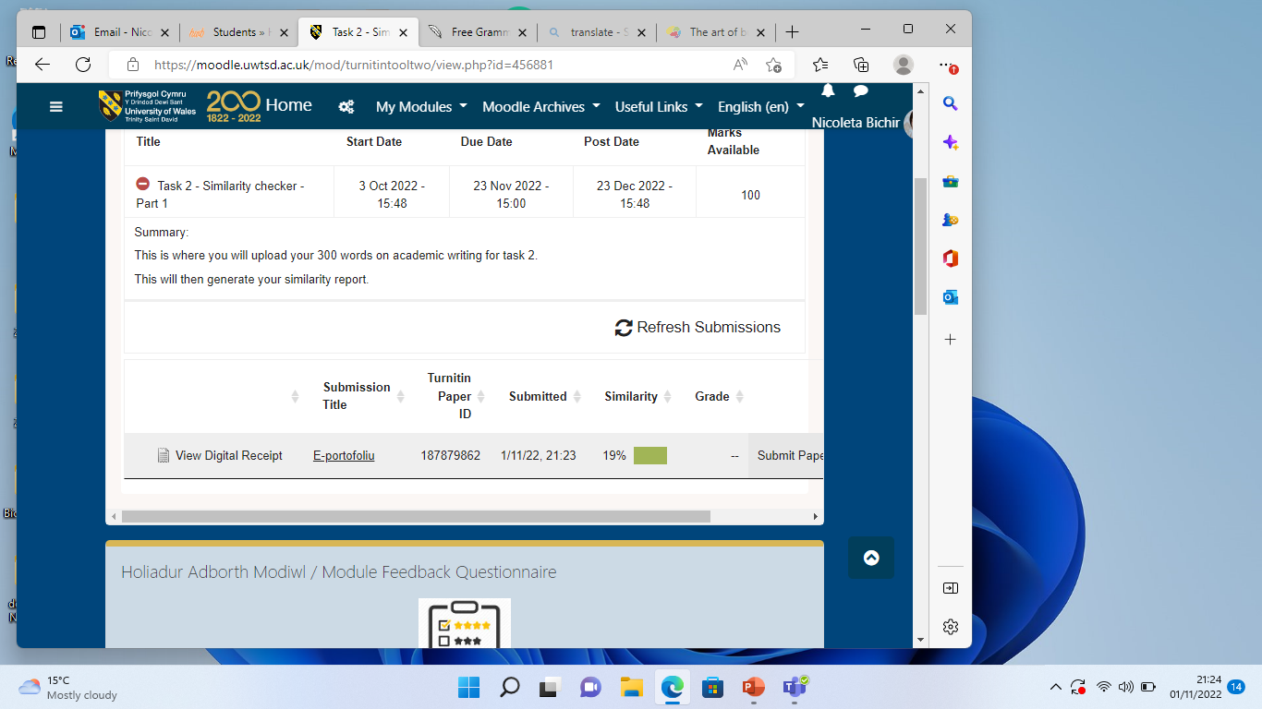

Conclusion Similarity:
The score allowed by our University for Turnitin is average 0-30%. After submitting my academic writing document, I found my similarity score to be 19%. There is a space for better and once I will more practice paraphrasing the affected areas, also I have to properly cite and reference things correctly in the further, I wish to get a lower score. However, I have then considered that 81% is my own work with 19% as.

Critical Analysis

"To critically analyses" means to assess the quality of the evidence and determine when it can and cannot support your position.
According to British School of Coaching for understanding and developing knowledge, the writer includes a demand that the student "analyses, interprets, and evaluates complicated material, concepts, and theories in order to generate modified conceptions a critical paper consists of two steps: critical reading and critical writing. The goal of writing a critique is to assess someone else's work (an essay, a book, a movie, a dissertation, a presentation, a picture, etc.) in order to improve the reader's knowledge of it. Because it provides the writer's opinion or evaluation of a text, a critical analysis is subjective writing (Barton, April 22nd, 2016).
Critical Analysis
After carefully studying the text under consideration, create the critique using this sample outline.
- Description of the work
- Evaluation and explanation
- Provide your readers some background information to help them understand what the work is about.
- Create a work summary.
- Determine the author's thesis and goal.
- To present accurate information
- Evaluate how the author has accomplished his purpose
- If the purpose is to inform, has the material been presented clearly, accurately, with order and coherence?
- If the purpose is to persuade, look for evidence, logical reasoning, contrary evidence (AcademicsEdu, 2022)

3 reasons why students should think about critical thinking when writing essays.

- It adds value to your essay: Having this section it will demonstrate How well the students has understood the writing work.
- It Facilitates a stronger conclusion: A student who has engaged in critical analysis is able to develop a conclusive argument based on a deeper understanding
- It widens the scope of research: When an report is prepared and created with the goal of participating in critical analysis , new research becoming available to the author. In order to make an opinion or conclusion the writer needs a good amount of information and a different topics and subtopics (Bartleby, 2022).

PowerPoint Presentation

Recording-20221124_162230.webm

Conclusion

The conclusion summarises the main points and highlight the key message or the idea you wish the reader to remember. It may also suggest additional research or investigation where appropriate. The conclusion should be clear, leaving the reader in no doubt as to what you think. It may also be a good idea to provide justification for why your conclusions are relevant and important. The conclusion is the final part of report, article or essay that summarizes the entire work, it is the end or result, and offer your final impression on the central idea. (Essex, 2008).

References:
Library, Leeds (2022)
[Online] Available at: www.library.leeds.ac.uk [Accessed] 14th October 2022
Azizi Ahmad Kuala Lumpur, 2018, Importance of Academic Writing [Online]
Available at: Importance of academic writing (livejournal.com)
[Accessed 31 October 2022]
Vanessa Parson,2011. What is academic writing? [Online]
Available at: What is academic writing? | The University of Sunderland
Accessed [01 November 2022]
Jack Smith,2022, What is academic writing?[Online]
Topic 2: Essential digital skills
Available at www.moodle.uwtsd.ac.uk
Accessed [31 October 2022]
Available at: What is Academic Writing? Characteristics & Types Of Academic Writing (academicwritingpro.com)
Accessed [ 31 October 2022]
Judith Barton ,2016, What is meant by critical analysis? [Online]
Available at : What is meant by critical analysis? | British School of Coaching
Accessed [20 NOVEMBER 2022]
Edu Academics Faculty, 2022, Critical analysis (Online)
Available at : CRITICAL ANALYSIS (southeastern.edu)
Accessed [ 21/11/2022]
Bartleby, 2022, Guide for a better Learning , The importance of Critical analysis in Academic Essay (Online)
Available: The Importance of Critical Analysis in Academic Essays | Bartleby
University of Essex, 2008 , How to improve your academic writing? [Online]
Available: SG Academic Writing Bk_20949 (Essex.ac.UK)
Accessed [01 November 2022]

Ted and Talk, Dana Gioia, 2012, Sense of Place (Video)
Available: A Sense of Place: Dana Gioia at TEDxSonomaCounty - Bing video
Accessed [ 22/11/2022]
UNIT 2 FORUM, Topic 1, 2022 , Sense of place and identity (Online)
Available at: https://moodle.uwtsd.ac.uk/mod/forum/view.php?id=436048
Accessed: [20/11/2022]

