University of Wels Trinity Saint David

Introduction to Health and Social Care

Pharmacy Service in UK

May 2026

Andreea-Daniela Belu - 2521415

LCHS4003 – DR Vivian Osuchukwu

PHARMACY SERVICES IN HEALTH AND SOCIAL CARE
Supporting Safe, Accessible and Effective Use of Medicines
How Pharmacy Services Function Today

Pharmacy services in the UK have their roots in the apothecaries of the 17th century, who were the first practitioners to both prescribe and dispense medicines to the public. The professionalisation of pharmacy was greatly advanced after the Pharmacy Act of 1852, which created the Pharmaceutical Society of Great Britain and formalised the regulation of the profession (Anderson, 2005). The introduction of the NHS in 1948 was a turning point, as community pharmacy became publicly funded health professionals, at the centre of primary care. The role of the pharmacist in clinical and public health has been further broadened since then, with the implementation of the Community Pharmacy Contractual Framework in 2005 (Moriarty et al., 2025).


What Are Pharmacy Services?
Pharmacy services are an integral part of the United Kingdom's health and social care system, offering community-based healthcare to millions of people every year. Pharmacies provide first point of contact health care without an appointment, unlike hospitals or general practice surgeries, and are one of the most accessible points of contact in the National Health Service (NHS). Pharmacists are highly trained clinical professionals who dispense prescribed medicines, provide health advice, administer vaccinations and manage minor ailments, which helps to alleviate the strain on overstretched GP services and emergency departments (Anderson and Sharma, 2020).

A Brief History of Pharmacy Services
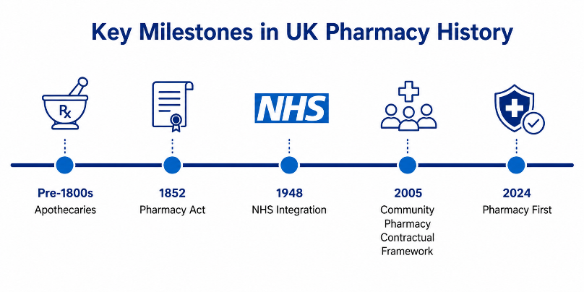

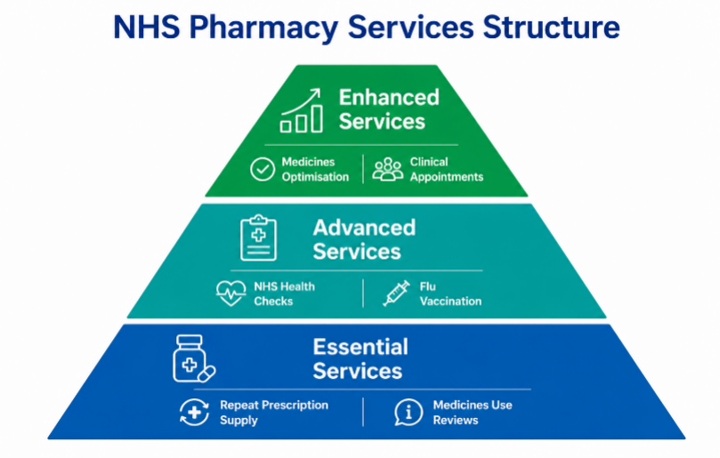
Challenges
Modern pharmacy services in the UK are provided under a tiered contractual structure, with essential, advanced and enhanced services. Essential services are those of dispensing, repeat dispensing and disposal of unwanted medicines. Advanced services include structured medication reviews, hypertension case-finding and the NHS Community Pharmacist Consultation Service (CPCS) which allows GPs and NHS 111 to refer patients directly to a pharmacist for a clinical consultation on the same day (NHS England, 2023a). In January 2024, the Pharmacy First initiative was introduced, which further expanded pharmacists' prescribing powers to allow them to prescribe seven common conditions, such as urinary tract infections, shingles and sinusitis, without a GP referral (NHS England, 2024).
.

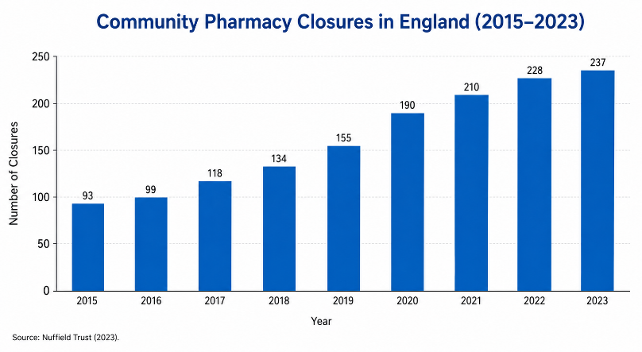
There are two major and interrelated issues that are currently confronting community pharmacies in the UK that are likely to have a significant impact on the sustainability of the UK's most accessible frontline service, the NHS. First, the sector is facing a serious and growing workforce crisis, despite a much broader scope of practice. According to the NHS England (2024), there are currently around 31% of unfilled positions in the pharmacy technician profession, and the vacancy rate for pharmacists has also hit a record high. These chronic staffing shortages have a direct impact on patient safety, the incidence of dispensing errors, the risk of burnout among the remaining staff, and a major contributor to the closure of pharmacies, especially in socioeconomically deprived areas where convenient, walk-in healthcare is most needed (Urionagüena et al., 2024). Second, and exacerbating this workforce shortage, since 2015, community pharmacies have seen a real terms funding cut of over 30%, leading to financial instability throughout the community pharmacy sector (Baird, Nuhu and Jiao, 2024). Since 2017, over 1,000 independent pharmacies have been shut down, especially in rural and economically disadvantaged areas. This shrinking of the pharmacy network exacerbates existing health inequalities and systematically limits access to key medicines and clinical guidance for those who are least likely to be able to access it elsewhere. Most importantly, Lewis and Williams (2023) states that if.

this dual crisis of understaffing and underfunding is not addressed urgently, it could lead to the emergence of a nationwide network of 'pharmacy deserts' in England, which would have a devastating impact on a service that millions of vulnerable people rely on every day for their health and wellbeing.

Strengths
However, there are significant strengths in community pharmacy. Pharmacists are trusted, highly qualified clinical professionals who are part of the community, available without an appointment and uniquely placed to provide frontline care. The Pharmacy First initiative (NHS England, 2024) is a good example of the growing clinical role of the pharmacy sector, where pharmacists can now treat common conditions that would have been referred to a GP. Pharmacy also offers excellent value for money in the NHS, a consultation in community pharmacy is significantly cheaper than a GP or ED attendance, and is one of the most cost-effective primary care models available (Lewis and Williams, 2023)

Solutions
There is an urgent need to reform the structure on two fronts to tackle these challenges. The NHS Long-Term Workforce Plan suggests increasing the number of training places in pharmacy and formalising prescribing technician roles, to help ease staffing pressures and enhance clinical capacity (NHS England, 2023b). A sustainable settlement based on inflation is a must on funding. The £645m Pharmacy First investment is a sign of government commitment, but a new Community Pharmacy Contractual Framework that fairly rewards clinical services, not just volume, is needed to stop further closures and ensure access to pharmacies is equitable in all communities, especially those at greatest risk of becoming a pharmacy desert (NHS England, 2024).

Task 2: Community Mental Health Services
Introduction
Community mental health services (CMHS) are one of the most important and controversial innovations in contemporary social care, reflecting a radical rethinking of the nature, treatment and provision of mental health care in society. It is important to first understand the historical context in which they came into existence and why they are possible and necessary in their current state, in order to critically assess their current function and importance.
Origins and Historical Context
In the UK, before the mid-twentieth century, mental illness was treated almost entirely by institutionalisation. Tens of thousands of people were kept in large psychiatric hospitals, or asylums, where the focus was on containment rather than treatment, and where they were often detained for long periods of time without any clear end in sight (Rogers and Pilgrim, 1995). The Royal Commission on the Law Relating to Mental Illness and Mental Deficiency in 1957 challenged the limitations of this model in its report, which was used to inform the Mental Health Act 1959, the first legislation to create a legal framework that focused on community care instead of institutional care. The next Hospital Plan of 1962 established goals for the reduction of long-stay psychiatric beds, which began to be phased out in the 1970s and 1980s (Bilir, 2018). However, the closing of institutions often did not go hand in hand with investment in community alternatives, and this imbalance remains a key feature of the debates about the service today.
Current Functioning of Community Mental Health Services
Modern community mental health services are delivered via a range of Community Mental Health Teams (CMHTs), crisis resolution and home treatment teams, early intervention in psychosis services and Improving Access to Psychological Therapies (IAPT) programmes (which are now known as Talking Therapies, (NHS England, 2023a)). These services are intended to help individuals with moderate to severe mental health needs to receive care in their own home and community, rather than be admitted to hospital, when clinically appropriate. The NHS Long Term Plan (2019) has set out a target to increase community mental health services, with an extra £2.3 billion to be invested in the service by 2023/24 and an additional 370,000 adults and older people to be accessing services each year (NHS, 2019). This is a step in the right direction, but there are definite drawbacks. There is a persistent delay in psychological therapies, with NHS Digital (2022) reporting that a significant number of referrals were waiting for more than eighteen weeks, which is the standard time for psychological therapies. In addition, the Care Quality Commission (2014) has expressed ongoing concerns about the quality of crisis services and the lack of coordination between CMHS, primary care, housing and social services, which disproportionately impacts those with the most complex needs. Therefore, it is not enough to assess CMHS only in terms of investment; the structural coherence of provision needs to be assessed as well.
Significance for Quality of Life
Despite these limitations, the significance of community mental health services in enhancing However, the importance of community mental health services in improving the quality of life of service users is well documented despite these limitations. Vaseel et al. (2025) suggest that when delivered well, well-resourced community care is more effective than institutional care in a number of areas, such as symptom management, social functioning and subjective wellbeing. The recovery-oriented approach that is part of the current philosophy of CMHS has been linked to increased self-efficacy and continued service engagement (Lim, 2018). Community-based support provides for the participation of many service users in employment, family life and civic society, which long-term hospitalisation would otherwise have prevented.
Conclusion
Community mental health services are a reflection of the ideals and paradoxes of contemporary social care. They were born of deinstitutionalisation but have not fully lived up to its promise; their present operation shows that they have grown but have not yet caught up with the promise of deinstitutionalisation. Their importance to service users' quality of life is very real, but depends on investment, integration and adherence to recovery principles that are not consistently provided by the system.

References
Anderson, C. and Sharma, R. (2020) “Primary health care policy and vision for community pharmacy and pharmacists in England,” Pharmacy Practice (Granada), 18(1).
Anderson, S. (2005) Making Medicines : A Brief History of Pharmacy and Pharmaceuticals. Pharmaceutical Press PP - London ; Chicago.
Baird, K., Nuhu, N. and Jiao, L. (2024) “The effect of Porter’s competitive forces on competitive advantage and organisational performance and the moderating role of management accounting practices,” Journal of Management Control, 35(2), pp. 303–332.
Bilir, M.K. (2018) “Deinstitutionalization in mental health policy: From institutional-based to community-based mental healthcare services,” Hacettepe Sağlık İdaresi Dergisi, 21(3), pp. 563–576.
Care Quality Commission (2014) Monitoring the Mental Health Act in 2012/13.
Lewis, R. and Williams, W. (2023) “Community pharmacy clinical services,” Nuffield Trust: The King’s Fund [Preprint].
Lim, K.H. (2018) “Personal journeys of recovery: Exploring the experiences of mental health service users engaging with the Kawa’River’model.” Brunel University London.
Moriarty, S. et al. (2025) “A qualitative evaluation of clinical services under the Community Pharmacy Contractual Framework.”
NHS (2019) The NHS Long Term Plan. Available at: www.longtermplan.nhs.uk.
NHS Digital (2022) Psychological Therapies, Annual Report on the use of IAPT services, England, 2021-22. Leeds: NHS Digital. Available at: https://digital.nhs.uk/data-and-information/publications/statistical/psychological-therapies-annual-reports-on-the-use-of-iapt-services/annual-report-2021-22#.
NHS England (2023a) Community Pharmacy Contractual Framework. NHS England. Available at: https://www.england.nhs.uk/primary-care/pharmacy/community-pharmacy-contractual-framework/.
NHS England (2023b) NHS Long Term Workforce Plan, NHS Long Term Workforce Plan.
NHS England (2024) Pharmacy First: Written evidence submitted by the Company Chemists ’ Association ( CCA ) ( PHA0045 ).
Rogers, A. and Pilgrim, D. (1995) A Sociology of Mental Health and Illness, Disability & Society. Available at: https://doi.org/10.1080/09687599550023778.
Urionagüena, A. et al. (2024) “Community pharmacy & primary care integration: qualitative study on stakeholders’ opinions and interventions,” Journal of Pharmaceutical Policy and Practice , 17(1), pp. 1–16. Available at: https://doi.org/10.1080/20523211.2024.2395551.
Vaseel, M. et al. (2025) “Transforming Mental Health Care: A Chart-Based Study of Home-Based Services,” Journal of Psychosocial Rehabilitation and Mental Health, pp. 1–8.

