lecturer: CHARLES OBINWA
Individual REPORT- INNOVATION & CUSTOMER JOURNEY
Student: Claudia LUCIA Piscorean
Student id: 2316909

Module LCLM6002 - Design Thinking and Innovation

Table of Contents

Introduction to the chosen organisation: Huawei
Key consumer and industry trends and data that affect the organisation: Huawei UK
Part 1: An analysis of Huawei’s approach to innovation including application of the Innovation Ambition Matrix and the current customer journey
Part 2: Proposed new digital transformation initiative and the way it will add value to Huawei
Conclusion
Reference list

Introduction to the chosen organisation: Huawei
Design thinking is a human-centred approach to solve problems and drive innovation based on the user's needs. These elements promote creative solutions and test them to ensure the products and services, along with the strategies to fetch reliable, desirable, and sustainable success for real people and situations. An efficient design thinking reduces risks and encourages thinking outside the box to explore novel approaches. It promotes balanced factors for desirability or customers’ needs, feasibility or the way it is possible, and viability or which is sustainable (Baldassarre et al., 2024; p. 30). Hence, through an effective design thinking, companies can promote innovation and proceed to functional solutions, which are delightful, business-oriented, and user-friendly as well. In this context, the present study concentrates on the innovation level of Huawei and addresses its present customer journey map. Based on the found gap, it will propose a new digital transformation initiative and address updated customer journey mapping to understand the success of that proposed initiative, which will be measured through KPIs.

Figure 1: Huawei logo
(Source: Huawei, 2025b)
Huawei is a leading provider of information and communication technology (ICT) infrastructure and smart devices throughout the world. Currently, this Chinese company operates in more than 170 countries, including the UK (Huawei, 2025a). It served more than 3 billion people worldwide with its 208 thousand employees. The vision and mission of this company is “to bring digital to every person, home and organization for a fully connected, intelligent world”. This company invests in research and innovation activities; its innovation practice is driven by two factors: customers’ needs, and science and technology. In 2024, this company spent more than £19 billion, which was almost 21% of its total revenue; its overall R&D investment in the last decade exceeded £130 billion (Huawei, 2025c). This company has been operating in the UK since 2001 and supplies the telecom infrastructure and devices. However, in 2020, “National Cyber Security Centre” (NCSC) concentrated on safety and security of the UK, while the US sanction banned Huawei’s ability to use the US technology and software to manufacture its products (NCSC, 2025). This resulted in NCSC’s decision to remove the products of this company from its 5G network within 2027.

Key consumer and industry trends and data that affect the organisation: Huawei UK

Core consumers
The prime consumer market of the smart devices of Huawei UK are the smartphone users, the users of wearables and audio devices, PCs, and tablets. This indicates the use of a business to consumer (B2C) business model, which promotes the sales of this company. On the other hand, the key customers of Huawei UK are the major mobile operators, such as BT (EE), Vodafone, and Three (Hutchison) (). These mobile operators assist this company to follow a business-to-business (B2B) business model. In other words, the telecommunication operators are the core customers of this company. The high-quality services of this company allowed it to communicate and continue businesses with these companies, based on 3G, 4G, and the initial 5G network.
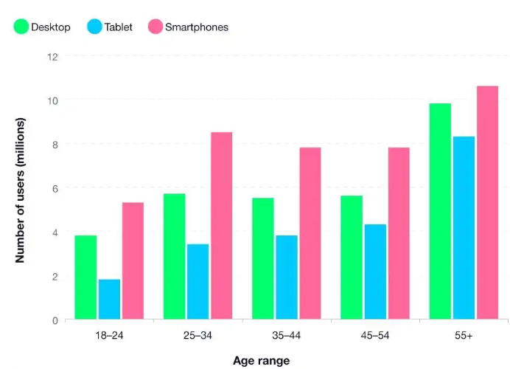
Figure 2: Digital population of the UK based on devices and age group
(Source: Baker, 2024)
The total number of smartphone users in the UK is 40 million, while the number of tablet users is almost 22 million and desktop users are more than 30 million. The above figure mentioned that the use of digital devices increases based on age; people at more than 55 years old use desktops, tablets and smartphones more (Baker, 2024). Hence, this group can be mentioned as the dominant group that is more than 10 million in number for using smartphones. Again, the number of smartphone users within the 18 to 24 years age group is only 5.3 million in this country. The number of smartphone users was 89% in 2023, which increased from 86% in the previous year. Hence, it can be said that the customer numbers for smartphones and other smart devices are increasing, which is effective for the development of the business processes.

Key trends in the telecommunication industry
The UK focuses on developing and upgrading its telecommunication services to improve its communication abilities and operations of the smart cities. The UK intends to potentially deploy the 5G network for its connection activities; this industry is planning to develop 6G infrastructure as well (‌TechUK, 2025). This industry intends to enhance the capacity of telecommunication activities and reduce latency. On the other hand, this industry in the UK aims to improve the use of fibre broadband through continuous rollout. It aims to boost the Project Gigabit for the underserved regions to potentially increase the UK home speed. This initiative delivered gigabit connectivity to more than 1.1 million hard-to-reach UK premises (‌Gov, 2025). This government initiative handles the digital divide in hard-to-reach regions; in this way, both the rural and urban telecommunication infrastructure can be improved. Moreover, this industry is investing in improving satellite services, which enables direct-to-device satellite communication. Nevertheless, the advanced use of open and interoperated networks, which is RAN architecture, can promote the services for the development of the business processes. AI is utilised to improve telecommunication practices; network optimisation, fraud detection, prevention, customer experience, and management can be promoted in the development of the business processes (‌Subex, 2024). AI assists the telecom operators to detect revenue leakage and ensure accurate billing. More personalised and faster services assist the companies to enhance customer services through chatbots services.

Key trends in the ICT industry
Cloud commuting is one of the dominant trends in information and communication technology (ICT). This industry observed massive enterprise adoption of cloud computing services for efficiency, scalability, and agility. The cloud commuting market in the UK achieved more than £21 billion in 2024, which accounted for the 20% of revenue share in this financial year. Moreover, this market can reach more than £57 billion by 2034 [Referred to Figure 3]. The UK prefers a strong IT ecosystem and has a high concentration of its regional and global cloud service to foster competitiveness and innovation practices. The financial industry, as well as all other industries, intends to use this technology to upgrade and strengthen the use of cloud services (‌Wadhwani, 2025). In fact, the UK government and regulatory framework support digital transformation for a secured and stronger cloud infrastructure.
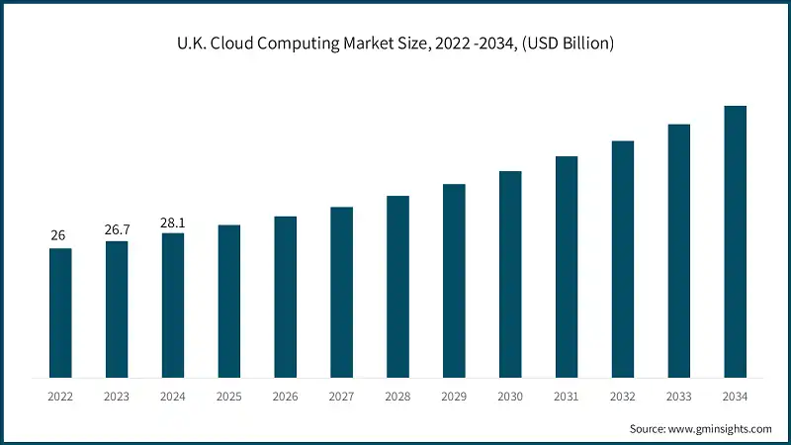
Figure 3: Cloud computing market size in the UK
(Source: Wadhwani, 2025)
The ICT industry increases spending to increase cyber security protocols to minimise the threats of data theft and Ransomware. In fact, all the industries aim to utilise AI for efficient human resource management by maintaining specialised talents and having an impact on network operations. In addition, the combined priority of AI and 5G network field the advance use of Internet of Things (IoT) in the ICT services (‌Travis, 2024). Nonetheless, rapid growth of “Software-as-a-Service” (SaaS) improves industrial practices in the UK ICT sector.

Response from the government
The UK government focuses on enhancing its national safety and security through telecommunication activities. It implemented “Telecommunications (Security) Act 2021” to protect the telecommunication activities in this country. This government cited national security risks on the products of this company; the US Sanction raised questions on the security issues of Huawei. It eliminated Huawei’s access to US semiconductor technology to reduce the security issues and reliability issues of its components. Hence, NCSC advised the UK government to avoid its products as this company and its products can no longer be relied on for national security. According to the report of ‌Clark et al. (2025), Chinese states and companies can exploit the weaknesses of telecommunication equipment in this country and foster cyber-attacks.
In this context, Huawei UK will need strategies to regain the trust of the UK government and continue its operations here to foster its survival and growth.

Part 1: An analysis of Huawei’s approach to innovation including application of the Innovation Ambition Matrix and the current customer journey

Innovation Ambition Matrix
- Core: Current design thinking of Huawei UK
Huawei UK focuses on improving its products, such as smartphones, PCs, tablets, and network gear. This company invests in better camera features, faster Kirin chips, and network optimization for carriers. Its ultra-Chroma camera is equipped with 1500 thousand spectral channels to produce its incredible true-to-life colours (‌Huawei, 2025d). The software-hardware chip cloud synergy potentially improved the camera capabilities to shoot photos and videos. This stage aims to maintain its market share and ensure its reliable offering to its core customers in the UK [Referred to Figure 5].
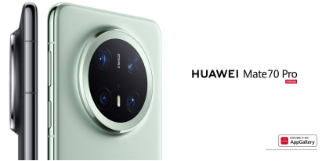
Figure 4: Ultra Chroma camera from Huawei UK
(Source: Huawei, 2025d)
- Adjacent: The innovation Huawei UK is engaged in
Huawei UK aims to explore its experience monetization, design products, offerings, and develop potential user bases. This entity innovates its leading carriers to verify its 5.5G technology, deploy its 5.5G commercial networks, and explore its innovation application scenario (‌Huawei, 2025d). This company intends to grow its “1+8+N” ecosystem for its products, which can improve its ICT capabilities for the UK government. These activities aim to attract new customer segments in this country and capture new revenue streams to build the stickiness of its ecosystem [Referred to Figure 5].
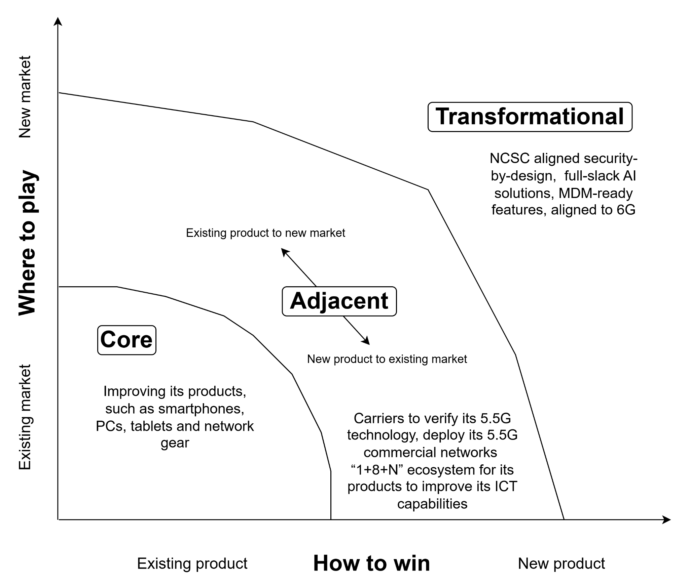
Figure 5: Innovation Ambition Matrix of Huawei UK
- Transformational: New innovation opportunities on Huawei UK’s horizon
Huawei UK can focus on creating a new business model, which will assist this company to achieve high reward. This company aims to upgrade its design innovation through efficient use of artificial intelligence (AI) (‌Huawei, 2025d). Its advanced cloud services, AI strategies, and full-slack AI solutions can be developed to promote network-based safety and security. In this financial year, this global entity can focus on increasing its involvement in long-term transparent reporting. Here, it can innovate and improve its 5G network, along with investment in 6G protocols, and products based on NCSC aligned security-by-design. By banning the default password system, Huawei UK can introduce MDM-ready features to comply with the new UK network security regulations. The goal of this innovation step is to make the company future-proof by creating disruptive growth and leading technological frontiers [Referred to Figure 5].
Based on the Innovation Ambition Matrix, it can be said that Huawei UK can promote its innovation to utilise AI based on NCSC aligned security-by-design, 6G infrastructure, and transparent MDM-ready features for its innovation practices.

Customer journey map
- Things that Huawei UK creates for its core UK customers
At the awareness stage, Huawei UK allows its core UK customers to discover its products within this country. Online advertisement, review from previous users, and online search for electronic products makes the customers aware of its devices. Huawei UK is present in social media channels, such as Facebook, LinkedIn, Twitter, YouTube, TikTok, and Instagram (Huawei, 2025e). Here, online ads, search engines, and word-of-mouth facilities can enhance the curiosity of the target customers of this company. However, customers often shift to common tech information to identify particular product details [Referred to Figure 6].
At the consideration stage, the customers of Huawei UK are allowed to evaluate its offerings and compare those with the offerings of its competitors and gather detailed information. At this level, the target customers visit Huawei UK website to find products and understand specifications. Third-party reviews from news sites and tech blogs influence their actions and they can compare both price and features on the websites; in fact, customers visit the mortar and brick stores of this entity. All these actions create positive emotions of the core customers of the UK, for which Huawei products are spread in almost all companies and households of this country. The pain point includes the way its products can meet particular ICT and telecommunication needs through the smart devices [Referred to Figure 6].
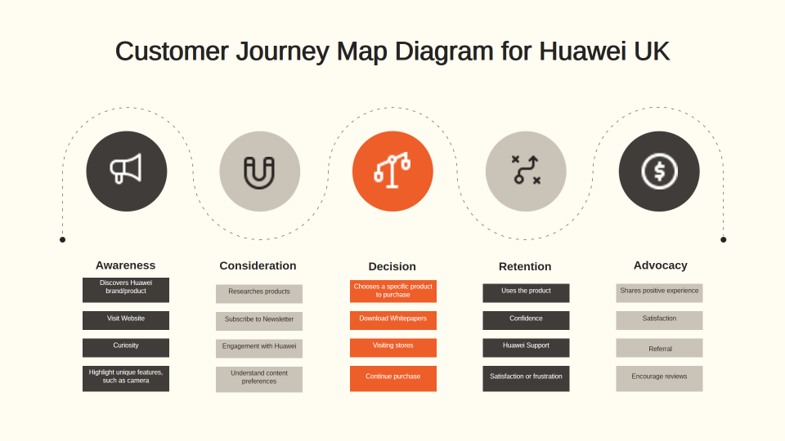
Figure 6: Customer journey mapping for the current services of Huawei UK

The decision stage allows customers to make decisions to purchase Huawei products and avoid its competitors’ products. In this stage, the customers add their desired smart and latest devices on an online cart for purchase from online sites or from physical stores (‌Roslan and Haron, 2024; p. 67). Seamless purchasing experience influences them to continue their purchasing activities; it generates the sense of anticipation, excitement, and relief based on their purchasing [Referred to Figure 6].
At the retention phase, Huawei UK intends to gather post-purchase experiences to fetch ongoing support from the customers. In this stage, the customers can download the online applications of this company; the company also allows customers to contact the company to fetch online support regarding any technical issue (Du and Rojniruttikul, 2025; p. 528). Here, its e-support channel website, and Huawei application plays the most essential role to promote both positive and negative emotions. Customers are satisfied with its products and are frustrated when issues arrive. In this case, customers face the pain point of difficulty in troubleshooting the technical issues and will need to support responses and learn the new software ecosystem [Referred to Figure 6].
The advocacy stage let’s satisfied customers advocate this Huawei UK brand; satisfied customers leave positive reviews for the products and recommend this brand to their families and friends. This stage generates positive emotions from the customers, such as loyalty and pride of ownership [Referred to Figure 6].
- Relevant pain of Huawei UK
The crucial pain that Huawei UK customers are facing is the customer service issues; they consider their purchasing experiences, as well as customer service experience horrific and terrible. The customers from the UK shared their mixed feeling about its products while some customers appreciate the designs and features of its products, other consumers share the issues that they encountered (TrustpilotUK, 2024). These raised questions on the quality consistency of its products; on the other hand, negative reviews regarding its customer experiences are prime issues of this company; they find that assistance and resolving their issue is very difficult. It increases customer dissatisfaction; they are gaining frustrating experiences when they are going to communicate with this company about the problems. For this reason, this company gained only a 1.6-star rating from customers [Referred to Figure 7].
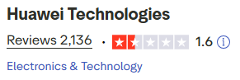
Figure 7: Lower customer satisfaction rate for the Huawei UK products
(Source: TrustpilotUK, 2024)
On the other hand, Huawei UK is expecting to face a decline in its revenue in the 2025 financial year. This Chinese telecom company faced a decline in its annual turnover from £229.6 million in 2023 to above £188 million in 2024. From 2019, this company is facing a steep fall in its revenue in the UK; in that financial year, the company gained £1.26 billion revenue (‌Killeen, 2025). It can be said that both governmental restrictions and negative feedback from the customers are resulting in this type of issues and loss in revenue.
- Gain points of Huawei UK
The gain points for the UK customers can be promoted for the development of their positive experiences in this country. “HUAWEI Member Points program” allows customers to gain points based on the purchases from online channels (‌Huawei, 2025f). The customers can gain points from their active involvement with this company; in fact, the customers are allowed to earn points from its offline stores as well. Customers can enjoy the offers and discounts from its purchasing activities.
- Identification of opportunities in customer journey of digital innovation of Huawei UK
Huawei UK was accused for inefficient security management in its products, while the customers are frustrated with its product designs and inefficient customer service. Based on this analysis, the entity can upgrade its services and activities for its customers. It can be said that this company will need to promote digital innovation based on its security concerns, along with user-friendly designs. Innovation in its customer service management activities are also required. AI-powered chatbots and virtual assistants can improve the organisational efficiency in communicating with customers. Through these devices, Huawei UK can improve its communication practices; the customers can share their experiences and issues based on their active involvement in chatbots. Virtual assistants can reduce call volume by solving their queries, as well as providing user guidance (‌Johnsen, 2025). On the other hand, the use of AI-based conversation intelligence will assist this company to assess customer conversation and evaluate trends, customer sentiments, and satisfaction.

Part 2: Proposed new digital transformation initiative and the way it will add value to Huawei

A new digital transformation initiative for Huawei UK
Huawei UK can invest in digital transformation initiatives for managing the business processes and the development of the brand image in the UK. The initiative can be named as “Future Forward Cybershift”, in which this entity can increase its investment. The aim of this initiative will be “Secure Network for Future”, which will indicate the value of this business processes and security focus of these organisational activities. Currently, the present company can address the value of the business processes and ICT infrastructure. The digital transformation can be based on UK-specific R&D strategies and digital platform strategies. The company can focus on the NCSC aligned security-by-design to shape its digital transformation (‌CISA, 2025). In this initiative, this Chinese company can utilise MDM-ready features in advanced digital platforms. The efficient use of advanced technology can upgrade the telecom infrastructure based on the potential activities. In this case, the present company can engage its working with UK operators; it is required to reduce the adverse effect of banishment from the UK on the reputational concern of this company. The telecommunication infrastructure can be transformed from 5G to 6G to upgrade potentials of this initiative. This initiative will be developed by the advanced use of AI-based chatbots and conversation analytics.

The way the initiative can overcome identified challenges of Huawei UK
The “Future Forward Cybershift” initiative will increase the potential and secure use of 5G technology in its devices. In addition, the incorporation of 6G applications based on “Telecommunications (Security) Act 2021” and NCSC’s security-by-design can increase the reliability of the products. Design and innovation focus on users’ needs and sustainable practices; however, questions on cyber security of a nation do not follow the sustainability goals, provided by the United Nation, especially SDG 16, “Peace and Justice, Strong Institution”. Cyber threats do not follow peace and justice of a country; hence, Huawei UK will need to look after and reduce the cyber security challenges. In this concern, the network equipment can be developed based on legal mandates; it can increase the value of this company for managing its security infrastructure. On the other hand, the activities under this digital initiative will align with the UK security standards.
In this process, the company will train its UK employees to understand the use of advanced technology and infrastructure. The changes in technology and all activities will be explained to them to align with this initiative goal. The digital security will be maintained in its advanced use of AI-based chatbots and conversation analytics. In the present task, trained employees will be able to use these technologies efficiently and ethically.

Updated and enhanced customer journey map for new initiative, “Future Forward Cybershift”, by Huawei UK
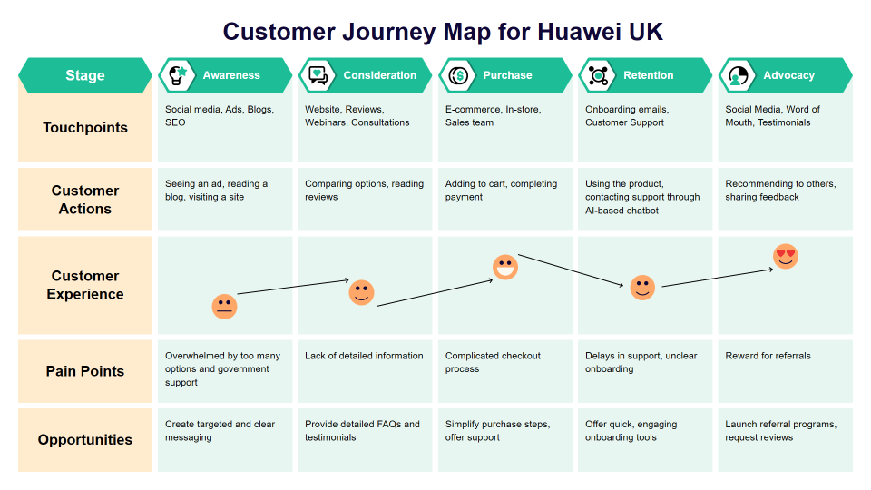
Figure 8: Updated customer journey map for Huawei UK for the digital initiative, “Future Forward Cybershift”
The updated customer journey map will be almost similar for the Awareness, consideration and purchasing activities. The customers, both businesses and common people, will be aware of the way the products of Huawei UK maintain government regulation. Documented government support can increase the demands of the products of this company potentially (Carayannis et al., 2024; p. 2). In this concern, the present company can highlight a positive brand image and potentially strengthen its market position in the UK. The retention stage will improve the customer journey and their positive experiences due to the use of advanced technologies. Figure 8 mentions that the use of AI-based chatbots will maintain a happy experience of the customers, which will improve the customer satisfaction level.

Positive impact of the initiative on Huawei UK
The “Future Forward Cybershift” initiative can have a positive impact on its international, as well as UK marketplace. Increased reliance and trust from the government enhances brand reputation and consumer trust (‌Celestin and Sujatha, 2024; p. 82). Hence, more telecommunication companies and common people will be able to trust again on this company and increase their purchase from it. Due to UK restriction and banishment, this international leading ICT Company faced a loss in its revenue from 2020. Hence, trust from this government, along with increased purchasing, can assist this company to regain its economy. However, the present company will need to concentrate on the ethical use of chatbots and conversation analytics to gain consumer trust for its services. Enhanced engagement of the customers in the organisational processes can be effective to increase support from key customers, which can mitigate the banishment consideration of this company in the UK.
Huawei UK will maintain the guidelines and directions of “Telecommunications (Security) Act 2021”. This act is landmark legislation to create and manage stronger cyber security practices for telecom providers (Legislation, 2025). This act aims to secure public electronic communications and networks from services to reduce security compromises. By maintaining this regulation, this entity will be able to be ready and aware of the global cyber security threats. Advanced use of cloud computing technology and AI will protect telecommunication technologies for the development of the business processes.

Way to measure positive impact and success of the initiatives by Huawei UK
High score on SDG parameter, especially in SDG 16:
The initiative will increase its score in the parameters of UN SDGs, with special focus on SDG 16. This goal aims to promote peace and justice, along with strong institutions, with a larger aim to maintain global peace (‌Martin, 2025). The UK government could not rely on this Chinese company Huawei, due to its inefficient and not reliable network connection. It can be considered as an example of lack of political trust and peace. Hence, this company will need to focus on this practice eminently to regain trust from the UK government and maintain its position in other operational areas [Referred to Figure 9].

Figure 9: Connection between Huawei UK and SDG 16

Increased score in Customer Satisfaction (CSAT) and star-based rating:
As Huawei UK will improve its customer communication and relationship, the present initiative will increase its score. Its success can be measured by its customer relationship and service rating to above 4 stars. Increased number of positive reviews can improve its performance in retention and advocacy steps.
Trust from the UK government and increase the number of operating countries:
Trust from the UK government will be highly crucial for the development of a positive and reliable image of Huawei UK. Trust and mitigation of banishment in this country will allow this company to regain its trust from other operational countries. As a result, this company will be able to expand its market in more countries and increase the number of its operating countries.

Conclusion
Design thinking and innovation management is crucial for developing the business processes and promote efficient management of the organisational practices and culture. This report concentrated on a Chinese company, Huawei, which operated in the UK; while introducing this globally leading organisation, this report found that it is facing operating issues in this country due to cyber security issues. Now, this company is facing a reputational issue as its products and 5G network are banned from the UK. This report found that the customer satisfaction rate is very low for this company, which increases operational efficiency. In order to understand the issues eminently, it utilised Innovation Ambition Matrix and Customer Journey Mapping. Based on this analysis, this present report provided a design thinking and innovation planning, which can improve its overall operation. This report suggested this company to utilise AI based on NCSC aligned security-by-design, 6G infrastructure, and transparent MDM-ready features to improve its innovation practices. Additionally, ethical use of AI-based chatbot and conversation analytics can smoothen customer management. Nonetheless, the KPIs regarding sustainability score, customer satisfaction rate, star-based rating, and trust from the UK government can meet the operational efficiency of this company.

References list

- Baker, N. (2024) UK mobile phone statistics 2025 – stats report. Uswitch. Available at: https://www.uswitch.com/mobiles/studies/mobile-statistics/ (Accessed: 10 December 2024).
- Baldassarre, B., Calabretta, G., Karpen, I.O., Bocken, N. and Hultink, E.J. (2024) ‘Responsible design thinking for sustainable development: critical literature review, new conceptual framework, and research agenda’, Journal of Business Ethics, 195(1), pp. 25–48.
- Carayannis, E.G., Dumitrescu, R., Falkowski, T. and Zota, N.R. (2024) ‘Empowering SMEs: harnessing the potential of Gen AI for resilience and competitiveness’, IEEE Transactions on Engineering Management. doi: (if available).
- Celestin, M. and Sujatha, S. (2024) ‘Impact on brand trust and consumer behavior: leveraging social media influencers to drive credibility and engagement across industries’, International Journal of Applied and Advanced Scientific Research, 9(2), pp. 81–87. Available at: https://ijaasr.dvpublication.com/uploads/66fee2d05e121_402.pdf (Accessed: 12 December 2024).
- Cybersecurity and Infrastructure Security Agency (CISA) (2023) Principles and approaches for secure by design software. Available at: https://www.cisa.gov/sites/default/files/2023-10/SecureByDesign_1025_508c.pdf (Accessed: 10 December 2024).
- Clark, A., Jozepa, I., Dawson, J., Lewis, J. and Curtis, J. (2025) Chinese state threat activities in the UK. House of Commons Library. Available at: https://commonslibrary.parliament.uk/research-briefings/cbp-10417/ (Accessed: 12 December 2024).
- Du, M. and Rojniruttikul, N. (2025) ‘Business case study: antecedents of user satisfaction with Huawei mobile phones’, Review of Integrative Business and Economics Research, 14(1), pp. 519–530. Available at: http://buscompress.com/uploads/3/4/9/8/34980536/riber_14-1_33_k24-156_519-530.pdf (Accessed: 10 December 2024).
- Huawei (2025a) Corporate information. Available at: https://www.huawei.com/en/corporate-information (Accessed: 11 December 2024).
- Huawei (2025b) Huawei United Kingdom. Available at: https://www.huawei.com/uk/ (Accessed: 12 December 2024).
- Huawei (2025c) Innovation and intellectual property. Available at: https://www.huawei.com/en/ipr (Accessed: 12 December 2024).
- Huawei (2025d) Huawei Investment & Holding Co., Ltd. annual report 2024. Available at: https://www.huawei.com/minisite/annual-report-download/annual_report_2024_en.pdf (Accessed: 12 December 2024).
- Huawei (2025e) Huawei social media privacy notice. Available at: https://consumer.huawei.com/uk/privacy/social-media-privacy-notice/ (Accessed: 12 December 2024).
- Huawei (2025f) Huawei member points. Available at: https://consumer.huawei.com/my/offer/huawei-member-points/ (Accessed: 12 December 2024).
- Johnsen, M. (2025) Developing AI applications with large language models. [Place of publication]: Maria Johnsen.
- Killeen, P. (2025) ‘Huawei UK expects to remain profitable despite consistent decline’, BusinessCloud. Available at: https://businesscloud.co.uk/news/huawei-uk-expects-to-remain-profitable-despite-consistent-decline/ (Accessed: 12 December 2024).
- National Cyber Security Centre (NCSC) (2025) Huawei advice: what you need to know. Available at: https://www.ncsc.gov.uk/information/huawei-advice-what-you-need-to-know (Accessed: 12 December 2024).
- Roslan, M.A.A. and Haron, H. (2024) ‘Designing the smart shopping cart mobile application (SmartCart) using mobile application development life cycle’, International Journal of Information Technology and Computer Science, 16(4), pp. 66–81. Available at: http://psasir.upm.edu.my/id/eprint/114682/1/114682.pdf (Accessed: 12 December 2024).
- Subex (2024) Revolutionizing telecom with AI: key solutions for 5G and IoT. Available at: https://www.subex.com/article/revolutionizing-telecom-with-ai-key-solutions-for-5g-and-iot/ (Accessed: 12 December 2024).
- TechUK (2025) techUK contributes to parliamentary research on the future of 6G. Available at: https://www.techuk.org/resource/techuk-contributes-to-parliamentary-research-on-the-future-of-6g.html (Accessed: 12 December 2024).
- Traviss, M. (2024) ‘5G networks, IoT and the ever-evolving role of AI’, Innovation News Network. Available at: https://www.innovationnewsnetwork.com/5g-networks-iot-and-the-ever-evolving-role-of-ai/43462/ (Accessed: 11 December 2024).
- Trustpilot UK (2024) Huawei Technologies reviews. Available at: https://uk.trustpilot.com/review/www.huawei.com (Accessed: 12 December 2024).
- UK Government (2025) Hundreds of thousands of Brits in rural villages and towns to benefit from UK government broadband boost. GOV.UK. Available at: https://www.gov.uk/government/news/hundreds-of-thousands-of-brits-in-rural-villages-and-towns-to-benefit-from-uk-government-broadband-boost (Accessed: 11 December 2024).
- UK Parliament (2021) Telecommunications (Security) Act 2021. Available at: https://www.legislation.gov.uk/ukpga/2021/31/contents (Accessed: 12 December 2024).
- United Nations (2025) Goal 16: peace, justice and strong institutions. Available at: https://www.un.org/sustainabledevelopment/peace-justice/ (Accessed: 12 December 2024).
- Wadhwani, P. (2025) Europe cloud computing market size – by service model, by enterprise size, by deployment model, by application, growth forecast, 2025–2034. Global Market Insights Inc. Available at: https://www.gminsights.com/industry-analysis/europe-cloud-computing-market (Accessed: 12 December 2024).

