University of Wales Trinity Saint David
School of Engineering


Application of CAE Processes

(ACHA6010) Structural & Fluid Analysis

Jac Evans
2305578
14/12/2025
Word Count: 3001

Contents
Introduction 3
Aims and objectives 4
Literature Review 5
Methodology 9
CAD Model 9
FEA Simulation 9
Validation 10
Piston 12
Materials 15
Initial Results 16
Optimisation 18
Considerations 18
Topology 18
CAD Optimisation 20
Safety Factor and Life Cycle Analysis 23
CAE Limitations 25
Conclusion 26
Further Investigations 27
Reference list 28
Appendix 29

Introduction
This report will detail the simulation of a portion of a real-world internal combustion engine system modelled in a computational environment. This includes generating an assembly of components, performing dynamic analysis under realistic operating conditions. Isolate the piston to conduct a static structural study to analyse and optimize this component, consider realistic structural loadings and fatigue life, whilst demonstrating how Computer Aided Engineering (CAE) tools are used in engineering design processes and highlight their limitations.

Aims and objectives
The aim of this project is to model and simulate the internal combustion engine in a computational environment before isolating the piston to optimize its mass considering realistic structural loadings and fatigue life.
The objectives to complete this are:
• Generate a Computer Aided Design (CAD) model of the selected components.
• Conduct a validation study on the Finite Element Analysis (FEA) software using case studies.
• Isolate the piston in a structural study to analyse the component
• Optimise the piston using CAE analysis to reduce the mass, considering real world factors.

Literature Review
A study conducted by Z.R.Lee and P.X.Ku on ‘Geometry design and optimization of piston by using finite element method’ details the use of FEA to optimize piston design.
This study explains how a tetrahedron meshing method is more accurate than a hex-dominant when studying a piston by analysing skewness and orthogonal quality. The lower the skewness value and higher the orthogonal quality the better the mesh. This is displayed in figure 1. In figure 2 the skewness and orthogonal quality of the mesh used in the conducted investigation are displayed, these values are acceptable when compared as the skewness value is slightly higher, but the orthogonal quality of the mesh is better providing confidence in this mesh.
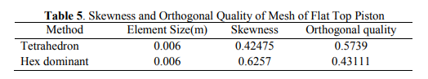
Figure 1: Mesh Method Solver Comparison
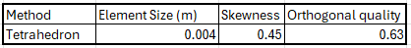
Figure 2: Skewness and Orthogonal Quality of Conducted
This study shows the convection thermal loadings and where on the piston they are applied, figure 3, which correlates with the thermal condition trends conducted during the investigation displayed in figure 4. This provides confidence that the thermal conditions are applied correctly.
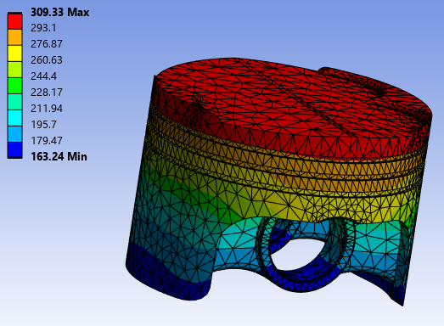
Figure 3: Conducted Study Thermal Gradient
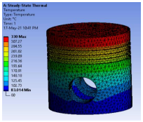
Figure 4: Paper Thermal Gradient
In addition, the study shows the maximum deflection and equivalent stress from their investigation. The design in this paper includes a flat top piston and a full 360-degree skirt whereas the piston in the conducted investigation uses a detailed crown and separated piston skirts. The paper also uses 4032 aluminium, and the conducted test uses 6061 T6 aluminium, but the trends of the components can be attributed. From figures 5, 6, 7 and 8, it displays that the studies generally correlate, with the most deformation occurring at the crown of the piston and around the gudgeon pin bore. The largest stress areas are at the crown of the piston, more specifically the detailed areas for the valve clearances. These are stress concentration areas in the conducted investigation.
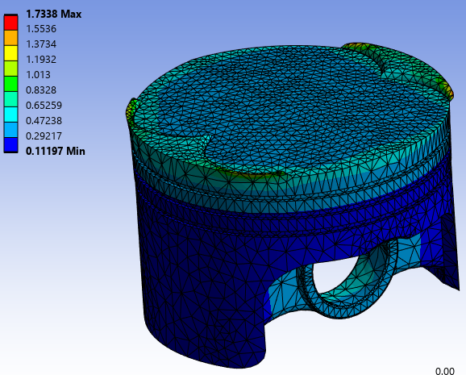
Figure 5: Conducted Study Deformation
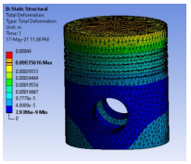
Figure 6: Paper Deformation
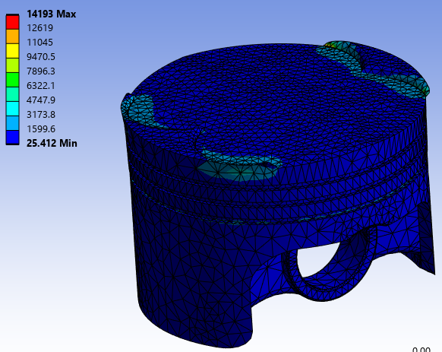
Figure 7: Conducted Equivalent Stress
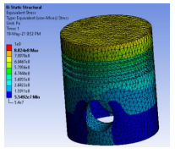
Figure 8: Paper Equivalent Stress
Topology optimisation is also covered by this paper. The paper suggests that the ideal area to reduce the mass of the piston would be in the piston bowl area as can be seen in figure 9. Although the piston bowl design is vastly different between the paper and the conducted test component, there is an emphasis on ensuring that the topology optimization does not influence the portions of the piston that interact with other components or the combustion chamber.
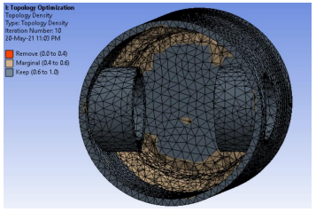
Figure 9: Paper Topology Optimisation

Methodology

CAD Model
The CAD model designed in Solidworks, in figure 10, contains a crankshaft, connecting rod, gudgeon pin and piston. These components allow the modelling of the forces between the connecting rod and the crank, the connecting rod and the gudgeon pin and the piston and the gudgeon pin. This model does contain some limitations which will be detailed further in this report.
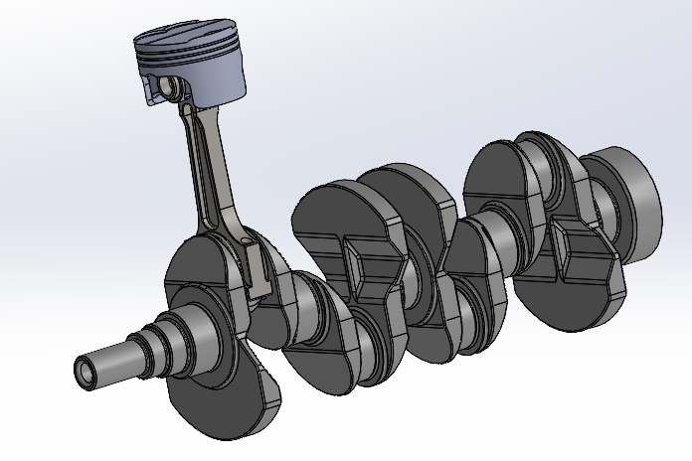
Figure 10: CAD Model of Engine Components.

FEA Simulation
The Finite element analysis software used to conduct the simulations was Ansys. Ansys is an industry standard software used across a range of applications. During this study the analysis systems used were static structural, steady-state thermal and rigid dynamics.

Validation
To validate the solvers chosen, a bimetallic strip case study from Dlubal was used which is displayed in the appendix. The component was replicated in CAD before being simulated in Ansys and compared against analytical hand calculations from Dlubal. A mesh independence study was also completed to ensure accurate results, investigating element sizing, mesh types and mesh method solvers.
The bimetallic strip from Dlubal, shown in figure 13, consists of 2 samples of material invar and copper. These two samples have different rates of thermal expansion; a thermal loading is applied to the bodies of 100 degrees Celsius as stated in the specifications sheet by Dlubal. But Ansys bases all its thermal loadings from ambient room temperature of 22 degrees Celsius therefore the input value is 122 degrees Celsius. The samples are joined together by a bonded joint and fixed at one end. A maximum deflection of 7.049mm is stated on the test paper from Dlubal, through altering mesh attributes to improve accuracy of the Ansys simulation simulated the maximum deformation to be 7.1198mm which is a deviation of 1.02% from the case study results. This can be deemed as accurate as the test paper does not state their boundary conditions which can account for this margin of error. The most accurate meshing method was found to be a hex dominant quadratic mesh with an element size of 0.8mm – 4mm which can be seen from figure 11 and 12. The 4mm mesh size was used as this saved computational time compared to the finer mesh size of 0.8mm without sacrificing accuracy.

Figure 11: Hex Dominant vs Tetrahedral Mesh Method Solvers

Figure 12: Quadratic vs Linear Mesh Types

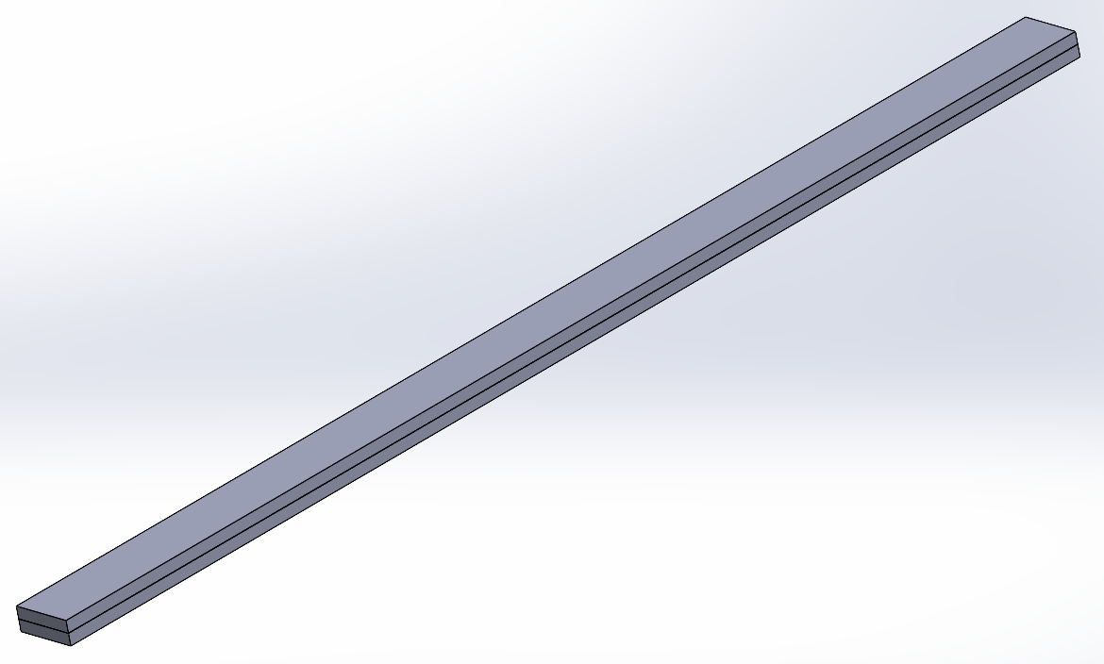
Figure 13: Bimetallic Strip CAD Model
A second validation study was completed to further validate the accuracy of the FEA solver. Another case study from Dlubal in the form of a cantilever beam with an axial force applied. The same methodology was used as the previous validation study, in terms of mesh independency study and replication of study boundary conditions.
A load of 1600N is applied in tension and a transversal load 7650N. The analytical solutions from the case study state, displayed in the appendix, a deflection of 0.012mm in the direction tension force is applied and as can be seen in figure 14 the Ansys simulated this to be 0.011901mm which is an extremely accurate correlation. From figure 15, it shows the simulated load to be 3555mm which is again an exact match to the analytical solution from the case study.
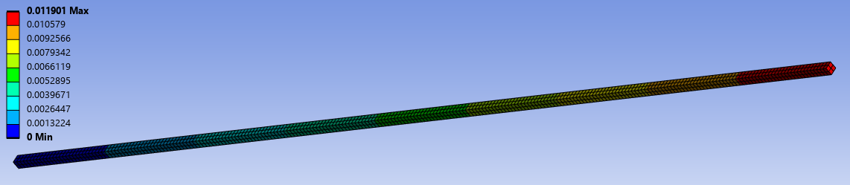
Figure 14: Deformation in Tension
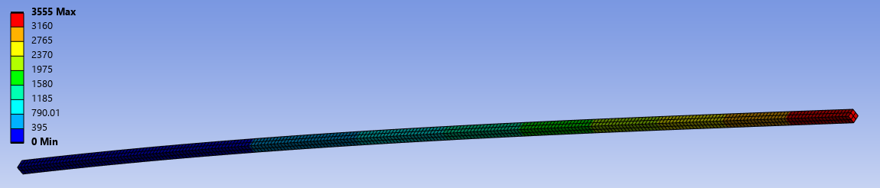
Figure 15: Deformation in Transversal

Piston
As mentioned previously the piston is the component that has been selected to analyse. To obtain the loadings on the piston a linked system was used, shown in figure 16, containing a rigid dynamic, steady state thermal and a static structural system.
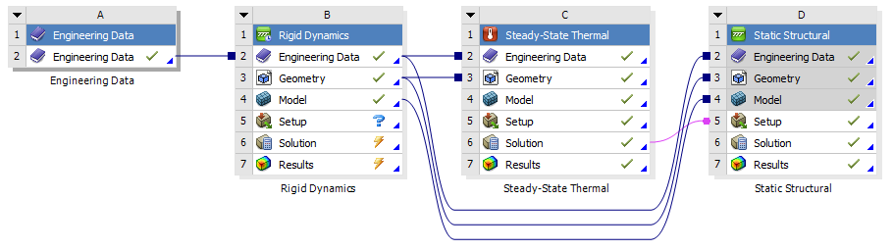
Figure 16: Ansys Workbench
The rigid dynamics analysis system is used to simulate the motion forces, the peak force from the simulation is selected and imported into the static structural study. The reason the peak force is selected as the purpose of this investigation is to optimise the piston mass as this will be when it experiences highest stress; therefore, it must be engineered to deal with the highest forces it will see. The steady state thermal study is used to simulate the thermal loadings on the piston. The thermal loadings are not a single consistent value as the crown will see the highest temperature due to the combustion chamber. The temperature gradient can be seen in figure 17. This is then also fed into the static structural analysis system.
Figure 17: Thermal Loadings Gradient
The static structural analysis system places a pressure on the crown face surface to simulate the combustion pressures, displayed in figure 18. The simulated loadings are simulated at once to take all loadings into account.
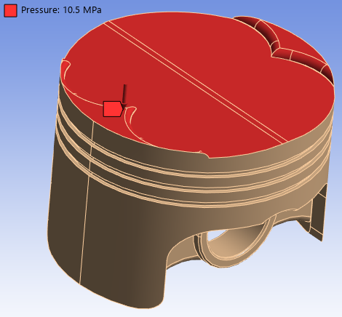
Figure 18: Pressure on Crown of Piston in Ansys Simulation
To further improve the accuracy of the results a mesh independence study was conducted to capture the details of the piston. Refining the mesh on independent faces to improve the details captured but not drastically increasing in computational time. The crown surface and the underside of the piston need to have a finer mesh to capture the small details as shown in figure 19. A tetrahedral mesh was used as it captures the fine details and curves of the piston.
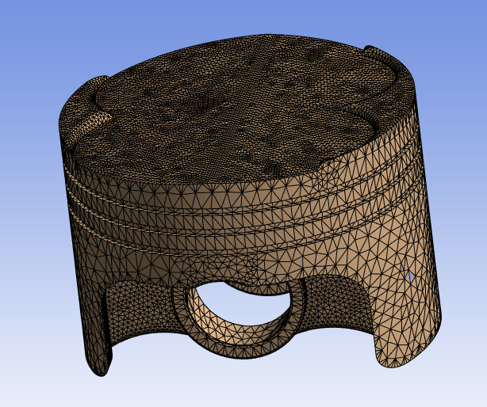
Figure 19: Mesh Independency on Piston

Materials
The combustion engine piston has developed significantly since it was invented beginning, with cast-iron flat-topped pistons developing to using modern aluminium alloys with detailed piston crowns. The selected material is highly dependent on cylinder pressures, temperatures, cycles and manufacturing methods. In addition to fundamentals such as mass, surface finish and cost. The modern answer to these requirements is an aluminium alloy. The materials often used are alloys of 2000, 4000 and 6000 series aluminium, (Kemi.L et.al 2018), (Goyal.N, Nema.T 2016). For this investigation a 6000 series aluminium was chosen, specifically 6061, as it has higher strength, reduced thermal expansion, good thermal conductivity, good strength to weight ratio, manufacturability and resistance to corrosion. (Kemi.L et.al 2018), (Goyal.N, NemaT 2016). The Aluminium silicon alloys are often coated with ceramic coatings to improve their efficiency and increase their resistance to creep failures. This was not taken into consideration in this model due to the complexity of modelling.

Initial Results
The initial results show low stress regions on the skirt, underside as shown in figure 20. This would indicate that the mass of these areas could be reduced using CAE methods. The detailed areas of the crown, shows higher stress regions as can be seen in figure 21, this would indicate that mass should not be reduced here. The standard component mass is indicated as 0.25765 kg, which is calculated by Ansys using the density and volume of the component. Moving forward boundary condition considerations must be made to ensure that the vital geometry of the piston is not affected.
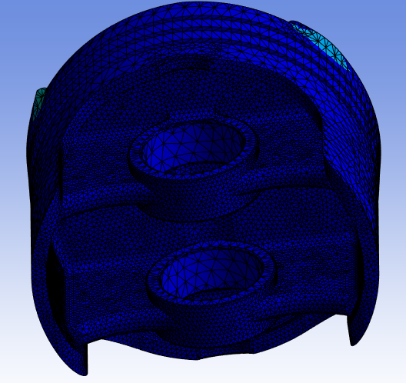
Figure 20: Von Mises Stress on Underside of Piston
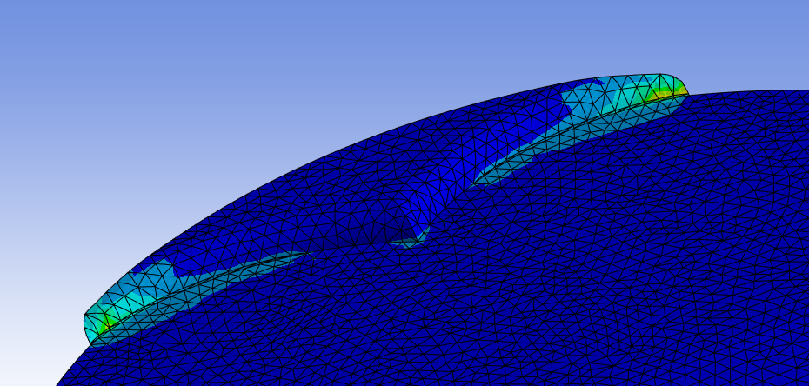
Figure 21: Higher Stress Regions of Piston Crown

Optimisation

Considerations
The geometry of a piston is detrimental to its purpose therefore this must be taken into consideration when reducing its mass. The piston must maintain the same circumference and skirt dimensions to ensure that it is not under or oversized as this will cause the engine not to work due to compression leakage or interaction with the cylinder walls. The piston crown and dimensions will affect the compression ratio of the engine which could lead to detrimental effects on the engine. The crown of the piston could also interact with the valves if the design is altered. The surface finish of these areas of the piston must be polished to ensure the oil film is able to form to reduce friction between components. This can also be attributed to the gudgeon pin bore. This is also a fixed dimension due to its interface with the gudgeon pin and therefore cannot be altered.
Areas that can be altered are mainly on the underside of the piston as this are does not have a detrimental effect on the piston interaction with other components. As most automotive pistons are produced through casting, these areas are often left unmachined due to time and cost benefits. The rough surface finish can also be attributed to stress concentrations although this is not replicated in the CAD model due to design simplicity.

Topology
Topology is a CAE tool which is used to remove unnecessary material from a component by analysing the stress distributions and removing material where possible. To avoid the critical areas being altered the local design restriction region tool is used and can be seen in figure 22 as the red area. The purple areas will be optimized as these areas will not influence the working areas of the piston. This region is typically left unmachined during standard piston manufacturing processes leaving unnecessary mass shown in figure 23.
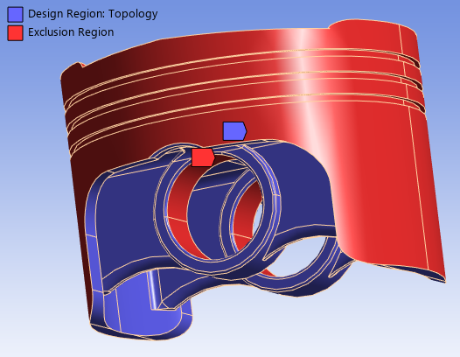
Figure 22: Topology Optimization Areas
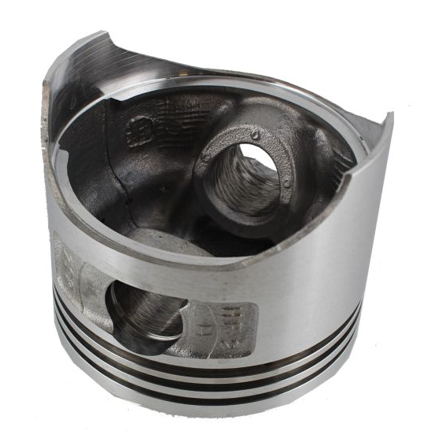
Figure 23: Honda Motorbike Piston
The topology solver in Ansys will not take into consideration thermal or rigid dynamic loads, therefore the only influence on the piston is the simulated cylinder pressure. The initial run of 75% retained mass, displayed in figure 24, shows the mass reduction in the under region of the piston. This method would induce stress concentrations therefore would not be recommended. This influenced the decision to move forward to with the reduction of mass in this area.
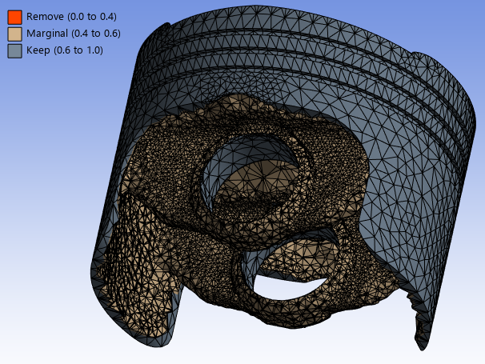
Figure 24: 75% Retained Mass Topology
Figure 25 displays the 50% mass retained model. This and the 75% retained mass model show the mass is reduced through reducing the material around the gudgeon pin planes. This influenced the decision moving forward to alter the design in CAD.
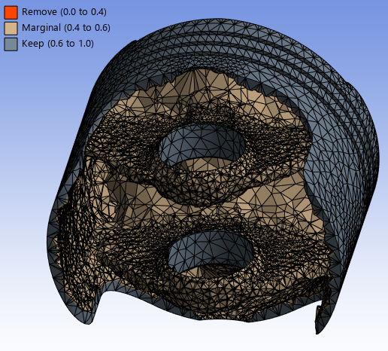
Figure 25: 50% Mass Retained Topology

CAD Optimisation
From the topology optimisation results a CAD developed piston was introduced to the investigation, pocketing the piston bowl and the gudgeon pin bore supports. The designs are displayed in figure 26 and 27. The mass of this adapted design is 0.24986Kg which is a mass reduction from the original design of 7g, which is not a significant amount, but the investigation has proven more material can be removed to further refine the component.
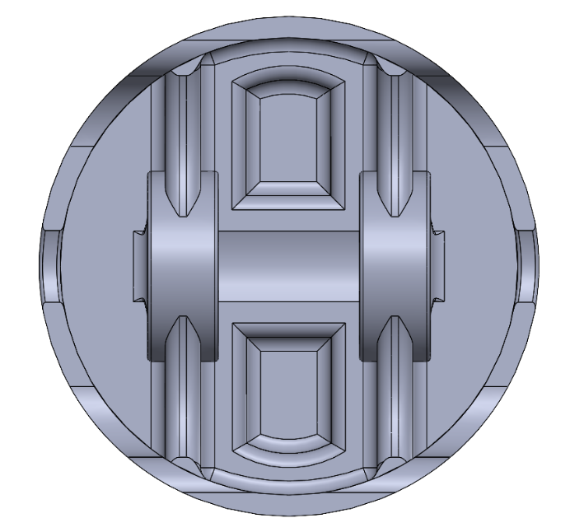
Figure 26: Underside of CAD Optimised Design
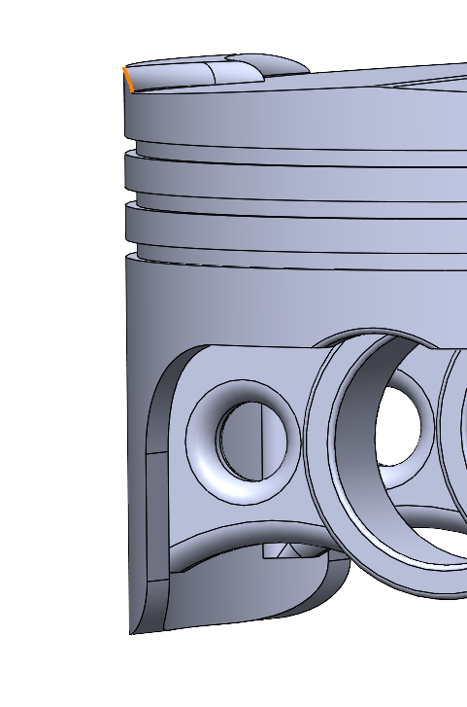
Figure 27: Pocketed Gudgeon Pin Bore Supports
This design was simulated in Ansys using the same boundary conditions as the original piston during the topology optimisation. The equivalent von mesis stress of this simulation displayed in figures 28 and 29 show that the pocketing of the underside of the piston have not had any implication on the stress concentrations on the underside of the piston, from this it would be possible to further reduce the mass of the piston in this area. Although the promising result in this region, the pocketed sections in the gudgeon pin bore, showed an increase in stress in this area. Moving forward with this optimisation from the knowledge gained, the optimal areas to reduce the mass would be on the underside of the crown.
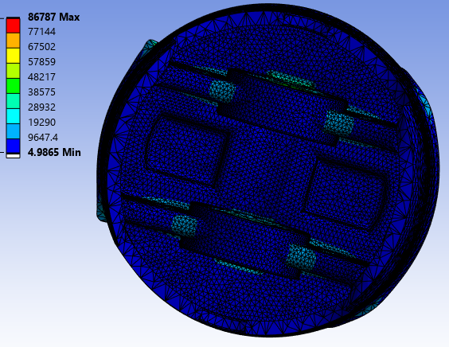
Figure 28: Underside of the Adapted Piston
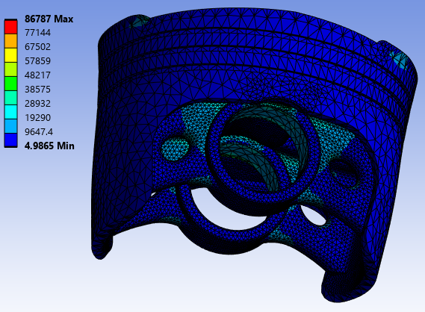
Figure 29: Gudgeon Pin Bore Supports of Adapted Piston

Safety Factor and Life Cycle Analysis
A safety factor and life cycle analysis was conducted on the un-adapted piston. The life cycle analysis study results are displayed in figure 30 and the safety factor study results are displayed in figure 31.
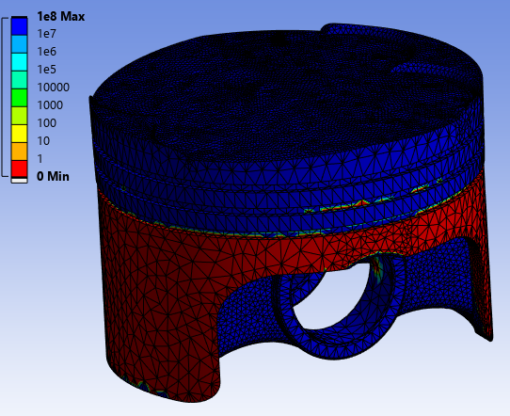
Figure 30: Life Cycle Analysis
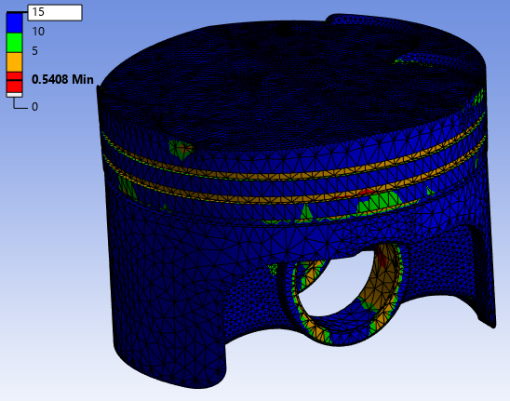
Figure 31: Safety Factor Analysis
From analysing and comparing these two studies it has become evident that the results do not correlate. Taking the skirt region for example the results from the safety factor analysis show that this region has a safety factor of 15, but when looking at the lifecycle analysis results this region will not be able to withstand a single cycle. This would indicate that this investigation is unreliable, and the results can not be deemed as valid. Safety Culture states that engine components should have a factor of safety between 6 and 8. Although the factor of safety results seems within tolerance from figure 31 apart from a few anomaly sections in the piston ring regions, figure 32 shows the areas which are out of tolerance.
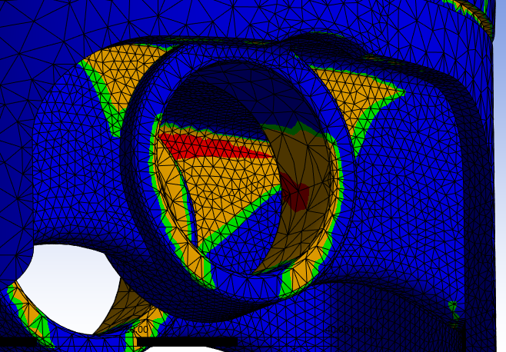
Figure 32: Zoomed in Areas of Interest Factor of Safety
These areas show that the force applied exceeds the ultimate tensile strength of the material. This means that the component would fail under the applied loads and would not be ideal for its application. But as proved when compared to the lifecycle analysis data this part of the investigation can not be deemed as accurate. This could be due to many factors such as inaccurate simulation, boundary condition influence or the material inaccuracies as detailed in the materials section of this report.

CAE Limitations
The FEA software calculates the stress on nodal points, generated by the mesh. This emphasises the importance of an in-depth mesh independence study to encapsulate detailed areas of the component.
Although a fine mesh will generate a large number of nodal points without a mesh on an atomic scale it would not replicate real world scenarios to 100% validity. To create a mesh on an atomic scale would not be computationally viable with resources and time. FEA software’s calculate results using equations. The equations used may not encapsulate every influence in a realistic scenario leading to inaccuracies in results.
As mentioned above the topology investigation does not consider the thermal or dynamic loadings which leads to inaccurate piston loadings. Therefore, the topology design cannot be taken as an accurate representation of the optimization.
As the rigid dynamic loads are not considered during the topology optimisation, the gudgeon pin bore is fixed giving an inaccurate representation of the stress and deformation seen. Fatigue life is also not considered when topology is used. As mentioned, the topology optimisation will induce stress concentrations increasing the likelihood of crack propagation, leading to component failure. The developed product by the topology optimisations would also be unrealistic to manufacture.
Another limitation of CEA is material modelling. Modelling of some materials especially alloys can become significantly complex due to the required material properties. This is especially true when it comes to coated materials such as the 6000 series ceramic coated material which was needed in this investigation. With the capability to model these efficiently this would increase the accuracy and validity of the results in this investigation.
There is a limitation in the comparison of the accuracy of the modelled piston in CAD and a realistic piston. As mentioned previously in the report, manufacturers often leave the inside of the piston bowl unfinished. The poor surface finish could induce stress concentration regions which are not accounted for during simulation. These could induce cracks and premature failure which would not be anticipated from the simulation.

Conclusion
This investigation of the use of CAE has proven that it is a beneficial process to design, test and optimise components without the cost and time implications of real-world testing. The investigation has also proven that validation studies and mesh independency studies are a vital part of ensuring and improving the accuracy of simulations. The investigation has also demonstrated limitations of CAE such as complex material modelling and fatigue studies. These limitations could be overcome but would need a substantial amount of time. Overall CAE is a beneficial process for design simulation but if boundary conditions are not completely accurate unreliable results are highly likely.

Further Investigations
Further investigations in this analysis could contain development in material accuracy, developing an accurate representation of a ceramic coated 6061 aluminium alloy. This will improve the accuracy and validity of the results obtained, this should improve the accuracy of the safety factor and life cycle analysis results allowing further analysis.
Further development into the piston optimisation and mass reduction could be made by, investigating further into removing material from the underside of the crown and improving the topology investigation. The poor surface finish could also be modelled in CAD, which would further improve the comparison of the investigation results to real world components.
A further investigation into the piston optimisation could be made through generative design, by supplying a software with boundary conditions and allowing it to generate a design.

Reference list
Dlubal Software (2025), ‘Verification example 0078’, Structural Analysis Models to Download. Available at: VE0078 | Bimetallic Strip
Dlubal Software (2025), ‘Verification example 0042’, Structural Analysis Models to Download. Available at: Verification Example 0042 | 4 | 002857
Goyal.N, Nema.T (10/2016), ‘Design and Optimization of Piston Used Uncoated Aluminium Aloy-6061 and Coated with Ceramic Material Using Catia & Ansys’. Available at: IRJET-V3I1019.pdf
L&S Engineers, ‘Engine Piston for Honda GX240 Series’. Available at: Engine Piston for Honda GX240 Series - OEM 13101 ZE2 010 | L&S
Kerni.L, Raina.A, Haq.M.I.U, (2018), ‘Performance evaluation of aluminium alloys for piston and cylinder applications’. Available at: Performance evaluation of aluminium alloys for piston and cylinder applications - ScienceDirect
Lee.Z.R, Ku.P.X, (2021), ‘Geometry design and optimization of piston by using finite element method’. Available at: Open Access proceedings Journal of Physics: Conference series
Safety Culture, ‘Factor of Safety: Ratio for Safety in Design and Use’. Available at: Factor of Safety (FoS) for Design and Use | SafetyCulture

Appendix
Bimetalic strip Mesh independence study
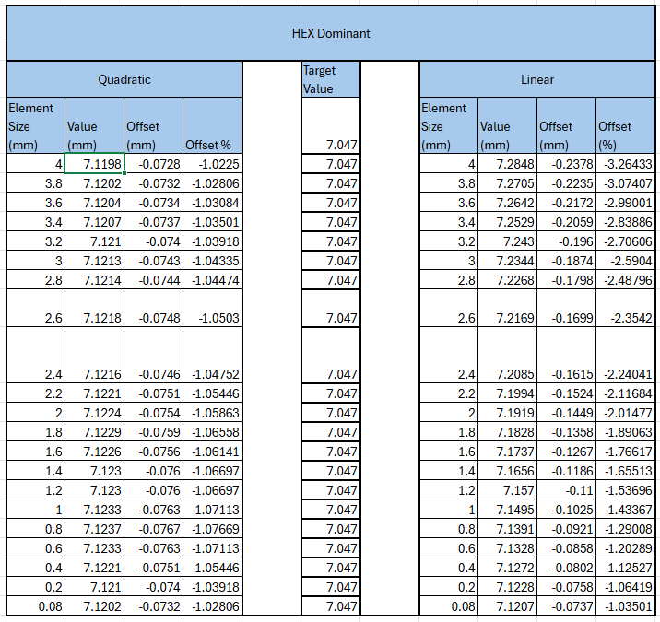
Figure 33: Bimetalic Strip Mesh Independency Study

Cantilever Beam Analytical Solutions
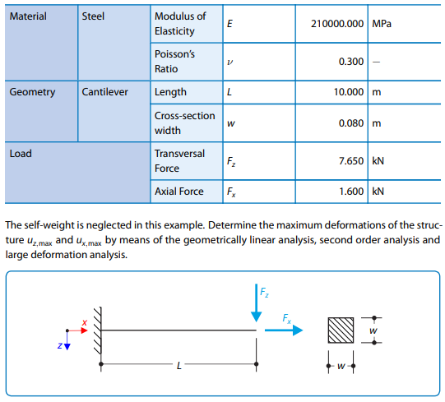
Figure 34: Dlubal Cantilever Variables
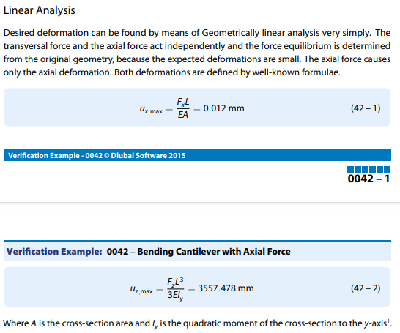
Figure 35: Analytical Solutions of Cantilever

Bimetalic Strip Analytical Solutions
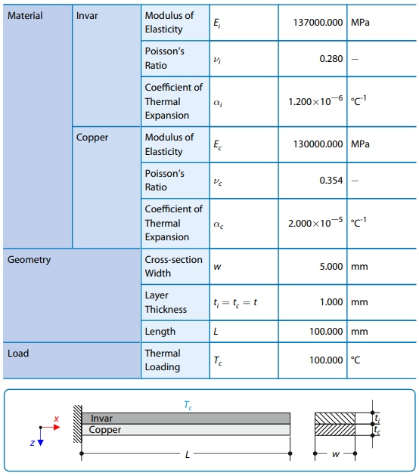
Figure 36:Bimetalic Strip Variables
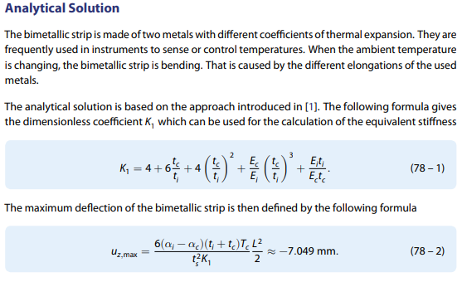
Figure 37: Bimetalic Strip Analytical Solutions

