Control Technology
Assignment 1

Contents Page

Page 1: Title Page
Page 2: Contents Page
Page 3: Introduction
Page 4: Task 1
Page 5: Task 2
Page 6: Task 2
Page 7: Task 2
Page 8: Task 3
Page 9: Task 3
Page 10: Task 3
Page 11: Task 3
Page 12: Task 3
Page 13: Task 4
Page 14: Task 5
Page 15: Task 5
Page 16: Task 5
Page 17: Conclusion
Page 18: References
Page 19: Appendix 1

Introduction
The following report details some of the various types of PLCs (Programmable Logic Circuit) used within industry. I will also discuss the various advantages and disadvantages of each PLC type that I have identified. Later in the report, I will detail each of the elements I have added to construct a functioning conveyor system, such as the physical elements i.e. conveyors, pushers and sensors, as well as the TIA programming elements to link the physical elements to the relevant networks, allowing the full function and display of each component. I will also detail the relevant screens created to display various characteristics of the conveyor such as: quantity of boxes emitted, the quantity of each size emitted as well as the error count.

Task 1

Within industry there are three main types of PLCs used. These are:
- Fixed Integrated PLC – This is where an IO and a controller are within a single unit. They are used for basic functions
- Distributed PLC – This type of PLC relies on a network connection between the controller and IO to function.
- Modular PLC – This type of PLC includes separate modules for the IO and controller, which are mounted into a rack/chassis.
Fixed Integrated PLC
Advantages | Disadvantages
Relatively simple systems to use | Not easy to setup initially
Reliable | Uses a fixed circuit operation
Often small in size/easy to use in a wide range of applications.
Cheap
Well suited to basic applications.

Distributed PLC
Advantages | Disadvantages
Can increase plant efficiency | If failures occur, skilled operators are required to resolve.
Enables applications such as production scheduling | A failure of one controller can affect more than one loop.

Modular PLC
Advantages | Disadvantages
Capable of housing large amounts of information. | Large amounts of stock required to use this system.
Easier fault detection | Decreases space efficiency
Less time to troubleshoot with individual modules
Easy to repair, giving less downtime
Easy to expand for various applications

Task 2
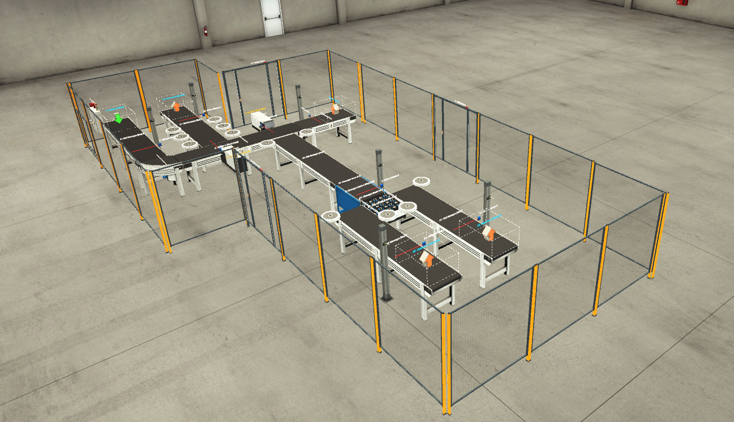
This is an overview of the factory I created, using the factory IO software. This setup uses multiple functions to transport various size and weight packages, from the emitting point to the relevant remover.
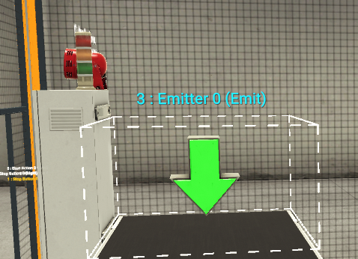
The emitter allows various size and weight packages to start at the beginning of the conveyor system.

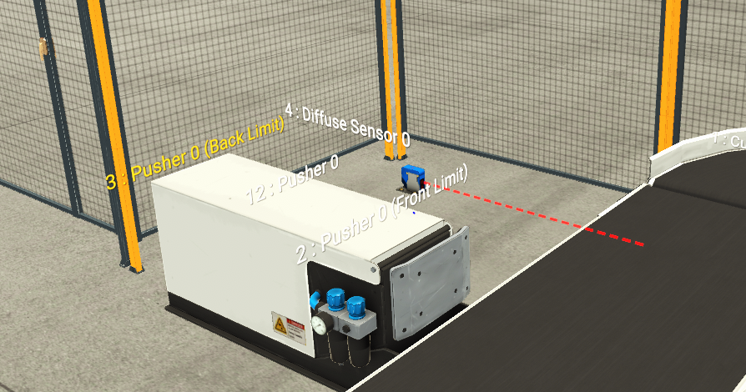
At the first corner of the conveyor system, I added a sensor specifically to trigger the first of 2 pushers. The first pusher moves all large boxes from the main conveyor to the sub conveyor, then to the following package remover.
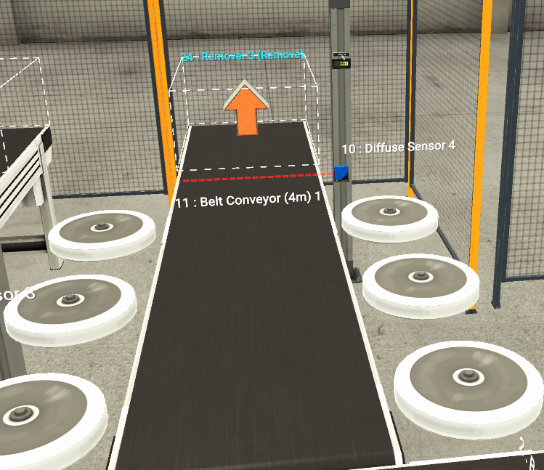
This is an image of the large box sub conveyor. The rotating barriers located either side of the conveyor ensure packages remain on the moving belt after being pushed off the main conveyor system. The sensor located at the rear right detects all large boxes passing through and adjusts the error count, accordingly, working in parallel with the first sensor on the main conveyor.
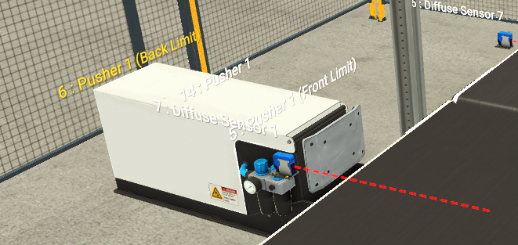
The second of the two pushers is specifically placed to push all medium boxes from the main conveyor to the sub conveyor.
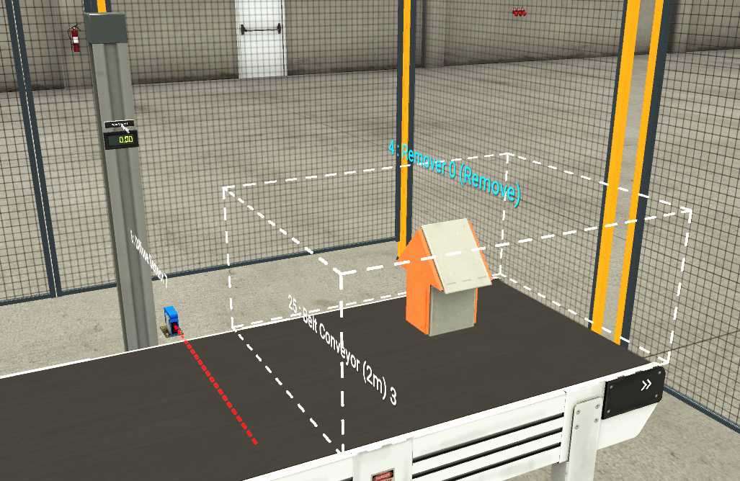
At the end of the main conveyor system the sensor again adjusts the error count, but for the palletising boxes. Once passing through the sensor, it is then taken by the package remover.
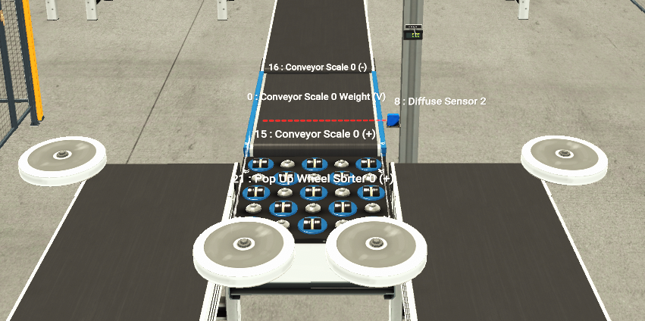
Working down the second sub conveyor section, the first element is the weighing scales. This stops for a defined time period allowing each package to be weighed, with each weight displayed on the digital readout to the right of the conveyor. Depending on the weight of the package, the popup sorter will either send the package to the left (as looking at the image) for higher weight (medium boxes) and to the right for lower weight (small boxes).
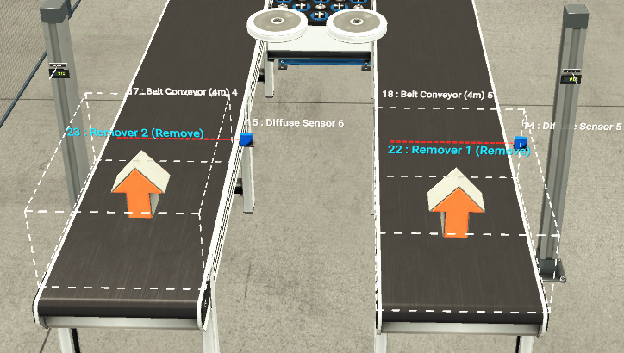
After being sorted by weight, each package will pass through a final sensor, adjusting the error count accordingly, before entering the remover.

Task 3
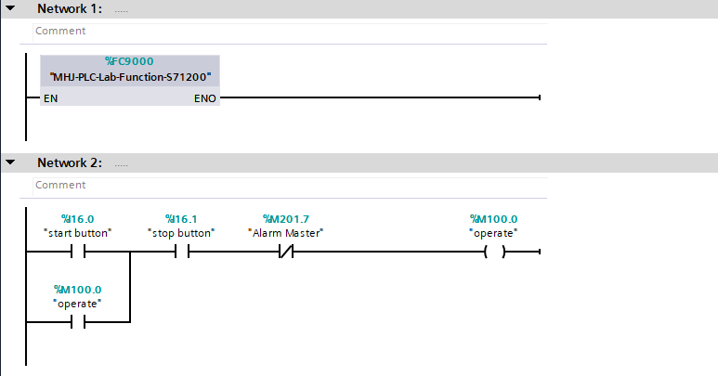
Network 2 controls the start/stop functions of the programme, allowing the conveyor to operate and stop when commanded.
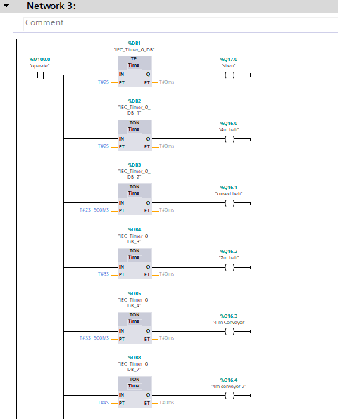
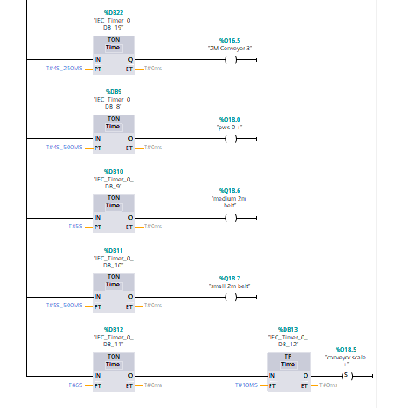
Network 3 controls the start siren and start sequence of each conveyor. This is done with the use of timer functions, incorporating delays into the start of the conveyors, in sequence.
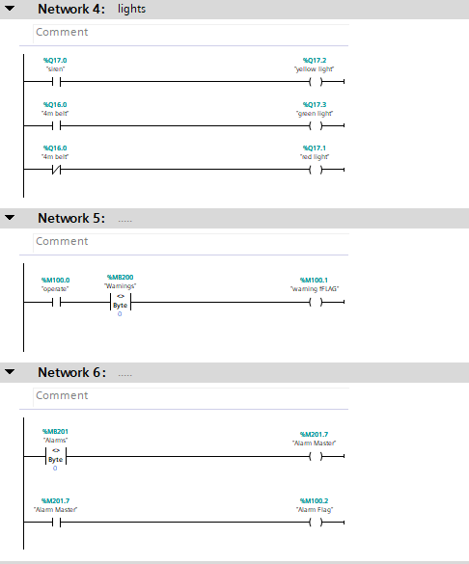
Network 4 shows the siren will sound when the yellow light is illuminated in the start sequence of the conveyor system. On the green light the 4m conveyor will start to function, then will stop when the red light is illuminated.
Network 5 and 6 links to the warning and alarm system on the robot and engineering screens.
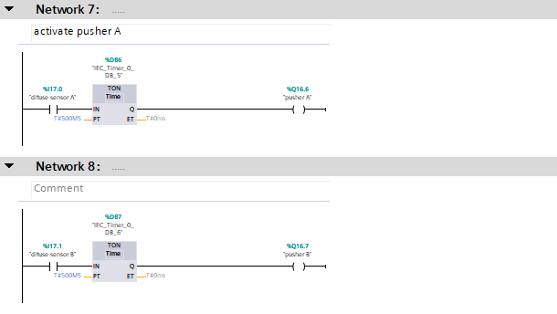
Network 7 and 8 links the sensor’s beam being broken and each of the pushers being operated, moving the large and medium/small boxes to the relevant sub conveyor.
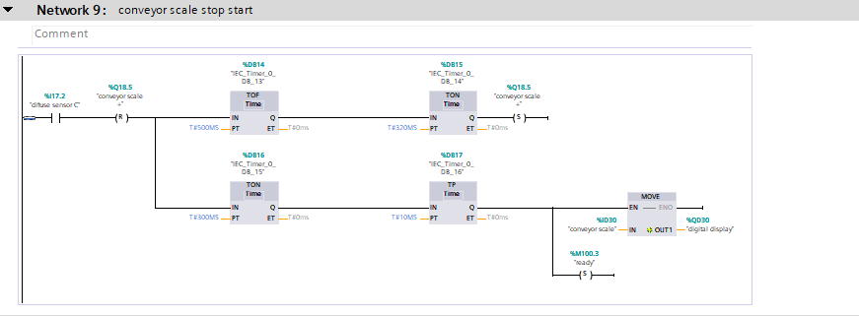
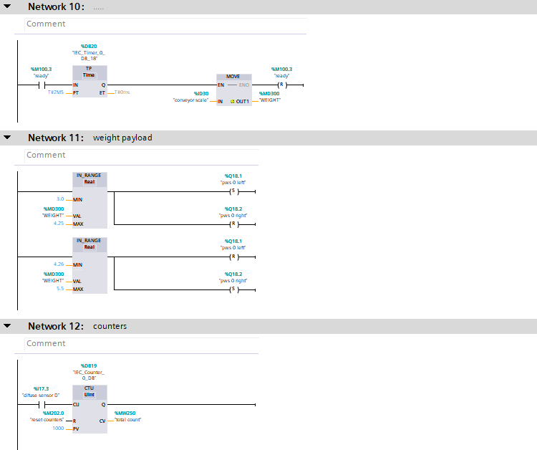

Network 9 and 10 shows the operation of the weighing scales element of the conveyor system. As above, each package will stop on the weighing scales for a defined time period, allowing the weight to be taken and displayed on the digital display to the side of the conveyor.
Network 11 details the operation of the popup sorter. Once the package has been weighed, depending on the weight of the package, the popup sorter will then move the package to the relevant sub conveyor.
Network 12 links to the robot screen, adding to the total count readout. This network uses the first sensor on the main conveyor system to detect every box added into the conveyor network.
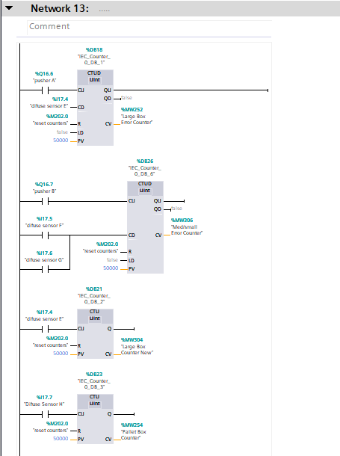
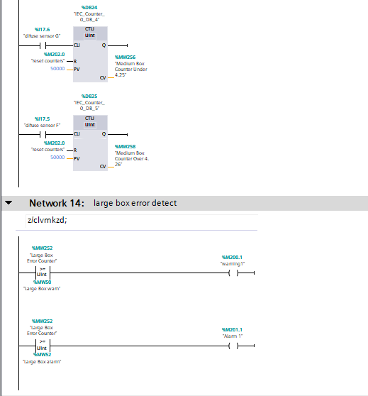
Network 13 shows the link between first counting sensor, to all of the other relevant sensors which are located just before each of the removers. These sensors will count the total number of each size box, as well as the error count. The error count comes into play where boxes may fall off the conveyor. This allows the relevant engineer to review the count of each box size, then potentially where boxes are falling off the conveyor system. This links to network 14.
Network 14 shows the link between the error count and warnings/alarms sounding. This works by using set parameters to ensure the conveyor is running correctly. Should the error count exceed the parameters set on the TIA programme, it will first send a warning to the warning screen, then if it exceeds the second parameters, it will raise alarm 1. This again allows the relevant engineer to identify any improvements/alterations that need to be made to the conveyor system, preventing packages falling off/being unaccounted for.

Task 4
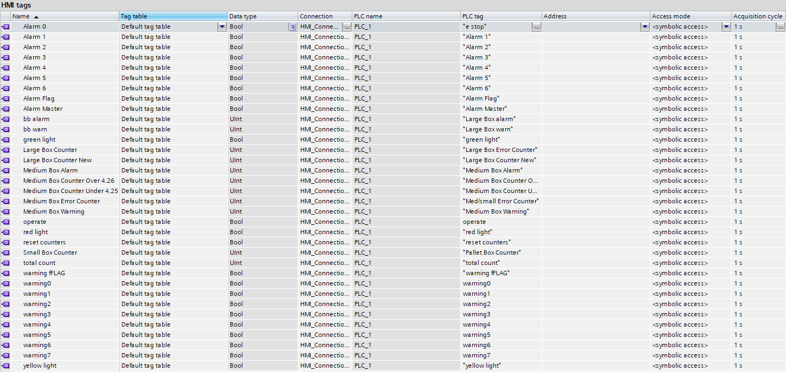

To link the various elements of the conveyor system, I used an HMI (Human Machine Interface) screen. The HMI tags seen in the screen above, allow me to connect the elements in the Factory IO to actual functions, linking in with the ladder and PLC tags. Within the HMI screen I used various data types, depending on the function of the element in question. For example, the alarms I have setup, these use a “Bool” (Boolean), this data type essentially is a true/false outcome. Depending on the outcome, the alarm will remain off, or trigger. I have also used “Ulnt” data types within the HMI screen. These have been used in conjunction with the various box size counters. These are used for elements containing actual values.

Task 5
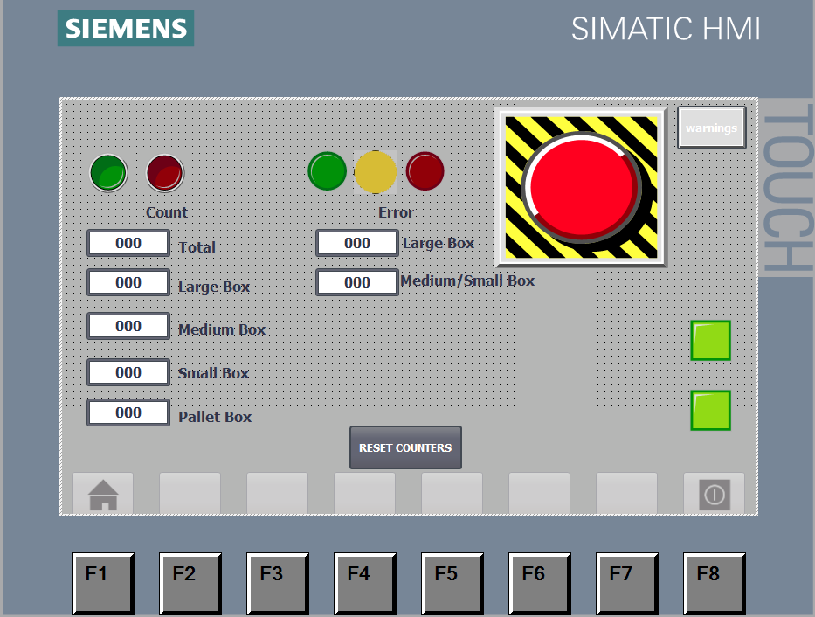
I created a “Root Screen” to show all elements of the conveyor system. The red and green light at the top left of the root screen, show whether the conveyor system is active or stopped. The green, yellow and red lights work in tandem with the light stack located on top of the control box, at the start of the conveyor system. This screen also houses an emergency stop button, which will shut down the conveyor when pressed. At the top right of the root there is a button linking to the warning page. Under the “Count” heading on the root screen, these digital readouts show the total number of boxes entering the conveyor system, as well as breakdown of what size boxes have passed through the conveyor. Under the “Error” heading, this displays the difference in value between the number of boxes entering the conveyor and the number of boxes that have passed through the sensors near the relevant box removers.
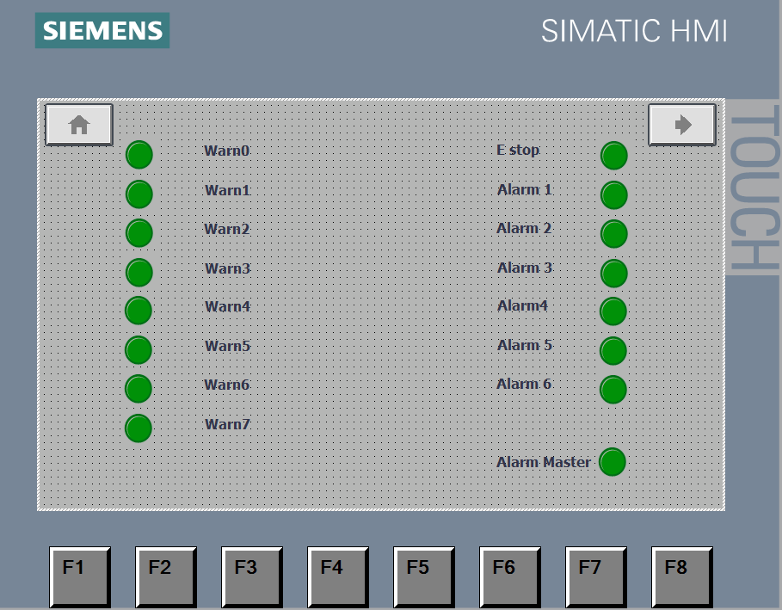
I created a warning and alarm page, this allows the relevant operator/engineer to identify where a fault has occurred and the potential root cause of the fault. Depending on the fault that occurs, this will trigger a different warning or alarm. This screen also displays if the system has shut down by use if the “E Stop” alarm at the top right of the screen.

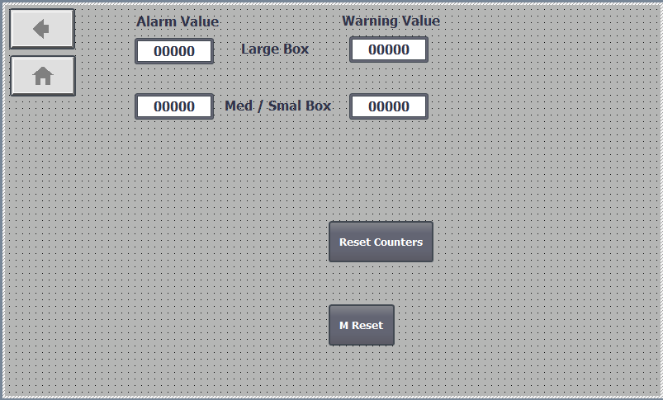
I have also created an engineer screen. This allows the relevant engineer access to further information as well as setting the parameters for when the warning and alarm sounds for the error counter. These warnings and alarms will activate depending on the parameter that has been breached. I have also added buttons “Reset Counters” and “M Reset”, this allows the engineer to reset the system, should there be a failure, then allowing the system to be restarted.

Conclusion
With use of the various software programs and relevant tools, I was able to create a functioning factory conveyor system. This system incorporates various functions, using elements such as an alarm/warning system, emitter, different size conveyors, pushers, sensors, weighing scales, pop up sorter and box removers. The mentioned elements are linked to appropriate screens to ensure they function as intended. The use of a root screen allows full visibility of the functioning system, displaying the relevant values, such as: counters for various box sizes and error counts throughout the conveyor system. I added a process flow diagram to Appendix 1 showing a functional overview of the conveyor system.

References
- engineerscommunity. 2019. Advantages and Disadvantages of DCS System. [ONLINE] Available at: https://engineerscommunity.com. [Accessed 12 July 2022].
- trainplc.blogspot. 2017. MODULAR AND INTEGRATED PLC : DIFFERENCES, ADVANTAGES AND DISADVANTAGES. [ONLINE] Available at: https://trainplc.blogspot.com/. [Accessed 14 July 2022].
- businesspartnermagazine. 2021. The Biggest Advantage and Disadvantages of a PLC. [ONLINE] Available at: https://businesspartnermagazine.com. [Accessed 10 July 2022].
- dipslab. 2022. Advantages and Disadvantages of PLC. [ONLINE] Available at: https://dipslab.com/. [Accessed 11 July 2022].

Appendix 1


