

The program of study: BA (Hons) Business Management

Module name and code: LCBB5013 Entrepreneurship

Assignment title: Portfolio - 6 elements

Student name: Rares Constantinescu
Student ID : 2516174

Table of Contents
TASK 1 (Week 8): Business Plan Development 2
Element 1: Business Idea, Products/Services, Objectives & USP 2
1.1 Description of the company and its products 2
1.2 Define the company’s objectives 4
1.3 The company’s Unique Selling Point 5
References 6

TASK 1: Business Plan Development

Element 1: Business Idea, Products/Services, Objectives & USP

1.1 Description of the company and its products
Fast fashion products develop new styles for customers at a record pace in order to match fashion industry trends. To provide durable and sustainable fast fashion products to customers, Pine Wear will produce fashionable products for UK customers. The products of the company will include clothing items for women and men, bags, and accessories. The product materials will be made from the cellulose that can be found in pineapple leaves. Leftover leaf waste from the farm and supermarkets will be collected by the company to make a leather-like, durable material that can be used to make clothing products, bags, and fashionable accessories. In the UK, almost 15,500 tonnes of fast fashion clothing products are received by charitable shops, but half of them have to be discarded due to the lack of scope for reuse (Black, 2025). In addition, donated fast fashion clothing cannot be reused for a longer time due to durability. The products frequently end up in landfills, which finally results in soil pollution due to harmful composition in materials. In order to avoid pollution and to mitigate the lack of durability, PineWear will develop cellulose from discarded pineapple leaves at a lower cost. As per the view Sethupathi et al. (2024) Pineapple leaf fibre is generally low cost, non-abrasive in nature, consumes less energy and is easily biodegradable. Developing products with cellulose material will lower negative effects on nature and conserve the environment. However, almost 700 tonnes of pineapple leaves were also discarded by supermarkets like Sainsbury's and farmers in the UK (Hill, 2023).
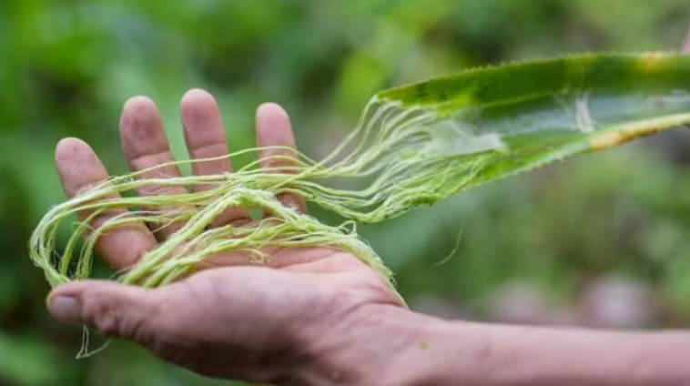
Figure 1: Pineapple leaf and fibre
(Source: Jones, 2026)
Using the wasted leaf to extract cellulose can also help in treating agricultural waste in the country. Therefore, PineWear will not only provide fashionable products, but it will manage sustainability throughout the production of the products.

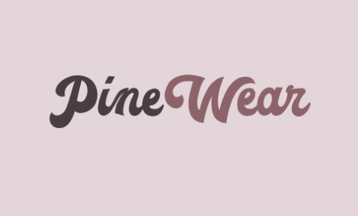
Figure 2: Company logo of PineWear
(Source: self-developed)
The company will incorporate limited liability legal structure since it can offer protection to personal assets of the owner from business risk. It can be adopted for developing resilience of the business from facing loss.

1.2 Define the company’s objectives
Specific | Measurable | Achievable | Relevance | Timeframe
To launch and develop the sustainable products with features like high durability, quality and bio degradability | Developing customers traffic by 3% in every week, | To approach to social media channel or the probation and develop sustainable fabric material for producing clothing, | It will mitigate the risk of having fast fashion products with lower durability of clothing. | 5-6 months
To generate strong partnership with the supermarket and pineapple farmers | Track the financial health of the company | The company will sign the contracts with business partners. | It will help the company to get the supply of the discarded pine apple leaf with rich cellulose fibre | 7-9 months
To launch the new 4000 new cumulative products for the sales and establish partnerships with the UK sustainable fashion retailers | To review products development from the financial reports | The company will develop production of products after robust market research | It will help the company to develop profit, increase market knowledge and develop visibility | 2-3 years
To utilize at least 10 tonnes of wasted pineapple leaf and collect the PineWear products to repair them or processing of end-of-life cycle | The company will review the sustainability reports and sell records. | The company will strengthen the partnership with the external suppliers of the pineapple and develop customers care for customer | It will help the company to show their commitment to the circular economic principles like reuse, repaid and recyclable | 3-4 years
Table 1: SMART objectives
(Source: Self-developed)

1.3 The company’s Unique Selling Point
Fast fashion product-developing companies like Zara and H&M face legal backlash for providing unsustainable products to customers and manipulating them into buying. Even after developing organic cotton products, 65% of the company’s products were sold at a high price. Therefore, the products may meet sustainable quality attributes but fail to be easily accessible to customers due to the high price of the products. Following these issues, PineWear will develop its products from scratch, which will not only be a sustainable alternative to leather fashionable products but will also develop low-price products for customers to improve affordability.
USP:
To transform the discarded pineapple leaves into durable, stylish and biodegradable clothing, accessories and bags, offering an innovative and eco-friendly alternative to fast fashion products while managing agricultural textile waste.
Tagline: “Waste To High Fashion.”

References
Black, K. (2025) Why are more clothes than ever being discarded? Available at:https://www.bbc.com/news/articles/c1jpgp6djrjo (Accessed: 14 October 2026).
British Business Bank (2026) Start Up Loans. Available at: https://www.british-business-bank.co.uk/business-guidance/guidance-articles/finance/start-up-loan (Accessed: 14 October 2026).
Hill, A. (2023) Pineapple loses its crown: Sainsbury’s sells leafless version to cut waste.Available at: https://www.theguardian.com/environment/2023/nov/01/pineapple-loses-its-crown-sainsburys-sells-leafless-version-to-cut-waste (Accessed: 13 October 2026).
Jones, L. (2026) Six fashion materials that could help save the planet. Available at: https://www.bbcearth.com/news/six-fashion-materials-that-could-help-save-the-planet (Accessed: 13 October 2026).
Sethupathi, M., Khumalo, M.V., Skosana, S.J. and Muniyasamy, S. (2024) ‘Recent developments of pineapple leaf fiber (PALF) utilization in the polymer composites—a review’, Separations, 11(8), p.245. Available at:https://www.mdpi.com/2297-8739/11/8/245 (Accessed: 14 October 2026).

