Student Name: Mit Ahir
Student ID: 2513323
Module Name: Health Care System Organisation and Leadership (LCHS7002)
Assignment Title: Medical Negligence Due To Identity Mix- Up: The kota hospital Incident
Programme/Course: Msc In Public Health And Social Care In Practice
Instructor/Supervisor: Dr. Fahad Khan
Date of Submission: 27/03/2026

Table of Contents
1. Introduction 4
2. Main Body and Analysis 4
a. Identifying the Problem and System Context 5
1. Description of the Core Problem 5
2. Global Context of the Problem 5
3. National Context (India) 6
4. Systemic Weaknesses 8
5. Governance Level Influencing the Problem 8
6. Underlying System Challenges 9
b. Centralisation or Decentralisation within the Case Study 10
1. Centralised Healthcare Systems 10
2. Decentralised Healthcare Systems 11
3. Critical Analysis of System Structure 12
c. Leadership Theories and Application to the Case Study 13
1. Relevant Leadership Theories 13
2. Application of Leadership Theories in the Case Study 13
3. Supporting Data and Evidence 14
4. Was the Leadership Style Appropriate for the Situation? 14
5. Were Leaders Reactive or Proactive? 15
6. Leadership Effectiveness 15
7. What Could Have Been Done Differently? 15
d. Improvement and Lessons Learned 16
1. Key Problems Identified and Evidence-Based Solutions 16
2. Linking System Structure, Leadership, and Feedback 17
3. Lessons for Other Health Organisations 17
4. Continuous Improvement Through Evidence and Data 18
3. Recommendations 18
3.1 Immediate Actions for the Organisation 18
3.2 Recommended Leadership Style for Sustaining Improvement 18
3.3 Strengthening Governance, Communication, and Systems Integration 19
3.4 Enhancing Technical and Allocative Efficiency 19
3.5 Continuous Learning, Stakeholder Engagement, and Co-production 19
4. Conclusion 20
References 21

Medical Negligence Due To Identity Mix-Up: The kota hospital Incident

1. Introduction
The chosen case study is on Kota Medical College Hospital, where an old man, basically the patient's family, was mistakenly and forcefully operated on. This eventually compromised patient health and well-being. The main issue occurred due to a lack of proper communication and understanding between the patient and the hospital authority.
The case study report will shed light on the leadership aspect of the healthcare organisation. As defined by Baker (2022), leadership can be defined as the ability of an individual to imbibe shared values and beliefs within others by influencing them and not forcing them. Leadership is not authority rather, it is sharing a common vision and compassion to contribute to the community or bring positive changes. In health and social care organisations, there is constant change and crises which can only be overcome by leaders who are flexible and have the confidence to train others in facing challenges.
In regard to the leadership of a healthcare organisation the concepts of centralisation and decentralisation comes into play. In regards to centralisation the main power is vested at the top which leads to application of uniformity in policy development but the system can be slow towards changes. Whereas decentralisation defines that power is vested in local regions which ensures fast responsiveness and innovation at operation level of health and social care. The local authorities provide services as per the needs of the local communities in case of decentralised power. But there is risk of inequality in services in case of such power dynamics (O'Kane et al. 2024). In case of health and social care it is important that the leadership style is situational to adopt with the different crisis situations. The proper style of leader ensures building resilience and tacking uncertainty. In addition leaders who are flexible and situational in nature tend to provide proper care service at times of crisis as well.
Thus the case study report will discuss the leadership and governance issues in Kota Medical College Hospital in regards to the wrong treatment process and patient management issues. The problem and solution of the chosen case study of Kota Medical College Hospital will be presented using a rich picture in conjunction with evidence related to the impact of the problem in the case. The position of centralisation and decentralisation in the case will also be identified. Followed by identification of the leadership failure events and lessons learnt from the case. The report will be culminated using recommendation related to effective leadership style for gaining sustained improvement.

2. Main Body and Analysis

a. Identifying the Problem and System Context

1. Description of the Core Problem
The central issue in this case study is a grievous medical mistake due to wrong patient identification and neglect of observing the standard verification protocol at Kota Medical College Hospital located in Rajasthan in India. On 12 April 2025, Jagdish Panchal, a 60-year-old male, was waiting outside the operating theatre with his son being taken through surgery following a road accident (scmp.com, 2025). One of the patients was summoned by the aide of another patient who had a similar name and had the dialysis fistula procedure. Since Panchal could not speak because he was paralyzed on the face, when the name was called he lifted his hand and he was sent to the operating theatre erroneously. Nurses did not adequately check the lab records of the patient prior to the surgery. The surgical team provided anaesthesia and made an incision upon his arm since they thought that he was the scheduled patient. This mistake was realized when the son of Panchal went through his surgery and found that he had not seen his father in the waiting room (scmp.com, 2025).

2. Global Context of the Problem
The scenario with medical errors and patient safety incidents is not unique to a single hospital or country but is a significant healthcare issue that impacts developed and developing health systems around the world (Erin Duffin, 2026. The World Health Organization (WHO) estimates that 1 out of every 10 patients suffers injuries during healthcare services, and over 3 million deaths occur annually all over the world because of unsafe medical services (who.int, 2023). These statistics reveal the grave consequences of the patient safety breaches on the health systems of the whole world and indicate that medical errors are still a widely-spread problem. Part of this problem is surgical mistakes. Over 300 million surgical operations are known to be undertaken annually worldwide and research indicates that about 10% of unnecessary patient injury happens in an operating theatre (who.int, 2023). The WHO also claims more than half of the damage that patients suffer in health care is avoidable, which means that more robust safety measures, enhanced communication and more precise verification might greatly decrease the practice (who.int, 2023).
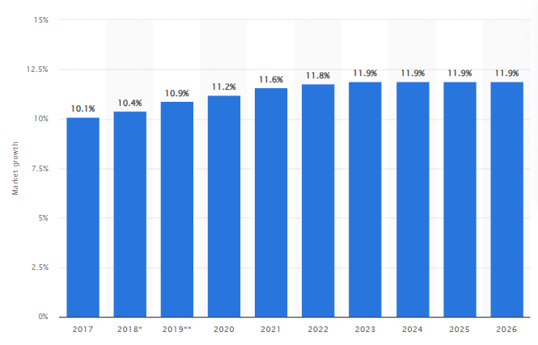
Figure 1: Global medication error
(Source: Erin Duffin, 2026)

3. National Context (India)
The hospital mix-up case in Kota Medical College Hospital in surgery is representative of the greater issue of patient safety in the Indian healthcare system in general (scmp.com, 2025). In India, medical negligence is an ever-growing problem because of a large number of patients, shortage of medical facilities and frailty of surveillance and control infrastructure. Research suggests that about 5.2 million cases of medical negligence are performing in India each year, which is a very big number of the problem (Sunil Khattri, 2023; imlindia.com, 2026). It is also reported that medical errors also claim almost 50 lakh (5 million) lives every year though not all of them are the direct consequence of negligence.
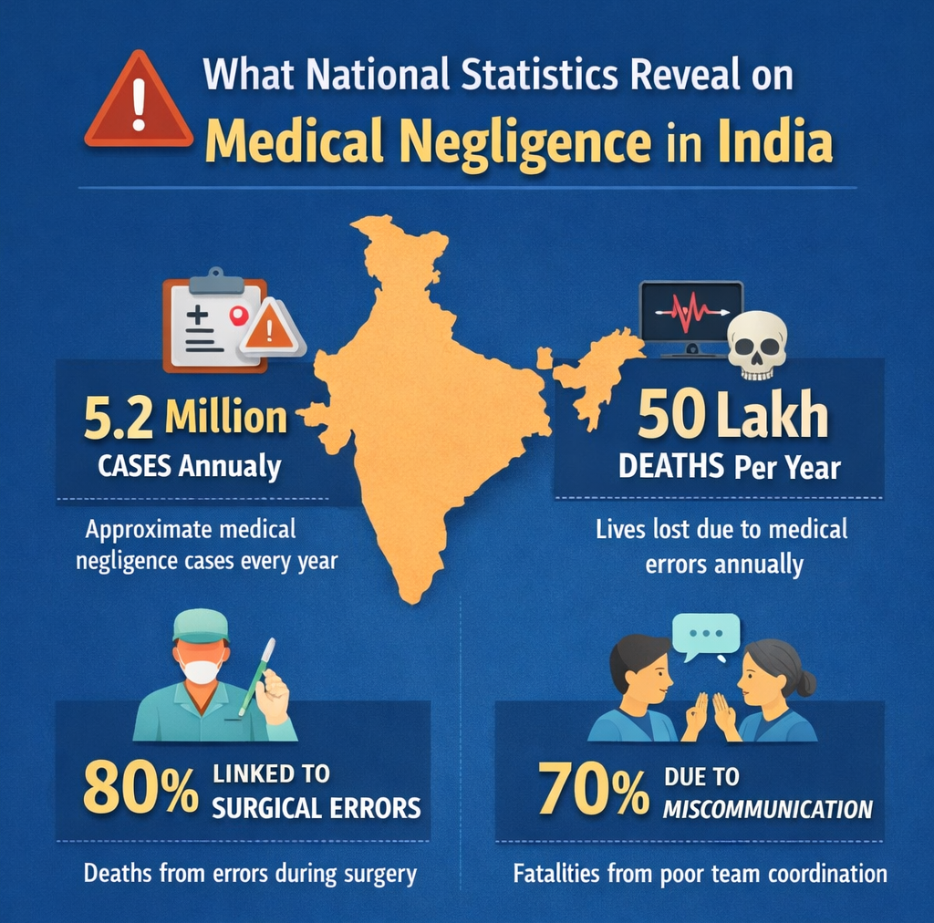
Figure 2: National Context (India)
(Source: Influenced by Sunil Khattri, 2023; imlindia.com, 2026)
According to research, an estimated 80 percent of all mortalities due to medical errors are related to the performance of surgical procedures, and 70 percent of those occurring are as a result of miscommunication and inappropriate team work during clinical care (Sunil Khattri, 2023). As an example, in December 2024, in Sultanpur, Uttar Pradesh, a surgeon supposedly noticed the right leg of an elderly woman when he should have operated on the left leg, which was fractured, which cast additional severe doubts on the management of hospitals and the verification procedure (Shweta Kumari, 2024). According to statistics given by the National Crime Records Bureau, medical negligence caused deaths in various parts of India.
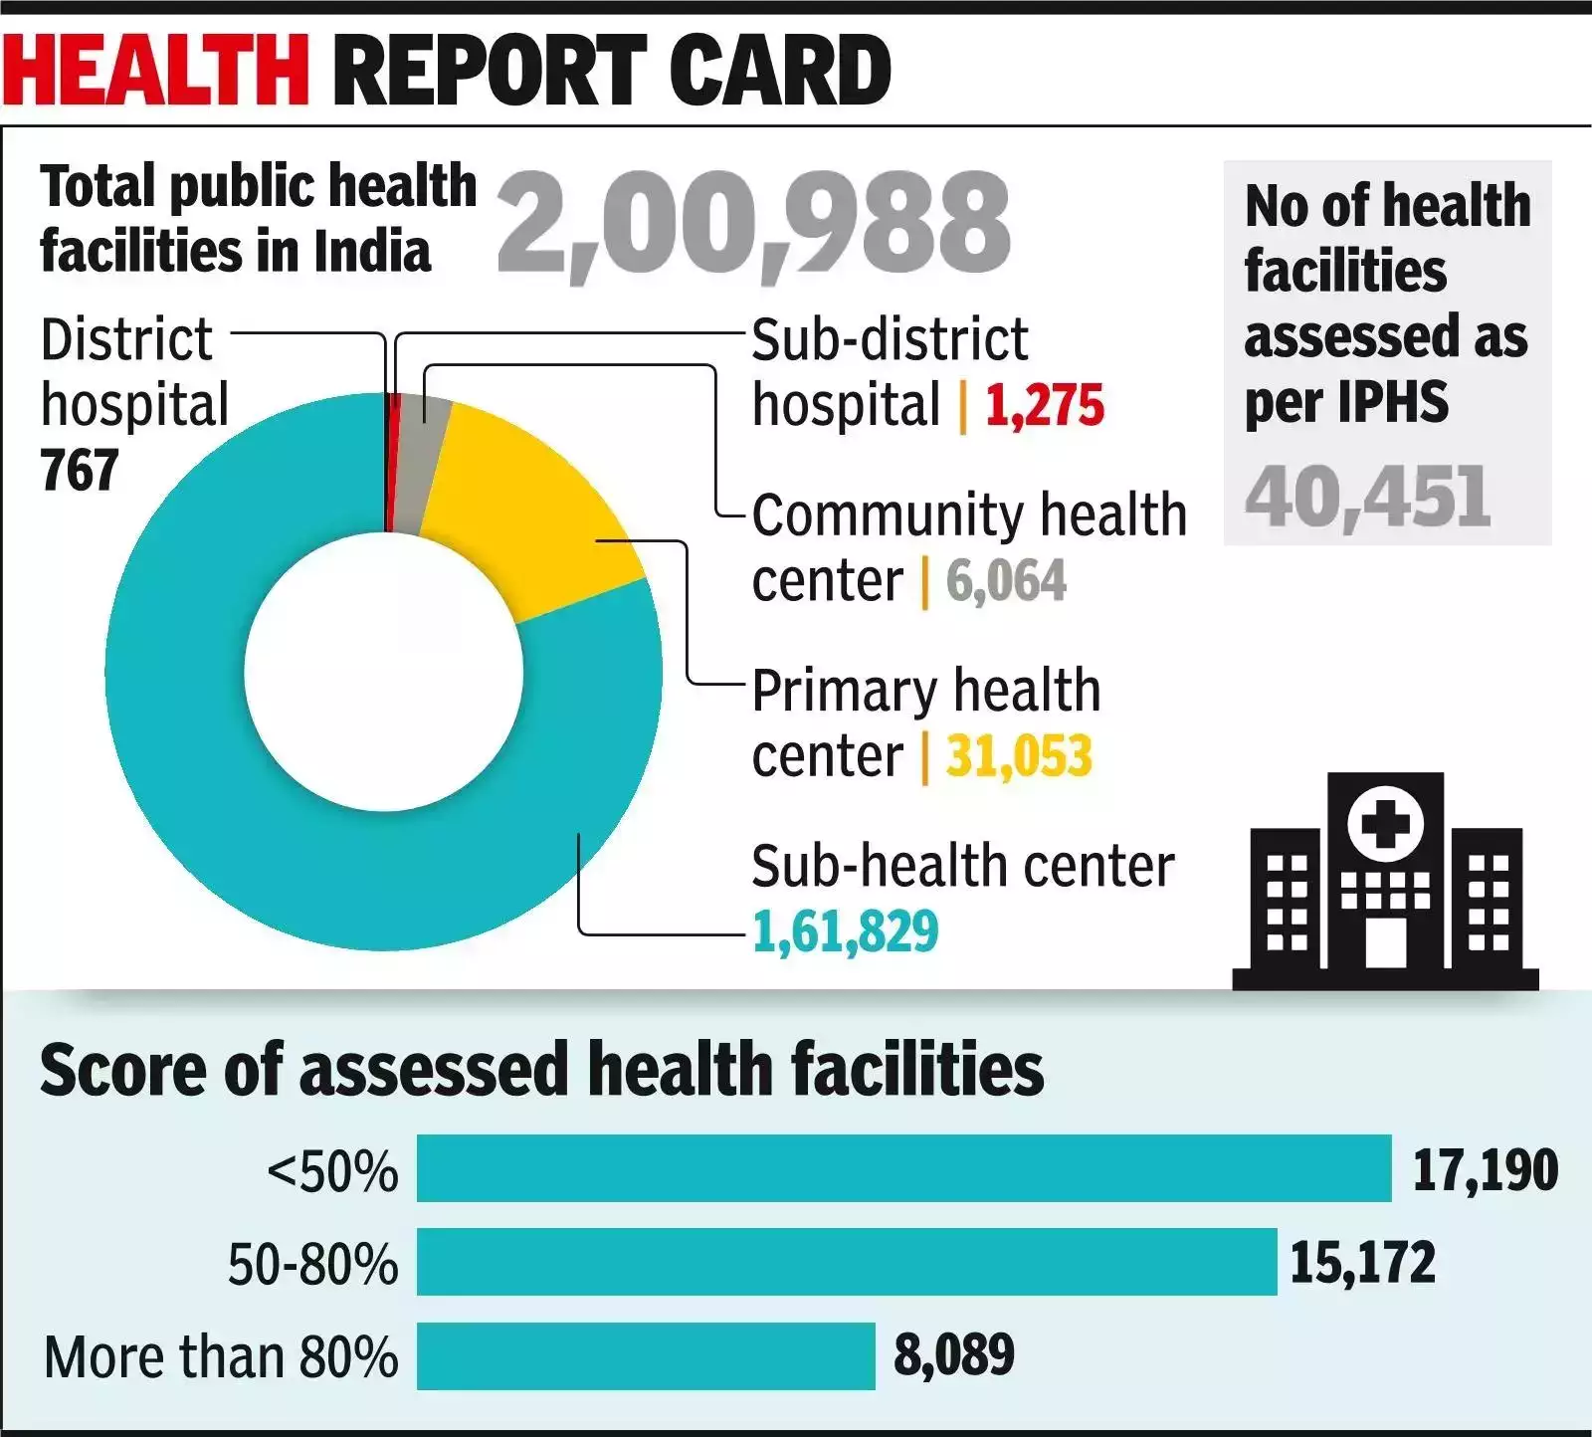
Figure 3: Public health facilities in India
(Source: The United Indian, 2025)

4. Systemic Weaknesses
A systems thinking lens reveals that the surgical error perpetrated at Kota Medical College Hospital did not happen as a result of one error, but it happened as a result of several systemic weaknesses in the healthcare process (scmp.com, 2025). The ineffective communication between hospital staff was one of the major failures. The elderly man in this case was merely taken to the operating theatre just because he responded after a name was called. None of the members of staff identified themselves by using hospital records, wristband identification, or verbal identification. Patient safety requires effective communication between nurses, surgeons and administrative personnel, and this is evidently lacking. The other weakness that was of a critical nature was that they failed to implement relevant patient verification procedures (Varshney et al. 2025).

5. Governance Level Influencing the Problem
Governance of health has also been important in ensuring safe health practices. Locally, surgical staff and hospital administrators have the duty of undertaking patient safety measures and gauging the performance of their staff (Debie et al. 2022). Overlooking the implementation of the identity verification measures in this instance directly supported the mistake. Regional sector Rajasthan state health officials control the hospitalisation provisions of hospitals, staff levels, and quality control mechanisms. Greater supervision and safety audits may aid in identifying areas of weakness in hospitals in terms of operations. At the national level, the Ministry of Health and Family Welfare sets policies on healthcare in India, as well as comes up with accreditation and surgical safety policies in India (Selvaraj et al. 2022).

6. Underlying System Challenges
This incident was also significantly contributed to by a number of broader healthcare system challenges. High workloads and burnout among healthcare workers are one of the main problems caused by a lack of staff in Indian hospitals (Debie et al. 2022). Hospitals that are overcrowded and have large numbers of patients may cause staff to overwork to observe all safety measures closely. The other obstacle is the absence of effective patient safety surveillance systems. The use of a manual record system is still prevalent in many hospitals and this increases the chances that records will be identified erroneously and further reduces the rate of incident reporting. Lack of proper policies and inadequate accountability systems also add to the chances of medical errors (Miziara and Miziara, 2022).
7. Rich Picture
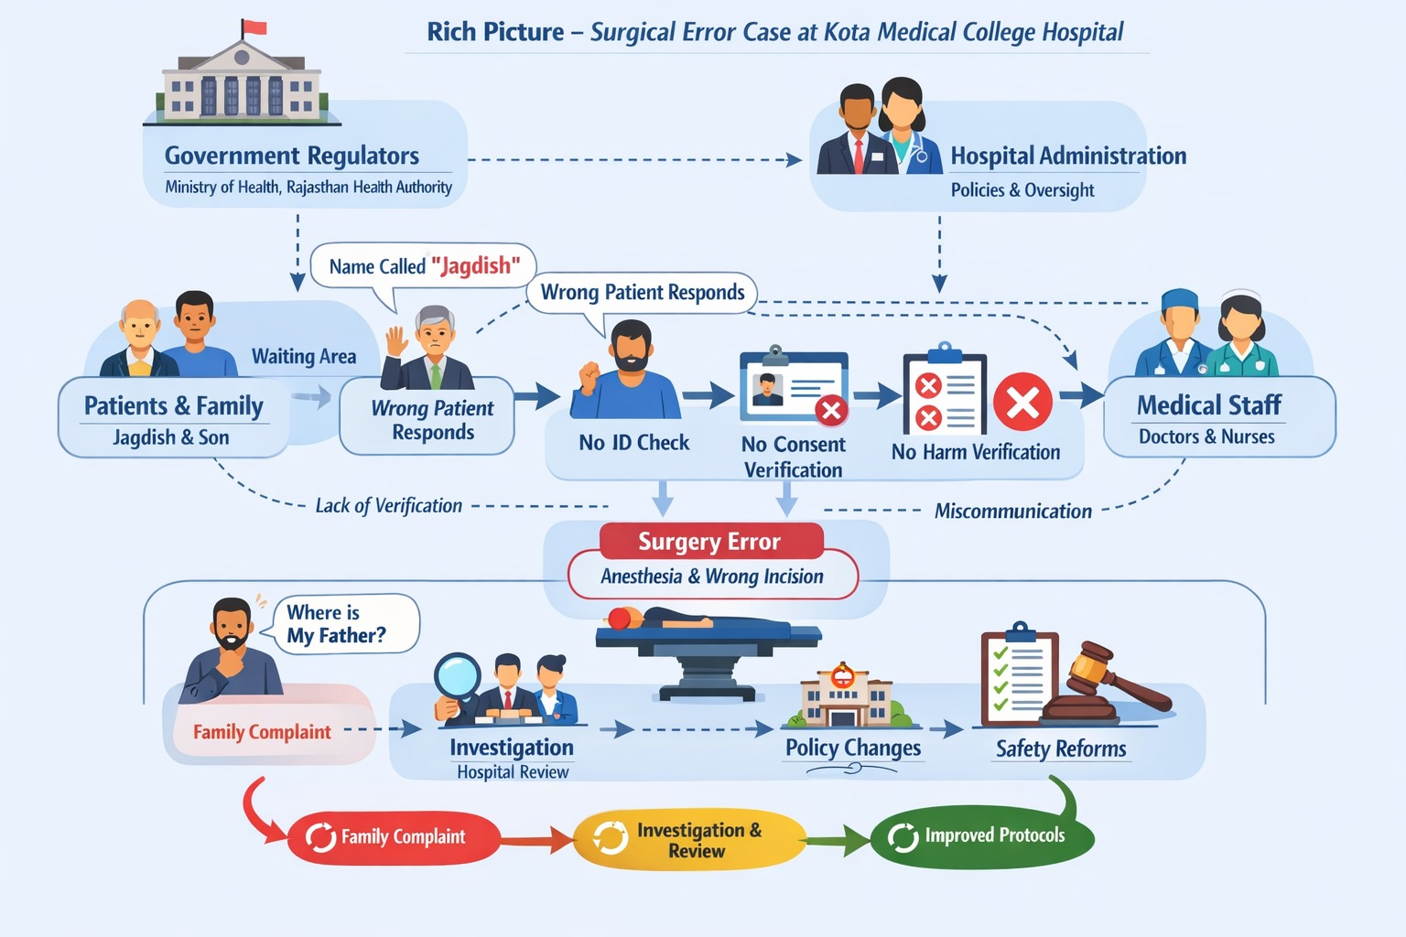
Figure 4: Rich Picture
(Source: Influenced by Selvaraj et al. 2022)

b. Centralisation or Decentralisation within the Case Study

1. Centralised Healthcare Systems
Explanation
In a centralised system of healthcare, the decision is made at higher levels of management, hospital administrators, government authorities or the regulatory bodies (Sapkota et al 2023). The senior leadership tends to design and implement policies, clinical guidelines, and safety procedures. The purpose of this structure is to bring about uniformity and standardisation of healthcare services. Huge public hospitals in India are frequently run on the centralised work systems owing to the fact that they are controlled by state health departments and also by national administration, like the National Medical Commission and the Ministry of Health and Family Welfare (Selvaraj et al. 2022).
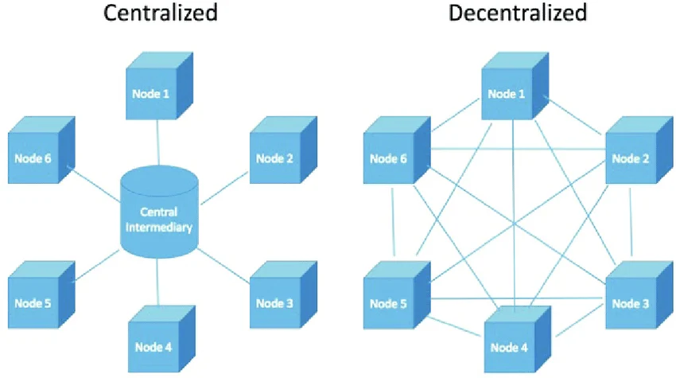
Figure 5: Centralised and Decentralised Systems
(Source: Sapkota et al 2023)
Example in the Case
The reaction to the operating room mistake in the Kota case exhibits centralised government aspects. Upon the publicity regarding the incident, the hospital administration commissioned an investigation and constituted a committee of three people to review the incident and provide a report (scmp.com, 2025). These activities are associated with a centralised method of decision making whereby top management steps in to audit crises and run crises (Romiti et al. 2025).
Advantages
They enable standardised processes and policies to be adopted within the departments so that clinical practices are guided by the national safety guidelines (Sapkota et al 2023). Administrative controls are also strong in ensuring adherence to regulations and ensuring that there is a uniform level of quality in the large hospital networks.
Disadvantages
Centralised structures can also, however, form constraints, however. The decision-making process may be time-consuming and bureaucratic, particularly in complicated hospital systems (Sapkota et al 2023).

2. Decentralised Healthcare Systems
Explanation
Decentralised healthcare dispels authority to various departments and clinical teams instead of being in a top-tier position (Almutari and Almutairi, 2023). The large hospitals also tend to decentralise to be faster in responding to clinical issues and developing teams among the healthcare professionals.
Example in the Case
A decentralised decision-making process can be identified in the case of the Kota hospital incident, where the surgical teams and nurses are given the clinical responsibility of dealing with the patient preparation and verification procedures. The patients can identify themselves, prepare the surgical site, and make sure that safety measures are taken, which are the general duties of nurses and other personnel working in the operating theatre before they are taken to the surgery (Almutari and Almutairi, 2023).
Advantages
Decentralised systems have one advantage in the speed of decision-making (Almutari and Almutairi, 2023). The clinical teams are able to act swiftly to address the needs of patients without administrative confirmation. It is also possible to promote responsiveness and teamwork through decentralisation since healthcare professionals can work directly in managing patient care.
Disadvantages
All these advantages notwithstanding, there are challenges associated with decentralisation when there are no robust control mechanisms. The core of the matter is that procedures can be interpreted in different ways across various departments, and thus, safety measures are not enforced uniformly (Almutari and Almutairi, 2023). Effective communication between teams may also contribute to the chances of medical errors.

3. Critical Analysis of System Structure
Kota Medical College Hospital has an organisational structure that incorporates the aspects of a centralised governance structure and a decentralised clinical practice structure (medicaleducation.rajasthan.gov.in, 2026). Though this arrangement is not unusual in large teaching hospitals, the surgical mix-up occurrence suggests how failure in the coordination of these two structures can have a significant impact on the safety of patients. The hospital has over 1,000 beds and an estimated 2,000-2,500 outpatients every day, with a major 300-500 surgeries done per day (medicaleducation.rajasthan.gov.in, 2026). The demands of such large volumes of patients demand powerful leadership supervision and a very strict level of compliance with safety standards (Abou Abbas, 2025).
Crisis Management
The system architecture was a bit helpful in the management of the crisis as the hospital leaders responded promptly once the error was realised. The hospital management commissioned an inquiry and constituted a team to investigate the case. The fact that the governance was centralised meant that the top leadership could intervene and take the right corrective measures, a fact that is valuable in ensuring the accountability of the institution (Brenya Bonsu et al. 2023). Nevertheless, the organisation also struggled with the crisis prevention due to the structure. Mechanisms that prevent occurrences of safety, like surgery safety checklists and patient identification measures, ought to have been implemented prior to the actual surgery (Paterson et al. 2024). These measures were not taken, meaning that there was no proper centralised oversight at the operational level.
Decision-Making
Organisational structure was a disadvantage to the decision-making process in the surgical preparation process. The front-line patient verification was done by nurses and surgical staff, thus depicting a decentralised clinical decision-making process (Brenya Bonsu et al. 2023). Although decentralisation generally provides a quicker solution to the needs of the patient, it may bring about dangers, provided that there is no adherence to communication and protocols. The patient in this situation was simply sent to an operating room because he responded when his name was called. Employees never ensured his identity through hospital documents or identification bracelets. Reported research in the area of patient safety demonstrates that communication breakdowns lead to almost 70 per cent of medical errors in a healthcare facility (Sunil Khattri, 2023).
Accountability
The system structure was also a source of trouble as it did not provide clear accountability in the hospital. A big teaching hospital, such as Kota Medical College Hospital, with an annual training population of about 250 MBBS and over 180 postgraduate seats, the issue of patient care can include several healthcare providers, such as nurses, surgeons, interns, and technicians (medicaleducation.rajasthan.gov.in, 2026). Despite the fact that the responsibilities of setting up the policies lie with the centralised leadership, decentralised groups need to make sure that they implement their policies in reality. In the given case, the absence of proper monitoring and enforcement regulations contributed to the occurrence of the error, which proves that the system structure of the hospital did not entirely facilitate safe clinical operations (Sunil Khattri, 2023).

c. Leadership Theories and Application to the Case Study

1. Relevant Leadership Theories
Behavioural Theory, Theory X and Theory Y (McGregor), Theory Z and Tannenbaum and Schmidt Continuum Theory (Tannenbaum Theory) are some of the leadership theories that can be applied to the Kota Medical College Hospital incident. Behavioural Theory is based on the behaviour of the leaders, especially whether they are people-oriented or task-oriented. Theory X involves employees being closely monitored and controlled, whereas Theory Y focuses on empowerment, trust and self-motivation (Talukdar, 2026). Collaboration, trust, and employee involvement in the long term are encouraged at Theory Z, which is typically prevalent in high-performing organisations. The Continuum Theory developed by Tannenbaum and Schmidt is a theory of the continuum of leadership, which interprets the decision-making processes of both autocratic and democratic leaders (leader-centred and team-centred) (Ujunwa and Danbeki, 2022). In healthcare, efficient leadership may necessitate stability between criminal control (safety compliance) and involvement (teamwork) (Bhati et al. 2023).

2. Application of Leadership Theories in the Case Study
Behavioural Theory is applicable to the Kota hospital case because their leaders did not adopt an objective focus on the safety measures, especially the identification of patients. Neither theory X factor was used heavily, since stringent discipline and execution of policies like checking of identities were not present. Simultaneously, the Theory Y and Theory Z concepts, including empowerment of the staff and groupwork, did not work because no member of the staff dared to challenge the bizarre scenario of a patient, who was not adequately prepared, moving to surgery (Talukdar, 2026). According to the model presented by Tannenbaum and Schmidt, the situation of leadership seems to have been ambiguous. There was neither high control of the members nor effective teamwork (Ujunwa and Danbeki, 2022). There was disregard for communication as the surgical team did not verify, and this implied the failure of both participative and directive leadership styles.

3. Supporting Data and Evidence
There is solid evidence that shows the positive relationship between leadership performance and patient safety (Bhati et al. 2023). Approximately 5.2 million cases of medical negligence are experienced every year in the Indian context, most of which are related to low quality of communication, ineffective supervision and coordination of medical teams (Sunil Khattri, 2023). Studies also suggest that about 70 per cent of severe healthcare mistakes are brought about by a lack of communication, which is a manifestation of failure in leadership behaviour and team management (Howick et al. 2024; Sunil Khattri, 2023). Theoretically, Behavioural Theory implies that leaders should be highly task-focused in order to make their subordinates follow safety standards, as well as to promote communication between the team members. This balance was not present in the Kota case, where employees did not observe simple identification practices. Theory X emphasises the necessity to control and supervise the situation in the high-risk area, including the surgical rooms closely; nevertheless, the lack of strict control of the rules in this dispute allows one to conclude about the insufficiency of this style (Wallace et al. 2025). Meanwhile, Theory Y and Theory Z focus on trust, teamwork and shared responsibility, which were also absent, and no member of the staff has challenged the situation. In addition, the Continuum Theory of Tannenbaum and Schmidt indicates that successful leadership demands a mix between the directive and participative leadership approaches.

4. Was the Leadership Style Appropriate for the Situation?
Healthcare that is highly risky is marked by the necessity of a blend of stringent adherence to rules (Theory X) and team consciousness (Theory Y). Nevertheless, the lack of adequate identity checks demonstrates that the leadership did not implement important safety regulations (Paterson et al. 2024). According to the Behavioural Theory, the balance of task orientation (meaning having procedures being followed) and people orientation (staff communicating their concerns) is recommended by leaders. In the given situation, these two aspects were not applied successfully. Leadership that is more organised and oriented to safety would have guaranteed that all of the surgical procedures were observed, and the incident would have been avoided (Talukdar, 2026).

5. Were Leaders Reactive or Proactive?
The style adopted by the leadership in this situation was very reactive, but not proactive. Only when the error was known did the hospital administration create a committee to investigate the case, and action was taken. Active leadership would have included the installation of effective systems of identification of the patients, frequent safety audit checks, and training of the staff prior to the incident taking place (Al-Harthi et al. 2025). WHO recommendations highlight the importance of active safety leadership in order to minimise unnecessary damage. Failure to implement preventive measures in this case implies that the leadership was more oriented toward responding to issues and not preventing them.

6. Leadership Effectiveness
The leadership performance is poor, as evidenced by the safety outcomes in this case. The fact that there was a wrong-patient surgery procedure shows that there was no implementation of safety standards and performance monitoring of the staff (Kiridjievska et al. 2024). When surgical safety practices are properly addressed through good leadership in the healthcare system, the rates of compliance are usually more than 90, which results in lower rates of errors (Kiridjievska et al. 2024). Nevertheless, the Kota example shows that even relatively simple procedures were not followed. Moreover, medical negligence and underreporting in Indian healthcare data reflect high proximate causes of poor leadership systems in most instances, which do not have robust monitoring and accountability devices. These results suggest that the ineffective leadership on both operational and administrative levels was in place for the safety of the patients (Dave et al. 2022).

7. What Could Have Been Done Differently?
Initially, using Theory Z principles would have enhanced collaboration and collective accountability in place of inviting staff to challenge strange circumstances (Tulenbaevna et al. 2025). Second, a more participative style, falling on the left end of the continuum by Tannenbaum and Schmidt, would enable the staff to raise issues freely and yet retain leadership authority. Third, communication, trust, and coordination of a team may be enhanced with the help of emotionally intelligent leadership (Falade et al. 2024). Structured systems of safety, like checklists and digital identification tools, should also be applied by the leaders.

d. Improvement and Lessons Learned

1. Key Problems Identified and Evidence-Based Solutions
Problem: Weak Patient Identification and Safety Protocols
The lack of adherence to the normal identification procedures of the patient was one of the most problematic issues raised in the Kota Medical College Hospital incident (Amin, 2024). Examples of this happened when the elderly man, Jagdish Panchal, gave false responses because the hospital staff had called upon a patient with a similar name, and they were placed in the operating theatre without checking, according to any similar name. This indicates a massive failure in the patient safety measures. The World Health Organisation holds that most surgical mistakes in the world are because of improper identification of patients (Wani et al. 2022). The studies show that more than 16 per cent of the hospital safety events can be attributed to identification errors, which evidences the necessity of the thorough verification process prior to medical procedures (Wani et al. 2022).
Data Evidence and System Weakness
The case indicates structural flaws in the governance of the hospital and leadership supervision. Kota Medical College Hospital has a big healthcare system that is endowed with over 1,000 beds and has about 2,000-2,500 outpatient visits on a daily basis, carrying out about 100-150 major surgeries daily (medicaleducation.rajasthan.gov.in, 2026). This is because in these high-volume settings, good safety measures and leadership monitoring are necessary (Brenya Bonsu et al. 2023). Nevertheless, the fact that several medical service providers, such as nurses or surgeons, failed to notice that this was not the intended patient implies a lack of communication skills and inefficient accountability policies. According to the WHO, 1 out of 10 patients around the globe suffers preventable injuries at health care institutions, and communication failures and poor governance are among the most frequent instances (who.int, 2023).
Improvement: Strengthening Patient Verification Systems
The introduction of more robust patient verification systems should be considered an important improvement (Khan et al. 2025). The hospitals should stipulate that staff must ensure that they have verified the identity of the patient by at least two identifiers (patient name, date of birth, identification wristbands) before conducting any surgical operation (Khan et al. 2025). Wrong-patient surgeries can be minimised through digital patient identification systems and those wristbands that have barcodes.
Problem: Weak Leadership Oversight and Accountability
Weak leadership oversight is another issue that was found in the case. The task of the hospital leaders is to make sure that the healthcare teams always adhere to safety measures. The reaction was reactive instead of preventive (Rotteau et al. 2022). Later, the hospital administration constituted a three-member investigation committee. The agenda of leadership must be to build a good safety culture in which the staff adheres to standards and believes in the necessity of pointing out possible mistakes. As per the study on patient safety rolled worldwide, almost 70 per cent of severe patient care events contain communication failures among employees, which reveals that better leadership direction and supervision are required (Logan‐Athmer, 2022).
Improvement: Enhancing Leadership and Safety Culture
Patient safety in healthcare organisations can be greatly enhanced by enhancing leadership practices in organisations (Ahmed et al. 2024). The leaders are expected to foster the culture of proactive safety, in which healthcare professionals are urged to question suspicious cases and report possible hazards. To make sure that the protocols will be adhered to, regular training of staff, safety exercises, and performance monitoring mechanisms can be employed. Furthermore, an organisation can make its medical errors visible by introducing the system of transparent reporting, which enhances organisational learning and responsibility (Ahmed et al. 2024).

2. Linking System Structure, Leadership, and Feedback
The effects witnessed in the Kota hospital event were the product of interplay among the system structure, leadership style, and poor feedback systems (scmp.com, 2025). The hospital is governed centrally, and it has a layered structure of clinical decision-making. Although the process of setting safety policies is the responsibility of leadership, patient care and surgical preparation involve frontline personnel. Such poor coordination between these levels, in this case, enabled the error to be made. There was also reactive instead of proactive governance, where leadership intervention came in after the incident (Ahmed et al. 2024).

3. Lessons for Other Health Organisations
This case can teach some crucial lessons. First, the medical care organisations have to be compliant with the patient identification procedures prior to any medical procedure (Popescu et al. 2022). Second, a culture of accountability and safety of the patient safety should be encouraged by the leadership. Third, hospitals ought to implement electronic reporting and monitoring systems to monitor medical errors and identify systemic inadequacies. Moreover, the training and communication behaviours of the staff should be enhanced to overcome the possibility of human error.

4. Continuous Improvement Through Evidence and Data
Data and evidence are important in enhancing healthcare control and patient safety. Hospitals are advised to analyse safety reports and incident data, as well as staff feedback, regularly to develop patterns of danger (Popescu et al. 2022). Constant tracking of performance metrics, including compliance with the safety of the surgical procedure, accuracy of patient identification and communication of the staff, can assist in the prevention of future incidents.

3. Recommendations

3.1 Immediate Actions for the Organisation
The significant aspect that Kota Medical College Hospital should focus on is fortifying patient safety measures and operational controls in order to avoid such incidents (Falade et al. 2024). The mix-up during surgery was present due to the fact that the identity of the patient was not established prior to the surgery, regardless of the obvious information about the fact that this individual had not passed through all preoperative procedures. This hospital needs to implement two-step patient identification measures directly (Falade et al. 2024). The processes are done in hospitals all over the world as per the World Health Organisation's recommended surgical safety standards. As an illustration, those who have embraced the WHO Surgical Safety Checklist have seen a cut of almost 36% in the surgical incidences and surgical mortalities, which reveals the usefulness of standardised verifications (Faria et al. 2022).

3.2 Recommended Leadership Style for Sustaining Improvement
Kota Medical College Hospital must implement a transformational and distributed leadership style to maintain the effectiveness of a long-term outcome. Leaders are supposed to encourage personnel to adhere to safety measures and to be vocal when it comes to expressing issues concerning possible risks (Curcuruto and Griffin, 2023). Moreover, distributed leadership can distribute the responsibility through clinical teams, where the nurses, surgeons, and technicians will get involved in safety monitoring. Hospital data in the National Health Service of the United Kingdom has demonstrated that organisations with transformational leadership and collaborative decision making had a tremendous increase in staff engagement and patient safety events (West et al. 2022).

3.3 Strengthening Governance, Communication, and Systems Integration
Well-established institutions of governance are critical in terms of adherence to patient safety measures. The accident displayed the lack of communicative skills among the hospital employees and the weaknesses in the procedures of monitoring. The hospital ought to implement centralised electronic reporting procedures, where employees are expected to submit the occurrences, safety and near-miss incidents (Alalaween and Karia, 2024). With such systems, leaders are able to detect risk patterns and take preventive actions. Indicatively, healthcare organisations with electronic incident reporting systems have claimed better disclosure and quicker reactions to medical mistakes (Alalaween and Karia, 2024).

3.4 Enhancing Technical and Allocative Efficiency
Enhancement of technical and allocative efficiency will assist hospitals in utilising their resources more efficiently without compromising the safety of patients (Curcuruto and Griffin, 2023). The institution has a huge patient workload of 2,000-2500 outpatients in a day and undergoes about 100-150 surgeries in a day, a factor that exacerbates the hazard of making mistakes in the performance of operations. Technical efficiency can also be enhanced with the introduction of digital patient identification technologies like barcode wristbands and electronic health records that will help decrease the number of errors in the manual verification. All the resources can be concentrated on staff education, patient safety protocols, and technological network instead of investigations that get initiated once the incidents have taken place, and then this allocative efficiency can be improved (Curcuruto and Griffin, 2023).

3.5 Continuous Learning, Stakeholder Engagement, and Co-production
Constant learning and teamwork among stakeholders have to be a part of a long-term betterment of the culture (Upadhyay, 2024). The hospitals are advised to work towards motivating healthcare workers to report the mistakes and near-miss events without the fear of punishment to enable organisations to learn about the mistakes and make improvements to the systems. Moreover, accountability can be reinforced by involving patients and families in the process of safety. Indicatively, looking at the treatment of the patient, they can be brought to ensure that before the affected person goes through the procedure, they will have to confirm their identity and treatment details (Upadhyay, 2024). Co-production models in which healthcare providers and patients collaborate with health administrators to enhance healthcare delivery have been a common practice in global health systems to enhance quality provision.

4. Conclusion
The Kota Medical College Hospital level surgical mix-up presented in the case study shows how patient safety systems, leadership oversight, and healthcare governance fail to gain considerable strength. It happened when a senior citizen was confused and wrongly called by name and was admitted to the operating theatre without any identification verification. It was revealed that the error was not occasioned by a single mistake but was caused by several systemic failures, such as ineffective communication amongst personnel, lack of effective patient identification steps, and lack of oversight in a busy hospital setting. The results underline the essential importance of efficient leadership and governance in the context of patient safety. A good safety culture should be encouraged, clinical standards should be adhered to, and healthcare groups should be motivated to communicate freely. The governance systems are also expected to offer visibility, routine audits and evidence-based policies that ensure that clinical practices are safe. The use of systems thinking will enable the healthcare organisations to know the interplay of leadership, organisational structures, and work processes on the outcome.

References
Abou Abbas, A., 2025. Transformational Leadership and Regulatory Compliance: Strategies for Safer Healthcare Delivery. J Glob Health Soci Med, 1(1), pp.1-8.
Ahmed, Z., Ellahham, S., Soomro, M., Shams, S. and Latif, K., 2024. Exploring the impact of compassion and leadership on patient safety and quality in healthcare systems: a narrative review. BMJ open quality, 13(Suppl 2).
Alalaween, M.A. and Karia, N., 2024. The predictive power of electronic reporting system utilization on voluntary reporting of near-miss incidents among nurses: A PLS-SEM approach. Belitung Nursing Journal, 10(1), p.15.
Al-Harthi, M.B.S.S., Albalawi, Z.A., Al Balawi, B.A., Alhawiti, S.S., Almshouri, M.S., Alrashidi, N.S., Alayadi, Y.A., Jafari, M.M., Albalawi, N.D., Albalawi, F.K. and Albalawi, B.O., 2025. Patient Safety Strategies Involving Integrated Management and Collaboration of Different Departments. Journal of Clinical Practice and Medical Research, 1(3), pp.89-100.
Almutari, M.S.W. and Almutairi, W.S.W., 2023. Nursing leadership and management: theory, practice, and future impact on healthcare. Mohammed Saad Waslallah Almutari.
Amin, M., 2024. A study to assess the compliance of Medical Records of IPD and Emergency Department in a tertiary care hospital.
Baker, E.L., 2022. Influence—a core leadership skill. Journal of Public Health Management and Practice, 28(5), pp.578-579.
Bhati, D., Deogade, M.S. and Kanyal, D., 2023. Improving patient outcomes through effective hospital administration: a comprehensive review. Cureus, 15(10), p.e47731.
Brenya Bonsu, A., Appiah, K.O., Gyimah, P. and Owusu-Afriyie, R., 2023. Public sector accountability: do leadership practices, integrity and internal control systems matter?. IIM Ranchi journal of management studies, 2(1), pp.4-15.
Broome, M.E., 2024. Transformational leadership in nursing: From expert clinician to influential leader. springer publishing company.
Curcuruto, M. and Griffin, M.A., 2023. Upward safety communication in the workplace: How team leaders stimulate employees’ voice through empowering and monitoring supervision. Safety science, 157, p.105947.
Dave, N., Yaddanapudi, S., Jacob, R. and Varghese, E., 2022. Quality improvement and patient safety in India—Present and future. Pediatric Anesthesia, 32(11), pp.1185-1190.
Debie, A., Khatri, R.B. and Assefa, Y., 2022. Successes and challenges of health systems governance towards universal health coverage and global health security: a narrative review and synthesis of the literature. Health research policy and systems, 20(1), p.50.
Erin Duffin, 2026. Global medication error reporting market growth from 2017 to 2026. Available at: https://www.statista.com/statistics/1042245/medication-error-reporting-market-growth-worldwide/?srsltid=AfmBOoo82EbJsBd7PHNjbje2ElbyFSGLWU3cWOM8c03yxjIpZydvfz_P [Accessed on: 12/3/2026]
Falade, I.M., Gyampoh, G.K.S., Akpamgbo, E.O., Chika, O.C., Obodo, O.R., Okobi, O.E., Aguguo, J.C. and Chukwu, V.U., 2024. A comprehensive review of effective patient safety and quality improvement programs in healthcare facilities. Medical Research Archives, 12(7).
Faria, L.R.D., Moreira, T.R., Carbogim, F.D.C. and Bastos, R.R., 2022. Effect of the Surgical Safety Checklist on the incidence of adverse events: contributions from a national study. Revista do Colégio Brasileiro de Cirurgiões, 49, p.e20223286.
Howick, J., Bennett-Weston, A., Solomon, J., Nockels, K., Bostock, J. and Keshtkar, L., 2024. How does communication affect patient safety? Protocol for a systematic review and logic model. BMJ open, 14(5), p.e085312.
imlindia.com, 2026. Over 5.2 mn medical malpractice cases filed in India annually, shows data. Available at: https://imlindia.com/corpcomm/week346.htm [Accessed on: 12/3/2026]
Khan, S., Akhtar, N., Mushtaq, M.F., Abdel Samee, N., Mahmoud, N.F. and Ashraf, I., 2025. Towards robust electronic health record systems: integrating formal verification and process modeling techniques. BMC Medical Research Methodology, 25(1), p.215.
Kiridjievska, L.V., Popovska, M.B., Latkovikj, M.T. and Drakulevski, L., 2024. The Role of Leadership and Organizational Culture In Medical Error Management: A Comprehensive Literature Review. JMS, 7(1), pp.25-32.
Logan‐Athmer, A.L., 2022. The necessary leadership skillsets for the high‐reliability organization framework adoption within acute healthcare organizations. Journal of Healthcare Risk Management, 42(1), pp.31-36.
medicaleducation.rajasthan.gov.in, 2026. Medical College, Kota. Available at: https://medicaleducation.rajasthan.gov.in/mckota/#/home/dptHome [Accessed on: 12/3/2026]
Miziara, I.D. and Miziara, C.S.M.G., 2022. Medical errors, medical negligence and defensive medicine: A narrative review. Clinics, 77, p.100053.
O'Kane, C., Mangematin, V., Zhang, J.A. and Haar, J., 2024. How research agendas are framed: Insights for leadership, learning and spillover in science teams. Research policy, 53(7), p.105029.
Paterson, C., Mckie, A., Turner, M. and Kaak, V., 2024. Barriers and facilitators associated with the implementation of surgical safety checklists: a qualitative systematic review. Journal of advanced nursing, 80(2), pp.465-483.
Popescu, C., El-Chaarani, H., El-Abiad, Z. and Gigauri, I., 2022. Implementation of health information systems to improve patient identification. International Journal of Environmental Research and Public Health, 19(22), p.15236.
Romiti, A., Del Vecchio, M., Cavicchi, C. and Vagnoni, E., 2025. Healthcare organizations in crisis context: decision-making models and roles of CEOs. BMC health services research, 25(1), p.273.
Rotteau, L., Goldman, J., Shojania, K.G., Vogus, T.J., Christianson, M., Baker, G.R., Rowland, P. and Coffey, M., 2022. Striving for high reliability in healthcare: a qualitative study of the implementation of a hospital safety programme. BMJ Quality & Safety, 31(12), pp.867-877.
Sapkota, S., Dhakal, A., Rushton, S., van Teijlingen, E., Marahatta, S.B., Balen, J. and Lee, A.C., 2023. The impact of decentralisation on health systems: a systematic review of reviews. BMJ Global Health, 8(12).
scmp.com, 2025. Indian hospital probed after man mistakenly operated on while waiting on son’s surgery. Indian hospital probed after man mistakenly operated on while waiting on son’s surgery. Available at: https://www.scmp.com/week-asia/health-environment/article/3307457/indian-hospital-probed-after-man-mistakenly-operated-while-waiting-sons-surgery?module=perpetual_scroll_0&pgtype=articlehttps://www.scmp.com/week-asia/health-environment/article/3307457/indian-hospital-probed-after-man-mistakenly-operated-while-waiting-sons-surgery?utm_source=chatgpt.com [Accessed on: 12/3/2026]
Selvaraj, S.K.K.A., Karan, K.A., Srivastava, S., Bhan, N., Mukhopadhyay, I. and World Health Organization, 2022. India: Health system review. Health systems in transition, 11(1).
Shweta Kumari, 2024. UP doctor operated elderly woman on wrong leg, alleges family, hospital denies. Shweta Kumari, Available at: https://newsable.asianetnews.com/india/up-doctor-operated-elderly-woman-on-wrong-leg-alleges-family-hospital-denies-shk-spaugh [Accessed on: 12/3/2026]
Sunil Khattri, 2023. Stats On Medical Negligence Cases In India In Comparison To Other Countries. Available at: https://www.delhimedicalnegligence.com/post/stats-on-medical-negligence-cases-in-india-in-comparison-to-other-countries [Accessed on: 12/3/2026]
Talukdar, M.R.I., 2026. Theories X and Y in five parts of the organization. Acta Psychologica, 264, p.106473.
The United Indian, 2025. World Health Day 2025: Can Technology Cure the Broken Healthcare System in India & Globally? Available at: https://www.theunitedindian.com/news/World-Health-Day-2025 [Accessed on: 12/3/2026]
Tulenbaevna, M.M., Atmaca, T., Tursynkyzy, A.K., Mamadaliyev, S. and Zholdasovna, K.Z., 2025, September. Collaborative roles in schoolwide bullying prevention: teachers’, psychologists’, and school principals’ shared responsibilities. In Frontiers in Education (Vol. 10, p. 1677350). Frontiers Media SA.
Ujunwa, M.D. and Danbeki, M.D., 2022. Understanding leadership in a formal organization: overview, roles, and theories. Public administration: theory and practice in Nigeria. Theory and practice in Nigeria, pp.138-154.
Upadhyay, D., 2024. Excellence in healthcare: nurturing servant leadership, fostering collaborative culture and promoting social sustainability in the UAE–strategies for transformation. Leadership in Health Services, 37(3), pp.394-407.
Varshney, A., Dwivedi, S. and Naga, R., 2025. Ensuring Patient Safety and Optimal Outcomes: A Surgeon’s Perspective on Safe Surgery Practices. Journal of Marine Medical Society, 27(3), pp.274-279.
Wallace, J., Pierce, R., Staff, T.J. and Allyn, R., 2025. Voices of frontline leaders: challenges and opportunities from frontline primary care clinic leaders in a safety-net health care system. The Joint Commission Journal on Quality and Patient Safety, 51(4), pp.261-269.
Wani, M.M., Gilbert, J.H., Mohammed, C.A. and Madaan, S., 2022. Factors causing variation in World Health Organization surgical safety checklist effectiveness—a rapid scoping review. Journal of patient safety, 18(8), pp.e1150-e1159.
West, T.H., Daher, P., Dawson, J.F., Lyubovnikova, J., Buttigieg, S.C. and West, M.A., 2022. The relationship between leader support, staff influence over decision making, work pressure and patient satisfaction: a cross-sectional analysis of NHS datasets in England. BMJ open, 12(2), p.e052778.
who.int, 2023. Patient safety. Available at: https://www.who.int/news-room/fact-sheets/detail/patient-safety [Accessed on: 12/3/2026]

