  Component One: Student Journal (learning log) 750 words +/- 10%  Contribution to Overall Module Assessment: 25% | Student No: | 2246594
 | Module Title: | Operating Hotel Facilities
 | Module Code: | BMIH4006
 | Lecturer: | Daniel Payne
Multiple tasks in relation to cleaning and reporting are embedded in the job roles and responsibilities of housekeeping. Tasks like vacuuming, sweeping, dusting shelves, emptying trash cans, mopping floors and cleaning windows are a few of them. After the advent of COVID-19, cleaning standards have evolved a lot and have taken a revolutionary turn in Hotel Premier Inn. I am trained in health and safety aspects and had to apply the learned skills in my internship. I am doing my practice at Premier Inn at Ashby de la Zouch. Cleanliness and hygiene are among the top factors which influence the decision-making behaviour of guests (Williams and Woolliams, 2020). Following is the description of the responsibilities given to me and the challenges faced by me through Gibbs's reflection cycle.
Description: I was given the responsibility to keep the guest room clean and disinfected. I was supposed to clean the rooms before the check-in time of the guests. Therefore, along with the cleaning part, I had to keep track of the guest check-in timings. I was given a chart that I used to update the guests coming into the hotel. As per this information, I used to prioritise the list of room numbers which need to be cleaned first. After the basic cleaning like sweeping and mopping the floor, I had to disinfect the curtains and other items which are often touched such as the doorknob. After disinfecting, I used to change the bedsheet, comforter and pillow covers to give a hygienic and clean experience to the guests.
Feelings: I was feeling very stressed while cleaning the guest room as it was the very first time I was taking up a job responsibility. I was very anxious about my job performance and along with this, I was nervous as I hesitated to ask questions. The reason was that I did not know whom I approach if I was having any issues with the instructions. However, many of the rules were already mentioned in the employee manual which is handed over to everyone working in the hotel. This manual was useful for me when I used to get confused. But, I was scared that if I made a mistake I could get scolded by my supervisor.
Evaluation: One of the things that went very well was that in spite I being a fresher in this job, I was able to maintain health and safety very well through the cleaning procedure. I did them all and my supervisor appreciated the work as well. However, the supervisor provided constructive feedback to me which mentioned that I could not complete the tasks within the time. It took a bit longer than anticipated to complete the role. This was not something that went well and I realised I needed to seek some time-management skills.
Analysis: I think that I could finish all the tasks because I have always been a self-motivated individual. I am always committed to the tasks assigned to me since my University life. Also, my presence of mind allowed me to complete the task as I read the employee manual very carefully which helped me to achieve this. On the other hand, I was so indulged in just finishing the task that I did not even take the “time factor” into account. I believe I could not manage my time since I could not balance between the tasks assigned and the time allotted for them.
Conclusion: I draw some significant conclusions from the analysis part of mine. I need to learn more about balancing various tasks within time. Moreover, I need to learn the procedures to be followed while completing a task. Therefore, I have decided to practise more mindful techniques to manage my stress and improve my focus to finish tasks within deadlines. I will focus more on the details of tasks to manage them in the best possible manner. I learned that sometimes we need to challenge ourselves in such job roles to finish tasks within a deadline.
Action Plan: In future, when deadline-oriented tasks will be assigned to me, I will first brainstorm and create a “work breakdown structure”. On paper, I will create this breakdown where I will mention the expected time to be taken for the assigned tasks. It will help me to create a benchmark and keep a hold of the time. Following are the steps that I will adhere to accomplish my approach:
- I will first research and I will learn more about housekeeping procedures
- I will adopt mindful techniques for managing anxiety and fear
- I will seek feedback from the supervisor once a week to improve my efficiency
- I will keep a track of the tasks for a continuous improvement

Component Two: Health and Safety Guide

Introduction
The proactive management of safety as well as health in a workplace helps an organisation for preventing injuries and ill-health at work. this guidance usually helps the organisation reduce personal loss which usually relates to accidents and ill health at work.
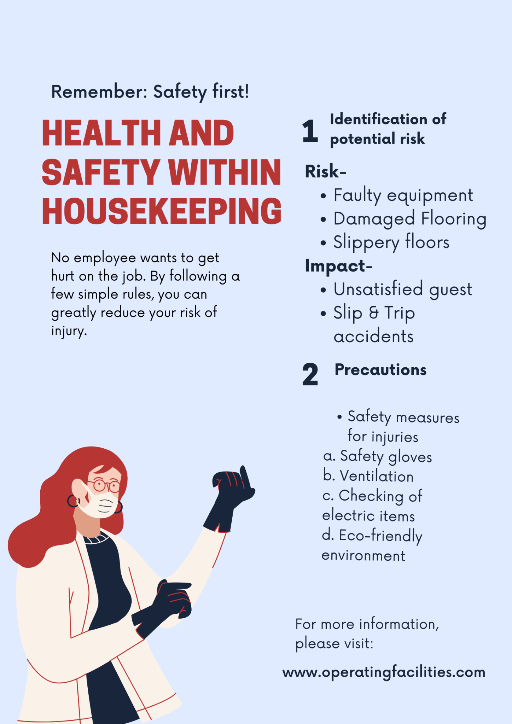

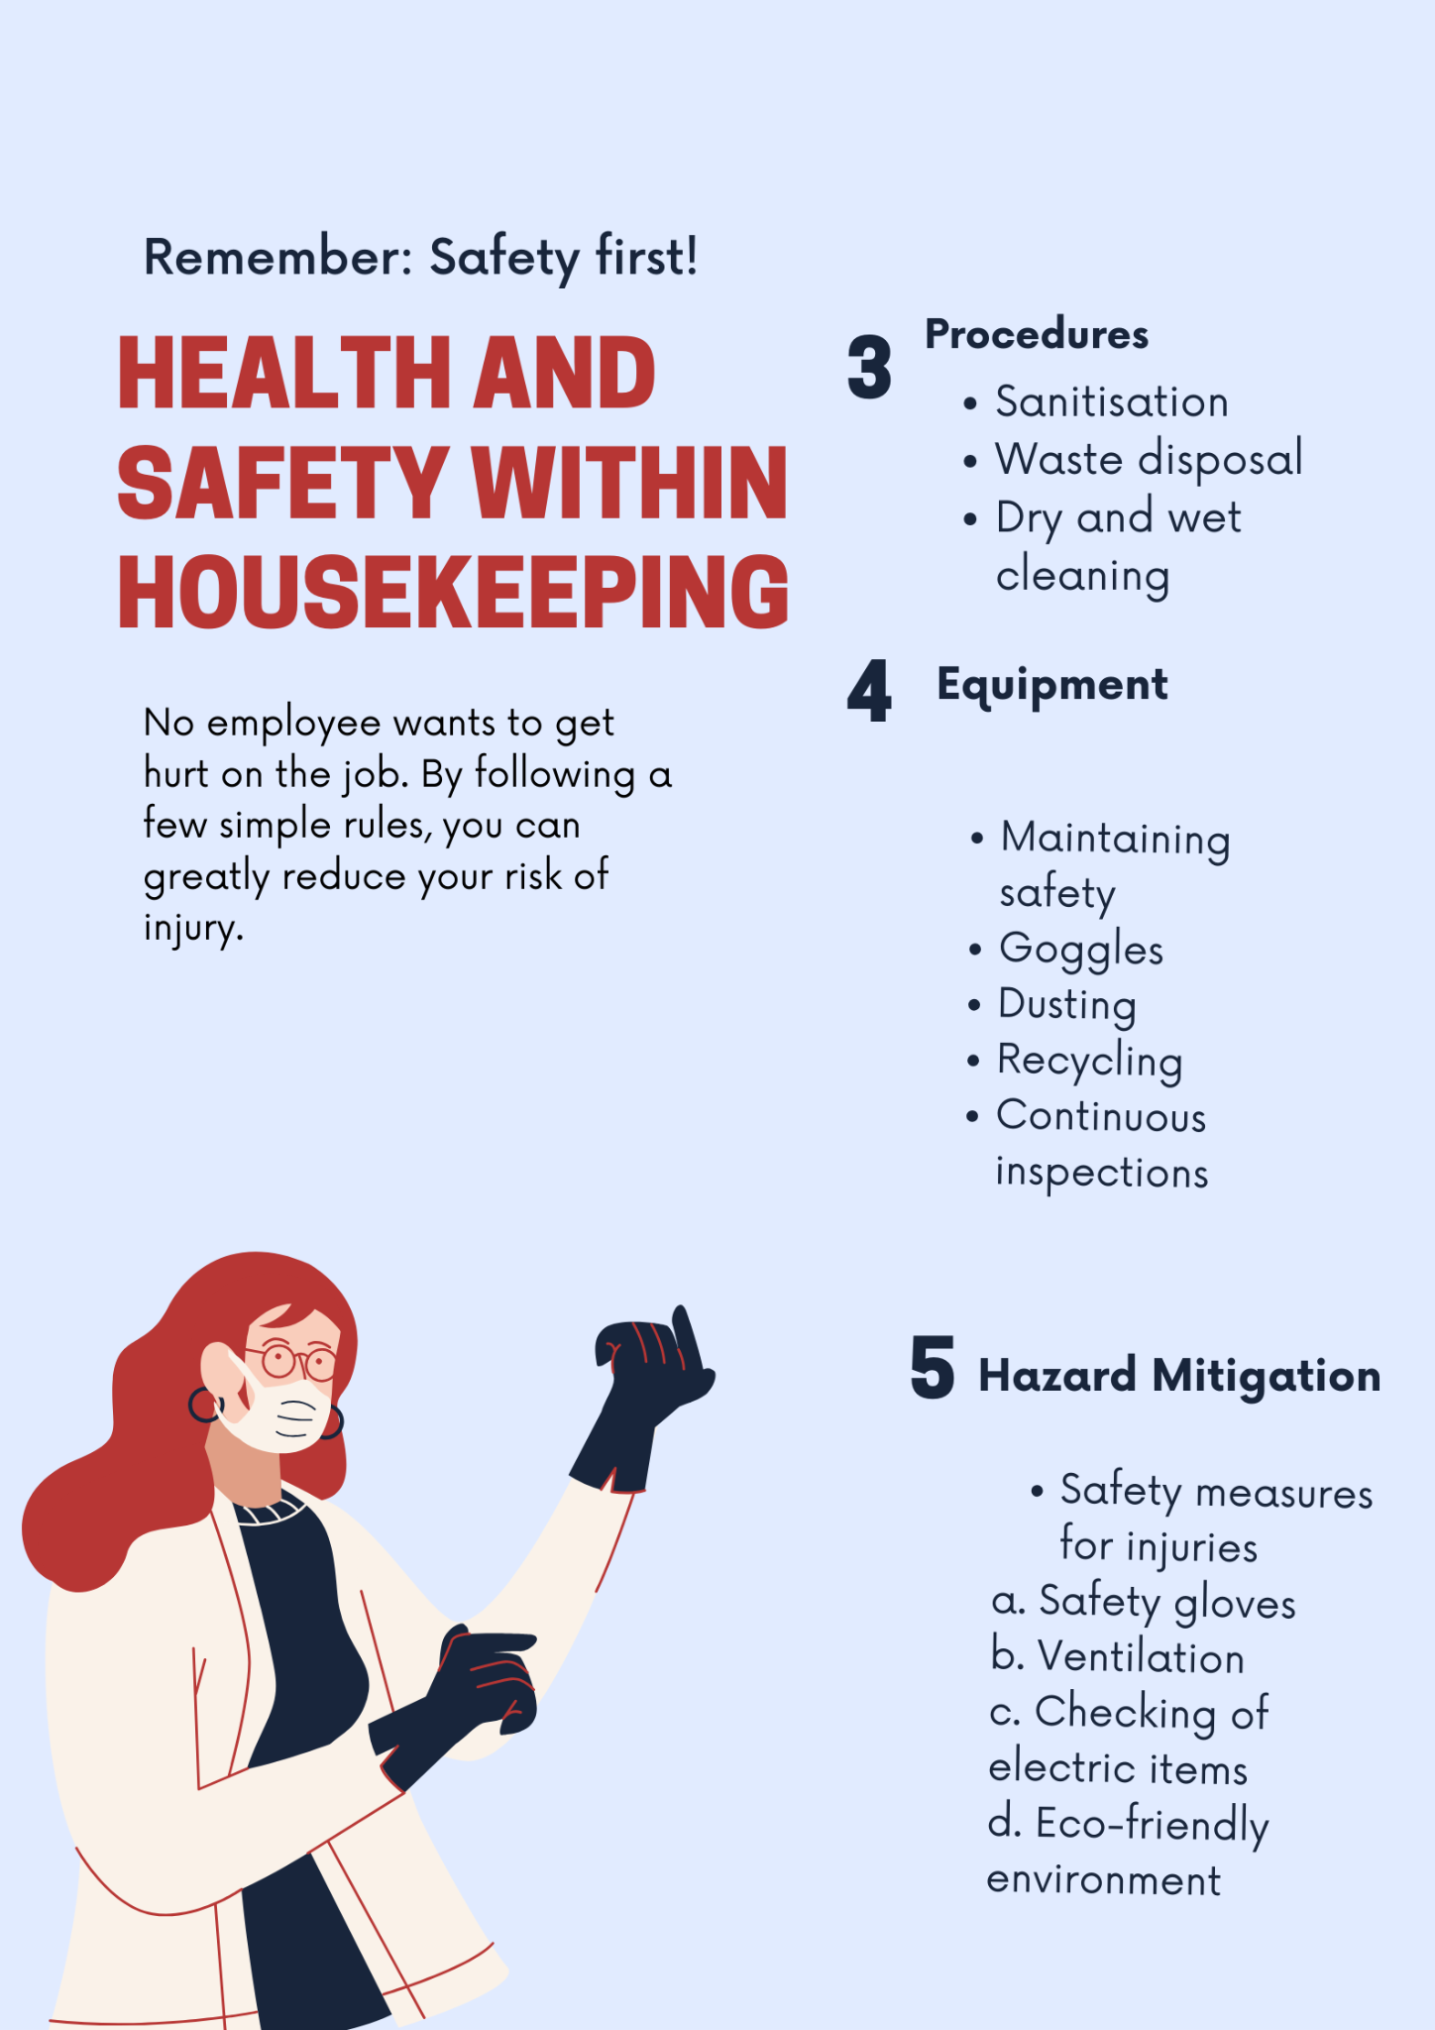

- Identification of potential risk
Risks
- Faulty equipment
- Damaged Flooring
- Slippery floors
Impacts
- Unsatisfied guest
- Slip & Trip accidents
- “Precautions”
- safety gloves
- ventilation
- checking for electric items
- eco-friendly environment
- “Procedures”
- sanitisation
- waste disposal
- dry and wet cleaning
- “Equipment”
- Maintaining safety
- goggles
- recycling
- continuous inspections
- “Hazard Mitigation”
- safety gloves
- ventilation
- checking of electric items
- eco-friendly environment
Conclusion
The study found a few risks which are most common at the workplace are damaged flooring, faulty equipment as well as slippery floors. these risks can be mitigated through safety gloves, continuous inspection and so on. It will not lead to dissatisfied employees or customers.

Reference List

Aurosiksha. R., (2023). Equipment required for Housekeeping. [Online] Available at: <https://aurosiksha.org/lica/ebook/housekeeping_chapter5> [Accessed on: 29 January 2024]
CCOH, (2023) Workplace Housekeeping - Basic Guide, Canadian Centre for Occupational Health and Safety. [Online] Available at: <https://www.ccohs.ca/oshanswers/hsprograms/housekeeping/house.html> [Accessed on: 29 January 2024]
Patricia. G., (2023). Cleaning Safety: A Short Guide, SafetyCulture. [Online] Available at: <https://safetyculture.com/topics/cleaning-safety/> [Accessed on: 29 January 2024].
Raghubalan, G. and Raghubalan, S. (2016) Hotel Housekeeping - Operations And Management. 3rd ed. India: Oxford University Press.
Williams, K, Woolliams, M & Spiro, J. (2020) Reflective writing, Macmillan International, Oxford.
Bridger, E. (2018) Employee engagement: a practical introduction. 2nd ed. HR Fundamentals. London: CIPD and Kogan Page.
Cottrell, S. (2019) The Study Skills Handbook. 5th ed. London:Red Globe Press.
Fallon, M. & Rutherford, D. (2010) Hotel Management and Operations. London: Pearson.
Johnston, R., Clark, G. & Shulver, M. (2012) Service Operations Management. London: Pearson.
Leiter, M. P. and Bakker, A. B. (2010) Work Engagement: A Handbook of Essential Theory and Research. Hove [England]: Psychology Press.
Mullins, L. and Dossor, P. (2013) Hospitality Management and Organisational Behaviour. 5th ed. Harlow: Pearson.
Quick, L. (2020) Managing Events. Real Challenges, Real Outcomes. London: SAGE Publications Ltd.
Sharma, N., Chaudhary, N. and Singh, V. (2019) Management Techniques For Employee Engagement In Contemporary Organizations. Hershey, Pennsylvania: IGI Global.
Tesone, D. (2010) Principles Of Management For The Hospitality Industry. 1st ed. London: Routledge.
Wood, R. (2013) Key Concepts in Hospitality Management.London: Sage.

