
An exploration of the impact of inflation on the cost of living in the United Kingdom
Student: Alina Coman (1919781)


Abstract

This study aims to analyse the impact of inflation on the cost of living for households, wage limitations, and business profitability in the United Kingdom between 2020-2022. The study seeks to examine the current status of the UK economy and inflation rate, investigate the main factors affecting the cost of living in relation to inflation, and identify the leading causes of inflation and how it affects household income
The aim for this research is to examine the relationship between inflation and the cost of living in the UK, including the factors influencing this relationship. Through a critical review of existing literature, the study identifies gaps in the current research and proposes to explore the impact of inflation expectations on the inflation-cost-of-living relationship. The significance of the study lies in its potential to provide valuable insights into the impact of inflation on the cost of living in the UK, with implications for policymakers and individuals alike.
The research will employ a deductive approach using a quantitative method to collect and analyse primary data through survey questionnaires targeting household income and secondary research will also be conducted by analysing existing literature and published reports. The study will use a cross-sectional time horizon and a non-probability convenience sample and the data collected will be analysed using Microsoft Excel to create visual diagrams to present the data. Findings from this study will provide valuable insights into the inflation impact on the cost of living in the UK and how it affects households, wages, and business profitability.
The survey questionnaire was designed with 11 questions categorized into four themes to address the research objectives. The responses collected from the participants have provided valuable insights, indicating that the majority agree that inflation significantly impacts both the cost of living and household income. Furthermore, the study has shown that such impacts can have significant implications for the profitability of businesses and the country's overall economy. The research has effectively achieved its objectives, providing supportive evidence for the theory and contributing to the existing literature. These results can serve as a foundation for future research in this area.

Acknowledgement

I would like to express my gratitude to the University of Wales Trinity Saint David for the knowledge I have gained throughout the length of this course and for the support received. A heartfelt thank you to my supervisor Dr Taye Osadiya for the invaluable guidance and support throughout this project. His insights, expertise, and dedication were instrumental in helping me achieve my goals. Also, I would like to mention my favourite teacher Zainab Atta whom has been my inspiration since year two. She has been one of the most intelligent, supportive and great teachers from whom I learn a lot. I would also like to thank my family, my mother and my friends Elena Ruseva and Gina Dinu for their unwavering support, encouragement, and love. Without their help, this project would not have been possible.

Table of Contents
Introduction 5
Background information 5
Aim and Objectives 6
Aim 6
Objectives 6
Research gap 6
Methodology 6
Organisation of the study 6
Research ethics 6
Action plan 7
Literature review 8
Introduction 8
Inflation 10
Inflation measures 10
The Consumer Price Index 10
The Producer Price Index 10
The core inflation 11
The Gross Domestic Product 11
Types of inflation 11
The Quantity Theory of Money 11
Monetary Theory 11
Demand-pull inflation 12
Cost-push Inflation 12
Structural inflation 12
Inflation and unemployment 12
Cost of inflation 14
Redistributions of income and wealth 14
Decreases in the pace of production growth 14
Methodology 15
Introduction 15
Ontology and epistemology 16
Ontology 16
Epistemology 16
Research philosophies 16
Research approach 17
The deductive 17
Research Design and Strategy 18
Research choice 18
Time horizon 19
Data collection and analyses 19
Data collection method 19
Sampling method 19
Sampling type 19
Sampling size 20
Analysis of the data 20
Research ethics 20
Research findings 21
Theme 1- Inflation impact on the cost of living and living standards. 21
Statement 1- Has inflation impacted my overall cost of living 21
Statement 2- Has inflation affected my overall standard of living 22
Theme 2- The inflation impact on the household’s consumption 23
Statement 1- I had to reduce my household consumption due to the increase in price. 23
Statement 2, figure 2- I had to change my shopping habits and switch to a lower quality products and services due to the increase in price. 23
Statement 3, figure 3- I do my grocery shopping more than once a week. 24
Theme 3- Inflation impact on the household’s energy consumption 25
Statement 1-I must make changes to my energy consumption to offset the rising cost. 25
Statement 2 -Did I notice any changes in the cost of gasoline, electricity? 26
Statement 3 -Has inflation affected my energy cost in the past year? 26
Theme 4- Inflation impact on the household’s income 27
Statement 1- Has inflation reduced my ability to save money for the future? 27
Statement 2- I had to reduce savings or increase debts due to rise in cost of living? 28
Statement 3- I have seen any changes to my wages, salary that have helped to offset the Impact of inflation on the cost of living? 29
Analysis of the findings 30
Discussion: Theme 1- Inflation impact on the cost of living and standards of living. 30
Discussion: Theme 2- The inflation impact on the household’s consumption 30
Discussion -Theme 3 – Inflation impact on the household’s energy consumption 31
Discussion- Theme 4- Inflation impact on the household’s income 32
Conclusion 33
Limitation of the study 34
Reflection 34
Further research 35
References 36
Appendix 43
Questionnaire survey 43
Survey findings results 45
Theme 1- The inflation impactv on the cost of living and living standards. 45
Theme 2- The inflation impact on the household’s consumption 46
Theme 3- Inflation impact on the household’s energy consumption 46
Theme 4- Inflation impact on the household income 47

Chapter 1

Introduction
The global macroeconomic environment influences the United Kingdom (UK) economy, pushing the inflation rate to rise through diverse movements such as Brexit and the Covid-19 pandemic and other world events such as the Russian and Ukraine wars. Due to these unpredictable forces, the price index increases in commodity goods and services, causing an economic crisis (Devine, 2022). Inflation is a widely discussed economic phenomenon, particularly in the United Kingdom, with significant implications for the cost of living. The impact of inflation on the cost of living is a matter of concern for individuals, households, businesses, and policymakers alike, which determines the subject of the research examining the relationship between inflation and the cost of living, including the factors influencing this relationship. Additionally, the study will investigate the effectiveness of policies aimed at mitigating the impact of inflation on the cost of living, focusing on the period between 2020 and 2022, reflecting how changes in inflation rates have affected the prices of essential goods and services, such as housing, food, wedges limitation and the business's profitability.
The study will also critically review the contemporary literature on inflation, highlighting possible issues and problems in developing a research aim and objectives. The researcher employs various methods, standards, and guidelines for performing a literature review to achieve a specific aim. The systematic review and narrative and citation analysis techniques can significantly contribute to the resolution of this research topic emphasizing the existing literature to identify the most frequently cited authors, papers, and journals in a particular field, summarizing and synthesizing the existing literature on a particular topic

Background information

The COVID-19 pandemic has significantly impacted the UK economy, resulting in weakened global economic activities, reduced export demand, and disrupted global supply systems (Gaba, 2021). Government restrictions aimed at reducing virus spread have caused severe disruption in economic activities, leading to a decline in private consumption and productivity loss, resulting in reduced household income and company revenue. These factors, combined with external cost pressures from changes in currency rates and commodity prices, have contributed to a decline in the Consumer Prices Index (CPI) from 1.7% in February 2020 (Office for National Statistics) and made it more challenging for businesses to increase demand by lowering prices (Bank of England, 2020). However, there are signs of consumers spending more on necessities like food and clothing due to lower prices for these items brought on by the coronavirus lockdown (Hardie, 2020).
The COVID-19 pandemic has led to supply limitations and increased demand for goods and commodities, contributing to inflation in many countries, including the UK (Partington, 2022). In September 2022, the UK experienced its highest inflation rate since 1980, with an annual rate of 10.1%. This rate was higher than the average for the Eurozone in August 2022 (Harrari et al, 2022). While the average wedges fall by 2.7% once inflation is considered, increasing wedges lead to higher prices for businesses to cover salaries, resulting in higher inflation. BBC News reported this on December 15, 2022 (BBC News, 2022).

Aim and Objectives

Aim
The aim of the study is to analyse the inflation impact on the cost of living for household, wages limitation and business profitability in United Kingdom between 2020-2022, evaluating the background information of the inflation impact on the UK economy and living costs.

Objectives
- To examine the status of the UK economy and inflation rate.
- To investigate the main factor affecting the cost of living in relation to inflation.
- To identify the main causes of inflation and how this affects the cost of living for household income.

Research gap

There has been considerable research on the impact of inflation on the cost of living in the UK, with many studies examining the relationship between the two. However, there are still some gaps in the existing research that warrant further exploration. While many studies have examined the relationship between inflation and the cost of living, there is still a need for research on the impact of inflation expectations. In the recent years it has been identified a significant increase in inflation rate and there is not many recent research conducted on the subject, therefore, understanding the role of inflation expectations in the inflation-cost-of-living relationship could be important for forecasting inflation and developing effective policies to mitigate its effects on the cost of living.

Methodology

The significance of this study lies in its potential to provide valuable insights into the impact of inflation on the cost of living in the UK. The study will employ deductive research using a quantitative method to collect and analyse data using survey questionnaire to gather important information targeting household income. The research investigation will be conducted through primary data applying survey questionnaire on household’s participants and secondary research analysing exiting literatures and published reports related to the topic. The time horizon chosen for this topic is cross-sectional due to the limited time allocated for the research and non-probability convenience sample which is suitable for the research enabling the researcher to conveniently choose the participants available.

Organisation of the study
- Chapter 1 -introduction
- Chapter 2 - comprehensively reviews the literature on inflation and the cost of living in the UK.
- Chapter 3 - outlines the research methodology.
- Chapter 4 - presents the study's findings.
- Chapter 5 – analysis and discussion.
- Chapter 6 - provides a conclusion, reflection and future research.

Research ethics
A variety of philosophical approaches to morality and moral action in the research setting are called research ethics. The ethical framework provides guidelines and ethical standards in terms of how the data gathered are used and treated when doing the study (Iphofen, 2018). In concordance with the ethical standards, the researcher will keep all information private and confidential, and it will be use only to use the purpose of the study.

Action plan

 | Week 1 | Week 2 | Week 3 | Week 4 | Week 5 | Week 6 | Week 7 | Week 8 | Week 9 | Week  10
Introduction
Literature Review
Methodology
Survey research
Analysis of the findings
Conclusion
Recommendation and reflection
Final draft and submission

Chapter 2

Literature review

Introduction
An efficient and well-conducted literature review provides a solid framework for knowledge expansion and the facilitation of theory building addressing research topics by incorporating the conclusions and points of view from several empirical findings and providing an overview of the many transdisciplinary study topics. Also, a literature review is a great approach to summarise study results to demonstrate evidence and identify areas in which additional research is required, which is an essential step in developing theoretical frameworks and conceptual models. Like any research, the quality of an academic review determines what was done, what was discovered, and how well the findings were reported (Snyder, 2019). The literature review aims to overview the inflation fundamental theories, debates, and empirical findings, outlining the different types of inflation and their causes before discussing the various approaches economists have taken to understand the dynamics of inflation. The review also examines the relationship between inflation and other economic variables, such as unemployment, household income, interest rates, and economic growth. Finally, it highlights some of the critical areas for future research in inflation.

Inflation has a long history in economics and has been the subject of extensive research and debate. In the early 20th century, economists such as Irving Fisher and John Maynard Keynes developed theories to explain the causes and consequences of inflation (Garcia, 2021). More recently, several studies have focused on the relationship between inflation and various economic variables, such as monetary policy, fiscal policy, exchange rates, and international trade. Diverse viewpoints on the correlation between inflation and growth are advanced in the theoretical literature on monetary growth and the negative impacts of inflation on long-term economic growth, along with these theoretical advancements and prior empirical literature, also puts forward divergent points of view on the matter. Empirical research over the past 20 years has primarily supported a negative and nonlinear relationship between the variable, indicating that the typical inflation thresholds for industrialised economies are 2 to 4 percent, and for emerging economies, 8 to 18 percent (Khan, 2020). Contrarily, emerging economies have lower central bank independence, weak fiscal systems, greater historical inflation rates, and the Balassa-Samuelson effects, among other factors, which have been linked to higher optimal inflation rates. However, most of the central banks in developing nations do not seem to be persuaded by these thresholds and often aim for far lower inflation rates than those suggested by this literature (Eggoh, 2014).
The British economy is the fifth-largest in the world behind China, Japan, the United States, and Germany, with a gross domestic output of 2.2 trillion British pounds in 2021 (Clark, 2022). As shown on Figure 1, the pandemic-related recession has successfully recovered since 2020 downfall of 9.4 percent (Clark, 2023) and in 2021, the GDP increqase by 7.5 per cent annually and the unemployment rate fall under 4 per cent (Hotten, 2022). On the other hand, the inflation rate quickly increased at the end of 2021 and peaked at 6.2% resulting in further decline for the UK economy (Clark, 2022), and more than 83% of UK families saw an increase in their cost of living as a result of price increases driven by the inflation rate, as reported by Statista (2022). The combined effect of all these variables results in a real family disposable income reduction of 2.2 per cent, the highest since 1956, and the annual inflation rate is forecast to reach 7.4 per cent in 2022 and stay at a relatively high level of four per cent in 2023 (Office for Budget Responsability, 2022).
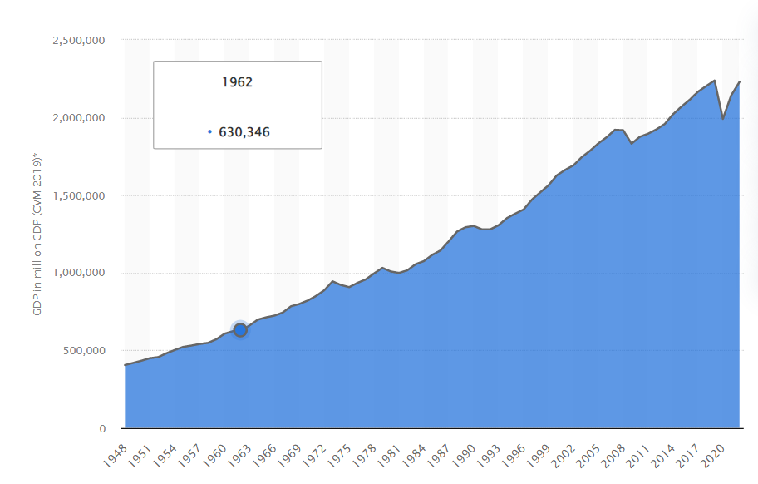
(Figure 1) (Clark, 2023)
Figure 2 below demonstrates that from 1989 to 2015, the CPIH remained stable, indicating a low rate of inflationary growth during that time.
The Consumer Price Index, which includes the cost of owning a home, increased by 8.9% in the 12 months ending in March 2023, representing a decrease from the 9.2% increase recorded in February 2022. The primary factor contributing to the rise in the inflation rate in March was the cost of housing and household services, specifically electricity, gas, and other fuels (Office of National Statistics, 2023).
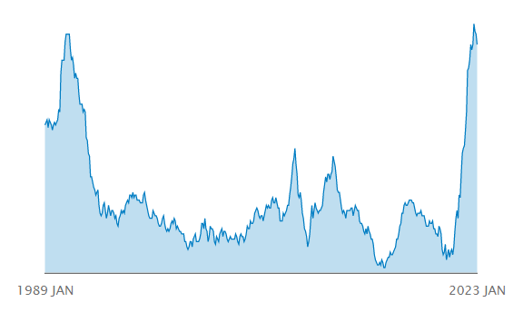
(Figure 2) (Office for National Statistics, 2023)

Inflation
Inflation has been well-known for its powerful effects on the economy, and since 1945, as indexed by Scopus, it has also received consideration in the scientific community (Musarat, 2021). However, from 1969, the research on the inflation rate acquired speed due to market growth and industry demand and is continuing today to improve both economic growth and the impact of inflation on industries and businesses (Kaldor, 1976). Although it is still below the heights of the 1970s, which followed two significant oil shocks, the rate at which prices faced by consumers have been growing has been at multi-decade highs for most sophisticated economies in the G7 group of countries and more than two-thirds of 29 nations experienced high inflation rates in September 2022 (Office of National Statistics, 2022).
Thus, several inflation thresholds have been identified in the literature, empirical studies conducted over the past two decades have conclusively shown that inflation negatively and nonlinearly impacts economic development over certain threshold levels (Khan, 2014). Money supply, currency rate, interest rate, inflation anticipation, imported inflation, and GDP are the variables that researchers have frequently used to explain inflation (GDP) (Y.C Lim, 2015). One explanation for this discrepancy may be that the inflation-growth relationship depends on variables particular to each nation. Hence, the nature of the relationship and its degree of sensitivity is affected by differences in the economic development of nations, indicating that the inflation-growth link has essential breaks that are country- and time-specific (Khan, 2014).
The uncertainty caused by inflation rate fluctuations makes it challenging to forecast monetary policies, including the interest rate, potential production, exchange rate, money supply, wage rate, trade openness, and expectations; therefore, inflation significantly predicts potential economic circumstances (Musarat, 2021). Furthermore, both investment and consumption decisions are influenced by inflation expectations and, more crucially, the level of nominal interest rates, impacting the business liquidity and affecting the asset's value, demonstrating how higher oil prices favoured inflation and led to price changes. (MacCoille, 2009).

Inflation measures
The Bank of England adopt different inflation measurements to monitor the variations in the pricing of products and services over time. There are several ways to calculate inflation, each having advantages and disadvantages. The Consumer Price Index (CPI), Producer Price Index (PPI), and Personal Consumption Expenditure (PCE) are used to calculate the inflation rate. No single index can fully capture the spectrum of price changes in the economy; therefore, economists must consider these indexes to provide a complete picture of the inflation rate (Pattel, 2021).
The Consumer Price Index (CPI) and the Producer Price Index (PPI)are the two most often used gauges of inflation (Boskin et all, 1998).
The Producer Price Index (PPI) monitors prices of goods and services at the producer or wholesale level, whereas the CPI measures changes in the price of a fixed basket of goods and services commonly consumed by consumers (Boskin et all, 1998).
The PPI and the CPI serve as indicators of producer and consumer prices, respectively. For instance, the PPI collectively refers to three distinct indices: one for raw materials, one for intermediate goods, and one for completed goods (Clark, 1995). The CPI refers to a single index that includes the costs of the average consumer's typical basket of goods and services (Wessel, 2018). There are furthermore accessible and more specialised consumer price indices. For instance, the so-called core CPI calculates the cost of consumer goods and services unrelated to food or energy, including healthcare expenses, based on what consumers spend each month and helps to identify the indirect expenditure highlighting the consumer switch to substitution when the price is higher than expected (Lavie, 2022).
The core inflation rate is another often-used metric. Unlike short-term inflation rates, this metric gives a more consistent and trustworthy indicator of inflation trends, using a specific approach to create a helpful measure rather than the measure's objectives (Vahey, 1995). According to one theory, core inflation is the consistent element of observed inflation. On the other hand, measured inflation's generalised component is core inflation. However, in both definitions, supply shocks are not included in core inflation, often linked to expectations and demand pressure components of measured inflation.
The Gross Domestic Product (GDP) deflator is another measurement approach to track inflation and modify monetary policy in response to shifting inflationary pressures. The GDP, which follows increases in the cost of all products and services produced inside a nation's boundaries, represents the yearly total value of production, final goods and services, and total income by all domestic industries (Chunbo Ma, 2010). Although the GDP deflator covers a broader area than the CPI, including price movements in all national economies, it is a delayed indicator since GDP numbers are released later and have varying degrees of accuracy due to the contrasts in the prices of comparable products and services created now with those during a base period (Litra, 2009).

Types of inflation
The recent economic progress is challenging in several aspects across nations, and the devaluation of currency is one of the primary issues affecting the financial, monetary, and economic sectors, which also impacts all facets of society (Yunusovna et. all, 2022). In industrialised nations, the expansion of the money supply is the primary source of inflation. In addition, variables generally associated with fiscal imbalances, such as greater money growth and currency rate depreciation resulting from a balance of payments crisis, dominate the inflation process in developing nations (Totonchi, 2011). The main drivers of economic growth are demand and supply, which are the leading causes of inflation. Several factors influence the demand and supply curve to shift, resulting in inflation rate changes such as productivity growth, monetary policy, exchange rates, oil prices, economic growth rate, wage growth and inflation expectation (Mankiw, 2020).
The Quantity Theory of Money- is one of the earliest still-existing economic theories, which supplied the main conceptual framework for interpreting contemporary financial events and served as the intellectual cornerstone of orthodox policy prescription intended to preserve the gold standard and the heart of 19th-century classical (Totonchi, 2011). However, the theory has improved and expand its dynamic by David Hume (1776) which explains that the monetary shift between economic sectors has a significant impact on the price-change. According to David Ricardo, such disequilibrium effects are transient and inconsequential in the long-run equilibrium analysis, rejecting the idea of potential positive output and employment impacts of monetary injection (Ricardo, 1821). Furthermore, the well-known Cambridge cash balance equation laid out by Irving Fisher , relates to the growing application of mathematics in neo-economic analysis by controlling the exogenously determined stock of high-power monetary control could be attained in a fractional reserve banking system (D. Bordo, 2011).
Monetary Theory- According to M. Friedman (1971), monetary policy is more effective for economic stabilisation than fiscal policy. The monetary theory adheres to the concept that money supply determines the output level and prices in the short and long run (Friedman, 1971). However, Fisher's well-known exchange equation identity, which monetarist often uses, explains that inflation has always been a monetary phenomenon and money supply has a low impact on output over the long-term resulting from a more rapid increase in money supply than in total production (Crowder, 1966).
Demand-pull inflation- happens when aggregate consumer demand diverges from the many consumer goods and services categories, raising the overall cost of living (Keynes, 1937). This phenomenon emerges from an imbalance between total aggregate supply and aggregate demand, where the intense pressure that consumer demand places on supply's output capacity causes the price to rise arbitrarily, resulting in an inflation rate increase (Jain, 2022). The rise in aggregate demand is driven by consumption, investment, and government spending, which cause demand-pull inflation. According to Keynes (1937), the inflationary gap emerges when aggregate demand exceeds the aggregate supply value at the employment level, increasing the inflation rate and general prices. Hence, the demand-pull inflation theory lowers each component of total demand, lowering pressure on demand and inflation.
This type of inflation is exceptionally prevalent in monetarist economies due to the inelasticity of supply, cutting the overall output rates to raise profit margins, leading to higher prices and a tax increase to manage money flow and reduce demand while containing inflation. Furthermore, under challenging circumstances, such as hyperinflation, a tax increase could help to restrict demand (Jain, 2022).

Cost-push Inflation- emerges from corporate profit margin expansion and wage hikes, which is the fundamental cause of cost-push inflation, increasing the production cost. The factors contributing to cost-push inflation are labour, raw materials, and capital goods, leading organisations to increase prices to maintain sustainable profitability and increase the cost of living (Javed, 2010). Thus, wage increases, and production costs apply to specific economic sectors or industries, and other industries' manufacturing costs will increase, leading to an overall increase throughout the economy (Throop, 1968). Furthermore, profit-push inflation, also known as price-push inflation or administered-price inflation, is another factor in cost-push inflation affecting monopolistic and oligopolistic businesses by increasing the cost of labour and manufacturing and, therefore, an increase in price. However, monopolistic, and oligopolistic businesses operate in an imperfect market structure, allowing them to control the price and boost profit (Totonchi, 2011).

Structural inflation- arises from long-term or persistent imbalances in an economy's supply and demand of goods and services. Structural factors can include changes in demographics, technology, government policy, labour shortages, raw materials, or energy (Dufour, 2010). This type of inflation is typically more challenging than cyclical inflation caused by temporary economic fluctuations and is controlled through government intervention in the market structure and by adopting decisive plans for fairly dividing the inflation pressure (Canavese, 1982).

Inflation and unemployment
The Phillips curve is an economic concept that describes the relationship between inflation and unemployment, suggesting a trade-off between inflation and unemployment: as unemployment decreases, inflation increases, and vice versa (Palley, 2011). The theory suggests that any association between present unemployment and future inflation shown in historical data should be expected to alter when the economic environment changes, predicting that inflation expectations should fluctuate as the economic environment changes (Humphrey, 1985).
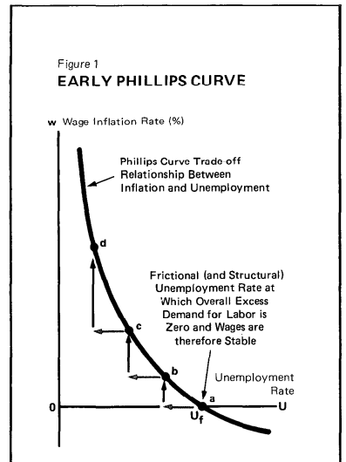
(Figure 3) (Humphrey, 1985)
As the labour market tightens and unemployment falls, employers may have to increase wages to attract workers, increasing production costs and ultimately leading to higher prices for goods and services (Atkeson, 2001). However, the relationship between inflation and unemployment is not always stable and can be affected by various factors, such as changes in monetary policy, supply shocks, and inflation expectations. As a result, the Phillips curve has been subject to criticism and debate among economists over the years.
The Phillips curve trade-off between price stability and full employment considers the importance of cos-push inflation. It emphasises the importance of cost-push forces, particularly the market power of unions, in explaining how inflation could occur even when an economy has not yet reached full employment (Schwarzer, 2018). Furthermore, the Philips curve enigma reinforces that inflation is both a demand-pull and a cost-push phenomenon, leading to the dilemma of the Phillips curve technique, which states that employment and prices are incompatible. Hence, the structural cost-push inflation occurs at full employment market power (Schwarzer, 2016). Nevertheless, Samuelson and Solow's findings from modelling a Phillips curve for American data showed that an unemployment rate of 5 to 6 per cent would be required, considered an unacceptably high cost by most economists. According to the Samuelson-Solow-Phillips curve, a 3 per cent unemployment rate is full employment, which predicts 4 to 5 per cent inflation (Hall, 2010).

Cost of inflation
The conventional method of cost of inflation regards accurate money balances as suitable for consumption and inflation as a cost of accurate balances. This method calculates the approximate area under the money demand curve to calculate the welfare cost using the general equilibrium method to evaluate the welfare cost of inflation (Dotsey, 1996).
The transaction technology, which produces a money demand is another critical component for measuring the cost of inflation however, study have shown that only a tiny portion of the overall cost of inflation in this scenario is captured by this technique. The model finds several other distortions connected to the inflation tax (Bailey, 1956). For instance, in a situation of general equilibrium, inflation pushes a portion of the labour force away from producing products and towards a different financial sector. For the allocative impacts of inflation to possibly affect both the growth rate and the level of aggregate production, the model needs specifications for goods-producing technology (Bailey, 1956).
Costs of inflation fall into two categories: decreases in the pace of production growth and redistributions of income and wealth. These costs exist even when inflation is most anticipated, but they become more critical the more unexpected the inflation (Horwitz, 2003).
Redistributions of income and wealth resulting from changes in relative prices occur even in the presence of a stable price level when they are correctly viewed as a necessary tool for adapting the composition and structure of productive activities to evolving trends in technology, new goods, and consumer preferences, among other factors (Cukierman, 1982).
The inevitability of long-term economic arrangements is the other major factor contributing to relative pricing changes that affect income and wealth which engages in agreements requiring future payments or receipts that necessitates a price level expectation suggested by every economic activity geared towards the future, such as relocating, preparing for a job, or purchasing a long-lasting item, frequently without an express contract (Stephenson, 1974).
This type of inflation occurs when the overall price level changes for two leading causes: individual prices and wages respond to the forces that enable or create inflation with variable lags, and significant economic arrangements last over time. In modern economies, the leading cause of the uneven delays in the reaction of specific wages and prices is the balance management between prices and salaries. These institutional reaction patterns are likely to change in a way that compresses all delays towards zero under the pressure of protracted and significant inflation (Ackley, 1978).
Decreases in the pace of production growth- The strong relationship between slower productivity growth relies on the transition from price stability to chronic inflation. The productivity growth slowdowns strongly imply that the inflationary process is a factor in the productivity slowdown (Clark, 1982). Excluding cyclical fluctuations in productivity, the economy's declines in productivity growth corelates with the rise in the inflation rate. An annual decline follows each percentage point increase in yearly inflation in labour productivity growth of around one-fourth of a percentage point (Clark, 1982).

This type of inflation significantly impacts the slowdown in productivity by reducing the price system's capacity for information transmission by raising the variance of relative prices. The factors contributing to the decline in productivity growth include inducing a shift towards more labour-intensive production, technical advancement, and reduction of tax deductions (Buck & Fitzroy, 1988). In addition, the relationship between productivity and the price level result in declines in productivity growth, causing increased inflation because of political efforts to keep real wages growing.

Chapter 3

Methodology

Introduction

A well-defined methodology is essential for producing reliable and valid results including a clear description of the research question or problem, the research design, the data collection and analysis methods, and the criteria used to evaluate the results, considering ethical and practical considerations, such as ensuring the safety and privacy of participants. The choice of methodology will depend on the nature of the research question, the type of data being collected, and the resources available to the researcher. Some standard research methodologies include quantitative methods, which involve numerical data and statistical analysis, and qualitative methods, which involve non-numerical data and interpretive analysis or mixed-methods research, combining quantitative and qualitative methods.

A systematic inquiry process known as research involves gathering data, documenting important information, and then analysing and interpreting that data and information following procedures in concordance with academic and professional disciplines (Adams, 2021). The actions to be taken for effective research, such as philosophies, choice of data collecting, techniques, and analysis procedures, are based on the data gathering process, representing the research onion, representing the figure presented bellow (Saunders, 2019).
Research onion
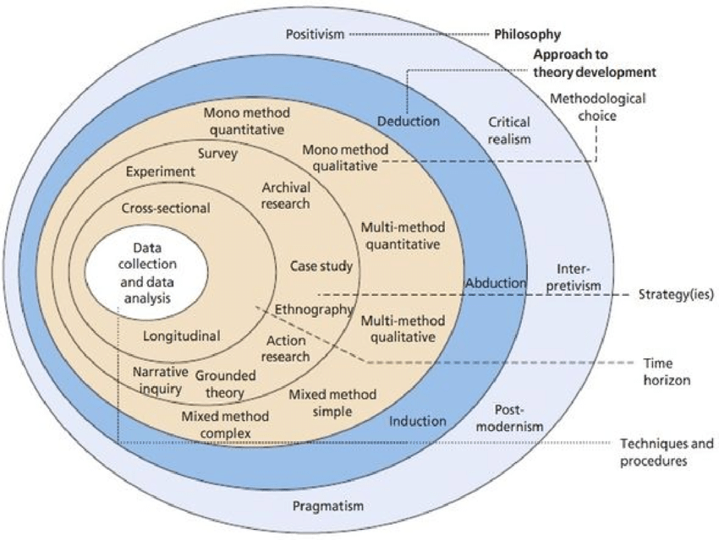
(Figure 4) (Sounders, 2019)

The research onion represents the framework for creating a research technique and is designed to resemble the layers of an onion, representing the process of creating a research technique to fit any methodology. Starting with the research philosophy and moving on to choose whether to utilise an inductive or deductive technique, each layer of the onion reflects a choice that must be made concerning the research project, outlining the processes to complete while creating a research technique.

Ontology and epistemology

The definition of knowledge and the methods are arbitrary to the subjectivity of educational research to comprehend the ontological and epistemological presuppositions that underlie each piece of research which connect presumptions to the technique and procedures of the researcher through research philosophies (Scotland, 2012). In connection to the ontology and epistemology assumptions, business and management research ideologies are dispersed over a multidimensional set of a continuum between subjectivism and objectivism. While epistemology objectivism tries to learn the truth using quantifiable facts, ontology objectivism embraces realism, which holds that social entities exist regardless of what individuals think (Saunders, 2019).

Ontology
Ontology aims to offer a comprehensive and conclusive classification of all entities in all domains of existence and what classifications of entities are required to comprehensively describe and explain all that occurs in the universe (Smith, 2003). The ontology objectives stance for realism and the fundamental existence of the societal entity regardless of the individual’s perception. In computer science and information science, ontology refers to a formal, explicit specification of a shared domain conceptualisation, typically represented using a set of concepts and the relationships between them. Ontologies are used in knowledge representation, the semantic web, and artificial intelligence applications to enable machines to understand and reason about the world like humans do (Sounders, 2019).

Epistemology
Epistemology is a branch of philosophy that explores the nature and extent of knowledge and how it is acquired, justified, and applied. It seeks to understand the foundations of knowledge and how to ensure that it is sufficient and reliable (Al-Ababneh, 2020 ). Epistemology also examines the relationship between knowledge and belief and the limitations of what can be known. In academic study, epistemology focuses on the validity of knowledge and comprises three subtypes: objectivism, constructionism, and subjectivism. Objectivism holds that life has a purpose and meaning independently of human perception, while constructionism emphasizes the role of human perception and interaction with reality in creating meaning. Subjectivism asserts that the individual subject imposes meaning and that objects have no inherent meaning (Sounders, 2003). To summarize, epistemology is concerned with understanding the nature of knowledge and how it is acquired, justified, and applied, focusing on subtypes that explore knowledge's validity from different perspectives.
To conclude, this research adopts epistemology philosophy and objectivism approach to examine the aim and objectives of this research and prove that the existing theory is meaningful by analysing the impact of inflation on the cost of living and human behaviours.

Research philosophies

The philosophical approach of a research method is determined by its assumptions about the world's most fundamental characteristics, including ideas about the mind, matter, reality, reason, truth, the nature of knowledge, and the justifications for knowledge and the approach chosen may also be influenced by the researcher's background, philosophical knowledge, and personal convictions; therefore, it is crucial to have a thorough awareness of the advantages and disadvantages of both strategies as well as the guiding principles behind them (Crossan, 2013).
Philosophical inquiry is by its very nature indirect and circular, which frequently promotes in-depth thought and leads to other inquiries into the subject at hand, clarifying reasons why exploring philosophy may be necessary, explicitly concerning research methodology:
- it can assist the researcher in clarifying the general research strategy defining the research methodologies by specifying the type of information obtained, where it came from, how it is analysed, and how it contributes to resolving the study questions addressed.
- understanding research philosophy will help the researcher evaluate various methodologies and procedures and prevent improper usage and pointless labour by recognising the limitations.
- it could encourage the researcher to be inventive and imaginative when choosing or modifying techniques that were previously outside the scope of their expertise (Crossan, 2013).
Philosophies and research paradigms are sometimes confused; however, in business management, paradigms and philosophies tend to coincide to some extent. (Saunders, 2019). In a nutshell, positivism refers to the philosophical position of natural scientists and calls for using an observable social reality. Additionally, positivism refers to the value of what is presented and emphasises empirical data and facts that are simply scientific and unaffected by subjective interpretation (Collis, 2013). Critical realism focuses on elucidating what it is and what people feel regarding reality's fundamental framework. interpretivism emphasises that because humans construct meaning, they vary from physical phenomena. Interpretivism study aims to give existing information new meaning by comprehending and interpreting it from many angles (Collis, 2013). The positivism philosophy is adopted for this research to maintain an objective viewpoint of the world and enable the researcher to obtain scientific data and facts to analyse this paper's topic further.

Research approach

A research approach is the path of conscious scientific reasoning and research using diverse approach such as deduction, induction, and abduction, which differ along several criteria (Sounders, 2019). Thus, analysing a research approach demands following the argumentation path of research, deduction, induction, and abduction were differentiated using a framework for the research process that investigates explicitly how the approach argumentation line is projected, identifying which line of inquiry, such as theory or empirical research, came first, adding a unique scientific nuance to the knowledge by taking different paths (Heit, 2010).

The deductive approach is often used in scientific research, mathematics, and philosophy to test hypotheses and theories. It starts with a general principle or hypothesis and then applies it to specific cases or situations to conclude (Thomas, 2006). In this approach, the reasoning follows a top-down approach, moving from general to specific and involves identifying a theory or principle, making a prediction based on that theory, and testing the prediction through observation or experimentation. If the evidence confirms the prediction, then the theory is supported. The theory must be modified or rejected if the prediction is not confirmed (Zalaghi, 2016). A deductive approach is used in quantitative research, where data is collected and analysed using statistical methods. However, it can also be used in qualitative research, where the researcher develops a theory or concept and then tests it against specific cases or observations.
The strength of a deductive approach is that it allows researchers to test specific hypotheses and make predictions based on a theory or principle, leading to more precise and accurate conclusions. However, ensuring that the general theory or principle used is valid and reliable for the deductive approach to be effective is essential (Sounders, 2016). When employing a deductive research approach, the author first develops a set of research objectives and then tests the theory using an appropriate technique. The study employs a deductive approach which allows the researcher to assess the hypothesis that inflation impacts the cost of living in the UK by analysing the literature and theory presented above.

Research Design and Strategy
The research design refers to the plan or strategy for conducting a research study. It outlines the methods and procedures that will be used to collect and analyse data, as well as the goals and objectives of the study (Adams, 2014). A research design includes research questions or statements the study aims to investigate or test, sampling strategy, data collection methods, data analysis and ethical considerations and timeframe required to complete the research.

The process of investigation for this research will be conducted through secondary and primary research, allowing the research to answer the research question by evaluating significant empirical secondary data such as theoretical literature published by different authors via books, journal articles, online websites, video, and other media platforms (Saunders, 2019) and investigate the theory by answering the research question using the questionnaire survey to prove the theory and which refers to the primary research (Collis, 2013).
The survey questionnaire is the chosen strategy for this research to collect essential and valuable numerical data through a set of questions to respond to the research topic. Survey research evaluates the link between the research philosophy and design and is associated with exploratory and descriptive research as it allows to achieve data from many respondents in a short period (Saunders, 2019). The questionnaire survey benefits the researcher to achieve the goal and purpose of the chosen topic by formulating simple and easy-to-answer questions vial online platforms to investigate and analyse the impact of inflation on the cost of living in the UK.

Research choice

For this research, the author adopts the quantitative research using probability single data collection reflecting the mono-method technique which allow the researcher to examine the variables which are measured numerically using graphs to ensure the validity of the data by selecting a diverse sample of population.
Making a distinction between numerical and non-numerical data is one technique to separate quantitative research from qualitative research. The assumption that hypotheses are formed from theories or hypothetical constructs is common in quantitative research which is the link between positivism and deductive approach to theory testing. On the other hand, a qualitative or constructivist method to research may be seen as inductive, and the aim is to produce theory and explanations of phenomena rather than to test theory (Saunders, 2019).
Quantitative research is a research method that involves collecting and analysing numerical data to understand a phenomenon. It is often used to test theories and generalise the link between positivism and deduction approach where data are collected to analyse and test the theory by analysing the variables and applying on the existing theory through numerical techniques (Collis, 2014). Although positivistic philosophy-based quantitative research aims to be objective, it also includes a lot of subjective elements. Examples of subjective aspects include the choice of a subjective alpha level, the directionality of hypotheses, and the interpretation and implications of results (Saunders, 2019). The aim of the quantitative method is to establish the theory, create the research question and objectives, design a strategy to answer the question by analysing the data to prove the theory and conclude with the confirmation or revision of the theory (Sounders, 2016).

Time horizon
The cross-sectional time horizon is most appropriate for academic research due to time constraints and the research concentration on a specific topic or phenomenon (Sounders, 2016). The cross-sectional time horizon is suitable for the research due to its nature of development in the short period allocated for the study, which is ten weeks.

Data collection and analyses
Data collection and analysis are two essential components of the research process involving gathering information or data relevant to a research question reflecting various methods, including surveys, interviews, experiments, and observational studies, allowing the researcher to collect and analyse raw data to extract meaningful insights and draw conclusions (Adams, 2014).

Data collection method
Data collection is gathering information or data from various sources for analysis and interpretation, planning the research and defining the research question and deciding on the research methodology, including the data collection and analysis method, and collecting the data using the chosen data collection method (Collis, 2013). The research author employs a survey questionnaire strategy to collect primary data comprised of 10 questions statements classified into four themes with five multiple-choice answers using the 5-Likert scale design. The questionnaire will be accessed via the Microsoft forms online platform and English language, and a copy of the questionnaire survey will be attached in appendix.

Sampling method
The study employs the non-probability convenience method, which allows the researcher to conveniently select the participants available to respond and participate in the research using exploratory research questions. Non-probability sampling is a method in which the probability of each member of the population selected for the sample is unknown, resulting in a non-random factors' selection such as the researcher's judgment, convenience, or availability. However, it is essential to recognize the limitations of non-probability samplings, such as the potential for sampling bias and the inability to generalize findings to the larger population (Sounders, 2019).

Sampling type
Convenience sampling is a non-probability sampling technique where participants are selected based on their easy availability and accessibility to the researcher, selecting participants who are conveniently located, easily accessible or readily available targeting the household and low-income population with the age of 18+ including all genders and diverse societal positions such as lower, middle, and upper class.

Sampling size
The size of the sample can have a significant impact on the accuracy and precision of the results obtained from the study. In statistics, the sample size refers to the number of individuals or observations included in a study or survey ( (Collis, 2013).The sampling size for this study comprise between 30-50 respondents from the targeted pool of the UK population. The sample can be accessed through social media platforms and internet.

Analysis of the data
Data analysis methods refer to the techniques used to interpret and make sense of data, intending to extract insights and knowledge. For this research, the author uses descriptive statistics to analyse and present the data by summarising and presenting data meaningfully, using Microsoft excel program to present the findings such as pie charts, tables, columns, lines, and other graphic designs.

Research ethics

In order to ensure the credibility and validity of a research study, it is crucial to collect both primary and secondary data using ethical and reliable means. Ethical considerations must be considered when collecting primary data through surveys, such as obtaining consent from participants, ensuring anonymity, and storing personal information for a specified period. In the case of secondary data, it is crucial to ensure the reliability of the sources from which the data is collected, and to properly reference and cite the information throughout the report to ensure clear understanding and to support the conclusions reached, emphasizing on the importance of these considerations in conducting a research study (Fisher, 2006).

Chapter 4

Research findings
The rising cost of living is a significant concern for many people worldwide, with inflation being one of the primary drivers of these rising costs. To better understand the impact of inflation on the cost of living, a questionnaire survey was designed to gather information on how people perceive the impact of inflation on their cost of living and how they have adjusted their financial planning and spending habits in response to these rising costs.
The research presents the key findings from the survey, involving 37 participants, including insights on how people perceive the impact of inflation on the cost of living, the changes they have made to their spending habits and financial planning, and how they are coping with the challenges posed by rising costs. The survey consists of 11 questions grouped into four themes related to the impact of inflation on the cost of living, collecting responses from diverse participants, including individuals from various age groups, income brackets, and geographical locations.

Theme 1- Inflation impact on the cost of living and living standards.

This section aims to examine the impact of inflation on the cost of living for the UK population, focusing on individuals' ability to maintain a suitable living standard during periods of high inflation. This study's results depend on various factors such as income, social status, and family situation. The accompanying figure provides a detailed breakdown of the results in percentages, shedding light on the outcomes of this research.

Statement 1- Has inflation impacted my overall cost of living
Statement summarizes the results of the survey with the aim to investigate the impact of inflation on the cost of living for individuals and families in the UK. The study employed primary data collection methods, specifically, a questionnaire administered to a diverse sample of people living in the UK affected by price changes during the specified period.

As shown in Figure 5 (81) percent of the people participating in this survey have been strongly affected by the cost of living, and 16 percent have been affected to a certain extent. The remaining 3 percent have disagreed to this statement. Overall, most answers for statement 1 strongly agree that inflation significantly impacts the living cost in the UK.

Figure 5

Statement 2- Has inflation affected my overall standard of living
This statement focuses on inflation's impact on people's living standards. The survey received 21 Strongly agree responses, and 12 responded agree, which explains that inflation significantly impacts people's living standards.

Figure 6
Statement 2 collected around 90 percent of positive responses, from which 53 percent had strongly agreed that inflation significantly impacts the standard of living for people in the UK and 33 percent had responded with agree, and only 8 percent disagreed with this statement, as shown in Figure 6. These results show that while most people are affected by the inflation effects, some can still maintain the same standards of living despite the increase in the cost of living, which can be related to the societal position, income and life standards.

Theme 2- The inflation impact on the household’s consumption

The second theme of this investigation aims to examine the relationship between inflation and household consumption among the UK population. The research also seeks to understand how individuals respond to price changes for essential goods and services during periods of high inflation.

Statement 1- I had to reduce my household consumption due to the increase in price.
The objective of statement 1 was to investigate household consumption during the period of inflation and to determine how people responded to this situation. The results indicate that inflation significantly impacts people's ability to purchase basic necessities required for their daily lives.

Figure 7
In Figure 7, most participants (80%) strongly agreed with the statement, while 50% agreed, which leaves a small percentage (10%) who disagreed. These findings suggest that the impact of increased household consumption costs may vary depending on factors such as income and family size. As a result, some individuals may not be as affected by these cost increases as others, suggesting that as inflation rises, it becomes increasingly difficult for people to afford essential items, making it a critical concern for individuals and families.

Statement 2, figure 2- I had to change my shopping habits and switch to a lower quality products and services due to the increase in price.
The survey results provide a detailed analysis of consumer behaviour related to household consumption habits, product choice, and quality, including the impact of inflation on consumer purchasing decisions and overall quality of life. Through the survey conducted, a comprehensive analysis of consumer behaviour towards household consumption patterns, product selection, and quality was obtained. Additionally, the findings shed light on how inflation affects consumer purchasing choices and their overall quality of life.

Figure 8

According to Figure 8, the majority (90%) of the respondents stated that they experienced an impact on their purchasing preferences due to the increase in prices. Specifically, they mentioned shifting towards lower-quality products as a reflection of the change in their standard of living. Additionally, some may argue that households can make adjustments, such as buying cheaper or generic brands, to mitigate the impact of inflation on their grocery budgets. The remaining 10% of respondents reported no change in their standard of living despite the price hike.

Statement 3, figure 3- I do my grocery shopping more than once a week.
The statement suggests that the consumer shops for groceries on multiple occasions within a week, which could be relevant in analysing the effects of inflation on consumer purchasing power. It highlights the importance of understanding how inflation impacts a consumer's decision-making and their ability to afford and purchase household groceries and how frequently they do so.

Figure 9
Among the respondents, there is a split opinion on the statement, with 15 agreeing, 10 disagreeing, and 12 strongly disagreeing, with the majority of respondents (22 out of 37) which do not agree with the statement. However, a significant number of respondents agree with the statement, with 15 out of 37 indicating that they shop for groceries more than once a week. It is possible that these individuals have larger households or dietary needs that require more frequent trips to the grocery store.
Those who agree with the statement likely believe that inflation can increase the cost of groceries, making it more difficult for households to purchase essential food items. This may be especially true for households with lower incomes or those living in areas where food prices are already high.
On the other hand, those who disagree with the statement may believe that the impact of inflation on household groceries is minimal or that other factors, such as changes in supply and demand, have a more significant effect on food prices. In summary, the responses to this statement likely reflect the varied experiences and perspectives of the respondents, and there is no clear consensus on the impact of inflation on purchasing household groceries.

Theme 3- Inflation impact on the household’s energy consumption

Theme 3 aims to understand how inflation affects the energy consumption patterns of households. The survey focus is to collect data on how households adjust their energy usage in response to price changes and whether they can maintain the same level of energy consumption as before.
The survey also aims to identify which energy sources are most affected by inflation and how households respond to these price changes, providing valuable insights into how households prioritize energy consumption when faced with rising prices and what measures they take to reduce their energy bills.

Statement 1-I must make changes to my energy consumption to offset the rising cost.
From the responses provided on Figure 10, most people (19 strongly agreeing and 13 agreeing) agreed with the statement, which indicates that people needed to change their energy consumption habits to manage rising costs. Only a small number of people (3) disagreed with the statement, and no one strongly disagreed, suggesting that most people recognize the need to change their energy consumption habits.

Figure 10
The data presented in Figure 10 indicates that the majority of respondents (86%) responded positively to statement 1, indicating that a significant number of respondents recognize the need to change their energy consumption habits in response to rising energy costs, suggesting that respondents believe that the increase in energy costs has significantly impacted energy consumption and affordability, recognizing the need to change their energy usage habits to manage these costs, indicating that the increase in energy costs has brought about a significant change in energy consumption.
Overall, the high percentage of positive responses suggests that respondents are aware of the impact of rising energy costs and are taking action to manage their energy consumption in response, which underscores the importance of managing energy consumption to maintain affordability and reduce overall energy usage.

Statement 2 -Did I notice any changes in the cost of gasoline, electricity?
The aim for Statement 2 is to collect information about people's awareness of changes in the cost of gasoline and electricity, as well as their opinions on government policies related to energy prices and their suggestions for addressing any challenges related to energy cost.

Figure 11
Figure 11 illustrates the results of a survey that measured the level of awareness among respondents regarding changes in the cost of gasoline and electricity in the past year. The data reveals that a majority of respondents, 78 percent (29), strongly agreed that they had noticed changes in energy prices, while 13 percent (5) agreed with the statement. These findings are significant as they shed light on how consumers perceive changes in energy prices and how these changes impact their daily lives. By increasing awareness among consumers about energy prices, these results could encourage individuals to reduce their energy consumption.

Statement 3 -Has inflation affected my energy cost in the past year?
Statement 3 inquired about the impact of inflation on the energy costs of the respondents over the past year. As presented in Figure 12, a significant majority of respondents (29 strongly agree and 8 agree), believe that inflation has affected their energy costs in the past year. Only a small minority of respondents (2 disagree and 1 strongly disagree), expressed disagreement with the statement.

Figure 12
Figure show that 70 percent of respondents have strongly agreed that inflation had affected their energy costs in the past year and 21 percent agreed with the statement. It is important to note that a small percentage, 7 per cent, disagreed or strongly disagreed and 0 neutral responses which further indicates the strength of opinion among participants. These findings suggest that majority of the participants for this survey have noticed an impact of inflation on their energy costs in the past year, which could have implications for their daily lives and household budgets, resulting less disposable income for other expenses, which may change spending patterns and lifestyle choices.

Theme 4- Inflation impact on the household’s income

The impact of inflation is not limited to the cost of goods and services, but it can also affect the purchasing power of individuals and households. Inflation can lead to a decrease in the actual value of income as the rise in prices outpaces the increase in income. Therefore, understanding the impact of inflation on household income is essential to develop effective policies that can mitigate its adverse effects. This theme, explores how inflation affects the income of households and its implications for their financial well-being.

Statement 1- Has inflation reduced my ability to save money for the future?
Based on the responses, majority of people (25 out of 37) strongly agree that inflation has reduced their ability to save money for the future, while 9 agree and 2 disagree. These finding suggests that many people feel that inflation has had a negative impact on their ability to save for the future.

Figure 13
In the data presented in Figure 13, majority of people (68%) strongly agreed with the statement that inflation has negatively affected their ability to save money for the future, with an additional (24%) indicating agreement. However, it is vital to remember that the impact of inflation can differ depending on various personal factors, including income, spending behaviour, and investment decisions. This explains why the remaining 8% of respondents disagreed with the statement.

Statement 2- I had to reduce savings or increase debts due to rise in cost of living?
Statement 2 collected a majority of positive answers (34) indicating that they had indeed reduced their savings or increased their debts due to the rising cost of living which deliver a strong message that inflation indeed impact people financial aspect.

Figure 14
The pie chart in Figure 14 gives a clear image of how inflation changes the financial status of the UK population. The survey responses have returned with an overall (92%) positive response, and only 8% of respondents disagreed with the statement, indicating that they did not need to reduce their savings or increase their debts due to the rising cost of living. One respondent was neutral, indicating they were neither affected nor unaffected by the rising cost of living. These results suggest that many respondents have had to adjust their financial situation due to the rising cost of living.

Statement 3- I have seen any changes to my wages, salary that have helped to offset the Impact of inflation on the cost of living?
Statement 3 received mixed responses, with 23 individuals showing a positive response and 12 showing a negative response. However, many disagreed or strongly disagreed with the statement, while others strongly agreed, indicating a lack of consensus among respondents. It is crucial to note that responses could differ based on factors such as industry, education level, location, and financial situation. Nonetheless, the results suggest that many believe their wages or salaries have not kept up with the rising cost of living due to inflation.

Figure 16
Figure 16 shows a mixed and complex response, indicating that the impact of inflation on individuals' income varies depending on various factors such as income level, societal status, industry, and position. The responses are divided into positive and negative, with 40% strongly disagreeing and 22% disagreeing that there were no changes to offset the cost of living during periods of high inflation in the UK. Conversely, 11% strongly agree, and 22% agree that they have seen changes that offset the cost of living, averaging 33% of participants in the survey. The remaining 5% of respondents had a neutral response.

Chapter 5

Analysis of the findings
Analysing the findings in any research project or investigation is crucial to identify patterns, relationships, and trends that support the research question or theory. The research involves statistical analyses, data visualization, and interpreting the results to draw meaningful insights supporting the conclusions and examine the contributing factors and their effects on various population segments. This chapter analyses primary data from surveys and applies secondary research findings to explore the impact of inflation on consumers and the challenges it poses. The aim is to comprehensively understand the complex relationship between inflation and the cost of living.

Discussion: Theme 1- Inflation impact on the cost of living and standards of living.
The results suggest that most respondents strongly agree that inflation significantly impacts both the cost of living and the standard of living. These findings suggest that inflation have a significant impact on people’s life standard and living cost which agree with the theory presented in chapter 2.
Inflation refers to the increase in the prices of goods and services, leading to a rise in the cost of living, meaning that people must spend more money to maintain their current consumption levels. Inflation is usually measured through indicators such as the Consumer Price Index (CPI) and the Producer Price Index (PPI), which reflect changes in the prices of a basket of goods. (Clark, 1995 and Wessel 2018). Also, inflation can particularly affect the prices of essential goods and services, such as food, housing, and healthcare, disproportionately impacting low-income households. The findings of the survey for statement 1 have strongly agreed that inflation significantly impacts the cost of living which is the crux of inflation and the Personal Consumption Expenditures (PCE) index (Pattel 2021).
The standard of living measures the quality of life and it is influenced by factors such as income, education, healthcare, and access to essential goods and services. Inflation can affect the standard of living in several ways. For example, if prices rise faster than wages, people will have less purchasing power, and their standard of living may decline. Inflation can also make it harder for people to save for retirement or invest in education or training (Vahey, 1995 and Chunbo Ma, 2010). Therefore, it is not surprising that most respondents strongly agree that inflation significantly impacts the standard of living.
In conclusion, the results suggest that inflation significantly impacts both the cost of living and the standard of living.

Discussion: Theme 2- The inflation impact on the household’s consumption
The data collected for this survey show that people has been affected by inflation and have had to change their household consumption patterns. Inflation refers to the general increase in prices of goods and services over time, which reduces the purchasing power of money. When prices rise, the same amount can buy fewer goods and services (Musarat 2021 and Khan, 2014). This means that people need to spend more money to maintain their standard of living, which can make it harder to save money for the future. For example, if a person earns $50,000 annually and inflation is running at 3%, the cost of goods and services they regularly buy could increase by 3% annually. If their salary remains unchanged, the person's purchasing power has effectively decreased by 3%, and they will need to spend more to maintain their standard of living. This can make it harder to save money, as there may be less money left over after paying for basic expenses.

Statement 1 findings show a significant majority of respondents (33 out of 37) agreed or strongly agreed that they had to reduce their household consumption due to increased prices, indicating that inflation has impacted their ability to consume goods and services at previous levels which prove that Cost push inflation theory, emerging from corporate profit margin expansion and wage hikes, which is the fundamental cause of cost-push inflation, increasing the production cost (Javed 2010 and Totonchi 201).
Statement 2 also received a high level of agreement, with 32 out of 37 respondents agreeing or strongly agreeing that they had to change their shopping habits and switch to lower-quality products and services due to the price increase. This suggests that inflation has led to a decrease in purchasing power and forced households to adjust their consumption patterns. According to the Demand-pull theory of inflation which is driven by consumption, investment, and government spending (Jain, 2022) which explain why most of respondents agreed with Statement 1. According to Keynes (1937), the inflationary gap emerges when aggregate demand exceeds the aggregate supply value at the employment level, increasing the inflation rate and general prices.
Statement 3, on the other hand, received more mixed responses, with 12 out of 24 respondents indicating that they do their grocery shopping more than once a week, while ten respondents disagreed and 12 strongly disagreed. This suggests that while some households may make more frequent trips to the grocery store in response to inflation, others may be trying to limit their overall spending by consolidating their shopping trips.
Overall, the survey results suggest that inflation can significantly impact household consumption patterns, leading to reduced purchasing power, changes in shopping habits, and adjustments to the quality and quantity of goods and services consumed which reflect the theoretical framework of inflation types and measures.

Discussion -Theme 3 – Inflation impact on the household’s energy consumption
The survey findings indicate that most respondents (19 strongly agree and 13 agree) believe they must change their energy consumption to offset the rising cost of inflation. This suggests that many households feel the financial impact of inflation on their energy bills and are willing to take action to address it.
The small number of respondents who indicated a neutral stance or disagreement may suggest that some households are not yet feeling the impact of inflation on their energy bills or may not see changes in their energy consumption as a viable solution to offset rising costs. However, it is essential to note that the survey findings do not provide specific information on the changes that households are willing or able to make to reduce their energy consumption.
The cost of gasoline and electricity can vary depending on many factors, such as geopolitical events, supply and demand, weather conditions, and government policies. These factors can cause fluctuations in the price of energy sources. In general, gasoline costs tend to be more volatile than electricity. Geopolitical events, such as wars or conflicts, and changes in supply and demand heavily influence gasoline prices (Clark 2022 and Statista 2022). Electricity prices are affected by various factors, including the cost of fuel sources, maintenance and upgrades to infrastructure, and government regulations. It is important to note that changes in the cost of gasoline and electricity can significantly impact individuals, businesses, and the economy (Friedman 1971 and Dufour 2010). Changes in the cost of energy sources can affect transportation, food, and other goods and services that rely on energy.

Discussion- Theme 4- Inflation impact on the household’s income
Based on the survey findings, there is a high level of agreement among respondents that inflation has had a negative impact on their ability to save money for the future (Statement 1), with 25 strongly agreeing and 9 agreeing. This suggests that inflation has made it harder for households to put aside money for emergencies or retirement, which could have long-term financial implications.
Similarly, the survey findings indicate that most respondents have had to reduce their savings or increase their debts due to the rise in the cost of living (Statement 2). Specifically, 26 strongly agree and 8 agree with this statement, suggesting that inflation has reduced disposable income, making it harder to save and forcing households to take on debt to meet their expenses.
In terms of whether changes to wages and salaries have helped offset inflation's impact on the cost of living (Statement 3), the survey findings are more mixed. While 15 respondents strongly agree that their wages and salaries have helped to offset inflation, there are also 8 who disagree and four who strongly disagree. This suggests that while some households may have seen their incomes increase in line with inflation, others have not, and the impact of inflation on household budgets is uneven.
Overall, the survey findings suggest that inflation has significantly impacted households' ability to save money for the future and meet their expenses, with many respondents reporting a reduction in savings and an increase in debt. While some households may have seen their incomes increase in line with inflation, this has not been the case for everyone, highlighting the uneven impact of inflation on different population segments.
The survey findings presented suggest that the relationship between inflation and household income and savings is complex and influenced by various factors. These factors include cost-push inflation, which can lead to rising prices, reduced purchasing power for households, and the impact of monetary policy on inflation (Dotsey, 1996). Additionally, the cost of inflation theory is relevant in understanding the impact of inflation on households, as it suggests that inflation can lead to a redistribution of income and wealth, with some groups benefiting while others experience losses.
To conclude, these survey findings highlight the complexity of the relationship between inflation and household finances and suggest that various factors can influence how households are impacted by inflation. They align with the Phillips Curve theory (Schwarzer, 2018), which emphasizes that the relationship between inflation and unemployment is not always stable and that various factors can impact this relationship, including both demand-side and supply-side factors.

Chapter 6

Conclusion
The United Kingdom's economy has been a topic of conversation lately due to various political and external events that have impacted the country's economic and financial status. These factors have contributed to economic challenges for the UK population, including increases in inflation and living costs. The country has faced both internal and external forces of supply and demand that have led to these economic difficulties, which identify the gap in the research literature and has led to the aim for this research topic to analyse the impact of the inflation of the cost of living in the UK with the objective of understanding the current status of the UK economy, the main factor leading to high inflation rate and how this impact the cost of living in the UK.
By conducting secondary and primary research, the first objective of examining the current state of the UK economy and inflation rate has been achieved. The literature review conducted as part of the secondary research has indicated that the country is currently facing one of the highest inflation rates since 1998, which has adversely affected the country's economy and resulted in a rising cost of living, impacting the UK population. Moreover, the results obtained from the primary research indicate that most participants strongly agree that inflation significantly impacts both the cost of living and living standards.
The second objective of the research was to examine the key factors that impact the cost of living concerning inflation. The literature review uncovered that inflation is primarily influenced by demand and supply, which are affected by external factors such as changes in the UK's political status (e.g. Brexit) and other global events (e.g. the Russian war). These factors have caused supply shortages and price increases, resulting in high inflation rates that have lowered purchasing power and reduced demand. Moreover, the research's primary data findings indicated that the price rise had reduced household consumption of goods and services. As a result, there has been a decline in demand for electricity, gas, and other fuel consumption, due to an increase in the cost of living, as individuals may have to spend more on necessities. Therefore, it is essential to monitor the factors that impact inflation and the cost of living to ensure that policies are in place to mitigate their adverse effects on households' financial well-being.
The third objective aimed to explore the primary causes of inflation and how it impacts the cost of living and household income. Through secondary research, the literature review reveals that inflation is primarily driven by supply and demand. The review also sheds light on various theories of inflation and types of measurements used by economists to identify and analyse the rise in inflation rates. These theories are relevant in understanding how inflation contributes to the rise in prices of goods and services, thereby affecting household income by increasing the cost of living.
One such theory is demand-pull inflation, which suggests that increasing prices reduces purchasing power, decreasing demand for goods and services which leads to the cost-push inflation theory, which explains how a shortage in supply can increase prices and the cost of living, further impacting household income. Moreover, the findings from the survey indicate that most participants agree that wages have been adversely affected by the rise in the cost of living, and inflation has reduced household income and affected business profitability.
In summary, the literature review and survey findings illustrate the crucial role of inflation in determining the cost of living and its impact on household income. It highlights the importance of understanding the underlying theories and measurements of inflation to gain insight into its drivers and economic effects.
In conclusion, the research has demonstrated that the cost of living is significantly impacted by inflation, which is influenced by external factors such as political changes and global events. The price increase has reduced household consumption of goods and services, leading to a decline in demand for fuel consumption. This can significantly impact the financial well-being of individuals and households, as it can increase the cost of living and reduce purchasing power. Additionally, inflation is a significant factor in determining the cost of living and household income. Supply and demand are the primary drivers of inflation, and different theories of inflation has explained its impact on the economy. Understanding inflation and its measurement is crucial to comprehending its effect on the price of goods and services and the cost of living. The survey findings indicate that inflation has negatively impacted wages and reduced household income, which can ripple effect on the overall economy, affecting business profitability.

Limitation of the study
It is essential to acknowledge that this research has certain limitations, such as the restricted time horizon, sampling size, and research methodology. Additionally, only quantitative research methods were utilised for this project and the research was conducted over ten weeks, making it necessary to opt for a quantitative methodology, resulting in a limited data collection. Moreover, the sampling size, method, and type were also constrained comprised only 37 participants and a non-probability convenience sampling method was employed.

Reflection
The rationale for studying the impact of inflation on the cost of living is twofold. First, it is important to understand how inflation affects individuals and households, particularly those with lower incomes who may struggle to afford basic necessities. Second, policymakers need to be aware of the impact of inflation on the economy as a whole, as it can affect factors such as economic growth, employment, and monetary policy.
By understanding the impact of inflation on the cost of living, policymakers can make more informed decisions about how to manage inflation and ensure that individuals and households can maintain a reasonable standard of living. This research can also help individuals better understand how inflation affects their own finances and make more informed decisions about spending and saving.
Reflecting on my experience of writing a dissertation on inflation, I realized that it was a challenging yet immensely satisfying task. To ensure a successful dissertation, I had to develop an accurate layout that included all the necessary steps for conducting the research. This involved finding accurate academic resources that matched my topic, which was time-consuming and tiring. Therefore, I had to develop an action plan to meet my deadline.
One of the biggest challenges I faced was conducting an accurate and well-detailed literature review, which explained the theoretical framework for the topic. This was crucial as it significantly impacted my choice of research methodology and research philosophy. The research methodology chapter also played a vital role as it determined the outcome of the survey, which was later analysed and connected to the literature review. Hence, the survey questionnaire had to be connected thoroughly with the literature review, and the questions asked had to apply the theoretical framework. If were to do this again, despite the difficulties, writing the dissertation gave me valuable knowledge and a unique experience that made me feel successful and valued. Writing a dissertation is something exiting, personal and career driven which can impact the future decision and path, therefore I feel valued for choosing this topic and is my area of interest, however I have my reservation that I might not be able to complete this task. Now that I have done it, I feel valued and complete and bust up my self-confidence.

Further research
This research has centred on analysing the effects of inflation on the cost of living in the UK, mainly focusing on the main drivers of high inflation rates that result in increased prices and how this impacts household consumption of goods and services, as well as income. Several areas of further research could be explored concerning the impact of inflation on the cost of living. Here are some potential research directions:
- Regional Differences: Investigating the impact of inflation on the cost of living in different regions.
- Demographic Differences: Further research could be conducted to explore how inflation affects different demographic groups.
- Impact on Quality of Life: Another potential area of research could be to examine the impact of inflation on quality-of-life measures.
- Long-Term Effects: Finally, research could be conducted to examine the long-term effects of inflation on the cost of living

References
Ackley, G., 1978. The goals of stabilization policy. American Economic Association, 68(2), pp. 149-153.
Adams, D. L., 2021. What is research?. Global Scientific Jurnal, 9(12), pp. 387-407.
Adams, J., 2014. Research Methods for Business and Social Science Students [electronic resource].. 1 online resource ed. New Delhi: SAGE Publications.
Al-Ababneh, M. M., 2020 . Linking Ontology, Epistemology and Research Methodology. Science & Philosophy , 8(1), pp. 75-91.
Aminu Umaru, M. D. S. M., 2013. An Empirical Investigation into the Effect of Unemployment and Inflation on Economic Growth in Nigeria. Interdisciplinary Journal of Research in Business, 2(12), pp. 1-14.
Andrew Atkeson, L. E. O., 2001. Are Phillips Curves Useful for Forecasting Inflation?. Federal Reserve Bank of Minneapolis Quarterly Review, 25(1), pp. 2-11.
Andrew T. Jebb, S. P. S. E. W., 2017. Exploratory data analysis as a foundation of inductive research. Human Resource Management Review, 27(2), pp. 265-276.
Luciano Floridi (ed.), Blackwell Guide to the Philosophy of Computing and Information. Oxford: Blackwell. pp. 155-166 (2003). pp. 155-166.
Bailey, M., 1956. The welfare cost of inflationary finance. Journal of Political Economy, Volume 64, pp. 93-110.
Bain, S., 2020. Galloping Inflation & Hyperinflation. [Online]
Available at: https://www.dyingeconomy.com/galloping-inflation.html
[Accessed 21 December 2022].
Bank of England, 2020. How does Covid-19 affect economic activity and inflation?. [Online]
Available at: https://www.bankofengland.co.uk/bank-overground/2020/how-does-covid-19-affect-economic-activity-and-inflation
[Accessed 05 December 2022].
BBC News, 2022. What is the UK inflation rate and why is the cost of living rising?. [Online]
Available at: https://www.bbc.co.uk/news/business-12196322
[Accessed 18 November 2022].
Buck, A. J. & Fitzroy, F., 1988. Inflation and Productivity Growth in the Federal Republic of Germany. Journal of post Keynesian economics, 10(3), pp. 428-444.
Canavese, A. J., 1982. The structuralist explanation in the theory of inflation. World Development, 10(7), pp. 523-529.
Cardiff Garcia, S. V. S., 2021. Fisher Vs. Keynes: Investing Tragedy And Triumph. [Online]
Available at: https://www.npr.org/2021/02/01/962828669/fisher-vs-keynes-investing-tragedy-and-triumph
[Accessed 12 March 2023].
Clark, D., 2022. The UK economy - Statistics & Facts. [Online]
Available at: https://www.statista.com/topics/6500/the-british-economy/
[Accessed 10 March 2023].
Clark, D., 2023. Cost of living crisis in the UK - Statistics & Facts. [Online]
Available at: https://www.statista.com/topics/9121/cost-of-living-crisis-uk/
[Accessed 12 March 2023].
Clark, D., 2023. Gross domestic product of the United Kingdom from 1948 to 2022. [Online]
Available at: https://www.statista.com/statistics/281744/gdp-of-the-united-kingdom/
[Accessed 12 March 2023].
Clark, P. K., 1982. Inflation and the Productivity Decline. AEA PAPERS AND PROCEEDINGS, 72(2), pp. 149-152.
Clark, T. E., 1995. Do Producer Prices Lead Consumer Prices?. [Online]
Available at: https://core.ac.uk/download/pdf/6799504.pdf
[Accessed 28 December 2022].
Collis, J., 2013. Business research: a practical guide for undergraduate & postgraduate students. Fourth ed. Palgrave Macmillan: E Book.
Collis, J., 2014. Business research : a practical guide for undergraduate & postgraduate students. Fourth edition. ed. London, England: Macmillan Education.
Conall MacCoille, D. G. B., 2009. THE FORMATION OF INFLATION EXPECTATIONS: AN EMPIRICAL ANALYSIS FOR THE UK. [Online]
Available at: https://www.nber.org/system/files/working_papers/w15388/w15388.pdf
[Accessed 10 March 2023].
Crossan, F., 2013. Research philosophy: Towards an understanding. Nurse Researcher , 11(1), pp. 46-55.
Cukierman, A., 1982. Relative Price Variability, Inflation, and the Allocative Efficiency of the Price System.”. Journal of Monetary Economics, Volume 9, pp. 131-162.
Daniel Harari, P. B. B. F.-D. M. K., 2022. Rising cost of living in the UK. [Online]
Available at: https://researchbriefings.files.parliament.uk/documents/CBP-9428/CBP-9428.pdf
[Accessed 28 December 2022].
David Lavie, B. C., 2022. How To Calculate Inflation: PCE & CPI. [Online]
Available at: https://www.forbes.com/advisor/investing/how-to-calculate-inflation/
[Accessed 12 December 2022].
Donovan, P., 2015. The Truth About Inflation. London and New York: Routledge Taylor and Francis Group.
Evan Heit, C. M. R., 2010. Relations Between Inductive Reasoning and Deductive Reasoning. Journal of Experimental Psychology, 36(3), pp. 805-812.
Faridah Djellal, D. F. C. G. F. G. Y. J., 2003. Revising the definition of research and development in the light of the specificities of services. Peace Economics, Peace Science and Public Policy, 30(6), pp. 415-425.
Fisher, B. A., 2006. A Summary of Important Documents in the Field of Research Ethics. Schizophrenia Bulletin, 32(1), pp. 69-80.
Friedman, M., 1971. A Monetary Theory of Nominal Income. Jurnal of Political Economy, 79(2).
Gaba, U., 2021. Impact of the coronavirus pandemic on the global economy. [Online]
Available at: https://countercurrents.org/2021/02/impact-of-the-coronavirus-pandemic-on-the-global-economy/
[Accessed 03 January 2023].
Holger Breinlich, E. L. D. N. a. T. S., 2022. THE BREXIT VOTE, INFLATION AND U.K. LIVING STANDARDS. [Online]
Available at: https://onlinelibrary.wiley.com/doi/pdf/10.1111/iere.12541
[Accessed 28 December 2022].
Horwitz, S., 2003. The Costs of Inflation Revisited. The Review of Austrian Economics, 16(1), pp. 77-95.
Hotten, R., 2022. UK economy rebounds with fastest growth since WW2. [Online]
Available at: https://www.bbc.co.uk/news/business-60344573
[Accessed 9 March 2023].
Humphrey, T. M., 1985. THE EVOLUTION AND POLICY IMPLICATIO OF PHILLIPS CURVE ANALYSIS. FEDERAL RESERVE BANK OF RICHMOND , 71(2), pp. 3-22.
Hurston, P., 2022. Cost of living crisis. [Online]
Available at: https://www.instituteforgovernment.org.uk/explainer/cost-living-crisis
[Accessed 12 March 2023].
Jean-Marie Dufour, L. K. M. K., 2010. Estimation uncertainty in structural inflation models with real wage rigidities. Computational Statistics and Data Analysis 54 (2010) 2554–2561, Volume 54, pp. 2554-2561.
Jude C. Eggoh, M. K. b., 2014. On the nonlinear relationship between inflation and economic growth. Research in Economics, Volume 68, pp. 133-143.
Kaldor, N., 1976. INFLATION AND RECESSION IN THE WORLD ECONOMYi. The Economic Journat, 86(344), pp. 703-714.
Keynes, J. M., 1937. The General Theory of Employment. The Quarterly Journal of Economics, 51(2), pp. 209-223.
Khusainova Leyla Yunusovna, S. A. A. S. B. L. H. F., 2022. Inflation and Its Socio-Economic Impact. [Online]
Available at: file:///C:/Users/Ally/Downloads/122-Article%20Text-230-1-10-20220325.pdf
[Accessed 12 March 2023].
Lane, P. R., 2022. Inflation Diagnostics. [Online]
Available at: https://www.ecb.europa.eu/press/blog/date/2022/html/ecb.blog221125~d34babdf3e.en.html
[Accessed 21 December 2022].
Lee, J., 2014. Quantitative versus Qualitative Research Methods, Two Aproaches to Organisation Study. [Online]
Available at: https://www.researchgate.net/profile/Jean-Lee-24/publication/227247717_Quanitative_versus_qualitative_research_methods_-_Two_approaches_to_organization_studies/links/55a5e05708aef604aa046595/Quanitative-versus-qualitative-research-methods-Two-approaches-t
[Accessed 28 December 2022].
Lindblom, C. E., 1948. The Union as a Monopoly. The Quarterly Journal of Economics, 62(5), pp. 671-697.
Liping, H., 2017. Hyperinflation, A World History. 1 ed. London: Ebook Publisher .
Litra, A., 2009. THE INFLATION RATE DETERMINED AS A CHANGE IN THE GDP DEFLATOR AND IN CPI. Economic Science, 2(51), pp. 1-6.
Ma, C., 2010. Account for sector heterogeneity in China's energy consumption: Sector price indices vs. GDP deflator. Energy Economics 32 (2010) 24–29, Volume 32, pp. 24-29.
Mankiw, N. G., 2020. Principles of macroeconomics. Ninth Edition ed. s.l.:Harvard Business University.
Matteo Ciccarelli, B. M., 2008. Global Inflation. [Online]
Available at: https://www.econstor.eu/bitstream/10419/70524/1/585159815.pdf
[Accessed 10 March 2023].
Michael D. Bordo, H. R., 2011. The Influence of Irving Fisher on Milton Friedman's Monetari Economics. [Online]
Available at: https://www.nber.org/system/files/working_papers/w17267/w17267.pdf
[Accessed 19 March 2023].
Michael Dotsey, P. I., 1996. The welfare cost of inflation in general equilibrium. Journal of Monetary Economics 37 (1996) 29 47 , Volume 37, pp. 29-47.
Michael J. Boskin, E. R. D. R. J. Z. G. a. D. W. J., 1998. Consumer Prices, the Consumer PriceIndex, and the Cost of Living. Journal of Economic Perspectives, 12(1), pp. 3-26.
Mike Hardie, B. N., 2020. Coronavirus: UK inflation hits 1.5% as lockdown begins to bite. [Online]
Available at: https://www.bbc.co.uk/news/business-52371062
[Accessed 05 December 2022].
Mr Prateek Jain, D. A. S. D. M. K., 2022. Recapitulation of Demand-Pull Inflation & Cost-Push Inflation in An Economy. Journal of Positive School Psychology, 6(4), p. 2980 – 2983.
Muhammad Ali Musarat, W. S. A. M. L., 2021. Impact of inflation rate on construction projects budget: A review. Science direct, 12(1), pp. 407-414.
Muhammad Khan, J. C. E., 2014. On the nonlinear relationship between inflation and economic growth. Elesvir, Research in Economics, Volume 68, pp. 133-143.
Muhammad Khan, W. H., 2020. Institutional quality and the relationship between inflation and economic growth. Empirical economics, 58(2), pp. 627-649.
Mustoe, H., 2019. How does Brexit affect the pound?. [Online]
Available at: https://www.bbc.co.uk/news/business-46862790
[Accessed 30 December 2022].
Office for Budget Responsability, 2022. The outlook for household income and consumption. [Online]
Available at: https://obr.uk/box/the-outlook-for-household-income-and-consumption/
[Accessed 12 March 2023].
Office for National Statistics, 2022. Recent drivers of UK consumer price inflation: March 2022. [Online]
Available at: https://www.ons.gov.uk/economy/inflationandpriceindices/articles/priceseconomicanalysisquarterly/march2022
[Accessed 28 December 2022].
Office for National Statistics, 2023. Inflation and price indices. [Online]
Available at: https://www.ons.gov.uk/economy/inflationandpriceindices
[Accessed 18 March 2023].
Office of National Statistics, 2022. Global inflation: 1970 to 2022. [Online]
Available at: https://www.ons.gov.uk/economy/inflationandpriceindices/articles/globalinflation/1970to2022
[Accessed 10 March 2023].
O'Gorman, K., 2015. Research methods for business & management : a guide to writing your dissertation. 2nd ed. Oxford, England : Goodfellow Publishers Ltd.
Olivier Armantier, W. B. d. B. S. P. G. T. W. v. d. K. B. Z., 2013. Measuring Inflation Expectation. [Online]
Available at: https://www.researchgate.net/profile/Waendi-Bruine-De-Bruin/publication/276289198_Armantieretal2013_inflation_AnnRevEcon/links/5555f4ee08ae980ca60c7e86/Armantieretal2013-inflation-AnnRevEcon.pdf
[Accessed 11 December 2022].
Palley, T. I., 2011. The Economics of the Phillips Curve: Formation. [Online]
Available at: https://www.econstor.eu/bitstream/10419/105946/1/imk-wp_2011-04.pdf
[Accessed 22 March 2023].
Partington, R., 2022. Why does the UK have the highest inflation in the G7?. [Online]
Available at: https://www.theguardian.com/business/2022/may/18/why-uk-highest-inflation-g7-ukraine-covid-brexit
[Accessed 5 December 2022].
Pattel, D., 2021. Measures of Price Inflation: RPI, CPI, and CPIH. [Online]
Available at: https://actuaries.blog.gov.uk/2021/08/23/measures-of-price-inflation-rpi-cpi-and-cpih/
[Accessed 19 December 2022].
Paul Furlong, D. M., 2010. A Skin Not a Sweater: Ontology and Epistemology in Political Science. Theories and Methods in Political Sience, pp. 17-44.
Ricardo, D., 1821. Principles of Political Economy and Taxation. Third Edition ed. London: John Muray.
Ron Iphofen, M. T., 2018. Quakitative Research Ethics. E Book: Cenveo publisher Service.
Sang Eun Woo, E. H. O. P. E. S., 2017. Best practices in developing, conducting, and evaluating inductive research. Human Resource Management Review, 27(2), pp. 255-264.
Saunders, M. L. P. a. T., 2003. A. Research methods for business for students. 3rd ed. ed. Harlow: Pearson : Education Limited.
Saunders, M. N. K., 2019. Research methods for business students. 8th ed ed. Harlow : Pearson.
Schmidt, J., 2022. How Inflation Erodes The Value Of Your Money. [Online]
Available at: https://www.forbes.com/advisor/investing/what-is-inflation/
[Accessed 21 December 2022].
Schwarzer, J. A., 2016. Price Stability versus Full Employment:The Phillips Curve Dilemma Reconsidered. [Online]
Available at: http://opus.uni-hohenheim.de/volltexte/2016/1217/pdf/Dissertation_Johannes_Schwarzer.pdf
[Accessed 22 March 2023].
Schwarzer, J. A., 2018. Cost-Push and Demand-Pull Inflation:. Journal of Economic Perspectives, 32(1), pp. 195-210.
Schwarzer, J. A., 2018. Cost-Push and Demand-Pull Inflation: Milton Friedman and the “Cruel Dilemma”. Journal of Economic Perspectives, 32(1), pp. 195-210.
Scotland, J., 2012. Exploring the Philosophical Underpinnings of Research. English Language Teaching, 5(9), pp. 1-8.
Smith, B., 2003. Guide to the Philosophy of Computing and Information. Oxford, Blackwell, pp. 155-166.
Smith, C., 2021. Types of Inflation: Demand-Pull vs. Cost-Push Inflation. [Online]
Available at: https://einvestingforbeginners.com/what-are-the-types-of-inflation-demand-pull-vs-cost-push-inflation-csmit/
[Accessed 21 December 2022].
Snyder, H., 2019. Literature review as a research methodology: An overview and guidelines. Journal of Business Research, Volume 104, pp. 333-339.
Stephen R. Bates, L. J., 2007. Teaching and Learning Ontology and. POLITICS, 27(1), pp. 55-63.
Stephenson, G. L. B. a. J. B., 1974. Inflation and the Redistribution of Wealth. The Review of Economics and Statistics, 56(1), pp. 1-13.
Thomas E. Hall, W. R. H., 2010. The Samuelson-Solow “Phillips Curve” and the Great Inflation. [Online]
Available at: http://www.fsb.miamioh.edu/fsb/ecopapers/docs/hallte-2010-08-paper.pdf
[Accessed 14 March 2023].
Thomas, D. R., 2006. A General Inductive Approach for Analyzing Qualitative Evaluation Data. American Journal of Evaluation, 27(2), pp. 237-246.
Throop, A. W., 1968. The Union-nonunion Wage Diferential and Cost-push Inflation. The American economic review, 58(1), pp. 79-98.
Totonchi, J., 2011. Macroeconomic Theories of Inflation. International Conference on Economics and Finance Research , Volume 4, pp. 1-4.
Vahey, D. Q. a. S. P., 1995. Measuring Core Inflation. The Economic Journal, 105(432), pp. 1130-1144.
Wessel, F. S. a. D., 2018. Measuring inflation: What’s changed over the past 20 years? What hasn’t?. [Online]
Available at: https://www.brookings.edu/blog/up-front/2018/07/25/measuring-inflation-whats-changed-over-the-past-20-years-what-hasnt/
[Accessed 18 November 2022].
William J. Crowder, D. L. H., 1966. The Long-Run Relationship between Nominal Interest Rates and Inflation: The. Journal of Money, Credit and Banking, 28(1), pp. 102-118.
Williams, C., 2007. Research Methods. Journal of Business & Economic Research , 5(3), pp. 1-8.
Yen Chee Lim, S. K. S., 2015. An Examination on the Determinants of Inflation. Journal of Economics, Business and Management, 3(7), pp. 678-681.
Zahoor Hussain Javed, M. F. a. S. A., 2010. Cost-push shocks and inflation: An empirical analysis from the economy of Pakistan. Journal of Economics and International Finance, 2(12), pp. 308-312.
Zalaghi, H., 2016. The Role of Deductive and Inductive Reasoning in. Asian Journal of Finance & Accounting, 8(1), pp. 1-15.

Appendix

Questionnaire survey
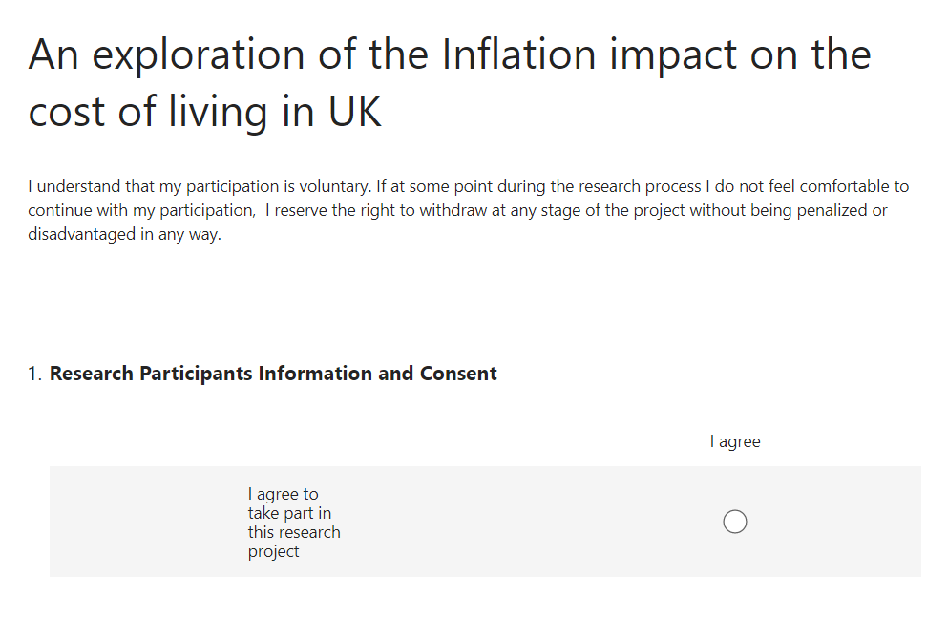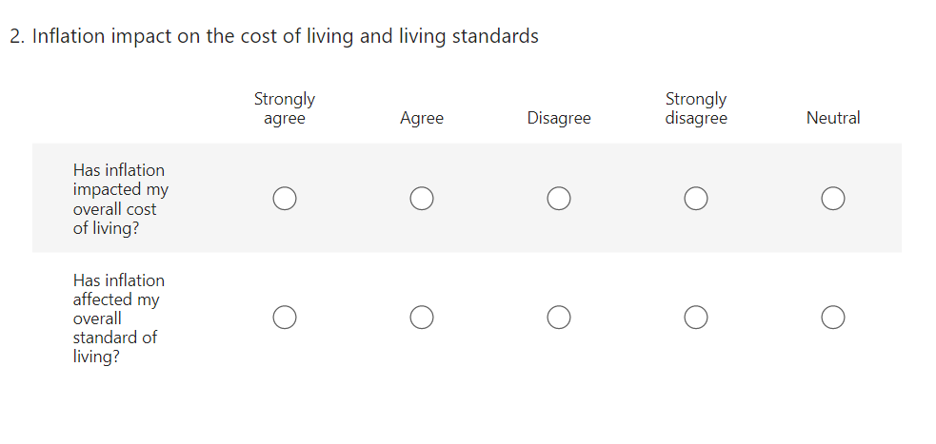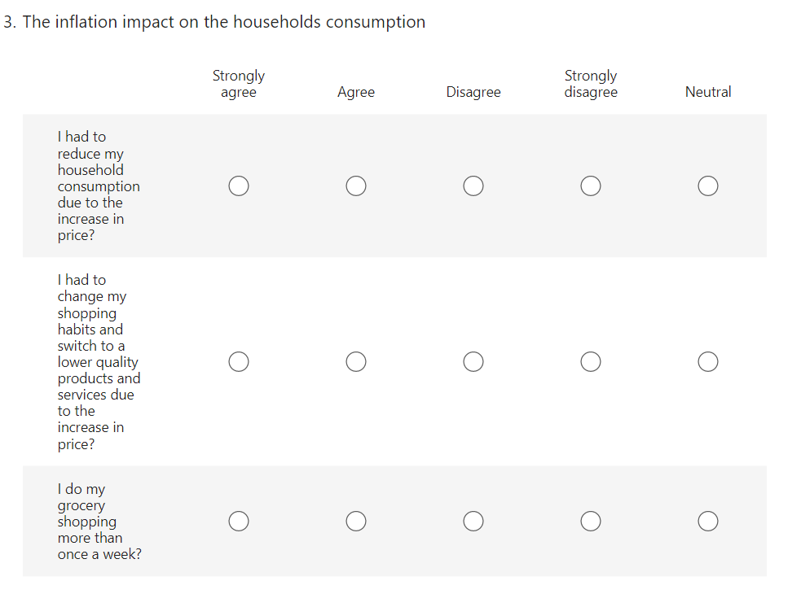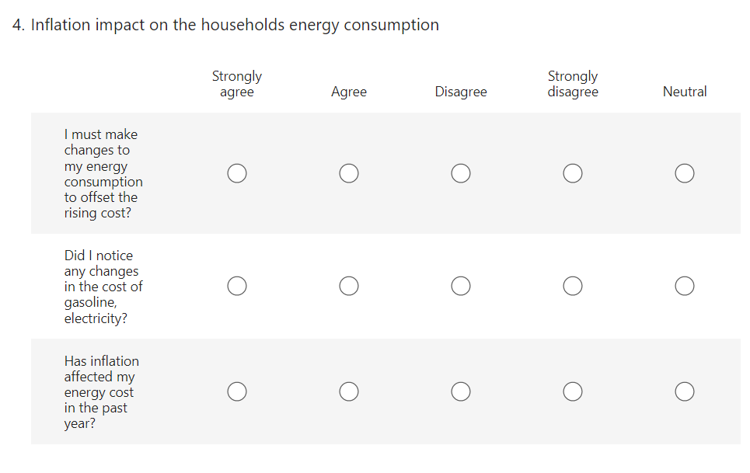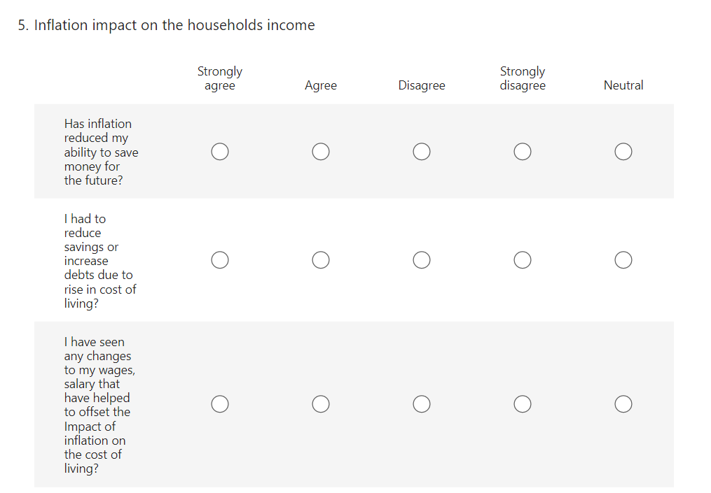

Survey findings results

Theme 1- The inflation impactv on the cost of living and living standards.
Table 1- Has inflation impacted my overall cost of living
Options | Participants-37
Strongly agree | 30
Agree | 6
Neutral | 0
Disagree | 0
Strongly disagree | 1

Table 2- Has inflation impacted my overall standard of living
Options | Participants-36
Strongly agree | 21
Agree | 12
Neutral | 0
Disagree | 3
Strongly disagree | 0

Theme 2- The inflation impact on the household’s consumption
Table 1- I had to reduce my household consumption due to the increase in price.
Options | Participants-37
Strongly agree | 21
Agree | 12
Neutral | 2
Disagree | 2
Strongly disagree | 0

Table 2- I had to change my shopping habits and switch to a lower quality products and services due to the increase in price
Options | Participants-37
Strongly agree | 18
Agree | 14
Neutral | 4
Disagree | 1
Strongly disagree | 0

Table 3- I do my grocery shopping more than once a week.

Options | Participants-37
Strongly agree | 0
Agree | 12
Neutral | 0
Disagree | 10
Strongly disagree | 12

Theme 3- Inflation impact on the household’s energy consumption
Table 1- I must make changes to my energy consumption to offset the rising cost.

Options | Participants-37
Strongly agree | 19
Agree | 13
Neutral | 2
Disagree | 3
Strongly disagree | 0

Table 2- Did I notice any changes in the cost of gasoline, electricity.

Options | Participants-37
Strongly agree | 29
Agree | 5
Neutral | 0
Disagree | 2
Strongly disagree | 0

Table 3- Has inflation affected my energy cost in the past year?

Options | Participants-37
Strongly agree | 26
Agree | 8
Neutral | 0
Disagree | 2
Strongly disagree | 1

Theme 4- Inflation impact on the household income
Statement 1- Has inflation reduced my ability to save money for the future.

Options | Participants-37
Strongly agree | 25
Agree | 9
Neutral | 1
Disagree | 2
Strongly disagree | 0

Statement 2- I had to reduce savings or increase debts due to rise in cost of living.
Options | Participants-37
Strongly agree | 26
Agree | 8
Neutral | 1
Disagree | 2
Strongly disagree | 0

Statement 3- I have seen any changes to my wages, salary that have helped to offset the Impact of inflation on the cost of living.
Options | Participants-37
Strongly agree | 15
Agree | 8
Neutral | 2
Disagree | 8
Strongly disagree | 4

