Written Evaluative Report
Game Design & Asset Creation 2
Thomas Nurse (2004043)

Contents
Overview 3
General Concept 3
Aesthetic Theme 3
Gameplay Mechanics 4
Research 5
Art References 5
Blender 6
Coding Research 6
References 8
Bibliography 9
Overview
General Concept
The idea for the game is a sci-fi space shooter where the player controls a ship that is armed with multiple turrets. The player can manoeuvre the ship's turrets independently to target enemies in a 360-degree radius around the ship, with limited vertical movement capabilities as well. Providing a large area of coverage by the weapons. The player’s goal is to eliminate all of the enemy ships that attack the player. The structure of the game has enemies scattered around a large area inside of an asteroid belt.
Aesthetic Theme
The aesthetic theme for the game is a style that leans towards realism focusing on a high contrast between the deep darkness of space and the ships as they are highlighted by the light of the nearby star. Ships are styled to be sleek and futuristic with elements such as bright emissive lighting emanating from areas of the ships such as the engines or intakes. A contrast in the cleanliness of the textures on the player and enemy ships is designed to portray that the player’s ship is more modern, sleeker, and well maintained. While the damaged and grimy enemy ships portray a weaker and poorly maintained force. Textures for the ships are designed to replicate the look of real materials with scuffs and scratches on the surface, revealing the bare metal below the paint. Dirt and rust on the enemy ships help portray the scrappy styling of the faction, presenting to the player that the ships they use could be old, repurposed civilian spacecrafts. Projectiles from weapons are bright and emissive, allows the projectiles to be easily seen in the darkness of space, providing a better visual representation of the battles.
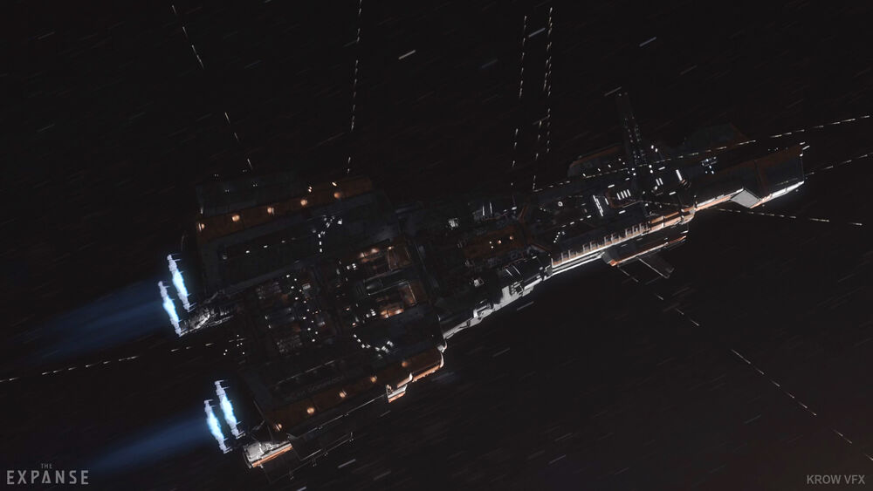
My initial inspiration for the game theme was derived from the TV Show “The Expanse”. Specifically, the scenes of ship combat with the turrets firing out towards space.
[1]

This aspect of the show directly inspired me to implement controllable turrets onto my player ship with the hope that it would capture the same flair of ship combat that is seen in the show. This also serves as my main inspiration for focusing on a more realistic visual atmosphere for the game.

Gameplay Mechanics
There are multiple primary gameplay mechanic modifications to the template.
Firstly, a complete overhaul of the player camera. I decided to completely remove the original camera system in the template as I found that the camera for the ship being locked directly behind the player ship to feel very restrictive and unnatural while playing. I replaced this system with a freely orbiting camera system. I decided to use an orbiting system as I felt that it provided the player more control over the game and was less restrictive, allowing for the player to garner a better view of the level and the enemies.
Secondly, I heavily modified the player weapons system to utilise independently controlled turrets on the surface of the player ship rather than the original system that had the player firing directly in front of the ship. This addition adds a great increase in player control that provides a more fluid and enjoyable experience. The player can control the turrets aim independently from the movement direction of the ship as the aiming direction is controlled by the orbiting camera system. Each individual turret will independently aim towards the exact point that the camera is looking at. Due to each turret aiming independently, it means that they can collectively focus on a single target, whether it is close or far, they will have a collective focal point of aim. Overall, this implementation of a weapon system provides a greater experience for the player in combat with multiple enemies as they have more freedom and control over the battle.
Thirdly, I removed broken or unused functions from the template and reimplemented the boost function. I concluded that many functions from the original template did not fit well in my game. An example of one of these functions would be the barrel roll feature. Due to my player ship being a much larger and therefore, less manoeuvrable; I decided that the function was not appropriate as it felt very out of place as it was clearly designed with a smaller, more nimble ship in mind therefore I removed it. Many functions of the player ship were initially broken by the removal of the original camera system, because of this I reimplemented the player ship boost ability. With my version of the ability, the player ship smoothly accelerates and decelerates to 4x of the normal speed. The FOV also appropriately reacts to the change in acceleration to emphasise to the player the speed increase. I believe this is a superior implementation of the mechanic as the combination of the greater view of the camera with the greater speed change and FOV adjustment results in a more dramatic and impactful ability to use.

Research
Art References
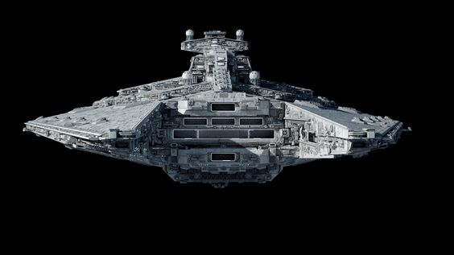
When creating my player ship model, I did some preliminary research in gathering image references that I could use for inspiration. To do this I used the website Pinterest. I knew that I wanted to create a larger ship, a class that would be capable of carrying smaller ships inside.
[2]

Above is an example of one of the images that I used for my initial inspiration. I created a moodboard of images like this one that served in assisting me with the initial concept of the ship design. While these reference images provided the initial inspiration, while I was modelling the asset, I began to stray away from the references more; Instead leaning towards a sleeker and clean design. This design shift resulted in a final design that was unlike the reference material in many aspects, leaning towards a cleaner and minimal design. While I believe my method of using reference images proved to be of assistance in the initial stages of design, as I got further into designing, I relied on the references less and less to eventually create a unique design.
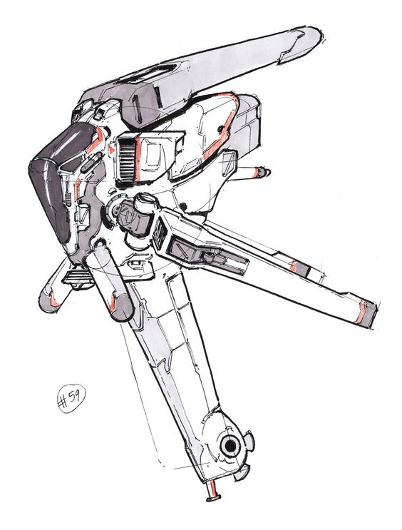
With my enemy ship model, I used a similar method to my player ship, however I didn’t have any initial idea of the sort of design I wanted for the ship. This resulted in me searching broadly for ship designs to find one that inspired me. I found this method to be somewhat ineffective as I had a difficult time finding designs that I felt would serve to be good inspiration.
[3]

Eventually I found an image that inspired me to design a spaceship that was a primarily vertical shape rather than the typical horizonal shape most designs are. From this I found other images that I also could use and put them into a moodboard. From here they served as light inspiration however I mostly didn’t use them and freely designed a ship of my own design only taking minor inspiration such as the lower antennae on my design being influenced by the lower wing-like section of a few of the reference images. For the enemy asset, I found the research method to be fairly ineffective, this is primarily due to the lack of initial inspiration to guide my research.
Blender
While creating my turret asset, I knew that I wanted to manipulate the model using a rig rather than a pair of assets combined in an Unreal Engine blueprint. Because of this I researched how to use the rigging system in Blender to create the simple rig that the turret uses. I first followed a tutorial on rigging for hard surface models ^{[4]} since I knew that my rig was going to be simple as it was only two bones. This tutorial taught me the basics in understanding how to create a basic rig that has the bones linked correctly. I knew that I wanted to use constraints on the bones to prevent them rotating in unintentional ways, so I followed a basic tutorial that showed how to properly assign constraints on rotation ^{[5]}. Following this I set constraints on the bones that limit their movement to specific values that prevent undesirable behaviour such as clipping. While the post is free to spin 360-degrees, providing the rotation that the turret uses. The gun itself can only pitch up 35 degrees and down 10 degrees. I chose these values after verifying the limits that the model had before clipping occurred. These limits are assigned to the bones on the rig and were imported into Unreal Engine.
Coding Research
While I was working with the new camera system, I found that it was fully functional and worked as expected when playing the demo level directly in Unreal’s Viewport. However, while I was entering the final stages of developing the project, I discovered that if the player loaded into the level by going through the main menu, the player would only have control over the camera while clicking the mouse, this was not acceptable as the clicking would also result in the player’s weapons firing. I found that this issue was difficult to find a solution to as I couldn’t see anything that looked out of place but eventually realised that it was likely an issue with the main menu not handing over controls to the normal player controller on load. This idea was only partially correct as I found the correct solution to my problem on the Unreal Engine forum ^{[6]} where I saw reference to the node “Set Input Mode Game Only”. When this node was used by the gamemode blueprint for the demo level on Begin Play, this corrected the issue with the camera. Allowing for normal control without the need to click the mouse.
When creating the new player ship boost, I found that the transition between the normal speed and the boost speed was very jarring as it would happen instantaneously. To resolve this, I knew that I wanted to use the “FInterp” node as this would gradually change the initial value to the desired one over a period of time. However, I wasn’t able to determine the correct usage of the node as it would still work instantaneously. After a while of unsuccessfully attempting to solve the issue myself, I began researching how to appropriately utilise the node. Eventually I found a forum post that also discussed interpolating values ^{[7]}, this is where I discovered that the “FInterp” node required a connection to “Delta Seconds” on the “Event Tick” node as well as the value that is being interpolated was required to be updated on every tick. Once I discovered this, I modified my implementation of the boost so that on activation both a variable called “Desired Speed”, and another called “Desired FOV” would update to the boost values which would be correctly interpolated to by the “FInterp” nodes attached to the “Event Tick” node. The result of this means that the transition to the boost speed and back is a smooth transition that is visually appealing and effective at conveying a sense of speed to the player without being jarring.

My research for the turret’s implementation began near the very beginning of the project where I was throwing around my general ideas about what I wanted to do with the project with ChatGPT. In this conversation, I discussed general ideas about how the implementation of a turret system may work and how the aiming system would function. This led to me discovering the use of raycasting as a means of telling an actor where the camera is aiming. I knew that I wanted to use this system since it would allow me to have independent controls of each turret as they will all converge at any point I aim at. When I began the implementation of the turret system, I began researching how to use raycasting and found an example in the Unreal Engine Documentation ^{[8]}. Following this guide, I created a functioning raycast that output the Vector location Coordinate of any point in space that the ray intersected another object. From this I built a system that transferred this Vector Value to each of the turrets which allowed them to independently face that point in space for aiming. The final result of this research was an implementation of an aiming system for turrets that individually points each turret at the location that the camera is looking at, allowing for accurate aiming of the turrets by the player.
References
[1] Fandom, “PDC,” the expanse wiki, No Date. [Online]. Available: https://expanse.fandom.com/wiki/PDC?file=Donnager_Point-Defence.jpg [Accessed May. 17, 2023]
[2] ArtStation, “Impellor-class Fleet Carrier 4k, Ansel Hsiao,” pinterest, No Date. [Online]. Available: https://www.pinterest.co.uk/pin/28429041384324241/ [Accessed Apr. 8, 2023]
[3] Pinterest, “Spaceships”, pinterest, No Date. [Online]. Available: https://www.pinterest.co.uk/pin/4433299626289559/ [Accessed Apr. 19, 2023]
[4] Markom3D, “Hard Surface Rigging in Blender Tutorial”, youtube. Sep. 23, 2022. [Online]. Available: https://www.youtube.com/watch?v=cH5QwlZlvmg [Accessed Apr. 22, 2023]
[5] Blender Secrets, “Blender Secrets – Robot Rigging (Part 3 – Bone Constraints),” youtube. Sep. 24, 2021. [Online]. Available: https://www.youtube.com/watch?v=eR0YilVKe7o [Accessed Apr. 22, 2023]
[6] Mr_Robville, Nsomnia, “Camera mouse control not active unless clicking in viewport”, dev community. Jun. 14, 2015. [Online]. Available: https://forums.unrealengine.com/t/camera-mouse-control-not-active-unless-clicking-in-viewport/32542/5 [Accessed May. 4, 2023]
[7] anonymous_user_68af3cbb, ClockworkOcean, “How to interpolate rotations”, dev community. May. 13, 2020. [Online]. Available: https://forums.unrealengine.com/t/how-to-interpolate-rotations/465115/3 [Accessed Apr. 28, 2023]
[8] Epic Games, “Using a Single Line Trace (Raycast) by Channel”, unreal engine. No Date. [Online]. Available: https://docs.unrealengine.com/4.27/en-US/InteractiveExperiences/Tracing/HowTo/SingleLineTraceByChannel/ [Accessed Apr. 27, 2023]

Bibliography
[1] ArtStation, “Velox-class Star Frigate,” pinterest, No Date. [Online]. Available: https://www.pinterest.co.uk/pin/322148179602742521/ [Accessed Apr. 8, 2023]
[2] ArtStation, “Imperial Customs Corvette and Variants,” pinterest, No Date. [Online]. Available: https://www.pinterest.co.uk/pin/70157706730522525/ [Accessed Apr. 8, 2023]
[3] ArtStation, “Impellor-class Fleet Carrier 4k, Ansel Hsiao,” pinterest, No Date. [Online]. Available: https://www.pinterest.co.uk/pin/28429041384324241/ [Accessed Apr. 8, 2023]
[4] Pinterest, “Spaceships”, pinterest, No Date. [Online]. Available: https://www.pinterest.co.uk/pin/4433299626289559/ [Accessed Apr. 19, 2023]
[5] Pinterest, “Spaceships”, pinterest, No Date. [Online]. Available: https://www.pinterest.co.uk/pin/3377768464595892/ [Accessed Apr. 19, 2023]
[6] ArtStation, “US Space Patrol, Virnard”, pinterest. No Date. [Online]. Available: https://www.pinterest.co.uk/pin/14284923797821880/ [Accessed Apr. 19, 2023]
[7] Markom3D, “Hard Surface Rigging in Blender Tutorial”, youtube. Sep. 23, 2022. [Online]. Available: https://www.youtube.com/watch?v=cH5QwlZlvmg [Accessed Apr. 22, 2023]
[8] Blender Secrets, “Blender Secrets – Robot Rigging (Part 3 – Bone Constraints),” youtube. Sep. 24, 2021. [Online]. Available: https://www.youtube.com/watch?v=eR0YilVKe7o [Accessed Apr. 22, 2023]
[9] Epic Games, “Using a Single Line Trace (Raycast) by Channel”, unreal engine. No Date. [Online]. Available: https://docs.unrealengine.com/4.27/en-US/InteractiveExperiences/Tracing/HowTo/SingleLineTraceByChannel/ [Accessed Apr. 27, 2023]
[10] anonymous_user_68af3cbb, ClockworkOcean, “How to interpolate rotations”, dev community. May. 13, 2020. [Online]. Available: https://forums.unrealengine.com/t/how-to-interpolate-rotations/465115/3 [Accessed Apr. 28, 2023]
[11] Mr_Robville, Nsomnia, “Camera mouse control not active unless clicking in viewport”, dev community. Jun. 14, 2015. [Online]. Available: https://forums.unrealengine.com/t/camera-mouse-control-not-active-unless-clicking-in-viewport/32542/5 [Accessed May. 4, 2023]
[12] Fandom, “PDC,” the expanse wiki, No Date. [Online]. Available: https://expanse.fandom.com/wiki/PDC?file=Donnager_Point-Defence.jpg [Accessed May. 17, 2023]

