Project planning and management within the workplace
BMSK5004
Mosamaa Marjana Khatun
1704984
Word count: 2,121

University of Wales Trinity Saint David
Table of Contents
1.0. Introduction 2
2.0. The tools and techniques of project management 3
2.1. The Iron triangle 3
2.2. Project life cycle 3
2.2.1. Initiation phase 4
2.2.2. Planning phase 5
2.2.3 Execution phase 8
2.2.4. Closure phase 10
3.0. Conclusion 13
4.0. Appendix 14
Appendix.1. Emailed invitation to participants 14
Appendix. 2. Agenda 15
Appendix. 3. Belbin’s nine team roles 16
Appendix .4. Project managers’ application of Gibbs, (1988), reflective cycle 17
Appendix. 5. Evaluation forms 19
5.0. References 21

Introduction

The role of a project manager involves the application of alternative project management tools and techniques that form a guide for the accomplishment of a project. The utilisation of specific tools facilitate the requirements of individual tasks from conception to completion. (Atkinson, 1999).

The organisation that will be reviewed throughout this report is the Swansea Council for Voluntary Services and the BME Skills Project. The project that had been proposed to a team of four was to arrange a workshop to assist in “demystifying strategic and business planning” for the stakeholders of the BME skills project.

The tools that the project manager had utilised will be described and an example of the application in the project will be incorporated.

The tools and techniques of project management

2.1. The Iron triangle

The iron triangle, (figure.1.), offers support in the continuous assessment of a projects performance. The three constraints in which success is measured are; cost, scope and time. Each of the metrics assist in the production and avoidance of alterations if issues are to arise. (Pollock, et al, 2018 and Dobson, 2004).

Figure.1. Iron triangle.

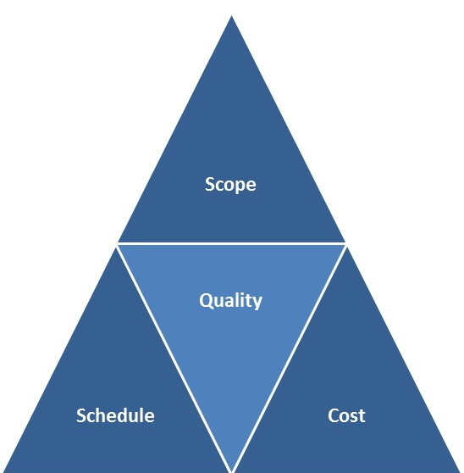

(Performance management consultants, 2018).

  - Application of iron triangle
The two prominent constraints that affected the performance of the workshop project were time and scope.

The project manager and project lead had evaluated and created a timetable for the workshop in correlation with BME skill project. This offered a definite understanding of the availability of an office space. Additionally, the times and agenda of the workshop had been constructed and emailed to all invited participants (Appendix, 1 and 2). (Swansea CVS, 2019).

Secondly, the continuous assessment and development of objectives enabled the project team to academically research and present relevant knowledge that magnified the preferred structuring of a business plan. Therefore, participants had received information that was accurate and applicable.

2.2. Project life cycle

The project life cycle, (figure. 2), provides a framework that underlines the project. The process involves the management of four phases from the conception to the completion of a project, these are; initiation, planning, execution and closure. (Pica, 2016 and Davis and Radford, 2014).

The tools and techniques that facilitate project managers in determining the achievement of each phase will be critically discussed, along with the evidence of application within the BME skills project.

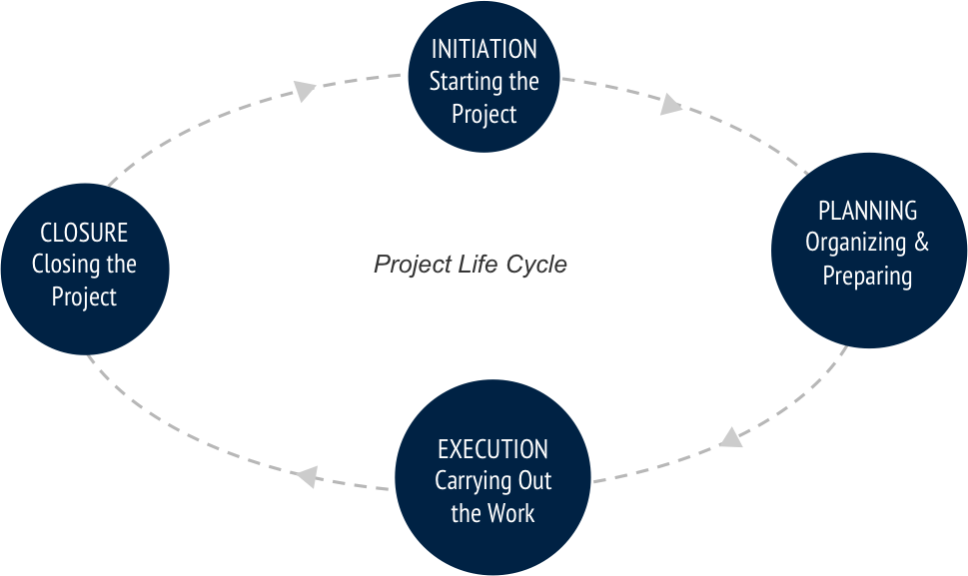
Figure.2. Project Life Cycle.

(Mavenlink, 2019).

2.2.1. Initiation phase

Firstly, the initiation phase establishes the core competencies as well as the project scope. Specification is offered to preliminary targets and alternatives that accompany the means to accomplish all goals. (Pica, 2016; Davis and Radford, 2014; Westland, 2007).

  - Core competencies of project management
The process of project management ensures that core competencies such as the coherent understanding, skills and knowledge that satisfy the criteria of the project, stakeholders and project team, are identified to assist in the execution of all objectives. (Rao, 2016 and Isik, et al, 2009).

  - Belbin nine team roles
A tool that supports the identification of individual characteristics when creating a balanced project team is Belbin's nine team roles. (appendix. 3). Project managers are advised to encourage team members to partake in selecting individual personalities to aid in the assignment of suitable roles. Likewise, project success is supported as team members are aware of responsibilities specific to their appointed role. (Belbin associates, 2019).

The general characteristics within the workshop project team expressed amalgamation of the strengths and weaknesses within multiple team roles. The project manager primarily acquired roles within the groups of action oriented roles and people oriented roles hence was selected to lead the project team.

  - Project scope
A project manager is encouraged to document the scope of the project using SMART when describing the objectives, aims, resources, time and cost, as it is aforethought as the process that determines the work and results that are specified during the stage of planning. This ensures the satisfactory delivery or completion of a project. (Derenskaya, 2018; Milosevic and Martinelli, 2016; Moustafaev, 2014).

  - Project scope of the workshop
The aim proposed by the project lead was to plan and deliver a three hour long workshop on the structuring of a strategic business plan. Additionally, invitations were marked to be distributed to ten participants of start-up organisations or charities within the BME skills project. (Swansea Council for Voluntary Service, 2019).

The objectives were firstly, to assist in expanding the knowledge and understanding on how to structure a business plan. Secondly, team members were encouraged to engage participants in activities as well as open conversations. A final objective was to provide an abundance of specific knowledge through multimedia resources such as a presentation, flat packs and email.

2.2.2. Planning phase

This planning phase is the formation of detailed and manageable plans to support and accomplish the initially developed objectives. Furthermore, this stage assists the project team in the establishment of essential tasks and resources, as well as the methods for producing said requirements. (Gardiner, 2005). Planning is supported by the application of tools such as the stakeholder’s analysis, the quad chart and risk management.

  - Stakeholder analysis
The stakeholder analysis is conducted by project managers to develop a strategic understanding and identification of key stakeholders and their importance within the internal environment of a project. Moreover, success is gained through the tailoring of communication to fit stakeholder needs along with the prevention of conflict and dispute. (Mushove and Vogel, 2005; Cobb, 2012; Freeman, et al, 2010).

The workshop project team had categorised its audience, (figure. 3), on the basis of interrelationships, attributes and the respective interests that relate to the project. Stakeholders have been prioritised as high, medium, or low along with their “actions” in relation to the project. (Mushove and Vogel, 2005).

Figure. 3. Stakeholder analysis

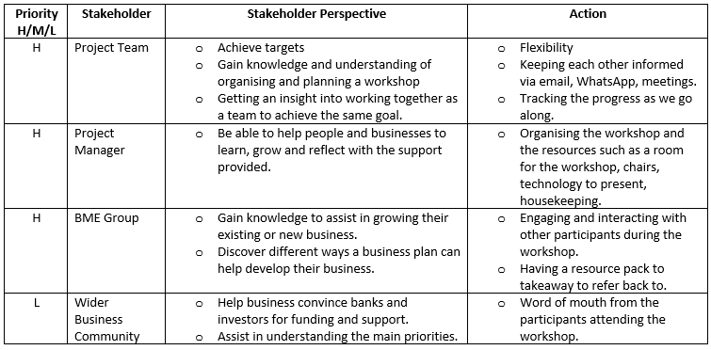

  - Quad chart
A quad chart is a quality tool that predominantly assists in the overall knowledge of a project, it communicates and divides a subject into four component parts that encourage management analysis and judgement. The four sections of the chart are: purpose, customers, desired end results and measures of success. The enhancement of the chart allows more thought on critical success factors that are essential to the project, such as underlying ethics, values and passion. (Paladino, 2010 and Ford and Wei, 2015).

The project manager had created two quad charts that include a breakdown of the project. The refined chart portrays secondary benefits and a motivational factor. Stakeholders were made aware of the outline of the project which was consistently referred to throughout project progression.

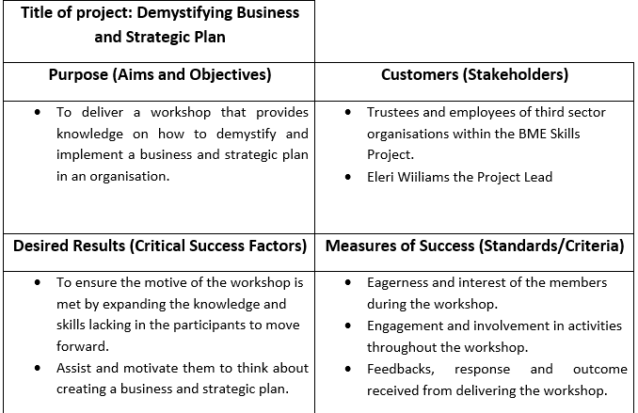
Figure. 4. Initial quad chart.

Figure. 5. Refined quad chart.
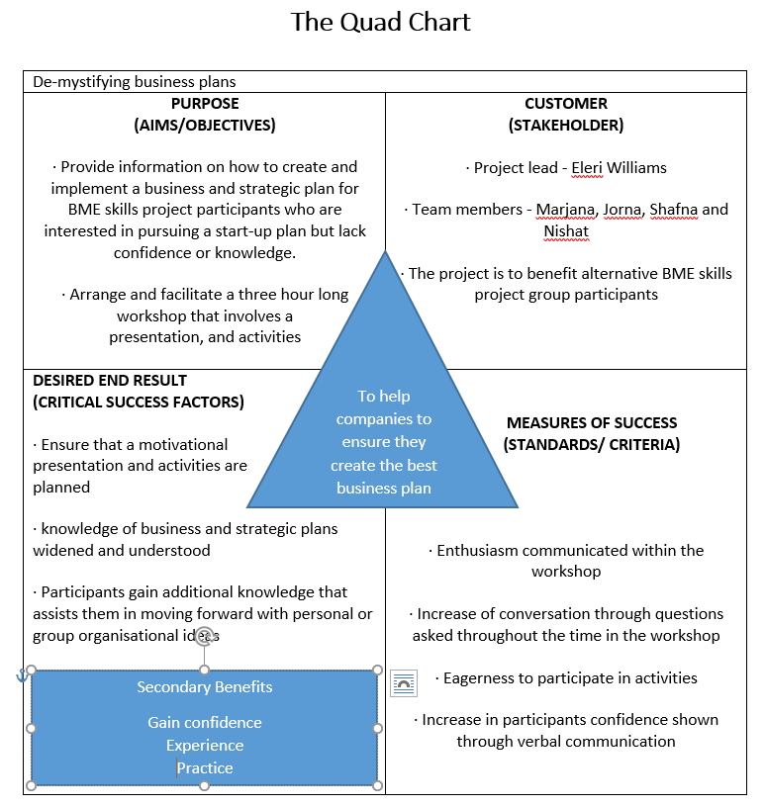

  - Risk analysis
The risk management tool enhances the value of judgement by enabling the project team to assess internal and external factors. The impact and likelihood of the risk is also categorised as high, medium or low. (Raftery, 1994 and Woods, 2011)

As evident in figure 6, five risks had been distinguished within the workshop project. An example is “limited impact” wherein the initial feelings of the project team surrounded the invitations and agenda having little effect on participants. The project manager had experienced some warning signs as responses had not been received and for this reason the action to reiterate a “save the date” email had been enforced.

Figure.6. Risk management
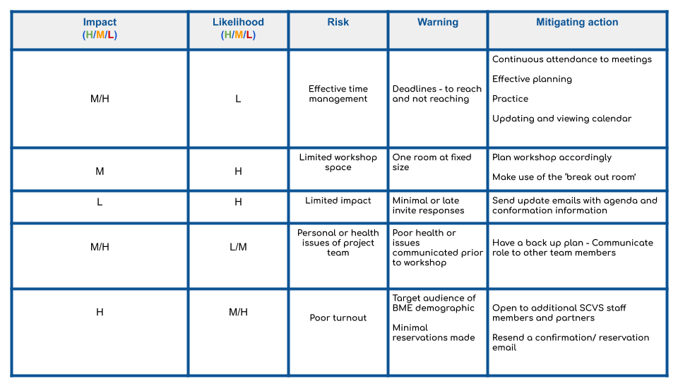

2.2.3 Execution phase

The execution phase is where all plans are implemented to facilitate in the project performance. In addition, project managers regularly monitor progress, which include both qualitative and quantitative components, in result, convenient adjustments are shaped and recorded. Finally, it aims to determine whether or not project objectives have been executed. (Turner, 2009; Tache and Ispasoiu, 2013; Jonas, 2010; Ekboir, et al, 2017).

The three tools that assist in the maintenance and control over the direction of the project are; the work breakdown structure, the Gantt chart and the PESTLE analysis.

  - Work breakdown structure
The work breakdown structure facilitates in forecast management, reflection, organisation and control. The tool can be viewed as a hierarchical tree that enables the division of a project into ‘SMART’ deliverables. It exhibits a subdivision of effort required to achieve a parallel between activities, pyramid objectives and potential risks. (Zecharu and Olaru, 2016; Cobb, 2012; Cann and Brumagim, 2008).

The top down structure is deemed more logical due to unfamiliarity besides the prior understanding of the project plan. (Project management, 2018 and Norman et al, 2008).

  - Work breakdown structure application
The project manager had created a ‘top down’ work breakdown structure, as specifics that are narrowed down iteratively was deemed logical (figure.7). The project scope is visibly defined and the hierarchical reflection of deliverables are separated by sub-activities from the main activity.

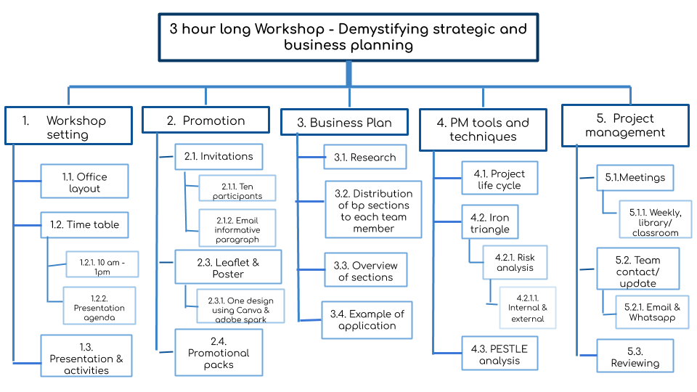
Figure.7. Work breakdown structure

  - Gantt chart
The WBS deliverables assist in the creation of the Gantt chart which is presented in a graph format. It allows a visual, practical and intuitive outlook of activities as well as the progression from each stage. Furthermore, the status of each activity is communicated to the project team along with the duration taken to complete them. (Geraldi and Lechter, 2010; Steffan, 2003; Cobb, 2012; Young, 2013).

  - Gantt application
The project manager of the workplace had created a Gantt chart using Microsoft Excel. The first was constructed during the planning phase, (figure.8.) wherein the resources and activities for the workshop were finalised. The start date and end date and task owners are visible. The project manager had encouraged team members to update the status of the activity to either upcoming, active or complete when tackling assigned tasks.

To continue, the updated chart, (figure.9.), expressed that the activities did not overlap and the team were able to manage time. Finally, this expressed that the communication between the project manager and team members encouraged the completion of tasks at a high standard and ahead of deadlines.

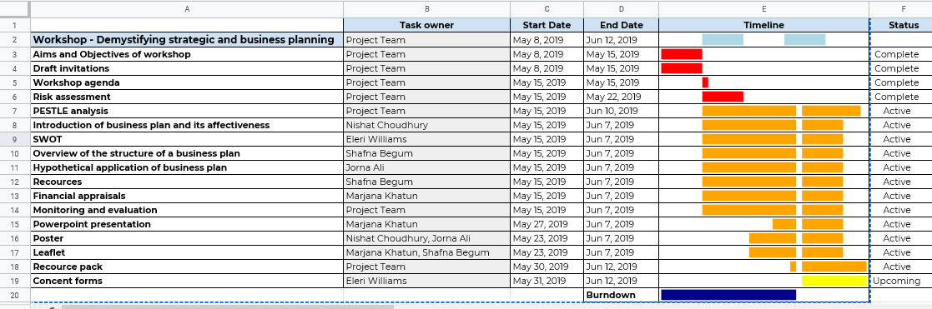
Figure.8. Initial Gantt chart.

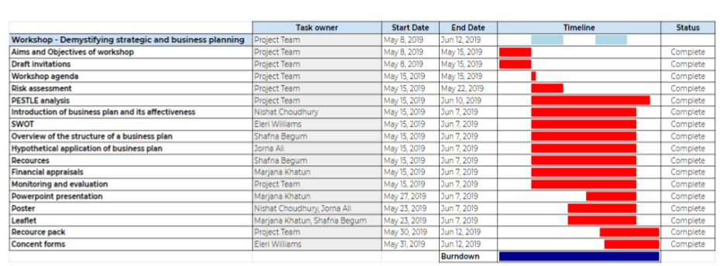
Figure.9. Updated Gantt chart.

2.2.4. Closure phase

The last phase of the cycle is dependent upon releasing the final deliverables and communicating the closure of the project to all stakeholders. In this step the project team evaluates the project from an internal or external perspective as well as individual performance which is retrospective and periodic. The knowledge collected is generated by the monitoring system and assists in the rectification of future performance. (Lock, 2007; Project management institute, 2013; Ekboir, et al, 2017).

  - Program evaluation, (1999)
To reflect upon the performance of a project, Milstein and Wetterhall, (2000), explicate a practical framework, (figure. 10 and 11), initially created by the Centers for Disease Control and Prevention, (1999). The model consists of six steps and four standards that provide an optimal program for evaluation. The project team had applied this framework to complete a comprehensive review on the outcomes to assist in indicating areas where progression is vital.
Figure. 10. Program evaluation cycle
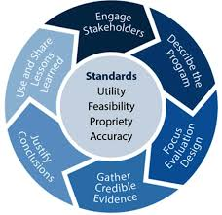
(CDC, 2019)
Figure. 11. Table of program evaluation
(Milstein and Wetterhall, 2000) 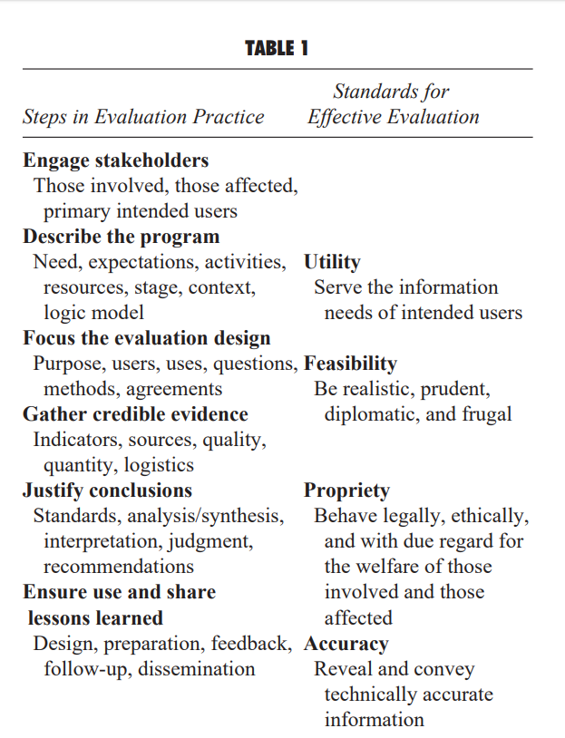
The credible evidence gathered from the workshop are viewed in the turnout which was seven participants out of a possible ten, and the evaluation forms that were completed by attendee participants, (appendix 5), each form magnified positive feedback and evidence that amplified the continuous reflection and utilisation of the project plans and the project scope.
  - Gibbs reflective cycle (1988)
The application of reflective models help in creating new perspectives for individual approaches and thought processing throughout the development of a project. Examples of reflective models and frameworks include; Kolb reflective cycle, (1984), Schön model (1991), Driscoll, (1994) and Gibbs reflective cycle (1988). (Mcgregor and Cartwright, 2011 and Bassot, 2016).

A cyclic framework of six stages for examining personal experiences is the Gibbs reflective cycle, (1988). The model, (figure.12), allows individuals to reflect on the positives and negatives of an experience and assists in magnifying areas for development. (Bassot, 2016).

Figure. 12. Gibbs reflective cycle.


(Oxford Brookes University, 2019).

To structure the personal reflection, the project manager had applied each topic in a clockwise motion. (Appendix, 4). The model has assisted in the deconstruction of the personal experience and management skills. Furthermore, this has enabled the project manager to set an action plan for areas to improve in future performances.

Conclusion

The progress of the demystifying business planning project has been magnified through the project manager’s utilisation of management tools. The wide array of application in alternative tools has allowed the team to gain success and positive feedback from the workshop audience and project lead.
The complex role of the project manager has enabled the formation of aims and objectives along with the monitoring and evaluation of all stakeholder needs. It is evident that all requirements surrounding the project had been tackled with the use of all nine tools and techniques. The prioritisation of stakeholders and activities assisted the team in managing time and resources relevant to the project and finally the evaluation phase has offered insist into future project performance and management.

Appendix

Appendix.1. Emailed invitation to participants



Appendix. 2. Agenda

Agenda

10-00 -10.05 Housekeeping - EW
10.05 -10.10 Intro. PPT - everyone
10-10 -10.20 Intro. For audience - who, role in org,
what they want from workshop
10.20 -10.25 Definition of business plan - Nishat
10.25 -10.30 Video
10.30 -10.45 Hypothetical SWOT - EW
10.45 - 11.00 Real SWOT for each org
11.00 - 11.15 15 min break
11.15 - 11.20 Overview of business plan Shafna
Each element:
11.25 - 11.35 Intro, overview, mission vision, values -Jorna Ali
11.35 -11.45 Resources- Shafna
11.45 - 12.15 Financial Appraisal- Marjana
12.15 -12.30 Monitoring & Eval – EW
12.30 Conclusions / questions / completing evaluation form

Appendix. 3. Belbin’s nine team roles

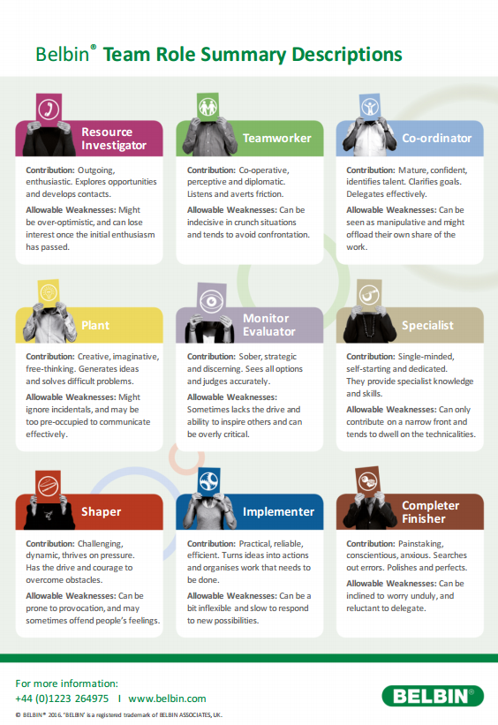

Appendix .4. Project managers’ application of Gibbs, (1988), reflective cycle

Project manager: Mosamaa Marjana Khatun

Gibbs reflective cycle, (1988)

Description:

My responsibility within the demystifying business plan project was to implement the project life cycle within all aspects as well as regularly motivate and assist my team members to achieve all relevant objectives to the highest standards and within agreed time and criteria. (Iron triangle).

Feelings:

Initially, perplexed emotions were outstanding, especially anxiousness and excitement, as I had not managed a project nor attended a workshop prior to this experience and did not know what to expect. In addition, my team was made up of individuals that I had never worked with, including the project lead who was introduced at the start of the project, therefore I had little understanding of how tasks would be performed and completed by each individual.

Evaluation:

Throughout the progression of the project my confidence had elevated and the process was extremely enjoyable and stress free. Presenting the knowledge we had gathered that was relevant to the workshop was nerve racking as we had to make sure we would not feed the audience false information. Each aspect planned for the workshop was tackled with positivity and verbal as well as written feedback from the project lead and audience allowed the team to understand the positive impact made.

Analysis:

I was able to motivate team members throughout their journey and support them when necessary. The effective work and commitment to achieve greatly can be viewed by the number of formal team meetings and “lunch dates” that had been organised to help tackle any downfalls and increase or enhance all tasks.

The workshop was successful as participants engaged in activities and open conversation, finally they have requested a follow up workshop.

Conclusion:

The re-examination of my overall performance has allowed me to understand that building confidence will aid in ongoing efficiency. If I understand and apply all the tools and techniques, tasks will be applicable and performed within set time. Also, I am now able to adapt to alternating styles of performance, such as being formal and informal. Finally, the relationship with my team helped me demonstrate the role of project management professionally.

Action Plan:

In future, I will ensure that I apply all the knowledge and skills that I have accomplished from this experience. I will aim to enhance and increase assertive skills to establish the maintenance in the relationship with all stakeholders. I intend to work on my nerves and speech to secure a positive verbal performance as this project brought to light the lack of confidence in my presentation skills and communication with all stakeholders. Finally, I will aim to reflect on all future performance throughout a project whilst asking for feedback from project teams and leads.

Appendix. 5. Evaluation forms
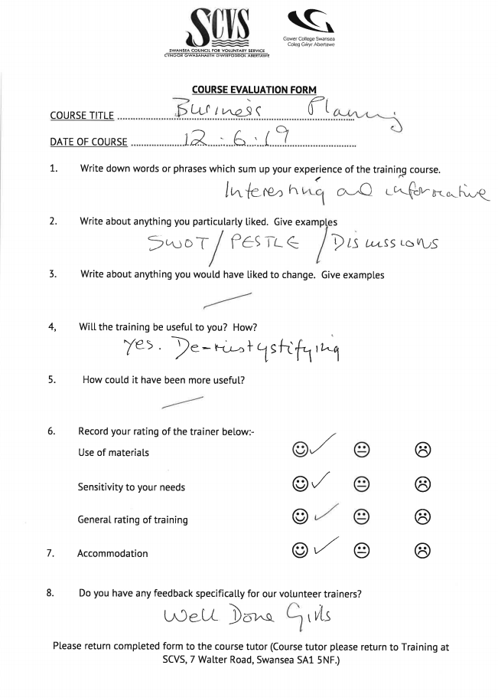

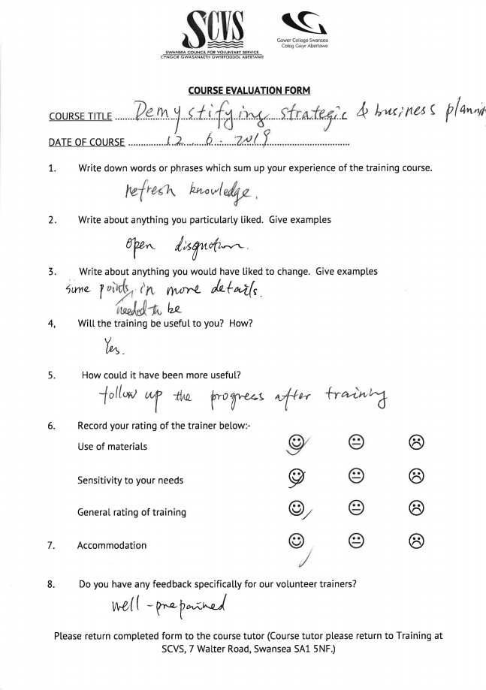

References

Atkinson, R. (1999). ‘Project management: cost, time and quality, two best guesses and a phenomenon, it’s time to accept other success criteria’, International journal of project management, 16(4), [online]. Available at: http://citeseerx.ist.psu.edu/viewdoc/download?doi=10.1.1.453.1057&rep=rep1&type=pdf, [accessed on 20. 06. 2019].
Bassot. B. (2016). The reflective journal, 2nd ed, London: Macmillan publishers limited.
Belbin Associates, (2019) ‘The Nine Belbin Team Roles’. [Online]. Available at: https://www.belbin.com/about/belbin-team-roles/ [accessed on 16. 05. 2019].
Cann, C. W. and Brumagim, A. L. (2008). ‘How Project Management Tools Aid in Association to Advance Collegiate Schools of Business (AACSB) International Maintenance of Accreditation’, Journal of education for business, 84(1), pp. 31-39, [online]. Available at: https://search-proquest-com.ezproxy.uwtsd.ac.uk/docview/202820932/fulltext/6594BE4050294997PQ/7?accountid=130472, [accessed on 25. 05. 19]
Cobb, A. T. (2012) Leading project teams: the basics of project management and team leadership. Thousand Oaks: SAGE. ch.2 & 4, pp. 13 - 84
Davis, B. and Radford, D. (2014). Going beyond the waterfall: managing scope effectively across the project life cycle, U.S.A: Ross publishing. [online]. Available at: https://books.google.co.uk/books?id=RHLhCgAAQBAJ&printsec=frontcover&dq=project+life+cycle+business&hl=en&sa=X&ved=0ahUKEwj7luS9pZbjAhUFiFwKHdpbCRIQ6AEIUTAG#v=onepage&q=project%20life%20cycle&f=false, [accessed on 20. 06. 2019]
Derenskaya, Y. (2018). ‘Project scope management processes’, Baltic journal of economic studies, 4(1), pp. 118 - 125, [online]. Available at: http://www.baltijapublishing.lv/index.php/issue/article/view/340/pdf, [accessed on 20. 06. 2019].

Dobson, M. S. (2004). The triple constraints in project management. USA: Library of Congress Cataloguing-in-Publication Data. [online]. Available at: https://books.google.co.uk/books?id=ihhFDwAAQBAJ&printsec=frontcover&dq=the+constraint+triangle&hl=en&sa=X&ved=0ahUKEwiXpvDJpJbjAhWXh1wKHTxuD1IQ6AEIRTAF#v=onepage&q&f=false, [accessed on 05. 06. 2019].

Ekboir, J., Canto, G.B. and Sette, C., (2017). ‘Knowing what research organizations actually do, with whom, where, how and for what purpose: Monitoring research portfolios and collaborations’. Evaluation and program planning, 61, pp. 64-75. [Online]. Available at: https://search-proquest-com.ezproxy.uwtsd.ac.uk/docview/1884833593/762F31972154421EPQ/4?accountid=130472 , [accessed on 12. 06. 2019]

Ford, D. J and Wei, T. (2015). ‘Quad charts in the classroom to reinforce technical communication fundamentals’, Journal of technical writing and communication, [online]. Available at: https://journals-sagepub-com.ezproxy.uwtsd.ac.uk/doi/full/10.1177/0047281615578848, [accessed on 05. 06. 2019].

Freeman, E.R., Harrison. J.S., Wicks, A.C., Parmar, B.L. & De Colle, S. (2010). Stakeholder Theory: The State Of The Art. Cambridge: Cambridge University Press.
Gardiner. D. P. (2005). Project management: a strategic planning approach. United Kingdom: Macmillan international higher education.
Geraldi, J. and Lechter, T. (2012), ‘Gantt charts revisited’, International Journal of Managing Projects in Business, 5(4), pp. 578-594. [online]. Available at: https://search-proquest-com.ezproxy.uwtsd.ac.uk/docview/1112229712?accountid=130472&rfr_id=info%3Axri%2Fsid%3Aprimo, [accessed on 25. 05. 19]
Isik, Z., Arditi, D., Dikmen, I., Birgonul, M. T. (2009). ‘Impact of corporate strengths/weaknesses on project management competencies’, International journal of project management, 27(6), pp. 629 - 637, [online]. Available at: https://reader.elsevier.com/reader/sd/pii/S0263786308001403?token=891E9B626D8B7FFA363C2E4D9415E23B132F81D28F4DE934ECCB67DB310C51391FC6B2DFC6245C996DFB0A200A192C2B, [accessed on 20. 06. 2019]
Jonas, D. (2010). Empowering Project Portfolio Managers: How Management Involvement Impacts Project Portfolio Management Performance, International Journal of Project Management, pp. 818-83
Lock, D. (2007). The essentials of project management, 3rd ed, Hampshire: Gower publishing company
Milosevic, D.Z & Martinelli. R.J. (2016). Project Management Toolbox. 2nd ed. New Jersey: John Wiley & Sons, Inc. chp. 8. [online]. Available at: https://books.google.co.uk/books?id=ixWRCgAAQBAJ&printsec=frontcover&dq=what+is+project+scope&hl=en&sa=X&ved=0ahUKEwj62rmU65PjAhUITRUIHR1fAasQ6AEIQzAE#v=onepage&q=project%20scope&f=false, [accessed on 10. 06. 2019]

Milstein, B. and Wetterhall, S. (2000). ‘A framework featuring steps and standards for program evaluation’, Health promotion practice, [online]. Available at: https://moodle.uwtsd.ac.uk/pluginfile.php/256211/mod_resource/content/1/frame%20work.pdf, [accessed on: 25. 06. 2019]
Moustafev, J. (2014). Project scope management, London: Taylor and Francis group. [online], Available at: https://books.google.co.uk/books?id=DXBYBQAAQBAJ&printsec=frontcover&dq=what+is+project+scope&hl=en&sa=X&ved=0ahUKEwiprpaI7ZPjAhXRShUIHSaKChkQ6AEIKjAA#v=onepage&q=%20project%20scope&f=false, [accessed on 20. 06. 2019].
Mushove, P. and Vogel, C. (2005). ‘Heads or tails? Stakeholder analysis as a tool for conservation area management’, Global Environmental Change, 15(3), 184-198. [Online]. Available at: https://www-sciencedirect-com.ezproxy.uwtsd.ac.uk/science/article/pii/S0959378004000858, [Accessed on: 2019.06.05]
Norman, S. E., Brotherton, A. S., Fried, T. R. (2010). Work breakdown structure: the foundation for project management excellence, London: John Wiley and Sons.
Paladino, B. (2010). Innovative corporate performance management: five key principles to accelerate results, New Jersey: John Wiley & Sons, pp.300
Pica, M. (2016). Project life cycle economics: cost estimation, management and effectiveness in construction projects, London: Routledge
Pollock, S. (2018). '6 strategies for effective performance management', [online], Available at: https://hrdailyadvisor.blr.com/2018/01/11/6-strategies-effective-performance-management/, [accessed on 20. 05. 2019]
Project Management. Com. (2018). ‘Work breakdown structure (wbs): top-down or bottom- up?’, [online]. Available at: https://project-management.com/work-breakdown-structure-wbs-top-down-or-bottom-up/ , [Accessed on: 25. 05. 2019]
Raftery, J. (1994). Risk analysis on project management. London: E & FN SPON, p. 5 - 10.
Rao, T, V. (2016), Performance management: towards organizational excellence, 2nd ed, ch.3, pp. 54 - 74. New Delhi: SAGE
Steffan, B. (2008). Essential management accounting: how to maximise profit and boost financial performance. London: Kogan Page Ltd. [online]. Available at: https://search-proquest-com.ezproxy.uwtsd.ac.uk/docview/357194756/B4ED2B5BCF5D403EPQ/6?accountid=130472, [accessed on 13. 06. 19]
Swansea council for voluntary service. (2019). ‘BME Skills project’, [Online]. Available: https://www.scvs.org.uk/bme-skills-project, [accessed on 16. 05. 2019]
Tache, F. and Ispasoui, C., (2013). ‘The Dynamic of Project Monitoring and Evaluation Mechanisms within Modern Organizations’. Revista de Management Comparat International, 14(4), pp. 628-636. [Online]. Available at: https://search-proquest-com.ezproxy.uwtsd.ac.uk/docview/1501910151?OpenUrlRefId=info:xri/sid:primo&accountid=130472, [accessed on 12. 06. 2019]
Turner, R. (2008). The handbook of project- based management: leading strategic change in organisations, 3rd ed London: McGraw hill proffesional
Westland, J. (2006), The project management life cycle, London: Kogan Page
Woods, M. (2011). Risk Management in Organisations. London: Routledge Taylor and Francis Group.

Young, T. L. (2013). Chapter 08: Planning the project, London: Kogan Page Ltd. (4th ed) [online]. Available at: https://search-proquest-com.ezproxy.uwtsd.ac.uk/docview/1810037349/B4ED2B5BCF5D403EPQ/1?accountid=130472, [accessed on 13. 06. 19]

Zecheru V. and Olaru, B.G. (2016). ‘Work Breakdown Structure (WBS) in Project Management’, Revista de Management Comparat International, 17(1), pp. 61-69, [online]. Available: https://search-proquest-com.ezproxy.uwtsd.ac.uk/docview/1814287304?accountid=130472&rfr_id=info%3Axri%2Fsid%3Aprimo, [Accessed on 25. 05. 2019]

