
APPENDIX GA36d
Student name: | Bala Jaya Chandra.Pichikala | Student ID number: | 2219819
Programme: | MSc Programme
Module: | Data Security, Governance and Compliance
Module code: | ACCA7028 | Contribution to Overall Module Assessment (%): | 50%
Lecturer: | Assoc. Prof. Carlene  Campbell | Internal Verifier: | Munyaradzi N  Murira
Assignment Title: | Apply the principles and practices of Data security, Governance and Compliance based on a given scenario. | Word count (or equivalent): | 3000
Submission deadline: | 9/01/2024 | Return date of provisional marks & written feedback:

LEVEL 7 ASSESSMENT SPECIFICATION

Data Security, Governance and Compliance

Table of Contents
Introduction 2
Data security and Governance framework for international Corporates 2
NIST CSF (National Institute of Standards and Technology) 2
ISO / IEC 27001: 2013-2015 3
COBIT: Control for Information and related Technology 4
HITRUST CSF (Health Information Trust Alliance 5
Design Approach for Data Security, Governance and Compliance for NatureGarden 8
Requirements of Security General for Applications Standard 8
Architecture of security and bastioned 8
Authentication and authorization 9
Audit and monitoring 11
Requirements of Security General for Cloud 11
Architecture of security and bastioned 12
Critical analysis on good practice on having updated data security regulations and standards 13
References 14

Introduction
NatureGarden is a popular brand that produces products for healthy living and has a global presence. They use cloud services for their IT needs and primarily rely on wireless networks. They have a strong online and social media presence. Due to their large staff and international customer base, there is pressure for them to allow access to their network using personal devices. Their main concern is the security of staff and client data, especially their valuable intellectual property. Currently, they do not have a clear policy to address their security needs.
From above background, using a case study of NatureGarden (NG), this research paper first, performs a research into different security frameworks or models using diagrams, figures, and charts, for example, the IT Infrastructure Library (ITIL) and data Security model, International Organisation for Standardisation such as ISO 27000. Thereafter, proposes a new method to meeting of NatureGarden’s information system security, governance, and compliance needs. Lastly, the paper criticises, examines, and discusses why it is excellent practice to have new or updated norms and standards on a regular basis.

Data security and Governance framework for international Corporates
Cybersecurity frameworks provide valuable and useful information in the design of cyber security risk control and mitigation processes. In that connection, it is important that auditors know the main reference frameworks and what type of companies their implementation is most convenient [1]. Then there are those most recognized. It should be mentioned, however, that frameworks should be used as a reference rather than as a final solution. The risk approach must always be borne in mind.

NIST CSF (National Institute of Standards and Technology)
The NIST framework, developed by the National Institute of Standards and Technology, is widely embraced by organizations across the United States. It has gained significant popularity in the field of cybersecurity, with projections suggesting that over half of all organizations will be utilizing it by 2020. The framework's importance is further emphasized by Executive Order 13800, which mandates its use by government agencies, as well as its adoption by various regulatory bodies such as the Securities and Exchange Commission and the Federal Deposit Insurance Corporation. Figure 1 provides a visual representation of the data security management process for international organizations.
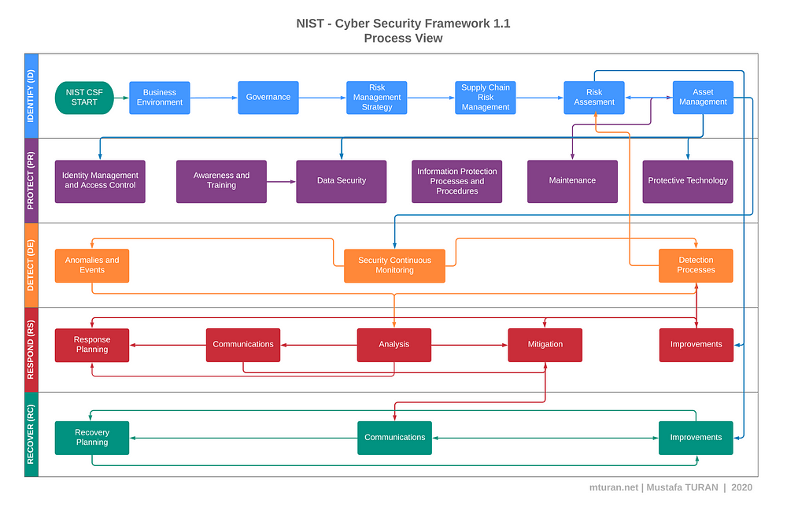Figure 1. NIST CSF Data security management process flow [3]

The NIST CSF is an all-encompassing and risk-focused framework, offering convenience to organizations across diverse industries. Developed by a U.S. government agency, it is particularly well-suited for organizations based in the United States. Nevertheless, multinational enterprises venturing into the U.S. market may also find value in considering NIST CSF or ISO/IEC 27001: 2013 for their overarching cybersecurity needs [3].

ISO / IEC 27001: 2013-2015
The International Organization for Standardization (ISO) has crafted and disseminated an exemplary framework that holds universal appeal for enterprises of diverse dimensions and industries. Comparable to the illustrious NIST CSF, this framework enjoys global recognition and reverence [4]. ISO 27001, in its essence, is devoted to safeguarding the sanctity of information within organizations, focusing on the pillars of confidentiality, integrity, and availability. Rooted in the principles of risk management, the ISO approach entails meticulous exploration of vulnerabilities followed by systematic remediation.
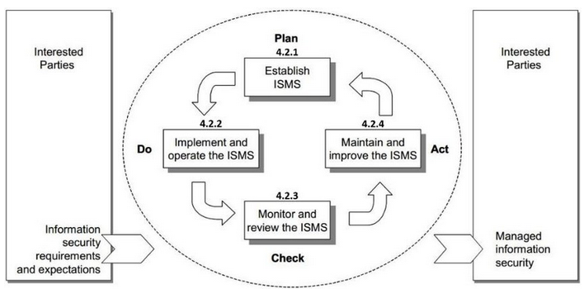
Figure 2. The ISO 27001 Data security management process flow [4]

The ISO/IEC 27001 Standard has become an indispensable tool for organizations, having been in existence for 15 years since its publication as an ISO standard in 2020. AENOR, a trusted certification body, has been chosen by over 500 esteemed public and private organizations worldwide to verify their (cyber) security management system, adhering to the guidelines of ISO/IEC 27001 [4].
The astute handling of cybersecurity enables the assurance of three vital principles: Confidentiality, guaranteeing exclusive access to authorized individuals; Integrity, ensuring precision and entirety in information and its processing techniques; and Availability, granting authorized users the necessary access to information and its associated assets. Furthermore, it facilitates adherence to legal obligations, encompassing the safeguarding of personal data and intellectual property [4].

COBIT: Control for Information and related Technology
The renowned ISACA, a global non-profit dedicated to IT governance, is responsible for the creation of the esteemed COBIT framework. This framework bears resemblance to other esteemed frameworks such as NIST and ISO, making it a versatile choice for organizations of all kinds. With a strong focus on both business and process, it provides a comprehensive and invaluable guide for IT control and supervision. Within its vast array of resources lies a treasure trove of references, including control objectives, audit maps, implementation tools, and a management technical guide, elegantly depicted in Figure 3.
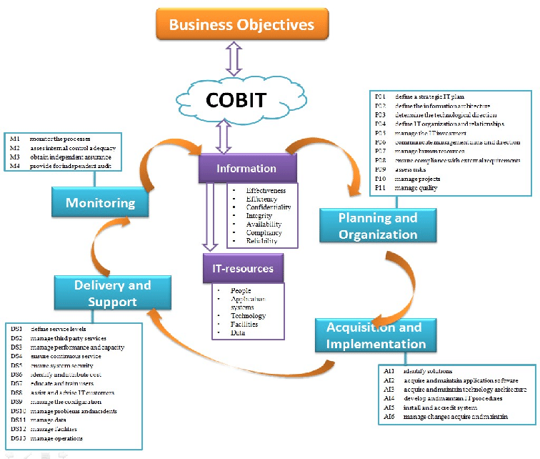

Figure 3. COBIT Framework for data security management in Corporates [5]

The IT Processes employing COBIT, as seen in Figure Created in each of the four categories 1.4. COBIT IT goals: COBIT outlines good practices for managing and running computer systems, including processes, methodologies, and control objectives. Organisations that use the approach show a greater capacity to offer their customers high-quality services. PO 1 is to design a strategic IT strategy; PO 2 is to create the information architecture; PO 3 is to decide on the technological direction; and PO 4 is to create the processes, organisation, and labour relations. PO 5: Putting IT investments to work PO6: Explain the management's objectives and philosophies PO 7: control IT personnel PO8: Quality Management PO9: Risk Assessment and Management PO10: Project Management [5].

HITRUST CSF (Health Information Trust Alliance
The illustrious Health Information Trust Alliance (HITRUST) crafted the renowned HITRUST CSF, which stands as the preeminent safety framework embraced by the health industry in the United States. Originally conceived to address pertinent aspects and inherent vulnerabilities within the health sector, notably including the esteemed Health Insurance Accountability and Portability Act (HIPAA), the CSF has undergone subsequent enhancements to encompass more comprehensive controls applicable to organizations at large [6].

Table 1. HITRUST CSF for Corporate data security [6]
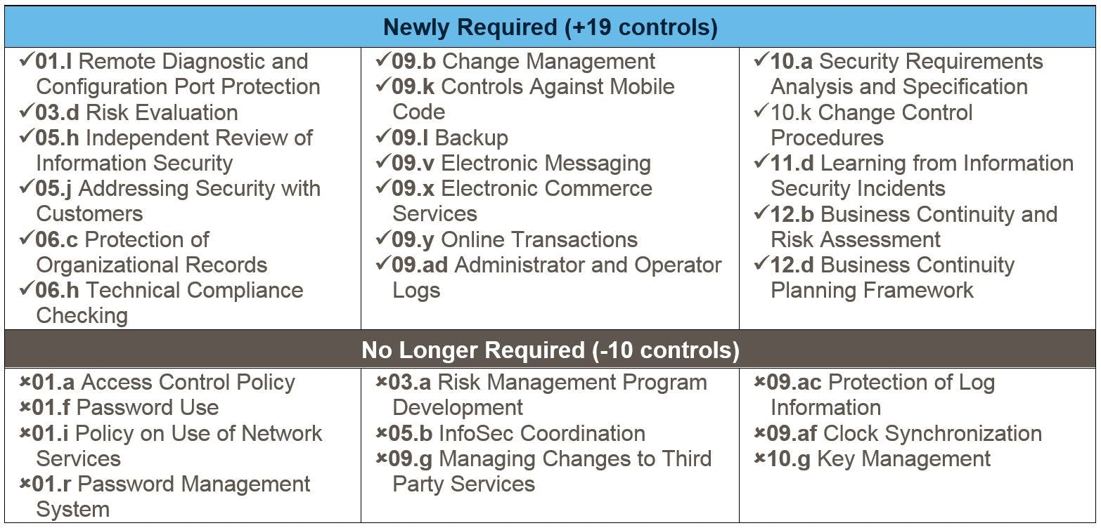
From Table 1, Version nine of HITRUST CSF includes several new regulatory requirements and industry frameworks, the most notable of which is the ability to complete a NIST Cybersecurity Framework (CsF) assessment [6]. The NIST CsF assessment enables an organisation to evaluate against 185 control requirements that are required to address the NIST CsF Core Subgroups and align with HITRUST CSFTM control requirements. As cybersecurity continues to be a highly scrutinised area for all organisations, regardless of size or industry, the addition of the NIST CsF assessment option will probably to be the most worldwide applicable and relevant of the changes incorporated into version nine [6]. The HITRUST CSF, a dynamic and ever-evolving risk-based framework, boasts the remarkable ability to accommodate a wide array of organizational characteristics such as type, size, and systems, alongside regulatory demands [6].
CSA Cloud Controls Matrix
The Cloud Security Alliance (CSA) has developed the Cloud Controls Matrix specifically for cloud providers. This framework addresses the unique risks associated with data storage in the cloud and establishes necessary security controls. The matrix is regularly updated and applicable to cloud providers of all sizes. Organizations heavily reliant on cloud providers can also utilize this resource to assess their providers' safety. The CSA Cloud Controls Matrix offers a comprehensive set of controls aligned with the Cloud Security Alliance guide across 13 domains. Please refer to Table 2 for the specific details of the CSA Cloud Controls Matrix v3.0.1.

Table 2. CSA Cloud Control Matrix v3.0.1[7]
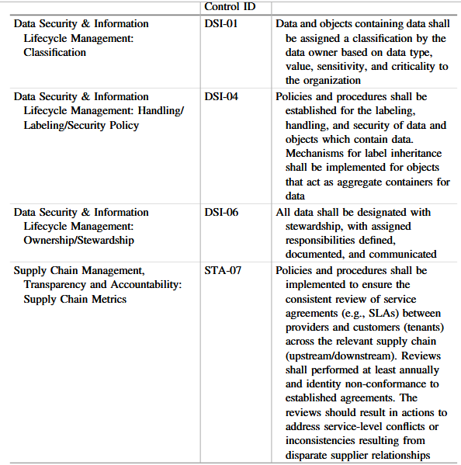
The CSA CCM enhances and fortifies the current information security control systems by prioritizing the business's specific requirements in terms of information security controls. Moreover, it effectively minimizes and detects potential security threats and weaknesses within the cloud infrastructure. Additionally, it offers a uniform approach to managing security and operational risks, while also striving to establish a common understanding of security practices, classification, and cloud-related terminology [7]. It is important to note that while certain frameworks may be suitable for particular organizations, there is no singular alternative that universally fits every company. The chosen strategy may vary based on the organization's clientele and its envisioned future growth [7].

Design Approach for Data Security, Governance and Compliance for NatureGarden
Given the above research on data security, governance, and compliance and since NatureGarden (NG) has an international presence, which requires it to manage its staff and customers, as well as other business transactions, a new approach using ISO/IEC 27002:2013, 2015), NIST guidelines, and CSA Cloud Controls Matrix is designed. This CSA Cloud Controls Matrix, ensures that NatureGarden (NG) uphold data security while using effective governance practices to ensure its cloud transactions comply to international data security standards [8].

Requirements of Security General for Applications Standard
As we have seen in the control frameworks for cloud governance standards such as ISO 27000 (ISO/IEC 27002:2013, 2015), NIST guidelines (NIST special Publication 800-146, 2012) and CSA Cloud security matrix as referred to the design and development of applications that are applicable to the implementation of the security of this Applications [9]. The approach will be divided in three big blocks the requirements of security for the applications that we want to deploy in a virtual environment, architecture security and bastioned, authentication and authorization, and monitoring and audit.
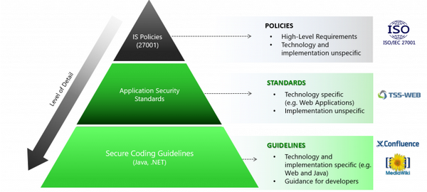

Figure 4. Requirements of Security General for Applications Standard [13]

Architecture of security and bastioned
Segmentation
  - Limiting access to assets by restricting which sources can to access to the equipment.
  - The frontal they will be protected by firewalls, and the communication of frontal and backend will be protected by a firewall too.
  - To access the assets it will be done through a front that authenticates to users, so that the backend is not directly exposed to users finals.
  - Establish filtering mechanisms to ensure separation between interfaces.
  - In case of the require connectivity with Internet:
    - A Frontal Extranet will be able do it directly
    - A Backend will require do it to through of a proxy, and only allow outbound traffic.
    - A Frontal intranet No will be able to access to Internet
Bastioned
  - The equipment on which the system or service will be deployed must be correctly basted, using Bastioning Guides of some reference body such as the CCN-CERT (CCN-CERT, 2020), CIS (CIS, 2020), NIST (NIST special Publication 800-146, 2012).
Security of the data and the communications
  - Personal or sensitive data must be encrypted, both when are stored as during their transmission, taking into account the process that is being done with the data, if it is being stored, interchanged or operating with he.
  - The use of the SHA-2 and SHA-3 digest functions is allowed for the generation of firms digital.
  - For the generation of keys, tokens of session either any other parameter cryptographic a pseudorandom number generator will be used cryptographically secure [11].
  - The algorithms of cryptography of clue public allowed are:
    - RSA with keys of further of 2048 bits.
    - RSA-PSS for signature digital.
  - Code the communications for guarantee the integrity, employing protocols insurance as SSH-2 and TLS (TLSv1.2 either TLSv1.3). (Mozilla SSL Configurator Generator, 2020). In the event that communications protocols offer the possibility to negotiate the use of security (e.g. STARTTLS options of SMTP either FTP), it will require to carry out a secure connection by flaw.
  - In the distribution of PKI certificates, these certificates have must be sent along with the complete certificate chain, including the authority certification root.
  - If public certificates are used, it will not be necessary for the chain of certificates include the authority root certification.

Authentication and authorization
ID
  - Provide to access to the assets to the users for whose use have been specifically authorized.
  - The Access, they must be realized with user nominal with the permissions necessary for can play the task that have entrusted.
    - It is responsible of the process automatic will justify and will document the need of saying user with privileges
    - The user will have a time of expiration lower to 3 months, and they will renew of the responsible of the user privileged.
    - Assign the permissions necessary for carry out the operations necessary controlling the origin by IP.
    - Will apply the solution of a second factor of authentication (2FA) in the following cases:
    - To all the Applications with information sensitive.
    - Systems based in Single Sign-On (SSO)
    - Access of administrators
Policy of passwords
  - The passwords only will be able transmit by a half sure.
  - For ease he use of managers of passwords, none system either service must prevent password pasting.
  - Passwords must have a minimum length of 8 characters (recommended 12) and must contain at least one number, one letter capital letter and other lower case.
  - Spaces should be allowed to encourage the use of passphrases. (passphrases). Likewise, it must allow the introduction of characters specials (_*+-$, etc.), although No will force your use.
  - It must allow passwords of until 64 characters.
  - Passwords may not include easily accessible data about the user (NIF, name,).
  - User accounts with an administrator profile and user accounts user privileged they must have passwords different each a; are Passwords must consist of a minimum of 16 chosen characters randomly and be formed by capital letters, lowercase and numbers.
  - Passwords for user accounts with an administrator profile they must be stored of manner encrypted in a manager of passwords.
  - The passwords they must expire in a cycle definite of 75 days.

Authorization
  - The permissions of access to the different parts of the application it must be managed based on roles or profiles, which must also be documented.
  - The minimum necessary permissions must always be configured to prevent unauthorized access and users must have a profile different access depending on the actions they are going to perform, following the principle of privileges minima.
  - The application you must ask for a new authentication either the use of a second factor authentication (2FA), before allowing the performance of an operation especially sensitive.

Revision of privileges of access
  - All access by a user to any application they have access to access must be revoked at the time the user cancels or that no longer need access to asset.
  - User identifiers that meet a period of inactivity of 60 days will be disabled and an additional 30 days will pass from the date of deactivation without that exist none claim, he identifier be erased.

Audit and monitoring
Record of logs of security
  - Both the accesses (successful and failed) and the relevant actions of user (both at the application and operating system level) must check in and be sent he corresponding log to a platform SIEM.
  - The logs of audit they must to register the following information:
    - The activity of the administrators.
    - The Access of the users, so much the satisfactory as the failed.
    - The changes in the parameters of setting.
    - The activation/deactivation either changes in the setting of the mechanisms that generate the logs.
    - Audit log generation mechanisms will not allow that the users can modify the registers of audit.
    - All assets must be synchronized by NTP with a clock source authorized.
Monitoring of alerts of security
  - The activity logs sent to the SIEM must allow the configure alarms about the activity of the users and the administrators.
  - Must provide of alarms about the activity anomalous of the users and managers (unauthorized operations, repeated attempts to failed accesses, accesses, mass queries, etc.), as well as the actions that he service either system is definite as critics (drop of a system, mistake, etc.).

Requirements of Security General for Cloud
As it further common in the Applications that it is deployed in environment of cloud public that use technologies of containers and orchestrators and others associated platforms. This plan defines a guide of basic requirements for security for deployment having in account always that the requirements mentioned in the previous section also apply to this one. Since the approach focuses on the security architecture and bastion of the containers already that for the management of users and the traceability and monitoring will continue applying the previous requirements [12].
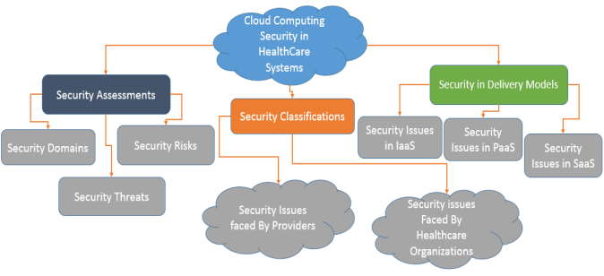
Figure 5. Requirements Security General for cloud systems [10]

Architecture of security and bastioned
Segmentation
- namespace must be used for each project, application and around.
- In each namespace pods will be created separating Backend functions (data and logic of business) and access front.
- Container management must be carried out using the tools and commands that offers, and No deploying server SSH inside of the container.
User must use the flag --uts=host, for guarantee the segmentation between the cloud system and machine hostess to level of namespace.
- No cloud server must use the flag --userns=host.
- For communications between different projects of different topologies will have to be done through a firewall, understanding by a firewall an element that provide the following capabilities:
  - Filtered out of packages depending of origin, destination, port
  - Discard of packages malformed
  - Stateful Inspection.
  - Inspection of packages.
  - Validation of protocol.
  - Control of management of changes.
  - Validation of modification of rules.

But they are projects of the same topology, the communications between pods, they must be realized doing use of the functionality of the platform called “Network Policies”.

Critical analysis on good practice on having updated data security regulations and standards
The results of not complying with the updated or novel data security, governance, and regulations are equivalent to fines in the millions of dollars. It is essential for international companies such as NatureGarden to assess their own risk and understand what it needs to do. Aside from fines, leaking confidential information results in financial and legal losses, and even reputational damage [14].
A review of data security regulations are applicable to the line of business of international companies is in. There are regulations that change by type of business and by type of industry. There updated regulations are tailored to specific business characteristics based on changing times, cloud technologies, change in corporate governance processes, as well as customer data security needs [15]. For example, since NatureGarden is an international company, there are foreign exchange market, there are regulations that are tailored to that specific characteristic. After doing this fundamental review, it is important to evaluate the risk and this must be contemplated in the company's information management policy, processes and controls. It is essential to understand how that the company's information policies can be validated in audits to ensure that the regulations are being complied with.
For both consumers and businesses, losing credit card or personal information can have disastrous consequences. Businesses should consider information protection to be morally just and essential to guaranteeing the security of their clientele. Nevertheless, there are laws that compel them to do so even while they disagree. Similarly, company policies should be regularly updated, and the degree of risk modified to suit the demands of the business [16].

References
[1] Kohnke, A., Shoemaker, D. and Sigler, K.E., 2016. The complete guide to cybersecurity risks and controls. CRC Press.
[2] Yvon, T., 2020. Exploring factors limiting implementation of the national institute of standards and technology cybersecurity framework (Doctoral dissertation, Colorado Technical University).

[3] Mustafa Turan. 2020. NIST Cybersecurity Framework Process Structure. [Online]. Available at: <https://medium.com/@musttrn/nist-cybersecurity-framework-process-structure-e847e7a45829> Accessed on 11-December 2023
[4] Proença, D. and Borbinha, J., 2018. Information security management systems-a maturity model based on ISO/IEC 27001. In Business Information Systems: 21st International Conference, BIS 2018, Berlin, Germany, July 18-20, 2018, Proceedings 21 (pp. 102-114). Springer International Publishing.
[6] Bakertilly. 2017. HITRUST CSF™ Version 9: updates and impacts for certification. [Online]. Available at: <https://www.bakertilly.com/insights/hitrust-csf-version-9-updates-and-impacts-for-certification> Accessed on 11-December 2023
[7] Formoso, S. and Felici, M., 2016. Evidence-based security and privacy assurance in cloud ecosystems. Privacy and Identity Management. Time for a Revolution? 10th IFIP WG 9.2, 9.5, 9.6/11.7, 11.4, 11.6/SIG 9.2. 2 International Summer School, Edinburgh, UK, August 16-21, 2015, Revised Selected Papers 10, pp.205-219.

[8] Tabrizchi, H. and Kuchaki Rafsanjani, M., 2020. A survey on security challenges in cloud computing: issues, threats, and solutions. The journal of supercomputing, 76(12), pp.9493-9532.
[9] von Solms, R. and Willett, M., 2017. Cloud computing assurance–a review of literature guidance. Information & Computer Security, 25(1), pp.26-46.
[10] Khattak, H.A.K., Abbass, H., Naeem, A., Saleem, K. and Iqbal, W., 2015, October. Security concerns of cloud-based healthcare systems: A perspective of moving from single-cloud to a multi-cloud infrastructure. In 2015 17th international conference on E-health networking, application & services (HealthCom) (pp. 61-67). IEEE.
[11] Mengdi, Z., Xiaojuan, Z., Yayun, Z. and Siwei, M., 2021, March. Overview of Randomness Test on Cryptographic Algorithms. In Journal of Physics: Conference Series (Vol. 1861, No. 1, p. 012009). IOP Publishing.
[12] Kumar, R. and Goyal, R., 2019. On cloud security requirements, threats, vulnerabilities and countermeasures: A survey. Computer Science Review, 33, pp.1-48.

[13] Secodis. 2023. Security Standards & Guidelines. [Online] Available at: <https://www.secodis.com/security-requirements/?lang=en#> Accessed on 11-December 2023
[14] Sharma, N., Oriaku, E.A. and Oriaku, N., 2020. Cost and effects of data breaches, precautions, and disclosure laws. International Journal of Emerging Trends in Social Sciences, 8(1), pp.33-41.

[15] Marelli, M., 2023. The law and practice of international organizations’ interactions with personal data protection domestic regulation: At the crossroads between the international and domestic legal orders. Computer Law & Security Review, 50, p.105849.

[16] Jobin, A., Ienca, M. and Vayena, E., 2019. The global landscape of AI ethics guidelines. Nature machine intelligence, 1(9), pp.389-399.

