

MODULE CODE: ACCC5000
CLOUD COMPUTING TECHNOLOGIES
ASSESSMENT TYPE: REPORT
ANUPAM MAZUMDAR

Name: Octavian Cristian Libotean
ID: 1815958
Mail: 1815958@student.uwtsd.ac.uk
Table of Contents
Introduction about Cloud Computing 2
Essentials characteristics and benefits 2
Service models and available real-world services 3
Deployment Models and Recommended model 4
Recommendation 7
An Explanation of Virtualization in Cloud Computing 8
Migration strategies of cloud computing 10
Concerns of Security 11
Essential Steps for implementing SaaS (Software as a service) 13
References 15

Introduction about Cloud Computing
Today is the generation of Cloud Computing Technologies in the Information and Technology Field. Cloud Computing is the most powerful architecture of computation which is work on the internet. Cloud computing is key for enhancing the field of the IT Industry. In this generation, all user wants the security, flexibility, and availability of data at any point. So, they use the cloud platform and it will be preferable for London Bikes Ltd. so they can save and access their data at any point and the user has to pay only for the services they had used.

Essentials characteristics and benefits
Characteristics of cloud computing:
- Cloud computing resources are used based on user demand. If a user wants to enhance their resources or any kind of modification so the user requests to the service provider for the modification or other specification, this is called on-demand services.
- The user can access the cloud resources at any time or any place using the good internet. It is the best feature of cloud computing that you don’t need your hardware to access it, this is called Broad network access.
- There are some features in cloud computing that multiple users can share the same application according to their use and still there is no issue of security because the same application differs the different data according to a particular user, this is called multi-tenancy.
- In cloud computing, all the users use the same physical resources and there are no issues because every user access the same platform or the same physical infrastructure and it is very safe for all users, this is called resource pooling.
- Cloud computing technology is very fat according to data because you can use and save your data on cloud and access it accordingly and if you want to delete some data you can delete it very easily, this is called elasticity.
- Cloud storing capacity is very high you can store anything on the cloud but this depends on the cloud provider that what kind of services you are using.
- It also provides high speed internet if you are using one of the best cloud provider services.
- Your data will store in many servers because of failures and backup process so that you can easily restore the data if data will be lost because of some failures [1].

Service models and available real-world services
There are three major services which are provided by Cloud computing:
- Software as a Service (SaaS): Software as a service is used for the independent software that is used by the companies or users. In his service the user demand for a copy of software that he can use for personal or commercial use. There is a service level agreement between customer and cloud provider which defines all the policies according to the service.
- Platform as a Service (PaaS): This kind of service provides you the platform where you can store the data and use it according to your payment policies. Here you have to pay only for those services which you have used. Here we pay for the web application tools and basic operating systems. Here you can use your database according to the payment process. Here you don’t have to build your application you can use provided application and develop anything you want.
- Infrastructure as a Service (IaaS): This kind of service is basically for enterprises that use the server, database, and many services according to cloud policies. So here we use the whole infrastructure provided by the cloud so we don’t have to use any kind of physical things on your link servers or storage. Amazon Web Services was the first IaaS provider and remains the leader and it provides one of the best services [2]. It provides you the machines for your use where you can use specifications that you want like RAM, storage, etc.
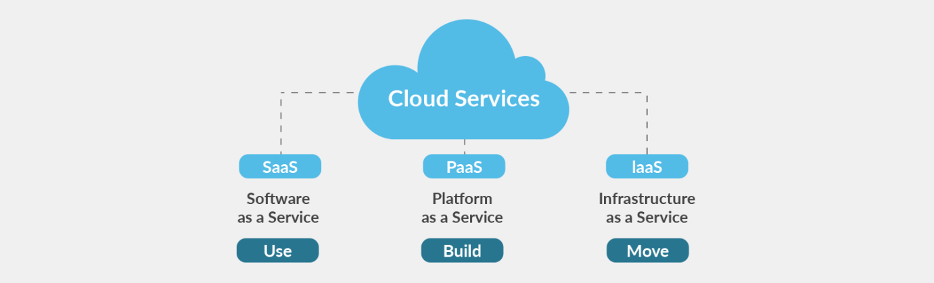
Figure 1: Cloud Service Models
There are some more services which are provided by Cloud Computing:
- Storage as a Service (SaaS): In this service, the small companies take the services of storage from big providers. It enhances their security and reduced their cost. In this services the company has the full support of provider so they can easily access their data and if there any modification in data so they syncing the data with previous data and allows the sharing of data in an online environment from one user to another user and data will be secured that will be the priority of any organization.
- Network as a Service (NaaS): In this kind of service we have the full advantage in network areas like we have full control over bandwidth and data transmission. In every kind of application, the speed of the internet should be fast and the application or infrastructure access time should be short so the user can easily and fast access the services. This kind of services gives full control to any data administrator.

Deployment Models and Recommended model
Public Cloud
This type of model is used publicly for application, storage, and also for machines. A cloud provider provides a more scalable and secure connection for services.
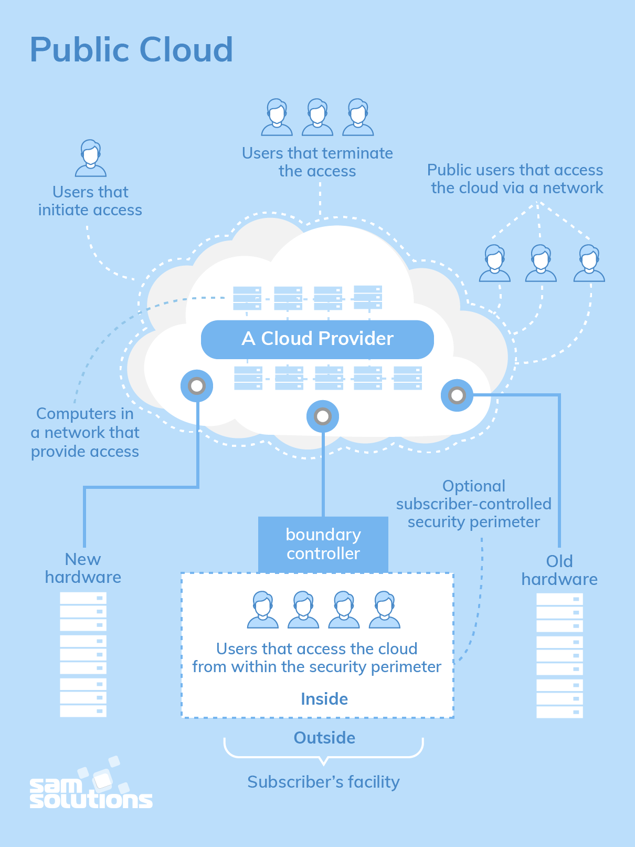
Figure 2: Public Cloud
Advantages of public cloud:
- If you want to move to a public cloud your cost-saving factor will increase because you can use all the equipment of the cloud according to your payment policies so you don’t have to keep any kind of server or storage machines which are very costly [3].
- You don’t have to settle the servers which are very costly and time is taken and there are many problems to set the servers, you need a good technician for this work but if you are using public cloud then you do not worry about it.
Disadvantages of public cloud:
Data security is a main issue in the public cloud. Public cloud is not so secured like other deployment models because the security of data if the first concern of any organization so this kind of model is not preferable for any company.

Private Cloud
In this type of model, the services or infrastructure provided privately. This is the most secure deployment model and every company wants to use its services. But because of their best services in terms of security, the private cloud is so expensive for some companies. Small companies can’t afford the private cloud services. It gives more control and managed services to any company. It is the best deployment model.
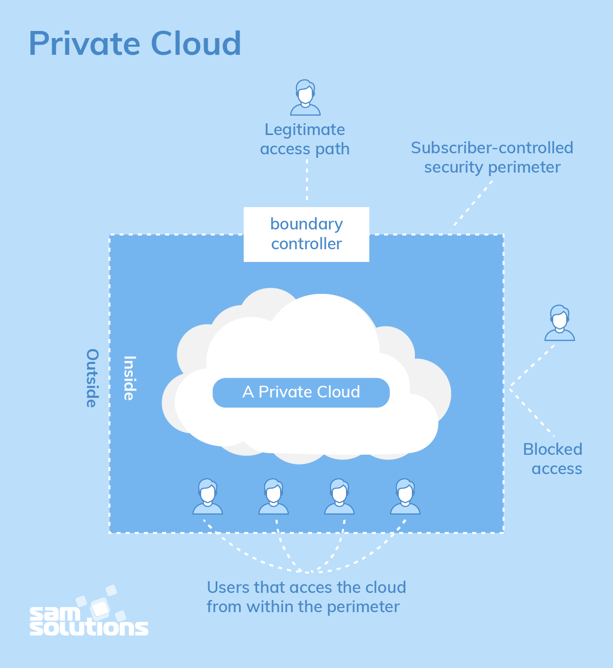
Figure 3: Private Cloud
Advantage of Private Cloud:
- It is the most secure cloud because of its security it is most reliable among the company.
- It gives you full control and authorization to the resources you used.
Disadvantages of Private Cloud:
There is only one disadvantage of a private cloud that the small companies can’t afford its services.
Hybrid Cloud
In this type of cloud, we have used the services of both types of public and private. It is much secure than a public cloud bout less secure than a private cloud. Most of the companies used this kind of cloud because it gives good security to its data and it is not worthy so every company can use their services without hesitation [4].
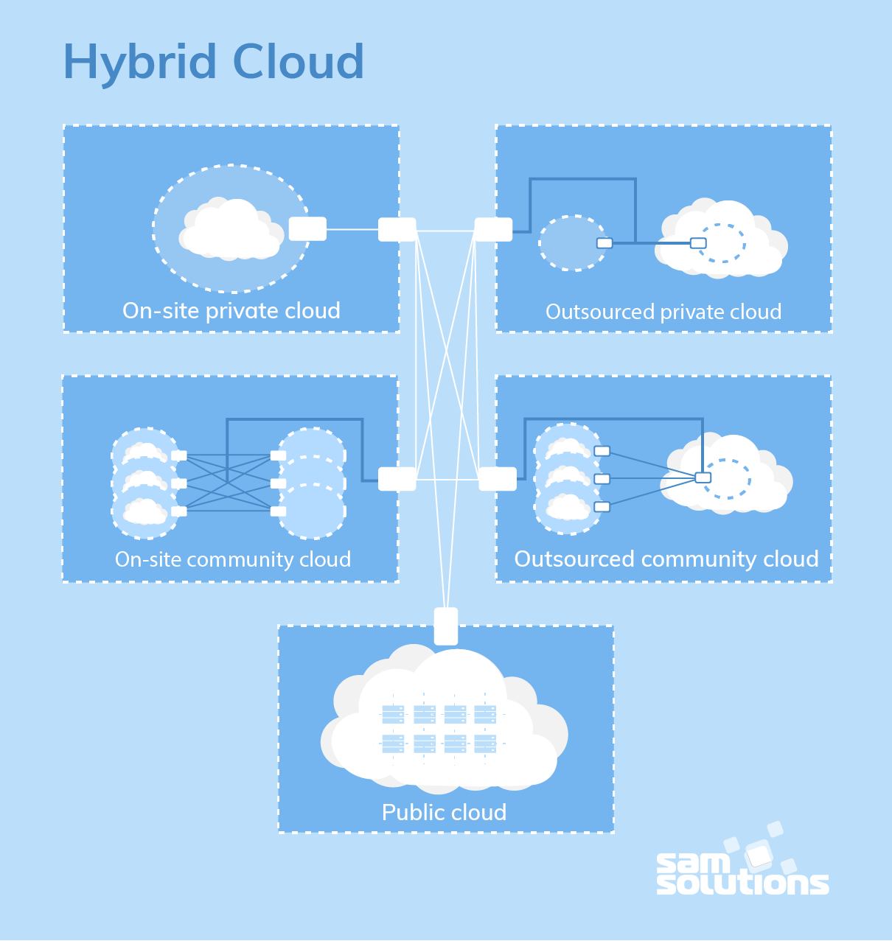
Figure 4: Hybrid Cloud
Advantages of Hybrid Cloud:
It is given good security and it is not so costly so the small companies can rely on this kind of cloud.
Disadvantages of Hybrid Cloud:
There are some issues with the security of data. You can’t use the hybrid cloud for defence and security purposes.

There are some cloud application examples which are using by the daily purpose:
- Google Drive: This is also a service of cloud computing where all the data of this app is stored online so we can use it easily like Google Docs, Sheets, and Slides. It is not only on desktop but you can also use that app in tablets, phones, and android phones and for that, they have different apps. There are many services of google which are using cloud computing technology.
- Apple iCloud: Apple cloud is a different type of cloud which stores only iPhone user data like contacts, calendar, and more. You can store all kinds of data into the cloud and retrieve it when you have used that data. Apple products are very expensive but its storage process is very easy and you can store anything you want. There is another option in iPhones that if your phone is stolen then you can find it by using some iPhone application which is based on cloud computing.
- Dropbox: This is an application that is used previously but now there are many file synchronization apps and mail apps, but this app is also used in cloud computing technology [5].

Introduction about Project
Here we want to deploy the database on the cloud of a company whose name is London Bikes Ltd. They provide bicycles specific for city riding but also take custom orders based on their customer requirements. They are hosting a website internally and they have also a managed Database system for customer accounts, order, and billing. They have good staff strength around 150 and they give them good payroll. But now they want to deploy their database on the cloud and improve their customer and staff services using cloud services.

Recommendation
I strongly recommended the Hybrid cloud or private for London Bikes Ltd. because the main issue is data privacy which is not resolved with public cloud because there are chances that your data can be leak and privacy is better in the private cloud but it is very expensive for a small company so I suggest that Hybrid cloud is the best choice for London Bikes Ltd. There are three types of service models which we defined earlier but for our London Bikes company, the SaaS (Software as a System) is best because firstly they want to store the data on the cloud so they can easily access and secured the data. So, in this model, the cloud provider sets the software for the company customers and staff so they can remotely access the software.

An Explanation of Virtualization in Cloud Computing
Virtualization in cloud computing is used to create a virtual environment where we can use the storage devices and server operating systems according to use. Cloud virtualization manages the workload and makes the co putting more scalable and efficient. The main use of virtualization is you can use multiple machines at the same time and you can share your resources using virtualization.
Virtualization is used for companies so they can share applications for their customers and their employees by using a single physical instance. Virtualization creates an environment that may be public or private. By using virtualization, we can maximize the resources of a system and reduced the physical instances so that can be more flexible and reduced the cost of a company. For our company of bikes, we can use virtualization and reduce our physical instances [6].
In cloud computing, there are some types of Virtualization:
Operating System Virtualization: Here we used a virtualized operating system that will be host by another instance and we don’t need to use other hardware for this. By using the virtualization, we test the application on different machines.
Server Virtualization: Here we install the application directly on the server. By using this virtualization, we can divide the one physical server into many servers so this is called server virtualization and balance the load of the server accordingly.
Hardware Virtualization: In this virtualization, we install the machines on hardware It is used in server machines so we can use the virtual machines which are created by the server.
Storage Virtualization: Here we create a grouping of physical storage with multiple storage devices. Storage virtualization is used for the storage process where you can access the data from different servers. Your data copy will store in every virtualized server so you can access it from anywhere.
Virtualization in Cloud Computing: In virtualization, if we need a cloud platform so we ask the cloud provider so they can provide their resources with us and the provider server and the software application. For this work, we pay to cloud providers. Here we can share the data with other users with the help of virtualization [7].
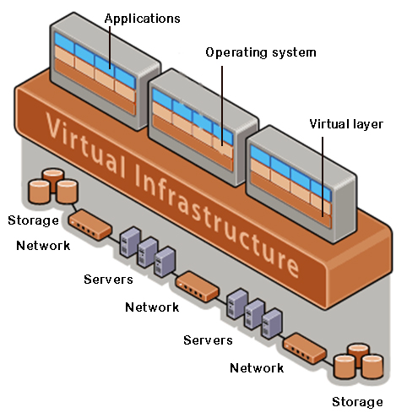
Figure 5: Types of Virtualization
Benefits of Virtualization:
- Security: Security is one of the main concerns when we used virtualization or any kind of cloud platform. Cloud provider used firewalls and many security equipment or software which decline the unauthorized access to the data. The data should be safe by any other kind of cyber-attack and viruses. The cloud provider also used the encryption process for the security of data that will protect the data when it is fetched and store by the user. And there is always a recovery process for data so if the data will be erased by mistake it will be fetched by cloud storage.
- Flexible Operation: It is very flexible to access the data and switch the network accordingly uses choice. There will be no harm to the data. By using virtualization techniques, we can solve a technical problem in the physical systems.
- Economical: Virtualization way better than more physical instances so the cost will be decreased by using virtualization and save another type of cost like hardware.
- Eliminates the risk of system failure.
- Flexible transfer of data

Migration strategies of cloud computing
Cloud migration is a process in which we move our business or company to the cloud. In cloud migration involves moving data from one datastore to another datastore and all the applications and IT processes are also moved this is called cloud migration. In cloud migration, we can move to one cloud to another cloud.
If we want to create our cloud, we need an infrastructure that includes servers, networking equipment, application, database, and much other hardware equipment. Our bicycle rental company is not that big so we may not update our infrastructure. So, we use other cloud providers to deploy our software and database to the cloud [8].
Benefits of migrating to the cloud:
- Scalability: cloud computing can set a large amount of data migration of any kind of support and enhancement in the server.
- Cost: Companies can reduce their cost by migrating their company into the cloud because there is no cost for extra hardware you can use virtualization for reduced cost of physical equipment.
- Performance: By migrating the company to the cloud you can easily access the data and software so the customer and staff can do their work easily and the performance will be better than previously.
- Flexibility: The customer or employee can access the data from anywhere. It makes it easier for a business for expanding its services and customers will be satisfied with your services.
Problems of migrating to the cloud:
- Migrating a large database: Data migration is a very tough work to do because sometimes the data will be too large so we can’t upload the data directly through the internet so some providers take the help of physical appliances to move the data from one place to another place.
- Data integrity: After data transfer, we have to check that there is no error in the data and data should be secured so that its integrity.
- Continued operation: The company needs to ensure that the time of migration of data we can do our work otherwise there will a big loss for the company.
Steps of cloud migration:
- Establish Goal: Ensure the dates of migration and what type of migration situation wants.
- Create security options: cloud cyber-security needs some different approaches for run time security. So here we deploy the cloud firewall in the system or a web application firewall which is necessary.
- Data replication: Here we replicate the existing data to a cloud provider. This should be done throughout all the migration process so the data will be secured.

Concerns of Security
There are some threats when we moving to the cloud:
- Consumers have reduced visibility and control: When we transfer the data to cloud providers, we lose some visibility and control over those operations on data. The responsibility of policies and infrastructure moved to the cloud providers. So that is a threat that we can access the data but can’t handle the data.
- On-demand self-service simplifies unauthorized use: There are many risks according to unauthorized use. Due to the lower cost and easy implementation, anyone can use your access and change your credibility so when you move to another cloud check the appropriate cloud provider and its policies otherwise your data will be lost.
- Internet management API can be compromised: Cloud providers define some application programming interface for the customer use which is for interaction use with cloud services. If there is any loophole in these APIs then there is a chance that it can be changed or threatened of losing data. By using these APIs, we monitor the data and our customer credibility.
- Separation among Multiple Tenants Fails: When an application supports multi-tenancy then there is a threat to the application that some failure has occurred when it works with multi-tenancy. This failure can be used by an attacker to fetch the data so it is a big threat for multi-tenancy applications [9].
- Data deletion is incomplete: There is a threat that if we erased some data from the database there is no proof that your data will be deleted because you don’t know that where your data will be store. There are many servers where the data will be stored because of failure issues so that is a big threat for customers.
- Credentials are Stolen: When we use the cloud application there may be a chance that when you access the data by confirmed your credentials at that time some attacker stolen your credentials and then they used your credentials to erase the data. So, there should be a good firewall in the cloud system. The cloud provider administrator has access to cloud network applications and systems but the company administrator can only access the cloud implementation.
- Vendor lock-in complicates moving to other Cloud providers: There is an issue when we want to change our cloud provider and move to another cloud there are some problems in this because our data will be secured but the first cloud provider consider some other API, and encryption but other cloud does not recommend that things so there are many issues in this.
- Increased Complexity in IT operation: When we move to the cloud the operations are much complex than before. Because key management and encryption become more complex. The monitoring of data, operation, and services become complex because some new policies will we added when we move to the cloud because of the data security and flexibility. But if you have good IT staff then you have no problem because IT staff have the capacity and skills to manage, integrate, and maintain the migration aspects. In the hybrid cloud, there are some more complex than other deployment models [10].
- Insider abuse authorized access: There are very least chances of break the security when we use good cloud platform but there is a chance that someone in IT staff has unauthorized access to data then there is a chance for data leak because that member can change the access or change the settings of application which may be a big problem for the company or cloud provider.
- Loss of data: Sometimes data stored in the cloud can be lost without malicious attack. There are some reasons like fire, earthquake can lead to the destruction of data sometimes when we encrypted the data by encryption key and we lost that key then nobody can fetch the data or decrypt the data, so that can be a reason of data loss.
- The supply chain is compromised: The cloud provider has the infrastructure and the chain of maintenance which is used by company and third party so if the chain will be compromised then there is a threat for the company that the data will be lost by the provider and the provider have the threat about his infrastructure.
- Insufficient security measures increase cybersecurity risk: When a company moves to the cloud using the cloud provider guidelines without understanding its policies then the threat will increase because we did not know about the security and monitor operation of that cloud provider. So, if you want to move to the cloud then you have to read all the policies and check its security parameters.

Essential Steps for implementing SaaS (Software as a service)
- Understand the business requirement: We have to understand the requirements of our business or company. First, our company name is London Bikes and it is a rental bicycle company which gives the customers bicycles for a city trip and give more facilities according to customer requirements. We need an application for a customer in which he can check the availability, price, and other specific details about a particular bicycle and he can book the bicycle by using that application so that company enhances its customer and the growth rate of the company will be increased [11].
- Identify the team to take on the task: The team should have great knowledge about SaaS implementation.
- Design a scalable infrastructure: The design of infrastructure needs some important parts:
- Data Centre
- Network Infrastructure
- Hardware
- Backup and monitoring tools
These four parts are the essential need of any SaaS platform. In network infrastructure, we check the connectivity and security of data. In hardware, we check both systems and storage. In backup and monitoring tools we check the backup plans and monitor the data flow [12].
When we finalizing decisions on the infrastructure, we must check the following aspects:
- Service Level Agreement (SLA)
- Scalability, performance factor and availability
- Disaster recovery
- Security management
- Customer support and incident reporting
- Network Bandwidth
- Finalize the bandwidth requirement and hosting facility: we need to decide the bandwidth and frequency for network speed because some customers are available at the company but some are outside so we have to test the network. We should consider the following aspects:
- Datacentre should be available 24*7*365
- Testing frequency
- Availability of power, systems and check other hardware
- Physical security of the centre
- Deployment of the SaaS delivery infrastructure: once the components are available then the team should deploy the SaaS components and configured the server and then check the security aspects. Configured the firewall according to the access policy.
- Plan for disaster recovery and continuity: If the application is ready then we need to check the disaster conditions and how we check the application time frames and its complications. There should be a proper plan for disaster recovery.
- Integration of monitoring solution: application monitoring is very important to found the errors and update them. There are the following parameters:
- Memory and CPU usage
- TCP layer, database, application servers, etc.
- Event logs from the application
- Prepare the customer support call centre: Once the application is out on the market then we create a customer support centre for the customer queries.
- Prepare the service level agreement (SLA): SLA should define the response time and application availability and also check the turnaround time [13].

References
- Alam, T., 2020. Cloud Computing and its role in the Information Technology. IAIC Transactions on Sustainable Digital Innovation (ITSDI), 1(2), pp.108-115.
- Bokhari, M.U., Makki, Q. and Tamandani, Y.K., 2018. A survey on cloud computing. In Big Data Analytics (pp. 149-164). Springer, Singapore.
- Bokhari, M.U., Shallal, Q.M. and Tamandani, Y.K., 2016, March. Cloud computing service models: A comparative study. In 2016 3rd International Conference on Computing for Sustainable Global Development (INDIACom) (pp. 890-895). IEEE.
- Dašić, P., Dašić, J. and Crvenković, B., 2016. Service models for cloud computing: Search as a service (SaaS). International Journal of Engineering and Technology (IJET), 8(5), pp.2366-2373.
- Diaby, T. and Rad, B.B., 2017. Cloud computing: a review of the concepts and deployment models. International Journal of Information Technology and Computer Science, 9(6), pp.50-58.
- Gibson, J., Rondeau, R., Eveleigh, D. and Tan, Q., 2012, November. Benefits and challenges of three cloud computing service models. In 2012 Fourth International Conference on Computational Aspects of Social Networks (CASoN) (pp. 198-205). IEEE.
- Huang, D. and Wu, H., 2017. Mobile cloud computing: foundations and service models. Morgan Kaufmann.
- Misra, S.C. and Doneria, K., 2018. Application of cloud computing in financial services: an agent-oriented modelling approach. Journal of Modelling in Management.
- Muzaffar, A.W., Mir, S.R., Anwar, M.W. and Ashraf, A., 2017, March. Application of model driven engineering in cloud computing: a systematic literature review. In Proceedings of the Second International Conference on Internet of things, Data and Cloud Computing (pp. 1-6).
- Odun-Ayo, I., Ananya, M., Agono, F. and Goddy-Worlu, R., 2018, July. Cloud computing architecture: A critical analysis. In 2018 18th International Conference on Computational Science and Applications (ICCSA) (pp. 1-7). IEEE.
- Singh, A., Sharma, S., Kumar, S.R. and Yadav, S.A., 2016, February. Overview of PaaS and SaaS and its application in cloud computing. In 2016 International Conference on Innovation and Challenges in Cyber Security (ICICCS-INBUSH) (pp. 172-176). IEEE.
- Stavrinides, G.L. and Karatza, H.D., 2016, June. Scheduling different types of applications in a saas cloud. In Proceedings of the 6th International Symposium on Business Modeling and Software Design (BMSD’16) (pp. 144-151).
- Suryateja, P.S., 2018. Cloud service models threats and vulnerabilities: A review. International Journal of Computer Sciences and Engineering, 4(3), pp.297-302.

