Matthew Vincent Hatherly

2306287

Computer Architecture and Operating Systems

ACCA4022

Table of Contents
Matthew Vincent Hatherly 1
2306287 1
Computer Architecture and Operating Systems 1
ACCA4022 1
Key Functions of General Operating Systems 3
What are operating systems? 3
User Interface Provision (GUI & CLI) 3
4
Task 1 - Use of Windows OS CLI Commands 7
Task 2 - Use of Linux OS CLI Commands 11
What is Linux? 11
13
13
13
13
13
13
14
Use of Windows OS Scripts 14
Use of Linux OS Scripts 16
Conclusion 18
Reference List 19
Appendix 21
Engagement with 1 certified course 21
What are the different types of operating systems? 22
Mobile Operating Systems 22
Network Operating Systems 22
Embedded & Real-time Operating Systems. 23
AI and Quantum Operating Systems 23

Key Functions of General Operating Systems
In this report, we will go over some of the key fundamentals of operating systems, including the different types of operating systems, as well as Windows and Linux OS CLI commands, and Windows and Linux OS Scripts, as well as a conclusion, reference list and appendix.

What are operating systems?
An operating system is [1] “the program that, after being initially loaded into the computer by a boot program, manages all of the other application programs in a computer.” Some instances wherein you may look to use an operating system could be because “many common tasks, such as sending a network packet or displaying text on a standard output device, such as a display, can be offloaded to system software that serves as an intermediary between the applications and the hardware.” Because of this, we know that operating systems hold a great performance. Generally, there are three essential functions of an operating system. These include the UI, application management and device management.
The importance of the UI is because [1] “every system requires a UI, enabling users and administrators to interact with the OS in order to set up, configure and even troubleshoot the operating system and its underlying hardware.”
The reason why application management is important is because [1] “An operating system handles the launch and management of every application. This typically supports an array of behaviors, including timesharing multiples processes, or threads, so that various tasks can share the available processors’ time; handling interruptions that applications produce to gain a processors’ immediate attention, ensuring there is enough memory to execute the application and its corresponding data without interfering with other processes; carrying out error handling that can gracefully remove an application’s processes; and performing memory management without disrupting other applications or the OS.”

User Interface Provision (GUI & CLI)
CLI stands for Command Line Interface, and this is a [22] “text-based interface used to interact with software and operating system by typing commands into the interface and receive a response in the same way.”
On the other hand, GUI stands for Graphical User Interface, and this is [22] “a visual-based interface which features the use of graphic images, including windows, icons, and menus. A mouse is the most common way to navigate through a GUI, although the keyboard is used sometimes. “Memory and Process Management

Memory And Process Management
The reason why memory management is important is because it [23] “is a method in the operating system to manage operations between main memory and disk during process execution. The main aim of memory management is to achieve efficient utilization of memory.”
In terms of process management, it [24] “refers to the set of activities involved in creating, scheduling, and terminating processes. A process management os can be thought of as an instance of a program that is currently executing on a computer system.”

File System Management.
[25] “File management in operating system is software that handles or manages the files present in computer software. “The operating system’s file system can manage individual and group files present in the computer system.”

Device Management (I/O devices & device drivers)
I/O, which stands for Input/Output, includes devices such [26] “mouse, keyboards, touch pad, disk drives, display adapters, USB devices, Bit-mapped screen, LED, Analog-to-digital converter, Ion/off switch, network connections, audio I/O, printers etc.”
[27] “A device driver is a piece of software that enables communication between an operating system or application and hardware or peripheral devices. It serves as a bridge between the different components of a computer, allowing them to interact with each other.”

System Security & Network Management
[28] “Operating system security (OS security) is the process of ensuring OS integrity, confidentiality and availability.” “OS security refers to specified steps or measures used to protect the OS from threats, viruses, worms, malware or remote hacker intrusions.”
[29] “Network management is the sum total of applications, tools and processes, used to provision, operate and maintain administer and secure network infrastructure. The overarching role of network management is ensuring network resources are made available to users efficiently and quickly. It leverages fault analysis and performance management to optimize network health.”
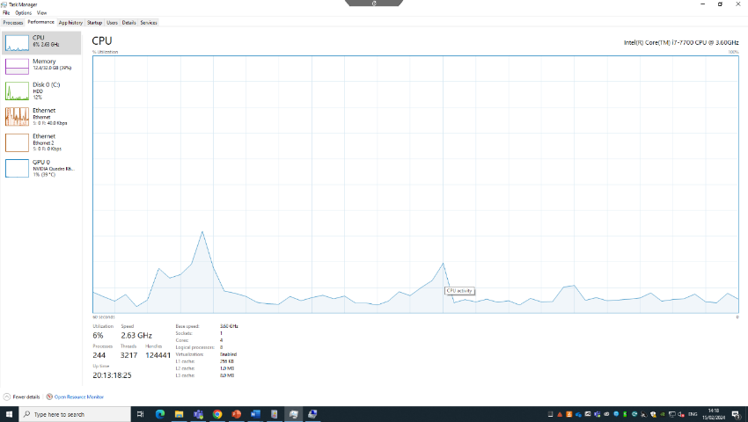

This is the Performance Tab located within the Task Manager. Here you can review the performance of the CPU, RAM, Hard Disk, Ethernet and the GPU. As we can see in the screenshot, there is only a utilization level of the CPU of around 6%, so there is the potential for a lot more to give with this system than what is currently being done.

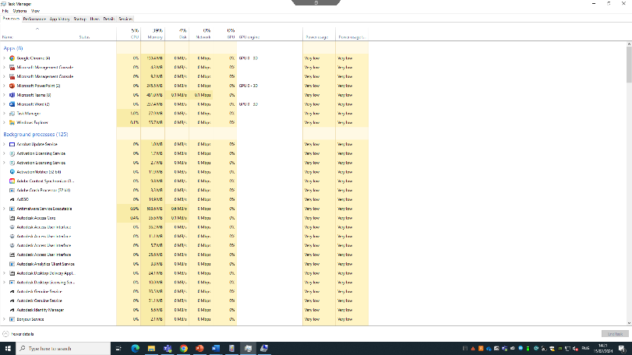

This is the Task Manager Processes tab, wherein you can see the current applications running on the system, as well as how much space they are currently taking up.

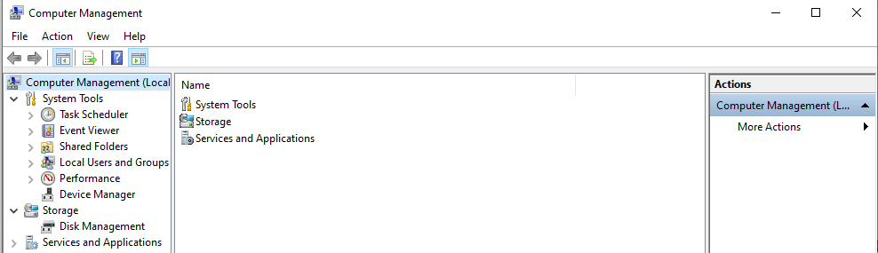

This is the Computer Management tool where you can view a number of different processes including the Device Manager, Performance and Storage.

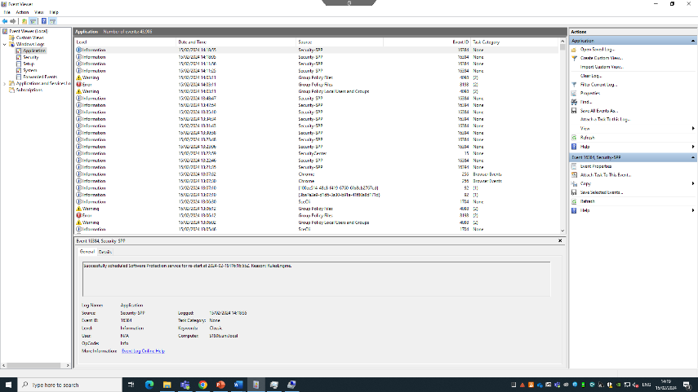

This is the Event Viewer window, on the applications tab, and we can see any potential errors which may have occurred during the running of programs on this system. As we can see from this screenshot.

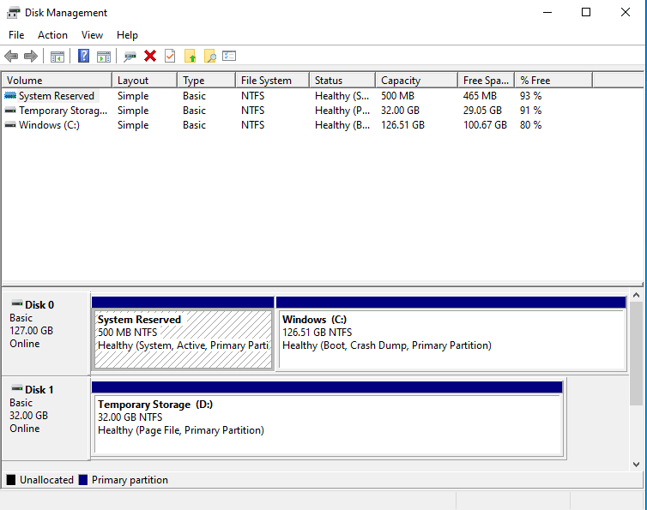

This is the disk management tool, which gives some disk information such as the capacity and the free space.

Task 1 - Use of Windows OS CLI Commands

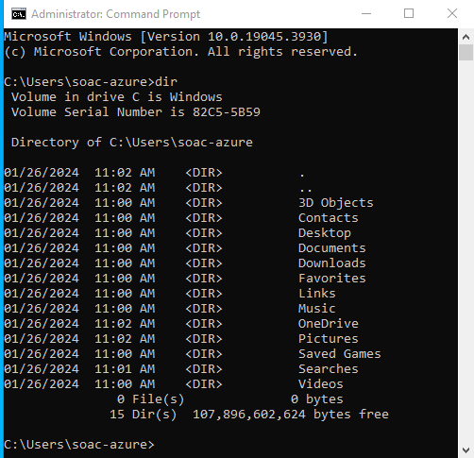

Dir – displays the list of contents in the current directory.

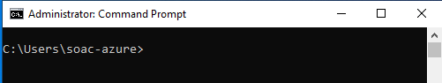

Cls – clears the window.

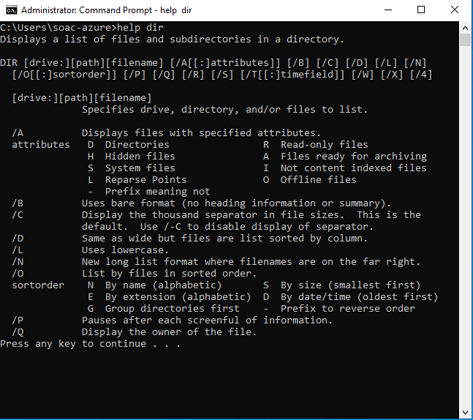

Help – displays a list of commands or help about a specific command.

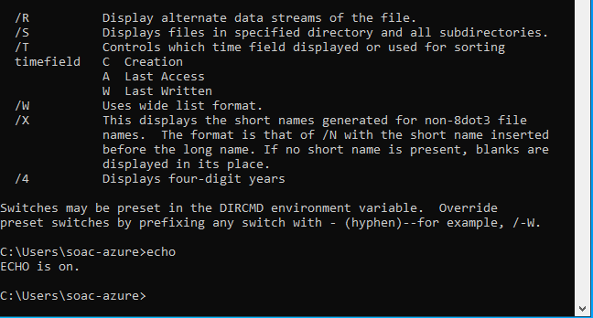

Echo – “Displays messages or turns on or off the command echoing feature.” [11]
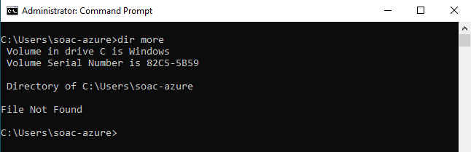

Dir more command – used to output text to the screen, e.g. up to a screen at a time.
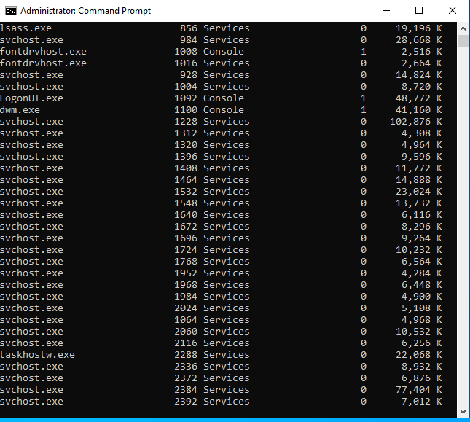

Taskmgr – Opens Task manager from command prompt.

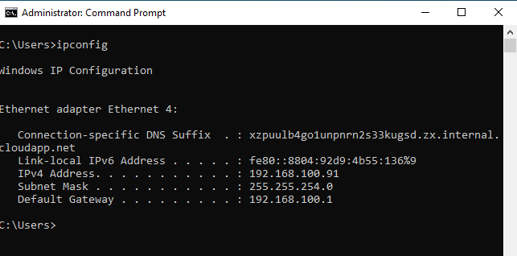

Ipconfig – “used to display information about your network configuration and refresh DHCP and DNS settings.” [9]

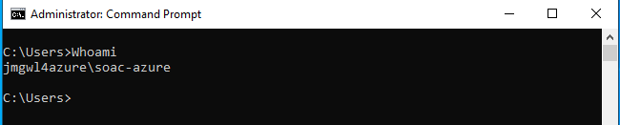

WhoAmI – “Displays user, group and privileges information for the user who is currently logged on to the local system. If used without parameters, whoami displays the current domain and username.” [12]
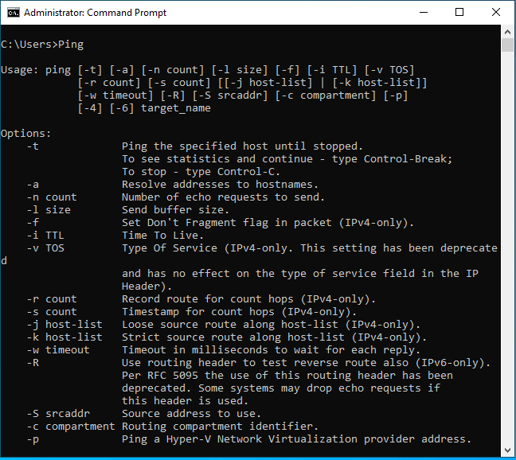

Ping – “Verifies IP-level connectivity to another TCP/IP computer by sending Internet Control Message Protocol (ICMP) echo Request” messages. [10]

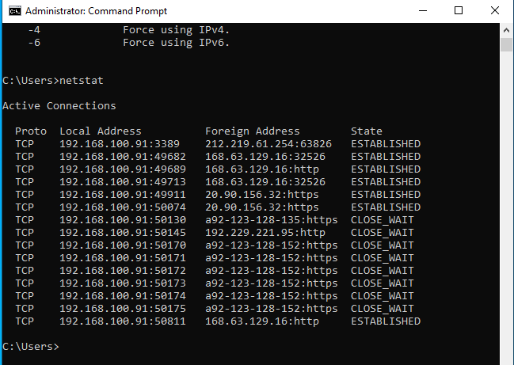

Netstat – Displays network information such as TCP addresses, active connections and listening ports.

Task 2 - Use of Linux OS CLI Commands

What is Linux?
[3] “Just like Windows, iOS, and Mac OS, Linux is an operating system. In fact, one of the most popular platforms on the planet. Android, is powered by the Linux operating system.”
Linux is also well known for being an open-source program. Per the Linux website, some benefits of this include “the freedom to run the program, for any purpose.”, “the freedom to study how the program works, and change it to make it do what you wish.” As well as “the freedom to distribute copies of your modified version to others.”
Overall, Linux has a lot of pros as an operating system, for instance, its reliability is a huge benefit, particularly, for those proficient with those with an understanding of computer systems.
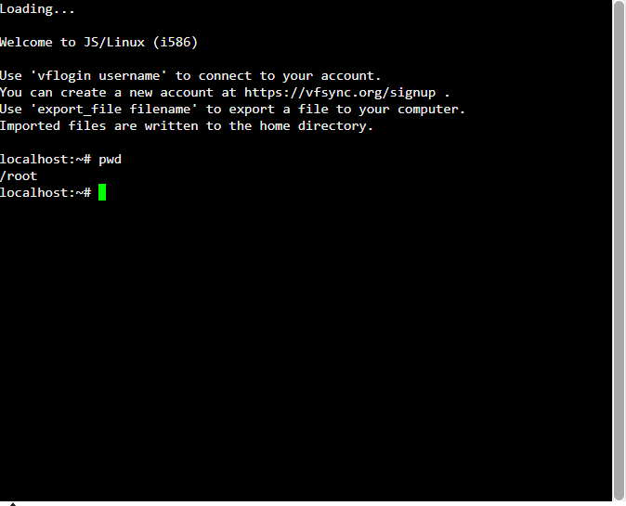

Pwd – prints your current working directory in the file system. (PWD = printing working directory). It prints out where you are.

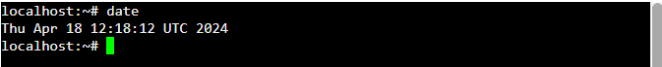
Date – prints out the date and time of your time zone.

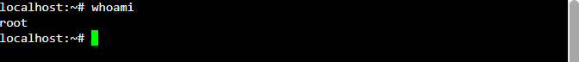

Whoami – outputs/prints your username.

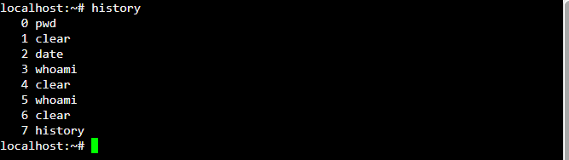

History – displays all the commands you have entered.

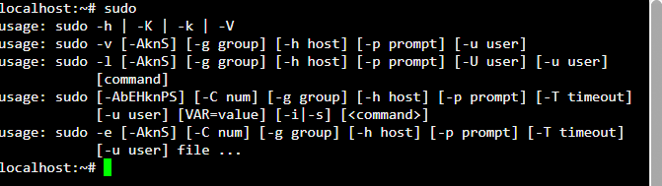

Sudo – gain superuser privileges provided you are an admin of the system. You will need to enter your administrator password.

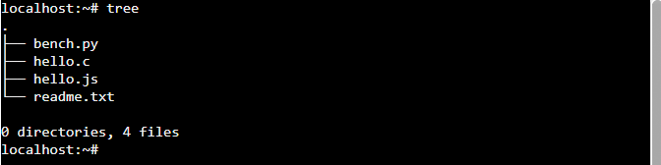

Tree - Lists the directory. tree / lists the whole system directory from the root /. ‘Tree | less’ outputs one page/window at a time and you can go back and forth between outputs. ‘CTRL C’ on the keyboard to stop last command and return to prompt. Instead of ‘less’ you can use the ‘pg’ command.

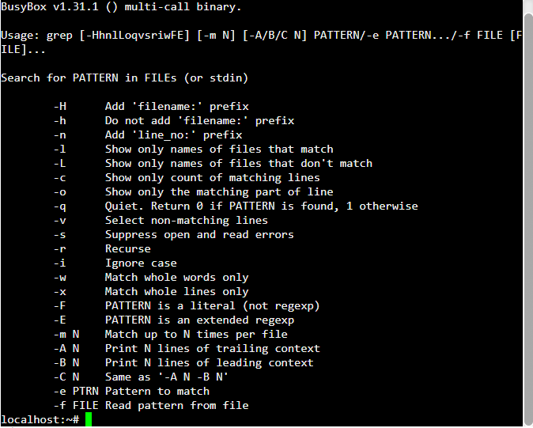

Grep – A “useful command to search for matching patterns in a file.” [5]
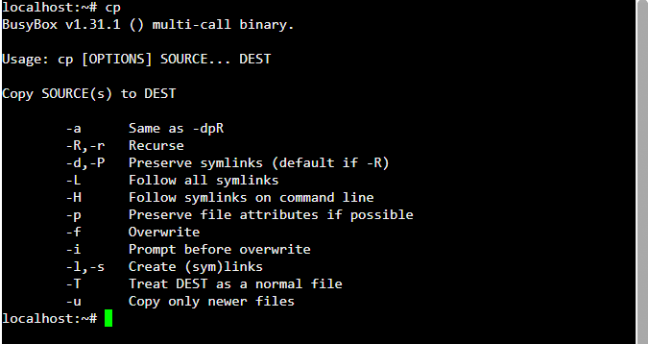

CP – “you can use the cp command in Linux to copy files and directories form one location to another.” [8]

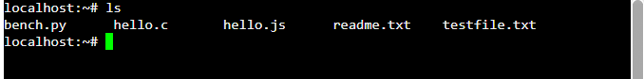

CD – “stands for change directory. It is used to change the current directory of the terminal.” [6]

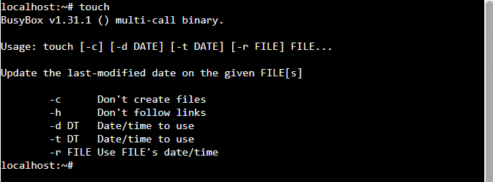
Touch – used to “change timestamps and access stamps in individual files or directories.” [7]

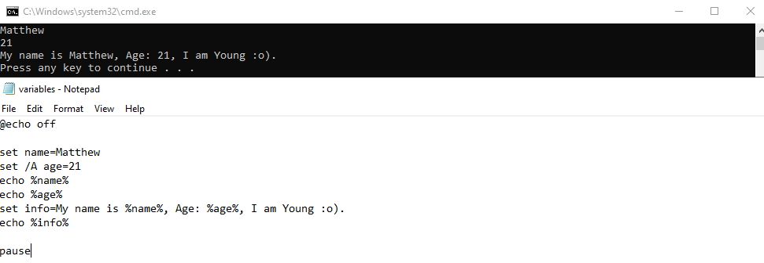
Use of Windows OS Scripts

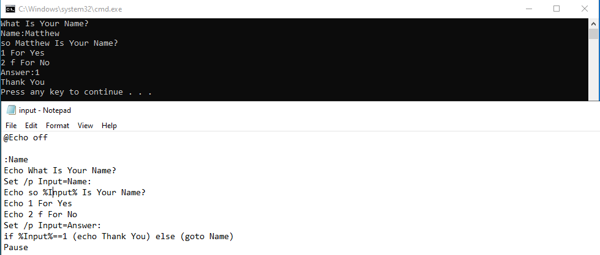
Variables – This code displays my name and age.
User Input, if else Statement & Goto commands – This code prompts the user to enter their name, and then gives the option to confirm answer by typing 1 for yes or 2 for no.
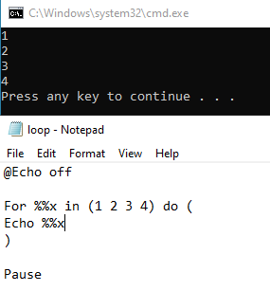
For Loop – This code counts from 1 to 4.
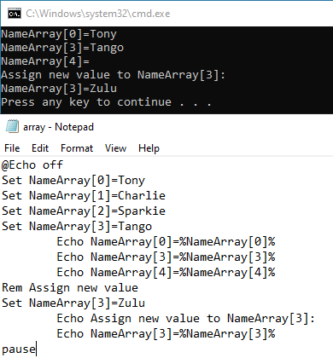

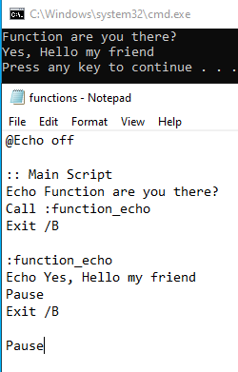
Array – This script displays names and assigns a new name to name array 3.

Functions – this script echoes if someone is there, and answers. In a webpage from tutorialspoint, [15] “a function is a set of statements organised together to perform a specific task. In batch scripts a similar approach is adopted to group logical statements together to perform a function.”

Use of Linux OS Scripts
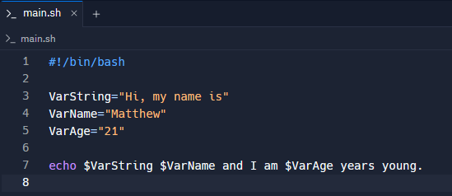
Variables – In this code, it runs a script stating my name and age.

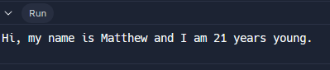

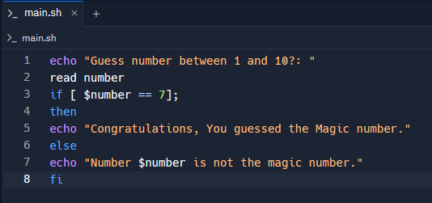
If else statements – In this statement, you are requested to select a number between 1-10, if you select the wrong number, it will tell you that you selected the wrong number, however, if you get it right then it will congratulate you and inform you that you chose the correct number. In this code the magic number is 7.

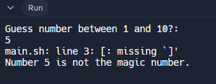

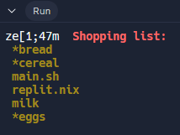
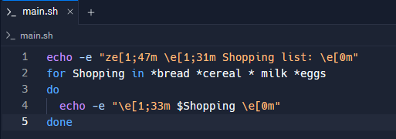
Loops – This code displays a shopping list using a loop format.

Arrays – This script says different weather in different countries. Unfortunately, the code command didn’t work as the command wasn’t found. However, the benefit of using arrays in bash scripting is that “script developers can efficiently organize, access, and manipulate data in a structured manner.” [14]
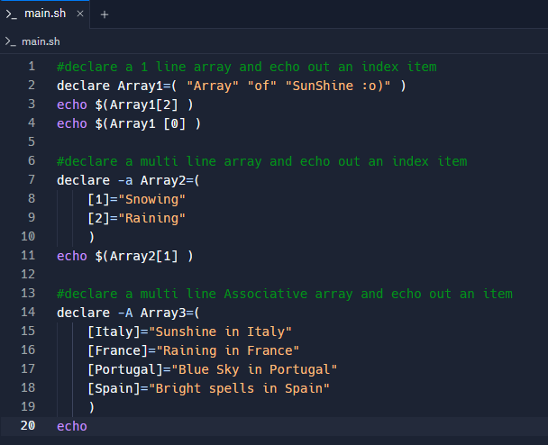

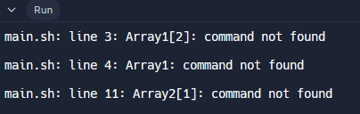

Functions – This code runs a script of a conversation between a man and a dog. The benefit of using functions in Bash Scripting is that you can “keep some of the variables local, which increases reliability”. [13]
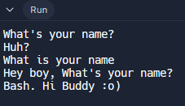
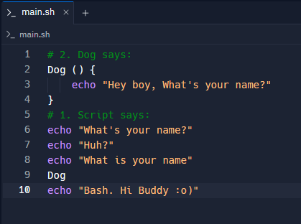

User Input – In this scenario, the user gets prompted with a question, and they have the freedom to answer with what they decide, and they will then be greeted with the name that they chose.
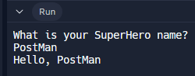
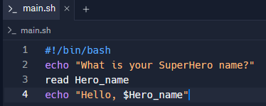

Conclusion
Overall, I feel like I have a far greater understanding of operating systems as a result of this assignment. Prior to going into this, I didn’t do much Bat Scripting or Bash Scripting, so it required a bit of a learning curve. However, after getting more practice and getting a better feel with using Command Line, identifying different processes in Task Manager, and writing Bat/Bash commands and scripts, I feel like I have a far greater understanding of the process and the functions. In addition to this, I feel like I have gained more of a familiarity with the different types of operating systems, and the variation between these.

Reference List
[1] Webpage, TechTarget, operating system [OS] Stephen J. Bigelow https://www.techtarget.com/whatis/definition/operating-system-OS [online] [Date accessed 15/02/24]
[2] [05/09/23] Webpage, Knowledge Hut, Types of Operating System [Pros and Cons], Sachin Bhatnagar https://www.knowledgehut.com/blog/web-development/types-of-operating-system [online] [Date accessed 15/02/24]
[3] [20/10/23] Webpage, Keele University, Names and Types of Computer Operating Systems, Ben Nancholas - https://online.keele.ac.uk/names-and-types-of-computer-operating-systems/ [online] [Date accessed 18/04/2024]
[4] Webpage, Linux, What is Linux? - https://www.linux.com/what-is-linux/ [online] [Date accessed [18/04/2024]
[5] [17/01/23] Webpage, freeCodeCamp, Grep Command in Linux – Usage, Options, and Syntax Examples, Zaira Hira - https://www.freecodecamp.org/news/grep-command-in-linux-usage-options-and-syntax-examples/#:~:text=Grep%20is%20a%20useful%20command,a%20powerful%20command%20to%20use. [online] [Date accessed 19/04/24]
[6] Webpage, educative, What is cd in Linux? - https://www.educative.io/answers/what-is-cd-in-linux [online] [Date accessed 19/04/2024]
[7] [06/12/23] Webpage, Digital Guide IONOS, How to use the Linux touch command - https://www.ionos.co.uk/digitalguide/server/configuration/linux-touch-command/#:~:text=The%20touch%20command%20is%20used,important%20in%20their%20daily%20work. [online] [Date accessed 19/04/2024]
[8] [24/05/2023] Webpage, freeCodeCamp, How to Copy a Directory in Linux with the cp command, Shittu Olumide - https://www.freecodecamp.org/news/how-to-copy-a-directory-in-linux-with-the-cp-command/#:~:text=The%20Linux%20cp%20command,specific%20syntax%20for%20copying%20directories. [online] [date accessed 19/04/2024]
[9] Webpage, Intermedia Cloud Communications, How Do I Use Ipconfig In The Command Prompt or Terminal? - https://support.intermedia.com/app/articles/detail/a_id/27175/~/how-do-i-use-ipconfig-in-the-command-prompt-or-terminal%3F#:~:text=The%20ipconfig%20command%20is%20used,Subnet%20Mask%2C%20and%20default%20gateway. [online] [date accessed 19/04/2024]
[10] [20/09/2023] Webpage, Microsoft Learn, ping - https://learn.microsoft.com/en-us/windows-server/administration/windows-commands/ping [online] [date accessed 19/04/2024]
[11] [16/02/2024] Webpage, Microsoft Learn, echo - https://learn.microsoft.com/en-us/windows-server/administration/windows-commands/echo [online] [date accessed 19/04/2024]
[12] [03/02/2023] Webpage, Microsoft Learn, whoami - https://learn.microsoft.com/en-us/windows-server/administration/windows-commands/whoami [online] [date accessed 19/04/2024]
[13] [Modified 2 months ago, date unknown] Webpage, Unix & Linux, Why write an entire bash script in functions? - https://unix.stackexchange.com/questions/313256/why-write-an-entire-bash-script-in-functions [online] [date accessed 19/04/2024]
[14] [19/03/2024] Webpage, NameHero, Unlocking the potential of Associative Arrarys in Bash, CJ Saathoff - https://www.namehero.com/blog/unlocking-the-potential-of-associative-arrays-in-bash/#:~:text=The%20use%20of%20associative%20arrays,data%20in%20a%20structured%20manner. [online] [Date accessed 19/04/2024]
[15] Webpage, tutorialspoint, Batch Script - Functions - https://www.tutorialspoint.com/batch_script/batch_script_functions.htm [online] [date accessed 19/04/2024]
[16] [14/02/2023] Webpage, USwitch, What are the different mobile operating systems?, Ray Ali - https://www.uswitch.com/mobiles/guides/mobile-operating-systems/ [online] [Date accessed 19/04/2024]
[17] Webpage, Gartner Information Technology, Network Operating System - https://www.gartner.com/en/information-technology/glossary/nos-network-operating-system#:~:text=A%20network%20operating%20system%20communicates,services%2C%20directory%20services%20and%20security. [online] [date accessed 19/04/2024]
[18] [11/12/2023] Webpage, Prepbytes, Network Operating System - https://www.prepbytes.com/blog/operating-system/network-operating-system/#:~:text=Examples%20of%20Network%20Operating%20Systems,Mac%20OS%20X%2C%20and%20BSD. [online] [Date accessed 19/04/2024]
[19] Webpage, LinkedIn, How can you compare real-time and embedded operating systems? - https://www.linkedin.com/advice/0/how-can-you-compare-real-time-embedded-operating [online] [Date accessed 19/04/24]
[20] Peer Reviewed Journal, AI Based OS, Computer Science & Engineering, Rajiv Ghandi Proudyogiki Vishwavidyalya, Bhopal, MP, India - https://www.ijtrd.com/papers/IJTRD22752.pdf [Date accessed 19/04/2024]
[21] Webpage, IBM, What is Quantum Computing? - https://www.ibm.com/topics/quantum-computing [online] [Date accessed 19/04/2024]
[22] [24/11/2020] Webpage, LinkedIn, CLI vs GUI – Which one is better? Gokul Korgaonkar - https://www.linkedin.com/pulse/cli-vs-gui-which-one-better-gokul-korgaonkar-1f#:~:text=CLIs%20are%20provided%20by%20most,for%20Linux%20and%20OS%20X).&text=before%20using%20it-,What%20is%20GUI%3F,windows%2C%20icons%2C%20and%20menus. [online] [Date accessed 19/04/2024]
[23] [06/09/2023] Webpage, geeksforgeeks, Memory Management in Operating System - https://www.geeksforgeeks.org/memory-management-in-operating-system/ [online] [Date accessed 19/04/2024]
[24] [27/02/2023], Webpage, DataTrained, Process Management OS, Akshat Dhawan - https://datatrained.com/post/process-management-os/#:~:text=In%20an%20operating%20system%2C%20process,executing%20on%20a%20computer%20system. [online] [Date accessed 19/04/2024]
[25] [28/02/2023], Webpage, DataTrained, File Management in Operating System - https://datatrained.com/post/file-management-in-operating-system/#:~:text=File%20management%20in%20operating%20system%20is%20software%20that%20handles%20or,present%20in%20the%20computer%20system. [online] [Date accessed 19/04/2024]
[26] Webpage, tutorialspoint, Operating System – I/O Hardware - https://www.tutorialspoint.com/operating_system/os_io_hardware.htm [online] [Date accessed 19/04/2024]
[27] Webpage, Lenovo, What is a device driver? - https://www.lenovo.com/gb/en/glossary/device-drivers/?orgRef=https%253A%252F%252Fwww.google.com%252F [online] [Date accessed 19/04/2024]
[28] [17/06/2023] Webpage, Techopedia, Operating System Security, Margaret Rouse - https://www.techopedia.com/definition/24774/operating-system-security-os-security#:~:text=Operating%20system%20security%20(OS%20security)%20is%20the%20process%20of%20ensuring,malware%20or%20remote%20hacker%20intrusions. [online] [Date accessed 19/04/2024]
[29] Webpage, opentext, What is Network Management? - https://www.opentext.com/what-is/network-management [online] [Date accessed 19/04/2024]
Tool used for Linux OS Scripting – Replit - https://replit.com/languages/bash

Appendix

Engagement with 1 certified course
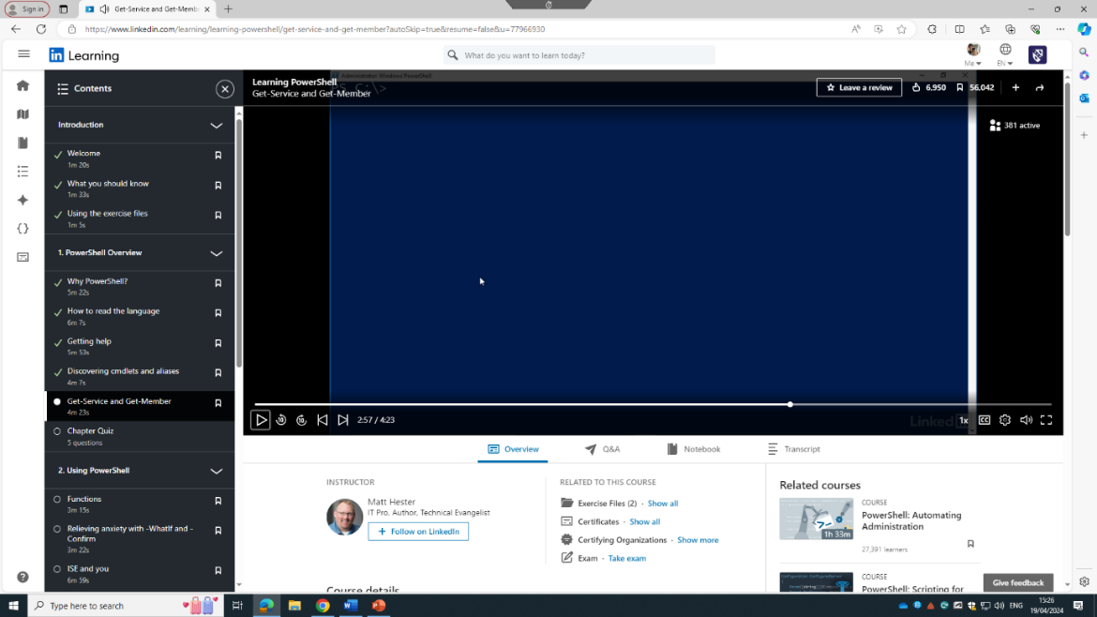

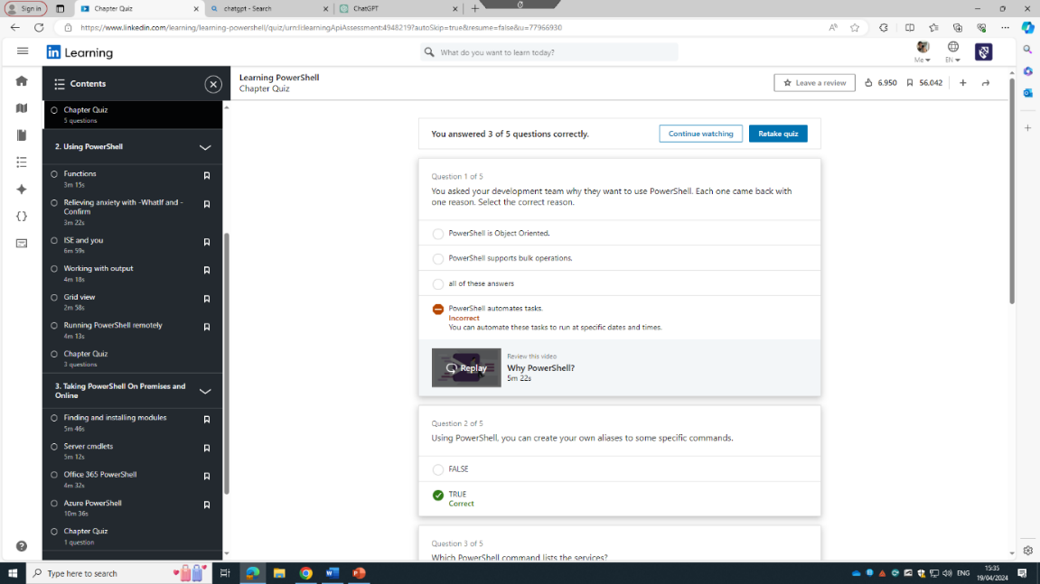

What are the different types of operating systems?
A webpage from KnowledgeHut states that there are 10 different types of operating systems. These include the Batch Operating System, wherein the users don’t have any direct contact with a computer, for instance, like a punch card. An advantage of this is that [2] “it can be used by more than one person at the same time.” However, a disadvantage of the Batch Operating System can be that “it’s hard to fix bugs in.”
According to a webpage from Keele University, the most popular operating systems are [3] “Microsoft Windows” which is deemed to account “for a huge 71.29% of the market”. Some other examples of popular operating systems include “MacOS”, “Linux”, “ChromeOS”, “Android” and “iOS”.

Mobile Operating Systems
There are several different types of mobile operating systems, however, by far and away the most common are iOS Android, and formerly, Windows mobile devices. With regards to iOS, which is the operating system that Apple uses for their iPhone and iPad devices, [16] “comes with the safari web browser for internet use, Apple Music application for playing music and Apple’s mail for managing your emails all pre-installed.” There is also Android, which is “owned by Google and powered by the Linux kernel, which can be found on a wide range of devices.” Windows mobile device updates were discontinued in 2019, however, those with phones that have a Windows Operating System can still use their devices.

Network Operating Systems
[17] “A network operating system is a set of software utilities that, working in conjunction with an operating system, provides the local area network (LAN) user interface and controls network operation. A network operating system communicates with the LAN hardware and enables users to communicate with one another and to share files and peripherals. Typically, a NOS provides file-to-print services, directory services and security.
Some examples of network operating systems can include [18] “UNIX, Linux, Microsoft Windows 2008, Microsoft Windows Server 2003, Novell NetWare, Banyan’s VINES, Arisoft’s LANtastic, MAC OS X and BSD.”

Embedded & Real-time Operating Systems.
Real time operating systems are [19] “an operating system that guarantees to respond to events or tasks within a predefined time limit, regardless of the system load. This is essential for applications that require high reliability, predictability, and accuracy, such as industrial control, robotics, aerospace, or medical devices.”
On the other hand, an embedded operating system [19] “is an operating system that is tailored to run on a specific hardware platform, usually with limited resources, such as memory, processing power, or battery life. An EOS is often embedded in a device that performs a single or a few functions, such as a smartwatch.”

AI and Quantum Operating Systems
[20] “An artificial intelligence operating system (AIOS) is a form of system software that manages computer hardware and software resources and provides common services for computer programs via general artificial intelligence.”
Whereas, Quantum Operating Systems include [21] “computer hardware and algorithms that take advantage of quantum mechanics – to solve complex problems that classical computers or supercomputers can’t solve, or can’t solve quickly enough.”

