Oliver Rhys Hearne
HND Construction management
Work Based Project
SN - 1911293

Background knowledge
As part of my learning over the last few weeks I have been looking into the background knowledge of contracts in the construction industry. I have been looking into the meaning of them and what they hold within them. In addition to this I have been learning about different types of contracts and a general overview of how each one works. In my report below I will outline what I have learnt.
A construction contract is a legally binding agreement between two parties based on conditions recorded in document form. The two parties involved are owners, and contractors. The owner has full authority to decide what type of contract should be used for a specific development to be constructed and to set the legally-binding terms and conditions in a contractual agreement. A construction contract is an important piece of document that outlines;
- The scope of work
- Risks
- Duties
- Legal rights of both the contractor and the owner
(How to choose the right construction contract, n.d.)
Contracts have previously been defined as 'a promise or set of promises which the law will enforce’. (CONTRACT | meaning in the Cambridge English Dictionary, n.d.). There is reciprocity of undertaking passing between the promisor and the promise.
In a contract, the rights are created by the acts of agreement between the parties to the contractual arrangement.
There are three types of contracts which are available for the traditional procurement method;
Lump sum – where the contract value is determined before construction starts, and the amount is entered in the agreement
Measurement – where the contract sum is accurately known only on completion, and after remeasurement and agreed.
Cost reimbursement – where the cost is agreed for the works including plant, labour materials, etc and then an additional fee is given for the overhead and profit.

In the construction industry there are different types of contracts which can be:
- Standard forms
- Modified standard forms
- Bespoke
Bespoke contracts are generally considered to more of a risk than standard contracts because they have not been tested in the courts and have been written for the benefit of the client so therefore put more risk onto the contractor than an amended standard contract. (Diploma in Surveying - administration of contracts 1, 1991)
I will be focusing on the standard forms of contract for my individual learning project.
There are five key areas within Construction contracts which must be outlined and agreed within the contract.
- Full name, address and signature of both parties – without these the contract will be useless and therefore must be present within the contact. This is important as the contract may later be looked at in Court if there is a claim.
- Scope of works – This is very important and should be put into detail in the contract to ensure it is done to the correct standard. It should include the following;
- Materials
- Quality
- Schedule of works
- Specifications
- Project cost and payment terms – The cost for the works should be clearly shown within the contract. A breakdown of each cost and total to ensure nothing is missed. Payment terms should also be agreed within the contract as well as retention details.

- Schedule of works - a clear programme should be set and agreed and incorporated within the contract. This should outline key dates such as start date and completion/ handover. This will ensure that the works are kept on track.

- Authority – This is who is in charge of making decisions within the contract and who will be running and taking the control of the works

JCT Contracts
The Joint Contracts Tribunal produces standard forms of contract for construction and standard documentation for use in industry.
Joint contracts tribunal revises the forms every decade. The most recent replacing the 2005 version, is the 2016 suite, as is commonly referred to as JCT 05. The main variants can be listed as follows;
- JCT minor works contract – this is considered suitable for works of a simple nature up to an amount of £100,000 approximately
- JCT intermediate form of contract – this is considered suitable for works up to approximately £500,000 in value and makes a provision for a contractors design portion of the works, it can be used with a bill of quantities or an activities schedule
- JCT standard form of contract
- JCT design and build contract
- JCT management contract
NEC Contracts
The New Engineering Contract is system created by the Institution of Civil Engineers that guides the creation of documents on civil engineering and construction projects. They legally define the responsibilities and duties of Employers and Contractors in the works information. The contract consists of two key parts the Contract Data part one contract Data part two. Several approaches are included making it a wide variety of options.
There have been four editions. The first was made in 1993, the second in 1995, the third in 2005 and the most recently in 2017.
NEC4 was announced in March 2017 and has been available since June 2017. This new edition reflects procurement and project management developments and emerging best practice, with improvements in flexibility, clarity and the ease of administration.
- It creates good management of the relationship between the two parties to the contract
- It can be used in a wide variety of commercial situations, for a wide variety of types.
- It is a clear and simple document - using language and a structure which are straightforward and easily understood. (NEC Contracts, n.d.)

Infrastructure conditions of contract
The infrastructure conditions of contracts were published by Thomas Telford on behalf of the institution of civil engineers, The Association of consulting engineering and the civil engineering contracts Association. The first edition was published in 1945 and the seventh and final edition was published in 2001. The ICC contracts were published in 2011 to replace the ICE Conditions of Contract and have a similar structure and approach to the contractual process.
The key characteristics of the original contract were:
- Valuation by measurement
- Engineering responsibility for design
- Engineer as the impartial certifier
- Engineers decision at the first stage
Now that I have learnt a general overview of the different types of contract I am now going to start analysing current contracts from my work place and see what areas of the contract I need to be checking in order to prevent taking on any high risk jobs. I plan to carry out an analysis on all of the above contracts so I have experience in them all when carrying my new skills into the workplace. (Diploma in surveying - administration of contracts - part 3, 19910)
Reflection
Sessions one and two have been very beneficial to me. Before carrying out this initial background knowledge research I had very little understanding of the different types of contract which can be used in the industry. I have discovered that they all have pros and cons which is why they change from different jobs between sub-contractors. Now that I have a general understanding of these contracts it will now allow me to develop my research further into the areas which I need to address within my learning program which will be risks involved with each and how to challenge under each.
Company information
I work for a company called Procter Bros Ltd which are a sub-contractor in the construction industry which provide temporary and permanent security fencing as well as automated gates and street furniture. As a company we take on many sub contracts which can vary between £1000.00 to £300,000.00. Therefore it is very important that these contracts are checked properly in order to avoid risks and leaving ourselves exposed. As part of my development within the company this will be a part of my role to check these once my training programme is completed.

Commercial and operational risk
In my recent studies I have been looking into the risks which are associated with sub contracts and how they can be overcome or avoided. I have discovered that the definition of a ‘Risk', can be defined as ‘an event or set of circumstances that, should it occur, will have an effect on the achievement of the project's objectives'. Risk exists as a consequence of uncertainty, and, in any project, the exposure to risk produced by uncertainty must be managed. (Allocation of risk in construction contracts, 2016)
Particular risk
The first category of risk is often known as pure and particular risk. It includes damage to persons and property. Examples would include;
- Fire
- Storm
- Water (flood)
- Collapse
- Subsidence
- Vibration
Contract conditions often make it a contractual obligation to take out insurance cover against these risks. (John, 2019)
Fundamental risk
The second category is fundamental risk. This includes external factors such as
- damage due to war
- nuclear pollution
- supersonic bangs
- The government policy on taxes
- Labour
- Safety
- Malicious damage
- Industrial disputes
Such incidents are all the subject of statutory liability and no insurance cover is normally available or needed. (Managing the risk of sub-contractors in construction, 2016)
Speculative risk
The third category, often referred to as speculative risk, is something which can be apportioned in advance as decided by the parties to the contract. This may include losses in money and losses in time. This could be the result from;
- unexpected ground conditions
- exceptionally adverse weather
- unforeseeable shortages of labour
- unforeseeable shortages of materials
- similar matters beyond the control of the contractor
There are also risks of losses of time and money due to delays and disputes poor direction, supervision or communication. This could be due to possessions of site not on time, late supply of information or inefficient execution of work. Other areas of risk may include delays in payments from the main contractor and also a delay in payment/ work programme due to unresolved disputes. (Jones, 10)
Due to the increasing risks involved with construction projects main contractors are now using sub-contractors more often as it puts less risk on them and more onto the sub-contractor. Therefore it is important that before signing onto contract the risks are checked, are fair and agreed upon.
Limiting risk exposure

I have been looking into what to look for in contracts before signing on them. Before committing to a project it is very important to check through the entire document to ensure I know exactly what I am signing the company up to doing. This will require taking time to go through each point and making sure that it is what was agreed and we aren’t signing onto something which we haven’t included for such as an additional piece of work or something we can’t achieve such as a completion date. By doing this I can avoid many problems by understanding what is required from the start, as appose to finding out half way through the project. In order to protect the company there is some questions which I need to ask and some checks to be carried out which do not include what is in the contract. These will be

What do I know about the contractor? – being a fencing sub-contractor we work for many different sized main contractors and therefore some I have never heard of. Therefore, it is important to give the company some research prior to signing onto any works with them to ensure they do not have a bad reputation in the industry. (Hugh Clamp, 2007)

Who I will be dealing with? – It is important that I know from the start who my main contact is as I will have queries when installing as well as their word for completion of works so that we can be payed

Once I have checked the company are credit worthy and have not got a bad reputation I will then begin to look into key areas of the contract which may catch me out.
- Payment terms – This should be discussed in the pre let meeting and therefore will be incorporated in the contract. However it must be checked to ensure it has not changed from what was discussed. The contract should include how many days payment will be from invoice as well as an invoice date specified if it is not the last day of the month. If this is not included within a contract I must ask the contractor to provide their standard payment terms.
- Key dates/ handover – This should also be agreed on within the pre let meeting. Key dates and completion dates are when works must be completed by a certain phase of a project. These dates may change in the contract and therefore must be checked before signing to save disputes at a later date.
- Inappropriate clauses - our contracts come from the main contract between the employer and principal contractor, which means that it may include terms and conditions that have been passed down. I will not be given a copy of this within the contract which I sign but if the job which we are signing onto is of high value it is important that I request to check this. Jobs with a value of £100,000 +.
- Drawings – The contract will include drawing numbers which we have priced off and will specify a product. It is important that these drawings are checked to ensure that we are not signing up to supply and install something which we have priced for. This will leave the company at risk of over spending on materials and not making money on the job. (John, 2019)
Challenging Contractual error
Now that I have an understanding of what to look for within a sub-contract I am now going to learn how to avoid signing onto these errors and how I can challenge the contractor or client to ensure we keep a good relationship and get the problem sorted. Once I have read through the contract and if I have discovered any errors then I will need to ensure they are highlighted and noted. If I have any errors in the contract then I will need to pass these back onto whoever sent me the contract. This will be sent by email to the main contractor. I have shown below a recent example of a contract which I have reviewed and challenged the errors.
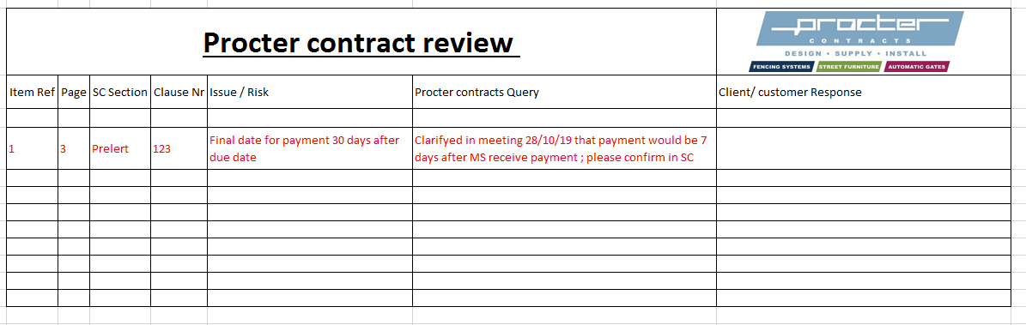
In order to help me when carrying out more contract reviews I created a sheet which I can use to record my findings and then send over to my customer/ client for review. Please see below.

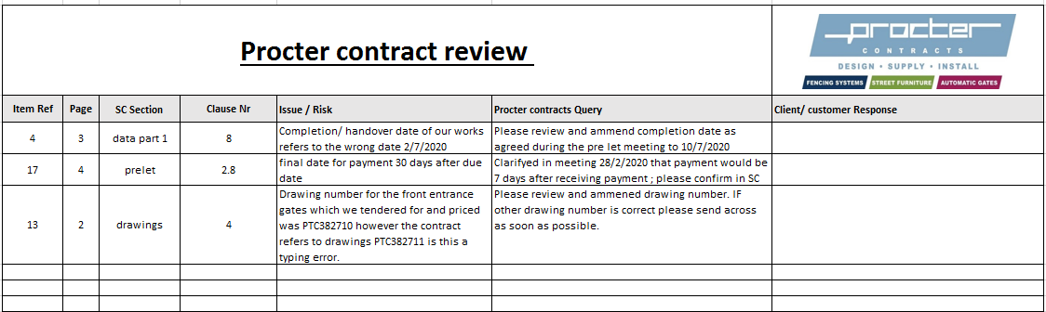
As part of my ongoing learning I sat down with my contracts manager and with what I had been learning I carried out a review of a current contract which we had won. However using the checklist which he provided me and what he taught me I started picking up some errors which may have cost us if we had signed up to them. Please see my contract review form below.

The first point which I picked up on was the completion/ handover date on the contract was wrong. When we visited site for the pre let meeting we discussed that the works which we needed to complete had to be done by the 10th of July 2020. However on review of the contract I noticed that this date had moved a week prior to the 2nd of July 2020. This therefore cut a week off of our time on site so I challenged it to ensure that we had enough time to complete our works. This could have potentially caused damages if we were delayed a week and did not challenge the changed date.

The second observation which I made was the payment terms. Originally agreed in the pre let meeting payment to be made 14 days from the contractor receiving the invoice, this had now changed to 30 days. As a subcontractor we run the risk of spending money on labour, plant and materials and getting nothing back for a long time. Therefore cash flow is a very important resource which must be looked after. The sooner we get payed the safer we are as a company and allows us to take on more work. As it was agreed in the pre let meeting I challenged this on the contract as well.
The final query I had with the contract was with a drawing number which was slightly different from the number we had at tender stage. The drawing number had changed by a digit for the front entrance gates to the school. As we had only seen the other drawing this gate may be completely different and therefore more expensive. To ensure we aren’t signing up to something which we hadn’t priced for I challenged the job number reference. This way we are not at risk of losing money on the job before it has started.

Now that I have completed the check on the contracts I will either send them back to the customer/ client signed if I am happy with it or I will need to send over the list of queries which I have. As a subcontractor in the industry we work for many different companies on many of their sites. Therefore we do not want to approach them in a bad manor which may cause disputes. Therefore it is very important to respond with the contract review sheet in a professional manor.
The first step in doing this will be to draft an email to the main contractor which highlights my concerns with the contract. Initially I will be asking them to review, amend and resend the contract in order to proceed with the works. However on a larger contract it may require a meeting to discuss and run through these details again. Some contractors may not be happy to move on what has been outlined in the contract which we will then have to make a decision on. An example of an email I will be sending to clients/ customers can be seen below.
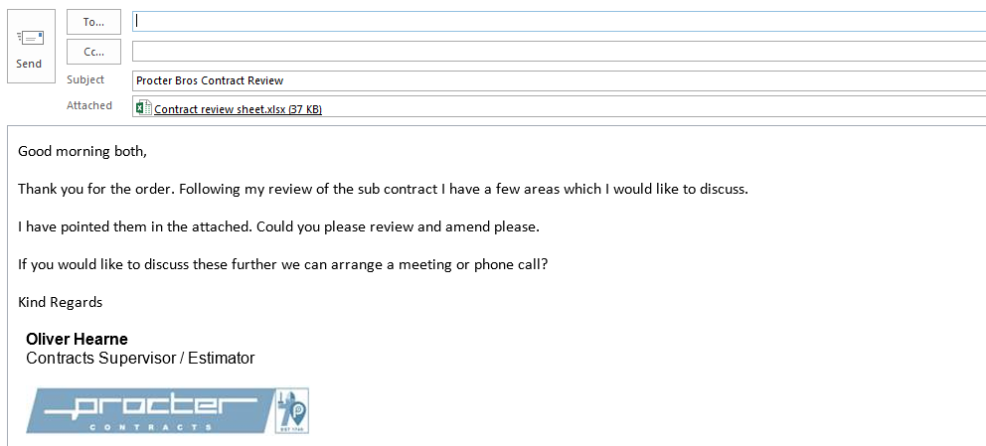

If the client/ customer comes back and refuses to amend the contract then as a company we will have to make a decision on whether we are happy to continue with these issues in the contract and run the risk of it affecting us in the future. Or de we refuse the work due to the risks which may occur with the problems in the contract.
From my learning with my senior contracts manager I have concluded that when we are dealing with regular customers which we have a good working relationship with I am able to let some clauses go pending on the potential risk which I will need to forecast. Also with our regular customers/ clients, this risks carried in the contract will also be reflected in the value of the job. We have discussed that any jobs which are less than £50,000 we have more allowance as we are dealing with less costs. However with anything above the £50,000 I must try everything I can to persuade them to change the clause in the contract to avoid losing the work.
When it comes to dealing with new customers there is a desire to keep them happy as you want them to develop into regular customers who sub-contract lots of work to us. Therefore it is important we do not upset them by claiming there are many issues with their contract. However, as they are a new customer we do not know much from our background check and therefore they could include clauses which put us at risk and therefore we must challenge them. It is a difficult decision but the best interest of the company has to be priority and that is insuring safety when signing onto any contract.

Review
What has this exercise taught you about yourself (personally and professionally) and what will you change going forward?
Over the past few months I have been learning each section of my targets with contracts on a weekly basis. During this time I received a promotion from trainee coordinator to my current role in the company which is contracts supervisor. My studies have allowed me to develop a better understanding of different areas of contracts which I now find extremely useful for my work. Prior to the universities ‘work based learning’ study I had very little knowledge of what contracts were and how they could impact a company if not looked at carefully. Therefore I had a lot to learn over this time to ensure I had a good understanding which I could practise in my place of work. I personally feel that my attitude towards new contracts will change going forward. Previously, I would have rushed into a new contract to gain work for the company. However knowing what I have learned I will be more cautious and take more time before agreeing to carry out any works due to the risks which can be hidden within a contract. On a professional level the work based learning module has encouraged me to take on more responsibility in the company. As mentioned previously my new role will involve signing off of contracts and I do not think I would have the confidence to do this if I had not studied them over the past few months. I now feel that I have the knowledge to be able to challenge those working for main contractors to ensure we are not at risk in a contract.
What was the journey to your goals, including successes and failures; how were issues resolved
When I first started carrying out the weekly lessons we decided to do them as and when we had the chance in the week. We were failing to achieve this in the first few weeks as we were very busy leading up to and after Christmas. Therefore we had to compromise and worked on late on a Friday to fit in the lessons after our planning meeting as we were both present for this weekly. This ensured that we were able to meet the goals which I had set and got all of the teaching completed.
The journey of the project involved increasing my knowledge and understanding of contracts and to protect the company by ensuring there is a structured system in place which will be used to prevent any contracts being signed without approval. As a company we were failing to protect ourselves by signing onto contracts of high value without carrying out thorough checks. By setting out my goals to achieve a better knowledge of contracts we also introduced new check reports which would be used across the company in the London and Leeds region. Those working in these regions are now using the templates which we have used for my learning. A personal success was that I developed an excellent understanding of each contract and the different clauses to check for within them. I have now taken this into my current work where I have recently been challenging contracts and am waiting to hear back on amendments which have been requested. As an overall success for the company would be that the ‘risk’ exposure will have reduced now from what it was as the whole subject has been highlighted and addressed through the division. I will be continuing my studies by developing a set of standard letters which those working in the division can use when challenging or working in accordance with a contract.
Given what you now know, would you do anything differently (if you were to do the project again)?
If I had the opportunity to carry out this module again I do not think I would change many things. I think that overall we covered everything which we set out to. However, if I was to pick an area in which we could have looked more into it would be in communication with main contractors. As a young person in the industry I feel that I am really telling an older person that they have made an error in their works. Therefore I do not feel as comfortable as possible when telling the main contractor this. Ideally if we had the opportunity to do this again I would ensure that we made more time to sit down and contact main contractors together. However, this is something I will slowly learn to develop when I progress in my new role and become more experienced.
Has what you have done changed your ambition or strengthened it?
This project has definitely strengthened my ambition. Prior to learning about contracts I found them very daunting not being able to understand what is written within them. Now I feel I have some knowledge I will definitely continue to develop on this. As I continue in my new role I will have confidence when taking on larger value jobs that I have read and understood all of the clauses within the contract before signing onto it and carrying out the works. As my career continues I hope to become contracts manager within my current firm in the next few years. If I am successful in this I will then be responsible for all contracts in the South and West of the country. This will require much more experience and knowledge before I get to this stage, however I will develop this from my foundation learning in this module and from experience in my new position. From my previous studies at AS level in Law combining construction with law may be something I look to progress my career in in the future.

Bibliography
Allocation of risk in construction contracts. (2016). Retrieved from Global Arbitration review: https://globalarbitrationreview.com/chapter/1145082/allocation-of-risk-in-construction-contracts
CONTRACT | meaning in the Cambridge English Dictionary. (n.d.). Retrieved from Dictionary.cambridge.org: https://dictionary.cambridge.org/dictionary/english/contract
Diploma in surveying - administration of contracts - part 3. (19910). The college of estate management .
Diploma in Surveying - administration of contracts 1. (1991). The college of estate managememt.
How to choose the right construction contract. (n.d.). Retrieved from Architecture.com: https://www.architecture.com/knowledge-and-resources/knowledge-landing-page/how-to-choose-the-right-construction-contract
Hugh Clamp, S. C. (2007). Which Contract? London: RIBA Publishing.
Jackson, S. (2012, 12 1). Standard form contracts - JCT. Retrieved from Pinsentmasons.com: https://www.pinsentmasons.com/out-law/guides/standard-form-contracts-jct
John. (2019, 3 19). 8 important provisions to look for in a construction contract. Retrieved from Construction review online : https://constructionreviewonline.com/2019/02/8-important-provisions-in-a-construction-contract/
Jones, K. (10, 11 2017). Identifying and managing construction project risk . Retrieved from Constructconnect: https://www.constructconnect.com/blog/identifying-managing-construction-project-risks
Managing the risk of sub-contractors in construction. (2016, Feb 9th). Retrieved from EGUE 2: https://www.eque2.co.uk/managing-the-risks-of-subcontractors-in-construction/
NEC Contracts. (n.d.). Retrieved from Institution of Civil Engineers (ICE): https://www.ice.org.uk/knowledge-and-resources/professional-practice/nec-contracts-and-ice-conditions-of-contract

