Understanding Bereavement:

A Guide for Healthcare Professionals
Table of Contents
What is Bereavement? 2
What is Grief? 3
Bereavement Facts and Figures 4
Who are affected and what is the impact? 5
Research into the Impact of Bereavement 6
The Process of Bereavement 7
Phase Model of Bereavement (Freud 1961) 8
Phase Model of Bereavement (Freud 1961) cont 9
Phase Model of Bereavement (Freud 1961) cont 10
Phase Model of Bereavement (Freud 1961) cont 11
Is Freud’s 1961 Phase Model useful? 12
Stage Model of Bereavement (Kubler-Ross 1969) 13
Stage Model of Bereavement (Kubler-Ross 1969) cont 14
Is Kubler-Ross’s 1969 Stage Model useful? 15
The Dual Process Model 16
Is the Dual Process Model useful? 17 & 18

WHAT IS bEREAVEMENT?

Bereavement can be defined as the period that individuals experience after loss and during this period, individuals can experience feelings of grief and mourning. In addition, bereavement is the state of experiencing a loss and along with it comes many different bereavement reactions and these can include psychological and behavioral reactions. Moreover, an individual’s emergence of bereavement reactions over time can be defined as the bereavement process (Osterweis, Solomon & Green, 1984).

The death of a spouse or a significant other can be one of the most stressful life events that an individual can encounter and can result in a higher risk of mortality in older adults. Death of a spouse has the potential to create an intense feeling of grief which can result in many negative health outcomes (Osterweis, Solomon & Green, 1984).

What is greif?
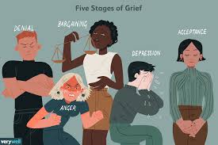
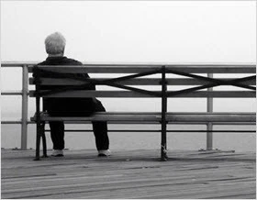
Over many years, there have been many different definitions of grief, although grief can be referred to as the emotional, cognitive, functional and behavioral responses to death. In addition, grief is also commonly referred to as the response to other types of loss and these can include an individual grieving the loss of their youth, the loss of functional abilities and the loss of access to opportunities (Zisook & Shear, 2009).
Mourning is another term that is commonly used to describe the outward expression of the grief being experienced by an individual. Mourning is a term used interchangeably with bereavement and grief and usually refers to the specific behavioral symptoms of grief which can be influences by social factors such as visitations and funerals (Zisook & Shear, 2009).

Bereavement facts and figures


- By the age of sixty-five, one half of all women and ten percent of all men experience the loss of a spouse and these figures rise to eighty percent and forty percent by the age of eighty-five.
- Research has shown that most older adults are resilient during the bereavement process.
- Previous studies have shown that 66.3 percent of older bereaved individuals were found to have increased resilience.
- Around ten to fifteen percent of older adults who have experienced loss show symptoms consistent with complicated grief.
- Bereavement and widowing are very common among individuals and by the age of sixty-five, one half of all women and ten percent of all men experience the loss of a spouse, and by the age of eighty-five, these figures can respectively rise to eighty percent in women and forty percent in men (Neimeyer & Holland, 2015).

WHO ARE AFFECTED AND WHAT IS THE IMPACT?

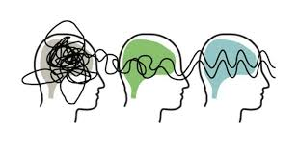
There are many individuals that can be affected by bereavement the most and these can include the older population, individuals who have experienced bereavement multiple times in a short space of time, those who do not have family or close friends for support and individuals who feel that their partner did not receive support or adequate care during the end of their life (Burton, Haley & Small, 2006).
In addition, bereaved individuals can be affected by loneliness and isolation and nearly a third of bereaved people over the age of sixty-five see themselves as lonely, more than one in five people believe loneliness affected them the most and the individuals without friends and family can find it difficult knowing who to turn to for support. Bereavement can also pose an impact on an individual’s mental and physical health (Burton, Haley & Small, 2006).

Research into the impact of bereavement


Over many years, bereavement and its impact have been widely researched and many studies have been produced. One of these can include that of Stroebe, Schut and Stroebe, 2007, who conducted a meta-analysis which explored current and past bereavement research and explored relation between bereavement and physical and mental health. This study concluded that bereavement is highly associated with an increased risk of mortality from the many different causes of bereavement (Stroebe, Schut & Stroebe, 2007).

Researchers have also conducted research into bereavement and how severe it can be based on many factors and one of these can include whether bereavement is expected or unexpected. One of these can include that of Burton, Haley and Small, 2006. This study used data obtained from one hundred and ninety-three participants who took part in the Changing Lives of Older Couples Study and the results of this study indicated that in individuals who experienced unexpected death, their risk of developing depression was higher. In addition, individuals who expected death showed improvements in social activity and support after bereavement (Burton, Haley & Small, 2006).

The process of bereavement


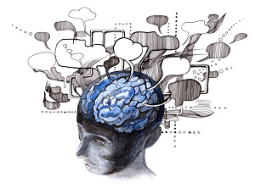
During the aftermath of bereavement, it can be difficult to know what to expect. Research into bereavement and grief has suggested that lack of information or understanding about what an individual may feel or experience when they are grieving can add to their current difficulties (Stroebe and Schut, 1999).
In order to provide individuals with an understanding of the process of bereavement and what takes place, theories can be used to provide an explanation.
Within psychology, a theory is used to provide a model or framework that are used to provide understandings of human thoughts, emotions and behaviours. In addition, a theory can be referred to as a fact-based framework that are most commonly developed to describe or explain a certain human phenomenon (Michie, Johnston, Abraham, Lawton, Parker & Walker, 2005).

In relation to bereavement, theories can be used to explain the process of bereavement, and in turn, can provide individuals with information which can help in understanding their current state of grief. Theories of bereavement can include Freud’s 1961 Phase Model, Kubler-Ross’s 1969 Stage Model and The Dual Process Model (Stroebe and Schut, 1999).

Phase model of bereavement (Freud 1961)

Phase model of bereavement (Freud 1961) CONT

Phase model of bereavement (Freud 1961) CONT

Following from Freud’s hypothesis, one study further developed Freud’s theory by examining the physic symptoms of grief and this study can include that of Dr Erich Lindemann. Lindemann, 1944, suggested that there were six physical stages of the grieving process that corresponded to Freud’s hypothesis (Hall, 2014). The stages identified by Lindemann are:

(Hall, 2014)

Phase model of bereavement (Freud 1961) CONT

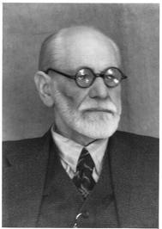
Lindemann’s research produced empirical evidence to Freud’s hypothesis and explained that letting go or detaching from the deceased is an important part of the grieving process. In addition, Freud’s theory is still a topic of focus among many different theorists and this can be due to how Freud's (1961) theories of grief were based on the clinical experience of depressed individuals (Novak, n.d.).
Lindemann, 1944, explained that in order to grieve effectively, individuals must become emotionally detach from the deceased and adapt to new environments and many studies have confirmed this hypothesis (Novak, n.d.).
Many researchers and psychologists have agreed with Freud and Lindemann’s findings and have implemented them to the healthcare sector and from many empirical findings, the hypothesis of both Freud and Lindemann can be implemented effectively when helping the bereaved (Novak, n.d.).

is Freud’s 1961 phase model useful?


Although Freud’s 1961 model has been widely used with regards to explaining bereavement, it has also received much criticism. Stroebe (1992) stated that Freud’s model does not explain that individuals dealing with bereavement have also got to avoid health consequence as well as going through the stages and some of these health consequences can include social withdrawal, sleep disturbance and loss of appetite.
In addition, many researchers have stated that the phase model does nor allow for any variations during the bereavement process, and this can lead to individuals misjudging what is the right or wrong way to grieve.
Moreover, phase models, like that of Freud 1961, have mostly been developed within a westernised culture and due to this, it can be difficult to apply to bereaved individuals from other cultures.

sTAGE MODEL OF BEREAVEMENT (kUBLER-rOSS 1969)

Kubler-Ross (1969) identified five stages of grief and these can include:

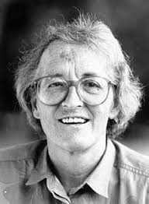

sTAGE MODEL OF BEREAVEMENT (kUBLER-rOSS 1969) cont

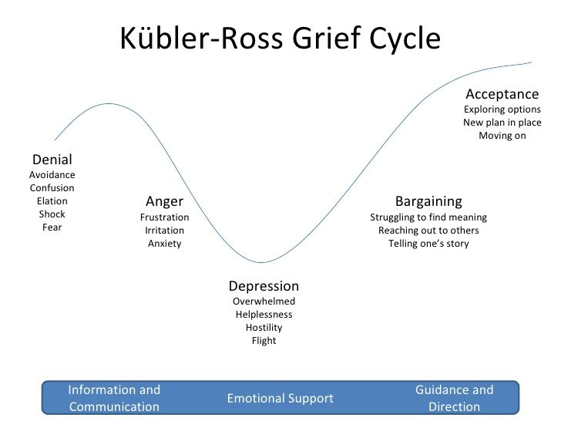
The stage model of bereavement was developed upon Kubler-Ross’s work with dying patients and her model was based around the anticipation of grief and how an individual will respond to a terminal diagnosis. From this, the five stages of grief were developed have found to be effective when applying them to bereavement experience and many other different types of change (Madison, 2005).

This bereavement model hypothesised that failure to complete any of the five stages would result in many complications for bereaved individuals and therefore enhanced the importance of this theory (Madison, 2005). In addition, Kubler-Ross (1969) explained that an individual who is bereaved should move through the stages sequentially, although it is possible for an individual to struggle with a particular stage and this could pose a challenge to move on. Due to this, their resolution to the grieving process can be delayed (Madison, 2005).

is kUBLER-rOSS’s 1969 stage model useful?


Although Kubler-Ross’s model has been widely used with regards to explaining bereavement, it has also received much criticism. One limitation of this perspective can include how it follows a set pattern, although in reality, the stages may occur at different times and individuals may not complete all stages. As cited by Buglass, 2010, Corr, 1993, explained that the work of the stage model is mainly produced around impressions of clinical experience and not empirical data.
In addition, according to Hall, 2014, over many years, the stage model has appealed to researchers due to its usefulness and this can be due to how it offers a sense of conceptual order to a process that is most often complex. It also explains that in the end, individuals experiencing bereavement will recover and receive closure.

Although the stage model can be useful for bereaved individuals, the stage model fails to capture the diversity and complexity of the experience that comes with grieving and bereavement (Hall, 2014). Moreover, researchers have explained that the five stages of bereavement identified by the stage model are too linear to be applied to the complex processes involved in grieving and bereavement (Buglass, 2010).

The Dual Process Model

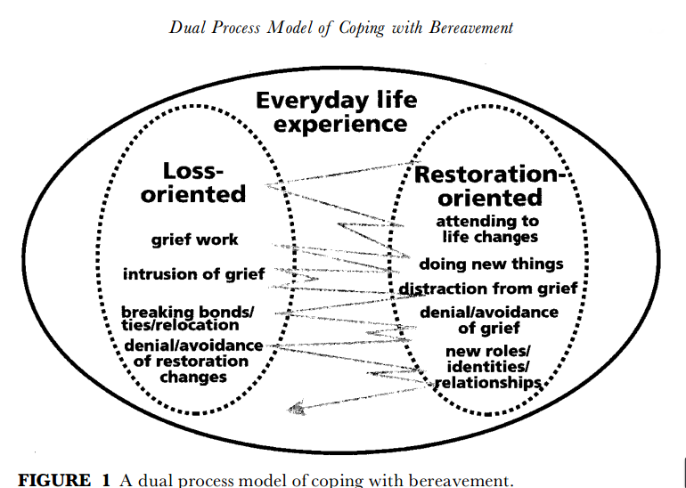
The dual process model (Stroebe and Schut, 1999) was produced to provide an explanation as to how individuals come to terms with the loss of a loved one. It was originally developed to explain how individuals cope with bereavement and has been widely used by researchers. The dual process model is also based on the principle that during the grieving process, coping is the product of a two-way process. From this, the model explains that an individual move from grieving a loss to coming to terms with the loss (Stroebe & Schut, 2010).
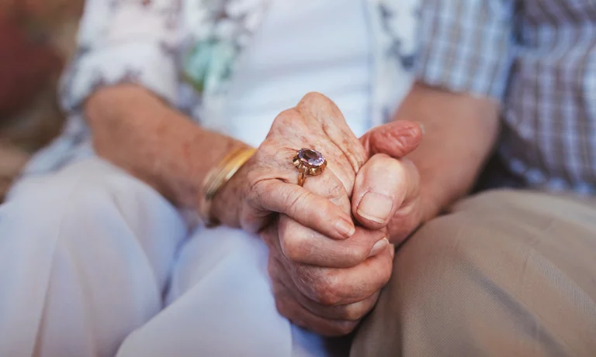
According to Stroebe and Schut, 2010, this movement can be described as ‘oscillation’ as people move between the loss-orientation process and the restoration-orientated process. During the loss-orientation process, individuals will go through their ‘grief work’ (as previously described in this report) and readjust to a new way of life. During the restoration-orientated process, individuals will make significant life changes and establish new relationships, attend to new activities and from this, will be distracted from grief.

is the dual process model useful?

Like Freud’s 1961 phase model of bereavement and Kubler-Ross’s stage theory of bereavement, Stroebe and Schut’s 1999 dual process model has also been used widely to provide a clear explanation of how individuals cope with bereavement. In addition, many studies have examined the use of the dual process model (DPM) and one of these can include that of Lund, Caserta, Utz and De Vries, 2010). The aim of this study was to test the effectiveness of the DPM on how people cope with bereavement. Participants in this study attended grief support groups that focused on factors of loss-orientation and restoration-orientation. The results of this study indicated that after individuals had received bereavement support, participants showed improved ways of coping and improvements in loss-orientation and restoration-orientation (Lund, Caserta, Utz & De Vries, 2010).
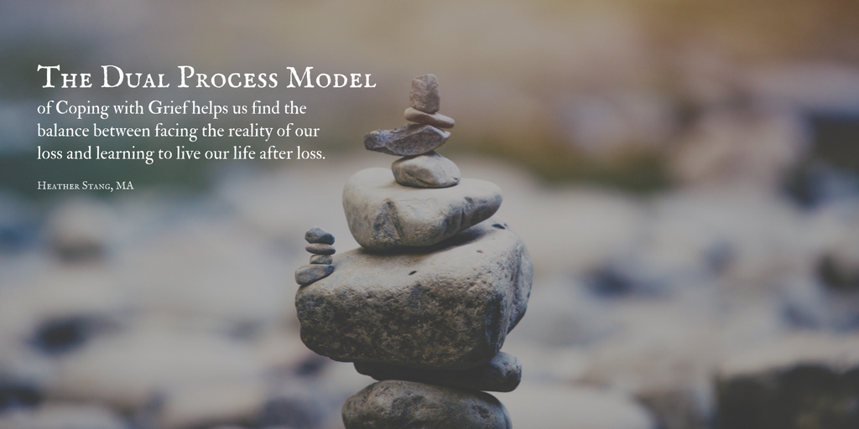
From the results of the above study, it can be said that the DPM can be useful in explaining how an individual cope with bereavement, although some researchers have criticised the model. Researchers have criticised the model by explaining that it has placed a lot of emphasis on an individual’s ability to cope and therefore suggesting that an individual’s way of coping is abnormal.

is the dual process model useful? cont


As well as the positive aspects of the DPM and the many positive results of previous studies, recent studies have also tested the DPM hypothesis and found different results. One of these studies can include that of Fasse and Zech, 2016.
The aim of this study was to investigate the bereavement experiences of widowed people and whether these experiences match up with the explanation of the DPM. Sixteen individuals took part in the study, all of which were interviewed. Results of this study indicated that the hypothesis of the dual process model did not match the experiences of grief reported by the participants. This occurred as most individuals did not distinguish between loss-orientation and restoration-orientation easily (Fasse & Zech, 2016).
From this study, it can be said that certain aspects of the dual process model are still ill-defined and need empirical development. Although, the DPM can be implemented effectively into the healthcare sector when providing support for bereaved individuals. (Fasse & Zech, 2016).
References:
AgeUK. (2019). Bereavement. Retrieved from: https://www.ageuk.org.uk/globalassets/age-uk/documents/information-guides/ageukig32_bereavement_inf.pdf
Buglass, E. (2010). Grief and bereavement theories. Nursing Standard (through 2013), 24(41), 44.
Burton, A. M., Haley, W. E., & Small, B. J. (2006). Bereavement after caregiving or unexpected death: Effects on elderly spouses. Aging and Mental Health, 10(3), 319-326.
Fasse, L., & Zech, E. (2016). Dual process model of coping with bereavement in the test of the subjective experiences of bereaved spouses: An interpretative phenomenological analysis. OMEGA-Journal of Death and Dying, 74(2), 212-238.
Hall, C. (2014). Bereavement theory: recent developments in our understanding of grief and bereavement. Bereavement Care, 33(1), 7-12.
Lund, D., Caserta, M., Utz, R., & De Vries, B. (2010). Experiences and early coping of bereaved spouses/partners in an intervention based on the dual process model (DPM). OMEGA-Journal of Death and Dying, 61(4), 291-313.
Madison, G. (2005). Bereavement and loss. Existential perspectives on human issues: A handbook for therapeutic practice, 338- 355.
Neimeyer, R. A., & Holland, J. M. (2015). Bereavement in later life: Theory, assessment, and intervention. In APA handbook of clinical geropsychology, Vol. 2: Assessment, treatment, and issues of later life. (pp. 645-666). American Psychological Association.
Novak, K. (n.d.). An Examination of Grief and Bereavement Theories in Human Service Practice. Retrieved from: https://www.academia.edu/15334073/An_Examination_of_Grief_and_Bereavement_Theories_in_Human_Service_Practic e
Osterweis, M., Solomon, F., & Green, M. (1984). Bereavement: Reactions, consequences, and care.
Stroebe, M. S., Schut, H. A. W., & Stroebe, W. (2007). Health consequences of bereavement: A review. The Lancet Infectious Diseases, 370(9603), 1960-1973.
Stroebe, M., & Schut, H. (2010). The dual process model of coping with bereavement: A decade on. OMEGA-Journal of Death and Dying, 61(4), 273-289.
Zisook, S., & Shear, K. (2009). Grief and bereavement: what psychiatrists need to know. World Psychiatry, 8(2), 67-74.

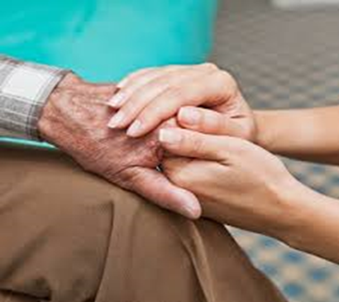
- Speak to family or friends, a health professional such as a counsellor
- Consider peer support. You can share your experience with other people who are experiencing the same thing as you
- Use many different bereavement interventions, some of these are listed below (NHS, 2019).
Counselling is a very common type of bereavement support and is used widely throughout the UK. This type of support is provided by a trained professional and can be given in a group or individual basis (Reif, Field, Payne & Relf, 2006).
Things you can do to help with bereavement

Bereavement Counselling

Bereavement counselling aims to provide a person-centered approach and involves using strategies such as listening, being with the client, facilitating the expression of emotion and allowing individuals to explain how they are feeling in a trustworthy environment (Reif, Field, Payne & Relf, 2006).

Useful Bereavement Organisations
Bereavement Interventions: Improve the way you deal with bereavement
Age UK:
0800 169 65 65 – Lines are open seven days a week from 8am to 7pm.
www.ageuk.org.uk
Cruse Bereavement Care:
0808 808 16 77
www.cruse.org.uk
Department for Work and Pensions Bereavement Service:
0800 731 0435
Samaritans:
116 123
jo@samaritans.org - www.samaritans.org

Does Bereavement
Counselling work?

Many researchers have looked into bereavement and the impact it has on bereaved individuals. Simonsen and Cooper, 2015, conducted a study which aimed to look at whether individuals believe bereavement counselling is helpful.



(AgeUK, 2019)
This study consisted interviewing participants on their experiences of bereavement counselling and the results of this study showed that overall, bereavement counselling can be helpful for individuals who have experienced bereavement (Simonsen & Cooper, 2015).

After the death of a loved one, support from peers and family is crucial. One of the ways you can receive help of others can include attending bereavement support groups. These support groups take place all over the UK and are available whenever you need them.
Bereavement Support Groups

CBT has been widely researched into its impact on bereavement and many researchers have looked at its effectiveness.

Does CBT work?

Currier, Holland and Neimeyer, 2010, conducted a study which looked how CBT interventions alleviate bereavement-related stress compared to non-CBT interventions and all the participants were given CBT based interventions over the course of thirty-three months.

Bereavement support groups aim to provide individuals with emotional and psychological support in a safe, non-judgmental environment. They also give individuals the time to grieve, while being in the company of other individuals experiencing the same type of emotional distress (Picton, Cooper, Close & Tobin, 2001).
Do Bereavement Support
Groups work?
Cognitive Behavior therapists mainly focus on an individual’s current situation and its solution, rather than their past. During CBT, an individual’s views and beliefs of their life are focused on and encourage individuals to replace their ways of living that do not work, with ones that do, as well as giving them control of their lives (Hofmann, Asnaani, Vonk, Sawyer & Fang, 2012).

Cognitive Behavioral Therapy (CBT) is a talking therapy that is based on the concept that an individual’s thoughts, feelings and actions can have a negative effect on physical and mental health. CBT is most commonly used to treat anxiety and depression but has also been used to help bereaved individuals (Butler, Chapman, Forman & Beck, 2006).

Findings from this study showed that CBT based interventions improved the overall stress levels of bereaved individuals. From this, healthcare services could include more CBT based interventions in their practices (Currier, Holland & Neimeyer, 2010).

Cognitive Behavioral Therapy

Jerome, Smith, Shaw, Barker, Pistrang, Thompson et al, 2018, conducted a study which looked at the effectiveness of a support group for individuals bereaved by cancer.
Twenty-seven participants all attended a six-session cancer bereavement group and all participants completed a questionnaire before and after attending the support group.
Results of this study indicated that after attending the support group, individuals showed less grief symptoms and the self-compassion of the participants increased (Jerome, Smith, Shaw, Barker, Pistrang, Thompson et al, 2018).

References

References:
Butler, A. C., Chapman, J. E., Forman, E. M., & Beck, A. T. (2006). The empirical status of cognitive-behavioral therapy: a review of meta-analyses. Clinical psychology review, 26(1), 17-31.
Currier, J. M., Holland, J. M., & Neimeyer, R. A. (2010). Do CBT-based interventions alleviate distress following bereavement? A review of the current evidence. International Journal of Cognitive Therapy, 3(1), 77-93.
Hofmann, S. G., Asnaani, A., Vonk, I. J., Sawyer, A. T., & Fang, A. (2012). The efficacy of cognitive behavioral therapy: A review of meta-analyses. Cognitive therapy and research, 36(5), 427-440.
Jerome, H., Smith, K. V., Shaw, E. J., Szydlowski, S., Barker, C., Pistrang, N., & Thompson, E. H. (2018). Effectiveness of a Cancer Bereavement Therapeutic Group. Journal of Loss and Trauma, 23(7), 574-587.
NHS. (2019). Grief after bereavement or loss. Retrieved from: https://www.nhs.uk/conditions/stress-anxiety-depression/coping-with-bereavement/
Picton, C., Cooper, B. K., Close, D., & Tobin, J. (2001). Bereavement support groups: Timing of participation and reasons for joining. OMEGA-Journal of Death and Dying, 43(3), 247-258.
Simonsen, G., & Cooper, M. (2015). Helpful aspects of bereavement counselling: An interpretative phenomenological analysis. Counselling and Psychotherapy Research, 15(2), 119-127.

