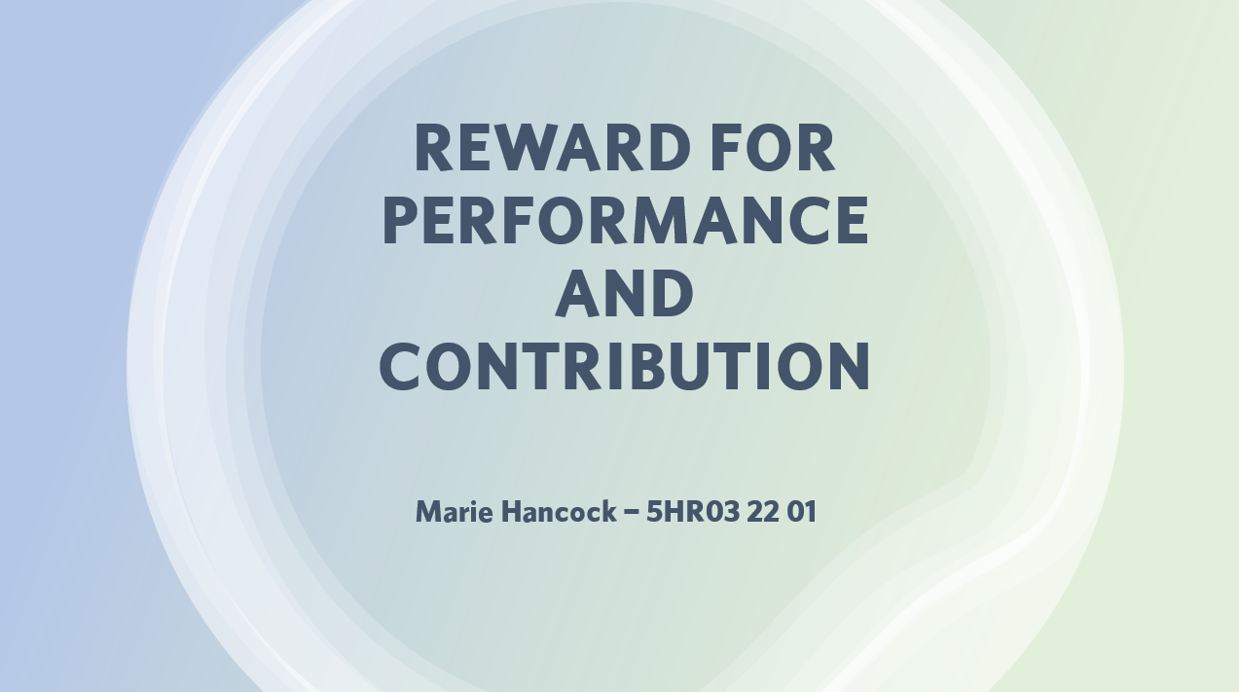

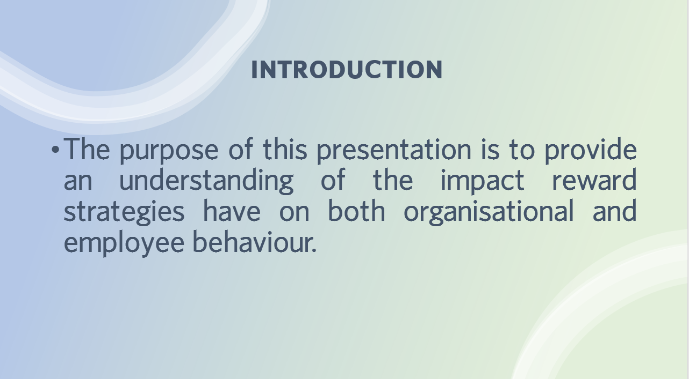

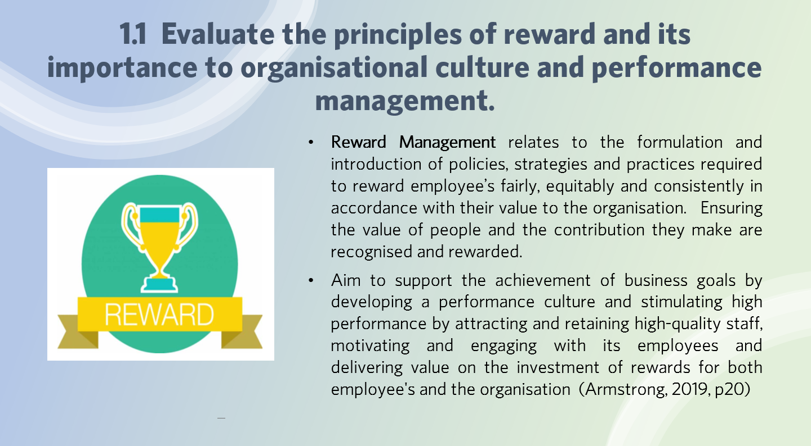
- Rewards no longer just include pay, according to CIPD (2022), the concept of total rewards incorporates a number of components which exist in the workplace but are often taken for granted and managed individually. Under the total reward approach all areas of work experience are included incorporating non-financial rewards, including flexible working and recognition of achievements .

  - Rewards can be intrinsic, meaning they are non-cash rewards
  - Extrinsic rewards that have physical existence and can be cash based.
How rewards impact company culture
- Emphasising reward and recognition within an organisations culture can make a difference to the organisation and its staff. If leaders were to recognise and reward its employees, encouraging employees to drive performance, to engage in the company at a deeper level, building levels of trust . And this engagement is at the heart of any successful organisational (REBA, 2019).
How rewards impact organisational performance
- The theory that reward management has a bearing on improvements to organisational performance followed with improvements in individual performance is difficult to prove. A number of research projects including one carried out McAdams and Hawk (1994) supported the principle that performance reward plans are instrumental in performance improvement, resulting in calculable returns (Armstrong, 2019, p124). Organisation performance can be monitored with the use of KPI’s, checking if targets have been met.
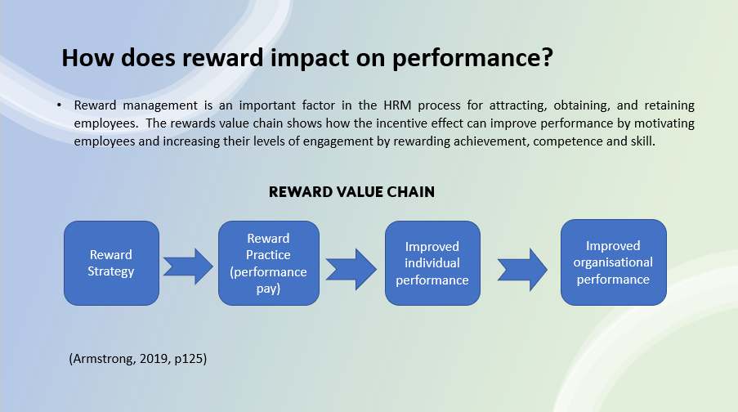

Performance Management plays a crucial role in motivating and engaging employees. By defining an individual’s performance and expectations, and assessing their performance helps initiate constructive feedback leading to agreed plans for performance improvement, learning and personal development linking to the organisation’s strategic goals (Armstrong and Brown, 2019)
Employers are encouraged to recognise the desires of their employees and ensuring the culture is hyper-focused on supporting the first layer of Maslow's hierarchy for employee motivation. They can build a positive work environment that promotes creativity, respect, productivity and continued motivation which can then give organisations the edge over competitors in the war for talent.

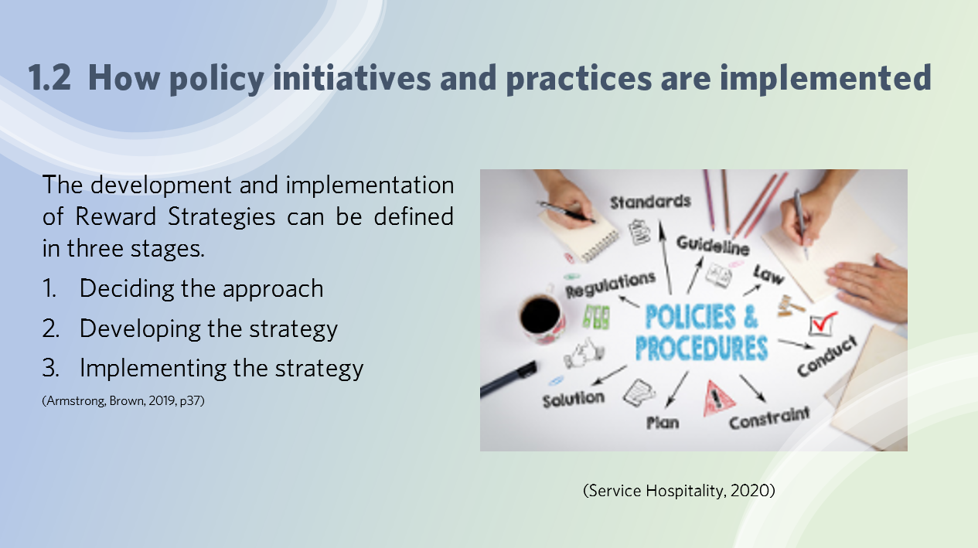
Deciding on the approach, involves identifying and agreeing the values and guiding principles that will control how the strategy will be designed and delivered. Setting the objectives and the success criteria. Creating a development and implementation programme based on the fair process approach to ensure consistency that all decisions do not vary arbitrarily and there is transparency in how the process works and how it affects those involved (Armstrong & Brown, 2019, p156)
Developing the strategy, identifying key people within the organisation who can contribute to help develop an initial strategy and develop a broader sense of ownership. To identify associated reward interventions by focusing on the evidence and information founded from good practices and proposals that have been tested to ensure they match the needs of the organisation and its employees. Consider any apparent issues i.e. under or overpayment comparative to the market or internal comparators and, feedback from employee surveys and inconsistencies within certain employee groups. Taking into account ethical considerations to be fair and consistent to help create a working environment where personal and employment rights are upheld to provide fair treatment for employees.
New policies and practices are more likely to be adopted if the key stakeholders within the organisation are involved in the policy development through collaboration and deliberation. Having different perspectives can help identify and overcome existing or potential issues.
Ongoing effort is required to embed these strategies, regularly reporting on its progress and monitoring the impact to assess if adjustments are needed or in response to any unexpected changes that need to be applied to stay relevant, current and effective for example if it may need to change to reflect changes in the labour market or legislative frameworks.

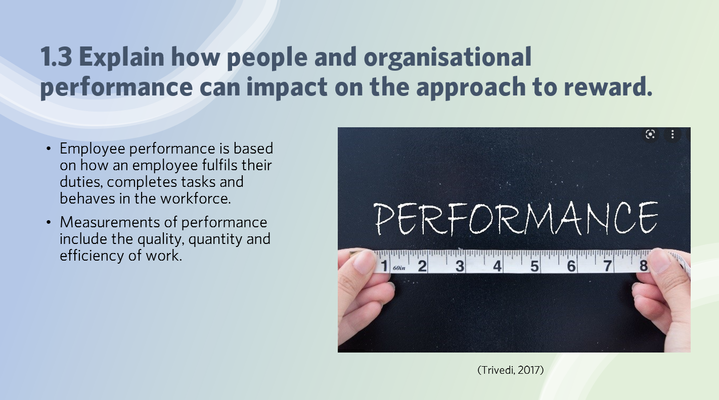
- Effectiveness of performance, reward management can help boost employee engagement and productivity by recognising and rewarding employees. Employees who feel valued show evidence of improved well-being, helps retain skilled and valued members of staff (Davidsonmorris, 2021)

- There are many external pressures that effect the performance of the organisation which affects the rewards organisations can offer their employees including:

  - Financial Restrictions, affordability ensuring reward systems in place don’t cost more the organisation can afford.
  - Competition from competitors
  - Labour Market – the economic determinants of the pay grades that are applied. And how levels of pay are affected.
  - Legislation - Living & Minimum wage
(Armstrong and Brown, 2019, p.358)
- Internal issuing including
  - Absenteeism costs.
  - Contribution to organisational objectives, i.e. safety records, production output, complaints and levels of achievements.
  - Labour turnover,

Organisations nowadays have such diverse and multidimensional workforces that it’s hard for employers to find that secret element that will help excite and motivate their employees to get them to work to the best of their ability and potential. They must know what they are trying to achieve in order to boost employee’s engagement at work.

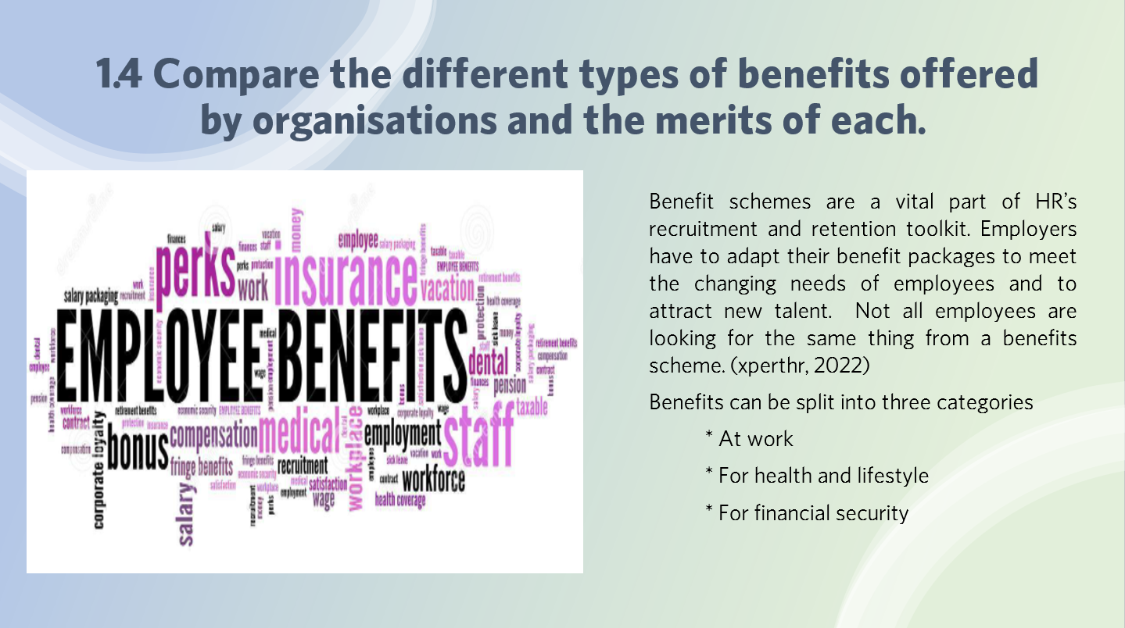
Work
- Flexible working arrangements, more important in the post-pandemic economy, employees becoming less inclined to compromise on flexibility resulting in hybrid working/homeworking.
- Sick Pay, paying sick leave enhances employee’s wellbeing.
- Enhanced redundancy pay, offering enhancements can ease the burden but comes at a cost to employers.
- Company cars or paying car allowance. Which enables them to take their car with them should they leave.
- Enhanced Maternity, paternity and adoption pay, great benefit, enhancing basic statutory payments, encourages employees to take more time off.
- Performance Related Pay, linking salary progression to employee’s performance by measuring against set objectives. Encourages motivation to meet objectives.

Health and Lifestyle
- Offering health insurance, wellness or wellbeing programmes are more popular benefit since the pandemic and is now considered essential.
- EAP (Employee Assistance program) help workers with personal or work-related problems that may impact their job performance, health and emotional wellbeing. Helps reduce stress and burnout and improves company culture.

Financial Security
- Pensions, employers are required to provide pension schemes in line with legislation. Greater the contributions the more attractive the scheme is to employees.
- Life Assurance, one off payment made to support the family in the event of the employee’s death.
- Commissions on sales, bonuses connected to performance offering pay rises or bonus pay-outs if goals are met or buying shares.

Overall today’s employees expect more, they want financial security and good work-life balance. So employers wanting to get a competitive edge need to ensure they select the best employee benefits that fit their workforce.

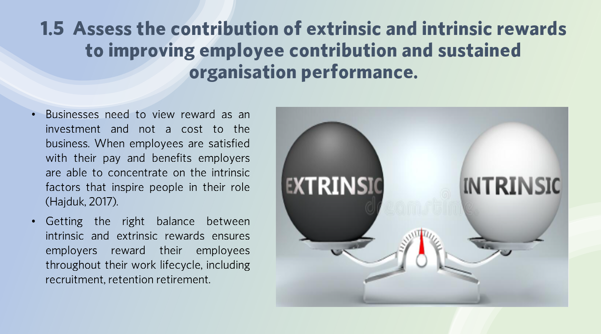
Intrinsic rewards include non-cash rewards such as employee recognition, acknowledgement, professional growth, respect and appreciation, giving employees sense of achievement.
These rewards are psychological rewards that employees get from doing meaningful work and performing well. Achieving them is largely dependent on their own effort giving them a positive emotional reaction, increased level of intrinsic motivation and enhance their skills. Employees with high levels of intrinsic motivation can benefit organisations by reducing labour costs and increasing innovation.
Extrinsic rewards are cash based, including payment of salaries, bonuses and indirect forms of payment as flexibility in time. These rewards have dominated the reward schemes for generations but there’s been a cultural shift in focus. Employees no longer consider money alone to be the main motivating factor. Since the pandemic, getting the right work-life balance is now just as important.
For organisations to maximise the value and impact of the reward packages, they need to focus on how they want to treat their employees to make them feel part of the wider vison and purpose of the organisation.
(Hajduk, 2017).
Organisations need to ensure the reward strategy applied has the desired impact, measuring the effectiveness by collating, analysing and interpreting the data obtained from gathering evidence i.e. employee surveys and external trends to assess the competitiveness and distinctiveness of the rewards. Using this information to establish a link between the reward spend and the benefit to and effect on the organisation. (Armstrong and Brown, 2019, p.358)

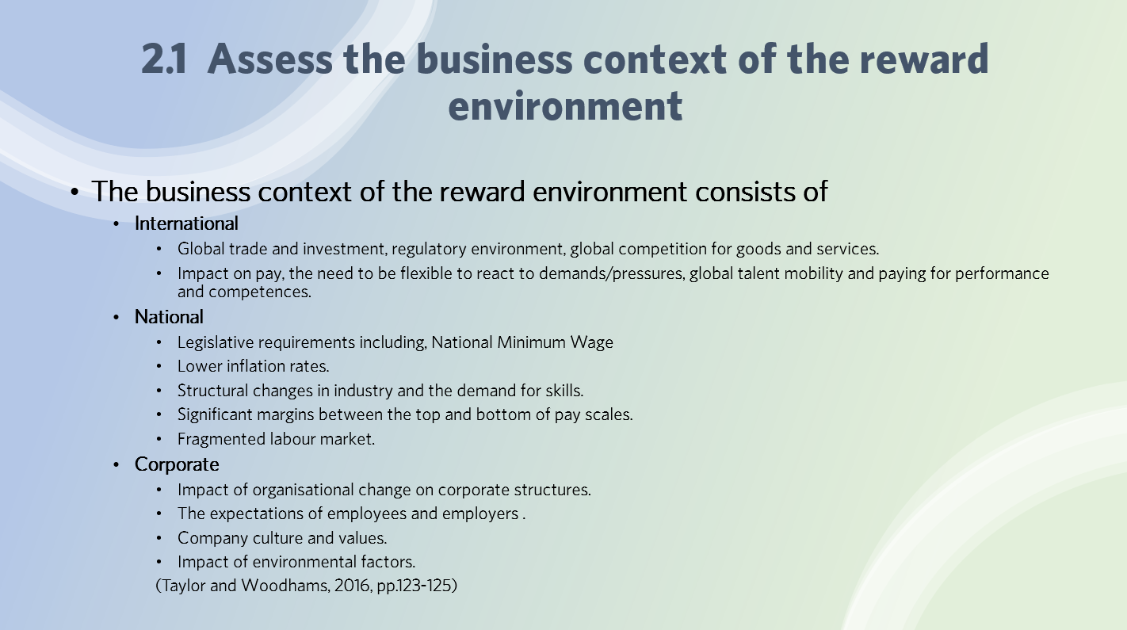
International context - Globalisation impacts the way organisations can reward their employees, it’s essential they maintain and update intransigent and outdated models that could compromise their competitiveness. Including revising their methods of delivering services and products to compete with the global marketplace and be flexible.
Organisations must ensure reward strategies and policies are compatible with the structure of their organisation, if not they’ll have difficulty in aligning the reward management with the strategic goals and culture of the organisation
National context – Largely influenced by politics and legislation.
The Introduction of National minimum wage lowered inflation and interest rates which suppressed annual pay rises applied, moving away from collective annual rises to individual awards based on contribution and efforts.
The demand for skills is considered the most important issue affecting reward management. The UK labour markets are largely becoming conceptualised as an hourglass (Taylor, 2011). Splitting the workforce into two sections, highly paid and skilled and lower skilled and paid jobs. Resulting from advances in technology and companies moving to developing countries.
All these factors including structural change in the economy with the move from an industrial base to a service base and the fragmentation of the labour market has meant adapting the reward strategies and approaches taken to fit the new context.
Corporate Context - All these factors have an effect on reward management and although some are internal factors they are also influenced by the external context e.g. employee expectations are influenced by external variables including education levels and comparisons made with friends or family working in other organisations. This can result in perceptions of unfairness which impacts the psychological contract.
(Taylor and Woodhams, 2016, pp.123-125).

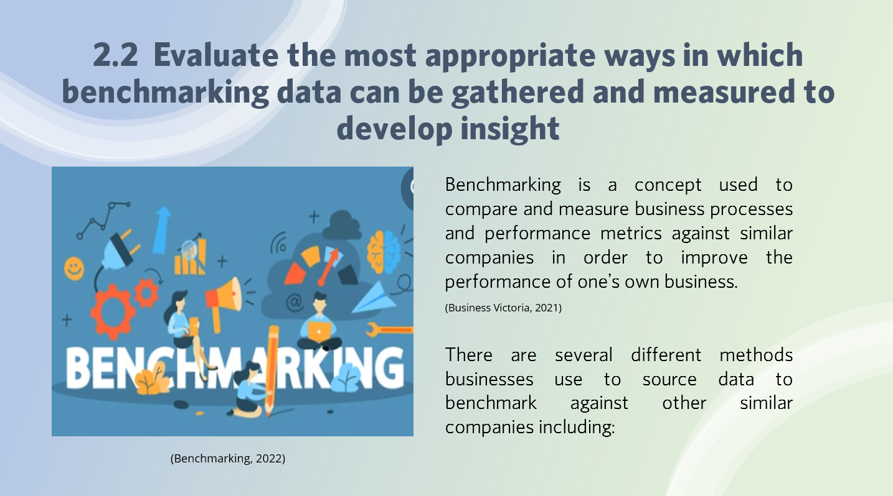
- Online sources - some companies offer employers the ability to compare metrics with other companies that also share data with them i.e. Compete and Turning Point HR solutions.
- Conduct formal interviews, issue questionnaires, surveys or having conversations with contacts from other companies. Other sources include
  - Office of National Statistics and Government reports and updates offering information on inflation, unemployment rates and average earning or working hours.
  - CIPD practitioners can use CIPD annual reward management surveys and other industry benchmarking data.
  - Recent statistics to analyse current trends within the industry, recruitment, vacancies and working hours.
(Taylor and Woodhams, 2016, pp.130)

- Secondary information collected from websites, reports, marketing materials and new articles.

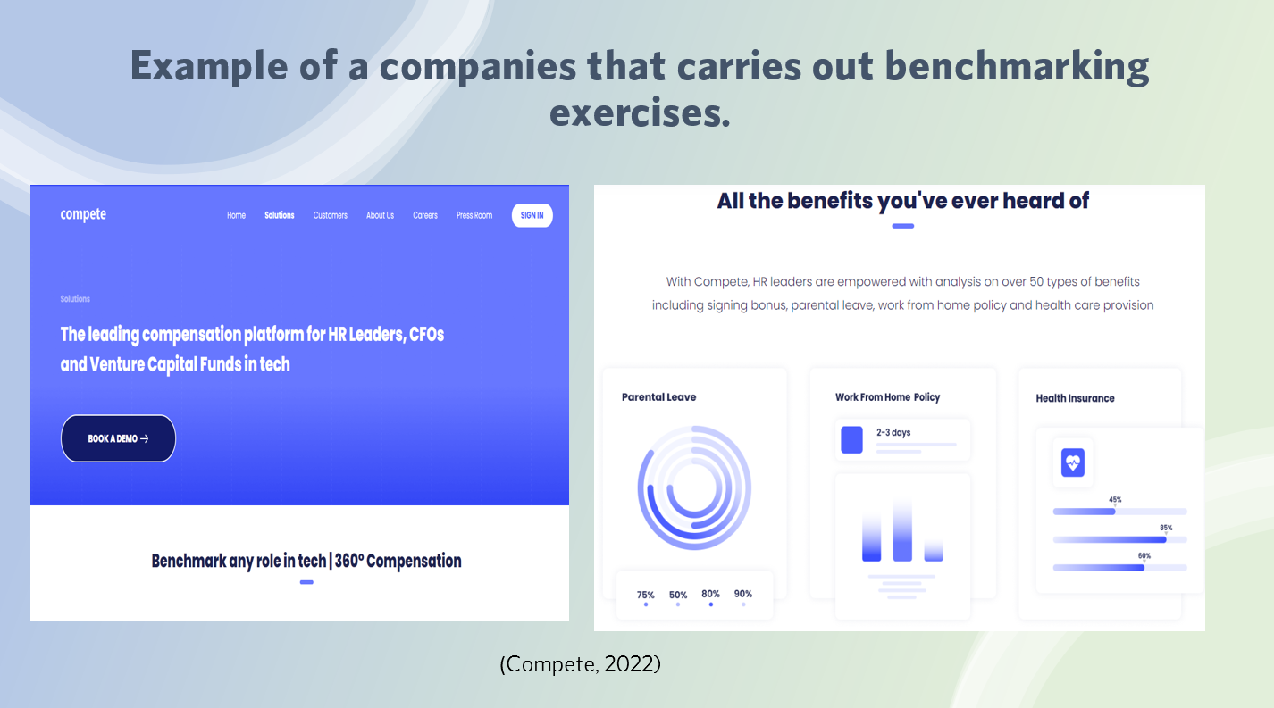
To evaluate the data it’s important check on its reliability and to look at it side by side using the metrics applied to identify any gaps and possible causes. To ensure that correct and valid comparisons are made, taking into account any operational, structural and cultural differences between the organisations. (Lucidchart, 2022). And also taking into account the effect of legislation when gathering and analysing the data.
Example – Following the effects of the recent pandemic WDP overhauled its benefit strategy after conducting a benchmarking exercise to review all starting salaries. Although they could not match salaries paid in the public sector, they were able to commit to being in the upper quartile of starting salaries and introduce cost-neutral benefits after taking on board employee’s needs. Ensuring it was sustainable for them and doing the best for their staff (Powell, 2022).
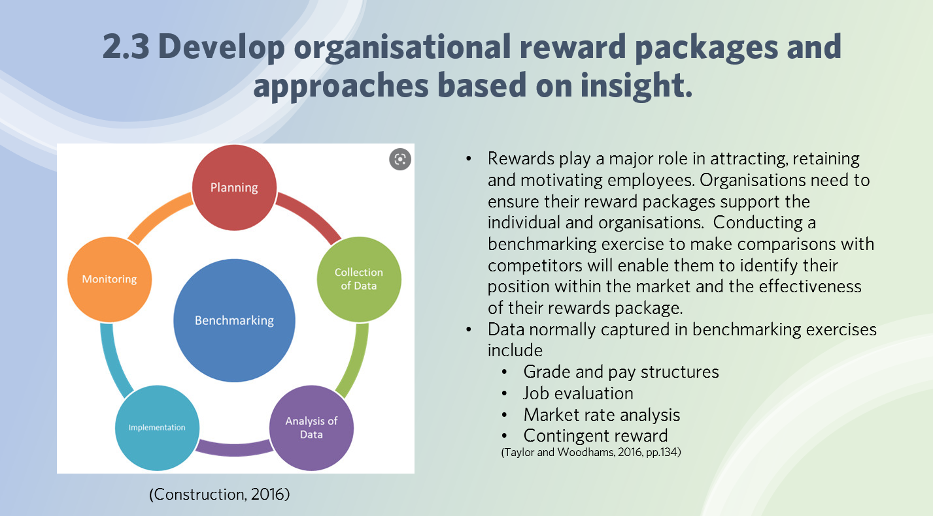
Pay structures are based upon a collection of wages that form a framework to position jobs against relevant pay grades. And are created to meet the business needs including affordability and meeting the needs and expectations of current and future employees. By making salary comparisons with competitors will help determine the average salary for particular roles within the external market and in turn help the organisation make informed pay decisions.
(Taylor and Woodhams, 2016, pp134-136)
Job evaluation is based on assessing the role and not the individual. According to Acas (2022) it’s a way to work out the relative importance of different jobs in an organisation. And should be a fair and transparent system that is communicated and understood by employees.
Market Pricing is the method to benchmark rates of pay paid by other organisations. This data is used to establish the market rate and monitor movements in those rates. With the aim to set organisations rates of pay at a level that will aid recruitment and retention of existing staff. It is important employers ensure their rates of pay remain internally equitable and externally competitive (CIPD, 2021)
Contingent reward is based on two questions,
- What do we value?
- What are we prepared to pay for?
And may pay an element of “base” pay and “bonus” pay. This method is seen as a motivational tool which links the element of pay to the achievement of a particular goal.
The benchmarking process is an important part of managing a business and can help prevent the loss of employees to rivals offering better reward packages and help in recruitment of future employees and future success of the organisation.

Internal example of benchmarking – Rates of Pay
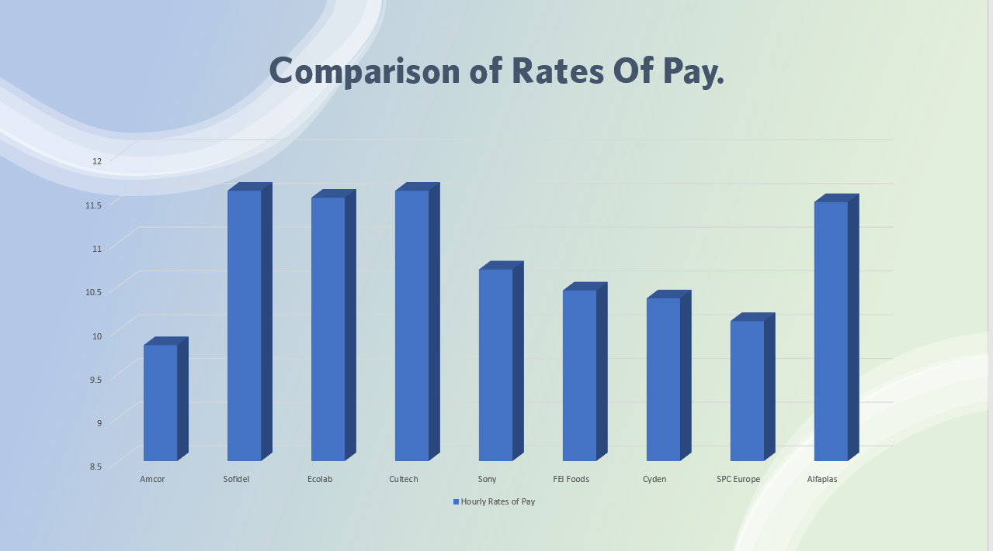A way of improving your organisations approach to reward based on organisational data.
The company had recently experienced difficulty recruiting employees for semi-skilled roles and had experienced an increase in labour turnover A benchmarking exercise was conducted to help understand where they were positioned in terms of rates of pay in comparison to other similar companies within a 25-mile radius.
(Amcor, 2022).
A plan was formulated
Step 1 – Planning, identifying required data, method , allocation of tasks and timeline.
Step 2 – Collection of Information, primary data was collected from employment agencies, external questionnaires and researching job adverts via online employment websites
Step 3 – Analysis of Data, converted into graphical format and present to company leaders. Showing where the company was positioned in comparison
Results - data indicated the company were paying significantly less. Additional analysis was conducted to establish a proposal to increase the rates of pay, taking into consideration the additional burden of costs. Agreed solution was a 3 year pay agreement.
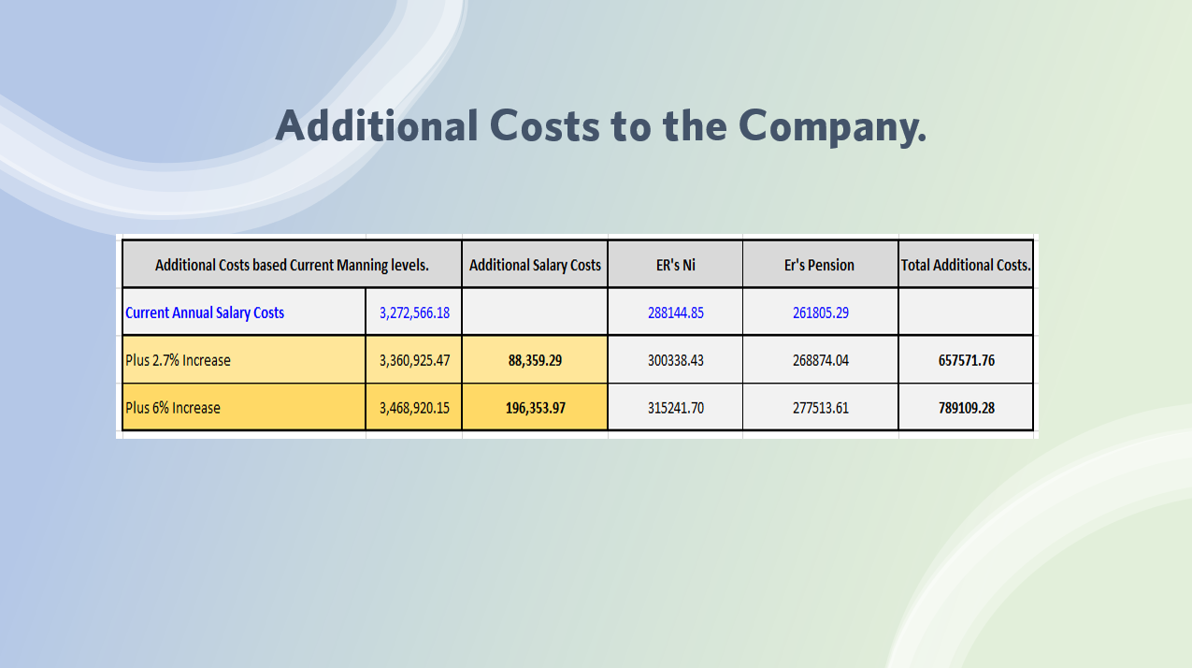
Step 4 – Implementation - Rates of pay applied to employees
Step 5 – Monitoring - Monitoring staff turnover, reasons for leaving and recruitment. With plans to repeat benchmarking exercise in 2 years’ time.
(Amcor, 2022)
Conclusion
The findings were clearly apparent the company was paying considerably less than the other companies hence the reason for poor recruitment and high staff turnover. By increasing the rates of pay made the company more competitive and helped attract and retain better quality staff.

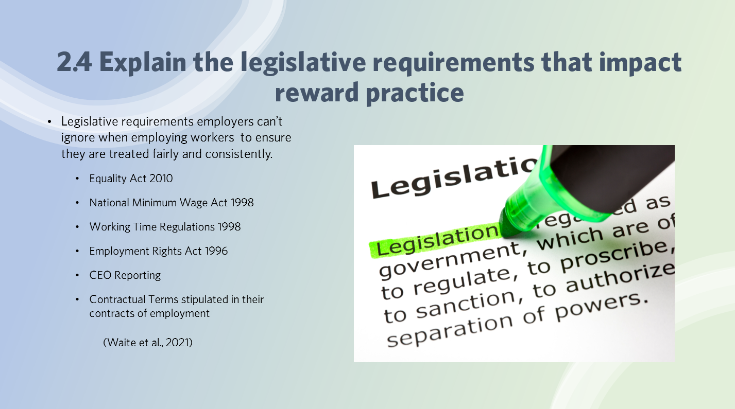
Equality Act 2010
- Equal pay focuses on the differences in pay between individuals.
- Gender pay gap identifies women should receive the same pay and benefits as a man when carrying out like for like roles.
  - Under the Government Equalities Office (2021) employers with more than 250 employees are required to submit their gender pay gap data annually (Waite et al., 2021).
The National Minimum Wage Act 1998
- Employers are required to apply the National Minimum Wage to all eligible workers 16 years and older. Failure to do so can result in being named and shamed on the Low Pay Commission websites (Waite et al., 2021)
Working Time regulations 1998
- Protects worker’s health and safety by setting minimum requirements in relation to working hours, rest period and entitlement to a minimum of 5.6 weeks paid annual leave. Employers
Employment Rights Act 1996
- Employers are also obligated to give eligible employees statutory leave and pay for maternity, paternity, adoption and sick pay. Employers can enhance the payments but have to pay the statutory minimum failure to do so could result in the employee reporting the issue to the HMRC statutory Payment Dispute Team.
CEO pay reporting and ratios
- In accordance with the Companies (Miscellaneous reporting) Regulations 2018 all publicly listed firms employing more than 250 UK employees have to publish the ratio between then total renumeration of their CEO’s and the full-time equivalent remuneration of their UK employees and a supporting narrative. This data helps to raise questions of fairness.

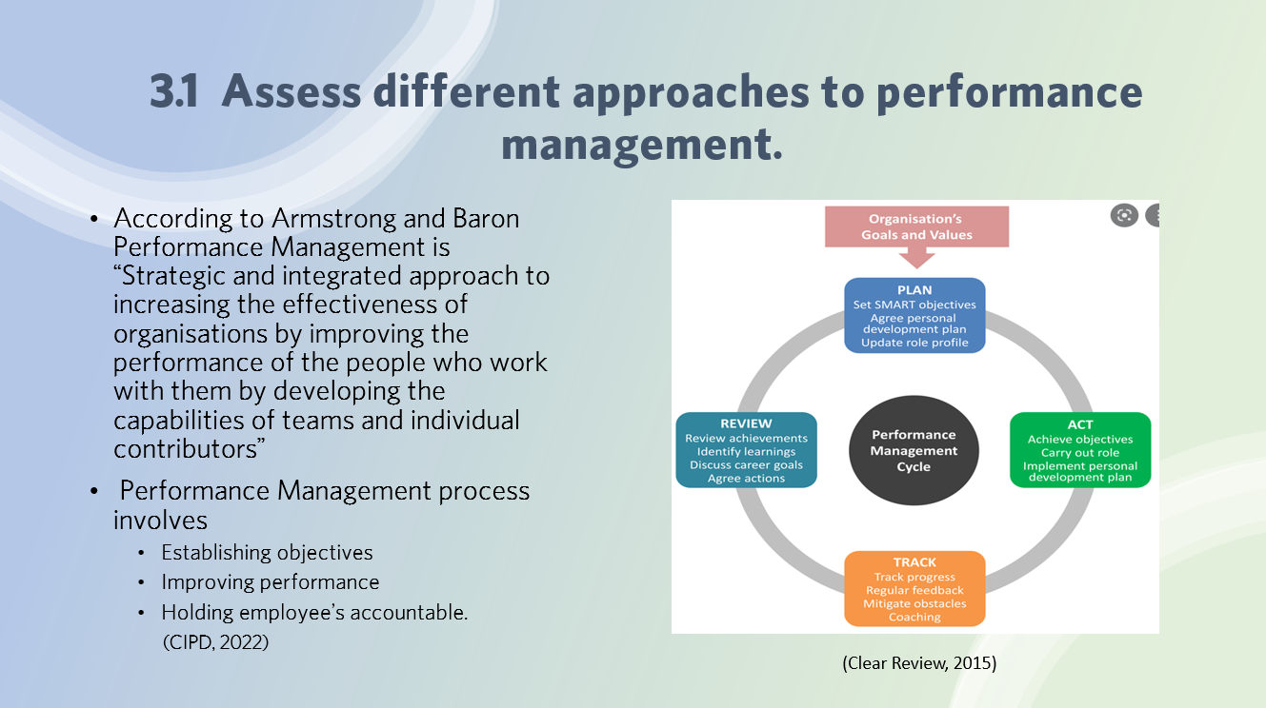
Its important employers identify measures of performance that are relevant to the objective and can be easily assessed by
- Informally by day-to-day management of employees by their manager.
- Or by having a formal framework which assesses the performance of individuals and identifies areas for improvement.
Appraisal Methods
Performance review meetings
- Meetings are two-way conversations between the individual and their manager reviewing their performance, development and growth, providing feedback. Is a critical component of an organisation’s overall performance management strategy (CIPD, 2022).
Objective Setting
- Most common focus of performance reviews as they link individuals’ efforts to tangible results, mainly based on short term goals which often takes the focus away from any longer-term factors like developing transferrable skills.
Personal development plans
- Based on training and development rather than the measurement of results against set objectives. Encourages the employees to take more ownership of their training and development, giving them greater control, increased personal responsibility and improves self-confidence.
(xperthr, 2022)
360-degree Assessment
- Can be applied when assessing the performance, taking into consideration the views and perceptions of others who have worked with the individual. Giving a rounded view and provides a more powerful and convincing assessment. This process can be costly in time and resources and is normally confined to managerial roles.
Relationship between performance management and reward can include
Performance Related Pay & Spot bonus’s
- Achieving personal objectives set out in formal performance assessments, linking it to the individuals annual pay increase or spot Bonus’s. This method is flawed by many weaknesses and can have an undesirable impact psychologically.

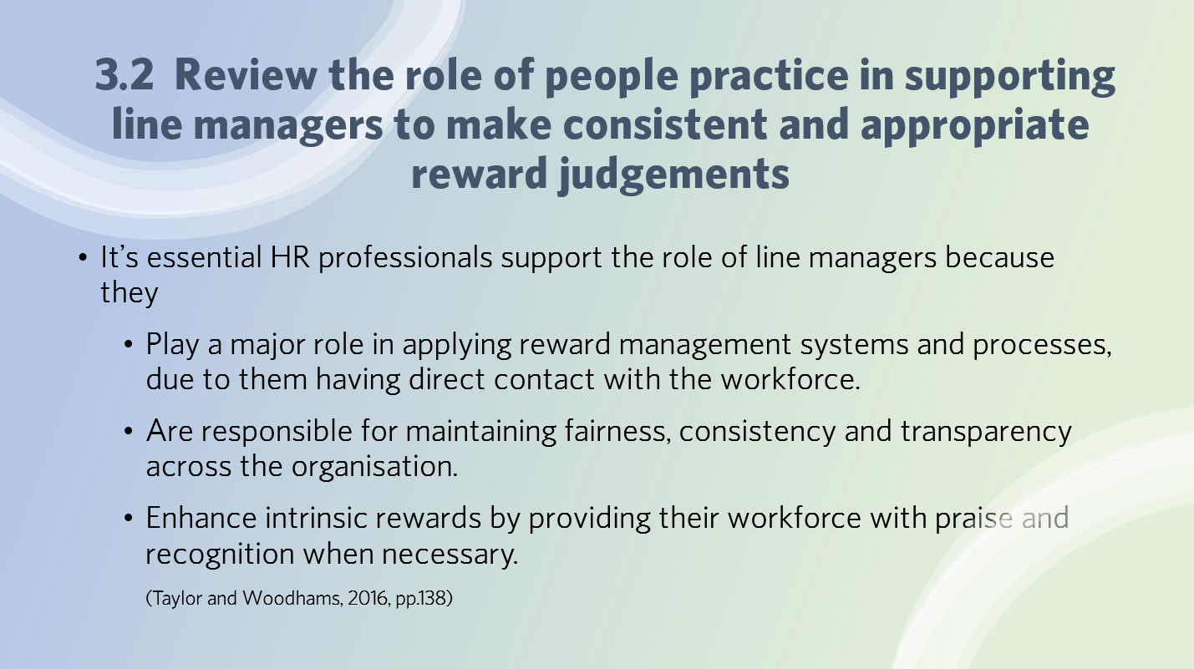
To support line managers HR professional must
- Find the time to support managers
- Consult with them on the reward management decisions and take into consideration their views and opinions. And support them by informing them when any external i.e. legislative decisions or internal variables that could affect the effectiveness of the reward decisions, systems and processes, making then redundant.
- Provide them with uncomplicated performance management systems to ensure managers do not cut corners or make hasty decisions. And are able to deal with the negative aspects and not only rewarding the positive performance.
- Explain and help them understand the pay structures in place, how to apply them and when it’s appropriate to distribute financial and non-financial rewards. To ensure consistency of rewards throughout the workforce.
- Provide training to enable them to make informed and objective decisions about performance and competencies to ensure the final reward decisions are consistent and fair.
- Ensuring the provision of adequate policies and procedures/guidelines to support them in the managing performance effectively. And to maintain equality, fairness consistency and transparency.
- Ensure there is no unfair discrimination when distributing rewards, if not recognised it could cause issues around equality and diversity which can have a negative impact on the psychological contract.
- Supporting line managers ownership of intrinsic and extrinsic rewards, training, job evaluation, promoting responsibility,
(Taylor and Woodhams, 2016, pp.138)
According to Brown & Purcell (2007) they stated how can your reward arrangements ever be effective if you managers can’t manage and communicate them (Armstrong book section 31)
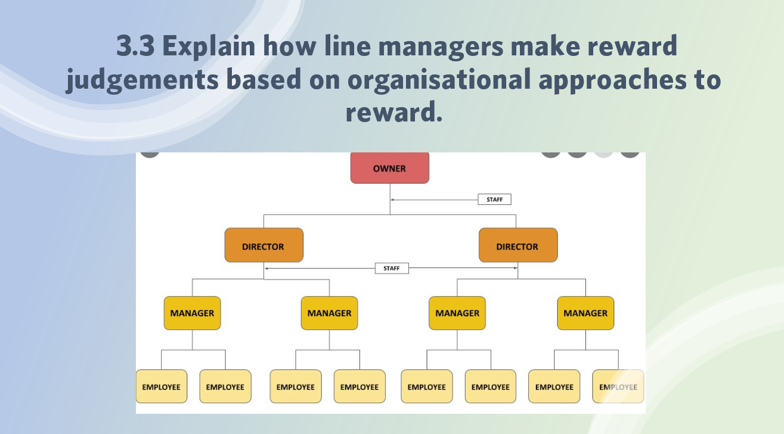
Line managers are positioned between the organisation leaders and lower levels of staff to whom they are responsible for. They play a crucial role in maintaining consistency, transparency and fairness throughout their department whilst understanding and applying company policies and procedures. Whilst promoting the organisations values and beliefs. They aren’t often involved in the setup of reward management, but their views and opinions should be considered.
Their role involves
- Identifying clear goals and objectives, analysing performance data and providing fair and constructive feedback. Linking this to training and development plans which often determines the pay grades awarded.
- Setting of objectives.
- Ensuring the working conditions are safe and free from hazards.
- Awarding intrinsic awards, recognising achievement and providing their staff with praise and recognition when necessary.
- Treating all employees equal and doesn’t unfairly discriminate against anyone.
- Provide support and building team spirit.
It is essential line managers are provided with the training and ongoing support to make effective reward decisions to avoid alienating and demotivating its employees.
(Taylor and Woodhams, 2016, pp.138)
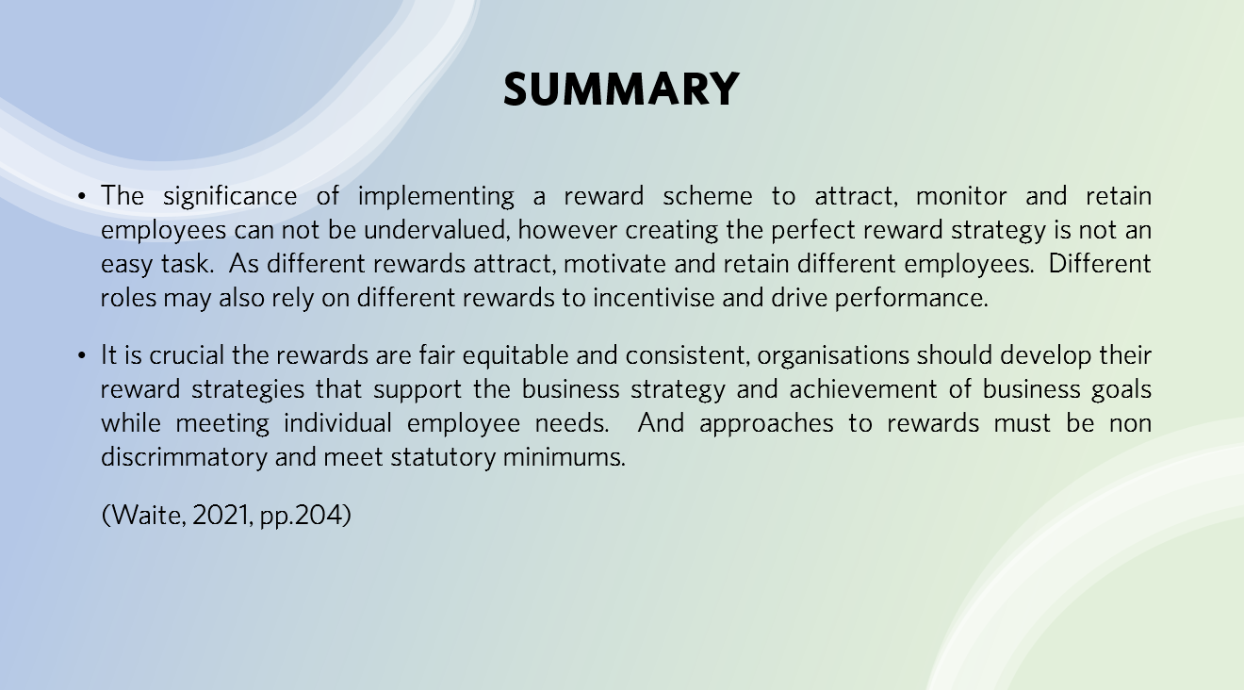

Bibliography
- ACAS (2014). Job evaluation: considerations and risks advice booklet | Acas. [online] www.acas.org.uk. Available at: https://www.acas.org.uk/job-evaluation-considerations-and-risks-advice-booklet [Accessed 7 May 2022].
- Armstrong, M. and Brown, D., (2019). Armstrong's Handbook of Reward Management Practice. London: Kogan Page, p.29.
- Armstrong, M. and Brown, D. (2019). Armstrong’s handbook of reward management practice improving performance through reward. 6th ed. London Koganpage, p.358.

- Business Victoria. (2021). Benchmark your business. [online] Available at: <https://business.vic.gov.au/business-information/marketing-and-sales/increasing-sales-through-marketing/benchmark-your-business> [Accessed 23 April 2022].

- CIPD (2020). Performance Appraisal | Factsheets | CIPD. [online] CIPD. Available at: https://www.cipd.co.uk/knowledge/fundamentals/people/performance/appraisals-factsheet [Accessed 14 May 2022].

- Cipd (2021). Job Evaluation & Market Pricing | Factsheets. [online] CIPD. Available at: https://www.cipd.co.uk/knowledge/strategy/reward/market-pricing-factsheet#gref [Accessed 12 May 2022].
- Compete. (2022). The leading compensation platform for HR Leaders. [online] Available at: <https://www.competewith.com/> [Accessed 24 April 2022].

- Process, B., (2016). Benchmarking Process. [online] Constructionforum-myanmar.com. Available at: <https://www.constructionforum-myanmar.com/2016/04/benchmarking-process.html> [Accessed 23 April 2022].

- Hajduk, P., (2017). What’s the real value of reward?. [online] Peoplemanagement.co.uk. Available at: <https://www.peoplemanagement.co.uk/article/1743866/real-value-reward#:~:text='Reward'%20encompasses%20everything%20an%20employee,meaningful%20contribution%20through%20their%20work.> [Accessed 23 April 2022].

- Lucidchart.com. (2022). 8 Steps of the Benchmarking Process | Lucidchart Blog. [online] Available at: <https://www.lucidchart.com/blog/8-steps-of-the-benchmarking-process> [Accessed 25 April 2022].

- Powell, C. (2022). WDP overhauled its benefits strategy to provide what was important to employees. [online] www.peoplemanagement.co.uk. Available at: https://www.peoplemanagement.co.uk/article/1746560/wdp-overhauled-benefits-strategy-provide-important-employees [Accessed 14 May 2022].

- REBA (2019). Three ways to build organisational culture around reward and recognition. [online] reba.global. Available at: https://reba.global/resource/three-ways-to-build-organisational-culture-around-reward-and-recognition.html.

- Service Hospitality. (2020). Have you reviewed your policies & procedures? - Service Hospitality. [online] Available at: <https://servicehospitality.com/have-you-reviewed-your-policies-procedures/> [Accessed 1 May 2022].

- Shutterstock. (2022). Benchmarking. [online] Available at: <https://www.shutterstock.com/search/benchmarking> [Accessed 24 April 2022].

- system/90112/?keywords=DIFFERENT+APPROACHES+TO+PERFORMANCE+MANAGEMENT&searchrank=1> [Accessed 25 April 2022].

- Taylor, S. and Woodhams, C. (2016). Human resource management : people and organisations. 2nd ed. London: Chartered Institute Of Personnel And Development, pp.113–115.

- Taylor, S. and Woodhams, C. (2016). Human resource management : people and organisations. 2nd ed. London: Chartered Institute Of Personnel And Development, pp.113–130.

- Taylor, S. and Woodhams, C. (2016). Human resource management : people and organisations. 2nd ed. London: Chartered Institute Of Personnel And Development, pp.113–138.

- Trivedi, P. (2017). Meaning of ‘Performance’ in Government Performance Management. [online] PA TIMES Online. Available at: https://patimes.org/meaning-performance-government-performance-management/ [Accessed 14 May 2022].

- Waite, K., Bevers, K., Small, N., Tomlinson, K. and Hussain, S., 2021. People practice. 1st ed. London: Kogan Page Limited, p.200.

- Wellness, B., (2022). Intrinsic vs. Extrinsic Rewards to Improve Employee Engagement. [online] Bravowell.com. Available at: <https://www.bravowell.com/resources/intrinsic-vs.-extrinsic-rewards-to-improve-employee-engagement> [Accessed 23 April 2022].

- Xperthr.co.uk. (2022). Building an effective performance management system | Employee performance and development | Good practice manual | Tools | XpertHR.co.uk. [online] Available at: <https://www.xperthr.co.uk/good-practice-manual/building-an-effective-performance-management-

