

RESULT

ASSIGNMENT DETAILS AND FEEDBACK

SOUTH WEST WALES CENTRE OF TEACHER EDUCATION

Sections marked with * should be completed by module lead
Student name: | Zoe Thomas | Student number: | 1501440
Programme: | BA Primary Education with QTS
Module: * | Enterprising and Creative Teaching and Learning | Module Level (4, 5, 6): | 6
Module code: * | ECAD6004/C | Contribution to Overall  Module Assessment (%): * | 50%
Module Lead:* | Mr T. Cox
Start date:* | 3/10/17 | Assignment No (x of x):* | 1 of 1
Submission deadline:* | 15/12/17 | Return date of provisional marks & written feedback:* | 26/1/18
Assignment Title:* | Critically evaluate your creativity and enterprise dispositions in terms of the Entrecomp frame work and how you might develop these to the next level and demonstrate progression.

Referencing: | In the main body of your submission you must give credit to authors on whose research your work is based. Append to your submission a reference list that indicates the books, articles, etc. that you have read or quoted in order to complete this assignment (e.g. for books: surname of author and initials, year of publication, title of book, edition, publisher: place of publication).
Submission: | All assignments must be submitted to Turnitin unless otherwise instructed by the Lecturer.  Note: the Turnitin version is the primary submission and acts as a receipt for the student. Late submission of the electronic version of the assignment will result in a late penalty. Penalties for late submission: Up to one week late, maximum 40%. Over one week late will be recorded as a non-submission. Late submission penalties may be lifted only with the approval of the Extenuating Circumstances Panel. | Date: | 15/12/17

Module lead to tick to indicate if a hard copy version of the assignment must be submitted.* | YES
 | NO | X

marking criteria and Student FEEDBACK

This section details the assessment criteria. The extent to which these are demonstrated by you determines your mark. The marks available for each criterion are shown. Lecturers will use the space provided to comment on the achievement of the task(s), including those areas in which you have performed well and areas that would benefit from development/improvement.

Common Assessment Criteria Applied | Marks available | Marks  awarded
1. Subject Knowledge and Understanding (which includes using research-informed literature and knowledge and understanding of the subject)  Extent of research and/or own reading, selection of credible sources, application of appropriate referencing conventions. Extent of knowledge and understanding of concepts and underlying principles associated with the discipline. | 30
2. Intellectual Skills (Analysis)  Analysis, evaluation and synthesis; logic, argument and judgement; analytical reflection; organisation of ideas and evidence | 30
3. Pedagogic and Professional Applications (Practical Application and Deployment)  Deployment of pedagogic methods, materials, tools and techniques; application of concepts; formulation of innovative and creative solutions to solve problems. Attributes in professional practice: individual and collaborative working | 30
4. Key Transferable Skills  Deployment of appropriate media; presentation and organisation. | 10
Assignment Mark (Assessment marks are subject to ratification at the Exam Board. These comments and marks are to give feedback on module work and are for guidance only until they are confirmed. ) | Late Submission Penalties (tick if appropriate) |  | %
 | Up to 1 week late | 40% Max | %
 | Over 1 week late | 0% | %

Student Self Evaluation Form
This section repeats in brief the common assessment criteria detailed on previous pages. The extent to which these are demonstrated by you determines your mark. Using these criteria, tick the box that best indicates the level of achievement you feel you have achieved with regard to each of them.

Common Assessment Criteria Applied | Level of Achievement
Common Assessment Criteria Applied | REFER |  | 3rd | 2:2 | 2:1 | 1st | 1st
 | OUTRIGHT FAIL | UNSATISFACTORY | SATISFACTORY | GOOD | VERY GOOD | EXCELLENT | EXCEPTIONAL
1. Subject Knowledge and Understanding (which includes using research-informed literature and knowledge and understanding of the subject) | 0-29% | 30-39% | 40-49% | 50-59% | 60-69% | 70-79% | 80-100%
 |  |  |  |  | \/
2. Intellectual Skills (Analysis) | 0-29% | 30-39% | 40-49% | 50-59% | 60-69% | 70-79% | 80-100%
2. Intellectual Skills (Analysis) |  |  |  |  | \/
3. Pedagogic and Professional Applications  (Practical Application and Deployment) | 0-29% | 30-39% | 40-49% | 50-59% | 60-69% | 70-79% | 80-100%
 |  |  |  |  | \/
4. Key Transferable Skills | 0-29% | 30-39% | 40-49% | 50-59% | 60-69% | 70-79% | 80-100%
4. Key Transferable Skills |  |  |  |  | \/
Student’s Name | Zoe Thomas | Date | 15/12/17
Student’s Signature | Z. Thomas

PLEASE COMMENT ON AREAS IN WHICH YOU FEEL THAT YOU HAVE PERFORMED WELL | PLEASE COMMENT ON AREAS you feel that you need TO DEVELOP
I feel I do have a deeper understanding of the topics and of the Entrecomp framework. I feel the amount read and references used is sufficient. I feel using a variety of writing styles, both on personal experiences and academic for the research was done well. | I feel this was difficult to talk about all the research and findings and personal experiences in the limited word count. There were many aspects that could have been looked at deeper and further. I feel I need to further develop my synthesising skills in order to say everything I want to say.

Critically evaluate your creativity and enterprise dispositions in terms of the Entrecomp frame work and how you might develop these to the next level and demonstrate progression.

Creativity is something described by NACCCE (1999) and Robinson (2013) as being an activity that will then result in an idea that is imaginative, original and has value. When NACCCE (1999) discuss the idea of ‘value’, this can be different to everyone. Grigg (2015) notes that there are different types of creativity, one being related to those such as scientists, artists and musicians, the typical people thought of when the words creativity are used, however, there is also one that is more individual and personal, this is where an individual has an idea that is new, meaningful and has value to them. Something of value to one person may be completely different to the next person. Barnes (2015:270) states that everyone is and can be ‘a creative being’.

Robinson (2013) and Grigg (2015) state that creativity is a process, you do not often end up with the idea you started with, the process involves questioning, exploring ideas and making connections.

Runco (2014), Land (2012) and Seelig (2012) believe that children are more creative than adults. Land’s (2012) research and study proved this. 98% of children aged five were classified as being genius’ whereas only 2% of adults scored that high. Seelig (2012:8) says that as adults, with pressures and expectations creativity does take a back seat, she says that ‘natural curiosity and creativity’ is shut down due to them having to deliver what is expected from them. If working under pressure, which occurs more as adults, only a small proportion of the brain is used, this limits the ideas (Land, 2012). He states that there is two kinds of thinking, divergent which uses ones imagination and then convergent which is where making judgements and being critical begin. Cook (2016) says that ideas must be appropriate and be able to turn into successful valuable outcomes. This is promoting the use of convergent thinking rather than divergent. Convergent thinking does not require much creativity. By thinking in a divergent manner, more ideas will be thought of, after this process takes place then the convergent thinking can begin. It is the responsibility of teachers to ensure these imaginative ideas are thought of by creating an environment where they feel comfortable and emotionally safe. Seelig (2012) says that attitude changes and adults use convergent thinking, limiting creative new ideas being thought of, this supports why creativity levels decrease as time goes on.

A disposition is similar to a habit, Dottin (2010) says that it is not about what teachers can do and know but is an end product, it relates to how they would go about carrying out a task. Prior experience and knowledge will always have an effect on ones dispositions. Dispositions are ones characteristics, (Gartner and Bellamy, 2009). Langer (1989, cited in Runco 2014:34) suggests that this may not be a good thing, she notes that one’s creativity will only develop if automatic responses and those, dispositions and habits are avoided. She suggests looking at new experiences to overcome and problem solve. Runco (2014) states that children are spontaneous and do not always need past experiences and routines to overcome certain situations, however, adults have more experiences and often rely on dispositions and routines therefore resulting in it being more difficult to think creatively.

Bacigalupo et al. (2016) created the Entrecomp framework. The Entrecomp framework and in particular the Entrepreneurship as a competence was devised to help people out in the community and countries develop certain skills that would enable them create original valuable ideas, engage and participate within society and to live their lives as best as possible. This relates almost exactly to the thinking of Donaldson (2015) where he proposes the new curriculum purposes. Donaldson (2015) has the uncertain, fast changing future in mind when he proposes that he wants to see learners become equipped with skills in order to be creative and enterprising contributors and be ambitious and confident valued citizens within the community and society.

The framework is comprised of 15 competencies which is divided into three areas; ideas and opportunities, resources and into action, altogether making the entrepreneurship competence, not all of these competencies need to be equal in regards to standards and proficiency, however, all 15 do make up a whole, in this instance it is the entrepreneurship competence.

Many competencies overlap and can link with many others, for example, in order to be good at planning and management, mobilising resources and also working with others would be a part of this organisation and management. As a teacher you are required to manage resources, support staff, have a vision and spot opportunities. Many of these are requirements of a good effective teacher.

The competencies of creativity, self-awareness and self-efficacy and planning and management will be looked at in greater detail in regards to my personal level.

Looking at creativity from the ideas and opportunities area, after understanding the outcomes I feel more confident in some areas than others. Grigg (2015:102) suggests that ‘creativity usually follows passion’ I strongly agree with this, in order for you to be confident and share good ideas and think outside the box you are required to be motivated and passionate. I am passionate about teaching, in most subject areas. Some subject areas I am less confident, however this is something I need to address and gain experience and confidence in. My personal creativity competence is important and is an important area to keep working on. Claxton (cited by Pound, 2009:16) notes that for children to learn, adults and teachers must demonstrate and model what they want them to learn and develop, this includes creativity. It is important for teachers to be as creative as possible in order for the learners to observe and learn from this. I would say I am currently at level 4 with some elements of level 3. Testing the value of my solutions with the pupils at the end, especially as a trainee teacher this was important. To do this assessment for learning was used, self and peer marking and the work was discussed. I also feel that tailoring my skills around certain problems is an area I am becoming more confident with, an initial idea was discussed and then using personal past experiences I was able to decide on a Victorian themed day and plan activities that again I felt most confident in, see appendix 8. When it came to experimenting with my skills in new and different situations I feel this is an area I wish to develop further in particular. I did try as many new subjects and skills as possible, I just wish to develop confidence in doing this. I said this particular area was a level 3.

In the resources area within the framework I have chosen to look at self-awareness and self-efficacy. This relates to believing in yourself and wanting to continue your personal development. Self-efficacy and self-awareness are said to be important factors when looking at ones metacognitive processes (Gravill et al, 2002), the way in which we think about our thinking. Grigg (2015) states that to be a successful teacher, it is not just important to know your pupils and subject knowledge but to also know yourself. Again I felt this was a mixture between level 3 and 4, I felt I can commit to carrying out tasks for my needs, interests and targets, however I can also reflect on my personal needs in relation to where I want to be next, looking into the future. As mentioned previously I was willing and wanted to teach new subject areas in preparation for the future in regards to starting my career, I wanted to cover as much as possible, this is evident in appendix 2 and 7. I would also confidently say a level 4 in the sense that I am motivated and happy to use my strengths and abilities in order to create valuable opportunities. I am a swimming teacher and have been for several years, this is an area I feel confident in so offered my placement school my time after placement had finished to help and lead the school swimming lessons, see appendix 4.

Thirdly I will assess myself in is the planning and management, the into action area. Grigg (2015) highlights that planning is important, it involves many things, setting goals, and developing ways to both teach and reach these goals. This I feel I am level 4, I can set short term goals and ensure I set ways of measuring how and when I have reached these goals, using action plans, see appendix 3 and 5. During placement I found being adaptable and being able to change plans an important skill, therefore giving myself a level 4 in this. Due to the nature of the school and it being a very small school, there was always changes or something on for the teacher to attend to so then lessons would be rearranged and brought forward, and covering for meetings and courses took place. I feel this was challenging at the time but I was able to continue and act professional and always tried my best, see appendix 1.

Personally I feel there is a need to develop on certain aspects and areas mentioned above. A teacher never stops learning and should always look to keep developing, especially with the changing times ahead, Donaldson (2015) wants individuals ready to learn throughout their lives. I can confidently place myself in the ‘intermediate area’, which specifies building independence, I feel this best describes where I am currently at. Working both individually and with peers and colleagues to share and take responsibilities. Experimenting and beginning to dare to take risks and try new approaches and teach new subject areas and then learn from these experiences whether the outcomes are positive or negative. Each will be a development to my learning and an insight into where I go next.

To develop my creativity the entrecomp framework outcomes suggest that I look into delivering and completing a creative project, so a series of lessons to develop my understanding of creativity being used across the curriculum and over a longer period of time. It will be interesting to see how this works and what it looks like. To also search for other methods of teaching, to use variations. If there is too much of a routine then this can hinder creativity, (Runco, 2014). Land (2012) says that you learn to be creative by experimenting – I will try new things whether it be class management techniques or teaching new topics and learn from them. Also by exploring, again exploring what I have yet not done, I will observe good practice and trial new things. Questioning also helps with creativity, I will question why and start asking what if to ensure I start to think outside of the box and also using imagination. Seelig (2012) created the innovation engine, this is a model which can help develop my creativity. Some of the components are knowledge which acts as the tool box, you need knowledge to be creative. Robinson (2013) states that Michael Gove believes that creativity cannot be developed unless the skills and knowledge are learnt first. For example one cannot be creative on the guitar if they don’t know how to play guitar, however, Rogers (2016) explains that he learnt musical instruments without understanding how to read notes, he goes on to say that creativity can be messy and disorganised, it does not mean it is not happening. Imagination and attitude are also components of the innovation engine which relate to Costa’s and Kallick’s (2008) habits of mind. Land (2012) proposes that creativity can be learnt. He says that you can exercise and train the brain to start being more innovative and creative. I will take these into consideration and try and exercise my brain to think more creatively.

Relating to the self-efficacy and self-awareness, believing in yourself and the desire to keep developing is something I strongly agree with. Donaldson (2015) discusses on numerous occasions how he feels the need to have lifelong learners and to ensure that everyone is ready to learn throughout their lives. Learning does not stop. Schultz and Schultz (2016) say that self-efficacy can be increased. Grigg (2015) highlights that self-awareness can also be improved, to do this you would reflect, research, set goals and talk with professionals. To improve on these personally I feel self-confidence is an area I need to develop, to develop onto the advanced outcome, I need to ensure my work and teaching can influence people and their work in a positive manner. I enjoy teaching new subjects and using different approaches to class management and other activities, confidence in doing so to ensure I feel comfortable is something I need to do. It is beneficial as a teacher to have strong self-efficacy, Grigg (2015) says that it can help learners increase their motivation and engagement, it allows the teacher to have more patience with certain individuals. It has many benefits.

To improve my planning and management, there is evidence from feedback that suggests I need to look further ahead when planning, I am able and confident in providing short term goals and planning however I need to develop this further in order to have detailed information about medium and long term planning, see appendix 6. This needs to be done to gain levels 6 and 7, making the links between all 3 elements of the planning. This is an important and vital aspect of teaching. The habits of mind is another approach towards ensuring learners have the qualities to be successful in the twenty first century. In regards to assessing these, Costa and Kallick (2008) suggest that goal setting is a priority, this is something I will take on board, especially for longer term goals.

Progression will be measured throughout the year and especially whilst out on placement. Progression in planning and management will be evident, prior to placement I will research and look into what and how medium and long term planning looks like and how they link, to ensure I will be confident in applying this knowledge whilst out in school. This will be evident on planning sheets during placement. Self-efficacy and awareness I will show progression by teaching in areas that I am least confident in and gaining experiences, Grigg (2015) says that those with strong self-awareness will learn from experiences whether they are positive or negative. Evidence of this could be in ARC reflections, a personal diary where I can express how I think the lesson went and how I felt. Do this over a few weeks and then compare to look for improvement. Barnes (2015) highlights that assessing and measuring creativity is difficult. Progression will be evident in the lessons that are taught and reflected on through arcs and action plans, you will see a variety of lessons and more project based activities adopting a cross-curricular approach to enhance learners’ creativity as well as my own..

Costa and Kallick (2008) say that due to the changing and twenty first century way of living, teachers need to ensure that they are creating learners that have the confidence and abilities to be creative, innovative and be independent. They suggest that with an understanding of the habits of mind, they can be used to ensure learners meet the ‘vision’ requirements of being independent, creative, capable and confident individuals. Donaldson (2015), Sharp (2004 cited in Grigg, 2015:107), Bacigalupo et al. (2016) have all put initiatives forward regarding ways to best prepare for the digitally driven future.

To conclude, I feel the Entrecomp framework doesn’t specifically look at developing and promoting creativity, however it is a competency and therefore recognised as being important in regards to the future of education and beyond. If these competencies and this framework works with and alongside other models and initiatives such as Donaldson’s (2015) four purposes and new curriculum, Seelig’s (2012) innovation engine, Costa and Kallick’s (2008) habits of mind and Grigg’s (2015) outlines of how to become an outstanding teacher then learners, educators, business owners and managers for example will be independent, creative and enterprising individuals ready to contribute and learn throughout their lives. I personally feel confident in what I have to develop in order to be as creative, enterprising and innovative as I can in order for my students to pick up from this.

Reference List:

Bacigalupo, M., Kampylis, P., Punie, Y., Van den Brande, G. (2016) Entrecomp: The Entrepreneurship Competence Framework. Luxembourg: Publication Office of the European Union. Available at: http://moodle.uwtsd.ac.uk/pluginfile.php/111407/mod_resource/content/1/Entrecomp%20Framework.pdf [Accessed: 10th December 2017].

Barnes, J. (2015) Cross-curricular Learning 3-14. (3rd ed.) London: SAGE.

Cook, P. (2016) Leading Innovation, Creativity and Enterprise. London: Bloomsbury.

Costa, A. and Kallick, B. (2008) Learning and Leading with Habits of Mind: 16 Essential
Characteristics for Success. Alexandria: ASCD.

Donaldson, G. (2015) Successful Futures: Independent review of curriculum and assessment arrangements in Wales. Cardiff: Welsh Government.

Dottin, E. (2010) Dispositions as Habits of Mind: Making prrofsional conduct more intelligent. Plymoth: Rowman Littlefield.

Gartner, W. and Bellamy, M. (2009) Creating the Enterprise. Mason: Thompson South-Western.

Gravill, J., Marcolin, B. and Compeau, D. (2002) Metacognition and IT: The Influence of Self-Efficacy and Self-Awareness. Eighth Americas Conference on Information Systems. Available at: http://melody.syr.edu/hci/amcis02_minitrack/CR/Gravill.pdf [Accessed: 14th December 2017].

Grigg, R. (2015) Becoming an outstanding primay school teacher. 2nd ed. Routledge: London.

Land, G. (2012) Ted: ‘The Failure of Success’ available at: https://www.creativityatwork.com/2012/03/23/can-creativity-be-taught/ [Accessed: 14th December].

NACCCE (1999) All Our Futures: Creativity, Culture and Education. Available at: http://sirkenrobinson.com/pdf/allourfutures.pdf [Accessed: 13th December 2017].

Pound, L. (2009) How Children Learn 3: Contemporary thinking and theorists. London: Practical Pre School Books.

Robinson, K (2013) ‘To encourage creativity, Mr Gove, you must first understand what it is’, The Guardian, 17th May. Available at: https://www.theguardian.com/commentisfree/2013/may/17/to-encourage-creativity-mr-gove-understand [Accessed: 13th December 2017].

Rogers, C. (2016) Intellectual Disability and Being Human: A Care Ethics Model. Abingdon: Routledge.

Runco, M. (2014) Creativity: Theories and Themes, Research, Development and Practice (2nd ed.) London: Elsevier.

Schultz, D. and Schultz, S. (2016) Theories of Personality (11th ed) Boston: Cengage Learning.

Seelig, T. (2012) InGenius: A Crash Course on Creativity. London: Hay House.

Appendix 1
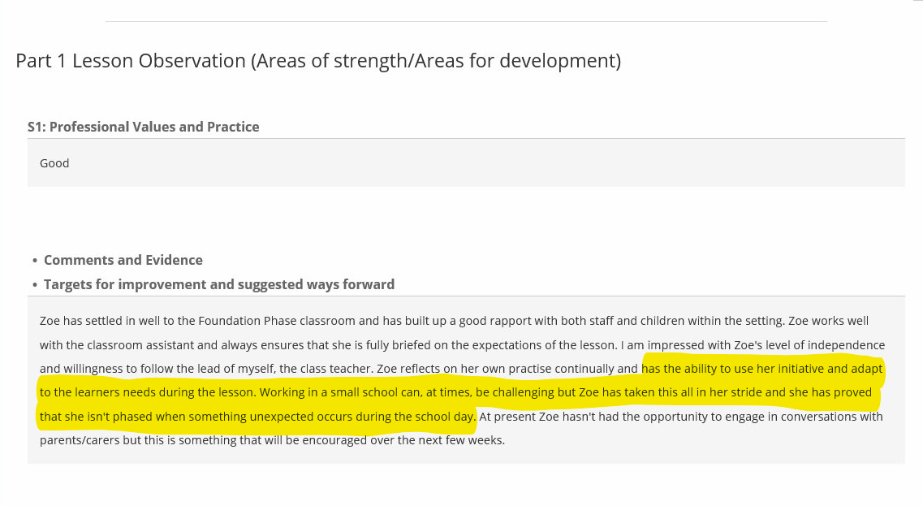
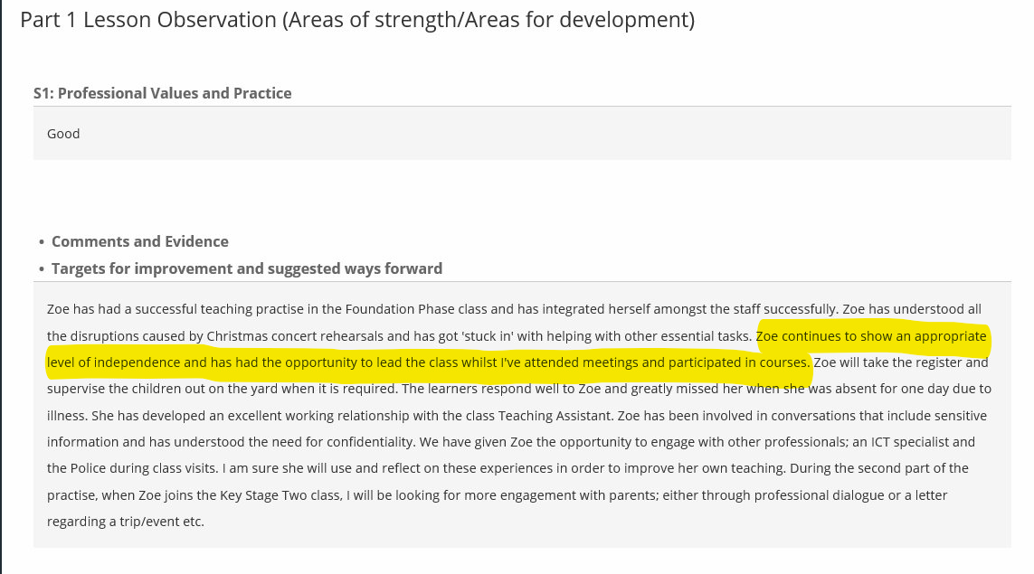

Appendix 2
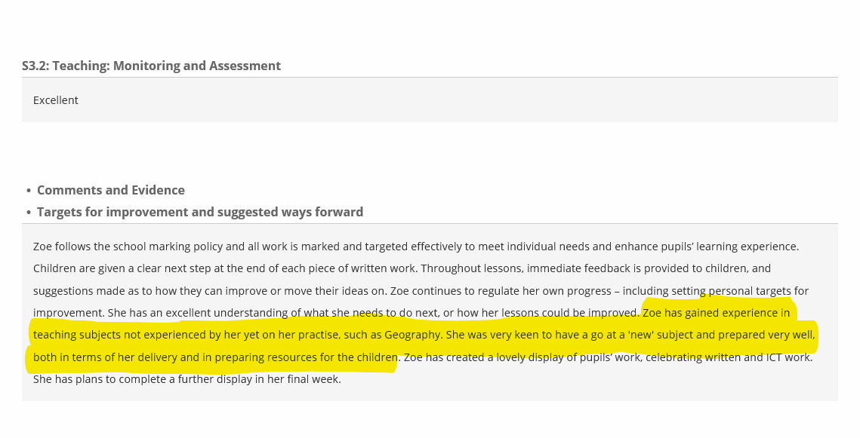
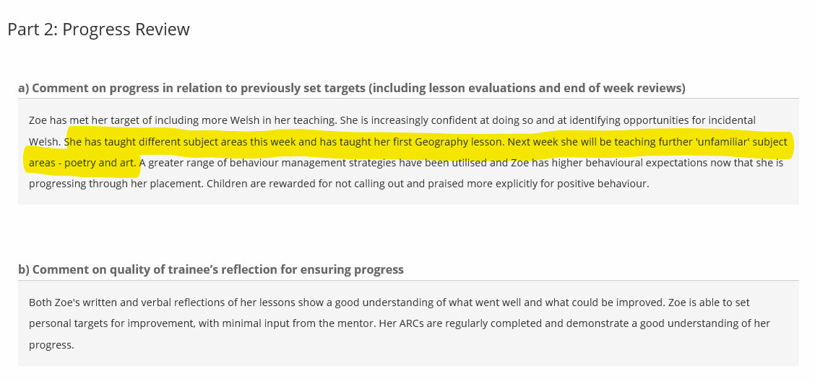

Appendix 3
Teaching new subject areas
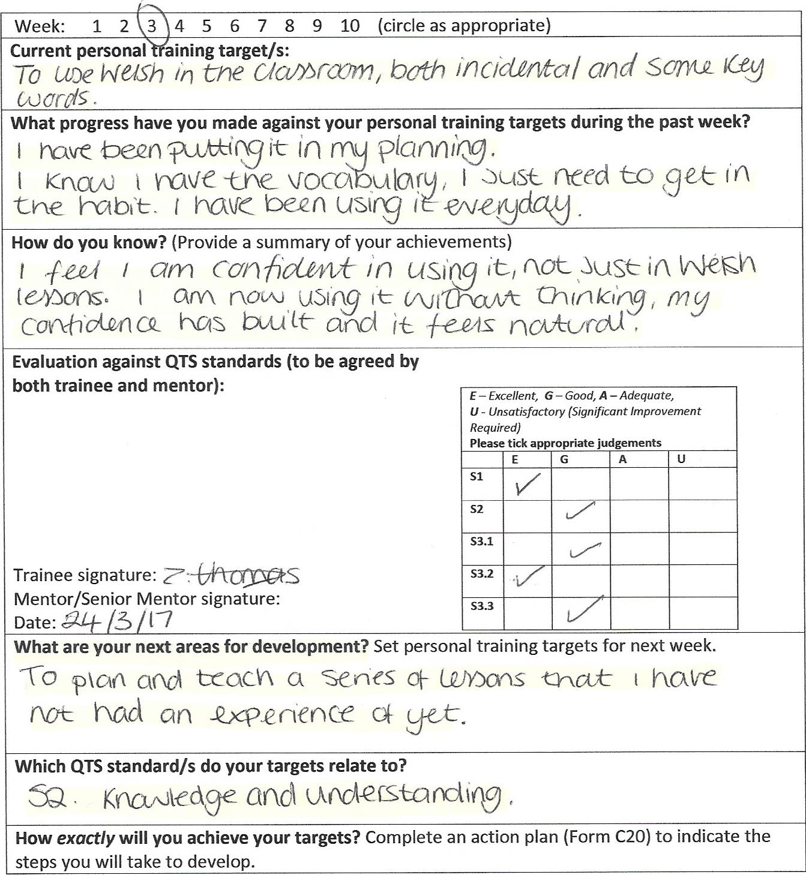Setting targets and goals via action plans in order to meet them.

Appendix 4
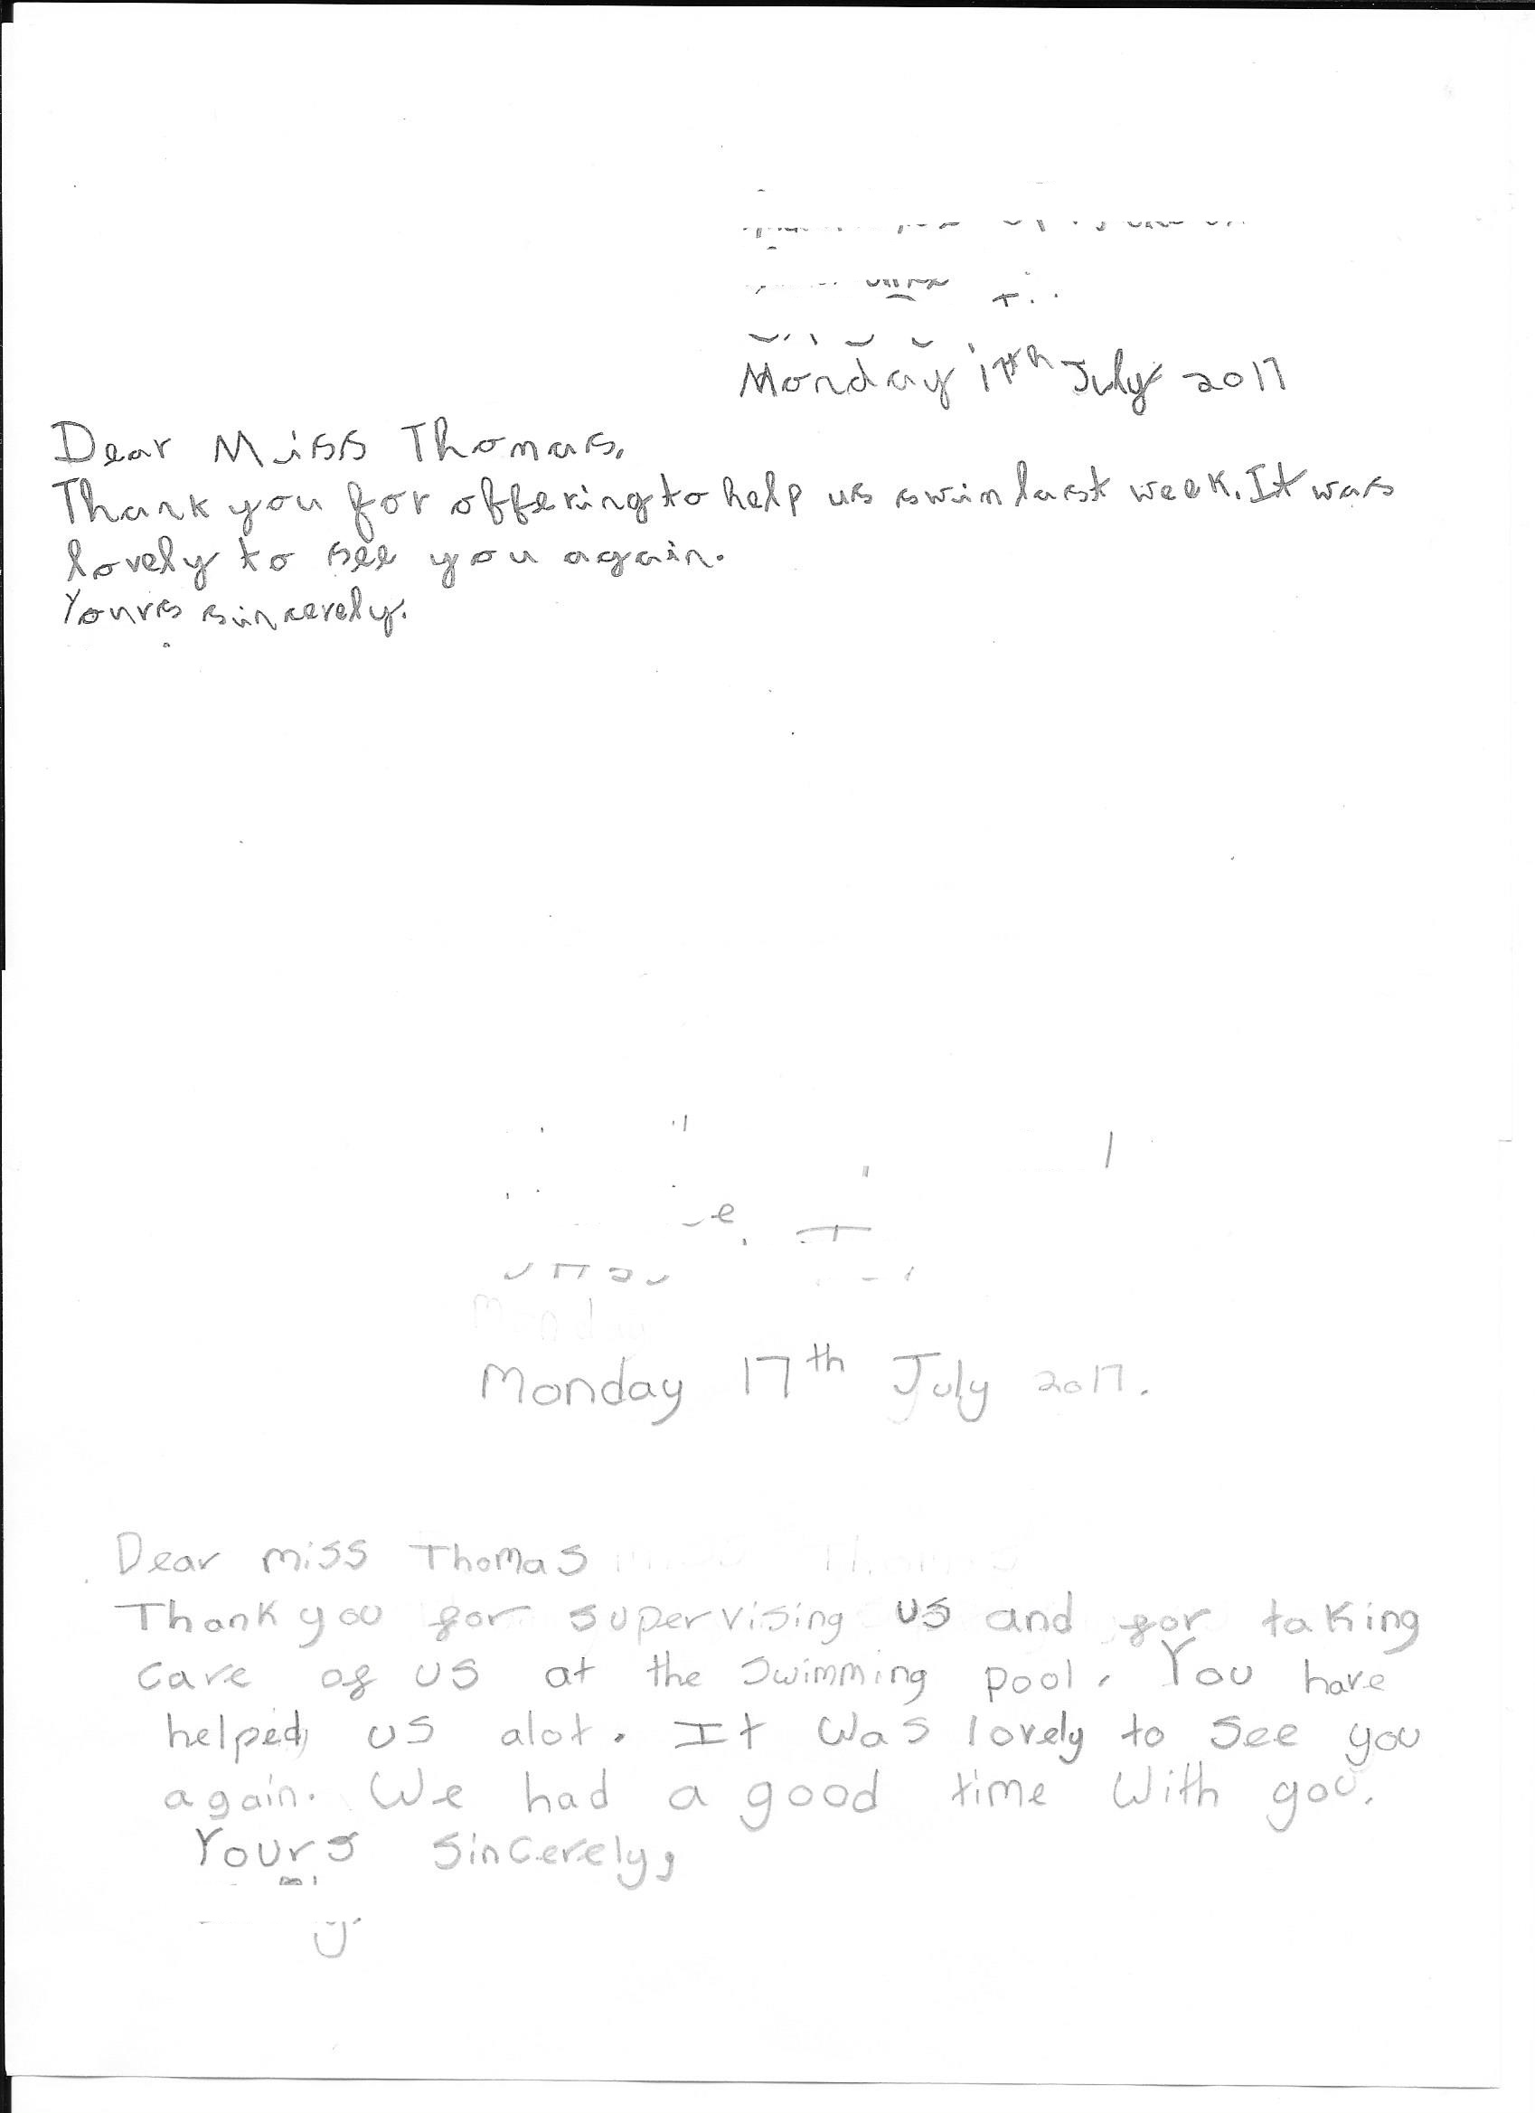

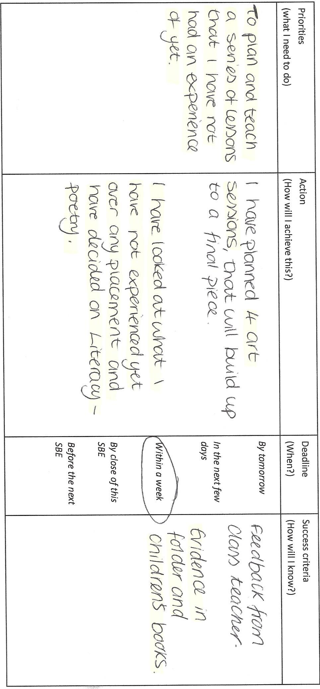Appendix 5

Appendix 6
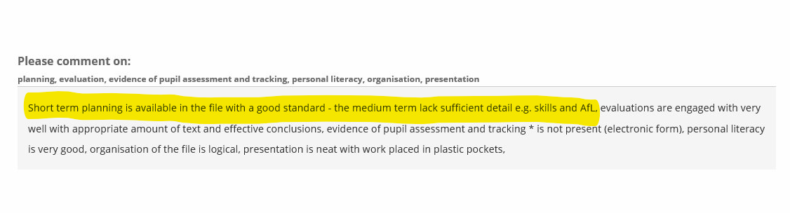
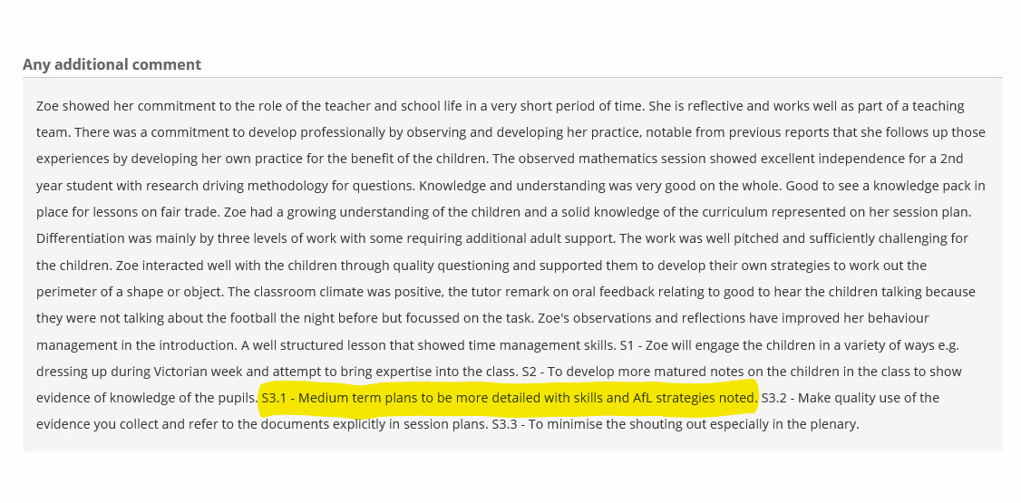

Appendix 7
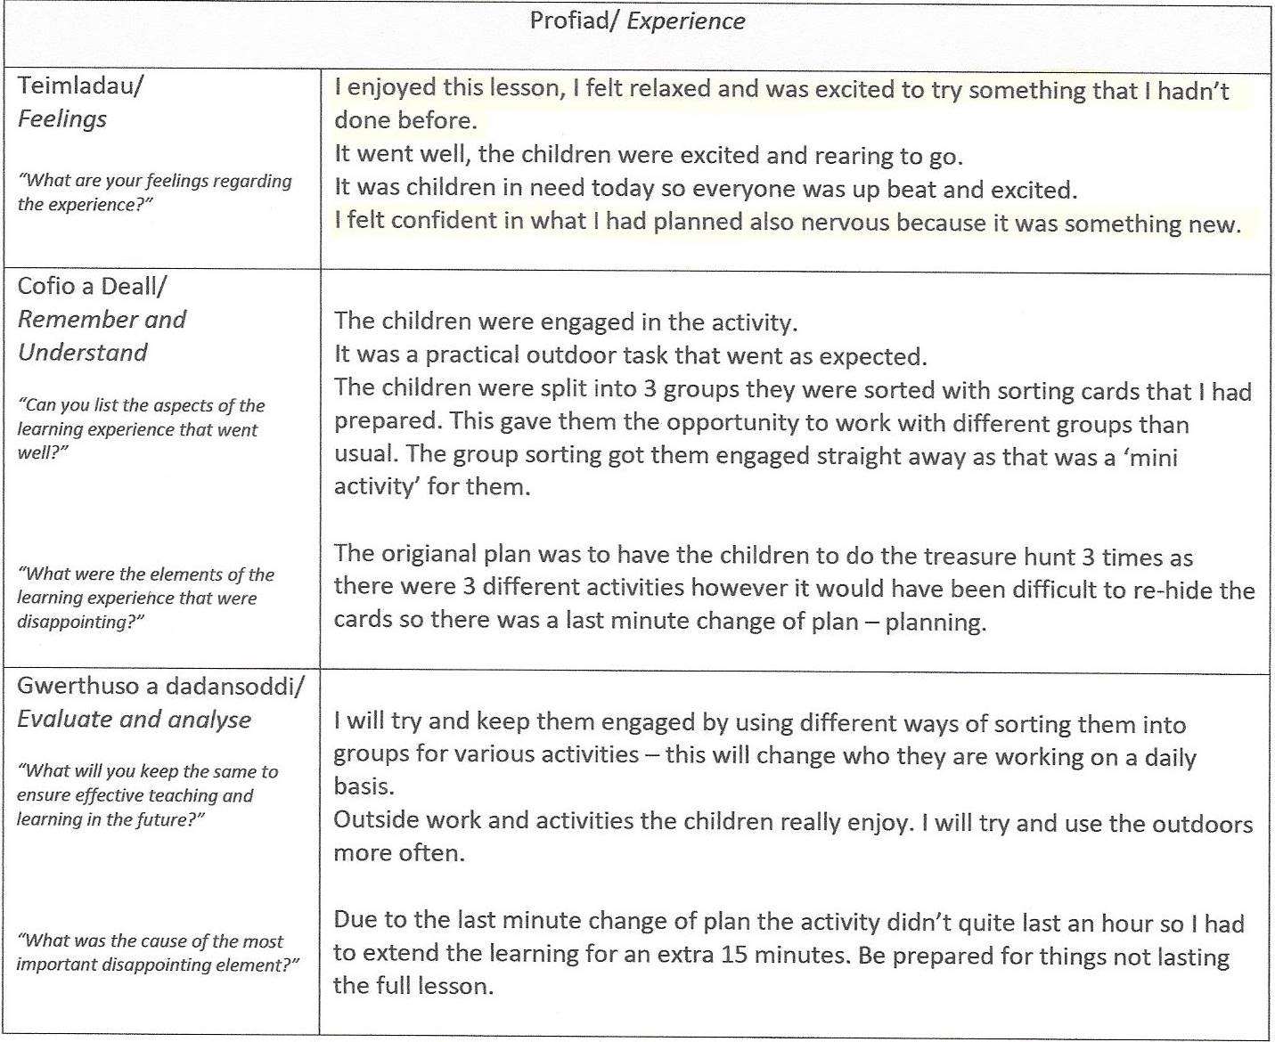

Appendix 8

