Handout 20 Data Analysis Using jamovi
- Exploratory factor analysis (Principal component or Principal axis) is used to identify the underlying dimensions of a construct.
- Cronbach's alphas are computed for each of the subscales
- Summated scores are calculated for all subscales which are used in the subsequent data analysis.
- Multiple regression analysis is used to examine the relative impact of the subscales in determining the dependent variable.
Open the file “Relational benefits”
- Principal Component Analysis
- Select Analyses and click Factor > Principal Component Analysis
- Drag and drop q1 to q11 to the Variables box
- Click the Component summary button beneath the Additional output option
Component Loadings
 |  | Component
 |  | 1 |  |  |  | 2 |  | Uniqueness
q1 |  |  |  |  |  | 0.800 |  | 0.360
q2 |  |  |  |  |  | 0.885 |  | 0.217
q3 |  |  |  |  |  | 0.902 |  | 0.182
q4 |  |  |  |  |  | 0.771 |  | 0.401
q5 |  |  |  |  |  | 0.518 |  | 0.730
q6 |  |  |  |  |  | 0.611 |  | 0.595
q7 |  | 0.870 |  |  |  |  |  | 0.235
q8 |  | 0.858 |  |  |  |  |  | 0.264
q9 |  | 0.921 |  |  |  |  |  | 0.145
q10 |  | 0.931 |  |  |  |  |  | 0.131
q11 |  | 0.900 |  |  |  |  |  | 0.186
Note. 'varimax' rotation was used
Component Summary
Component |  |  |  |  | SS Loadings |  |  |  |  | % of Variance |  |  |  | Cumulative %
1 |  |  |  |  | 4.06 |  |  |  |  | 36.9 |  |  |  | 36.9
2 |  |  |  |  | 3.49 |  |  |  |  | 31.8 |  |  |  | 68.7

Reliability Analysis
- Select Analyses and click Factor > Reliability
- Drag and drop q7 to q11 to the Variables box
Scale Reliability Statistics
 |  | Cronbach's α
scale |  | 0.938
- Click Factor > Reliability
- Drag and drop q1 to q6 to the Variables box
Scale Reliability Statistics
 |  | Cronbach's α
scale |  | 0.846

Compute summated scores
- Select Data
- Scroll to the end of the data column and move the cursor to the first empty column
- Click Setup and click New computed variable
- Type the name of the new variable (the variable name you will assign to the scale score) in the Computed variable box (e.g. Factor 1).
- In the Function box click the (f_{x}) button. Scroll down under Statistics and double click MEAN. It should read, = MEAN( ) in the function box
- From the Variables box select the variables that are included in the scale by double clicking each variable to move it into the parentheses.
- Add a comma between each variable in the parentheses. Once you have confirmed this, press enter and you are finished. It should read, MEAN(q7,q8,q9,q10,q11) in the function box.

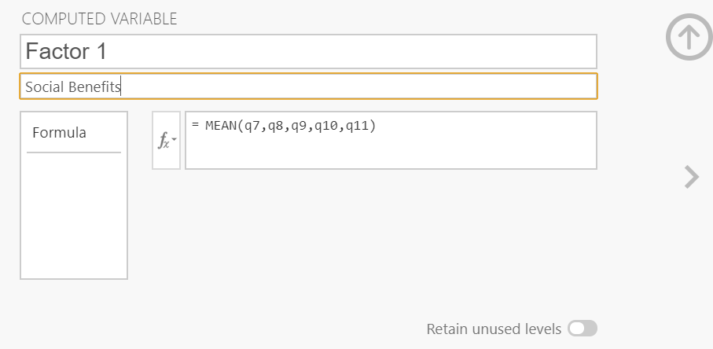

Linger Regression

Equation: Social benefits + Confidence benefits sat
- Select Analyses and click Regression > Linear Regression
- Drag and drop sat to the Independent variables box
- Drag and drop Social Benefits and Confidence Benefits to the covariates box
- Click the Model fit submen and click the F test button beneath the Model fit option
- Click the Model coefficients submenu and click the Standardized estimate button beneath the Standardized estimate option
Model Fit Measures
 |  |  |  |  |  | Overall Model Test
Model |  | R |  | R² |  | F |  | df1 |  | df2 |  | p
1 |  | 0.305 |  | 0.0932 |  | 5.14 |  | 2 |  | 100 |  | 0.007

Model Coefficients - sat
Predictor |  | Estimate |  | SE |  | t |  | p |  | Stand. Estimate
Intercept |  | 3.3875 |  | 0.6332 |  | 5.350 |  | < .001
Social_Benefits |  | -0.0515 |  | 0.0859 |  | -0.600 |  | 0.550 |  | -0.0575
Confidence_Benefits |  | 0.4035 |  | 0.1261 |  | 3.200 |  | 0.002 |  | 0.3071

Equation: Social benefits + Confidence benefits beh
- Select Analyses and click Regression > Linear Regression
- Drag and drop sat to the Independent variables box
- Drag and drop Social Benefits and Confidence Benefits to the covariates box
- Click the Model fit submen and click the F test button beneath the Model fit option
- Click the Model coefficients submenu and click the Standardized estimate button beneath the Standardized estimate option
Model Fit Measures
 |  |  |  |  |  |  |  | Overall Model Test
Model |  | R |  | R² |  |  |  | F |  |  |  | df1 |  | df2 |  |  |  | p
1 |  | 0.363 |  | 0.132 |  |  |  | 7.59 |  |  |  | 2 |  | 100 |  |  |  | < .001
Model Coefficients - Beh
Predictor |  |  |  |  |  | Estimate |  |  |  |  | SE |  |  |  |  | t |  |  |  | p |  |  |  | Stand. Estimate
Intercept |  |  |  |  |  | 2.295 |  |  |  |  | 0.5640 |  |  |  |  | 4.07 |  |  |  | < .001
Social_Benefits |  |  |  |  |  | 0.152 |  |  |  |  | 0.0765 |  |  |  |  | 1.98 |  |  |  | 0.050 |  |  |  | 0.186
Confidence_Benefits |  |  |  |  |  | 0.346 |  |  |  |  | 0.1123 |  |  |  |  | 3.08 |  |  |  | 0.003 |  |  |  | 0.289

Confirmatory Factor Analysis
- Select Analyses and click Factor > Confirmatory factor analysis
- Drag and drop q7 to q11 to the Factor 1 box
- Click the + Add new factor box
- Drag and drop q1 to q6 to the Factor 2 box
- Click the Estimates submenu and click the standardized estimate button beneath the Statistics option
Additional resources:
Quick start: https://www.jamoviguide.com/index.html
Advanced topics: https://lsj.readthedocs.io/en/latest/lsj/Introduction.html
Watch "Confirmatory factor analysis- jamovi" on YouTube https://youtu.be/2LzoRo3sziU
Watch "Confirmatory factor analysis- jamovi" on YouTube https://youtu.be/2LzoRo3sziU

Data Cleaning
- Univariate outliers
- Compute standardized scores to identify outliers. Cases with standardized scores in excess of 2.5 (p < .05) are potential outliers (Hair, Anderson, Tatham & Black, 2009). Some researchers suggest a cut-off point of 3.29 (p < .001).

- Normality
- Visual Method (boxplot)
- The boxplot shows the median as a horizontal line inside the box and the interquartile range (range between the 25th to 75th percentiles) as the length of the box.
- The whiskers (line extending from the top and bottom of the box) represent the minimum and maximum values when they are within 1.5 times the interquartile range from either end of the box.
- Scores greater than 1.5 times the interquartile range are out of the boxplot and are considered as outliers, and those greater than 3 times the interquartile range are extreme outliers.
- A boxplot that is symmetric with the median line at approximately the centre of the box and with symmetric whiskers that are slightly longer than the subsections of the centre box suggests that the data may have come from a normal distribution.
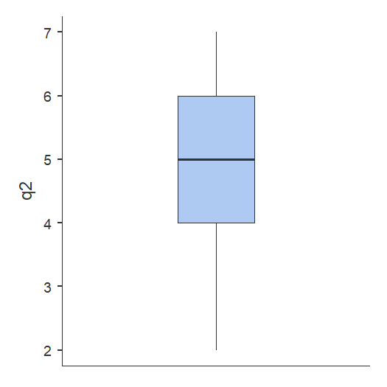 | 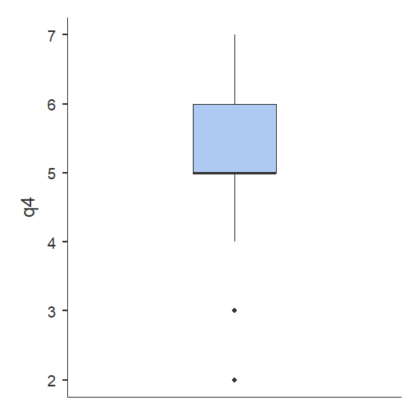
Boxplot of approximately normally Boxplot of skewed data
distributed data

- Histogram and Q-Q plot
Plotting a histogram of the variable of interest will give an indication of the shape of the distribution
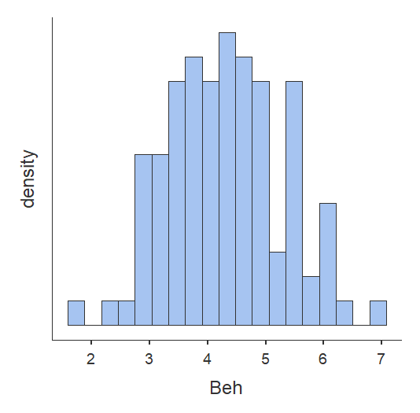 | 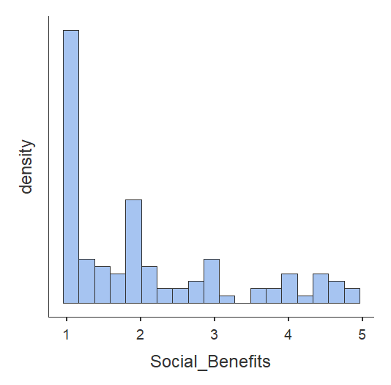
Histogram of approximately normally Histogram of skewed data
distributed data
Another way to check whether a sample violates the normality assumption is to draw a Q-Q plot (Quantile-Quantile plot). This allows you to visually check whether you're seeing any systematic violations. In a Q-Q plot, each observation is plotted as a single dot. The x coordinate is the theoretical quantile that the observation should fall in if the data were normally distributed (with mean and variance estimated from the sample), and on the y co-ordinate is the actual quantile of the data within the sample. If the data are normal, the dots should form a straight line.
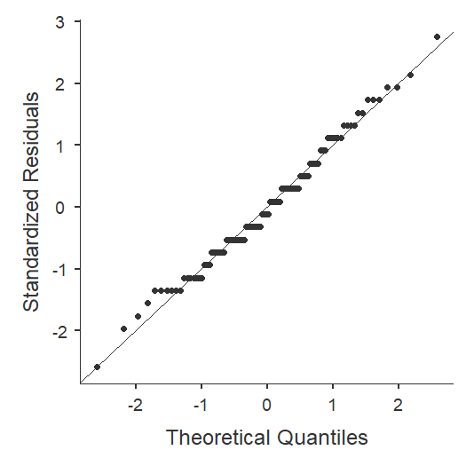 | 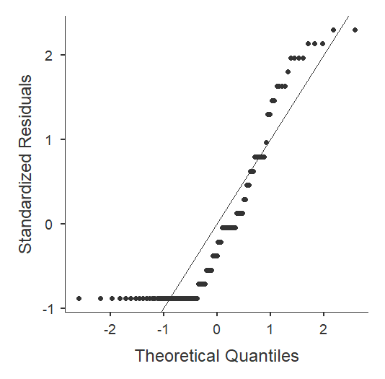
Q-Q plot of approximately normally Q-Q plot of skewed data
distributed data

- Skewness
Another technique is to calculate the skewness and kurtosis of the data set. The normal distribution is perfectly symmetrical with respect to the mean, and thus any deviation from perfect symmetry indicates some degree of non-normality in the measured distribution. Figure 1 provides examples of skewed distribution shapes.

Skewness can be a positive or negative number (or zero). Distributions that are symmetrical with respect to the mean, such as the normal distribution, have zero skewness. A distribution that “leans” to the right has negative skewness, and a distribution that “leans” to the left has positive skewness. As a general guideline, absolute skewness values that are less than 2 indicate sufficient normality.

Figure 1  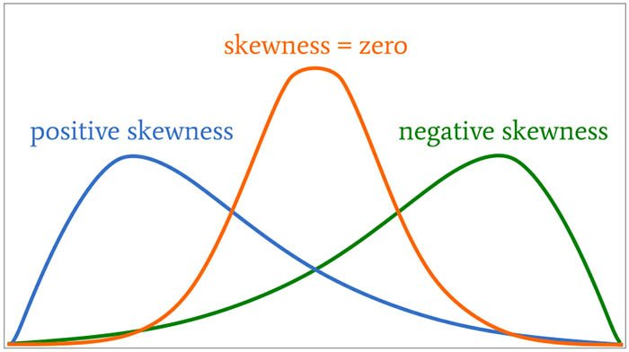 | Figure 2  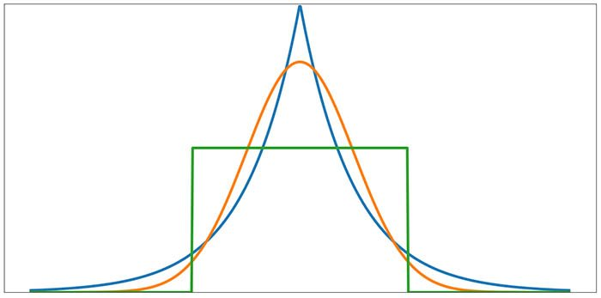
Depiction of positive skewness, skewness Notice that kurtosis greater than or less than 0
and negative skewness. corresponds to non-normal distribution shapes.

- Kurtosis

A measure of the "peakedness" or "flatness" of a distribution. A kurtosis value near zero indicates a shape close to normal. A negative value indicates a distribution which is more peaked than normal, and a positive kurtosis indicates a shape flatter than normal. An extreme positive kurtosis indicates a distribution where more of the values are located in the tails of the distribution rather than around the mean. A kurtosis value of +/-1 is considered very good for most psychometric uses, but +/-2 is also usually acceptable.

- Tests for assessing if data is normally distributed
There are also specific methods for testing normality but these should be used in conjunction with either a histogram or a Q-Q plot. The Kolmogorov-Smirnov test and the Shapiro-Wilk’s W test determine whether the underlying distribution is normal. Both tests are sensitive to outliers and are influenced by sample size. For smaller samples, non-normality is less likely to be detected but the Shapiro-Wilk test should be preferred as it is generally more sensitive. For larger samples (i.e., more than one hundred), the normality tests are overly conservative and the assumption of normality might be rejected too easily (see robust exceptions below). Any assessment should also include an evaluation of the normality of histograms or Q-Q plots as these are more appropriate for assessing normality in larger samples.

Chi-Square Test of Association
The Accident Rates of Public Light Buses (Minibuses) in Hong Kong

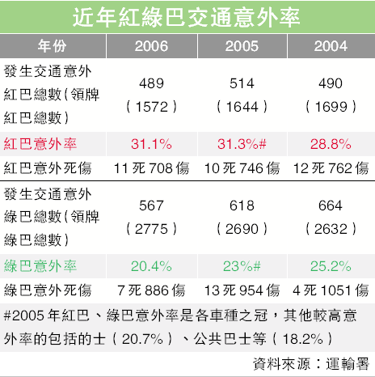
Total number of licensed Green Minibuses
Number of accidents
Number of green minibuses involved in accidents
Total number of licensed Red Minibuses
Number of red minibuses involved in accidents

Suppose you want to examine the public light buses’ accident rates. The data set contains the safety records of 4,347 minibus in Hong Kong in 2006. The first variable denotes the vehicle type (1 = red minibus, 2 = green minibus), the second variable denotes its safety records (1= involved in an accident, 2 = no accident).
- Open the file “Minibus traffic accidents 2006”
- Select Analyses and click Frequencies>Independent samples (χ² test of association)
- Drag and drop “vehicle type” to the Row box and “safety records” to the Column box
- Click the Cell submenu and click the row button beneath the percentage box option
Contingency Tables
 |  |  |  | Safety Records
Vehicle Type |  |  |  | 1 Involved in accident |  | 2 No accident |  | Total
1 Red minibus |  | Observed |  | 489 |  | 1083 |  | 1572
 |  | % within row |  | 31.1 % |  | 68.9 % |  | 100.0 %
2 Green minibus |  | Observed |  | 567 |  | 2208 |  | 2775
 |  | % within row |  | 20.4 % |  | 79.6 % |  | 100.0 %
Total |  | Observed |  | 1056 |  | 3291 |  | 4347
 |  | % within row |  | 24.3 % |  | 75.7 % |  | 100.0 %

H0: (null hypothesis) The two variables are independent.  H1: (alternative hypothesis) The two variables are not independent. (i.e., they are associated)
  χ² Tests
   |  | Value |  | df |  | p
  χ² |  | 62.2 |  | 1 |  | < .001
  N |  | 4347

