Population Health And Digital Health Promotion

Student Name : Neelkumar Patel
Student Id : 2504974
Tutor Name : Dr. Besty Jose

Task 1
Blog 1: Hypertension monitoring of UK older adults by smartwatch
1. Hypertension and risk among the United Kingdom older adults
Hypertension is a serious health risk among UK adults. It is a concern as 32% of UK adults have hypertension (140/90 mmHg), whereas 32% remain undiagnosed, and it leads to stroke and CVD (ONS, 2023; Sinnott et al., 2017). The figure shows that hypertension prevalence is highest (60%) among people aged above 65 years (NHS England, 2023). Thus, hypertension management and control are essential to prevent worse outcomes like CVD or stroke.
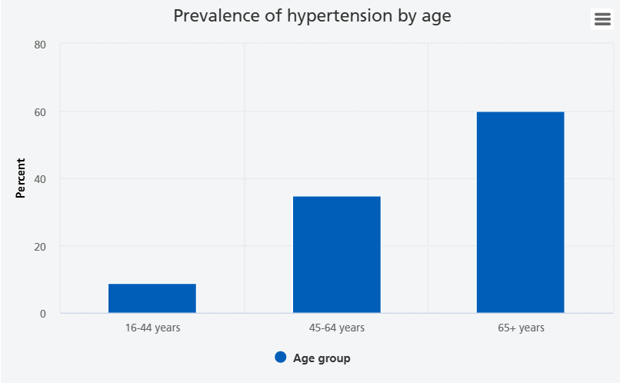
Figure 1: Hypertension prevalence in the UK
(Source: NHS England, 2023)
2. Self-monitoring wearable device
In health promotion
Self-monitoring wearable devices such as “smart watches” are used as a portable diagnostic in health promotion. Portable diagnostics are devices, apps or smart assistive technology that help to monitor patient condition or progress (O'Neil, 2019). This innovation can be linked with the “Ottawa Charter”, which aimed to alert disadvantaged groups about health concerns (Naidoo and Wills, 2016). Thus, it contributed to the advocacy of digital health promotion.
In Hypertension monitoring
In disease control and effective management, “smart watches" effectively contributed to continuous monitoring. For example, “Apple Watch” uses FDA-cleared “Hypertension Notification Feature (HTNF)” to detect hypertension by monitoring blood pressure (Di Achille et al., 2025). Thus, this wearable digital innovation can alert people about the possibility of hypertension and monitor BP.
3. Wearable devices in hypertension management
The usefulness of a smartwatch to monitor BP is clearly seen among the UK population. Consequently, the sensitivity of the already used HTNF facility is 41.2%, and the specificity was 92.3% (Di Achille et al., 2025). Besides, smartwatch KC08 gives significant (p <0.05) results in BP monitoring and hypertension management [Figure 2] (López-Ortiz et al., 2025). Hence, digital technology is shown to be accurate in detecting BP status.
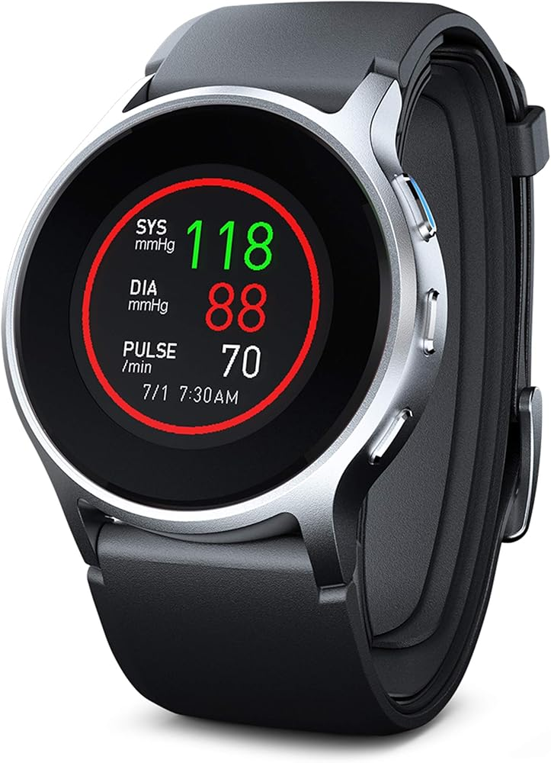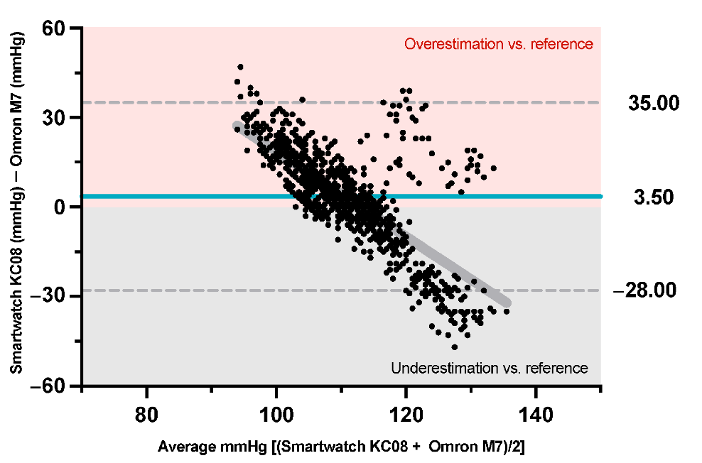
Figure 2: Significance of smartwatch in BP monitoring
(Source: López-Ortiz et al., 2025)
4. Impact of wearable devices in health promotion
Impact
A smartwatch, as a digital technology, helps in continuous monitoring and early disease identification of hypertension.
Advantages
- In the detection of systolic hypertension, the specificity of the smartwatch was 83 to 92% (Achille et al., 2025; Falter et al., 2022).
- Smartwatches are highly significant for the measurement of SpO2, BP and Heart rate (López-Ortiz et al., 2025).
Disadvantages
- Overestimation of the diastolic BP and low estimation of systolic BP (Falter et al., 2022)
- In the case of diastolic hypertension smartwatch (Samsung Galaxy Watch) has lower accuracy (41%) (Falter et al., 2022).
5. Shortfall management
- Use of “high-frequency BP” monitoring for addressing the limited accuracy of existing smartwatches (Falter et al., 2022).
- Inclusion of Artificial Intelligence (AI) with HTNF can improve accuracy and effectiveness in the detection and alarming of hypertension to the patients in the UK setting (Di Achille et al., 2025).

References
Blog 1
Di Achille, P., Cai, L., Wu, J., Gao, M., Daryani, B., Wang, J., Khanna, U., Ko, H., Pathak, A., Malhotra, M. and Patel, S., (2025). Opportunistically Detecting Signs of Hypertension on a Consumer Smartwatch. medRxiv, pp.2025-12. https://www.medrxiv.org/content/10.64898/2025.12.10.25341972.full.pdf
Falter, M., Scherrenberg, M., Driesen, K., Pieters, Z., Kaihara, T., Xu, L., Caiani, E.G., Castiglioni, P., Faini, A., Parati, G. and Dendale, P., (2022). Smartwatch-based blood pressure measurement demonstrates insufficient accuracy. Frontiers in cardiovascular medicine, 9, p.958212. https://www.frontiersin.org/journals/cardiovascular-medicine/articles/10.3389/fcvm.2022.958212/full
López-Ortiz, S., García-Chico, C., Musso-Daury, L., González-Ustio, S., Peñín-Grandes, S., Pinto-Fraga, J., Maroto-Izquierdo, S. and Santos-Lozano, A., (2025). A Smartwatch or Just a Watch? A Validation Study of the Smartwatch KC08 for Measuring Blood Pressure. Sensors, 25(12), p.3793. https://www.mdpi.com/1424-8220/25/12/3793
Naidoo, J. and Wills, J., (2016). Foundations for Health Promotion E-Book: Foundations for Health Promotion E-Book. Elsevier Health Sciences. https://books.google.com/books?hl=en&lr=&id=zGYOZw8EOssC&oi=fnd&pg=PP1&dq=Naidoo,+J.+and+Wills,+J.+(2016)+Foundations+for+health+promotion.+Fourth+edition.+London:+Elsevier.&ots=7drnwBlums&sig=A_dhZmsfUO0ZtVWTZowV0Cse060
NHS England (2023). Health Survey for England, 2021 part 2. Available at: https://digital.nhs.uk/data-and-information/publications/statistical/health-survey-for-england/2021-part-2/adult-health-hypertension (Accessed: 04.02.2026)
O'Neil, I. (2019). Digital Health Promotion: A Critical Introduction. John Wiley & Sons. https://books.google.com/books?hl=en&lr=&id=7pazDwAAQBAJ&oi=fnd&pg=PA2002&dq=O%27Neil,+I.,+2019.%C2%A0Digital+Health+Promotion:+A+Critical+Introduction.+John+Wiley+%26+Sons.&ots=Y5L3GjYApT&sig=unxAG5HiJMwvVmtEKGUTEEmmS3k
ONS (2023). Risk factors for undiagnosed high blood pressure in England: 2015 to 2019. Available at: https://www.ons.gov.uk/peoplepopulationandcommunity/healthandsocialcare/healthandwellbeing/articles/riskfactorsforundiagnosedhighbloodpressureinengland/2015to2019 (Accessed: 04.02.2026)
Sinnott, S.J., Smeeth, L., Williamson, E. and Douglas, I.J., (2017). Trends for prevalence and incidence of resistant hypertension: population based cohort study in the UK 1995-2015. Bmj, 358. https://www.bmj.com/content/bmj/358/bmj.j3984.full.pdf

Blog 2: AI-induced smartwatch and hypertension management of UK older people
1. Hypertension is a concern among UK older adults
Sedentary lifestyle and limited care accessibility raise the possibility of hypertension among older adults. In both males and females, hypertension is a health concern, as by 75 years, the prevalence was 71% among females and 66% among males [Figure 1] (ONS, 2023). A cross-sectional study showed limited hypertension control associated with older age, obesity, alcohol consumption and low self-management (Tapela et al., 2021). Thus, among older people, inappropriate hypertension management is a serious concern which requires further support.
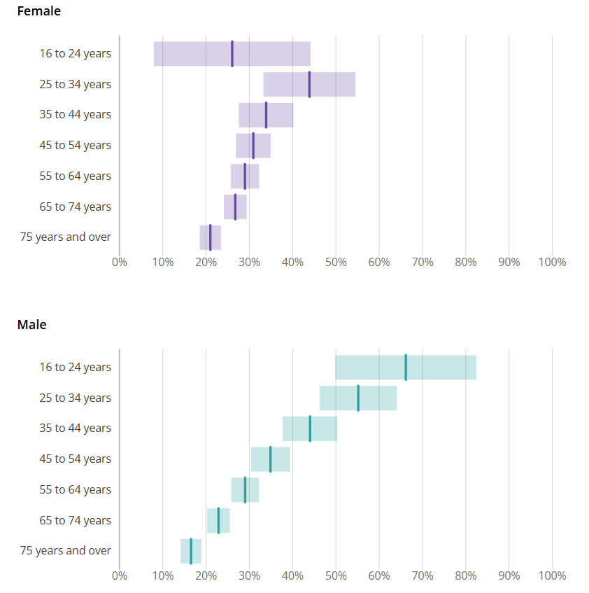
Figure 1: Hypertension prevalence by gender
(Source: ONS, 2023)
2. Automated AI-induced wearable device
The “smartwatch” interventions can be improved with the automated feature by the inclusion of AI, which improves accuracy and effectiveness in BP monitoring. “Hypertension Notification Feature (HTNF)” is an already used feature in smartwatches to notify people after measuring high BP for a long period, such as “Apple Watch” (Di Achille et al., 2025). This feature can be improved through the inclusion of AI-powered wearable devices, real-time tracking of BP for constant monitoring and identification of hypertension [Figure 2] (Sadeghi et al., 2025). Henceforth, among wearable devices (shoes, belts, glasses, watch and clothes), watches will be the digital device used for hypertension monitoring and management among the UK older adults.
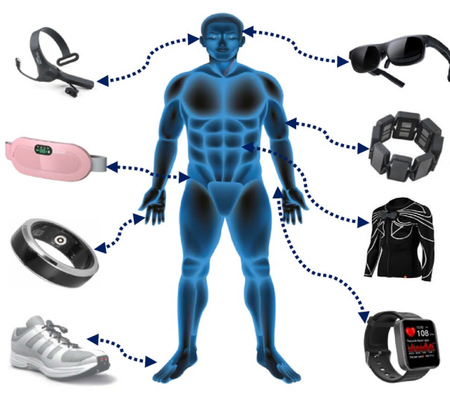
Figure 2: AI-powered real-time BP tracking devices
(Source: Sadeghi et al., 2025)
3. Use of innovation in health promotion to address hypertension
Health promotion
The AI-induced smartwatch with an alarming feature for hypertension can be aligned with the “self-monitoring” aspect of behaviour change (O'Neil, 2019). Linking to “Health Belief Model (HBM)”, “perceived susceptibility” helps an individual to understand undesirable outcomes (Alyafei and Easton-Carr, 2024). “Perceived susceptibility” of HBM also achieved via alarming feature of smartwatch as it informs older adults about possibility of hypertension by constant BP monitoring. Thus, a learning feature of the smartwatch will help older people to understand high BP and ensure needs for management actions.
Hypertension management
AI-featured alarming systems inform the individual about rising BP and associated risk and provide suggestions to manage hypertension. For example, the predictive real-time monitoring ability of AI can identify and set an alarm while BP is over 140/90 mmHg and the use of “long short-term memory” helps in dependency capture (Tsoi et al., 2021). As a result, this proposed intervention can help in early identification, alarming and management of BP among at-risk populations, older people of the UK.
4. Impact of automated wearable devices in health promotion
Impact
The AI-featured smartwatch will raise the accuracy in the detection of systolic and diastolic blood pressure of UK older adults.
Advantages
- Previous success of a machine learning model for the estimation of diastolic (+0.67 mmHg) and systolic blood pressure (+1.91 mmHg) (Tsoi et al., 2021).
- AI-featured smartwatches prevent worsening of disease and help in continuous monitoring of the hypertension patients' outcomes through therapeutic response (Visco et al., 2023).
Disadvantages
- Technical issues such as the black box nature of ML algorithms, disrupted patient data privacy and underfitting (Visco et al., 2023).
- Higher cost and limited availability of previous interventions' success, while AI is included in the wearable devices (Tsoi et al., 2021).
5. Recommendations
- The privacy shortfall can be managed through the adoption of a multi-modal approach and further clinical trials to identify the gaps in the interventions and address the technological limitations (Visco et al., 2023).

References
Blog 2
Alyafei, A. and Easton-Carr, R., (2024). The health belief model of behavior change. StatPearls. https://www.ncbi.nlm.nih.gov/books/NBK606120/
Di Achille, P., Cai, L., Wu, J., Gao, M., Daryani, B., Wang, J., Khanna, U., Ko, H., Pathak, A., Malhotra, M. and Patel, S., (2025). Opportunistically Detecting Signs of Hypertension on a Consumer Smartwatch. medRxiv, pp.2025-12. https://www.medrxiv.org/content/10.64898/2025.12.10.25341972.full.pdf
O'Neil, I. (2019). Digital Health Promotion: A Critical Introduction. John Wiley & Sons. https://books.google.com/books?hl=en&lr=&id=7pazDwAAQBAJ&oi=fnd&pg=PA2002&dq=O%27Neil,+I.,+2019.%C2%A0Digital+Health+Promotion:+A+Critical+Introduction.+John+Wiley+%26+Sons.&ots=Y5L3GjYApT&sig=unxAG5HiJMwvVmtEKGUTEEmmS3k
ONS (2023). Risk factors for undiagnosed high blood pressure in England: 2015 to 2019. Available at: https://www.ons.gov.uk/peoplepopulationandcommunity/healthandsocialcare/healthandwellbeing/articles/riskfactorsforundiagnosedhighbloodpressureinengland/2015to2019 (Accessed: 04.02.2026)
Sadeghi, H., Ahmadi, M. and Rajabi, D., (2025). Design and prototyping of an AI-powered wearable device for continuous vital signs monitoring with intelligent alerting. Scientific Reports. https://www.nature.com/articles/s41598-025-28772-2_reference.pdf
Tapela, N., Collister, J., Clifton, L., Turnbull, I., Rahimi, K. and Hunter, D.J., (2021). Prevalence and determinants of hypertension control among almost 100 000 treated adults in the UK. Open heart, 8(1), p.e001461. https://openheart.bmj.com/content/openhrt/8/1/e001461.full.pdf
Tsoi, K., Yiu, K., Lee, H., Cheng, H.M., Wang, T.D., Tay, J.C., Teo, B.W., Turana, Y., Soenarta, A.A., Sogunuru, G.P. and Siddique, S., (2021). Applications of artificial intelligence for hypertension management. The Journal of Clinical Hypertension, 23(3), pp.568-574. https://onlinelibrary.wiley.com/doi/pdf/10.1111%2Fjch.14180
Visco, V., Izzo, C., Mancusi, C., Rispoli, A., Tedeschi, M., Virtuoso, N., Giano, A., Gioia, R., Melfi, A., Serio, B. and Rusciano, M.R., (2023). Artificial intelligence in hypertension management: an ace up your sleeve. Journal of cardiovascular development and disease, 10(2), p.74. https://www.mdpi.com/2308-3425/10/2/74

