

Programme: BA (Hons) Leadership and Management Skills for the Workplace
Module code and name: BMSW5106_Knowledge and Information Management Skills for the Workplace
Name of the Student: Aneliya Kirkova-Georgieva
ID Number: 2125657

Lecturer Name: Dr. Essa Bah
Title: Task 1 – Scenario Case

Contents page
- Introduction…………………………………………………………………………………3
- Discussion…………………………………………………………………………………..4
  - Emirates Airlines’ and Amazon’s overview….……………………...………………4
  - TOWS analysis of Emirates Airlines’ and Amazon’s Knowledge Management System…………………………………………………………………………………..5
    - TOWS analysis of Emirates Airlines’ Knowledge Management System…..……..5
    - TOWS analysis of Amazon’s Knowledge Management System ………………….7
  - Evaluation of both organizations’ Knowledge Management systems …………….9
    - KM Value Chain Analysis……….……………………………………….……………..9
    - Supporting IT Systems..………………….……………………………………….…..12
- Deployment Strategies………………………………………………...…………………..13
- Recommendations for both organizations……………………………………………….14
- Conclusion…………………………………………………………………………………..16
- References………………………………………………………………………………….17

- Introduction
A Knowledge Management System (KMS) is a strategic tool designed to organize, capture, store, and distribute knowledge within an organization, fostering collaboration, innovation, and efficiency. At its core, a KMS aims to harness the individuals’ and teams’ expertise and insights of individuals and teams, transforming them into valuable assets that drive decision-making and problem-solving processes.
The primary objective of a Knowledge Management System is to facilitate the creation, sharing, and utilization of knowledge across various levels and functions within an organization. By implementing robust KMS platforms, businesses can effectively capture explicit knowledge (tangible, codified information) and tacit knowledge (personal insights, expertise) residing within their workforce.
Through features such as document repositories, discussion forums, expert directories, and search functionalities, a KMS enables employees to access relevant information quickly, collaborate on projects, and learn from each other's experiences. Furthermore, advanced KMS systems often incorporate machine learning algorithms and data analytics tools to identify patterns, extract insights, and recommend relevant knowledge resources to users.
In addition to enhancing productivity and decision-making, a well-implemented Knowledge Management System promotes organizational learning, mitigates knowledge loss due to employee turnover, and fosters a culture of continuous improvement and innovation. Ultimately, by leveraging the collective intelligence of its workforce, an organization can gain a competitive advantage and adapt more effectively to dynamic market conditions.
This report includes a TOWS analysis of the KMS of Emirates Airlines and Amazon and highlights the differences and similarities in the context of knowledge management existing in both organizations. In this paper, the company's knowledge management value chains are considered as an important tool for transforming existing organizational knowledge into value, which could ensure the competitive advantage and success of both organizations.
The report also discusses different sophisticated IT systems and their interaction with the Knowledge Management Systems of the company to enable the organization to harness knowledge effectively, drive innovation, and maintain a competitive edge.

- Discussion
  - Introduction of Emirates Airlines and Amazon
Emirates and Amazon stand as two prominent organizations operating in vastly different sectors, yet both demonstrate a profound commitment to leveraging knowledge management systems (KMS) to enhance their operations and maintain competitive advantages in their respective industries. While Emirates dominates the airline industry with its luxurious services and extensive global network, Amazon has revolutionized e-commerce and diversified into various sectors, becoming a titan of technology and retail. Despite their differences, both organizations recognize the critical role of knowledge management systems in optimizing internal processes, fostering innovation, and delivering superior customer experiences.
With a fleet of modern aircraft and a widespread route network spanning six continents, Emirates has redefined air travel luxury. In knowledge management, Emirates invests heavily in systems designed to capture, organize, and disseminate vast amounts of information crucial for its operations. The airline utilizes advanced technologies to manage flight schedules, crew rotations, maintenance logs, and customer data. These systems streamline day-to-day operations and enable Emirates to analyse trends, anticipate customer needs, and tailor services to individual preferences.
Moreover, Emirates' commitment to knowledge management extends beyond operational efficiency. A key component of delivering exceptional service is employee development and training, which is strongly emphasized by the airline. Through comprehensive training programs and interactive learning platforms, Emirates empowers its workforce to stay abreast of industry trends, safety protocols, and customer service standards. By fostering a continuous learning and knowledge-sharing culture, Emirates ensures that its employees remain adaptable and responsive to evolving customer demands and market dynamics.
On the other hand, using cloud computing, streaming, and artificial intelligence, Amazon expanded its footprint across diverse sectors, including retail, cloud computing, and streaming. At the core of Amazon's success lies its sophisticated knowledge management infrastructure, which underpins every aspect of its operations. The company's proprietary algorithms analyse vast quantities of data to personalize product recommendations, optimize supply chain logistics, and enhance customer engagement.
Amazon's knowledge management systems not only facilitate seamless transactions but also drive innovation across the organization. Through initiatives like Amazon Web Services (AWS) and Machine Learning University, the company empowers developers and data scientists to harness the power of data and develop cutting-edge solutions. By democratizing access to knowledge and fostering a culture of experimentation, Amazon nurtures a fertile environment for creativity and invention.
  - TOWS analysis (Threat/Opportunities/Weaknesses/Strengths) of Emirates Airlines’ and Amazon’s Knowledge Management System.
Knowledge Management Systems (KMS) is a set of developed processes that play a pivotal role in modern organizations, facilitating the efficient creation, storage, sharing, and utilization of knowledge assets. By systematic and organized use of their “brain power”, organizations use knowledge management to generate efficiencies, sustain competitive advantage, and innovate (Serban et al., 2002). Knowledge management refers to the process of handling knowledge assets to create value to meet the company’s strategic and tactical objectives (Al-Ansi, 2021). It also empowers organizations to make informed decisions and adapt to dynamic environments.
The following analysis focuses on Emirates (Figure 1) and Amazon (Figure 2), two globally recognized entities, examining the Threats, Opportunities, Weaknesses, and Strengths (TOWS) in the context of their Knowledge Management Systems.
    - TOWS analysis of Emirates Airlines’ Knowledge Management System
Strengths:
- Investment in research and development: Emirates has strong backing from the government and that helps to invest in research and development in technology, processes, and employee training, which in turn fosters innovation and operational efficiency (Schneckenberg et al, 2015).
- Global network and partnerships: Emirates Airlines operates a vast global network and has partnerships with various stakeholders in the aviation industry. These partnerships can facilitate knowledge sharing and collaboration, leading to innovation.
- Diverse workforce: Emirates Airlines benefits from a diverse workforce and strong internal culture of knowledge sharing among its employees, facilitated by training programs (including external) and collaborative platforms (Goswami et al., 2021).
Weaknesses:
- Hierarchical structure: Like many large organizations, Emirates Airlines has a hierarchical structure that could hinder knowledge sharing and collaboration across different departments and levels of the organization.
- Cultural barriers: Cultural differences among employees may create communication barriers, affecting knowledge-sharing initiatives.
- Silos and departmentalization: Siloed departments and lack of cross-functional communication may inhibit the flow of knowledge within the organization, leading to duplication of efforts and missed opportunities for innovation.

Figure 1. TOWS analysis of Emirates Airlines’ KMS

(Source: created by author, 2024)
Opportunities:
- Technology integration: Emirates Airlines can benefit from adopting emerging technologies, such as blockchain, data analytics, and artificial intelligence, to improve knowledge creation processes. These technologies can improve operational efficiency, customer experience, and decision-making.
- Knowledge-sharing platforms: Implementing robust knowledge-sharing platforms and collaboration tools can facilitate the exchange of ideas and best practices among employees across departments and geographic locations.
- Continuous learning culture: Promoting a culture of continuous learning and innovation can encourage employees to actively contribute to knowledge-creation efforts and stay updated on industry trends and developments.

Threats:
- Competitive pressure: The aviation industry is highly competitive, with rivals constantly innovating to gain a competitive edge. Failure to keep pace with competitors in terms of knowledge creation and innovation could result in loss of market share and relevance.
- Regulatory changes: Regulatory changes in the aviation industry can impact how Emirates Airlines operates and create knowledge. Compliance with new regulations may require significant resources and could divert attention away from knowledge-creation initiatives.
- Cybersecurity risks: Due to the increasing reliance on data-driven technologies and digital platforms, Emirates Airlines become vulnerable to cybersecurity threats. As a result of these threats, sensitive information may be compromised, and knowledge-creation processes can be disrupted.
2.2.2. TOWS analysis of Amazon’s Knowledge Management System:
Strengths:
- Massive data pool: Amazon leverages its vast data analytics capabilities and customer-centric approach to gather valuable insights and generate knowledge (Michael, 2023). It possesses a wide amount of customer data from various sources, including purchase history, browsing behaviour, and user reviews. This data serves as a valuable resource for generating insights and driving informed decision-making.
- Technological infrastructure: Amazon has developed sophisticated technological infrastructure, including cloud computing services (Amazon Web Services), machine learning algorithms, and data analytics tools. These technologies enable the company to analyse vast amounts of data and extract actionable insights for knowledge creation.
Weaknesses:
- Dependency on technology: While Amazon's technological capabilities are a strength, they can also be a weakness if the company becomes overly reliant on technology-driven solutions. This dependency may limit creativity and innovation in certain areas where human intuition and judgment are required.
- Privacy concerns: Gathering and analysing customer data raise privacy concerns and regulatory challenges, affecting Knowledge Management practices.
- Employee turnover: High employee turnover rates may result in knowledge loss and disrupt continuity in Amazon's Knowledge Management initiatives.

Figure 2. TOWS analysis of Amason’s KMS

(Source: created by author, 2024)
Opportunities:
- Partnerships: Amazon could partner with innovative companies in various industries to gain access to new knowledge and expertise. Strategic acquisitions and partnerships can help expand Amazon's capabilities and fuel future growth.
- Investment in research and development: Continued investment in research and development initiatives can drive knowledge creation in areas such as artificial intelligence, robotics, and logistics. These investments can help Amazon stay at the forefront of technological innovation and maintain its competitive advantage.
Threats:
- Competition and disruption: Amazon operates in highly competitive markets where competitors are constantly innovating and challenging its dominance. Disruptive technologies and business models from competitors pose a threat to Amazon's market position and its ability to create and leverage knowledge effectively.
- Data privacy and security concerns: Amazon faces increasing scrutiny and regulatory pressure related to data privacy and security due to the vast amount of customer data it collects and analyses. Data breaches or mishandling of customer information can erode their trust. Further, Amazon operates globally, so it should make sure that adequate safeguards are in place when transferring personal data abroad.
Both Emirates Airlines and Amazon recognize the importance of knowledge management in their respective industries. They share common strengths such as a strong organizational culture that promotes knowledge sharing and investment in technological infrastructure. However, they also face similar challenges, such as the need to address data security concerns.
One notable difference is that Emirates Airlines focuses on knowledge management within a highly regulated and service-oriented industry, where customer satisfaction and safety are paramount. On the other hand, Amazon operates in the fast-paced e-commerce sector, where scalability, data-driven decision-making, and innovation are critical.
  - Evaluation of both organizations’ Knowledge Management Systems
The Knowledge Management (KM) value chain is a concept that outlines the processes involved in managing knowledge within an organization and consists of knowledge acquisition, storage, dissemination, application, and feedback loops (Alavi & Leidner, 1999). It provides a structured framework for understanding how organizations manage knowledge processes to create value.
    - KM Value Chain Analysis
Emirates Airlines emphasizes knowledge generation through continuous employee training programs, industry research, and customer feedback mechanisms. (Figure 3)
Similarly, Amazon focuses on knowledge generation through data analytics, user reviews, and market trends. Their algorithms analyse vast amounts of data to personalize recommendations, optimize supply chains, and forecast demand. By leveraging big data analytics, Amazon gains insights into consumer behaviour, product preferences, and market trends, driving strategic decision-making. (Figure 4)
Both organizations excel in knowledge storage and dissemination. Emirates Airlines uses specialized aviation software for managing flight operations, maintenance records, crew scheduling, and regulatory compliance. They employ document management systems and repositories to store policies, procedures, safety protocols, and training materials for employees, where the data could be easily retrieved (Emirates Group, 2017). Dissemination of knowledge within the Emirates is facilitated through various channels, intranet portals, and regular training sessions. Pilots, cabin crew, and ground staff leverage these channels to share insights, troubleshoot issues, and foster a culture of continuous learning (Emirates Group, 2021).
Figure 3. Emirates Airlines’ KM Value Chain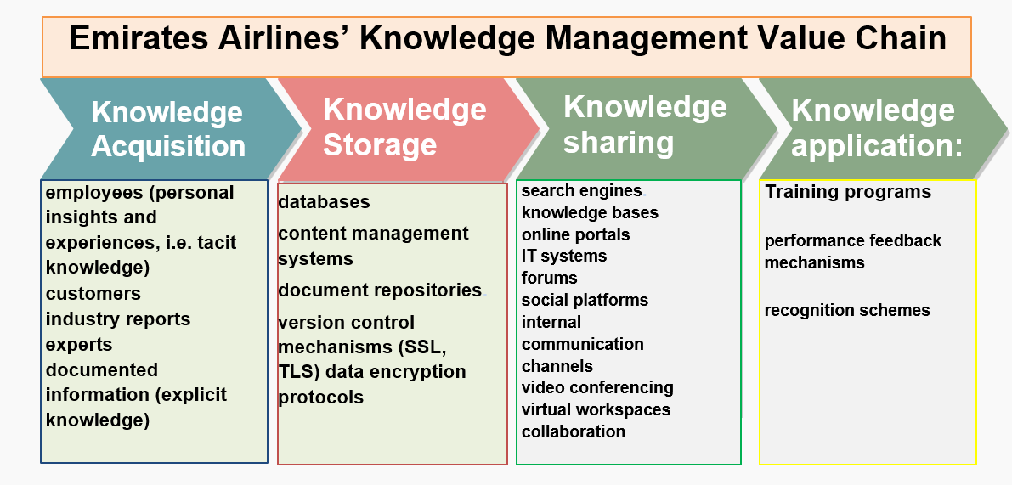
(Source: created by author, 2024)
Meanwhile, Amazon's cloud-based infrastructure facilitates real-time data storage and retrieval, enabling seamless communication and collaboration among global teams. Amazon's knowledge dissemination efforts are facilitated through internal communication platforms like Chime and WikiDocs, where employees collaborate on projects, share best practices, and contribute to organizational knowledge (Amazon, 2021). Furthermore, Amazon Web Services (AWS) provides a scalable infrastructure for hosting knowledge repositories, data lakes, and analytics tools, enabling seamless access to information across geographically dispersed teams.
In terms of knowledge application, Emirates Airlines empowers employees to make informed decisions by providing access to comprehensive databases, expert networks, and decision support tools. Pilots, for example, rely on real-time weather forecasts, route optimization algorithms, and aircraft performance data to enhance flight safety and efficiency. Also, the airline employs sophisticated IT systems for flight planning, scheduling, and maintenance. These systems integrate data from diverse sources to optimize operational efficiency and ensure passenger safety. Furthermore, Emirates encourages cross-functional collaboration and innovation through initiatives like the Knowledge Champions program, where employees are recognized for their contributions to knowledge sharing and process improvement.
Similarly, Amazon empowers employees with self-service analytics tools, AI-driven insights, and recommendation engines to personalize customer experiences, optimize operations, and drive revenue growth. The company uses robotics, machine learning, and predictive analytics to streamline order processing, inventory management, and logistics operations. Knowledge application is deeply embedded within Amazon's operational processes and decision-making frameworks. For instance, predictive analytics models guide inventory management decisions, while customer feedback loops inform product improvements and service enhancements. Moreover, Amazon's culture of experimentation and innovation encourages employees to apply knowledge creatively to solve problems and drive continuous improvement across the organization.
Figure 4. Amason’s KM Value Chain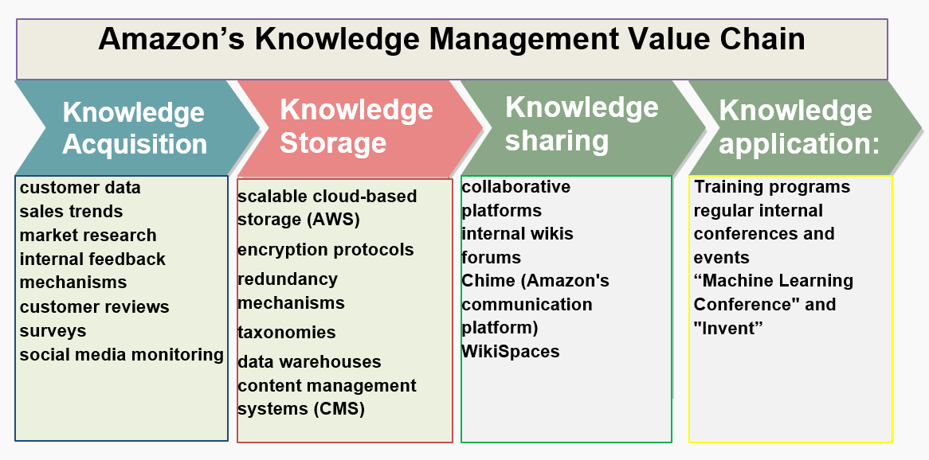
(Source: created by author, 2024)
Feedback mechanisms are integral to the KM value chain, enabling organizations to capture lessons learned, identify knowledge gaps, and improve processes iteratively. Emirates Airlines solicits feedback from passengers, employees, and industry experts through surveys, focus groups, and social media channels. They use this feedback to enhance service quality, refine operational processes, and innovate customer experiences.
Likewise, Amazon gathers feedback from customers, sellers, and employees through product reviews, seller ratings, and employee surveys. Their data-driven culture emphasizes continuous improvement, agility, and customer-centricity, driving innovation and competitive advantage.
    - Supporting IT Systems
Emirates utilizes IT systems such as SAP ERP (Enterprise Resource Planning) for integrated business processes, Amadeus for reservations and ticketing, and Sabre for flight operations management. These systems capture and process vast amounts of data related to flight schedules, passenger bookings, and revenue streams, enabling Emirates to optimize resource allocation and improve customer service.
Moreover, Emirates invests in cutting-edge technologies like blockchain and artificial intelligence to enhance security, streamline operations, and personalize customer experiences. For instance, blockchain-powered loyalty programs and AI-driven chatbots enable Emirates to engage customers more effectively and gain insights into their preferences and behaviours (Lopes et al., 2021).
On the other hand, Amazon's IT infrastructure is anchored by AWS, which provides scalable computing power, storage, and analytics capabilities. AWS services such as Amazon S3, Redshift, and SageMaker enable Amazon to process and analyse petabytes of data in real time, driving business intelligence, predictive modelling, and process automation.
Furthermore, Amazon leverages IT systems for inventory management, order fulfillment, and logistics optimization. Robotic automation technologies like Amazon Robotics and Kiva Systems enhance warehouse efficiency and reduce order processing times, while predictive analytics algorithms anticipate customer demand and optimize inventory levels across fulfillment centres.
Both organizations exemplify distinct approaches to Knowledge Management, driven by their respective business models, organizational cultures, and strategic objectives. While Emirates prioritizes knowledge acquisition and operational excellence in the aviation industry, Amazon focuses on customer-centric innovation and data-driven decision-making in the e-commerce sector.
- Deployment Strategies
For ubiquitous quality service satisfaction and to reduce operational costs, the knowledge management deployment strategy is crucial (Gacanin et al., 2019). The success of the deployment of a knowledge management program depends on а number of critical enablers, including employee training and involvement, teamwork, etc. (Figure 5)
Initially, the airline likely would assess its knowledge needs, identify key stakeholders, and develop a strategic plan for KMS implementation. Afterward, they would select appropriate KMS technology that aligns with its requirements and integrates seamlessly with existing technology systems. This includes configuring the system, testing it, and rolling it out across the organization.
Figure 5. KMS deployment cycle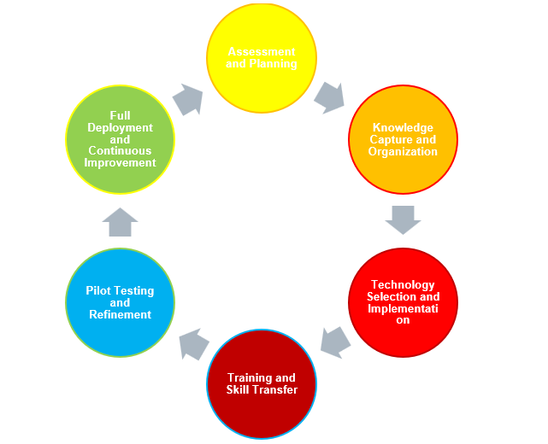
(Source: Created by author, 2024)
The next step could involve conducting comprehensive training programs to familiarize employees with the KMS functionalities and impart essential skills for knowledge sharing and retrieval through workshops, online courses, and hands-on sessions. The company might conduct pilot tests of the KMS in select departments to identify potential issues and develop the system based on user feedback and performance metrics. Once the KMS is optimized, Emirates would deploy it across the organization, monitoring its usage and effectiveness. Also, continuous improvement processes would be established to adapt to evolving knowledge needs and technological advancements.
By following these steps, Emirates would successfully transfer knowledge from developers to operational units while ensuring that employees acquire the skills necessary to leverage the KMS effectively.
On the other hand, Amazon's approach to KMS deployment is often characterized by its agility and innovation. The company adopts a more iterative and experimental approach, focusing on rapid prototyping and continuous improvement.
The e-commerce giant might place a strong emphasis on user feedback and data analytics to refine its KMS continuously. For instance, Amazon may deploy a KMS to streamline customer service operations. Knowledge developers compile a comprehensive database of customer inquiries, responses, and solutions. Through training sessions, customer service representatives learn how to leverage the KMS to quickly access relevant information and provide timely assistance to customers. As the system evolves, feedback from both users and developers helps refine the content and functionality of the KMS, leading to continuous improvements in customer service delivery.
While Amazon prioritizes agility and experimentation, Emirates Airlines emphasizes structured planning and integration. The transfer of KM skills at the airlines is facilitated through structured training programs, whereas Amazon fosters a culture of ownership and continuous learning among its employees. These distinct approaches reflect the unique organizational cultures and business requirements of each company.
- Recommendations for both organizations
In today's fast-paced business environment, organizations like Emirates Airlines and Amazon need to manage and utilize knowledge resources to maintain their competitive edge and ensure future success. Here are recommendations to both organizations, focusing on developing their Knowledge Management Systems (KMS) and fostering knowledge development:
- Comprehensive Knowledge Capture and Documentation: Emirates Airlines and Amazon would prioritize the comprehensive capture and documentation of knowledge across all departments and functions. Implementing robust systems to capture tacit knowledge through interviews, documentation of best practices, lessons learned, and employee experiences will be pivotal. Utilizing advanced technologies such as AI-powered chatbots and knowledge repositories can facilitate seamless knowledge capture and retrieval processes.
- Cultivating a Knowledge-Sharing Culture: Both organizations might foster a culture of knowledge-sharing and collaboration among employees. Encouraging open communication channels, cross-functional collaboration, and knowledge-sharing sessions can facilitate the exchange of ideas and expertise. Recognizing and rewarding employees for their contributions to knowledge-sharing initiatives can further incentivize participation and foster a collaborative environment.
- Leveraging Technology and Innovation: Emirates Airlines and Amazon could leverage emerging technologies and innovation to enhance their Knowledge Management Systems. Investing in machine learning algorithms, natural language processing capabilities, and advanced analytics tools, can enable organizations to extract actionable insights from vast amounts of data and facilitate informed decision-making processes. Additionally, exploring blockchain technology for secure knowledge sharing and verification can enhance data integrity and confidentiality.
- Continuous Learning and Development: Both organizations would prioritize continuous learning and development initiatives to future-proof talent and enhance knowledge development within their microenvironments. Implementing robust training programs, mentorship opportunities, and skills development workshops can enable employees to adopt new skills and stay abreast of industry trends and technological advancements. Encouraging employees to pursue certifications and external learning opportunities can further enrich their knowledge base and contribute to organizational growth.
- Establishing Communities of Practice: Emirates Airlines and Amazon might establish communities of practice within their organizations to facilitate collaboration and knowledge sharing among employees with shared interests and expertise. Creating dedicated forums, online platforms, and regular meetups can provide employees with opportunities to exchange ideas, seek advice, and collaborate on projects relevant to their areas of expertise. Nurturing communities of practice can foster a sense of belonging and encourage continuous learning and innovation within the organization.
- Embracing Change and Adaptation: Lastly, both organizations could embrace change and adaptation as integral components of their knowledge management strategies. Recognizing the dynamic nature of the business environment and being proactive in identifying emerging trends, disruptive technologies, and evolving customer needs can position Emirates Airlines and Amazon as industry leaders. Encouraging a culture of experimentation, agility, and adaptability will enable organizations to effectively navigate uncertainties and capitalize on new opportunities for growth and innovation.

- Conclusion
Implementing an effective knowledge management procedure is vital for organizations to thrive in today's dynamic and competitive landscape. This process enables businesses to harness the collective intelligence, insights, and expertise of their workforce, leading to improved decision-making, innovation, and overall performance.
One of the primary benefits of a robust knowledge management procedure is the preservation and dissemination of critical knowledge within an organization. By capturing tacit knowledge and documenting explicit knowledge, companies can minimize the risk of knowledge loss due to employee turnover, retirement, or other disruptions.
Moreover, a well-defined knowledge management procedure promotes collaboration and information sharing among employees across different departments and geographical locations. This fosters a culture of continuous learning and enables teams to leverage each other's experiences and best practices to solve problems and drive growth.
Furthermore, effective knowledge management enhances organizational agility and responsiveness to changing market conditions and customer needs. By leveraging insights gained from past experiences and data analytics, companies can make informed decisions and adapt their strategies more efficiently.
Ultimately, investing in knowledge management is an investment in the long-term success and sustainability of an organization. By prioritizing the capture, organization, and dissemination of knowledge assets, businesses can cultivate a competitive advantage and position themselves for continued growth and innovation in the global marketplace.
This report discussed a TOWS analysis regarding the used KMS in organizations, its main stages and deployment, and the ways it interacts with the Information Systems within the process of transforming the organizational knowledge into value.

6. References:
Al-Ansi, A.M., (2021). Applying Information Technology-Based Knowledge Management (KM) Simulation in the Airline Industry. International Journal of New Practices in Management and Engineering, 10(02), pp.05-09.
Alavi, M. and Leidner, D., (1999). Knowledge management systems: issues, challenges, and benefits. Communications of the Association for Information systems, 1(1), p.7.
Amazon., (2021). Our culture. [online] Available at: https://www.aboutamazon.com/working-at-amazon/our-culture (Accessed: 17/2/24)
Emirates Group, (2021). About Us - Our Business Model. Emirates. Available at: https://www.emirates.com/uk/english/about-us/financial-transparency/our-business-model/ (Accessed: 17/2/24)
Gacanin, H., Perenda, E. and Atawia, R., (2019). Self-deployment of non-stationary wireless systems by knowledge management with artificial intelligence. IEEE Transactions on Cognitive Communications and Networking, 5(4), pp.1004-1018.
Goswami, A.K., Agrawal, R.K. and Goswami, M., (2021). Influence of national culture on knowledge management process: literature review and research agenda. Benchmarking: An International Journal, 28(4), pp.1186-1212.
Lopes, D.P., Rita, P. and Treiblmaier, H., (2021). The impact of blockchain on the aviation industry: Findings from a qualitative study. Research in Transportation Business & Management, 41, p.100669.
Michael A., (2023). How Amazon Uses Data Science and Analytics to Drive E-commerce Success. [online] www.linkedin.com. Available at: https://www.linkedin.com/pulse/how-amazon-uses-data-science-analytics-drive-success-michael-ampofo/. (Accessed: 17/2/24)
Schneckenberg, D., Truong, Y. and Mazloomi, H., (2015). Microfoundations of innovative capabilities: The leverage of collaborative technologies on organizational learning and knowledge management in a multinational corporation. Technological Forecasting and Social Change, 100, pp.356-368.
Serban, A.M. and Luan, J., (2002). Overview of knowledge management. New directions for institutional research, 2002(113), pp.5-16.
The Emirates Group, (2017). The Emirates Group Annual Report 2016-2017, Available at: https://cdn.ek.aero/downloads/ek/pdfs/report/annual_report_2017.pdf (Accessed: 16/2/24)
The Emirates Group, (2022). The Emirates Group Annual Report 2022-2023. Emirates

