

Postgraduate/Distance Learning
Assignment coversheet & feedback form

THIS SHEET MUST BE THE FIRST PAGE OF THE ASSIGNMENT YOU ARE SUBMITTING (DO NOT SEND AS A SEPARATE FILE)

For completion by the student:
Student Name: Vadim Zaver

Student University Email: 2111154@student.uwtsd.ac.uk
Module code: HPCA7027  Module title: Sacred Skies  Word count: 3149 | Student ID number: 2111154 |  |  | Educational support needs:  Yes
Assignment title: Explore the Cultural Significance of a Sky Myth

Assignment due date: 31/07/2022
This assignment is for the 1st 2nd 3rd 4th 5th 6th module of the degree
I confirm that this is my original work and that I have adhered to the University policy on plagiarism.
Signed ……/vadimzaver/………………………………………………………
Email submission:if you are submitting this form via email, please tick this box □
(as a substitute for your signature) to confirm that you agree to the above declaration.
Assignment Mark
1st Marker’s Provisional mark
2nd Marker’s/Moderator’s provisional mark
External Examiner’s mark (if relevant)
Final Mark

NB. All marks are provisional until confirmed by the Final Examination Board.

ALL COMMENTS ARE ON THE PDF OF YOUR PAPER IN TURNITIN

For completion by Marker 1 :
Comments:

Marker’s signature: |  |  | Date:
For completion by Marker 2/Moderator:

Comments:

Marker’s Signature: |  | Date:
External Examiner’s comments (if relevant)

External Examiner’s Signature: |  | Date:

Introduction
This paper considers the myth of Orion and the Pleiades. It will explore this myth through poems of Homer and Hesiod and the ancient Greeks’ culture. It will look at the origins of the myth and how it is connected with rituals and practices. Both Homer and Hesiod lived well before elements of scientific thinking started to appear, and the paper will look at the myth from the mythical thinking position, as defined by Cassirer, where for the ancient Greeks the mythological Orion and the Pleiades are also stars and constellations. It is unclear why a myth, which had survived for 100,000 years, at some point faded away in some places. One surviving (arguably incomplete) copy of the myth is attributed to a Roman author — Gaius Julius Hyginus (c. 64 BC – AD 17). This paper will also look at the Pleiades calendar and its influence on the ancient Greek culture. The calendar was used in the ancient Greece for agriculture and seafaring, but with introduction of the Julian calendar in 46BC the popularity of the Pleiades calendar faded. The aim of this paper is to investigate the cultural significance of Orion and the Pleiades myth for the ancient Greeks and connection between the myth and the Pleiades calendar. The paper will look in turn at poems of Hesiod and Homer and investigate the connections between the myth, the calendar and the ancient Greek culture.
Greek myth summary
The myth of Orion and Pleiades is found in Myths of Hyginus.
Pleiades were seven sisters who were daughters of Atlas and Pleio, daughter of Ocean. There were seven sisters, but only six stars are visible in the skies. The myth explains it as six of Pleiades bore children of immortal gods, but the seventh, Merope, married a mortal Sisyphus. Because of this, her star is less bright. When Pleiades and their mother once were travelling through Boeotia, Orion, who was accompanying her, tried to attack the mother. She escaped, but Orion sought her for seven years and couldn't find her. Jove, pitying the girls, appointed a way to the stars, and later, by some astronomers, they were called the Bull's tail. And so up to this time Orion seems to be following them as they flee towards the west. Our writers call these stars Vergiliae, because they rise after spring. They have still greater honour than the others, too, because their rising is a sign of summer, their setting of winter — a thing is not true of the other constellations.
Definition of myth
In this essay I will use William Bascom’s definition of myth:
Myths are prose narratives which, in the society in which they are told, are considered to be truthful accounts of what happened in the remote past. They are accepted on faith; they are taught to be believed; and they can be cited as authority in answer to ignorance, doubt, or disbelief.
Definition of culture
According to Terry Eagleton, culture is one of the most complex words in the language: ‘The Latin root of the word ‘culture’ is colere, which can mean anything from cultivating and inhabiting to worshipping and protecting’. will examine the following culture meanings in relations to the sky myth: cultivating/agriculture, colony/occupation, invasion/war.
Mythological thinking
Mythological thinking preceded scientific thinking, elements of which started to appear in fifth century BC. According to Cassirer - ‘For mythical thinking all contents crowd together into a single plane of reality’. Cassirer described peculiar structure of the mythical consciousness as ‘myth expresses all natural reality in the language of human, social reality and expresses all human, social reality in the language of nature’. For the ancient Greeks, Orion and the Pleiades constellations were indeed mythical Orion and the Pleiades and vice versa. Frankfort et al described the thinking of the ancients as: ‘The thought of the ancient […] appears wrapped in imagination. We consider it tainted with fantasy’. At the same time according to Malinowski a myth ‘contains practical rules for guidance of man […] a vital ingredient of human civilisation […] not an idle tale but a hard-worked active force’. Leach describes a myth as ‘a coded message badly snarled up with noisy interference’.
Hesiod
Two great ancient Greek poets, Homer and Hesiod mentioned different aspects of the Orion and Pleiades myth. Both poets thought to be lived between 750BC and 650BC. The ancient period of the Greek history lasted from 800BC to 480BC. Hesiod wrote Works and Days around 700BC. He addressed the poem to his brother Perses. Hesiod and Perses inherited a farm. Perses didn’t have sufficient knowledge to run his part of the estate, squandered it, and then with help of bribed judges came after Hesiod’s share. Works and Days was written to educate Perses and is a kind of farmer’s manual. According to Eagleton, the word ‘culture’ is derived from Latin for cultivating, linking culture to agriculture. Hesiod in his poem teaches his brother Perses how to cultivate the land, but also, he gives him a moral advice — trying to make the brother cultured and self-sufficient. An important part of Hesiod’s ‘farmers manual’ is Orion and the Pleiades mythology, especially it’s calendar utility:
When the Pleiades and Hyades, Orion in his might,
Are setting, then remember that the season now is right
For plowing: may the seed you sow lie firm beneath the earth.
And though desire for sailing stormy seas should draw you forth,
At such time as the Pleiades are hurtling in flight
Toward the misty sea, before Orion in his might,
And gales of every kind of wind are raging furiously,
No longer should you sail your ships upon the wine-dark sea,
But keep on working, mindful of the earth, as I command.
Prop up your ship with rocks when you have hauled it onto land,
Orion and the Pleiades calendar plays an important part in the poem, as timing is one of the most crucial things in agriculture.
Knowing what needs to be done is not enough. It’s the timing of each step that can make all the difference between a good yield and a mediocre one.
In the poem, Hesiod was referring to the Pleiades calendar, which was used by the ancient Greeks for agriculture and seafaring. Unlike ancient solar and lunar calendars, which were floating, the Pleiades calendar floats very little and can be used reliably for agricultural purposes. The Pleiades calendar likely empowered many cultures around the world by being the hidden force behind the agricultural revolution.
This revolution entailed major long-term changes in the structure and organization of the societies that adopted this new way of life as well as a totally new relationship with the environment. Humans truly began to harness the earth.
Keeping time today is a simple task, but 11,500 years ago, when according to Price and Bar-Yosef agriculture begun, determining the right timing for ploughing and harvesting was an uneasy task especially with the harvest and well-being of the farmers at stake.
An incomplete world map enclosed (see Appendix 1), where the cultures which have the Orion and Pleiades myth are marked with green colour. The map listed in the Appendix 2, covers the centres of origin of agriculture. Both maps cover roughly the same areas, and this is an indication, that Orion and the Pleiades myth, and associated with the Pleiades calendar was used for agricultural purposes in all these places. As a result, agricultural revolution enabled the birth and development of many cultures around the world.
Incidentally, the poem was written at the time of food shortages in the ancient Greece. City-states in the ancient Greece were cultural centres which produced uncountable cultural treasures. But the polies only existed and were sustainable, because the surrounding rural areas were growing wheat and barley, and were supplying food to the polies. But limited agricultural land couldn’t provide enough food for growing urban population. Eagleton associated culture not just with agriculture, but also with invasion, occupation and colonization. At the time of Hesiod, there were ninety Greek colonies which were growing and supplying food to the metropolies:
Greek colonies and settlements stretched all the way from western Asia Minor to southern Italy, Sicily, North Africa, and even to the coasts of southern France and Spain.
Greece is surrounded by seas and the ancient Greek seafarers, used ships for trade and for war as described in The Iliad. According to Hesiod, Orion and the Pleiades were the key for determining shipping seasons. So far, we can see that Orion and the Pleiades were instrumental to the farming and seafaring of the ancient Greeks. However, Orion and the Pleiades myth could be much older than the ancient Greeks’ husbandry and seagoing. There are two ways to establish approximate dating of the myth.
Firstly, there is a large number of similar myths across the world cultures (see Appendix 1). One explanation of spreading the myth around the globe is that the myth was already a part of the mythology of the humans who were migrating and populating these parts of the world. Aboriginal Australians have many variations of the myth. According to Norris and Norris, the myth could be over 100,000 years old:
When the Australians and Europeans were last together, in 100,000 BC, the Pleiades would have appeared as seven stars. Given that both cultures refer to them as “Seven Sisters”, and that their stories about them are so similar, the evidence seems to support the hypothesis that the “Seven Sisters” story predates the departure of the Australians and Europeans from Africa in 100,000 BC.
Secondly, although Hesiod refers to the agricultural and navigational usage of the Orion and Pleiades myth, there is another usage, which likely predates the first two. According to Price and Bar-Yosef, agriculture started around 9,500BC, but humans survived as hunter-gatherers for some 200,000 years before that. The rising and setting of the Pleiades marks a change of seasons, and the change of seasons marks the movement of the herds of migrating animals around the world. In 1871, by Arkansas river there still were herds containing over 4,000,000 bison. We can only imagine the size of migrating herds tens of thousands of years ago. Mastering the Pleiades calendar might have allowed the early humans to reach to the endless food supply — hunting and scavenging on millions of passing by animals.
The Lascaux cave contains over 2,000 prehistoric images. The Lascaux cave art was created ‘in at least two phases, ~17,000–21,000 cal. BP and 21,500–22,500 cal. BP’. One of the hypotheses claims that ‘the group of spots floating above the back of the largest Auroch painted on the ceiling of the cave, might represent the open cluster of the stars — the Pleiades’. The dating by Norris and Norris of Orion and the Pleiades myth to 100,000 BC — some 80,000 years before the first images in the Lascaux cave were created, adds some weight to the hypothesis.
In his poem, Hesiod mentions several times Orion and the Pleiades as the time guides for plowing, harvesting and seafaring. The myth was likely adopted by the ancient Greeks as it is likely much older than the ancient Greeks civilisation. Myth enabled culture
At the time of Hesiod, the myth seems was in use, but afterwards was lost in Greece, as the last (arguably incomplete) copy is attributed to a Roman scholar — Gaius Julius Hyginus (c. 64 BC – AD 17). It seems that Orion and the Pleiades myth faded away during Hyginus lifetime. Incidentally, Roman calendar reform introduced Julian calendar in 46BC, and with its introduction the use of the Pleiades calendar seems also faded away. This could be an indication that the spread of Orion and the Pleiades myth geographically and in time might be linked to the Pleiades calendar, which the ancient Greeks likely adopted and successfully used for building and expanding their culture.
Homer
Another ancient Greek poet who mentioned Orion and the Pleiades mythology was Homer. He in great detail described the Shield of Achilles, which featured Orion and the Pleiades:
There he made the earth and there the sky and the sea
and the inexhaustible blazing sun and the moon rounding full
and there. the constellations, all that crown the heavens,
the Pleiades and the Hyades. Orion in all his power too
and the Great Bear that mankind also calls the Wagon:
she wheels on her axis always fixed, watching the Hunter,
and she alone is denied a plunge in the Ocean's baths.
The Iliad is one of the oldest books, and the scholars over the centuries analysed it’s every line from all possible angles, and generally viewed the Shield of Achilles to be a product of Homer’s fantasy.
Nothing really like this shield has ever been found nor ever will be. […] The decoration of the shield is derived from poetic invention not from history.

It is now generally acknowledged that the shield is a more or less free invention on the part of the poet. I will not be concerned with the question of the relationship between the Shield and actual works of art.
But Troy for centuries also thought to be a product of Homer’s fantasy, until in 1871, Heinrich Schliemann excavated the city. Twenty-two years ago, a discovery happened, which might change the scholars’ view on the Shield of Achilles. In 1999, in Germany, near a small town of Nebra, the Nebra Sky Disc (see Appendix 3) was found by two metal detectorists and shortly afterwards the police confiscated it. ‘The disc is currently judged to be about 3,600 years old, dating it to the Bronze Age’. The Nebra Sky Disc seems to features the Pleiades constellation and initially was used as a calendar tool, likely in the manner as described by Hesiod. The Disc:
[…] is considered both the first-known portable astronomical instrument and the oldest-known graphic depiction of celestial objects in human history.
The Disc have had several transformations and ‘was reworked several times during its history, suggesting its cosmological significance was not static’. In the final modification ‘thirty-eight […] perforations were made along its rim’. The Disc was found with two Bronze Age swords and it suggests that its last purpose was a military one, as according to Garrow and Wilkin:
It is possible that The Sky Disc was fixed to a shield, carried in ceremonies or into battle.
The Nebra Sky Disc likely was a part of composition on the shield, as it is 30cm in diameter, but the Greeks’ Bronze age shields were over one metre in diameter, weighing about eight kilograms and were large enough for carrying bodies and crossing rivers. This finally brings us to the Shield of Achilles. Although the Pleiades constellation on the Nebra disk is a suggestion, Homer’s mentioning of the Pleiades on the Shield of Achilles adds some weight to this suggestion.
- The Pleiades might have been used for predicting the dates of animal migrations by Palaeolithic hunter-gatherers.
- The Pleiades were used for prediction of the harvest and ploughing time by the ancient Greek farmers.
- The Pleiades were used for predicting good and bad weather by the ancient Greek seafarers.
It seems that the purpose of putting the constellation on a shield wasn’t to make the shield stronger, and wasn’t to terrify the enemy with a scary image, as only Achilles had such a shield. The Shield was made by gods and clearly was a sacred item. If we continue the line of what the Pleiades were used for previously, then the constellation purpose on a shield during a war would be predicting the outcome or choosing the right time.
An artistic interpretation of the Shield of Achilles is listed in Appendix 4. The artist actually replaced the described by Homer Elements and Constellations, with a zodiac wheel, as he probably felt that the shield was used for astrological purposes. With the discovery of the Nebra Sky Disk, a new point of view on the Shield of Achilles has emerged. The Shield of Achilles could have been real after all, and also might have astronomical, astrological and calendar significance.
The Iliad is one of the oldest works of literature. With Orion and the Pleiades located on the main artefact of the poem, one might speculate about the artefact’s astronomical, astrological and calendar significance. With Orion and the Pleiades known to be used for predictions by the ancient Greeks, and some of the ancient Greeks’ main gods being actual planets, there might be a new viewpoint at the poem through the prism of astronomy and astrology. Some of The Iliad main players are the gods (some of them actually planets), who decide and influence destinies of humans. The poem has many prophecies and predictions and these might have some astronomical context or some astrological meaning. The Nebra Sky disc discovery, could be one of the most exciting developments for almost three thousand years of The Iliad history.
Despite Orion and the Pleiades myth being by some evaluations 100,000 years old and well-studied, new archaeological discovery have shed new light on the myth, and its cultural significance for the ancient Greeks.
Conclusion
In a cycle of life, a person is born, grows and dies. Eagleton links culture to agriculture, colonising and war. This culture cycle reminds of a cycle of life. This cycle could be called a culture cycle of Eagleton.
- creating a culture by agriculture
- expanding a culture by colonising
- ending a culture by a war
Orion and the Pleiades myths are widespread throughout the world, especially in places where the agriculture has originated. According to Hesiod, in the ancient Greece the farming greatly depended on Orion and the Pleiades calendar. The ancient Greece’s agriculture, by production of surplus food, enabled birth of cultural centres — poleis. Orion and the Pleiades calendar was helpful to the ancient Greeks seafaring, and as the result the ancient Greeks exported their culture and created many colonies. Seafaring was used also for war and colonization, and therefore Orion and the Pleiades calendar was instrumental in culture destruction.
Was the Pleiades calendar a part of the myth? With the original ancient Greeks myth being lost, it is impossible to determine and one might only speculate. The longevity of the myth has some correlation with the length of usage of the Pleiades calendar.
Finding of the Nebra Sky Disc underlined importance of the Pleiades for the ancient cultures and created a Schliemann moment for The Iliad scholars. The Shield of Achilles has partly moved from the realm of fantasy, to the being the key to understanding the poem’s riddle. The Shield could be a proof that another branch of astrology existed.
Overall, Orion and the Pleiades myth likely was instrumental to the birth and expansion of many cultures around the world. It was a culturally significant myth for the ancient Greeks. But eventually the importance of both — the myth and the Pleiades calendar faded out with the development of the modern calendar.
.

Bibliography
Primary sources
HYGINUS, Caius Julius, The Myths of Hyginus. Translated and Edited by Mary Grant, 1960
Secondary sources
Duncan Garrow and Neil Wilkin, The World of Stonehenge (British Museum Press, 2022)
Eagleton, Terry, The Idea of Culture (John Wiley & Sons, 2013)
Ferreira, Becky, ‘How Old Is This Ancient Vision of the Stars?’, The New York Times, 13 September 2020, section Science <https://www.nytimes.com/2020/09/13/science/nebra-sky-disk.html> [accessed 25 March 2022]
Hesiod, Works & Days (Clarendon Press, 1978)
Homer, The Iliad (Penguin, 1991)
Magazines, Caxton, ‘Timing Makes a Big Difference in Farming’, Farmer’s Weekly, 2016 <https://www.farmersweekly.co.za/crops/vegetables/timing-makes-a-big-difference-in-farming/> [accessed 23 March 2022]
Michael Benson, Cosmographics: Picturing Space Through Time (Abrams, 2014)
Norris, Ray P., and Barnaby R. M. Norris, ‘Why Are There Seven Sisters?’, in Advancing Cultural Astronomy: Studies In Honour of Clive Ruggles, ed. by Efrosyni Boutsikas, Stephen C. McCluskey, and John Steele, Historical & Cultural Astronomy (Cham: Springer International Publishing, 2021), pp. 223–35
Price, T. Douglas, and Ofer Bar-Yosef, ‘The Origins of Agriculture: New Data, New Ideas: An Introduction to Supplement 4’, Current Anthropology, 52.S4 (2011), S163–74
Rappenglück, Michael, ‘The Pleiades in the “Salle Des Taureaux”, Grotte de Lascaux. Does a Rock Picture in the Cave of Lascaux Show the Open Star Cluster of the Pleiades at the Magdalénien Era (ca 15.300 BC?"’, in Actas Del IV Congress de Las Seac ‘Astronomia En La Cultura’, ed. by Jaschek C. and Barandela Atrio, 1997, pp. 217–25
Seán Hemingway, ‘Ancient Greek Colonization and Trade and Their Influence on Greek Art’, The Met’s Heilbrunn Timeline of Art History <https://www.metmuseum.org/toah/hd/angk/hd_angk.htm> [accessed 26 March 2022]
JSTOR
Bamforth, Douglas B., ‘HISTORICAL DOCUMENTS AND BISON ECOLOGY ON THE GREAT PLAINS’, Plains Anthropologist, 32.115 (1987), 1–16
Bascom, William, ‘The Forms of Folklore: Prose Narratives’, The Journal of American Folklore, 78.307 (1965), 3–20
Byre, Calvin S., ‘Narration, Description, and Theme in the Shield of Achilles’, The Classical Journal, 88.1 (1992), 33–42
Cassirer, Ernst, The Philosophy of Symbolic Forms: Volume 2: Mythical Thought (Yale University Press, 1955)
Frankfort, Henri, John Albert Wilson, and Thorkild Jacobsen, Before Philosophy: The Intellectual Adventure of Ancient Man; an Essay on Speculative Thought in the Ancient Near East (Penguin Books, 1951)
Gittins, Rhiannon, and Paul Pettitt, ‘Is Palaeolithic Cave Art Consistent with Costly Signalling Theory? Lascaux as a Test Case’, World Archaeology, 49.4 (2017), 466–90
Leach, Edmund Ronald, Genesis as Myth: And Other Essays (Cape, 1969)
Malinowski, Bronislaw, ‘The Role of Myth in Life’, in Magic, Science and Religion and Other Essays (Read Books Ltd, 2014)
Taplin, Oliver, ‘The Shield of Achilles within the “Iliad”’, Greece & Rome, 27.1 (1980), 1–21

Appendix 1 Map of Orion and Pleiades myths

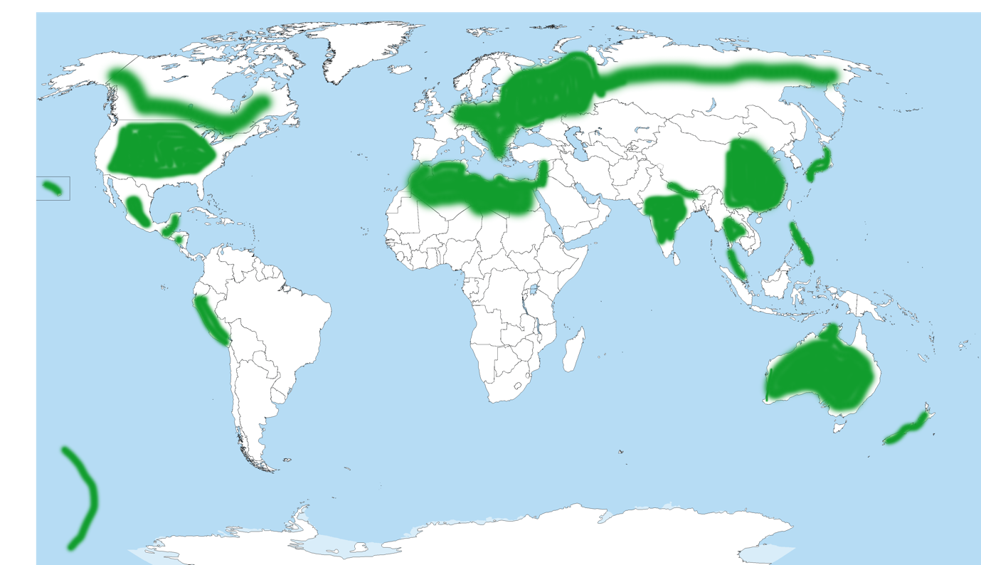
Figure 1 Map of Orion and Pleiades myths around the world, produced by Vadim Zaver

Appendix 2 Map of centers of origin of domesticated plants

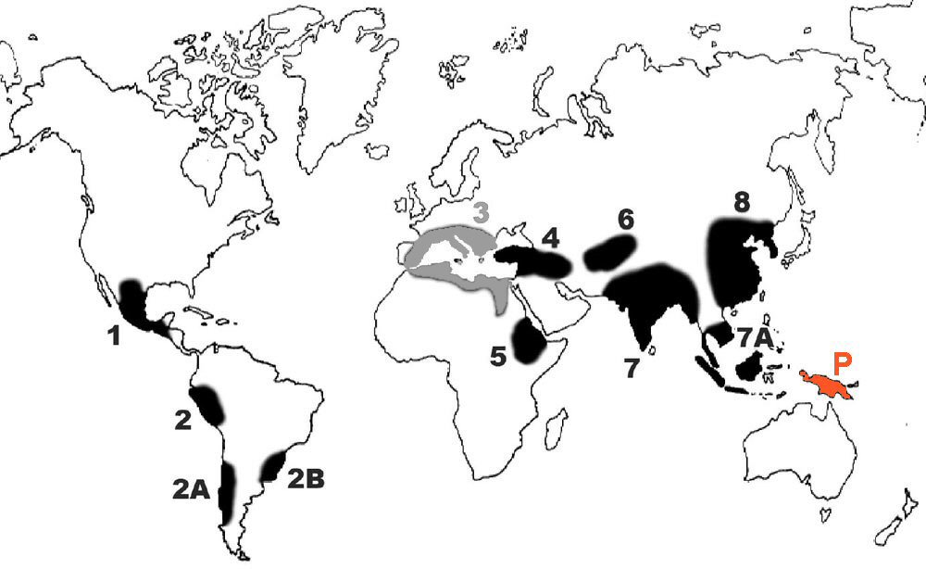
Figure 2 Centers of origin of domesticated plants identified by Nikolai Vavilov during the 1930s, updated to show area 3 no longer regarded as a center, and Papua New Guinea (P) added. This image was created by Chiswick_Chap and is licensed under the Creative Commons Attribution-Share Alike 4.0

Appendix 3 The Nebra Sky Disk

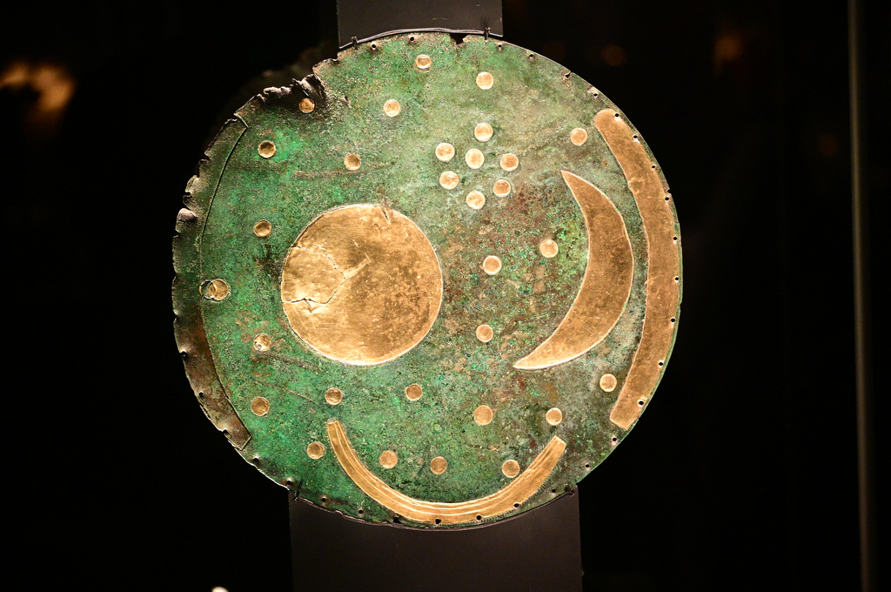
Figure 3 The Nebra Sky Disk, photograph by Vadim Zaver

Appendix 4 Artist interpretation of the Shield of Achilles

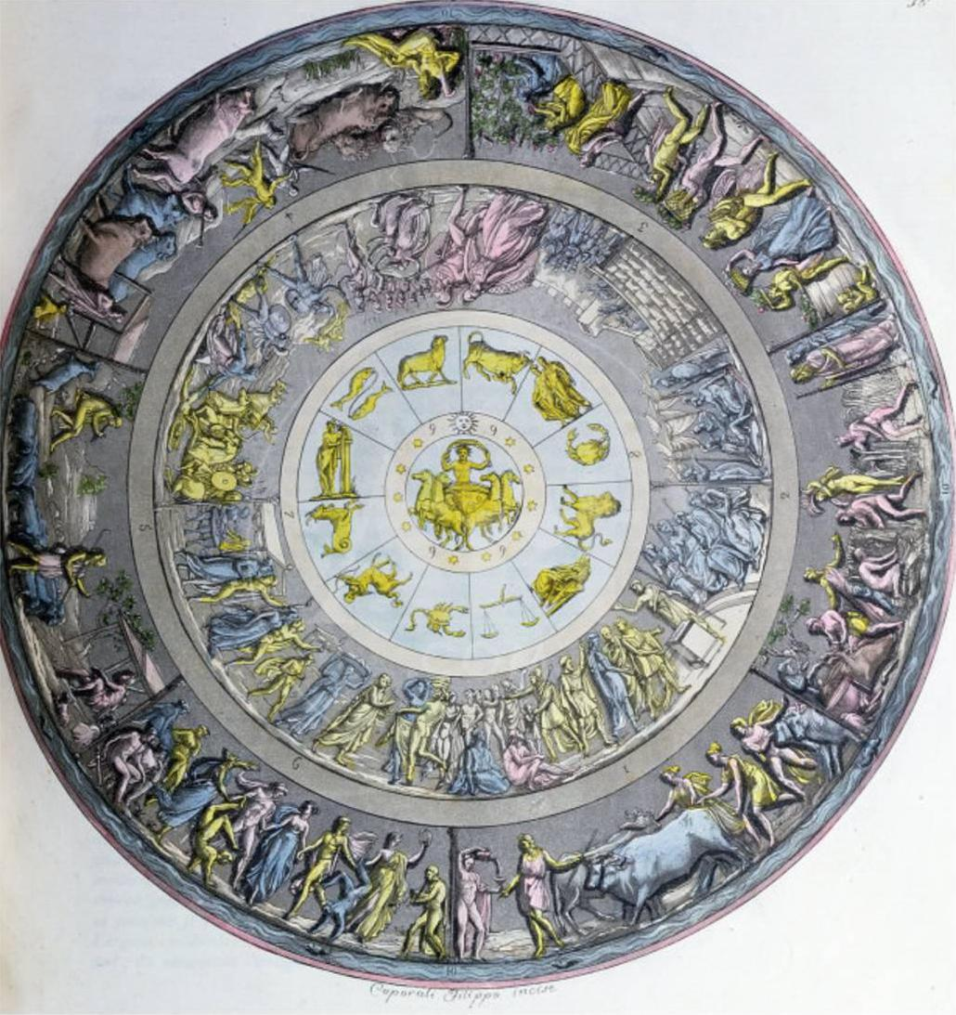
Figure 4 An interpretation of the Shield of Achilles design described in Book 18 of the Iliad, by Angelo Monticelli (1778-1837) Copyright expired in 1907.

Ernst Cassirer, The Philosophy of Symbolic Forms: Volume 2: Mythical Thought (Yale University Press, 1955).
Caius Julius HYGINUS, The Myths of Hyginus. Translated and Edited by Mary Grant, 1960, sec. 2.21.
HYGINUS, sec. 2.21.
William Bascom, ‘The Forms of Folklore: Prose Narratives’, The Journal of American Folklore, 78.307 (1965), 3–20 (p. 4).
Terry Eagleton, The Idea of Culture (John Wiley & Sons, 2013).
Cassirer, p. 42.
Cassirer, p. 192.
Henri Frankfort, John Albert Wilson, and Thorkild Jacobsen, Before Philosophy: The Intellectual Adventure of Ancient Man; an Essay on Speculative Thought in the Ancient Near East (Penguin Books, 1951), p. 11.
Bronislaw Malinowski, ‘The Role of Myth in Life’, in Magic, Science and Religion and Other Essays (Read Books Ltd, 2014), p. 199.
Edmund Ronald Leach, Genesis as Myth: And Other Essays (Cape, 1969), p. 9.
Hesiod, Works & Days (Clarendon Press, 1978), ll. 620–24.
Caxton Magazines, ‘Timing Makes a Big Difference in Farming’, Farmer’s Weekly, 2016 <https://www.farmersweekly.co.za/crops/vegetables/timing-makes-a-big-difference-in-farming/> [accessed 23 March 2022].
T. Douglas Price and Ofer Bar-Yosef, ‘The Origins of Agriculture: New Data, New Ideas: An Introduction to Supplement 4’, Current Anthropology, 52.S4 (2011), S163–74 (p. S171).
With some exceptions, but further research is needed. Note by Vadim Zaver
The maps need to be compared more accurately and the areas further researched, but this is a task for a separate research. Note by Vadim Zaver
Seán Hemingway, ‘Ancient Greek Colonization and Trade and Their Influence on Greek Art’, The Met’s Heilbrunn Timeline of Art History <https://www.metmuseum.org/toah/hd/angk/hd_angk.htm> [accessed 26 March 2022].
Ray P. Norris and Barnaby R. M. Norris, ‘Why Are There Seven Sisters?’, in Advancing Cultural Astronomy: Studies In Honour of Clive Ruggles, ed. by Efrosyni Boutsikas, Stephen C. McCluskey, and John Steele, Historical & Cultural Astronomy (Cham: Springer International Publishing, 2021), pp. 223–35 (p. 233).
Douglas B. Bamforth, ‘HISTORICAL DOCUMENTS AND BISON ECOLOGY ON THE GREAT PLAINS’, Plains Anthropologist, 32.115 (1987), 1–16 (p. 10).
Rhiannon Gittins and Paul Pettitt, ‘Is Palaeolithic Cave Art Consistent with Costly Signalling Theory? Lascaux as a Test Case’, World Archaeology, 49.4 (2017), 466–90 (p. 466).
Michael Rappenglück, ‘The Pleiades in the “Salle Des Taureaux”, Grotte de Lascaux. Does a Rock Picture in the Cave of Lascaux Show the Open Star Cluster of the Pleiades at the Magdalénien Era (ca 15.300 BC?"’, in Actas Del IV Congress de Las Seac ‘Astronomia En La Cultura’, ed. by Jaschek C. and Barandela Atrio, 1997, pp. 217–25 (p. 217).
Homer, The Iliad (Penguin, 1991), bk. 18.565-71.
Oliver Taplin, ‘The Shield of Achilles within the “Iliad”’, Greece & Rome, 27.1 (1980), 1–21 (p. 3).
Calvin S. Byre, ‘Narration, Description, and Theme in the Shield of Achilles’, The Classical Journal, 88.1 (1992), 33–42 (p. 33).
Becky Ferreira, ‘How Old Is This Ancient Vision of the Stars?’, The New York Times, 13 September 2020, section Science <https://www.nytimes.com/2020/09/13/science/nebra-sky-disk.html> [accessed 25 March 2022].
Michael Benson, Cosmographics: Picturing Space Through Time (Abrams, 2014), p. 73.
Duncan Garrow and Neil Wilkin, The World of Stonehenge (British Museum Press, 2022), p. 175.
Duncan Garrow and Neil Wilkin, p. 176.
Duncan Garrow and Neil Wilkin, p. 177.

