Contemporary Themes in the Hotel and Hospitality Sector

Student Name : Alexandra Madalina Patrascu
Student ID : 2019192
Lecturer : Giulia Chifari

Table of Contents
Introduction 3
Overview of the Hotel Premier Inn 3
Literature Review 4
Related theories and concepts 5
PESTLE 7
Empirical research 8
Application to the hotel and hospitality sector 8
Evaluation of sustainable environment Practice 11
Recommendations 11
Conclusion 12
References 14

Introduction
Environmental sustainability has become an important factor in every industry to maintain and balance the planet for current and future generations. The theme of sustainable environmental practice has much significance in the hotel and hospitality industry (McKinnon, 2018). The hotel and hospitality industry is playing a critical role in environmental pollution by increasing wastage which is directly destroying the ecological system, and as natural resources are reduced hotels are sophisticated about environmental sustainability. Proper utilization of resources, and recycling through renewable energy can change this situation. Renewable energy can make a huge change in the hotel industry, it is the procedure of deriving natural sources refilled at a higher rate than they are consumed (Moriarty and Honnery, 2019). The research has discussed contemporary theme sustainability (Renewal Energy) for hotel Premier Inn, for that is has analysed two theories and PESTLE for renewal energy and the application process of it. Finally it has evaluated why renewable energy in important for Premier Inn and how they can improve the current process.

Overview of the Hotel Premier Inn
Premier Inn is a famous and largest British limited-service hotel chain which has a strong worldwide (UK, UAE, Qatar, Germany, Somalia, Ireland and so on) presence (Bas and Sivaprasad, 2022). It can serve a huge number of customers with 72,000 rooms and 800 hotels (Premier Inn., 2023). They always choose strategic locations for their hotels such as city centres, airports, restaurants and so on. They always offer the lowest price possible to gain more customers. This company was established in 1987 by Whitebread, then it was known as Travel Inn. In 2007, it was finalised as Premier Inn. Over the years, it has gained a strong position in the industry and customers mind for excellent service qualities, which is why they are planning to expand it more.

Overview of Literature
Tomislav (2018) stated that the contemporary environmental sustainability theme in the hotel industry includes many things such as using eco-friendly products, energy-efficient lighting, water-saving fixtures, using sustainable transportation, green building, minimizing energy consumption, and reducing waste generation, and water usage. Koçak, Ulucak, and Ulucak, (2020) have shown that the hospitality industry is responsible for 5% of global CO2 emissions and 75% hotel environment is directly related to excessive consumption of resources. In the UK, 100 standard hotel rooms consume around 50,000 kWh per day. It creates pressure in the local community. Blowfield and Blowfield (2019) mentioned that renewable energy plants in the hotel and hospitality industry can make changes in the ecological system and hotel environment. Pamfilie et al., (2022) pointed out that, Solar panels are generating 70% of hotels electricity need which has reduced demand for oil and natural gas which reduced their energy cost 30%. It has also reduced the dependency on the fluctuating utility rates and grid vulnerability.
For using renewable energy hotels are using LED lights which have longer lifespan and low maintenance cost. Mitchell (2022) pointed out that, renewable sources has reduced cost 20% operational cost of the UK hotels. Adoption of renewable energy technology has reduced water consumption by 40%.
Jones et al., (2019), the Rapid price of oil is also forcing the hospitality industry to transform energy sources.
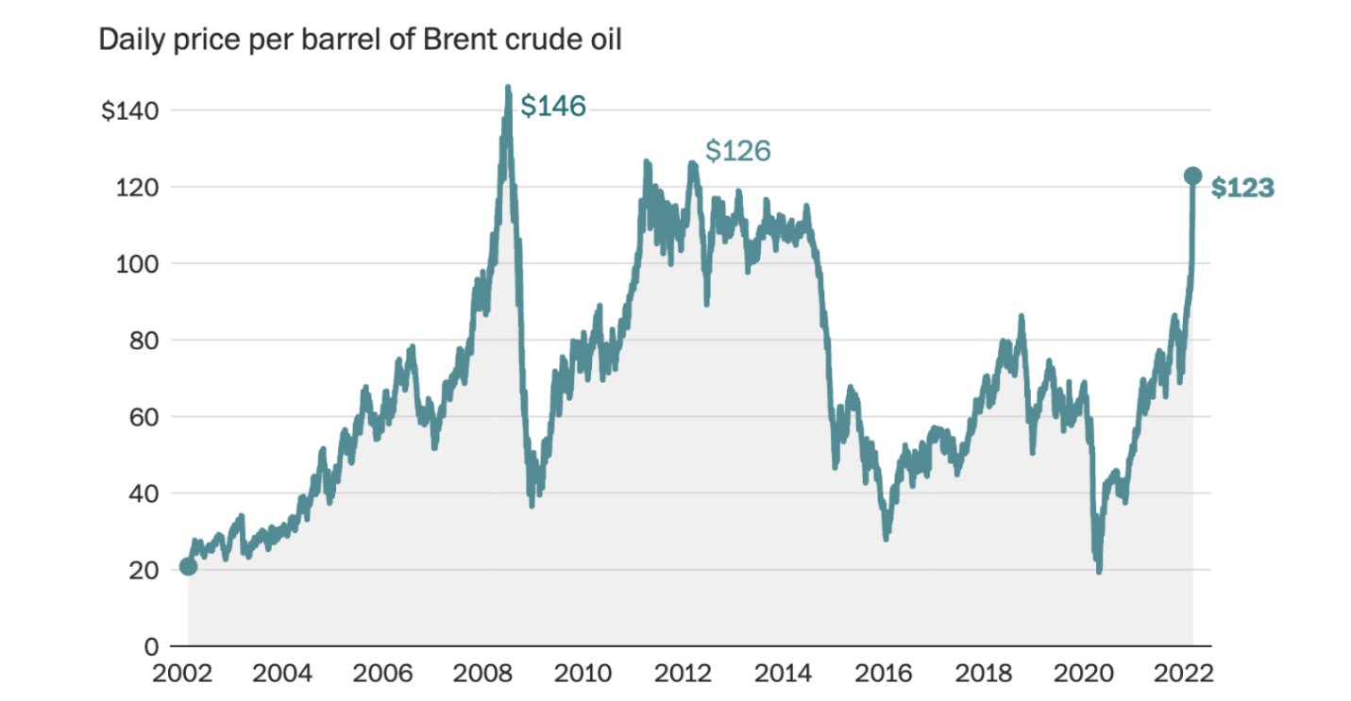
Figure 1: Price of oil (2002-2022)
Source: Quint and Venditti (2023)

There are many sources of renewable energy, such as sun, wind, biomass and hydroelectric.
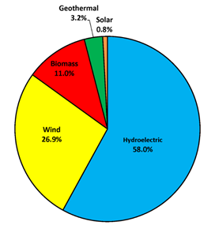
Figure 2: Percentage of energy produced by different renewable energy sources
Source: Ritchie, Roser and Rosado (2023)

Related theories and concepts
According to Alhaddi (2019), this theory is focused on three things: Economic, environmental and social. In the hospitality sector, this environmental focus can bring so many benefits. When a hotel adopts renewable energy, the cost of non-renewable energy decreases. Moreover, the cost of renewable technologies is decreasing. Henriques, and Richardson, (2019), pointed out that, non-renewable sources (coal, natural oil, gas, nuclear energy e.g.) produce a huge amount of CO2, CH4 and many CFC gasses, which affect the O3 (Ozen) layer; these are seriously effecting the environment.
The Triple Bottom Line
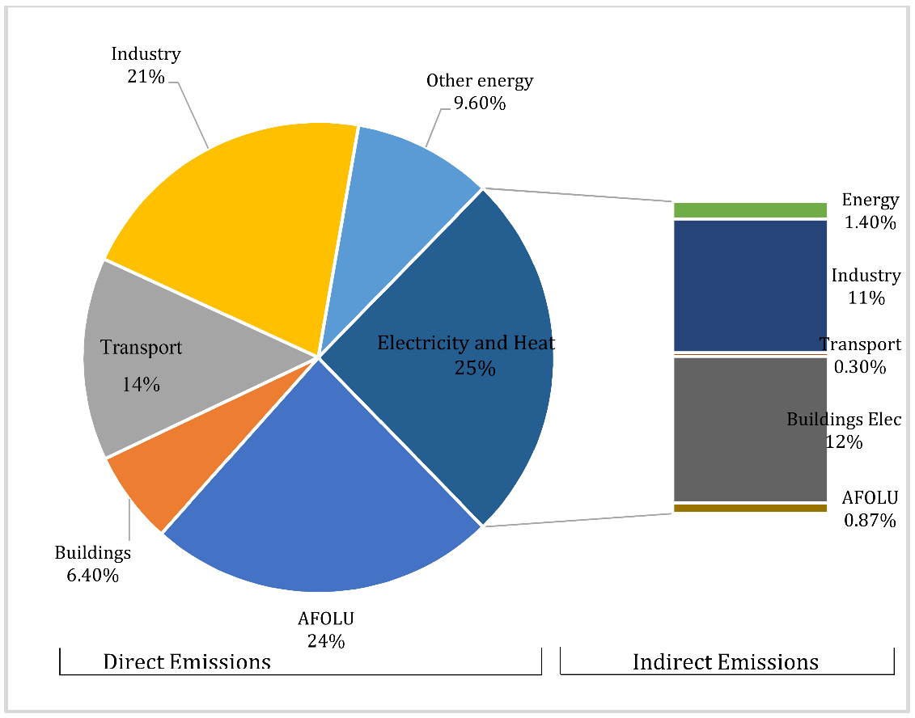
Figure 3: Average carbon emission form hotel and hospitality sector
Source: Ritchie, Roser and Rosado (2023)
According to the following report, electricity and heat have a huge contribution to carbon emissions. Abdou et al., (2022) pointed out that, when hotels adopt renewable technology, they will hit a positive change to the planet and in their financial condition.
Ecological Modernization Theory
York, Rosa, and Dietz, (2018) stated that ecological modernization theory is focused on energy and resource efficiency, producing innovative products and processes via environmental management and sustainable supply chain management. According to Pushpakumara et al., (2018), power that is generated from renewable sources is 100% efficient, while non-renewable sources provide 25-85% efficiency.
Green Building Certification Systems
Doan et al., (2017) pointed out that, Green building certification provides standards and rules for sustainable environmental development. LEED (Leadership in Energy and Environmental Design) is a widely used rating system for green building. It includes many necessary things such as energy efficiency, standard indoor, and fresh air system, water preservation, proper utilization of resources and so on. The adoption of renewable energy will ensure efficiency in energy and resource utilization. When a hotel gets this certificate, it means then have excellent indoor environment and energy service.

PESTLE
Political:
Gregoric (2019) stated that The Climate Change Act commits the UK government by law to reduce greenhouse gas emissions by at least 100% of 1990 levels (net zero) by 2050. Premier Inn has decided to reduce carbon emissions by 50% by 2025, and within 2040 their target is zero carbon emissions.
Economic:
The cost of renewable energy has decreased in the last decades, and it will bring many economic benefits too.

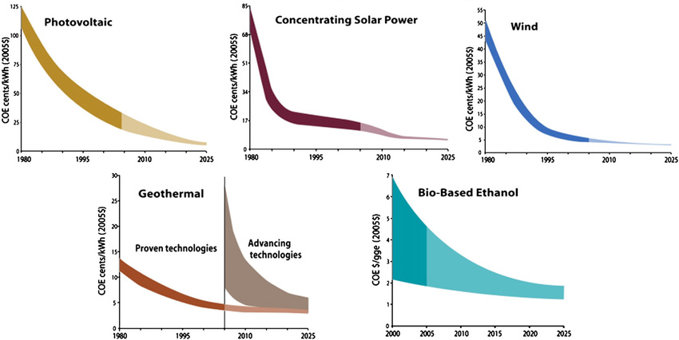
Figure 4: Price of Renewable energy technologies
Source: World Economic Forum, (2023)
Rahman (2021) mentioned that the cost of renewable energy is decreasing because sources are infinite in Nature.
Society:
According to Kolios and Read, (2018), British people are socially aware of the environmental crisis which has created a positive impact on their spending. 70% hotel guest prefer to stay in an eco-friendly accommodation globally (Team Wanderlust., 2022). Premier Inn hotel understands it that is why they are planning to use eco-friendly alternatives.
Technology:
Renewable energy technologies (wind, solar (photovoltaic (PV) and thermal), bio-mass, geo-thermal, tidal and hydro-power (small and micro) are effective sources of energy, reduce food waste, decline carbon, emission and so on. Hotel industry produces 289,700 tone of waste globally each year, adoption of renewable energy is 100% utilising these waste to transform into energy. Customer satisfaction is increasing, as a report has shown that 70% customer prefer eco-friendly products.
Environment:
Researchers have shown that a 1% increase in renewable energy consumption, reduces 1.25% CO2 emission per capita. Even, SO2, NO2, and H2SO4 emissions will also decrease.
Premier Inn is the first hotel with entirely renewable energy in the UK and Germany. It uses solar photovoltaic panels, which are recyclable.
Legal:
To ensure clean energy and the environment UK government has imposed the Energy Act 2013, which has aimed to transform their current electricity into a low-carbon emitted and affordable for communities and industries.

Empirical research
For Premier Inn Hotel, empirical research can provide more relevant and meaningful insight into the use of renewable energy. The research will show how and where this application can make economic benefits. They did not apply this technology in all of their hotels so research will show which area needs, which type of sources.
The amount of carbon emission, waste production, water consumption, and energy use rate can help to perform quantitative research about Premier Inn. For example, comparison of carbon emissions in 2020 and 2022, the authority could find out their improvement.
For qualitative research, guests, employees, shareholders, investors, regulators and the local community around them could provide the necessary information. This will find many new areas of improvement.
Both quantitative and qualitative research will help Premier authorities make the best decisions and strategies for the future.

Application to the hotel and hospitality sector
Renewable energy is important in the business world and hospitality industries are also focusing on it. It has many positive impacts on the contemporary sustainable theme. A relevant example of the application of renewal energy and management responses is given below-

Management Response

- Selecting energy source:
There are many sources of renewable energy so it is important to select the right source of it (Abdmouleh et al., 2019). Common sources are solar power, wind power, geothermal heating and CHP (Combined Heat and Power) (Peake, 2018). Premier use solar power, but it can also use wind, and biomass for a smooth energy supply.
Limitation:
It will be difficult for Premier Inn to establish solar, wind or biomass power in every hotel. Redesigning the lighting system
Premier Inn Hotel needs to change its lighting structure to take energy from renewable sources. This is their system so they can use it as much as they want. Large hotels like, Premier Inn needs a huge amount of energy, sometimes the local community faces problem in providing them with proper services. Renewal sources have reduced this dependency. It has reduced huge amounts of costs and saved the environment from being polluted by this hotel chain.
Limitation:
Sometimes produced renewal energy is not enough to serve customers, it needs more service. All Premier hotels are not under renewal sources.
- Waste-to-Energy
Now many organizations are using this technique to recycle their waste and utilize it properly. Premier Inn produce a huge amount of food waste, which can be transformed into nutrient-rich soil. They can establish an on-site composting system with third-party organizations that will divert waste to renewable energy. Hotel Verve in Africa converts 70% of the waste into renewable energy (Tabasová et al., 2017). They collect all the food waste and then send it to their compost site, finally, technologies help to convert it, into energy. It is both helpful for the environment and Premier Inn.
Limitations:
For implementing this type of site in a hotel, extra space must be away from the main hotel and residents so that people do not feel the odd smell of food. Even needs extra machinery and labour force to complete the entire process. Sometimes it is costly which is why many organizations have shown indifferent behavior for it.
- Technology Solutions
To implement renewable energy, hotels need financial resources, places, government support, suitable weather and so on. Renewable energy technology has created a massive change in the world to make it environmentally sustainable and maintainable (Sinsel et al., 2020). Premier Inn authority has enough ability to implement it successfully in their hotels. All of its new-build hotels are set to be built to this all-electric specification from 2026. Moreover, it produces a huge amount of waste, by managing them in a productive way they can increase energy efficiency. Computerized food tracking technology, food waste measurement systems, inventory management systems etc can help to work with renewable technology.
Limitations:
This type of strategy needs a huge amount of financial resources and a skilled labour force. It also skilled employees for proper monitoring to ensure the implementation properly. Premier Inn must re-organize everything before starting it.
- Electronic waste (E-waste)
Recycling and reusing electrical waste can be helpful in the energy-intensive manufacturing process. These waste come from fridges, computer, telecommunications, solar panels, LED bulbs or vending machine. Thermal Depolymerization, waste heat recovery, municipal solid waste sorting and recycling are some processes of recycling or reusing e-waste (Shahabuddin et al., 2023). This technique can reduce the demand for many materials which can reduce costs.
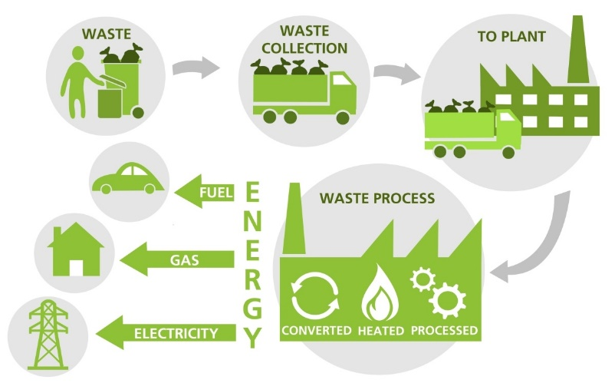
Figure 5: Process of transforming E-waste to energy
Source: Kadam et al., (2023)
Limitations
E-waste recycling and reusing are expensive and many times the outcome is not profitable (Kiddee et al., 2017). Sometimes too much utilisation is not possible or it can produce waste again.

Evaluation of sustainable environment Practice
Hotel Premier Inn has decided to establish a sustainable contemporary theme in their hotels to reduce their dependency on nationally produced energy. Renewal energy does not produce harmful gases or elements that harm the environment. By executing renewal energy plants in all the Premier Inn hotels the company can minimise environmental pollution and generate sustainable energy. The evaluation of this system and technology, for sustainable environment practices are given below-
- Premier Inn has envisioned establishing a strong renewable energy plants in its hotels around the world, which will help to reduce their waste production and increase efficiency.
- Energy plants will reduce Premier Inn’s dependency on nationally produced electricity, local community will get many benefits from it.
- This technology will help to utilize available resources properly. Such as all the food waste will be utilised for energy and new materials. Premier Inn will be able to reduce costs in some aspects which will help them to be cost-effective.
- The company will use different technologies which will increase employees working ability and improve their skills. Career-oriented employees will show their interest in working in the Premier Inn hotels to upgrade their careers. Employee engagement and performance level will increase which will positively impact the company’s performance.
- When Premier Inn introduce a new eco-friendly technology it will attract the visitors and local community. The company will get many loyal customers because of fair ecological practices. It will also encourage many visitors to participation effectively.
- Premier Inn will be able to make strong partnerships with local food banks and charitable companies. It will increase networking in the business world.

Recommendations
- There are some effective recommendations that the hotel Premier Inn can apply in their hotels (Based on geographical locations) to improve and avoid mistakes while implementing renewable energy plants-
- For implementing renewable energy plants the first and foremost importance is financial stability. It needs a huge amount of financial resources and a skilled labour force. It is a long-term process, in the beginning, the company will not get any economic benefits, but after a few months, they will get environmental benefits. For economic efficiency through it, the company need to wait for the long term. In addition, the authority must arrange enough financial resources and skilled labour on time. They should train their employees on time to increase performance levels. However, Premier Inn will not be able to establish a renewable energy system in their entire organization because it will lead to huge expenses.
- Next, Premier Inn has to select a proper process or source for their renewable energy. Solar PV is the most common use source of this energy. Life time of most Silicon-based solar panels is 25 or more (Meng et al., 2018). After that company can recycle them. So it will be a better source than others. But based on geographical locations they can be the source.
- Premier Inn has already taken steps for sustainable environmental practices via a renewable energy system. Implementation of energy-efficient systems, reduction of single-use plastics, and explanation of recycling programs can further demonstrate the hotel's commitment to maintainability and motivate visitors to receive more eco-friendly practices during their stay.
- Premier Inn offers the lowest price ever, but many guests have complained that their service quality is low. Here company should create more space and enhance service quality. Many guests complain about their room structure, Premier authority must redesign it.
Conclusion
The Hotel Premier Inn's commitment is to enhance their excellence in the current service quality be adopting renewable energy for sustainable environment. The evaluation part has shown that it will create a huge value for them. The hotel provides a welcoming and considerate atmosphere by putting a high priority on customer service. Guests can enjoy a secure and comfortable environment with the emphasis on cleanliness and hygiene, as well as tight protocols to maintain high standards across the property, which are directly tied to its performance. A memorable stay is what Hotel Premier Inn intends to provide for each guest by combining personalized benefits, cleanliness, various amenities, supportability, visitor feedback, and innovation. The objective of Premier Inn is to go above and beyond for guests and establish itself as a top choice for travelers in a low price. Premier Inn is dedicated to offering great hospitality experiences that leave a lasting impact on its guests with a commitment to quality and constant improvement. Now environmental concern will increase their positive market image.

References

Abdmouleh, Z., Alammari, R.A. and Gastli, A., 2019. Review of policies encouraging renewable energy integration & best practices. Renewable and Sustainable Energy Reviews, 45, pp.249-262.
Abdou, A.H., Shehata, H.S., Mahmoud, H.M.E., Albakhit, A.I. and Almakhayitah, M.Y., 2022. The Effect of Environmentally Sustainable Practices on Customer Citizenship Behavior in Eco-Friendly Hotels: Does the Green Perceived Value Matter?. Sustainability, 14(12), p.7167.
Alhaddi, H., 2019. Triple bottom line and sustainability: A literature review. Business and Management studies, 1(2), pp.6-10.
Bas, T. and Sivaprasad, S., 2022. An Exploratory Insight into the Impact of COVID-19 on the Travel and Tourism Sector: UK Evidence. Bas, T. & Sivaprasad, S.(2022). An exploratory insight into the impact of COVID-19 on the travel and tourism sector: UK evidence. In S. Karabulut (Ed.), Economic and Financial Analysis of Global and National Developments, pp.355-369.
Blowfield, M. and Blowfield, M., 2019. Business and sustainability. Oxford University Press.
Doan, D.T., Ghaffarianhoseini, A., Naismith, N., Zhang, T., Ghaffarianhoseini, A. and Tookey, J., 2017. A critical comparison of green building rating systems. Building and Environment, 123, pp.243-260.
Gregoric, M., 2019. PESTEL analysis of tourism destinations in the perspective of business tourism (MICE). In Faculty of Tourism and Hospitality Management in Opatija. Biennial International Congress. Tourism & Hospitality Industry (p. 551). University of Rijeka, Faculty of Tourism & Hospitality Management.
Henriques, A. and Richardson, J. eds., 2019. The triple bottom line: Does it all add up. Routledge.
Jones, P., Hillier, D. and Comfort, D., 2019. Sustainability in the global hotel industry. International Journal of Contemporary Hospitality Management, 26(1), pp.5-17.
Kadam, A.R., Singh, N., Dhoble, N.S., Vengadaesvaran, B. and Dhoble, S.J., 2023. Management of solar cell e-waste: challenges and techniques. In 360-Degree Waste Management, Volume 2 (pp. 255-272). Elsevier.
Kiddee, P., Naidu, R. and Wong, M.H., 2017. Electronic waste management approaches: An overview. Waste management, 33(5), pp.1237-1250.
Koçak, E., Ulucak, R. and Ulucak, Z.Ş., 2020. The impact of tourism developments on CO2 emissions: An advanced panel data estimation. Tourism Management Perspectives, 33, p.100611.
Kolios, A. and Read, G., 2018. A political, economic, social, technology, legal and environmental (PESTLE) approach for risk identification of the tidal industry in the United Kingdom. Energies, 6(10), pp.5023-5045.
McKinnon, A., 2018. Environmental sustainability. Green logistics: improving the environmental sustainability of logistics. London.
Meng, L., You, J. and Yang, Y., 2018. Addressing the stability issue of perovskite solar cells for commercial applications. Nature communications, 9(1), p.5265.
Mitchell, C.W., 2022. ‘Impact hospitality: Creating social impact through hospitality’, Sustainability, 14(10), p. 6274. doi:10.3390/su14106274.
Moriarty, P. and Honnery, D., 2019. What is the global potential for renewable energy?. Renewable and Sustainable Energy Reviews, 16(1), pp.244-252.
Pamfilie, R., Firoiu, D., Croitoru, A.G. and Ionescu, G.H.I., 2022. Circular economy–A new direction for the sustainability of the hotel industry in Romania. Amfiteatru Economic, 20(48), pp.388-404.
Peake, S., 2018. Renewable energy-power for a sustainable future (No. Ed. 4). OXFORD university press.
Premier Inn., 2023. Book A Hotel. Book a Hotel | Premier Inn. (n.d.). https://www.premierinn.com/gb/en/book-a-hotel.html
Pushpakumara, H., Atan, H., Khatibi, A., Azam, S.F. and Tham, J., 2018. Contribution of green orientation for the organizational performance: a review of stakeholder relationships and ecological modernization perspectives on sustainability. International Journal of Business and Management Review, 6(9), pp.56-72.
Quint, D. and Venditti, F., 2023. The influence of OPEC+ on oil prices: a quantitative assessment. The Energy Journal, 44(5).
Rahman, M., 2021. PESTEL analysis of the tourism industry. URL: https://howandwhat. net/pestel-analysis-tourism-industry.
Ritchie, H., Roser, M. and Rosado, P., 2023. Renewable energy, Our World in Data. Available at: https://ourworldindata.org/renewable-energy (Accessed: 17 October 2023).
Shahabuddin, M., Uddin, M.N., Chowdhury, J.I., Ahmed, S.F., Uddin, M.N., Mofijur, M. and Uddin, M.A., 2023. A review of the recent development, challenges, and opportunities of electronic waste (e-waste). International Journal of Environmental Science and Technology, 20(4), pp.4513-4520.
Sinsel, S.R., Riemke, R.L. and Hoffmann, V.H., 2020. Challenges and solution technologies for the integration of variable renewable energy sources—a review. renewable energy, 145, pp.2271-2285.
Tabasová, A., Kropáč, J., Kermes, V., Nemet, A. and Stehlík, P., 2017. Waste-to-energy technologies: Impact on environment. Energy, 44(1), pp.146-155.
Team Wanderlust., 2022. 12 of the Best Eco Hotels in the world 2022, Wanderlust. Available at: https://www.wanderlust.co.uk/content/best-eco-hotels-in-the-world/ (Accessed: 18 October 2023).
Tomislav, K., 2018. The concept of sustainable development: From its beginning to the contemporary issues. Zagreb International Review of Economics & Business, 21(1), pp.67-94.
World Economic Forum., (2023). ‘renewables’ power ahead to become the world’s cheapest source of energy in 2020 (no date) World Economic Forum. Available at: https://www.weforum.org/agenda/2021/07/renewables-cheapest-energy-source/ (Accessed: 17 October 2023).
York, R., Rosa, E.A. and Dietz, T., 2018. Ecological modernization theory: Theoretical and empirical challenges. The international handbook of environmental sociology, 2, pp.77-90.

