Contents
Research question 2
Abstract 2
Introduction 3
Methodology 8
Design and Procedure 8
Participants 9
Materials 9
Data Analysis 10
Findings 11
Discussion 18
Conclusion 21
References 22
Appendices 28
Appendix A 28
Appendix B 28
Appendix C 32
Appendix D 54
Appendix E 72
Appendix F 74

Research question
A qualitative report using thematic analysis on teaching assistants’ experiences working with children with ADHD.

Abstract
This qualitative study explores the experiences of teaching assistants (TAs) working with children diagnosed with Attention Deficit Hyperactivity Disorder (ADHD) in Welsh primary schools, employing thematic analysis to examine perspectives, barriers, and facilitators. Semi-structured interviews with six female TAs, aged 22 to 48, revealed complex emotional perspectives: while many TAs found their roles rewarding and expressed satisfaction from observing children's progress, others reported significant stress, emotional exhaustion, and feelings of isolation. Key barriers identified included insufficient funding, limited access to training, lack of support from colleagues and leadership, and misconceptions about ADHD among teaching staff. Conversely, positive relationships with parents and knowledgeable staff, as well as opportunities for professional development, were found to facilitate effective support for children with ADHD. The findings highlight the dual nature of the TA role—balancing fulfilment and challenge—and underscore the necessity for improved training, increased resources, and greater collaboration to foster inclusive educational environments. This research addresses a gap in the literature regarding TAs' perspectives and provides recommendations for policy and practice to enhance support for both staff and pupils with ADHD in mainstream settings.

Introduction
Attention Deficit Hyperactivity Disorder (ADHD) is classified as a neurodevelopmental condition characterised by persistent symptoms which significantly disrupt social and educational functioning across a range of settings (APA, 2013). The estimated prevalence among children ranges from 2% to 16% (Schoeman & De Klerk, 2017). ADHD is categorised into three types: hyperactivity-impulsivity, inattentive, and combined. The hyperactivity-impulsivity and combined types are particularly evident in schools, where pupils may display disruptive behaviours (O’Regan, 2019). Recent changes in policy regarding adult diagnosis have led to a notable increase in ADHD diagnoses among children (Young et al., 2021).
Inattention is represented by distractibility and difficulties completing tasks or following instructions. Hyperactivity manifests as an inability to remain seated, frequent fidgeting, and excessive talking. Impulsivity involves difficulty waiting turns and interrupting others (Weyandt, 2017). These symptoms are noticeable in classroom settings, often challenging both staff and peers (Mulholland, Cumming & Jung, 2015; Ward, Kovshoff & Kreppner, 2021). Additionally, Greenway and Rees-Edwards (2020) identified a recent rise in the prevalence of ADHD within classroom settings.
Despite extensive research, some continue to question ADHD’s validity, leading parents to advocate strongly for their children’s support and acceptance (O’Regan, 2019; Weyandt, 2017). Teachers play a critical role in identification and referral, observing inattention, impulsivity, and hyperactivity in the classroom (Braude & Dwarika, 2020). Children with ADHD often struggle with working memory, organisation, and self-regulation, obstructing access to the curriculum and resulting in lower academic performance (Ward, Kovshoff & Kreppner, 2021). However, with appropriate support, children with ADHD can succeed in mainstream schools (O’Regan, 2019).
Teachers’ attitudes, perceptions, and knowledge are vital for effective school support. Braude and Dwarika (2020) found teachers often lack understanding, especially regarding ADHD recognition. Lasisi et al. (2017) and Mulholland, Cumming & Jung (2015) reported that insufficient knowledge leads to inaccurate information and poor identification. Training improves knowledge and reduces negative attitudes and misconceptions (Braude & Dwarika, 2020). Lee and Witruk (2016) noted that more experienced teachers tend to have more favourable attitudes towards learners with ADHD.
Many schools rely on TAs to support pupils with additional learning needs. TAs positively impact student outcomes (Webster & Boer, 2019), often helping individuals or small groups with both pastoral and academic support. Blatchford & Russell (2020) highlighted the difficulty teachers face in differentiating instruction as class sizes and behavioural challenges rise. TAs help ease classroom pressures, allowing teachers to focus on the wider class. The Welsh Government (2019) reported that TAs make up 29% of the education workforce in Wales.
Research presents mixed findings on TA impact. Blatchford, Russell & Webster (2012) found general classroom support by TAs can lead to poorer outcomes for children with additional learning needs, while Slavin (2018) showed structured, targeted interventions by trained TAs produced positive results. While TAs may foster inclusion, their involvement can reduce interactions between pupils, teachers, and peers, potentially creating dependency on adult support (Webster & Boer, 2019).
Currently, no statutory guidelines define TA responsibilities in Welsh and English schools. Roles are determined by school leaders and teachers, with TAs spending most of their time supporting children with additional learning needs, often in informal teaching capacities prioritising task completion (Sharples et al., 2015). Professional Standards for Teaching Assistants (National Education Union, 2019) emphasise collaboration with teachers, promoting learning, independence, self-esteem, and inclusion.
Research on TAs’ perspectives regarding ADHD is limited, prompting this study to include teacher-focused literature. Ward, Kovshoff & Kreppner (2021) found teachers feel unprepared to support children with ADHD and require more training and resources (O’Regan, 2019). Braude & Dwarika (2020) highlight the need for ongoing professional development to help teachers support students with ADHD and additional learning needs. Inclusive education, according to Walton (2018), involves increasing access and participation while reducing exclusion.
Furthermore, a survey conducted by ComRes (2017) included 803 UK teachers who reported that 89% had taught pupils with ADHD, but nearly 63% felt insufficiently trained and supported. Mohammed (2018) and Mulholland et al. (2015) identified that teacher perceptions, attitudes, and levels of knowledge and understanding are critical factors in the success of school interventions and in fostering effective interactions between teachers and students.
Ghanizadeh, Bahredar & Moeini (2006) found teachers’ tolerance for ADHD increases with knowledge. Cueli et al. (2022) and Mulholland, Cumming & Jung (2015) showed that limited understanding negatively affects perceptions. Teachers also report heightened stress when working with pupils with ADHD, which can strain relationships and increase conflict.
According to Anderson, Watt & Shanley (2017), teachers’ attitudes towards ADHD influence behavioural management strategies, pupil engagement, academic achievement, behaviour, and well-being. Attitudes also affect teaching methods, personalised instruction, collaboration with families, and classroom climate (Toye, Wilson & Wardle, 2019). Despite this, teachers generally possess limited knowledge of ADHD (Soroa, Gorostiaga & Balluerka, 2016), with insufficient understanding notably affecting attitudes (Mulholland, Cumming & Jung, 2015). This highlights the need to examine educators’ knowledge and perceptions, considering experience and responsibilities.
Greenway & Rees-Edwards (2020) compared ADHD knowledge and attitudes among primary and secondary teachers and TAs in South Wales, using SASK and SASA scales. Results showed all participants had adequate knowledge, but TAs demonstrated greater knowledge and more positive attitudes towards ADHD.
Attitudes towards ADHD also affect emotional outcomes. Individuals with ADHD may experience higher anxiety, lower self-esteem, and diminished self-concept (Cueli et al., 2020). Teachers’ perceptions impact academic performance and pupil wellbeing (Tsiplakides & Keramida, 2010); limited knowledge correlates with less favourable attitudes, highlighting the need for targeted training across all school levels. According to Ward et al.’s (2020) meta-analysis, standard teacher training programs produce short-term results but their effectiveness fades over time, indicating the need for improved, long-lasting strategies.
Effective home-school communication is vital, with parental involvement linked to improved behaviour and social conduct. However, Braude & Dwarika (2020) found that interactions between parents and teachers of children with ADHD often involve persistent reprimanding, which can negatively impact relationships.
Positive relationships among staff are crucial for sharing accurate information and providing meaningful support for each child. Teachers often rely on TAs, who may have deeper insights into individual pupils, while TAs benefit from ALNCO access and collaboration with external agencies. Ward, Kovshoff & Kreppner (2021) noted that some teachers felt unable to seek help from senior leaders, leading to feelings of isolation. Their research emphasised teamwork and communication as vital for implementing appropriate strategies. Using TAs in annual handovers helps children transition smoothly, passing on useful intervention information. The study also found gaps in ADHD knowledge and training among staff, indicating a need for further professional development.
This study aims to explore teaching assistants’ perspectives about their role in supporting children with ADHD and to identify factors that facilitate or hinder their work. The research addresses a gap in literature concerning TAs working with children with ADHD, particularly in Wales. The research questions are:
- What are teaching assistants’ perceptions of their role when working with children diagnosed with ADHD?
- Which factors do teaching assistants consider to be facilitators or obstacles in their work with children with ADHD?

Methodology

Design and Procedure
The study employed a qualitative research design, selecting only TAs who worked with children diagnosed with ADHD through purposive sampling. This method ensured the collection of relevant viewpoints. Data was analysed thematically using Braun and Clarke’s framework (2006, 2013).
For participant recruitment, emails describing the study were sent to headteachers at primary schools in West Wales, who then distributed them to all TAs. Consent was obtained from participants before interviews, which took place in person and were recorded on a Dictaphone, each lasting between 20 and 40 minutes. To maintain anonymity, every TA received an ID number.
Ethics approval was granted by the University ethics panel. Participants were given an information sheet explaining that their participation was voluntary and that they could withdraw from the study at any stage.

Participants
This research utilised six interviews drawn from a larger dataset, provided by the module tutor. All participants were female teaching TAs, aged between 22 and 48 years (M = 35.33, SD = 9.83). Their experience as TAs ranged from one to fourteen years (M = 8.67, SD = 4.80), while specific experience working with children diagnosed with ADHD spanned from 8.5 months to ten years (M = 5.07, SD = 3.66). Each TA supported between two and eight children at a time (M = 4, SD = 2.10).

Materials
Semi-structured interviews were conducted, consisting of seven main questions (refer to Appendix A), along with additional prompts informed by existing literature on ADHD. The intention was to capture detailed accounts of the TAs’ experiences of working one-to-one with children diagnosed with ADHD.
Interviews were recorded using a Dictaphone, with prior permission obtained from participants. TAs were reassured that their responses would remain anonymous. The interviews lasted between 20 and 40 minutes. A sample question included: “In your experience, do you see any barriers to your work with children with ADHD?”. To further protect anonymity, each TA was assigned an ID number.
The study received ethics approval from the University ethics panel. Participants were informed via an information sheet that their involvement was voluntary and that they could withdraw from the study at any time. Demographic information was collected at the start of each interview which included age and years of service, in order to maintain confidentiality and anonymity.

Data Analysis
Thematic analysis was used to examine the interviews. This method, as described by Clarke & Braun (2017), takes an inductive approach to spotting patterns and themes, resulting in a thorough and refined understanding of the data. The data analysis was conducted in accordance with the methodology outlined by Braun and Clarke (2013). To ensure data accuracy and familiarisation, interviews were reviewed multiple times. During the final review, observations regarding teaching assistants’ emotions and perspectives were documented for each transcript (Refer to Appendix B). Subsequently, coding was undertaken by repeatedly examining each interview to identify emerging codes within the data; this process was executed manually through the use of highlighting pens and written labels on the transcripts. Coding was performed independently (See Appendix C, D, E & F), focusing on analysing and categorising specific statements relevant to the research interests. The findings were then organised into a table detailing overarching themes, sub-themes, and representative extracts from the transcripts to substantiate each theme (see table below).

Findings
Themes and quotes relating to teaching assistants’ experiences working with children with ADHD.
Theme | Sub-theme | Quote
Positive feelings of working as a TA. |  | “I get so much job satisfaction from seeing children develop.” (Interview 1)  “I like working with children with ADHD and autism and complex needs” (Interview 3)
Negative feelings of working as a TA. |  | “I feel that I am on my own most of the time, fighting for my child.” (Interview 4)  “It can be tiring; some days I don’t even get a break from it.” (Interview5)
School environment | School environment barriers | “There’s no money for extras, no training, nothing.” (interview 5)
 | Classroom management | “If he loses his temper and starts kicking chairs…the teacher asks me to take him out of the classroom which isn’t always the best thing for him or the others.” (Interview 4)
Teacher perspectives and attitudes | Teacher negative attitudes | “I would say 90% of teachers in our school have that feeling of-off he goes again- he’s always doing that.” (Interview2)  “There are some class teachers who don’t interact with me or the children with ADHD.” (Interview 1)
 | Teacher misconceptions | “Why can’t he just sit down or why can’t he just do this or things like that.” (Interview 2)
Support | Parents | “Well, the parents of the child I’m urgently working with are fab.” (Interview 1)  “Some parents make more problems than there should be they love attention on themselves.” (Interview 3)
 | Staff | “Luckily I have a supportive SENCO.” (Interview 6)  “The more that happens, you know, kicking off etc, the harder it is to get the teacher and head to understand.” (Interview 4)

The results indicate mixed feelings among TAs working with children with ADHD; some find the role rewarding, while others find it stressful, particularly when lacking support.
Positive feelings of working as a TA.
Most TAs described their work as rewarding, especially seeing children's progress. One TA shared, “I have learned so much… they are wonderful children who simply need your time and help” (Interview 1).
Many TAs highlighted the value of learning and the need for more training. “This knowledge and new strategies helped me do my job better and improve things for the child” (Interview 5). All TAs remarked on being highly sought after in mainstream classrooms and stressed the importance of keeping children in these settings, so they receive equal support.
Negative feelings of working as a TA.
All TAs reported negative emotions. Many described feeling drained, “it can be tiring; some days I don't even get a break from it.” (Interview 5) and isolated, spending most of their time with just their designated child.
Numerous TAs felt stressed from battling for support, “I feel that I am on my own most of the time, fighting for my child.” (Interview 4). Without a supportive team, the role is extremely challenging.
Many blamed themselves when things went wrong and felt responsible for the children’s actions. TAs reported lacking ADHD training and feeling unsupported by parents and staff, which contributed to feelings of being undervalued and unappreciated in their role. One TA voiced “One major issue that I am dealing with currently is parental interference.” (Interview 6).
School environment
School barriers
Funding was identified as a major barrier, with TAs noting that schools lack money for extra support and resources. One said, “There’s no money for extras, no training, nothing.” (interview 5). Another felt the system is failing children with ADHD, as schools often push those with ALN out of mainstream classes and into specialised units.
TAs reported that limited funding leaves schools unable to provide extra resources or staff, which means inadequate support for children with ADHD. Teachers also worry that budget constraints prevent access to specialised training. “So, there is only one child with ADHD, so as you can imagine, there's no call for training or any money for this child.” (Interview 4).
Some TAs mentioned that, due to lack of funding and resources, schools move children with ALN out of mainstream classes and into specialised units. One TA said the system is failing children with ADHD, as this reduces inclusivity and isolates them from peers.
Classroom barriers
TAs highlighted classroom barriers, such as limited autonomy to support children. Teachers often removed disruptive pupils rather than letting TAs deescalate, as one stated, “The teacher asks me to take him out of the classroom which isn't always the best thing for him or the others.” (Interview 4).
Some TAs found keeping students in class helped manage behaviour: “if it's just a small escalation that you can stop and deescalate the situation then I think it's better to try and keep it in the classroom.” (Interview 3). Peer interactions also posed challenges, as classmates sometimes provoked children with ALN, escalating disruptions.
Teacher perspectives and attitudes
Teacher negative attitudes
TAs reported that teachers often reacted negatively to children with ADHD, frequently passing responsibility for disruptive behaviour to the TA. As one explained, “They kind of say well that’s your job you deal with him, and they get cross if my child disrupts the class.” (Interview 1). TAs felt teachers would be less negative if they understood ADHD better.
Many TAs observed that teachers lacked understanding of ADHD, resulting in reduced interaction and uncertainty about support. Improved behaviour led to more positive attitudes, as one TA described: “So, I guess with his improvement in behaviour their attitudes changed, it’s as if he became more approachable and they would feel that it was easier to talk to him.” (Interview 2). Another TA recalled a teacher displaying dissatisfaction with her in front of the class, prompting her child to say, “Sorry for getting you in trouble.” (Interview 1). These experiences highlight the need for better ADHD awareness and training.
Teacher misconceptions
Many TAs noted that teachers often see children with ADHD as merely naughty or disruptive, which impacts effective support. One TA said, “Because there’s a lot of professionals working with these children in schools would put this down to naughtiness and to be honest, they can’t help it.” (Interview 3). Such misconceptions reinforce negative stereotypes and hinder both the child’s progress and the TA’s ability to help.
Several TAs reported teachers delegating all responsibility for children with ADHD to them, saying things like, “Just get on with it, don’t bug me with anything, he’s your problem, deal with it.” (Interview 4). This led to teachers avoiding relationships with these children, resulting in negative interactions and feelings of exclusion.
Despite these challenges, TAs valued their connections with children with ADHD, with one sharing, “So, he benefited well from our relationship, umm academically and socially.” (Interview 2). Their support was vital for the children’s academic and social progress, especially in the absence of active engagement from teachers.
Some TAs also observed teachers expected children with ADHD to act like their peers, as shown by remarks such as, “Why can’t he just sit down or why can’t he just do this or things like that.” (Interview 2), highlighting a lack of understanding about ADHD. These unrealistic expectations further illustrate the gap in knowledge and empathy among teaching staff, making it harder for children with ADHD to receive the support they need.
Support Network
The TAs reported mixed experiences with parental and staff support when working with children with ADHD. While some found this support vital, others felt a lack of support was a significant barrier, causing frustration in their role.
Parents
Some TAs faced negative interactions with parents, describing them as demanding and confrontational, which strained relationships and increased stress.
One TA noted some parents were in denial about ADHD, which created additional problems. One TA explained, “It is my job to try and combat these negative attitudes and help children and parents to understand that this is a disorder, not just naughty behaviour.” (Interview 6).
Other TAs appreciated supportive parents, noting, “His mum helps, makes my job much easier” and “I work closely with his mum. I speak to her on a Monday morning and at the end of the week, at least.” (Interview 4).
Some TAs shared that parents who were open to new ideas and proactive in sharing information with schools made TAs’ roles more rewarding.
Staff
Several TAs valued school support, citing they had a head teacher who was readily available, whenever assistance was needed, and an ALNCO who "ensures we have everything required to manage our daily responsibilities" (Interview 6).
One TA noted open communication and staff respect served as a facilitator: "If I need to raise something with somebody, I can, because he knows I have the experience and capability to carry out tasks, but it is supportive." (Interview 1).
On the other hand, others felt unsupported, especially in smaller schools, regarding the lack of training: "We are a small school with just a few SEN kids, and they tend to leave it up to the LSAs. We don’t get much support." (Interview 5).
Also, One TA had to research at home as the ALNCO responded, "I don’t know myself." (Interview 3). Another said, "The more that happens, you know the kicking off etc, the harder it is to get the teacher and head to understand. They just roll their eyes." (Interview 4).
These accounts illustrate how gaps in knowledge and support from leadership and colleagues can leave TAs feeling isolated and undervalued. Such systemic issues not only create frustration for TAs but also hinder the effective inclusion and support of students with ADHD, as insufficient guidance from leadership can result in unmet needs for both staff and pupils.

Discussion
Due to the limited amount of research carried out on TAs working with ADHD, this research would provide important information regarding the emotions being the TA role, and the barriers and facilitators they face each day. By gaining this information it would provide understanding of the role in order to support schools and policy makers provide changes and create appropriate education and support for all staff and children.
The results reveal a complex range of emotions experienced by TAs working with children with ADHD. While many TAs find their roles rewarding and express satisfaction in witnessing children's progress, others report significant stress and emotional exhaustion, particularly when support is lacking. These findings underline the dual nature of the TA experience: on one hand, there is a sense of fulfilment derived from making a positive impact; on the other, feelings of isolation, frustration, and undervaluation are common, especially when systemic barriers and insufficient support persist. This was recorded in a study carried out by Greenway and Rees Edwards (2021) and Kelly (2020) where they found that when the TAs were spending all day with their designated child, they had very little interaction with any other staff making the role isolating and mentally draining. This was also found in the research carried out by Aldabbagh et al. (2024) where many teaching staff found working in class with children with ADHD very demanding and stressful.
Positive aspects of the TA role include learning opportunities, increased job satisfaction, and the ability to foster academic and social development in children with ADHD. This aligns with research carried out by Moore et al. (2017) where they highlight independent learning together with the trial-and-error strategies that the TAs use is crucial to the success of this role. TAs frequently highlight the importance of ongoing training and resources, suggesting that professional development is crucial for enhancing their effectiveness and maintaining motivation. This is in line with previous research, which demonstrates that knowledge about ADHD and access to appropriate strategies positively influence attitudes and outcomes for both staff and pupils (Cueli et al., 2024; Greenway & Rees-Edwards, 2020).
Conversely, negative feelings are commonly associated with a lack of support, insufficient training, and challenging interactions with both parents and staff. Many TAs report feeling mentally drained and isolated, often battling for resources and recognition. The emotional toll is intensified by the tendency of teachers to delegate responsibility for managing children with ADHD exclusively to TAs, sometimes accompanied by negative attitudes and misconceptions. These findings echo the literature, which highlights the prevalence of conflicted and sometimes negative attitudes among teachers towards children with ADHD, often rooted in limited understanding and insufficient training (Anderson et al., 2017; Cueli et al., 2022).
Barriers within the school environment, including funding constraints, lack of resources, and the push to segregate children with additional learning needs (ALN) into specialised units, further hinder effective support. TAs often feel unsupported, particularly in smaller schools where ADHD training is not prioritised. This aligns with research indicating that limited funding and professional development opportunities negatively impact the capacity of schools to provide inclusive education for children with ADHD (Greenway & Rees-Edwards, 2020; Cueli et al., 2022).
Support networks, particularly the presence of knowledgeable staff and collaborative relationships with parents, are recognised as facilitators that ease the TA role and improve outcomes for children. Where positive relationships exist, TAs report greater job satisfaction and effectiveness (Ward, Kovshoff & Kreppner, 2021; Moore et al, 2017). However, inconsistent support from leadership and colleagues, as well as challenging interactions with parents who may lack understanding or be in denial about their child's condition, create additional stress. The literature supports these findings, noting that collaborative environments and parental engagement are key to successful inclusion and support for children with ADHD (Cueli et al., 2024; Greenway & Rees-Edwards, 2020).
Nevertheless, the research has certain limitations. The sample size was restricted to six female TAs, which may not be representative of the broader population. Furthermore, the inclusion of only female participants introduces potential gender bias, limiting the applicability of the identified themes and restricting the generalization of the findings.
In summary, the results reflect a complex picture of TA experiences. Positive feelings are fostered by meaningful relationships with children and supportive environments, while negative emotions stem from systemic barriers, lack of training, and insufficient support. Addressing these challenges through enhanced training, increased funding, and greater collaboration between staff and parents is essential for improving outcomes for both TAs and children with ADHD. Future research should continue to explore strategies for fostering inclusive school environments and easing the burdens faced by TAs.

Conclusion
This qualitative study has shared important aspects on the different experiences TAs encounter working with children diagnosed with ADHD. The findings reveal that while many TAs receive substantial fulfilment and job satisfaction from supporting children’s academic and social development, their roles are often accompanied by significant emotional strain, feelings of isolation, and persistent barriers within the school environment. A lack of adequate training, limited resources, and insufficient support from colleagues and leadership worsen these challenges, highlighting the need for systemic improvements. Conversely, strong support networks, positive relationships with parents, and collaborative staff environments act as facilitators, enhancing both TA effectiveness and student outcomes. Addressing these issues through enhanced professional development, increased funding, and inclusive practices is vital for ensuring that TAs and children with ADHD are both valued and supported within mainstream educational settings. Future research should continue to explore effective strategies to strengthen support systems and foster genuinely inclusive environments, ultimately benefiting children with ADHD and the professionals who work with them.

References
Aldabbagh, R., Daley, D., Sayal, K., & Glazebrook, C. (2024). Exploring the unmet needs of teachers of young children with ADHD symptoms: A qualitative study. Children, 11(9), 1053. https://doi.org/10.3390/children11091053
American Psychiatric Association. (2013). Diagnostic and statistical manual of mental disorders (5th ed.). Washington, DC: Author.
Anderson, D. L., Watt, S. E., & Shanley, D. C. (2017). Ambivalent attitudes about teaching children with attention deficit/hyperactivity disorder (ADHD). Emotional and Behavioural Difficulties, 22(4), 332–349.
Blatchford, P., Russell, A., & Webster, R. (2012). Reassessing the impact of teaching assistants: How research challenges practice and policy. Oxon: Routledge.
Braude, S., & Dwarika, V. (2020). Teachers’ experiences of supporting learners with attention-deficit hyperactivity disorder: Lessons for professional development of teachers. South African Journal of Childhood Education, 10(1), a843. Teachers_experiences_of_supporting_learners_with_ (1).pdf
Braun, V., & Clarke, V. (2013). Successful qualitative research: A practical guide for beginners. London: Sage.
Clarke, V., & Braun, V. (2017). Thematic analysis. The Journal of Positive Psychology, 12(3), 297–298. https://doi.org/10.1080/17439760.2016.1262613
ComRes. (2017). Shire ADHD at school survey. Retrieved from https://www.comresglobal.com/polls/shire-adhd-at-school-survey/
Cueli, M., Rodríguez, C., Cañamero, L. M., Núñez, J. C., & González-Castro, P. (2020). Self-concept and inattention or hyperactivity–impulsivity symptomatology: The role of anxiety. Brain Sciences, 10(4), 250. https://doi.org/10.3390/brainsci10040250
Cueli, M., Cañamero, L. M., Rodríguez, C., & González-Castro, P. (2024). What different education professionals know about ADHD and their attitudes towards it. European Journal of Special Needs Education, 39(1), 33–47. https://doi.org/10.1080/08856257.2023.2185860
Cueli, M., Areces, D., Rodríguez, C., Cabaleiro, P., & González-Castro, P. (2022). Differences between Spanish students’ and teaching professionals’ knowledge of and attitudes toward ADHD—does knowledge influence attitude? Psychology in the Schools, 59(2), 242–259. https://onlinelibrary.wiley.com/doi/10.1002/pits.22605?msockid=29e38a7b094b663b0ba09e48087367d7
Ghanizadeh, A., Bahredar, M. J., & Moeini, S. R. (2006). Knowledge and attitudes towards attention deficit hyperactivity disorder among elementary school teachers. Patient Education and Counselling, 63(1–2), 84–88. https://www.sciencedirect.com/science/article/abs/pii/S0738399105002661
Greenway, C. W., & Rees-Edwards, A. (2020). Knowledge and attitudes towards attention-deficit hyperactivity disorder (ADHD): A comparison of teachers and teaching assistants. Australian Journal of Learning Difficulties, 25(1), 31–49. https://www.tandfonline.com/doi/full/10.1080/19404158.2019.1709875
Greenway, C. W., & Rees Edwards, A. (2021). Teaching assistants’ facilitators and barriers to effective practice working with children with ADHD: a qualitative study. British Journal of Special Education, 48(3), 347–368. https://doi-org.uwtsd.idm.oclc.org/10.1111/1467-8578.12377
Kelly, L. J. (2020). The emotional experiences of teaching assistants, working 1:1 with a child [Professional Doctorate thesis, Tavistock and Portman NHS Foundation Trust / University of Essex]. https://repository.tavistockandportman.ac.uk/2269/
Lasisi, D., Ani, C., Lasebikan, V., Sheikh, L., & Omigbodun, O. (2017). Effect of attention deficit-hyperactivity-disorder training program on the knowledge and attitudes of primary school teachers in Kaduna, Northwest Nigeria. Child and Adolescent Psychiatry and Mental Health, 11(15), 1–8.
Lee, Y., & Witruk, E. (2016). Teachers’ knowledge, perceived teaching efficacy, and attitudes regarding students with ADHD: A cross-cultural comparison of teachers in South Korea and Germany. Health Psychology Report, 2(2), 103–115. https://hpr.termedia.pl/Teachers-knowledge-perceived-teaching-efficacy-and-attitudes-regarding-students-with,61993,0,2.html
Mohammed, F. (2018). Effects of a tailored incredible years teacher classroom management programme on on-task behaviour of school children with ADHD in Addis Ababa. Journal of International Special Needs Education, 21(1), 1–13. https://doi.org/10.9782/15-00055R2
Moore, D. A., Russell, A. E., Arnell, S., & Ford, T. J. (2017). Educators’ experiences of managing students with ADHD: A qualitative study. Child: Care, Health and Development, 43(4), 489–98. https://doi.org/10.1111/cch.12448
Mulholland, S. M., Cumming, T. M., & Jung, J. Y. (2015). Teacher attitudes towards students who exhibit ADHD-type behaviours. Australasian Journal of Special Education, 39(1), 15–36. https://doi.org/10.1017/jse.2014.18
National Education Union (2019) Professional standards for teaching assistants. https://neu.org.uk/advice/professional-standards-teaching-assistants
O'Regan, F. (2019). Successfully Teaching and Managing Children with ADHD: A Resource for SENCOs and Teachers (2nd ed.). Routledge. https://doi.org/10.4324/9780429024290
Schoeman, R., & De Klerk, M. (2017). Adult attention-deficit hyperactivity disorder: A database analysis of South African private health insurance. South African Journal of Psychiatry, 23, a1010. https://doi.org/10.4102/sajp.v23.1010
Sharples, J., Webster, R. & Blatchford, P. (2015). Making Best Use of Teaching Assistants. Guidance Report. London: Education Endowment Foundation. https://educationendowmentfoundation.org.uk/uploads/pdf/Making_best_use_of_TAs_printable.pdf
Slavin, R. E. (2018). New findings on tutoring: Four shockers. https://robertslavinsblog.wordpress.com/2018/04/05/new-ﬁndings-on-tutoring-four-shockers/
Soroa, M., Balluerka, N., & Gorostiaga, A. (2014). Measuring teachers’ knowledge of attention deficit hyperactivity disorder: The MAE-TDAG questionnaire. The Spanish Journal of Psychology, 17(e75), 1–10. https://pubmed.ncbi.nlm.nih.gov/26055541/
Toye, M. K., Wilson, C., & Wardle, G. A. (2019). Education professionals’ attitudes towards the inclusion of children with ADHD: The role of knowledge and stigma. Journal of Research in Special Educational Needs, 19(3), 184–196. https://nasenjournals.onlinelibrary.wiley.com/doi/10.1111/1471-3802.12441
Tsiplakides, I., & Keramida, A. (2010). The relationship between teacher expectations and student achievement in the teaching of English as a foreign language. English Language Teaching, 3(2), 22–26. https://www.researchgate.net/publication/43941693_The_Relationship_between_Teacher_Expectations_and_Student_Achievement_in_the_Teaching_of_English_as_A_Foreign_Language
Walton, E. (2018). Decolonising (through) inclusive education? Educational Research for Social Change, 7, 31–44. https://doi.org/10.17159/2221-4070/2018/v7i0a3
Ward, R. J., Kovshoff, H., & Kreppner, J. (2021). School staff perspectives on ADHD and training: Understanding the needs and views of UK primary staff. Emotional and Behavioural Difficulties, 26(3), 306–321. https://doi.org/10.1080/13632752.2021.1965342
Ward, R. J., Bristow, S. J., Kovshoff, H., Cortese, S., & Kreppner, J. (2020). The effects of ADHD teacher training programs on teachers and pupils: A systematic review and meta-analysis. Journal of Attention Disorders, 1087054720972801. https://journals.sagepub.com/doi/10.1177/1087054720972801
Webster, R., & De Boer, A. (2019). Teaching assistants: Their role in the inclusion, education and achievement of pupils with special educational needs. European Journal of Special Needs Education, 34(3), 404–407. https://doi.org/10.1080/08856257.2019.1615746
Welsh Government (2019) ‘Schools’ Census Results: as of January 2019,’. https://gov.wales/schools-census-results-january-2019
Weyandt, L.L. (2017). An ADHD Primer (2nd ed. E-book). Routledge. https://doi.org/10.4324/9781315097312
Young, S., Asherson, P., Lloyd, T., Absoud, M., Arif, M., Colley, W. A., ... & Skirrow, C. (2021). Failure of healthcare provision for attention-deficit/hyperactivity disorder in the United Kingdom: A consensus statement. Frontiers in Psychiatry, 12, Article.

Appendices

Appendix A
Interview questions
- You have experience with ADHD in the classroom- do you see any benefits of working with ADHD children? Please give examples.
- Do you see any disadvantages of working with ADHD children? Please give examples.
- Thinking of your experiences- do you see any barriers to working with ADHD children?
- Have your experiences relating to the barriers you discuss changed overtime?
- Thinking of your experiences- do you see any facilitators that help you to work with ADHD children?
- Have your experiences relating to the facilitators you discuss changed overtime?
- What impact does working with ADHD children have on you?

Appendix B
Transcript excerpts
Example of transcript and notes and highlighted sections.
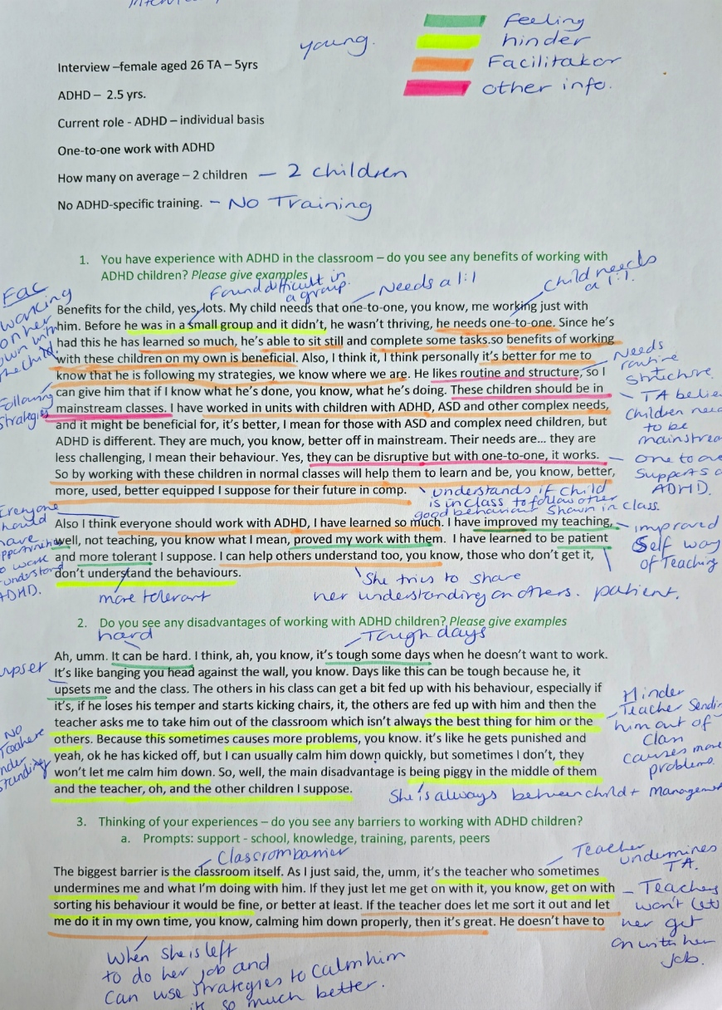
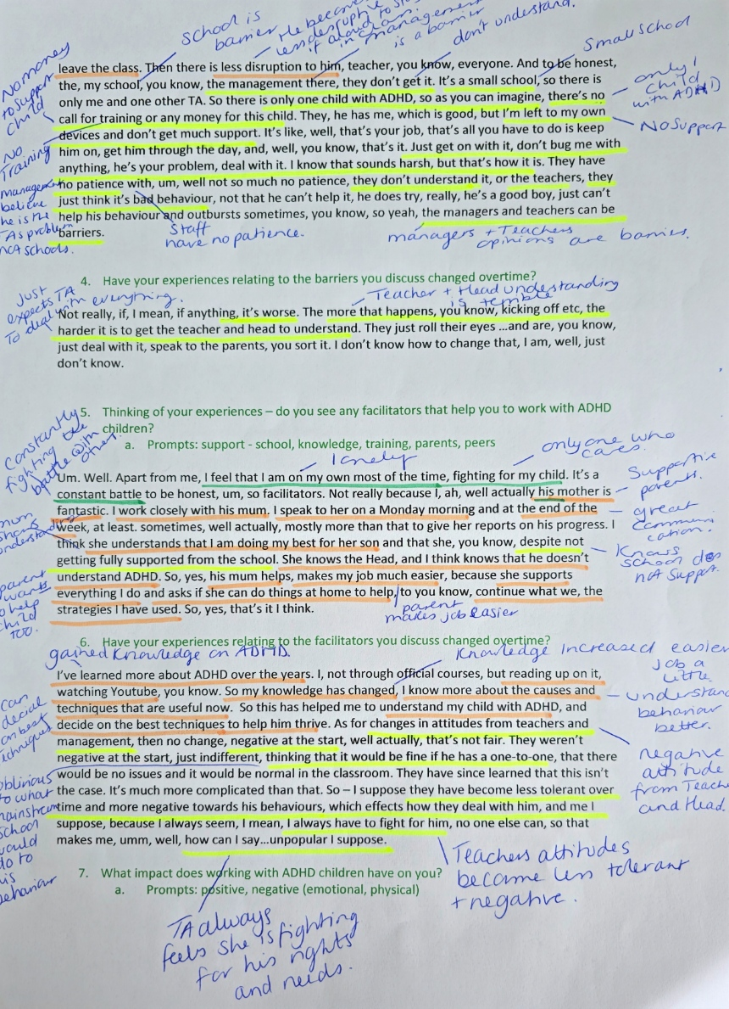
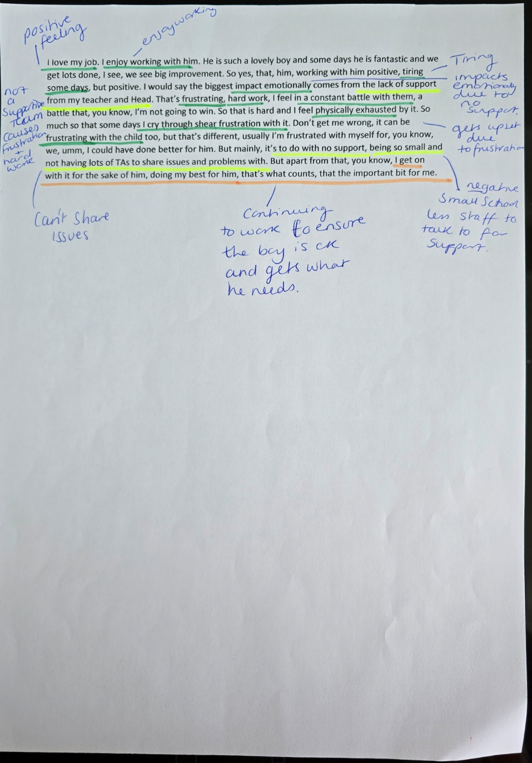

Appendix C
Codes across
Below are the initial descriptive codes from each interview:
Interview initial codes.
1 Rewarding
Positive feelings
Loves the job.
Gets job satisfaction.
Understands needs.
Children are accepting of ADHD.
Need to patient.
Children and TA have learned the needs of the child.
Can’t rush.
Negative feelings
Exhausted
Very cross
Need to be patient and concentrate.
Harder than working with other ALN.
People are so negative.
Unable to make friends.
Working in difficult conditions
No teacher interaction
Attitude
Teacher gets cross if they disrupt.
Teacher expects TA to deal with ADHD.
Funding
More support for the school itself
Less resources is not an issue for this TA.
Some teacher’s attitudes towards the child
Negative teacher attitude towards TA in front of children
Hard to balance child and class teacher.
Feeling sad
Good relationship with parents
Parents are supportive.
Some parents can be difficult.
Argumentative parents
Demanding more support
Worried and stressful
Trying to keep everyone happy
Child centred
Resilient- learning from other negative encounters
Enjoyment of learning about ADHD
No training
People’s attitudes
People’s negative perspectives
Times have changed people’s opinions are always negative.
Children have changed.
Children ignore the disruptions.
The more time children spend with ADHD they get used to it.
Ignoring children due to behaviour
Difficult and sad
Parents can be great.
Hard to stay in mainstream.
Childs needs are too complex for mainstream school.
People gaining knowledge of ADHD.
Communication is easier.
Open communication in school is a positive
School is laid back.
Head teacher attitude.
Head teacher is hands on
Had no support in other schools.
Due to experience, she is respected and supported.
Seems to take full responsibility for child’s actions.
Beating themselves up if something goes wrong.
Home routine before school could hinder.
Happy to make a difference.
No acknowledgement
The path of working with ADHD is difficult.
Feeling work is hard.
Acknowledged from ed psychs
Children being labelled.
Gaps in research
Everyone needs training on ADHD.
ADHD children are perceived as naughty.
Social disruptions

2 Younger staff members
No training
Provides problem solving.
Reactions
Built patience.
Learned how to control reaction
Having a 1:1 improved academically.
No teacher interaction to control class.
Happy parents
Pleasure to see improvement.
Built a positive relationship and it benefited the child socially and academically.
Negative feeling- stress, difficult, frustration, handful, intimidated, ‘on pins,’ physically draining.
Understanding the child’s behaviour and emotions
More advantages than disadvantages
Starting the job with no training
To better the job needs training.
Supportive environment
Supportive ALNCO
Supported through receiving advice
Having a person to rely on
Many teachers did not understand.
Teacher was negative towards the child.
Teachers are naïve towards ADHD.
Lack of understanding
90% of teachers have negative perspectives.
Need to show empathy to understand.
No head teacher support
Head teacher doesn’t understand.
Child only built a relationship with 2 adults.
Supportive parents
Parents could see progress.
Parents willing to try new things.
Parents and school working together.
Peers accepted
Some children were frustrated with the ADHD behaviour.
Other ALN children were jealous.
Teachers understanding hasn’t changed.
Less judgement and attitudes changed due to improving behaviour.
Teachers’ negative attitudes changed.
They found it easier to talk to him.
Lack of knowledge
TA didn’t read up on ADHD.
Built a relationship by asking questions to get to know him.
Good support network
Supportive ED psych through giving advice.
Work is ok if supported by ALNCO as child only likes them.
Parents are good.
Need to know traits.
Trying different things
Parents are happy that he is supported.
Sharing info
Parents advice
Not settling as attended 4 different schools.
Parents are happy with trial and error.
Most peers are supportive.
Understand his behaviours.
Peers understand him.
Older boys get frustrated.
Girls were a little standoffish at the beginning.
as his behaviour improves their attitude changes towards him
constantly waiting for bad behaviour
positive emotions- happy, rewarding.
learned more about him
got to know him for him.
more training to gain knowledge.
not fully understanding of ADHD
teachers need ADHD training.

3 older
No training
Sharing knowledge and understanding
Understands ADHD
Others referring to them as naughty.
Sees ADHD as a disability.
Negative feelings- stress, hard work, challenging, tiring.
A lot of attention
Negative behaviours
Negative impact on all children
Only remove if violent
Need to be on top of everything.
Know how to react to behaviour.
Keep in mainstream.
Letting them to stay in class helps behaviour.
Deal with positive ways.
Build relationships with others is a positive
Children are seen as naughty.
You have to ask for support.
Having children who are not diagnosed.
Need knowledge and paperwork to ensure they get the right needs.
Always pushing ALN out of class into units
Trial and error of interventions
Needs early interventions.
Need training.
Support from outside agencies/ ALNCO
Researched herself.
ALNCO couldn’t help as they didn’t understand.
Teachers don’t understand or see the issue.
Teachers don’t take responsibility.
Teachers don’t work with the children.
Need more than one person to support or sort the child.
Needing more support
Teachers sometimes helps.
Teachers always say they have the class to teach.
All staff need training especially the teachers to put interventions in place.
Negative parents
Parents making the issues about themselves.
Some parents are needing help too.
Communication
Some parents are in denial.
Parents are scared of admitting defeat.
Not admitting there is a problem can cause more problems.
Negative behaviour in class
Can wind up and escalate behaviour.
Child needs full attention.
Children can be frightened.
Mixture of emotions
2 or more staff needed.
Taking staff from others
Children need full attention.
Some work as a team to solve problems.
Some people help.
She changed her ways in different environments.
Environment change due to complex needs of students.
Support from outside agencies
Always in
Some support if you need it.
Research ADHD yourself.
Observation supports understanding of behaviour.
Now and next cards are positives.
Staff had no understanding of what to do.
Behaviours seen in class.
Interventions and strategies help
Negative feelings- fearful, anxious, tiring, physically exhausted, failure, stress, emotionally drained
A little positive
Anxious over the unknown
Loves her job.
Passionate about job
Enjoys a challenge.
Likes to gain information.
Have to research.
Enjoy working with ALN.
Sometimes can’t find answers.
Try something new because it is dependent on their mood.
Brain working overtime.
The unknown
Impacts emotionally.

4 No training
Young
Working on her own with the child
Following strategies
Found it difficult in groups.
Needs a 1:1.
Needs routine and structure.
TA believed children need to be in mainstream.
1:1 supports ADHD
Understands if child is in class to follow other good behaviour shown in class.
Improved self-way of teaching.
Everyone should have opportunities to work and understand ADHD.
More tolerant
Positive feeling- patient,
She tries to share her understanding on others.
Negative feeling- hard, upset, tough days, tiring emotionally draining, frustrating, hard work.
No teacher understanding.
Teacher sending him out of class causes more problems.
TA is always between staff and child.
No teacher understanding.
Classroom barrier
Teacher undermines TA.
Teachers won’t let her get on with her job.
When TA is left to do her job, she can use strategies to calm him it’s so much better.
No money to support the child.
School is a barrier.
He becomes less disruptive if allowed to stay in class.
Management is a barrier.
Don’t understand.
Small school
Only got 1 child with ADHD.
No support
No training
Management believe he is the Tas problem not schools.
Staff have no patience.
Managers and teachers’ opinions are barriers.
Just expects TA to deal with everything.
Teacher and head teachers understanding is terrible.
Constantly fighting the battle with others
Lonely
Only one who cares.
Supportive parents
Great communication
Knows school does not support.
Parent makes job easier.
Parents want to help the child too.
Mum shows understanding
Gained knowledge on ADHD.
Knowledge increased job gets easier.
Understand behaviour better.
Can decide on best techniques.
Oblivious to what mainstream school would do to his behaviour.
Negative attitude from teacher and head teacher
Teachers’ attitudes become less tolerant and negative.
TA always feels she is fighting for his rights and needs.
Love my job.
Enjoy working.
Impacts emotionally due to no support.
Gets upset due to frustration.
Small school less staff to talk to for support.
Continuing to work to ensure the child is ok and gets what he needs.
Can’t share issues.
Not a supportive team
Causes frustration and hard work.

5 Older
No training
Child thrives with adult 1:1.
1:1 is needed
No understanding
Didn’t believe in ADHD.
Once worked with ADHD began to understand behaviours.
Now understands their complex needs.
Learned on the job
Needs a caring 1:1.
Need to understand them.
They only work with one adult.
Children don’t integrate due to always being with 1:1.
Build a relationship with TA.
TA always has to stay with him.
They learn not to need anyone else except for TA.
Don’t spend time with anyone.
Negative feelings- isolated, lonely, it’s hard, tiring, tough, terrified, stressed, no sleep, worried, ill drained, exhausted, not eating, awful.
No interaction with other staff
No one else cares
Loves the job.
Always on my own
No break
School system is failing children with ADHD.
Only a few ALN children
Small school
Teachers leave it to Tas.
No support
No money
No training
No guidance
Gran is a barrier.
Gran doesn’t understand ADHD.
No involvement with guardian
Gran swearing
Gran is not interested.
Poor support
Doing the same work as everyone
Complicated
Trial and error
Didn’t know strategies.
Own research
Bought books.
Built her own confidence.
Lots of information online
Gaining knowledge and new strategies helped
Work life balance.
Constantly learning
Children have taught the TA.
More knowledge = easier the job
Always willing to voice opinions and concerns.
Teachers asking for TA advice.
Teachers’ attitudes have changed.
Teachers have begun to help.
More respect due to knowledge and experience.
No help
Learning and research
Confidence grew.
Understand the children.
Keep up to date/ organised.
Not all children are the same.
TA is still learning.
Loves the job.
Job satisfaction
Praise
Have to be on your toes when working with ADHD.

6 Older
No training
Uses social stories and behaviour modification techniques.
Learning from the child
Extreme satisfaction
Own research
Trial and error approach
Suffered due to stigma and exclusion.
Gaining understanding and knowledge has helped her role.
Job is not easy.
Worse without medication
No learning trying to control behaviour.
Emotions lead to exclusion due to teacher reactions.
The mother is not happy.
Parents interfering
Parents winding the teacher up.
Not happy about the work being done.
Not a great relationship with the parents
Mothers attitude rubbing off on child’s attitude creating a difficult learning environment.
Teachers lack understanding of ADHD.
All teacher talk is negative.
Teacher has negative attitudes towards children.
All negative talks involve disruption and naughty behaviour.
TA needs more training.
If they had more understanding there would be less negativity
Other children pick up on the negativity.
Teachers need more training.
Experiences and research help
Children need to understand ADHD too.
Children have learned to deal with them.
Parents are always wanting more.
Due to the child’s behaviour, the class does not include them.
Supportive ALNCO
ALNCO helped her to fulfil job.
Ensures staff has everything they need.
Can talk.
Lots of experience
Hands on experience and knowledge
Head teacher is supportive.
Support from more than 1 person
Good morale in school great ALNCO
Support from ALNCO when dealing with parents and class teachers.
Worked with no support in another school.
Staff are happy.
ALNCO makes the role easier.
Children including child with ADHD.
Lots of positives in the job
Child progression
Building own self esteem
Happy knowing you have supported a child.
Have to fight for the child with other parents.
Negative opinions
Parents input leads to children being negative.
TA feels it’s her job to help the children and parents understand ADHD.
TA has to work through negative and ensure child is ok.
Negative opinions upset the child.
Negative feelings- exhausted, upset, mentally exhausted, sad, frustrated.

Appendix D
Codes organised into initial themes
Teacher perspectives and attitudes
Teacher undermines TA.
Teachers asking for TA advice.
Teachers’ attitudes have changed.
If they had more understanding there would be less negativity
Teachers have begun to help.
Oblivious to what mainstream school would do to his behaviour.
Negative attitude from teacher and head teacher
Teachers’ attitudes become less tolerant and negative.
Teachers won’t let her get on with her job.
Management believe he is the Tas problem not schools.
Staff have no patience.
Managers and teachers’ opinions are barriers.
Just expects TA to deal with everything.
Teacher and head teachers understanding is terrible.
No teacher interaction
Teachers sometimes helps.
Teachers always say they have the class to teach.
Teacher gets crossed if they disrupt.
Teacher expects TA to deal with ADHD.
Some teachers negative attitude towards the child
Negative attitude towards TA in front of children
ADHD children are perceived as naughty.
Children being labelled.
Many teachers did not understand.
Teacher was negative towards the child.
Teachers are naïve towards ADHD.
90% of teachers have negative perspectives.
Teachers understanding hasn’t changed.
Less judgement and attitudes changed due to improving behaviour, so teacher attitudes changed.
ALNCO helped her to fulfil job.
Ensures staff has everything they need.
Support from more than 1 person
Good morale in school great ALNCO
Support from ALNCO when dealing with parents and class teachers.
Can talk.
Lots of experience
Hands on experience and knowledge
Teachers found it easier to talk to him.
Teachers don’t understand or see the issue.
Teachers don’t take responsibility.
Teachers don’t work with the children.
Staff had no understanding of what to do.
Teacher is sending him out of class causes more problems.
Emotions lead to exclusion due to teacher reactions.
Teachers lack understanding of ADHD.
All teacher talk is negative.
Teacher has negative attitudes towards children.
All negative talks involve disruption and naughty behaviour.

Support network
Communication is easier.
Open communication in school is a positive
Headteacher attitude
Head teacher is hands on
Due to experience, she is respected and supported.
Supportive environment
Supportive ALNCO- supported through receiving advice.
Having a person to rely on
No head teacher support
Headteacher did not understand.
Sharing knowledge and understanding
You have to ask for support.
Support from outside agencies
ALNCO couldn’t help as they didn’t understand.
Need more than one person to support or sort the child.
All staff need training especially the teachers to put interventions in place.
Support from outside agencies
Always in
Some support if you need it.
Some work as a team to solve problems.
Some people help.
Good relationship with parents
Parents can be great.
Parents are supportive.
Some parents can be difficult.
Argumentative parents
Demanding for more support
Happy parents
Parents could see progress.
Parents willing to try new things.
Parents and school working together.
Parents are happy that he is supported.
Sharing info
Parents advice
Parents are happy with trial and error.
Negative parents
Parents making the issues about themselves.
Some parents are needing help too.
Communication
Some parents are in denial.
Parents are scared of admitting defeat.
Not admitting there is a problem can cause more problems.
Knows school does not support.
Parent makes job easier.
Parents want to help the child too.
Mum shows understanding
Gran is a barrier.
Gran doesn’t understand ADHD.
No involvement with guardian
Gran swearing
Gran is not interested.
The mother is not happy.
Parents interfering
Parents winding the teacher up.
Not happy about the work being done.
Not a great relationship with the parents
Mothers attitude rubbing off on child’s attitude creating a difficult learning environment.
Have to fight for the child with other parents.
Negative opinions
Parents input leads to children being negative.
TA feels it’s her job to help the children and parents understand ADHD.

Positive feelings of working as a TA.
Positive feelings
Loves the job.
Gets job satisfaction.
Happy to make a difference.
Acknowledged from the ED Psychs
Built patience.
Building own self esteem
Happy knowing you have supported a child.
Pleasure to see improvement.
More advantages than disadvantages
She tries to share her understanding on others.
Work is ok if supported by ALNCO as child only likes them.
Positive feelings- happy, rewarding, praised.
She changed her ways in different environments.
Passionate about job
Enjoys a challenge.
Enjoys working with ALN.
Work life balance.
Constantly learning
Children have taught the TA.
More knowledge = easier the job
Always willing to voice opinions and concerns.

Improvement in their role
Enjoyment of learning about ADHD
Everyone needs training on ADHD.
Learned how to control reactions
Need to know traits.
Trying different things
Understands ADHD
Researched herself.
Likes to gain information.
Improved self-way of teaching.
Everyone should have opportunities to work and understand ADHD.
Gained knowledge on ADHD.
Knowledge increased job gets easier.
Understand behaviour better.
Can decide on best techniques.
Continuing to work to ensure the child is ok and gets what he needs.
Didn’t know strategies.
Bought books.
Built her own confidence.
Lots of information online
Gaining knowledge and new strategies helped

Building a relationship with 1:1
Understands needs.
Child centred
Learned more about him
Got to know him for him.
Social disruptions
Having support from 1:1 improved the child academically.
Built a positive relationship and it benefited the child socially and academically.
Child only built a relationship with 2 adults.
Built a relationship by asking questions to get to know him.
Build relationships with others is a positive
Needs a caring 1:1.
Need to understand them.
They only work with one adult.
Children don’t integrate due to always being with 1:1.
Build a relationship with TA.
TA always has to stay with him.
They learn not to need anyone else except for TA.
Don’t spend time with anyone.

Negative feelings of working as a TA.
Negative feelings- sad, worried, stressful, Exhausted, very cross, difficult, frustration, handful, intimidated, ‘on pins,’ physically draining, tiring, challenging, hard work emotionally draining, tough days, upset, lonely ill drained, awful, not eating no sleep, worried, terrified.
Trying to keep everyone happy
No interaction with other staff
Always on her own
No break
Job is not easy.
Constantly fighting the battle with others
Impacts emotionally due to no support.
Gets upset due to frustration.
Lonely
Only one who cares.
No understanding
Didn’t believe in ADHD.
TA always feels she is fighting for his rights and needs.
Can’t share issues.
Not a supportive team
Causes frustration and hard work.
Need to be patient and concentrate.
Having children who are not diagnosed.
Harder than working with other ALN.
No acknowledgement
Brain working overtime.
Sometimes can’t find answers.
The unknown
Impacts emotionally.
The path of working with ADHD is difficult.
Work is hard.
Anxious over the unknown
Working in difficult conditions
Seems to take full responsibility for child’s actions.
Beating themselves up if something goes wrong.
Starting the job with no training
To better the job needs training.
Constantly waiting for bad behaviour
Negative impact on all children
TA has to work through negative and ensure child is ok.
Negative opinions upset the child.

Knowledge and experience
Gaps in research
Everyone needs training.
Need to show empathy to understand.
Lack of knowledge
TA didn’t read up on ADHD.
More training to gain knowledge.
Not fully understanding of ADHD
Sees ADHD as a disability.
Keep up to date/ organised.
Not all children are the same.
TA is still learning.
Need to be on top of everything.
Know how to react to behaviour.
Need knowledge and paperwork to ensure they get the right needs.
Working on her own with the child
Following strategies
Found it difficult in groups.
Needs a 1:1.
Needs routine and structure.
TA believed children need to be in mainstream.
1:1 supports ADHD
Understands if child is in class to follow other good behaviour shown in class.
People can be so negative.
Worse without medication
No learning trying to control behaviour.
Hard to balance child and class teacher.
Resilient-from learning from other negative encounters
No training
Worked with no support in another school.
Once worked with ADHD began to understand behaviours.
Now understands their complex needs.
Learned on the job
Times have changed people’s opinions are always negative.
Had no support in other schools.
Child not settling as attended 4 different schools.
Teachers need ADHD training.
Trial and error of interventions
Needs early interventions.
Need training.
Try something new because it is dependent on their mood.
Gaining understanding and knowledge has helped her role.
Have to be on your toes when working with ADHD.
Suffered due to stigma and exclusion.

Peer perspective
Children have changed.
Most peers are supportive.
Understands his behaviours.
Children ignore disruptions.
The more time children spend with ADHD they get used to it.
Ignore the children due to behaviour.
Peers accepted
Children including child with ADHD.
Some children were frustrated with the ADHD behaviour.
Other ALN children were jealous.
Children are accepting of ADHD.
Peers understand his behaviours.
Older boys get frustrated.
Girls were a little standoffish at the beginning, as his behaviour improves their attitude changes towards him.
Other children pick up on the negativity.
Children need to understand ADHD too.
Children have learned to deal with them.
Due to the child’s behaviour, the class does not include them.

School environment
Funding
More support needed for the school itself.
School is laid back.
Less resources
Hard to stay in mainstream.
Childs needs are too complex for mainstream school.
Negative impact on all children
Only remove if violent
Keep in mainstream.
Letting them to stay in class helps behaviour.
Deal with positive ways.
Always pushing ALN out of class into units
Negative behaviour in class
Can wind up and escalate behaviour.
Child needs full attention.
2 or more staff needed.
Taking staff from others
Environment change due to complex needs of student.
Observation supports understanding of behaviour.
Now and next cards are positives.
Interventions and strategies help
Classroom barrier
When TA is left to do her job, she can use strategies to calm him it’s so much better.
No money to support the child.
School is a barrier.
He becomes less disruptive if allowed to stay in class.
Management is a barrier.
Small school
Only got 1 child with ADHD.
Small school less staff to talk to for support.
Child thrives with adult 1:1.
1:1 is needed
School system is failing children with ADHD.
Only a few ALN children
Small school
Teachers leave it to TAs.
No support
No money
Uses social stories and behaviour modification techniques.
No training
No guidance

Appendix E
Revision of initial themes and sub-headings
Teacher perspectives and attitudes
-Teacher misconceptions
-Teacher negative attitudes
-Teacher behaviours
-Teachers’ knowledge

Support network
-Supportive ALNCO
-Supportive Headteacher
-Outside agency input
-Unsupportive staff
-Positive parent perspectives and involvement
-Negative parent perspectives and involvement
-Relationship between school and parent

Positive feelings of working as a TA.
-Work pleasures
-Positive impact on TA wellbeing

Improvement in their role
-Building knowledge
-Exploration of understanding

Building a relationship with 1:1
-Impact of having a 1:1 TA
-How to build a positive relationship

Negative feelings of working as a TA.
-Negative impact on Tas wellbeing
-Negative behaviours which impacts the role of a TA

Knowledge and experiences
-Negative experiences
-Positive experiences
-How knowledge supports the role?

Peer perspectives
-Positive peer perspective
-Negative peer perspective

School environment
-School environment barriers
-Classroom management
-Positive understanding of a school environment

Appendix F
Final themes and sub-themes
Themes Sub-Headings

Positive feelings of working as a TA.
Negative feelings of working as a TA.

School environment School environment barriers
Classroom barriers

Teacher perspectives and attitudes Teacher negative attitudes
Teacher misconceptions

Support network Parents
Staff

