Managing Projects in the Organisation
(BMSW5009_SWAN)

Lecturer: Giulia Chifari

Student: Claudiu Florea – 2330390

Saint Thomas Church Food Donation Project

Date: 03/07/2026
Contents
Executive summary: 3
1. Introduction to Saint Thomas Church Food donation Project. 4
2. Group Formation and Project Initiation 5
3. Project Scope, Objectives and Stakeholder Management 6
4. Stakeholder Analysis and Communication 7
5. Project Management Tools and Techniques 8
Work Breakdown Structure (WBS) 8
Gantt Chart 10
6. Monitoring and Evaluation Throughout the Project Lifecycle 11
7. Recommendations for Future Projects 12
8. Conclusion 13
Reference list: 14

Executive summary:
This report critically evaluates the management of the St Thomas Church Food Donation Project, an initiative designed to support individuals and families experiencing food insecurity. The project aimed to collect approximately 30–50 non-perishable food items within a £100–£300 budget and complete delivery within a four-week timeframe. Following consultation with St Thomas Church, the team identified a local need and developed a practical response supported by community donations and Tesco management through discounts and vouchers.
The report examines the project lifecycle, including group formation, project initiation, scope management, stakeholder engagement, communication, project management tools, monitoring and evaluation, and lessons learned. The analysis highlights the use of traditional project management techniques, particularly the Work Breakdown Structure (WBS) and Gantt chart, which supported task organisation, scheduling and accountability. However, the project demonstrated that such tools must be combined with flexibility, effective communication and stakeholder collaboration to respond to uncertainty.
Key challenges included the initial consideration of unrealistic project ideas, reliance on informal communication methods and dependency on external stakeholders. These experiences highlighted the importance of feasibility analysis, structured communication and proactive risk management. The project was successful in achieving its objectives due to strong teamwork, shared commitment and effective stakeholder support.
The report concludes that successful community project management extends beyond meeting time, cost and scope constraints.
Future projects would benefit from earlier feasibility assessment, formal communication strategies, wider stakeholder involvement and stronger contingency planning to improve resilience and long-term social impact.

1. Introduction to Saint Thomas Church Food donation Project.

Project management involves the application of knowledge, skills and techniques to achieve specific objectives within agreed constraints of time, cost and quality. Effective project management is particularly important in community-based initiatives where resources are limited, and stakeholder expectations are diverse (Joos, et. al., 2020).
However, reliance on the traditional time–cost–quality framework alone has been criticised for overlooking broader measures of project success, such as stakeholder satisfaction and long-term community value (Pereira, et al., 2021).
The St Thomas Church Food Donation Project was established to address food insecurity by providing non-perishable food to vulnerable individuals and families (Lambie-Mumford et al., 2023).
Following consultation with St Thomas Church, the group identified this need and organised a food donation initiative, supported by community contributions and Tesco through discounts and vouchers.
The project aimed to support local people experiencing food insecurity by collecting 30–50 food items within a £100–£300 budget over four weeks. This report critically evaluates the project lifecycle, recognising that project success extends beyond meeting time, cost and scope constraints to include stakeholder value and continuous learning for future practice (Pereira, Varajão and Takagi, 2021).

2. Group Formation and Project Initiation

The project team consisted of five mature students: Claudiu, Iustina, Raluca, Piotr and Dre. Despite different backgrounds, members shared common values centred on supporting the community. Following democratic discussions, Claudiu was elected group leader, which encouraged participation and commitment. However, democratic leadership can sometimes delay decision-making when quick action is required (Briscoe and Fortuna, 2024; Vroom, 2000).
According to Tuckman (1965) and Kohn and Smith (2010), teams typically progress through forming, storming, norming and performing stages. The team experienced forming while developing relationships and exploring ideas, followed by storming when disagreements emerged regarding project selection. This reflects a common stage of team development where differing viewpoints influence decision-making (Zirar et al., 2024).
Several ideas were considered, including volunteering initiatives, beach-cleaning and student wellbeing activities. Although socially valuable, these were rejected due to limitations in time, resources and organisational approval, demonstrating that creativity must be balanced with feasibility (Sarhadi et al., 2021).
The final project was selected after Raluca identified St Thomas Church as requiring support, with discussions confirming food insecurity as a key community need. The food donation initiative was achievable within four weeks and aligned with SMART principles for realistic objectives (Delisle, 2020).
However, SMART objectives may overemphasise measurable outputs, meaning successful delivery also depends on stakeholder engagement, communication and understanding community needs (Raiden and King, 2021; Maddaloni and Sabini, 2022).

3. Project Scope, Objectives and Stakeholder Management

Following project selection, defining the scope of the St Thomas Church Food Donation Project was essential to establish clear boundaries and prevent scope creep. The scope included identifying food requirements with church representatives, collecting donations, securing Tesco support, purchasing non-perishable items and delivering supplies by 16 June 2026.
Activities such as long-term financial assistance, permanent food bank operations and supporting other charities were excluded to maintain focus. However, while scope control supports effective use of time and resources, overly restrictive boundaries may limit wider social impact. Therefore, scope management requires balancing project constraints with stakeholder needs and community value (Association for Project Management, 2019; Leiringer, 2021).
The project aimed to support individuals and families experiencing food insecurity through practical community action. Objectives included collecting 30–50 food items, maintaining expenditure within a £100–£300 budget and completing the project within four weeks.
Although measurable objectives supported planning, project success should also consider social value and beneficiary outcomes, as stakeholders may assess success differently (Chow and Leiringer, 2020; Mulholland et al., 2020).
The project also reflected the balance between time, cost and quality. While completing the project within budget and timeframe was important, quality depended on whether donations addressed the needs identified by St Thomas Church rather than simply achieving numerical targets (Joos et al., 2020).
Although the Iron Triangle remains widely recognised, it has been criticised for overlooking stakeholder satisfaction and long-term benefits (Atkinson, 1999). Therefore, success depended not only on meeting constraints but also on creating meaningful community impact.

4. Stakeholder Analysis and Communication
Stakeholder management was essential throughout the project lifecycle, as delivery depended on collaboration between the project team, St Thomas Church representatives, Tesco, donors and community beneficiaries.
St Thomas Church helped identify community needs, while Tesco and donors provided resources that supported delivery within budget. However, stakeholders have different levels of influence and expectations, requiring effective engagement to maintain alignment and maximise value (Aaltonen and Kujala, 2016; Mok et al., 2015).
Communication through meetings, calls, messages and group discussions enabled information sharing and quick responses to issues. Although effective communication contributes to project success (PMI, 2021), reliance on informal methods increased the risk of misunderstandings and unclear responsibilities. A more structured communication plan could have strengthened accountability.
The project also demonstrated stakeholder dependency, as external support from Tesco and donors influenced outcomes. While these relationships increased available resources, they also created risks if support changed. Therefore, stakeholder relationships require active management and contingency planning to improve project resilience (Aaltonen et al., 2021).

5. Project Management Tools and Techniques

The planning and execution of the St Thomas Church Food Donation Project relied primarily on traditional project management tools, including the Work Breakdown Structure (WBS) and Gantt chart. These tools supported the planning, scheduling and monitoring of activities throughout the project lifecycle. According to the Project Management Institute (PMI, 2021), project management tools facilitate coordination and improve control over resources, time and deliverables. However, their effectiveness depends largely upon the complexity and uncertainty associated with the project.

Work Breakdown Structure (WBS)
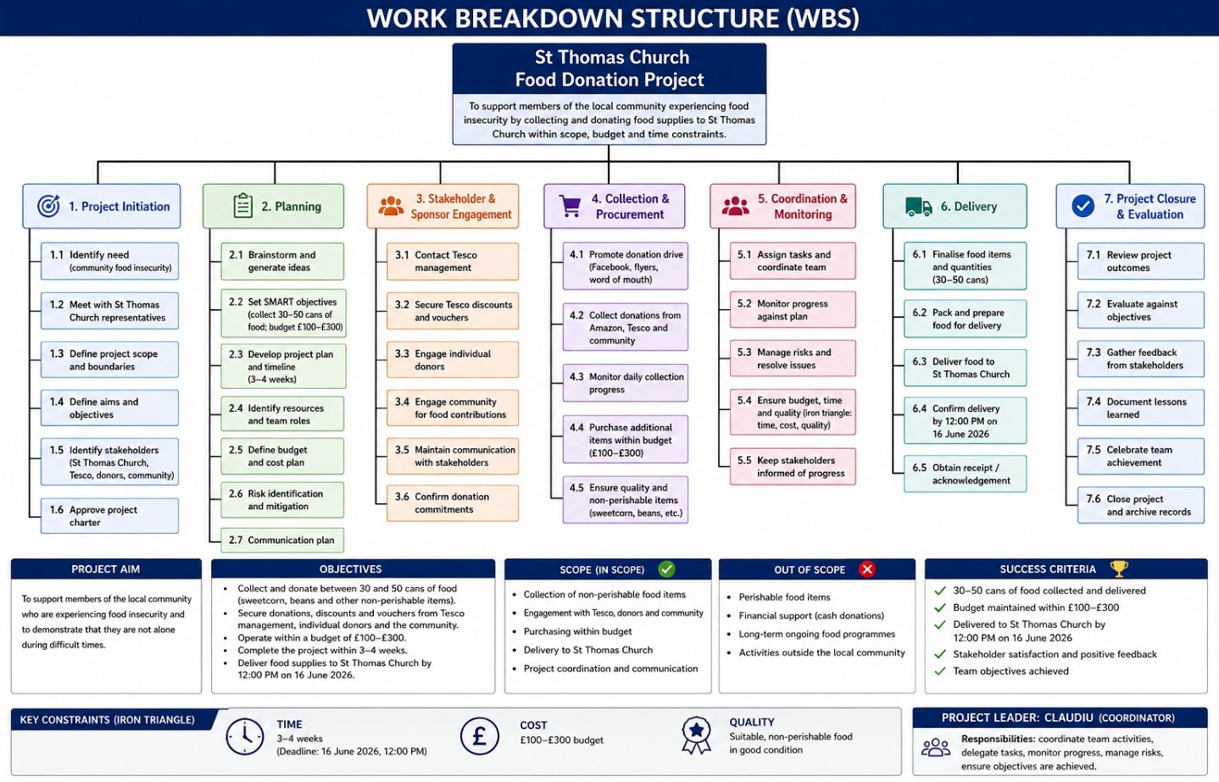
(Florea, 2026 – St Thomas Church food donation WBS).

A Work Breakdown Structure (WBS) was used to divide the St Thomas Church Food Donation Project into smaller and manageable activities, including identifying project ideas, consulting church representatives, promoting donations, contacting Tesco, collecting contributions, purchasing supplies and organising delivery.
This improved task visibility, role allocation and accountability among team members. However, although WBS supports effective scope planning and control, it does not eliminate uncertainty or guarantee successful delivery when project requirements change.
Therefore, structured planning tools must be combined with flexibility and continuous review throughout the project lifecycle (Cerezo-Narváez et al., 2020).
Responsibilities were distributed across the group, with Claudiu coordinating progress, Piotr and Dre exploring alternative project ideas, and Raluca and Iustina maintaining communication with St Thomas Church.
The early changes in project direction demonstrated that while WBS improves organisation, project teams must also adapt decisions as new information emerges (Cerezo-Narváez et al., 2020).
Although the WBS improved organisation and task visibility, its effectiveness was constrained by the dynamic nature of the project. Initially, the group considered several alternative projects, including Amazon-sponsored volunteering hours, beach-cleaning initiatives and mindfulness sessions. The need to abandon these ideas demonstrated that project planning rarely follows a linear process.
Geraldi and Lechter (2012) argue that projects frequently evolve due to uncertainty and changing circumstances. Therefore, whilst the WBS facilitated structure and coordination, it provided limited flexibility when adapting to new priorities.

Gantt Chart
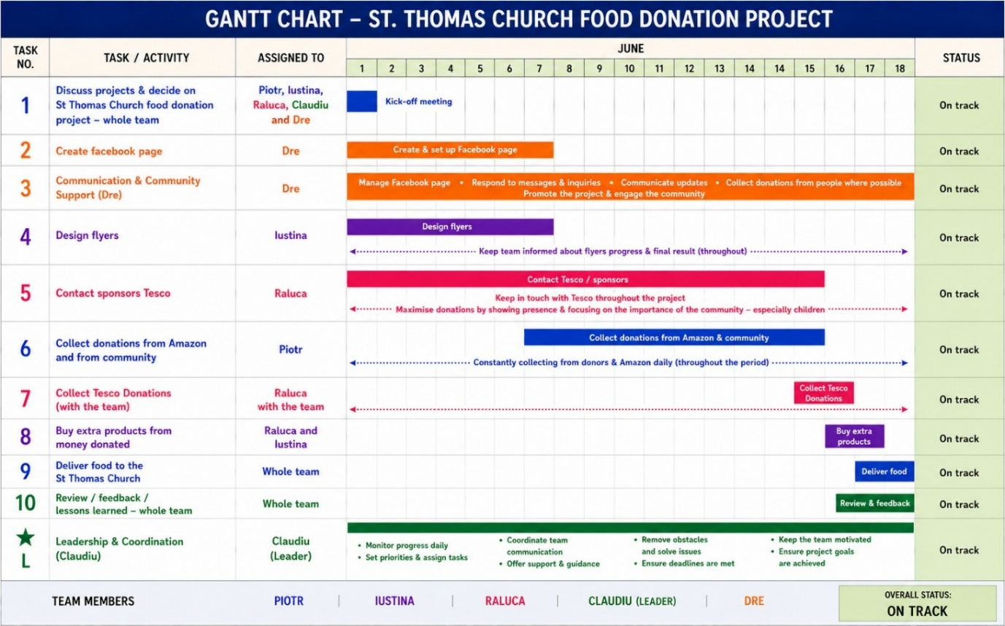
(Florea, 2026 –Gantt Chart Saint Thomas Church project).

In addition to the WBS, a Gantt chart was used to schedule activities over a three-to-four-week period. Tasks were organised chronologically from initial meetings and stakeholder communication through to food collection and final delivery on 16 June 2026. The chart enabled the team to visualise deadlines, dependencies and progress, improving coordination and communication among members (Vanhoucke, 2013).
However, although Gantt charts provide a clear overview of planned activities, they can create a simplified representation of project progress and may become less effective when schedules require frequent adjustment due to uncertainty or changing conditions. Therefore, the chart supported monitoring and accountability but required regular review throughout the project lifecycle (Maravas and Pantouvakis, 2025; Brčić and Mlinarić, 2018).

This highlights one of the major criticisms of traditional project planning approaches: they often struggle to accommodate unexpected changes and may create unrealistic expectations of certainty (Geraldi and Lechter, 2012). More adaptive approaches, such as Agile project management, may have enhanced flexibility and responsiveness.

6. Monitoring and Evaluation Throughout the Project Lifecycle

Monitoring and evaluation occurred throughout the project lifecycle through meetings, calls and group discussions, enabling progress reviews and identification of challenges (Chapman and Ward, 2011). Although effective for a small team, reliance on informal communication created risks of unclear responsibilities and inconsistent information sharing; therefore, more structured processes could improve accountability and transparency (Sicotte and Delerue, 2021).
The WBS, Gantt chart and monitoring activities supported coordination and problem-solving. However, the project highlighted that a tool alone cannot ensure success, as outcomes also depend on communication, stakeholder engagement and adaptability to uncertainty (Serrador and Turner, 2015). Dependence on Tesco and donors further demonstrated the importance of early risk identification and contingency planning.
Belbin’s model also highlighted that team roles are not fixed, as members may demonstrate multiple behaviours depending on the situation. During the project, adapting to challenges required leadership beyond coordination, including problem-solving and decision-making (Syahlan et al., 2024). SWOT analysis, peer feedback and Action Learning supported reflection and continuous improvement, although feedback can be subjective and influenced by participant engagement (Helms and Nixon, 2010; Kenton, 2025).
A key lesson learned was the importance of feasibility assessment. Initial ideas created delays due to insufficient consideration of practical constraints, demonstrating that successful projects require a balance between ambition, resources and realistic objectives. Effective delivery depends not only on technical planning but also on communication and stakeholder alignment (Badewi, 2021; Eskerod et al., 2015).
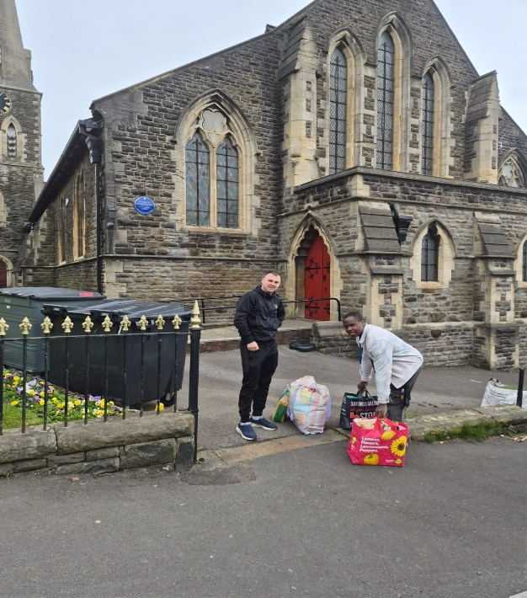
(Florea, 2026 – food delivered at St. Thomas Church).

7. Recommendations for Future Projects
Several recommendations can be proposed to improve future project management. Firstly, greater emphasis should be placed on feasibility analysis during project initiation, as unrealistic ideas can create delays and require resources to be redirected. Therefore, early evaluation of project constraints, resources and stakeholder expectations should complement brainstorming activities (Ssegawa, and Muzinda, 2021).
Secondly, a formal communication plan should be introduced. Although informal communication was effective for this project, relying mainly on verbal updates may increase the risk of unclear responsibilities and inconsistent information sharing. Structured communication processes can improve coordination and accountability among project participants (Zulch, 2014).
Thirdly, risk management should become more proactive through risk registers and contingency planning. However, risk management should not only identify possible problems but also support decision-making when uncertainty occurs (Raz, et al., 2002).
Furthermore, digital project management tools such as Trello or Microsoft Project could improve collaboration, visibility and monitoring. Nevertheless, technology should support rather than replace effective teamwork and communication, as tools alone cannot resolve project complexity (Gemino et al., 2021).
Finally, stakeholder involvement should be expanded to include local businesses, community organisations and volunteers. A wider stakeholder network can strengthen resources and reduce dependence on individual contributors, improving project sustainability (Aaltonen and Kujala, 2016).

8. Conclusion

The St Thomas Church Food Donation Project demonstrated the importance of effective project management throughout the entire project lifecycle. Beginning with group formation and project initiation, the team successfully selected a realistic and socially meaningful project that addressed food insecurity within the local community. Project management tools, including the Work Breakdown Structure and Gantt chart, facilitated planning and coordination, whilst stakeholder engagement and continuous monitoring contributed to successful implementation.
However, the project also highlighted limitations associated with traditional planning techniques, stakeholder dependency and informal communication processes. Self-reflection through SWOT analysis, Belbin Team Roles and peer feedback provided valuable opportunities for leadership development and learning. Overall, the experience emphasised that successful project management extends beyond technical tools and requires adaptability, communication and stakeholder collaboration. Future projects would benefit from more formal risk management, enhanced communication strategies and broader stakeholder involvement to maximise long-term impact.

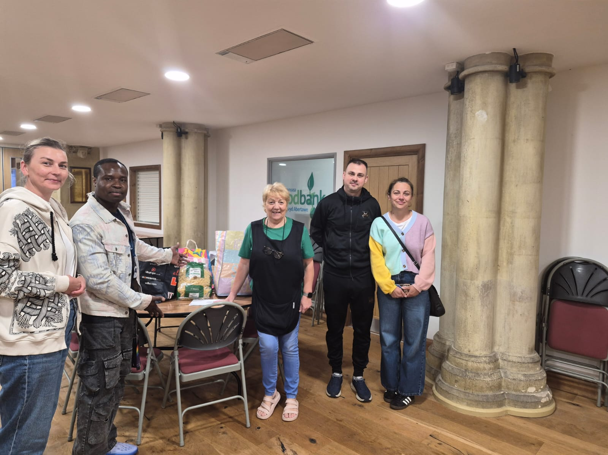
(Florea, 2026 – Group photo with St. Thomas Church`s administrator).

Reference list:

Aaltonen, K. and Kujala, J. (2016). Towards an improved understanding of project stakeholder landscapes. International Journal of Project Management, 34(8), pp.1537–1552.
Available at: https://doi.org/10.1016/j.ijproman.2016.08.009.

Aaltonen, K., Derakhshan, R., Di Maddaloni, F. and Turner, R. (2021). Call for papers: Project stakeholder management. International Journal of Project Management.
Available at: https://doi.org/10.1016/j.ijproman.2021.08.001.
APM (2019). What is scope management?
Available at: https://www.apm.org.uk/resources/what-is-project-management/what-is-scope-management/.
Accessed on 1/07/2026
Atkinson, R. (1999) ‘Project management: cost, time and quality, two best guesses and a phenomenon, it’s time to accept other success criteria’, International Journal of Project Management, 17(6), pp. 337–342.
Available at: https://doi.org/10.1016/S0263-7863(98)00069-6
Garthwaite, K. (2026). Exploring the Growth of ‘Emergency’ Charitable Food Aid in the UK. Bristol University Press eBooks, pp.140–152.
Available at: https://doi.org/10.51952/9781529252149.ch010.
Badewi, A. (2021). When frameworks empower their agents, the effect of organizational project management frameworks on the performance of project managers and benefits managers in delivering transformation projects successfully. International Journal of Project Management, 40(2).
Available at: https://doi.org/10.1016/j.ijproman.2021.10.005.
Brčić, M. and Mlinarić, D. (2018). Tracking Predictive Gantt Chart for Proactive Rescheduling in Stochastic Resource Constrained Project Scheduling. Journal of information and organizational sciences, 42(2), pp.179–192.
Available at: https://doi.org/10.31341/jios.42.2.2.

Briscoe, P. and John Della Fortuna (2024). Elite High-Level Sport Coach and the School Leader: What Can We Learn from Them? Open journal of leadership, 13(01), pp.89–107.
Available at: https://doi.org/10.4236/ojl.2024.131006.
Chapman, C. and Ward, S. (2011) How to Manage Project Opportunity and Risk: Why Uncertainty Management Can Be a Much Better Approach than Risk Management. 3rd edn. Chichester: Wiley. Available at: https://www.wiley.com/en-gb/How+to+Manage+Project+Opportunity+and+Risk-p-9780470686492
Cheng, C. (2022). Project Management Literature Review: The Iron Triangle.
Available at: https://doi.org/10.13140/RG.2.2.32434.27849.

Chow, V. and Leiringer, R. (2019). The Practice of Public Engagement on Projects: From Managing External Stakeholders to Facilitating Active Contributors. Project Management Journal, 51(1), p.875697281987834.
Available at: https://doi.org/10.1177/8756972819878346.
Cliffsnotes.com. (2025). Understanding the Iron Triangle Theory in Project Management.
Available at: https://www.cliffsnotes.com/study-notes/24576869
Accessed 20/06/2026.
Delisle, J. (2020). Working time in multi-project settings: How project workers manage work overload. International Journal of Project Management, 38(7).
Available at: https://doi.org/10.1016/j.ijproman.2020.04.001.
Eskerod, P., Huemann, M. and Savage, G. (2015). Project Stakeholder Management—Past and Present. Project Management Journal, 46(6), pp.6–14.
Available at: https://doi.org/10.1002/pmj.21555.

Gemino, A., Horner Reich, B. and Serrador, P.M. (2020). Agile, Traditional, and Hybrid Approaches to Project Success: Is Hybrid a Poor Second Choice? Project Management Journal, 52(2), p.8.
Available at: https://doi.org/10.1177/8756972820973082.

Available at: https://doi.org/10.1177/8756972820973082.
Geraldi, J. and Lechter, T. (2012) ‘Gantt charts revisited: A critical analysis of its roots and implications to management practice’, International Journal of Managing Projects in Business, 5(4), pp. 578–594.
Available at: https://doi.org/10.1108/17538371211268889
Helms, M.M. and Nixon, J. (2010) ‘Exploring SWOT analysis – where are we now?’, Journal of Strategy and Management, 3(3), pp. 215–251.
Available at: https://doi.org/10.1108/17554251011064837
Joos, H.C., Aufseß, D. zu K. and Pidun, U. (2020). Project Stakeholder Management as the Integration of Stakeholder Salience, Public Participation, and Nonmarket Strategies. Schmalenbach Business Review, 72.
Available at: https://doi.org/10.1007/s41464-020-00092-0.
Kenton, W. (2025) ‘SWOT Analysis: How To With Table and Example’
Available at: https://www.investopedia.com/terms/s/swot.asp
Kohn, N.W. and Smith, S.M. (2010) ‘Collaborative fixation: Effects of others’ ideas on brainstorming’, Applied Cognitive Psychology, 25(3), pp. 359–371.
Available at: https://doi.org/10.1002/acp.1699
Lambie-Mumford, H., Loopstra, R. and Okell, A. (2023). Household food insecurity in the UK: data and research landscape. Household food insecurity in the UK: data and research landscape.
Available at: https://doi.org/10.46756/sci.fsa.hee561.
Leiringer, R. and Zhang, S. (2021). Organisational capabilities and project organising research. International Journal of Project Management, 39(5).
Available at: https://doi.org/10.1016/j.ijproman.2021.02.003.

Maddaloni, F.D. and Sabini, L. (2022). Very important, yet very neglected: Where do local communities stand when examining social sustainability in major construction projects? International Journal of Project Management, 40(7), pp.778–797.
Available at: https://doi.org/10.1016/j.ijproman.2022.08.007.
Maravas, A. and Pantouvakis, J.-P. (2025). Schedula Anima: Dynamic Visualization of Gantt Charts and Resource Usage Graphs in Project Scheduling. Buildings, 15(3), p.393.
Available at: https://doi.org/10.3390/buildings15030393.
Marnewick, A. and Joseph, N. (2019). The importance of planning for communication in a project during the requirements process. IEEE Engineering Management Review, pp.1–1.
Available at: https://doi.org/10.1109/emr.2019.2952563.
Mok, K.Y., Shen, G.Q. and Yang, J. (2015). Stakeholder Management Studies in Mega Construction projects: a Review and Future Directions. International Journal of Project Management, 33(2), pp.446–457.
Available at: https://doi.org/10.1016/j.ijproman.2014.08.007.

Mulholland, C., Chan, P.W., Canning, K. and Ejohwomu, O.A. (2020). Social value for whom, by whom and when? Management, Procurement and Law, 173(2), pp.75–86.
Available at: https://doi.org/10.1680/jmapl.19.00018.
Narvaez, A.C., Fernández, A.P., Mateo, M.O. and Pérez, P.B. (2020). Integration of Cost and Work Breakdown Structures in the Management of Construction Projects, 10(4), p.1386.
Available at: https://www.mdpi.com/2076-3417/10/4/1386.
Pereira, J., Varajão, J. and Takagi, N. (2021). Evaluation of Information Systems Project Success – Insights from Practitioners. Information Systems Management, 39(2), pp.1–18.
Available at: https://doi.org/10.1080/10580530.2021.1887982.

Project Management Institute (PMI) (2021) A Guide to the Project Management Body of Knowledge. 7th edn. Newtown Square, PA: PMI.
Available at: https://www.pmi.org/pmbok-guide-standards/foundational/pmbok
Raiden, A. and King, A. (2021). Social value, organisational learning, and the sustainable development goals in the built environment. Resources, Conservation and Recycling, 172, p.105663.
Available at: https://doi.org/10.1016/j.resconrec.2021.105663.
Raz, T., Shenhar, A.J. and Dvir, D. (2002). Risk management, project success, and technological uncertainty. R&D Management, 32(2), pp.101–109.
Available at: https://doi.org/10.1111/1467-9310.00243.
Sarhadi, M., Hasanzadeh, S. and Hoseini, S.H. (2021). Stakeholder Analysis in the Feasibility Process of Projects: a Structural Evaluation of the Power-Oriented Relationship. Project Management Journal, 52(4), p.875697282199949.
Available at: https://doi.org/10.1177/8756972821999499.
Serrador, P. and Turner, R. (2015). The Relationship between Project Success and Project Efficiency. Project Management Journal, 46(1), pp.30–39.
Available at: https://doi.org/10.1002/pmj.21468.

Sicotte, H. and Delerue, H. (2021). Project planning, top management support and communication: A trident in search of an explanation. Journal of Engineering and Technology Management, 60(1), p.101626.
Available at: https://doi.org/10.1016/j.jengtecman.2021.101626.

Ssegawa, J.K. and Muzinda, M. (2021). Feasibility Assessment Framework (FAF): A Systematic and Objective Approach for Assessing the Viability of a Project. Procedia Computer Science, 181(1), pp.377–385.
Available at: https://doi.org/10.1016/j.procs.2021.01.180.

Syahlan, F., Sobandi, A. and Santoso, B. (2024). Leadership Styles in Management. The Eastasouth Management and Business, 2(03), pp.249–263.
Available at: https://doi.org/10.58812/esmb.v2i03.253.
Tuckman, B.W. (1965) ‘Developmental sequence in small groups’, Psychological Bulletin, 63(6), pp. 384–399.
Available at: https://doi.org/10.1037/h0022100
Vanhoucke, M. (2013). Project Management with Dynamic Scheduling.
Available at: https://doi.org/10.1007/978-3-642-40438-2.
Vroom, V.H. (2000). Leadership and the decision-making process. Organizational Dynamics, 28(4), pp.82–94.
Available at: https://doi.org/10.1016/s0090-2616(00)00003-6.
Zirar, A., Muhammad, N., Upadhyay, A., Kumar, A. and Garza‐Reyes, J.A. (2023). Exploring lean team development from the Tuckman’s model perspective. Production Planning & Control, 1(1), pp.1–22.
Available at: https://doi.org/10.1080/09537287.2023.2275693.
Zulch, B.G. (2014). Communication: The Foundation of Project Management. Procedia Technology, 16(1), pp.1000–1009.
Available at: https://doi.org/10.1016/j.protcy.2014.10.054.

