Site-specific report. 1000 words

How does site-specific art respond differently to contemporary (digital) art on screens.

Introduction.
Site-specific art is explorative. To remove this experience would disembark the viewers journey in figuring out how an artwork is pieced together, disregarding the importance of a location. The digital world of art has its positives and negatives; the exposure gained could span further than its site-specific location, but it could also be completely dismissed without you even knowing. It requires less interaction, and possibly less understanding of that where you are stood when viewing. Experiencing art and photographic installations in person offers a unique experience, entitled to a unique audience; depending on the longevity of an artwork, it allows for something to be seen in person, and not to be recounted the same again.

Artwork 1:
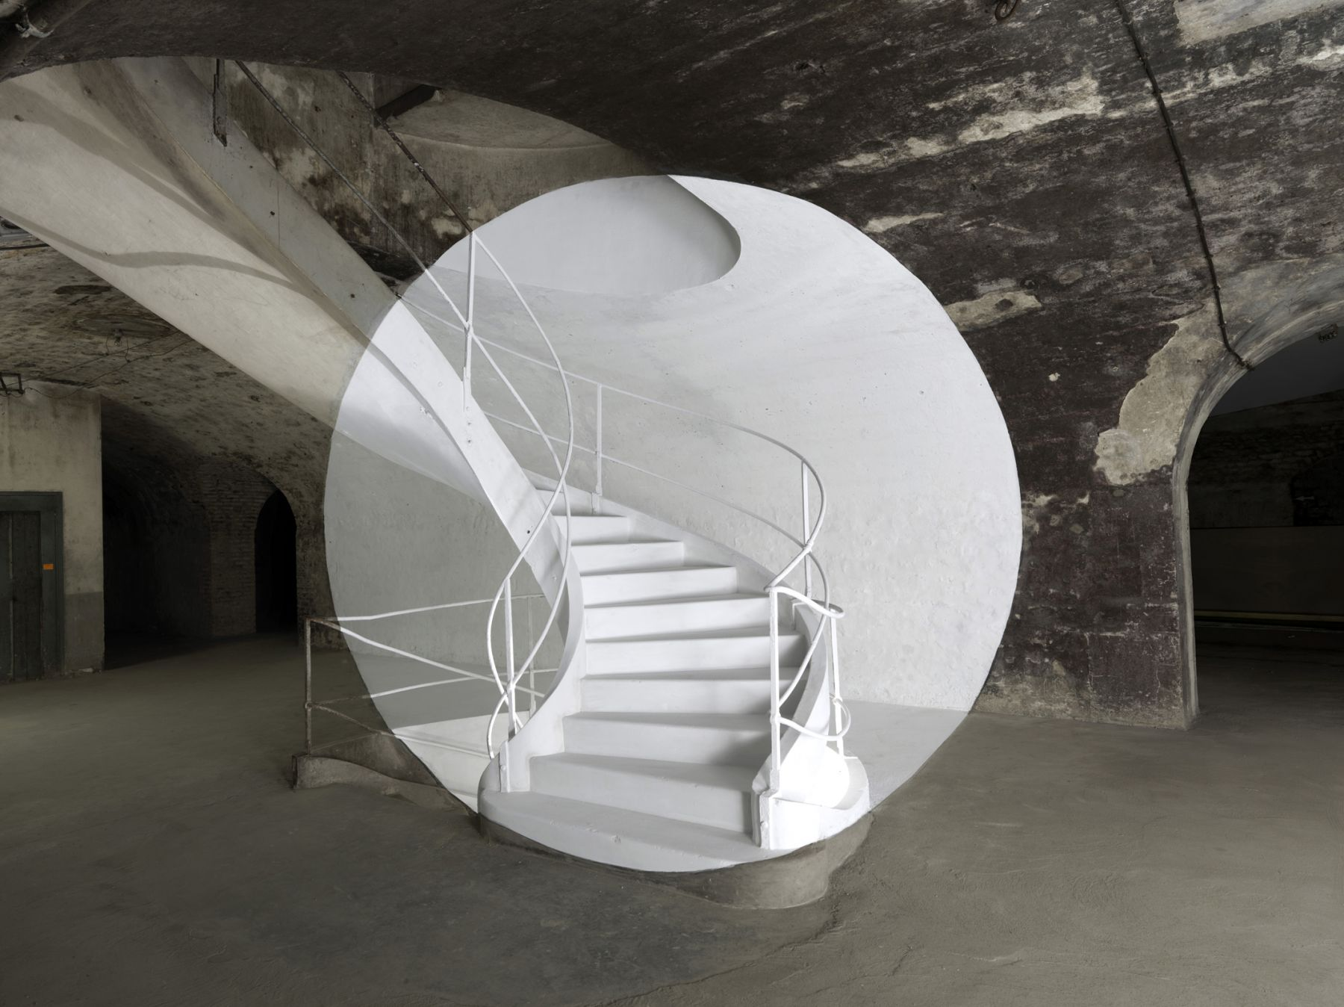‘Reims’, 2011, Georges Rousse
In what is a mixture of digital presentation and site-specificity, Georges Rousse’s work is known for its “captivating large-scale photographs that depict painted alterations within existing spaces” (3) - those that are soon to be demolished, leaving only a digital footprint behind. Rousse’s work questions more of his creative mindset than the actual outcome; what is the weight of physical work in a world where everything can be replicated digitally? When looking at his work as a digital piece, we’re forced to simply consider the realities of these derelict spaces reimagined, rather than experience; what can be described as “reality flattened” (5). Faced with a scene distorted in perspective, its correct viewing can only be seen from the single point provided: the camera lens (3). It argues for the importance of a physical audience, and how Rousse’s work would generate a huge response to seeing it in person, but his experience of the work is to be dedicated to a single photograph instead. In what is considered both site-specific and contemporary art and photography, the work balances between the why it works as a site-specific piece presented digitally; where Rousse’s work is still incredibly engaging and thought-provoking, there is almost a yearning to be considered more in the artwork and its space, which is the effect of contemporary art reduced to screens.

Artwork 2:
‘When Tomorrow Comes’, 2021, Random International
Random International: a post digital art group led by Hannes Koch and Florian Ortkrass, who explore the impact of technological development on the human condition, through large-scale installations (7). In what is presented as a digitalised triptych, this piece confronts the viewer with its collective, swarming movements, as we humans begin to create an emerging consciousness to engage with (6). A wall of screens tower over you, leaving no room to avert your eyes, and therefore unable to take in any of the other potential surroundings. Koch stated that “your physical presence impacts how the art unfolds in front of you” (6)

Bibliography
- https://hicarquitectura.com/2020/06/olafur-eliasson-the-mediated-motion/
- https://olafureliasson.net/artwork/the-mediated-motion-2001/
- https://www.photoandcontemporary.com/en/artisti/georges-rousse/
- https://www.artnet.com/artists/georges-rousse/
- https://www.souslesetoilesgallery.net/artists-installations/georges-rousse?view=slider
- https://www.designboom.com/art/interview-random-international-ritualism-triptych-swarm-scorpios-bodrum-when-tomorrow-comes-08-25-2024/
- https://www.random-international.com/about

